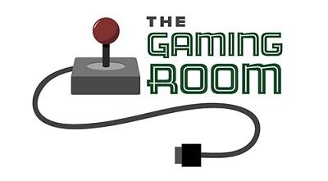

Draw It or Lose It

CS 230 Project Software Design
Version 1.3 | Portfolio Edition

Table of Contents

CS 230 Project Software Design 1
Table of Contents 2
Document Revision History 2
Executive Summary 3
Requirements 3
Design Constraints 3
System Architecture View 3
Domain Model 4
Evaluation 5
Recommendations 7

Document Revision History

Version | Date | Author | Comments
1.0 | 6/10/2026 | Leslie Richmond | Initial draft of software design document
1.1 | 6/13/2026 | Leslie Richmond | Added evaluation of operating platforms and UML documentation.
1.2 | 06/21/2026 | Leslie Richmond | Added final recommendations, storage management, memory management, distributed systems, security analysis, and final edits.
1.3 | 10/09/2026 | Leslie Richmond | Portfolio edition: refined Singleton explanation, layout, and conclusion.

Executive Summary

The Gaming Room has requested a web-based version of their game application so users can play across multiple platforms. The proposed solution is to design a distributed, web-based application that supports multiple players, manages game sessions, and keeps game data organized and secure. The system should allow players to join games, create teams, and participate in game rounds while maintaining accurate information for each user and game instance.

The client’s main business requirement is to expand the game so it can reach more users through a web browser instead of being limited to one platform. The main technical requirements include supporting multiple users at the same time, maintaining unique game and team names, protecting user data, and ensuring the application is scalable, reliable, and easy to maintain.

Requirements

The client requires a web-based game application that allows users to access the system from different devices and operating systems. The application must support multiple players, teams, and games while preventing duplicate games or team names. The system must also manage user information, game sessions, and player participation accurately. From a technical standpoint, the software should be scalable, secure, and able to handle communication between users in a distributed environment.

Design Constraints

The application must be designed for a web-based distributed environment, which means it needs to support users connecting from different locations and devices. Because multiple users may access the game at the same time, the system must manage concurrency and prevent conflicts, such as duplicate names or incorrect game states. The design must also consider security, including protecting user information and controlling access to game data.

Another constraint is scalability. As the number of users grows, the application should be able to handle increased traffic without major performance issues. The design should also remain maintainable so future updates, features, or platform changes can be added without rewriting the entire application.

System Architecture View

The system follows a three-tier architecture consisting of a client layer, an application server layer, and a data storage layer. Users access the game through a web browser, which communicates with the application server via HTTPS requests. The server handles game logic, manages active sessions, and enforces business rules such as preventing duplicate game or team names. A centralized database stores persistent data including user accounts, game instances, and team information. This separation of concerns supports scalability, as each tier can be updated or scaled independently.

Domain Model

The UML class diagram shows the main classes used in the game application and how they relate to each other. The GameService class controls the overall game logic and manages the list of active games. It implements the Singleton design pattern, meaning only one instance of GameService can exist at a time. Within one application process, this provides a centralized service for managing game sessions. In a distributed deployment with multiple server instances, unique names and consistent game state would also require shared storage constraints or coordination across servers. The Game class represents an individual game instance and contains a list of teams, while the Team class represents a group of players within a game and contains a list of players. The Player class represents an individual user participating on a team. The Entity class serves as a parent class and provides shared attributes, such as a unique ID and name, that are inherited by the Game, Team, and Player classes.

The diagram demonstrates several object-oriented programming principles. Inheritance is shown through the Game, Team, and Player classes all extending the Entity class, allowing them to share common attributes without repeating code. Encapsulation is applied by keeping data within each class and providing access through defined methods such as getters and toString. Composition is reflected in the relationships between classes, where a game contains teams and teams contain players. The multiplicity notation on the diagram shows that one game can contain many teams and one team can contain many players, which supports the scalability requirements of the application. Additionally, the ProgramDriver and SingletonTester classes serve as utility and testing classes, used to run the application and verify that the Singleton pattern is functioning correctly.
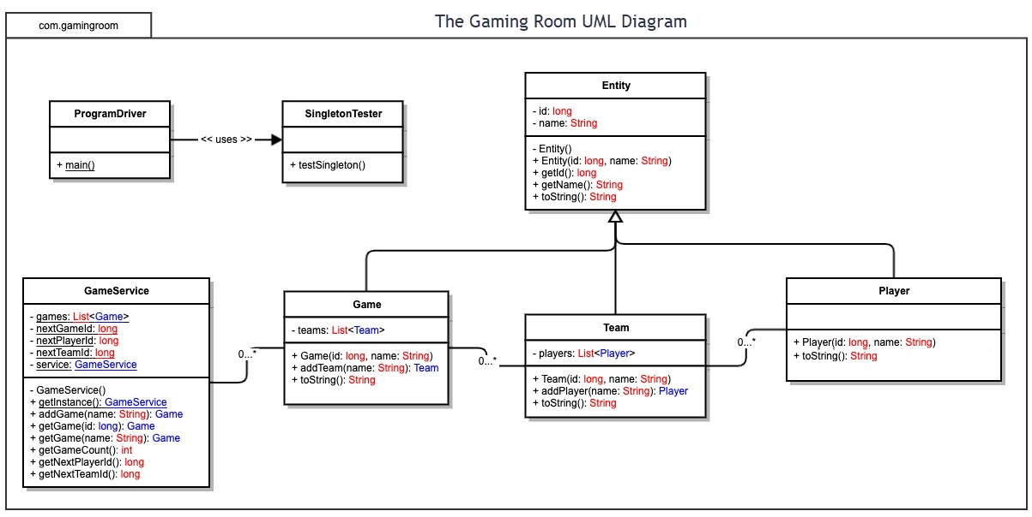

Evaluation
Development Requirements | Mac | Linux | Windows | Mobile Devices
Server Side | Provides a stable and secure environment for hosting web applications. It is built on a UNIX foundation, which offers strong networking and security features. However, Mac servers are less common in enterprise environments, making support and scalability more limited compared to Linux. The higher hardware costs also make Mac a less practical choice for large-scale web hosting. | Linux is the preferred platform for hosting web-based applications because it is open source, highly scalable, secure, and cost-effective. Linux supports most modern web technologies and cloud platforms while providing excellent performance and reliability. Its flexibility and low operating costs make it ideal for a distributed gaming environment that may need to support a growing number of users. | Windows Server provides a user-friendly interface and strong integration with Microsoft technologies such as .NET and Azure services. While it offers good performance and support, licensing costs are significantly higher than Linux. Windows may also require more system resources, making it a less cost-effective option for hosting large-scale web applications. | Mobile devices are not suitable for hosting a web-based application due to limited processing power, storage capacity, and network reliability. Mobile platforms are designed primarily for client-side access rather than server-side hosting. While mobile devices can connect to and use the application, they should not be used as hosting platforms.
Client Side | Supporting Mac clients requires ensuring compatibility with Safari and other Mac-supported browsers. Development costs are moderate because modern web applications can typically run through standard web browsers. Testing is necessary to ensure consistent performance across macOS versions. | Linux clients can access web-based applications through modern browsers such as Firefox and Chrome. Development costs are relatively low because browser-based applications minimize operating system-specific requirements. The primary consideration is ensuring compatibility across different Linux distributions. | Windows supports the largest user base and offers compatibility with most browsers and hardware configurations. Development efforts focus on browser compatibility and user experience rather than operating-system-specific coding. Supporting Windows clients is essential because of its widespread adoption among users. | Mobile support is critical because many users access applications through smartphones and tablets. Developers must design responsive interfaces that adapt to different screen sizes and touch-based interactions. Additional testing is required to ensure compatibility across Android and iOS platforms.
Development Tools | Mac development commonly uses Java, C++, JavaScript, HTML, and CSS. Popular tools include Eclipse, IntelliJ IDEA, Visual Studio Code, and Xcode. These tools support cross-platform web application development and testing. | Linux supports Java, C++, Python, JavaScript, HTML, and CSS. Common development tools include Eclipse, Visual Studio Code, IntelliJ IDEA, Git, Docker, and Apache web servers. Linux is widely used in professional software development environments. | Windows supports Java, C++, C#, JavaScript, HTML, and CSS. Common development tools include Visual Studio, Eclipse, Visual Studio Code, and IntelliJ IDEA. Windows provides strong support for enterprise development and testing. | Mobile application development commonly uses Java and Kotlin for Android, Swift for iOS, and JavaScript frameworks such as React Native for cross-platform development. Development tools include Android Studio, Xcode, and Visual Studio Code.

Recommendations

- Operating Platform: Linux is the recommended operating platform for The Gaming Room. Linux offers excellent scalability, reliability, security, and performance while maintaining low operating costs. Compared to Windows Server, Linux avoids licensing fees and provides greater flexibility for web-based deployments. Compared to macOS, Linux is better suited for server environments and is more widely supported by cloud infrastructure providers. Because Draw It or Lose It will operate as a web-based application serving multiple users across different devices and operating systems, Linux provides the flexibility needed to support future growth and cloud deployment.

- Operating Systems Architectures: Linux uses a modular architecture consisting of the kernel, system libraries, and user-space applications. The kernel manages memory, processes, hardware resources, and network communication. This architecture promotes stability, security, and efficient resource management, making Linux well suited for distributed web applications that require high availability and performance.

- Storage Management: Linux supports a variety of reliable file systems, including Ext4 and XFS, which provide efficient storage management and data integrity. For The Gaming Room, a centralized database management system such as MySQL or PostgreSQL should be used to store game, team, and player information. Both options are open-source, well-supported on Linux, and capable of handling concurrent users efficiently. This approach ensures data consistency, supports multiple simultaneous users, and allows information to be accessed reliably across platforms.

- Memory Management: Linux uses virtual memory management to allocate resources efficiently among active processes. The operating system dynamically manages RAM usage and utilizes swap space when necessary. This approach helps maintain application performance when multiple users are accessing Draw It or Lose It simultaneously and supports scalability as user demand increases.

- Distributed Systems and Networks: The Gaming Room should use a distributed client-server architecture. Users will access the application through web browsers while centralized servers manage application logic and data storage. Network communication should use standard web protocols such as HTTPS to ensure secure data transmission. Redundant servers, load balancing, and cloud infrastructure can help minimize downtime and maintain availability during outages or periods of high demand.

- Security: Security should be implemented through multiple layers of protection. Linux provides strong user permission controls, regular security updates, and robust networking security features. User data should be protected through encryption both in transit using HTTPS and at rest within the database. Authentication and authorization mechanisms should ensure that users can only access appropriate game resources. Regular security monitoring and updates will help protect the application from emerging threats.

Conclusion
The Gaming Room design demonstrates how client requirements can guide decisions about application architecture, operating platforms, and system reliability. By evaluating cross-platform access, object-oriented relationships, server infrastructure, data storage, and security, I developed a technical recommendation that balances scalability with maintainability. This project strengthened my ability to translate business needs into a documented software design and to explain technical trade-offs—skills I can apply to software engineering, systems analysis, and manufacturing technology projects.

