Rebecca Christopfel

IT FDN 100 A Au 19: Foundations Of Programming: Python

Module 06

Assignment 06

Due: November 13th by 11:59pm

**Step 1**

*Watched Intro To Python Mod06 Video and played along with Labs practicing the elements of python as described by Randal.*

**Step 2**

*Read book sections from Chapter 6*

**Step 3**

*Reviewed web pages and performed the exercises.*

**Step 4**

*Watched the videos….*

**Step 5**

Do the assignment using the starter file… add code to make it work!

**Step 6 - Document**

*I pasted the starter file script into a new python file called Assignment 06 in a folder called PythonClass, sub folder Assignment 06.*

*Using many of the techniques discussed in this week’s module video, I was able to piece together the steps as outlined in the starter file.*

*The first step was creating a blank .txt file.*

*Using the starter code, I created a few entries in the ToDoFile.txt. I tested the starter file code and all worked as it should. I was then tasked with trying to manipulate the “processing” code and turn it into functions.*

*Using Randal’s Assignment 6 part 1 video was very helpful in starting. For the most part, much of the code could be copy and pasted into the appropriate class (FileProcessing or IO) and functions were defined.*

*I first attempted menu item 2 (adding new tasks and priorities) followed by menu item 3 (removing a task row from the list). Code shown below. These were mostly just copy and pasted with sum subtle changes to names/variable.*

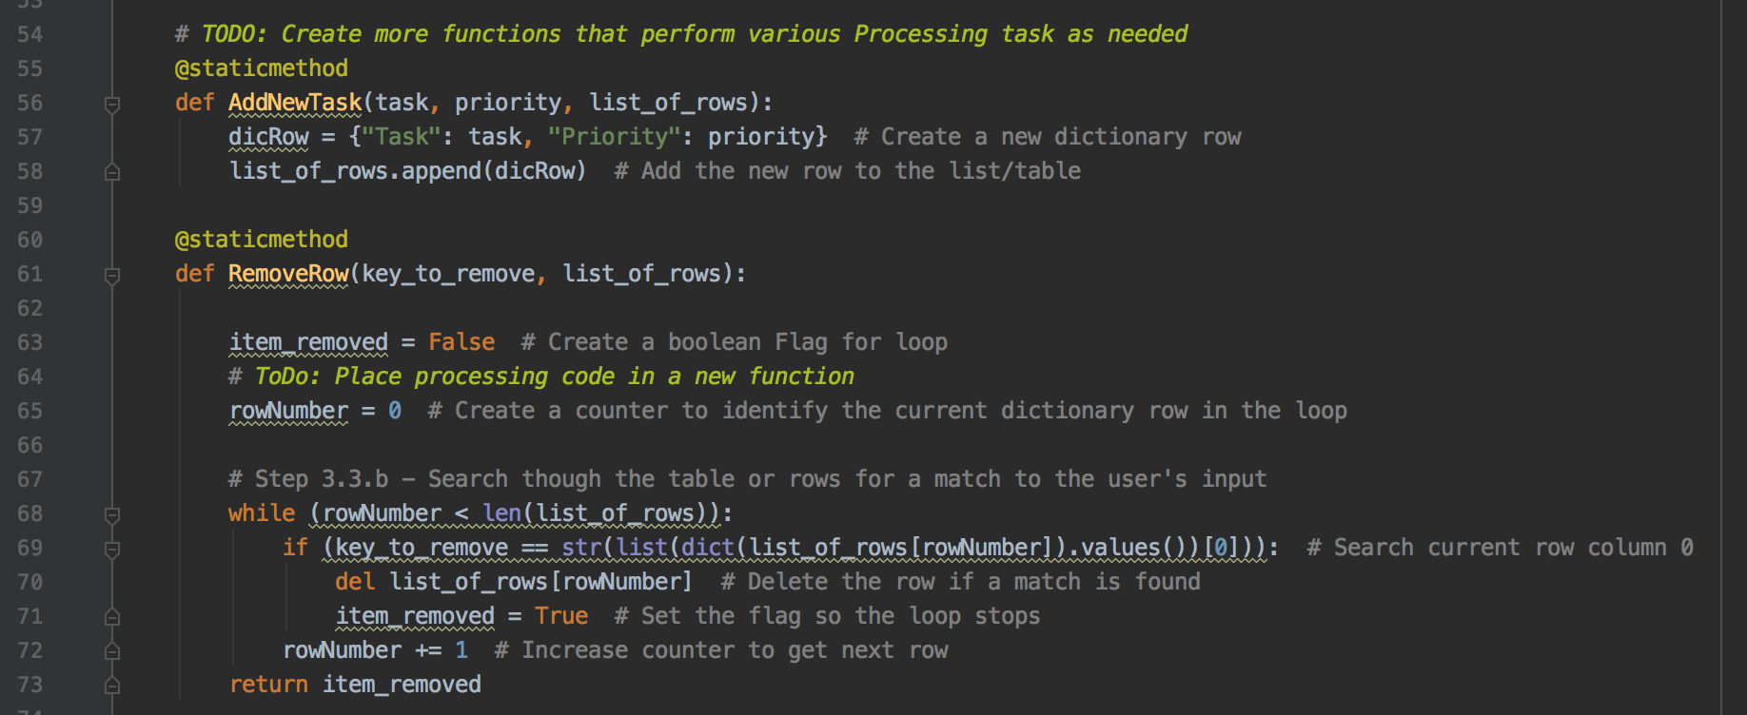

*I then had to call the function in the appropriate section associated with that menu item selection. Screen captures of those below.*

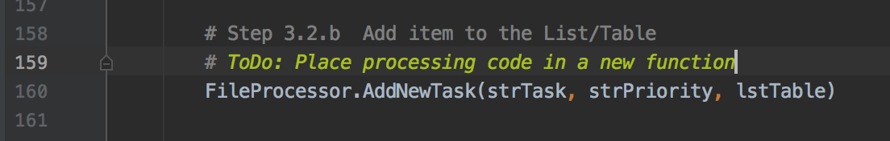

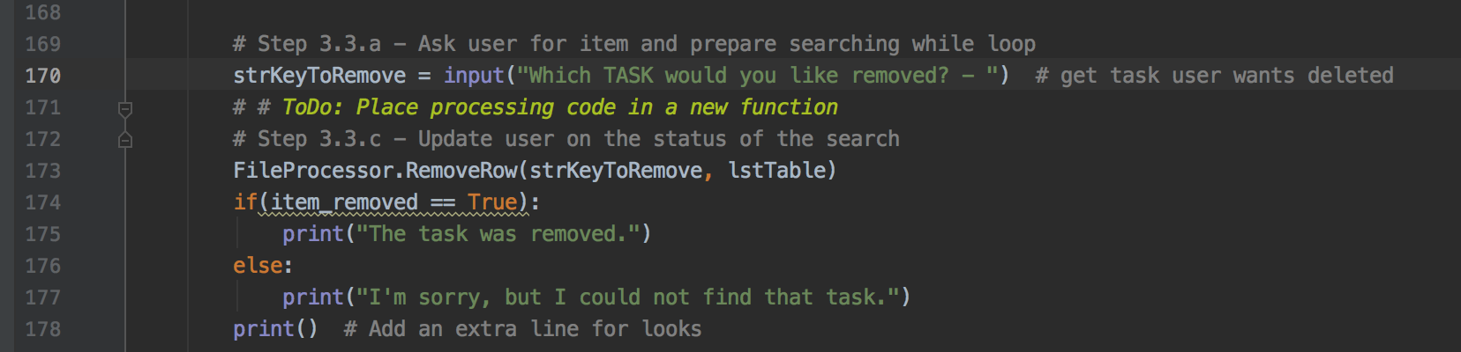

*All in all, there was a lot of trial and error to make this work, and still lots of holes in terms of functionality.*

*Screen shots of code in action below.*

