Rebecca Christopfel

IT FDN 100 A Au 19: Foundations Of Programming: Python

Module 08

Assignment 08

Due: December 8th by 11:59pm

**Step 1**

*Watched Intro To Python Mod08 Video and played along with Labs practicing the elements of python as described by Randal.*

**Step 2**

*Read book sections from Chapter 8*

**Step 3**

*Reviewed web pages and performed the exercises.*

**Step 4**

*Watched the videos….*

**Step 5**

Update a script to complete the pseudo code using Assignment08_starter file. The goal is to utilize multiple classes and the components inside them (constructors, attributes, properties, methods).

**Step 6 – Document**

To complete this assignment, build out the provided pseudo code in the Assignment08 starter file.

There are three main classes listed:

class Product

class FileProcessor

class IO

and then the main body of the script.

Utilizing the hints in the pseudo code and some of the lab and listing scripts from Module 08, I copy and pasted several lines of code with similar functionality and replaced names and instances to match the goal of the pseudo code.

For the class Product, the trickiest part was activating the property using the getter and setter features. Mostly just the syntax became problematic as I tested various methods to achieve the desired results. Adding in some if else statements also helped to rule out the user entering a float where a string was required and vise versa. Code excerpt below.

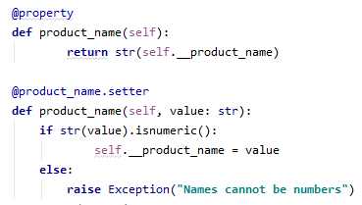

A similar trial and error methodology was used for the remaining classes and additional hints were used from Randal’s videos. This example shows a try except block with an error message to the user.

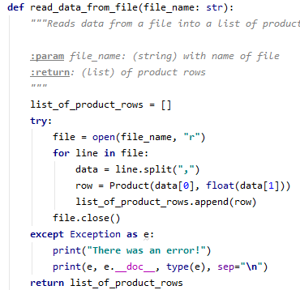

Screen shots of code running in pycharm and command window below.

