Q1.10 While development of the functions in Q1.5 and Q1.6 use the debugging tools to show the following:

Using breakpoints in Virtual Studio Code
<A screenshot of a break point set up>

A breakpoint set up for sequentialSearch function

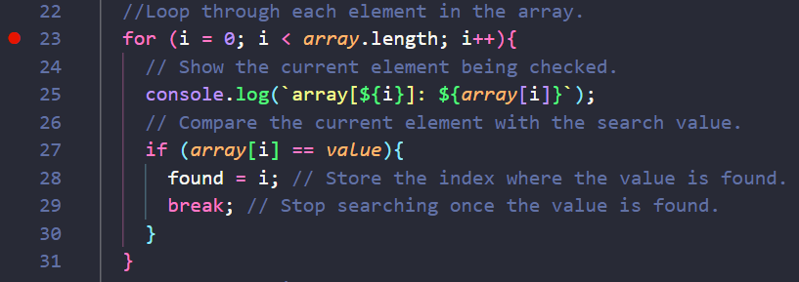

A breakpoint set up for binarySearch function

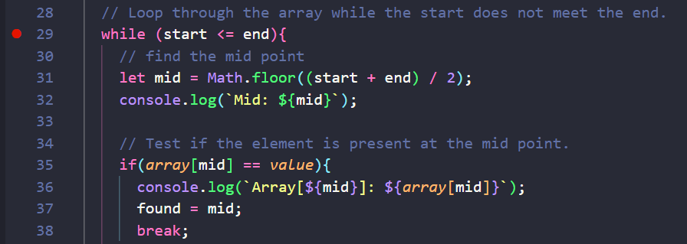

<Screenshots of a step-by-step flow of one of the functions>

The current line being executed in sequentialSearch function

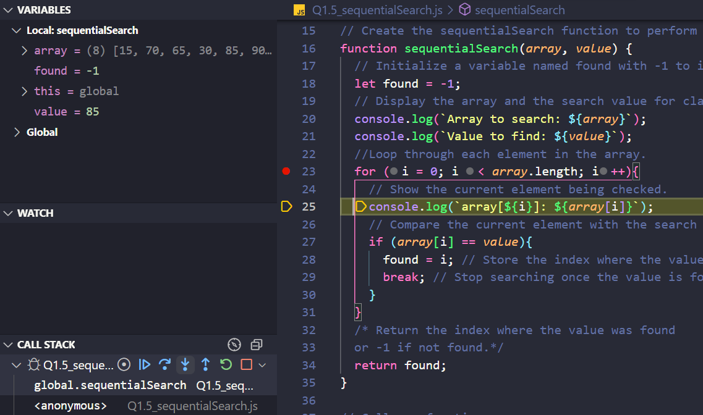

The current line being executed in binarySearch function

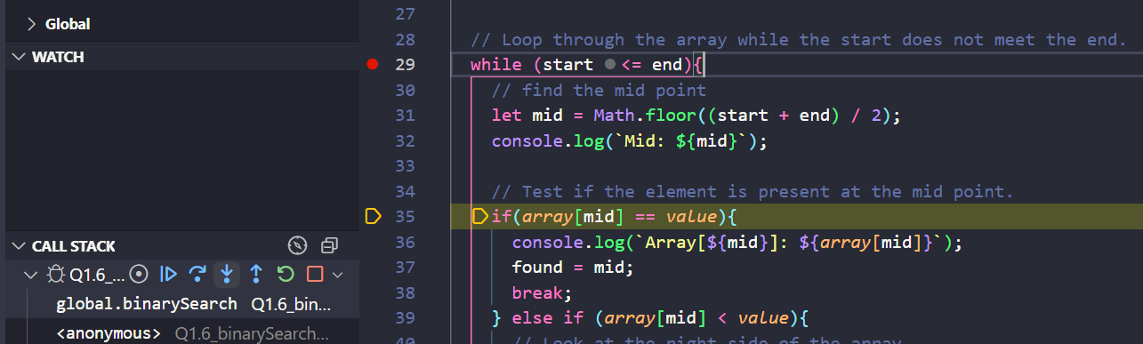

<A screenshot of variable contents>

A sequentialSearch function worked correctly and found the key.

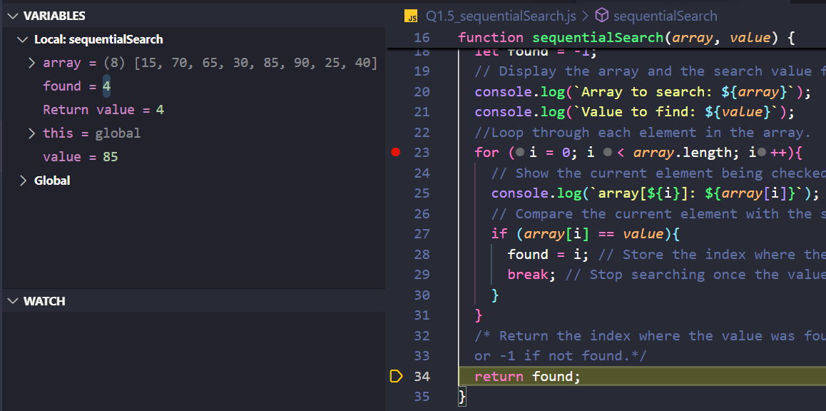

A binarySearch function worked correctly and found the key.
