Riley Ibero
CIVE 202
Spring 2026
Project 5: Integrate

Introduction/Background
Understanding travel behavior is essential for transportation planning and policy development. The National Household Travel Survey (NHTS) provides a rich, multi-level dataset that captures detailed information on household, people, vehicle, and trips. A coalition of Midwestern Departments of Transportation has tasked me with understanding and exploring travel behavior by conducting a cross-level analysis of the NHTS dataset. Using data provided by the NHTS, a cross-level analysis was conducted to answer the following research questions: (1) Do rural households in the Midwest make longer trips using fuel-based vehicles compared to urban households? (2) How does public transit usage vary across trip types, age groups, and income levels in the Midwest?
Methods
To answer the two research questions posed to better understand travel behavior in the Midwest using the NHTS data set, the data was loaded into a Jupyter notebook and python code was used to organize the data. The following summarizes the methods used in python to answer the research questions:
To answer the first question, the data was first filtered to only show data from gas-powered vehicles. With the filtered data, both a boxplot and violin plot were created to display the difference in distribution between urban and rural vehicles.
To answer the second question, the data was filtered to only include the data on public transit. This was done by including lines of data where “PUBTRANS” was 1. With the filtered data, statistical summaries were generated to view trip types, age groups, and income levels seen on these public transport trips. For each, a count plot was generated for visual reference.
Summary of Findings
In seeking to find whether rural households take longer trips with gas-fueled vehicles when compared to urban households, a violin plot was generated to compare the distribution of trip miles of each as well as the average for each. The violin plot clearly shows the average trip miles for rural households is indeed greater than the average trip miles for urban households. Furthermore, the violin plot shows that for urban households, there is a great frequency of trips near 1-2 miles, whereas the rural households have a more equal distribution of trips between 0-10 miles in length.
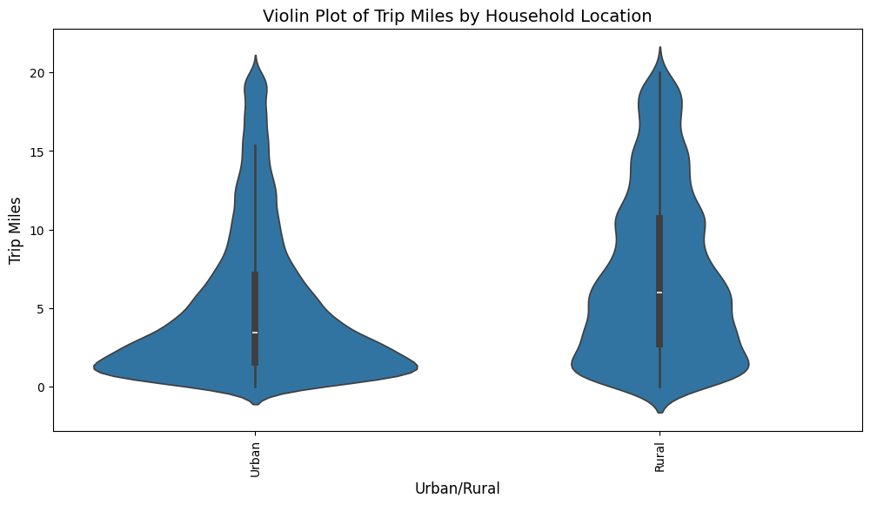
To answer the second research question, “How does public transit usage vary across trip types, age groups, and income levels in the Midwest,” a countplot was generated to show the total number of trips taken using public transportation among different trip purposes, age groups, and income levels.
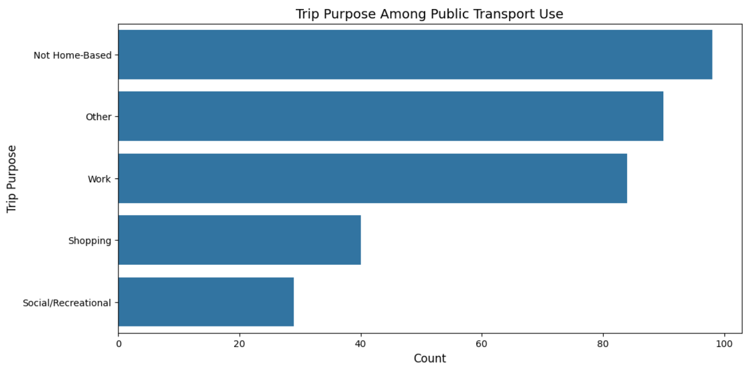
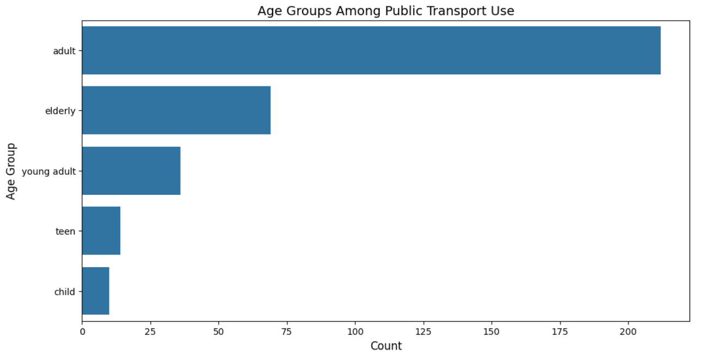
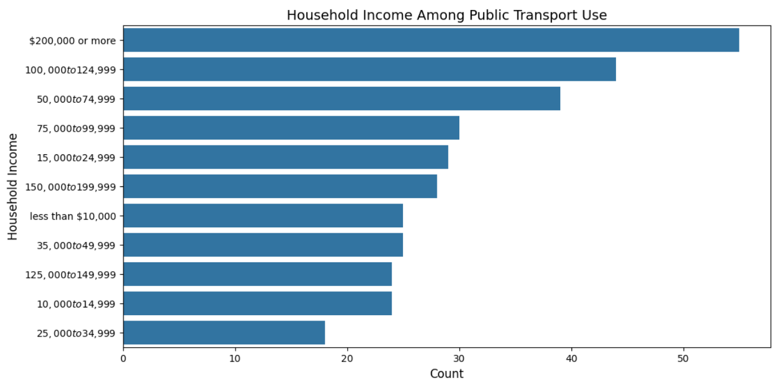
Among the trip types of public transportation use, the most common trip type was “Not Home-Based.” Because the NHTS classifies the trips by home-based and not, it is unclear what these trips were for. Furthermore, the most common trip type among home-based trips was classified as “other.” For most of the trips captured by the NHTS, the purpose of the trip is inconclusive for the purpose of this project. Among the trips where trip purpose was clearly defined, the most common was work, followed by a smaller number of trips for shopping and for recreational purposes.
Among age groups using public transportation, the majority is clearly among adults, from age 25-60. This is not a surprising result, as this is the largest age range. If any further research were needed to answer this question, the “adults” age range could be split into smaller groups. Among the other age ranges, the elderly range and young adult range had a decent showing, where teenagers and children had a very minimal frequency of use.
Among income levels, the most trips taken with public transportation were among those with household income of $200,000 or more and from $100,000 - $125,000. The least amount of use is among household income of $25,000 - $35,000 and $10,000 - $15,000. In general, higher household income sees more use, where lower household income sees less use of public transportation.

