 **College of Engineering**

Carnegie Mellon University

5000 Forbes Ave.

Pittsburgh, PA 15213

[www.engineering.cmu.edu](http://www.engineering.cmu.edu)

**Contact:** Adam Dove For immediate release:

412-268-6792 December 9, 2016

[amdove@andrew.cmu.edu](mailto:amdove@andrew.cmu.edu)

**Is there a floor for lithium-ion battery production costs?**

PITTSBURGH—Since their introduction in the early 1990s, the costs of lithium-ion batteries have fallen from thousands of dollars per kWh, to a few hundred. Many predict these drastic cost reductions to continue, even dropping to less than $100 per kWh. However, a recent Carnegie Mellon University analysis aimed at showing how this might be possible has uncovered that there are significant challenges to getting to some of the price points commonly cited.

Engineering and Public Policy (EPP) Ph.D. student Rebecca Ciez and Materials Science and Engineering (MSE) and EPP Professor Jay Whitacre accounted for the materials and manufacturing expenses necessary to produce both cylindrical and prismatic lithium-ion cells in a study recently published in the *Journal of Power Sources*. Both formats, cylindrical and prismatic, are commonly used in applications like electric vehicles and stationary energy storage systems, and the study focused on the specific cell chemistries commonly found in the United States.

The study specifically examined how variations in the cell design, chemistry, and production volume would impact the overall cost. Although there are initial cost reductions from increasing the production volume, these economies of scale are reached at volumes already common today, and further increases in production capacity appear to have minimal impacts on the cost per kWh.

Some cost reductions are possible if manufacturers can avoid markups on cathode precursor materials, and by increasing the size of the cells. In this regard, prismatic cells have a slight advantage over cylindrical cells, because they can use thicker electrodes and have a higher storage capacity per cell. But even with these changes, none of the cells considered reached the Department of Energy cost target of $125 per kWh

In all the scenarios, materials consistently made a substantial contribution to the overall cost of the cells.

“Many of these materials are already highly commoditized, and unlikely to see significant cost reductions,” says Ciez. “While we are open to the idea that very low-cost lithium-ion batteries can be produced, our comprehensive analysis does not show a clear pathway to this based on what we know today.”

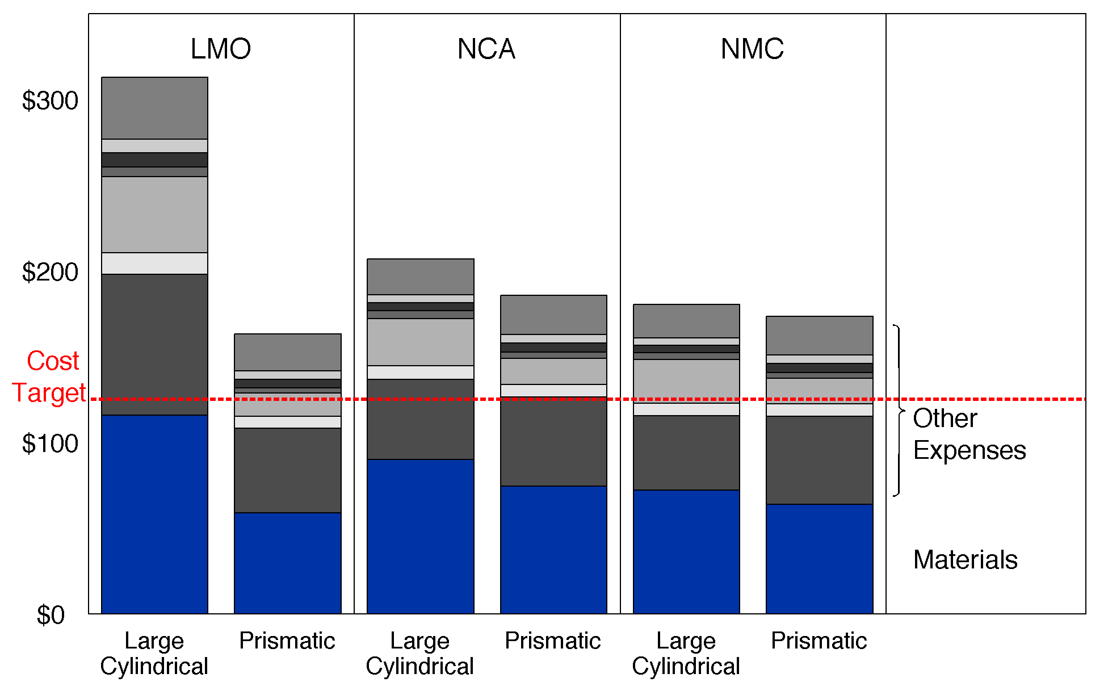

Figure: Cost per kWh for lithium ion batteries made in two different configurations: cylindrical and prismatic. Even at full scale, where all economic advantages are realized, no approach is near the $125 per kWh target.

This work was supported by a National Science Foundation Graduate Research Fellowship.

###

**About the College of Engineering:** The College of Engineering at Carnegie Mellon University is a top-ranked engineering college that is known for our intentional focus on cross-disciplinary collaboration in research. The College is well-known for working on problems of both scientific and practical importance. Our “maker” culture is ingrained in all that we do, leading to novel approaches and transformative results. Our acclaimed faculty have a focus on innovation management and engineering to yield transformative results that will drive the intellectual and economic vitality of our community, nation and world.

**About Carnegie Mellon University:** Carnegie Mellon ([www.cmu.edu](http://www.cmu.edu/)) is a private, internationally ranked university with programs in areas ranging from science, technology and business to public policy, the humanities and the arts. More than 13,000 students in the university’s seven schools and colleges benefit from a small faculty-to-student ratio and an education characterized by its focus on creating and implementing solutions for real world problems, interdisciplinary collaboration and innovation.