1 Analysis
1.1 Introduction
1.2 Background
1.3 Current Solution
1.4 Prospective Users
1.5 User Requirements
1.6 Objectives
1.6.1
1.6.2
1.6.3
1.7 Acceptable Limits
1.8 Programming Languages
2 Documented Design
3 Technical Solution
3.1 Server-side
3.1.1 sever.py
3.1.2 keyCreator.py
3.2 Client-side
3.2.1 graphicsMath
3.2.1.1 graphicsMath.h
3.2.1.2 graphicsMath.cpp
3.2.2 graphicsHandler
3.2.2.1 graphicsHandler.h
3.2.2.2 graphicsMath.cpp
3.2.3 hashtable
3.2.3.1 hashtable.h
3.2.3.2 hashtable.cpp
3.2.4 fileHandler
3.2.4.1 fileHandler.h
3.2.4.2 fileHandler.cpp
3.2.5 licenseChecker
3.2.5.1 licenseChecker.h
3.2.5.2 licenseChecker.cpp
3.2.6 main.cpp
4 Testing
5 Evaluation

1 Analysis
1.1 Introduction

3D graphics has always been a highly researched topic, as it allows for tangible visual output to the user, paving the way for CAD software, physics simulators and video games. My investigation aims to create an application that allows developers to render 3D geometry through files that specify an objects vertices while having the ability to build more functionality on top of this.

1.2 Background

Many applications use 3D graphics, and some of the companies may choose to build their own framework, with others using a pre-existing framework. Typically, a graphics API is used as this means the GPU is utilised, as hardware manufacturers specifically design their device drivers to support the three main graphics API. These are Vulkan, OpenGL and DirectX. They all work in a similar way. The vertices specifying the object to be rendered will go through stages in the graphics pipeline, with some of these stages being programmable using shader languages. These give graphics developers access to the vertex, tessellation, geometry and fragment shaders while abstracting away the parts graphics developers wouldn’t need to use. The shader language for Vulkan and OpenGL is GLSL, while DirectX uses HLSL. My investigation will use OpenGL with GLSL, as DirectX and HLSL are owned by Microsoft, so it only works on Windows platforms, and I believe Vulkan is too verbose for the investigations needs.

1.3 Current Solutions
1.3.1 Unity
unity.com
Unity is the one of the most popular game development engine, with almost 60% of all games released being built using unity, as of 2018. However, although unity is marketed as a game engine, developers can use it for other applications as well.
Unity has built in 3D graphics, supporting custom shaders written in either GLSL or HLSL. It also has many required features already built into the engine, so developers don’t have to spend their time creating and optimising basic infrastructure for their applications
Unity is both free and intuitive to use as it has a well designed GUI. This attracts a lot of hobby game developers as it means they don’t have to spend much time researching how to use this platform and they don’t have to spend money to just develop games. This is part of why unity is so popular.

Advantages
- Free for hobby developers
- Easy to use
- Built in physics engine and camera
- Custom shader support
- 2D and 3D support
Disadvantages
- Unity watermark on compiled games
- Paid for games that make a certain revenue
- Proprietary

1.3.2 OGRE
ogre3d.org
OGRE is an open-source graphics engine that gives developers the option to build custom 3D applications without boxing themselves in to a real-time game engine. It acts as an API that developers can use to avoid writing their own OpenGL application.
OGRE is designed to allow developers to use their own shaders, however it still has default shaders if the developer doesn’t need to write custom shaders. It supports both HLSL and GLSL, however it also has its own shading language, Cg, which serves as a system agnostic shading language for either DirectX or OpenGL / Vulkan systems. This makes it very cross platform, working for Mac, Windows and Linux systems.
OGRE is an API, so it doesn’t have a GUI to see features with, forcing developers to read through many pages of documentation to learn how to use it. However, this makes OGRE a very powerful tool, with developers being able to use it for a lot more solutions than a traditional game engine.
However, OGRE does use the assimp library for its texture loading which has been known to have security issues.

Advantages
- Open-source
- Versatile
- Agnostic shader support
- Free for anyone
- Lightweight API
Disadvantages
- Not intuitive
- No 2D support
- Potential security issues

1.3.3 Unreal Engine

1.4 Prospective Users

The audience I plan to cater for is developers looking for a preliminary, open-source graphics engine, so that they can build a 3D application on top of it.

1.5 User Requirements

1.6 Objectives
1.5.1 Initial Objectives

These are a list of loose objectives I will follow during the course of my project:

  - A window to display a scene
  - Scenes can contain any amount of meshes
  - Performance of the application is good enough that movement seems smooth
  - Meshes can be given various colours and textures
  - Meshes can be any shape / model
  - Users can interact and change scenes
  - The application can verify that a user ‘owns’ it
  - Debugging features

1.5.2 Final Objectives

These final objectives are more specific project and in-depth requirements:

Application
- The ability to create meshes and render these meshes from files that specify the all the vertices in the model
- The ability to control the position, orientation and size of the mesh programmatically
- The ability to move and rotate the entire rendered scene in real time to emulate a camera
- The ability for meshes to use and switch between various shader programs
- The ability to colour and texture meshes with any image or colour.
- Lighting model
- Live FPS counter
- Wireframe mode to see if models are loaded correctly
- No-lighting mode to see if lighting is being applied correctly
- The application to run at at least 24 FPS so movement appears to be smooth

User ownership verification
- Client-server model for user license verification
- Database to store licenses and any associated data
- The ability to generate random, unique licenses

1.5.3 Extension Objectives

I have also thought of a list of objectives that would increase the solution effectiveness, but are not necessary for the projects success.

- Physics simulation
- Syncing the graphics engines FPS to the monitors refresh rate
- Blending edge pixels with background pixels to make mesh edges appear smoother
- Anti-piracy measures
- Animation support

1.7 Acceptable Limits

These features would normally be required in a genuine product, however, for this project, I have deemed these objectives fall outside of the scope of it for various reasons.
- Support for multiple image and mesh file types. Normally 3D modellers and artists work with many different file types when creating their meshes and textures, which all require different methods of extracting the data. This would be a huge waste of time as once the data is extracted from the file, it is used in the exact same way.
- A way to obtain licenses. Customers should have a way to buy licenses otherwise the product is worthless. This would require creating a website then implementing a payment gateway, which typically costs money and would also prove difficult to debug.
- Server verification daemon being hosted on a cloud server. For users to be able to verify, the server-side verification daemon would need to be hosted on a server accessible on the internet. Self hosting would require me to open home network ports to the internet, which could prove to be risky and hosting on a cloud server costs money.

1.8 Programming Languages

I believe for the client-side, C++ will be the best language to use. This is because C++ is a compiled language and is designed to create fast programs over everything else, making it a good choice for this project as being able to render frames quickly is imperative. The OpenGL API also natively supports C++, meaning I need to use less libraries, making the client-side program take up less storage, improving the user experience.
For the server-side, I’ve decided to use python. Python is a language I’m already quite familiar with. Python also abstracts many elements, this makes creating python applications much quicker than in another language. The speed of the server-side program is also not critical, neither is the security. This makes python attractive for this use case.

2 Documented Design

2.1 Program overview
This project will have 3 critical areas
These are:
- Ownership verification
- File loading
- Rendering loop
The application goes through these critical areas during its lifetime according to this flowchart
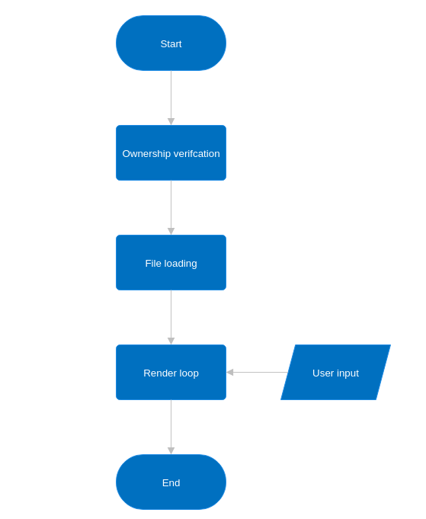

These critical areas can all be broken down into various different functions. To display this I have created this hierarchy chart.
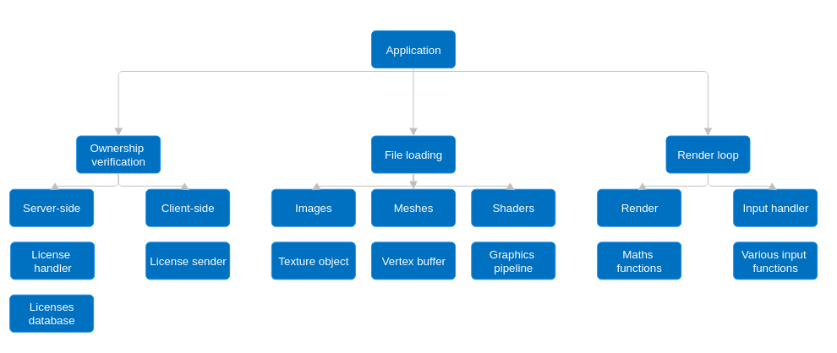

2.2 Ownership verification
As I’ve stated in the objectives, users should be able to input a license key to verify their ownership of the application. However, so I can identify if a license key has already been used and who used it, I’ve decided that users should also be sending an email along with the license key. To make this simple, the client will format the data into a single json encoded string, which will be sent to the server. This means the server can still easily extract sent data and can also use the HTTP protocol without much trouble.
So it’s easy to keep track of valid license and emails, this will all be stored in a database on the server. When a client sends data, the server can query the database then send back a response code depending on whether the license and email was valid or not. The server will be checking for data that has been sent to http://127.0.0.1/licenses

2.2.1 License checking
Client-side
To implement these features, I first designed a flowchart for the basic behaviour of this feature.

flowchart

The application first shows a prompt that users will enter their license key and email into. This prompt should never appear again once the user enters a valid license key and email.

Design of the license key prompt

If a user enters an invalid license key and email combination, the error prompt will show where they will decide to either re-enter their license key and email or to quit the application.

Design of the error prompt

I then created a pseudocode implementation of this feature.

pseudocode

Server-side
As I’ve already mentioned, the server will host a simple HTTP application. Clients will use HTTP POST requests to send data to it on http://127.0.0.1/licenses

Flowchart representing the server-side license checking process

The server will use a simple database that stores licenses and emails, with licenses being the primary key of this database.

Entity relationship diagram between licenses and emails

The email column is allowed to have empty fields. This will indicate that a license is unclaimed. Records containing empty email fields will be updated to the email a client provides when they send a license key matching that record. The email field should not be changed if the field is not empty.

Client license keys and emails will only be considered valid if:
- The license key they provide is stored in the database
- The record containing the license key has an empty email field or the email they provide matches the email already stored in the record

Once the server has come to a conclusion on the validity of a license key and email a client has provided, it will reply with a HTTP response code.
These are:
- Valid: 200
- Invalid: 401
- Erroneous data: 400 Although this feature isn’t used by the client, it is still a good idea to make sure the server can recognise and ignore erroneous data so it doesn’t crash.
Clients will then be able to determine what their next course of action will be according to these response codes.
Flowchart to represent how license keys and emails are validated

Pseudocode implementation of the server-side license checker:

2.2.2 License creator
Since the server only uses a very simple database, I will also add being able to view and reset the database from the same program in addition to the license generation.
This program will only ever be used by developers, so I there will not be a GUI added to it.
Flowchart for an overview of this programs behaviour

License generation
Random licenses need to be able to be created. Licenses will take the form
XXXX-XXXX-XXXX-XXXX where the X’s are any letter between A and Z.
The behaviour of this feature should look like this:
Because the license keys are the primary key of this database, I thought it was necessary to ensure that the new, randomly generated license key is not a duplicate by adding a check.

Pseudocode definition of the license generation:

Database viewer
The database viewer will output the entire database in this format
Licenses Emails
ABCD-EFGH-IJKL-MNOP user@example.com
… ...

This will be accomplished by following this flowchart:
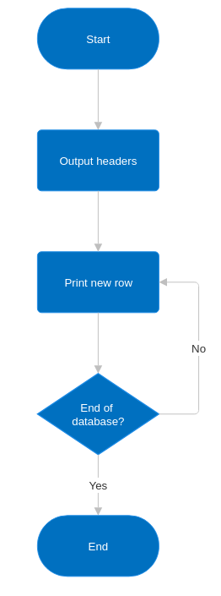

Database eraser

This procedure will just delete the databases table, then recreate a new table with the same columns, effectively erasing it.

PROCEDURE tblErase
DROP licenseTbl
CREATE TABLE licenseTbl(license CHAR(19), email VARCHAR(100))
END PROCEDURE

2.3 File loading
2.3.1 Overview
There are a few file types that must be loaded during the runtime of the program (images, meshes, etc.). These all have various different file formats that need to be loaded in different ways.
To streamline this, each file type will have a wrapper function that detects the file format, then uses the correct loading function.
It’s done like this over having one wrapper function that detects the file type and then the file format as C++ is typed language, and I would end up having to return memory locations, then cast them to the correct type – which would be much more complex than managing a few different functions.

FLOWCHART DEMONSTRATING THESE

As mentioned earlier, I have decided to only implement one file format for each file type. However, I will not neglect being able to add new file formats with ease.
This will be accomplished by using a dictionary, using the file extension as the key and a function pointer that loads the associated file format as the stored data.
An example dictionary to demonstrate this:

DICTIONARY formatloadersdictionary = {
“format1”: format1-loader-pointer,
“format2”: format2-loader-pointer,
“format3”: format3-loader-pointer
}

Format loading functions can be fetched with formatloaders[“format”], meaning once we have a file format, nothing else has to be done with the string to get this function.

All these dictionaries will be stored in a class, defined as such:

CLASS formatloaders
public:
DICTIONARY imageformats
DICTIONARY meshformats
DICTIONARY shaderformats
DICTIONARY sceneformats
// any other file types that may be needed in the future
ENDCLASS

CLASS DIAGRAM IDK

There will then be a file loader class, which stores the wrapper functions. It uses an object of the previous class to instantiate it. This is useful as it means I can test different format loading functions without having to touch already functioning code.

CLASS fileloader
public:
SUBROUTINE fileloader(formatloaders formatfunctions)
//class constructor
//takes an object of formatloaders as an argument
formats = formatfunctions
ENDSUBROUTINE

SUBROUTINE imageloader(STRING filepath)
…
ENDSUBROUTINE
//the other wrapper functions would go here
//each wrapper function would take a file path as an argument
private:
const formatloaders formats
//this variable shouldn’t be changed after being assigned
ENDCLASS

ANOTHER CLASS DIAGRAM I GUESS

2.3.2 Image Loading
In order to place images on a rendered mesh, OpenGL requires the image data and its resolution to create a texture.
Since this process of creating the texture should be the same for every image format, it will be in the wrapper function.
All specific format loaders will return a class, image, that the wrapper function will use to do this.

DIAGRAM OF WHAT I MEAN

This is what the class image will look like.
CLASS image CLASS DIAGRAM HERE??
public:
unsigned int width
unsigned int height
unsigned char imagedata
ENDCLASS

When this class is passed back to the wrapper function, the members will be passed to the OpenGL API in order to create the texture.

PNG Loading
The only supported image format for this project is the PNG format. Since reading binary data, using decompression algorithms to obtain the image data, then storing it into a memory location falls out of the scope of this project, I will be using a PNG loading library.

The PNG loading procedure will work like this:

FLOWCHART!!!!!

2.3.3 Mesh Loading

2.3.4 Shader Loading

2.4 Rendering

2.4.1 Matrices

2.4.2 Matrix Transformations

2.4.3 Shader code

2.4.4 Render objects

2.4.5 Render loop

