Latino HealthCare Forum (LHCF) seeks to develop an open source mobile application and publish in limited beta production to address specific community/user needs. The methodology or approach will be a “human-centered” one with a collaborative focus in order to get new relevant solutions that create a positive impact. The development of the mobile application will be primarily based on input gathered by the LHCF. The goal for this project is to develop an Android and iOS smartphone application that is responsive to multiple devices, that is smartphones and tablets. In exchange for the Design & Developer Fee, the Developer will produce a Smartphone or Mobile Application System, in accordance with the list of features detailed below:

* **About us button**: About us feature/section will contain information about the LHCF and a description of this project with Rundberg as funded by the City of Austin. This content will be supplied by the LHCF to the developer to be included into the application
* **Resource Directory button**: This feature/section will provide a graphical representation of health care resources available to the user relative to the specific user and geolocation data.

The resource directory at a minimum will contain health care resources, such as the

locations of hospitals, clinics, physicians, pharmacies, laboratories, etc. This data will be

provided by the LHCF for the developer to include into the application. The data is not required to exist on the mobile application locally but can exist in the cloud using either a google service, IBM Bluemix service or similar. The aforementioned listing of health care resources will be buttons on mobile application that users can search for based on their individual needs. Documentation on how feature/capability was developed MUST be included in the documentation section of the LHCF GITHUB account.

* **Speech to Text, Text to Speech button** (language translation capabilities for two way conversations); ability to allow users to speak into the application, in their native language; the application will translate the content into English for two way conversations. Additionally, the application will allow other users to speak into the application in English and the application will translate the content into the original user’s native language. An example would be if User1 speaks only Spanish, User1 would speak into the application in the user’s native language and the application will translate this into English. If this user allows another user (User2) to share the phone to respond to a question or comment provided by User1; User2 (assuming User2 to speaks only English) will be able to speak into the application and the application will translate English into the native language of User1. Documentation on how feature/capability was developed MUST be included in the documentation section of the LHCF GITHUB account.
* **Contact us button**: to send emails to communitysupport@lhcf.org
* **LHCF GITHUB**

This project will be managed via the LHCF GITHUB account to the extent possible by the Developer and reasonably permissible, as necessary and appropriate, in order to support multiple developers, when the project calls for it and as the project and needs grow. The GITHUB account will be operated and managed by the LHCF CTO; the developer will update pertinent documents, architecture design(s) and all or other related content as reasonably permissible, as necessary and appropriate to this GITHUB and related accounts on a weekly basis at a minimum, deadline will be every Friday by 11:59pm CST. The GITHUB account will be updated by the developer with the following content:

* + Hybrid, iOS and/or Android source code
  + Any files that describe the methodologies, technologies and any other information that pertains to the project.
  + Documentation on the developers notes that are not included in the source code
  + Any and all schematics that represent how the mobile application integrates with any of the following:
    - Ionic Lab
    - Apache Cordova
    - IBM Bluemix
    - Google
    - Other
* **Target Users/Characteristics**

The initial target users for this application and project will be, but not limited to the following:

* + LHCF Community HealthCare Workers or Promotores, via an Android or iPhone smartphone mobile application
  + Rundberg general community members via an Android or iPhone smartphone mobile application
  + General community members at large; a kiosk will be available at a central physical location in the Rundberg community, specific location to be determined
  + Feature as many of the following languages as possible: Spanish, Arabic, Vietnamese, Nepali, French, or other.

Following is a snapshot of the mobile app framework to be used from the “creative” perspective. The main page will have options for the user to choose from to obtain other information and access interactive features:

Mobile application main “About us” or “About the project” screen:

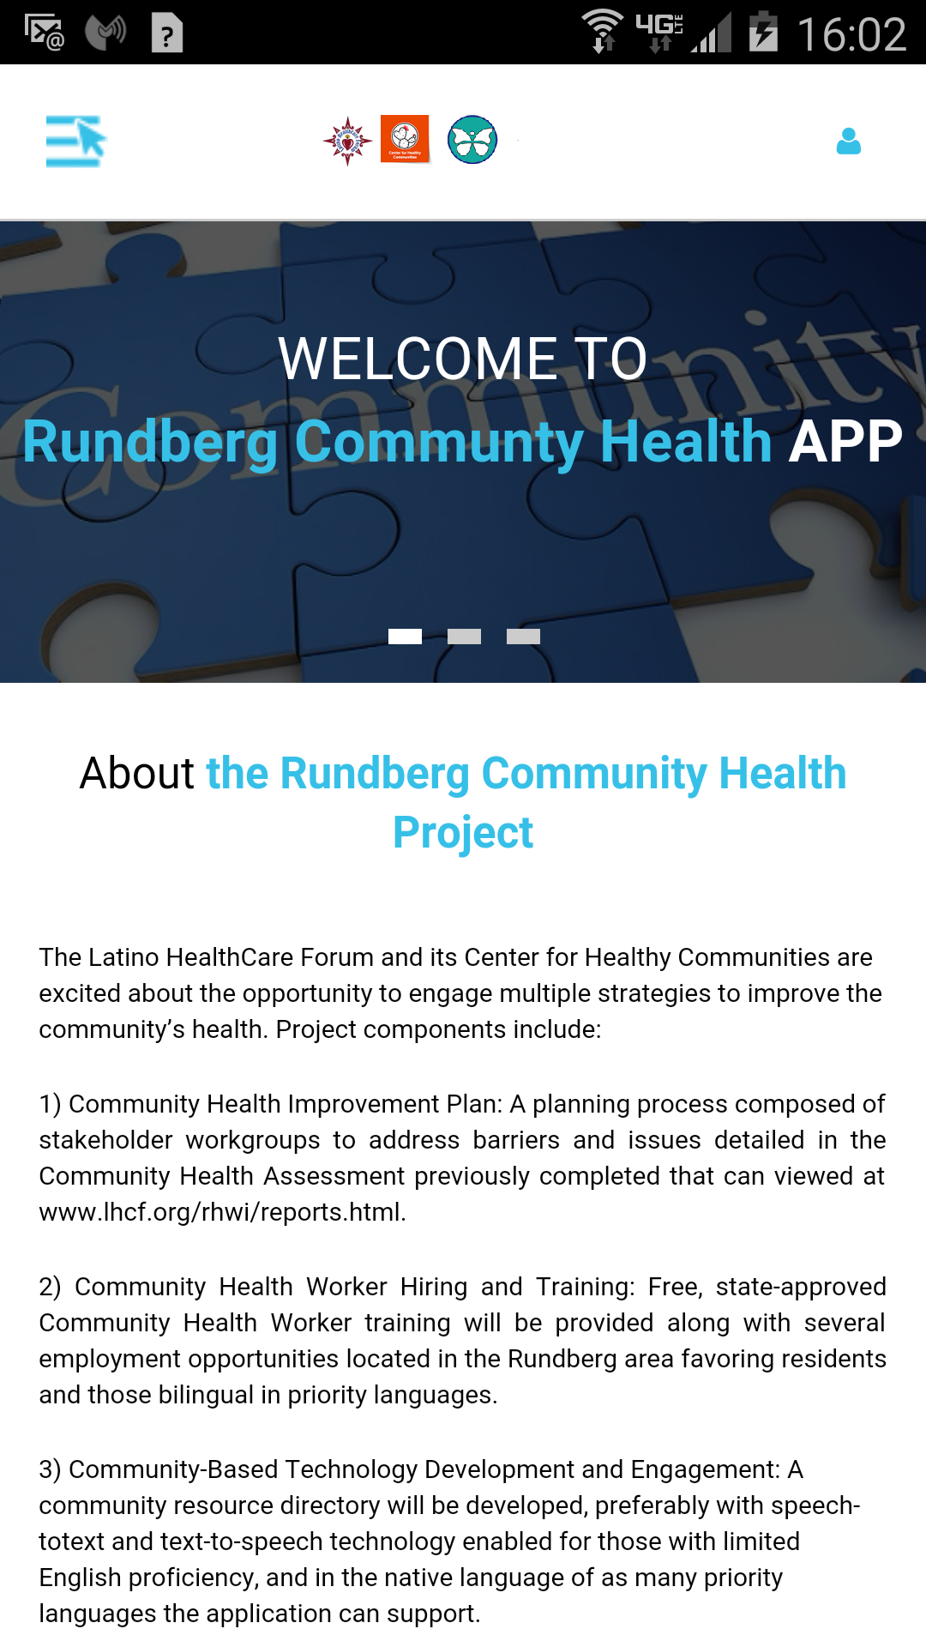

Mobile application mockup of available options or features:

