Melody Wheelwright
Joshua Braegger
CS 3750 – Grayston
Use Case Model for ATM

Use Case Diagram:

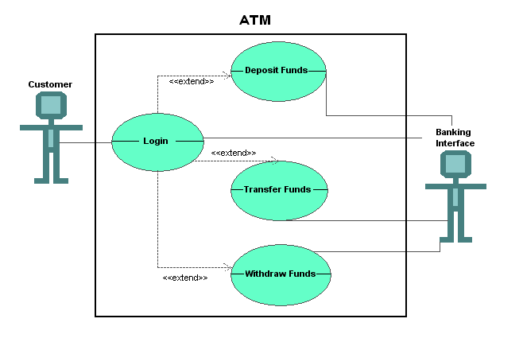
Detailed Descriptions for ATM

Use Case Name
Login to ATM

  - Brief Description
This use case is started by the customer. It provides the capability for the customer to access the customer’s account.

Flow of Events
  - Basic Flow
    - ENTER USERNAME
The use case begins by the system asking for the User ID and password. The customer enters the User ID.

    - ENTER PIN
The customer enters their PIN number.

    - LOGIN TO SYSTEM
The customer presses the LOGIN button. The use case ends.

  - Alternative Flow
    - QUIT
The customer can quit any time during the use case. When the customer selects the Quit option, the use case ends.

    - INVALID USER ID / PASSWORD
At LOGIN TO SYSTEM, the system determines if the User ID and/or PIN is not valid. The system displays an error message and the use case ends.

    - CANNOT RETRIEVE INFORMATION
At LOGIN TO SYSTEM or ACCESS SPECIFIC ACCOUNT, the system determines that the system is down, or the specified account is not available. The system displays an error message and the use case ends.

Special Requirements
None

Preconditions
The customer must have approached the ATM system, and already have an existing account.

Post Conditions
None

Extension Points
None

Use Case Name
Transfer Funds

  - Brief Description
This use case is started by the customer. It provides the capability for the customer to transfer funds within the customer’s account.

Flow of Events
  - Basic Flow
    - TRANSFER FUNDS
The system displays the functions available to the customer. The customer may select Transfer Funds, Withdraw Funds, Deposit Funds and Quit. The use case begins when the customer selects Transfer Funds.

    - SELECT FIRST ACCOUNT
The system displays a list of accounts available to the customer within the user's account. The customer selects the first account from which funds are to be withdrawn.

    - SELECT SECOND ACCOUNT
The customer selects the second account to which the funds are to be deposited.

    - FUNDS TRANSFERRED
The customer selects the amount to be transferred and presses the transfer button. The system subtracts the amount withdrawn from the first account balance and adds the amount transferred to the second account balance. The system displays a message stating the funds have been successfully transferred and the use case ends.

  - Alternative Flow
    - SAME ACCOUNT SELECTED
At SELECT SECOND ACCOUNT, the system determines the first and second account chosen are the same. The system displays an error message and the use case ends.

    - INVALID FUNDS
At FUNDS TRANSFERRED, the system determines there is not enough money in the first account chosen. The system displays an error message and the use case ends.

    - QUIT
The customer can quit any time during the use case. When the customer selects the Quit option, the use case ends.

    - CANNOT RETRIEVE INFORMATION
At TRANSFER FUNDS, the system determines that the specified service or account is not available. The system displays an error message and the use case ends.

Special Requirements
None

Preconditions
The customer must already be logged in to the system.

Post Conditions
None

Extension Points
None

Use Case Name
Withdraw Funds

  - Brief Description
This use case is started by the customer. It provides the capability for the customer to withdraw funds from any available account of the customer.

Flow of Events
  - Basic Flow
    - WITHDRAW FUNDS
The system displays the functions available to the customer. The customer may select Transfer Funds, Withdraw Funds, Deposit Funds and Quit. The use case begins when the customer selects Withdraw Funds.

    - SELECT ACCOUNT TO WITHDRAW
The system displays a list of accounts the customer can withdraw from that are available to the customer within the user's account. The customer selects the account from which funds are to be withdrawn.

    - FUNDS WITHDRAWN
The customer selects the amount to be withdrawn and selects transmit. The system subtracts the amount withdrawn from the current account balance. The funds are then dispensed. The system displays a message stating the funds have been successfully dispensed and the use case ends.

  - Alternative Flow
    - INVALID FUNDS
At FUNDS WITHDRAWN, the system determines there is not enough money in the account withdrawn. The system displays an error message and the use case ends.

    - QUIT
The customer can quit any time during the use case. When the customer selects the Quit option, the use case ends.

    - CANNOT RETRIEVE INFORMATION
At SELECT ACCOUNT TO WITHDRAW, the system determines that the specified service or account is not available. The system displays an error message and the use case ends.

Special Requirements
None

Preconditions
The customer must already be logged in to the system.

Post Conditions
None

Extension Points
None

Use Case Name
Deposit Funds

  - Brief Description
This use case is started by the customer. It provides the capability for the customer to deposit funds to any available account of the customer.

Flow of Events
  - Basic Flow
    - DEPOSIT FUNDS
The system displays the functions available to the customer. The customer may select Transfer Funds, Withdraw Funds, Deposit Funds and Quit. The use case begins when the customer selects Deposit Funds.

    - SELECT ACCOUNT TO DEPOSIT
The system displays the list of accounts available to the customer that are available to the customer within the user's account. The customer selects the account which the funds are to be deposited.

    - FUNDS DEPOSITED
The customer also selects the amount to be deposited. The system adds the amount deposited to the current account balance. The system displays a message stating the funds have been successfully deposited and the use case ends.

  - Alternative Flow
    - QUIT
The customer can quit any time during the use case. When the customer selects the Quit option, the use case ends.

    - CANNOT RETRIEVE INFORMATION
At DEPOSIT FUNDS or SELECT ACCOUNT TO DEPOSIT, the system determines that the specified service or account is not available. The system displays an error message and the use case ends.

Special Requirements
None

Preconditions
The customer must already be logged in to the system.

Post Conditions
None

Extension Points
None

