DIGRAPHS AND TREES

A relation R on a set A can be represented by a directed graph (digraph) as follows.
node (vertex): represents any member of A.
arrow (edge): represents any pair in R.

indegree of a node: the number of arrows pointing into the node.
outdegree of a node: the number of arrows pointing out from a node.

Example 1: A = {1,2,3,4,5,6,7,8}
R = {(1,5),(3,2),(3,7),(4,3),(4,6),(4,8),(8,1)}

Boolean matrix M_{R} of relation R:

1 2 3 4 5 6 7 8
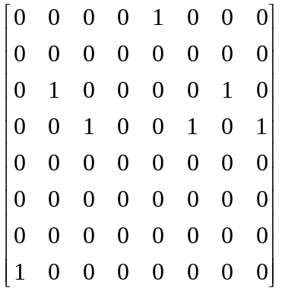

Node 1 2 3 4 5 6 7 8 Total
In-degree 1 1 1 0 1 1 1 1 7
Out-degree 1 0 2 3 0 0 0 1 7

Digraph of relation R:

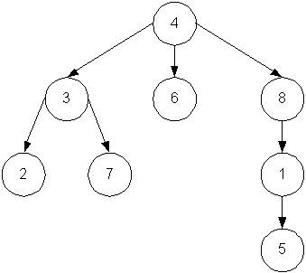

DIGRAPHS AND TREES

tree: a relation having a special node r with the property that there is a single path from r to every other node, but no path from r to itself. The relation in Example 1 is a tree.

Node r is called the root of the tree. In Example 1, the root is node 4.

Properties of Trees

1. A tree has no cycles.
2. A tree has only one root.
3. A root has in-degree 0.
All other nodes have in-degree 1.
4. A tree is irreflexive.
5. A tree is asymmetric.
6. A tree is never transitive. For each path of length 2 from node a to node b, there is never a path of length 1 from a to b.
7. A tree is weakly connected.

A relation is connected if there is at least one path between every pair of nodes.
A relation is weakly connected if its symmetric closure is connected.

Tree Terminology

height of a tree: the length of the longest path (from the root).
level of a node: the length of the path from the root to the node.

parent node: has a path of length 1 from it to another node.
offspring node: has a parent node.
sibling nodes: have the same parent node.
leaf node: has no offspring.
descendant of node v: any node at the end of a path from v.

n-tree: the maximum number of offspring for any node is n.
binary tree: a 2-tree.
complete n-tree: all nodes except leaf nodes have exactly n offspring.
subtree: a subset of a tree (relation) that is also a tree.

The tree in Example 1 is a 3-tree, but not a complete 3-tree.
It's height is 3.

