Group C – Team Assignment 4 Narrative
Group Members: Lorin Kartchner, Todd Brown, Royce Judd, Josh Braegger, Jeremiah Stephenson
CS 4280 - Spring 2007
Intro to Computer Graphics

Problem Statement:

This group assignment consisted of 5 parts as listed in Case Study 5.3 entitled, Decomposing a 2D Affine Transformation on page 278 of the text.

Problem 1: Verify by direct multiplication that M is the product of the three matrices given in equation 5.39.

Problem 2: Why is the rightmost matrix given in equation 5.39 recognized as a rotation?

Problem 3: Show that we can write the sequence of operations that rotate point (x,y) as the three shears given in the middle of page 279.

Problem 4: Develop a program for calculating the positions of n points around a circle using the shear operations developed in task.

Problem 5: Develop a test program that uses the drawArc2 routine given in Figure 5.68 (p. 280) to draw arcs.

Solutions to Problems:

Solution to Question 1 of Team Assignment number 4

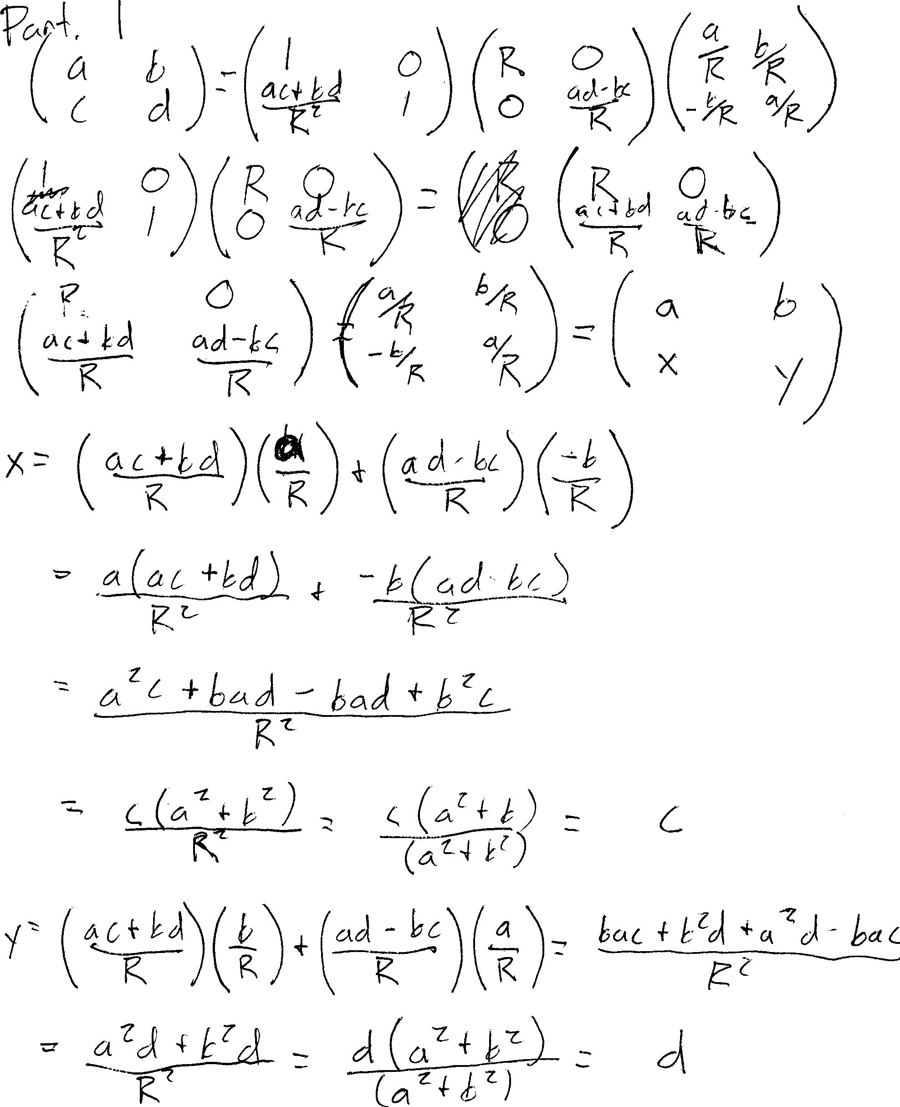
Solution to Question 2 of Team Assignment number 4
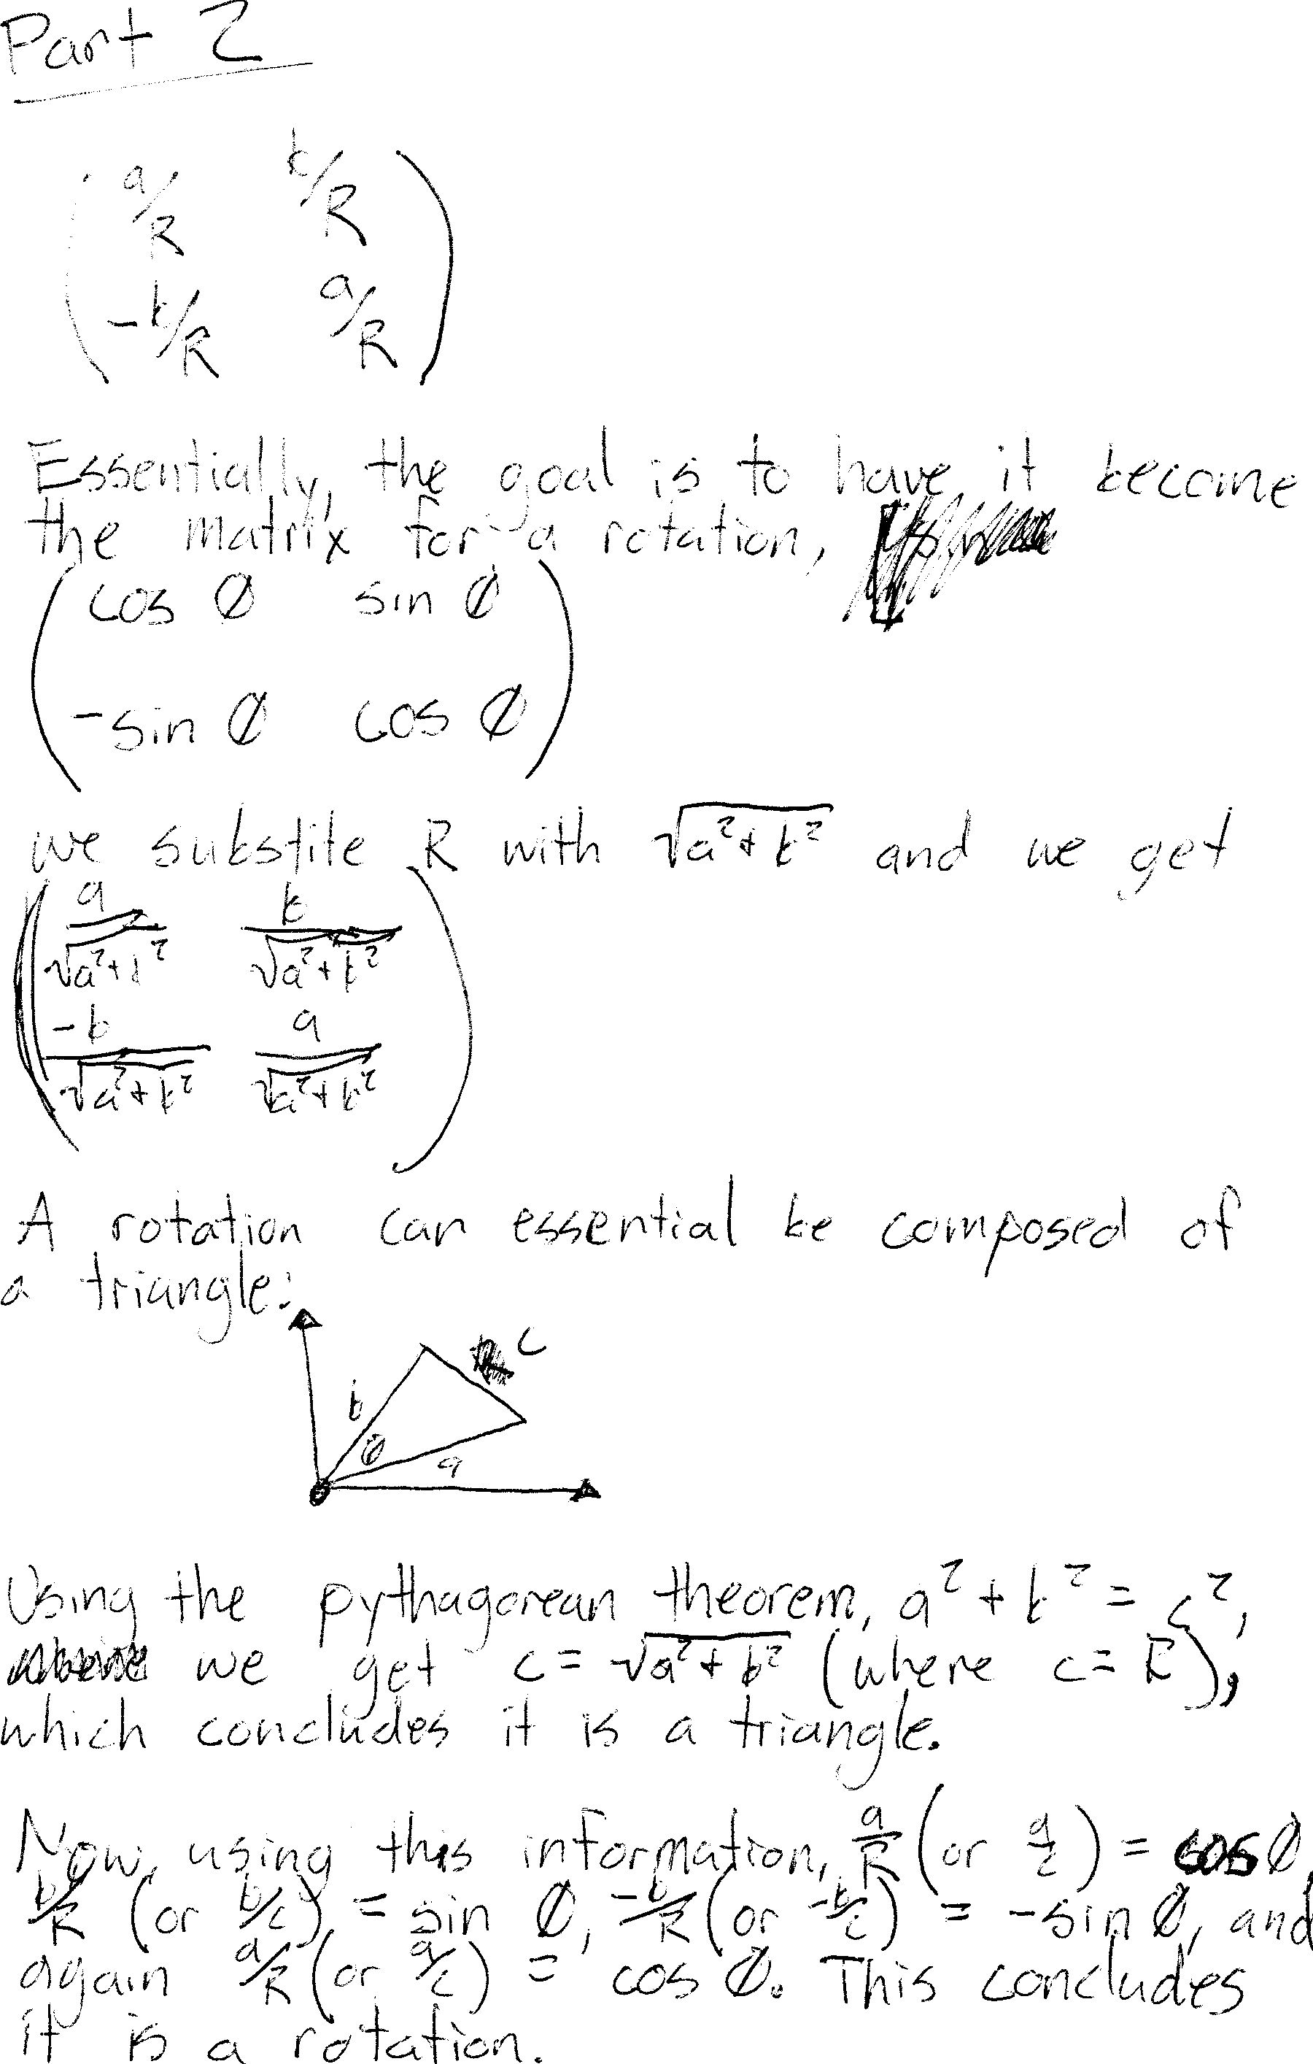

Solution to Question 3 of Team Assignment number 4 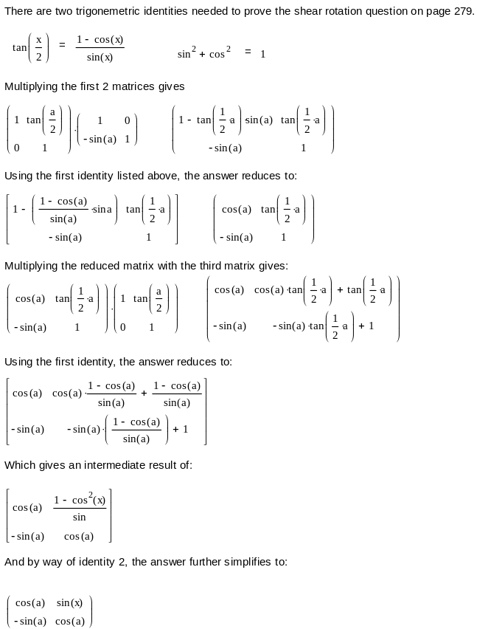
Problem 4 summary:

The purpose of program 4 was to demonstrate how three shears can be used to produce a rotation. The program starts by drawing a circle and then drawing two equally spaced points on the circle. The program calculates the positions of the points on the circle by using a slightly modified version of the “drawArc2” function from the text on page 280, figure 5.68. The function used in the program was renamed to drawPoints:

void drawPoints(Point2 p, double R, double startangle, double sweep)
{
#define RadPerDeg 0.01745329
double delang = (RadPerDeg * sweep / num_points);
double T = tan(delang/2); //calculates the three shears
double S = 2*T/(1+T*T);
double snR = R*sin(RadPerDeg*(startangle + rotate));
double csR = R*cos(RadPerDeg*(startangle + rotate));

for(int i = 0; i < num_points; i++)
{
snR += T * csR;
csR -= S * snR;
snR += T * csR;
circlePoint[i].set(p.getX() + csR, p.getY() + snR); //sets the points into the array
circlePoint[i].draw(); //draws the points
}
}

The drawPoints takes in the center point, radius, start angle, and the sweep. This function uses the three shear methods examined in the case study to calculate the proper positioning of the points on the circle. After the positions are calculated, the function draws the points on the circle. The calculated coordinates of the points are displayed in the command line window.

The program offers some interactivity to the user through different key presses. By pressing the “up arrow” or “down arrow” on the keyboard, the user can increase or decrease the number of points that are drawn on the circle upto 50 total. By pressing the “left arrow” or the “right arrow” keys, the user can cause the points to rotate on the circle. As points are added, subtracted and rotated on the circle, the command console provides each point’s coordinates in real time.

Another user option is to change the size of the circle. This is done by clicking the left mouse button somewhere in the OpenGL window.

Problem 5 summary:

This program uses the drawArc2 routine as illustrated in the text on page 280, figure 5.68 to draw arcs. The test program was written in a way that allows the user to interact with it.

Through a series of pre-assigned keypresses, the user is able to demonstrate how an arc is drawn. When the program is executed, a pre-drawn arc is presented with a radius of 10 units, with a starting angle of 90 degrees. Using the “up arrow” key, the size of the radius is increased producing a larger arc. In the reverse, if the “down arrow” key is pressed, the radius is decreased by one unit causing the arc to shrink in size. Pressing the “right arrow” key rotates the arc in a clockwise direction, and the “left arrow” key rotates counter-clockwise.

The ‘s’ key functions as a toggle to switch the roles of the right and left arrow keys. When the ‘s’ key is pressed, the “right arrow” will decrease the angle of the arc and the “left arrow” now increases the size of the arc’s angle. If the ‘s’ key is pressed a second time, the arc can once again be rotated with the left and right arrow keys.

To calculate the arc, the drawArc2 function from the text book was used. This is the same function that was used to calculate the points in problem 4 above. The only difference is this time we are drawing line instead of points.

void drawArc2(Point2 c, double R, double startAngle, double sweep){}

The test program passes the center point, the size of the radius, the start angle and the sweep into the function which calculates and draws the arc which can be manipulated by the user as previously explained.

Summary

This was an interesting project in the fact that it wasn’t all coded as in previous projects. Problems one, two and three were a little tricky because of the mathematics involved in solving them. For some of us, it has been awhile since we did any Trigonometry so it took some work to work through the problems.

The test programs were neatly coded and pretty straight forward in their functionality. All in all, the team pulled together once again to pull off this project and meet the requirements.

