**Add your app to Goggle play or AppStore and manage your IAP in store side**

1. [Google play manual](https://docs.unity3d.com/Manual/UnityIAPGoogleConfiguration.html)

2. [Apple AppStore manual](https://docs.unity3d.com/Manual/UnityIAPAppleConfiguration.html)

you need to activate unity IAP service and import IAP plugin, don't forget to add ADDIAP scripting symbol

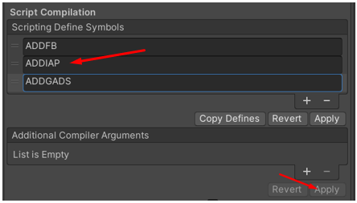

**Manage your IAP in game side.**

1. Open first scene – Lobby.
2. Select in hierarchy Purchaser.
3. Select Inspector tab.

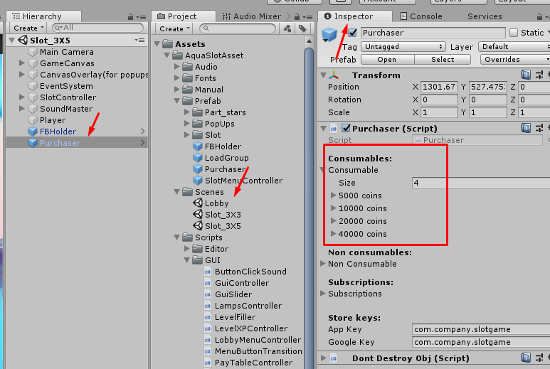

You can see 3 types of goods (Consumables, Non consumables and Subscription).

We use consumable (only for example).

Fold out the item

|  |  |
| --- | --- |
| In red frame – unique ID for store. |  |
|  |  |
| Keys for stores(Apple and Goggle) – your keys |  |

1. Add or remove items

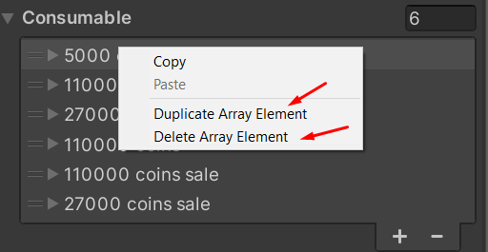

Set up purchase event for each item (what happened after succesfully purchasing)

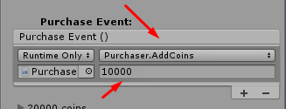

**Store side**

Add your iap IDs to google play side (unity manual https://docs.unity3d.com/Manual/UnityIAPGoogleConfiguration.html)

 you need to add **full id**, as example:

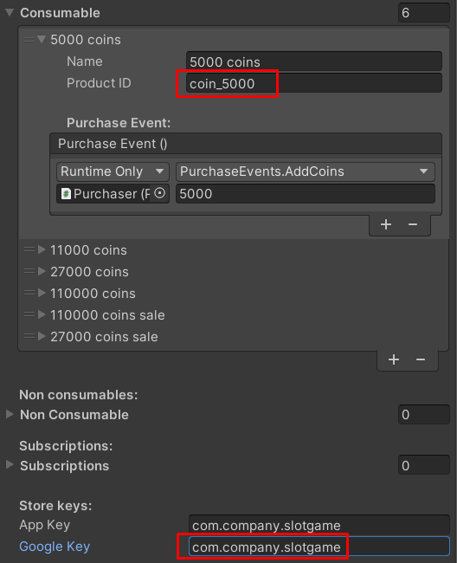

**full product ID**: com.company.slotgame.full

IAPs work only after publishing and submitting your app on google play

how to test read here: https://docs.unity3d.com/Manual/UnityIAPGoogleConfiguration.html