Provisioning Lab Sessions
- Login to your Cloudswyft account.
- Go to the lab profiles tab.
- Search for your assigned course.
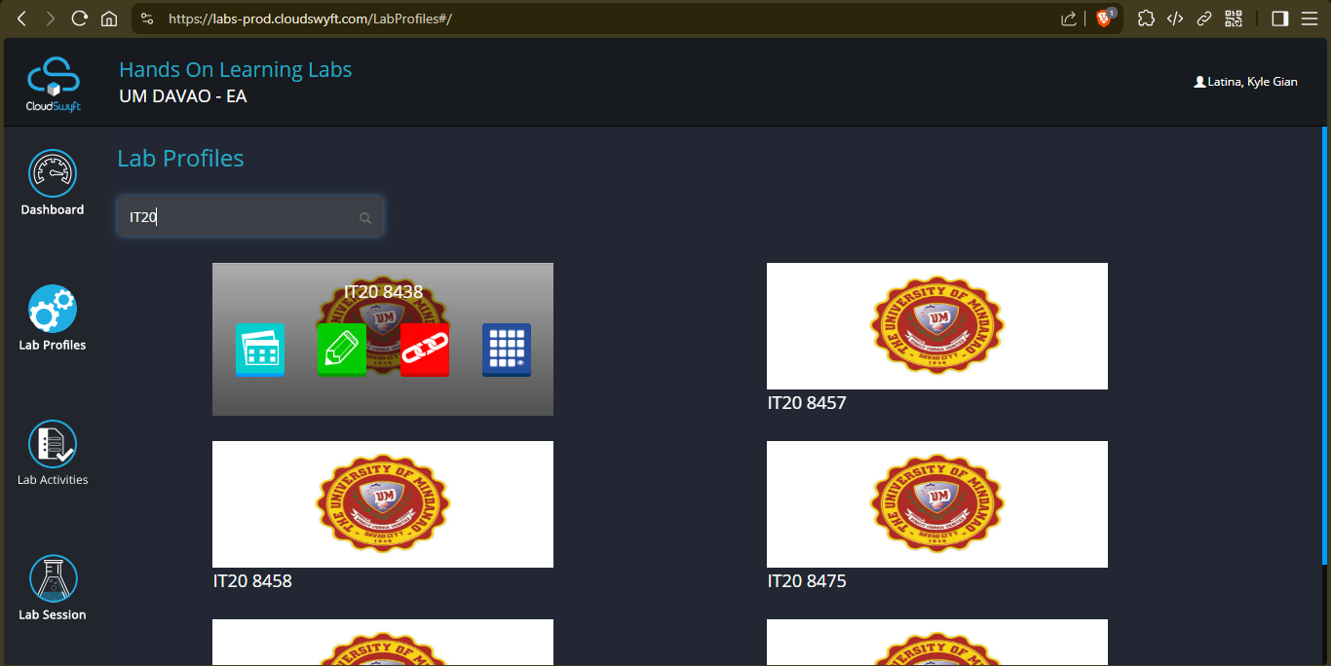
- Press the “Grant Lab Access” button (the red button).
- Search for your name and tick the box beside it.
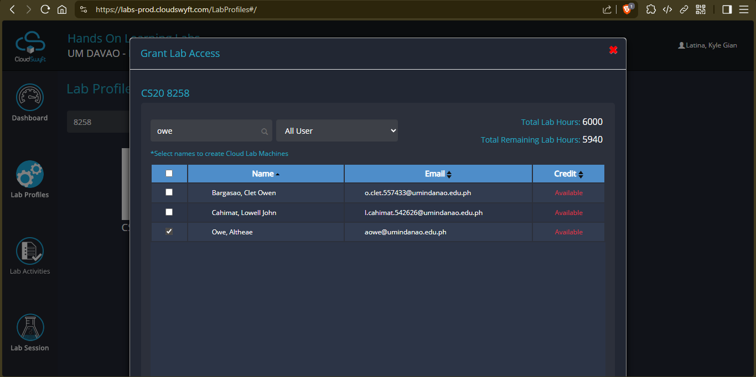

- Press the “Grant Access” button. (NOTE: If it’s not visible, zoom out your browser)
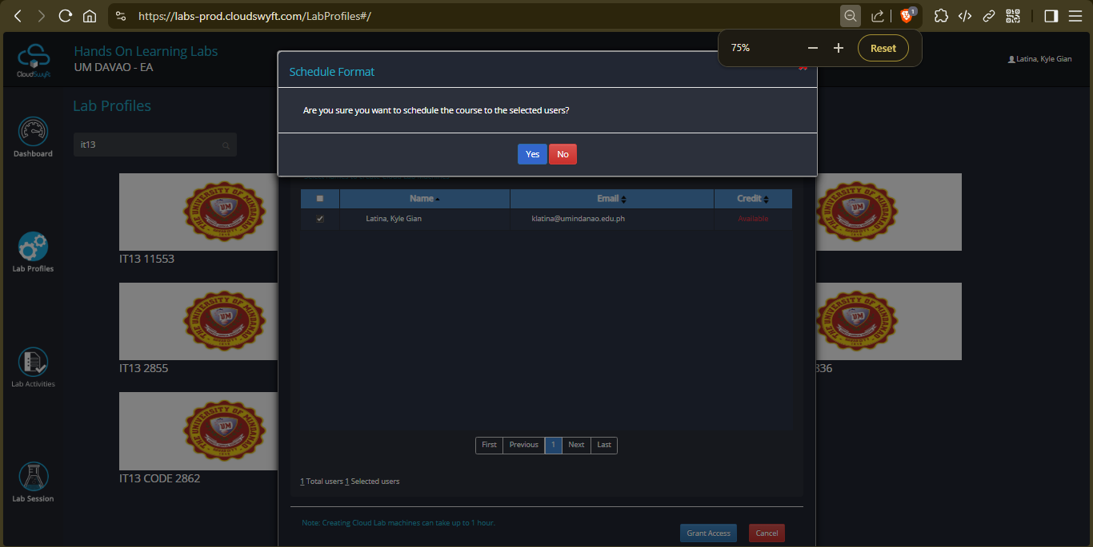
- Go to the lab session tab.
- Press the “Provision” button in your lab session. This will give you the login credentials.
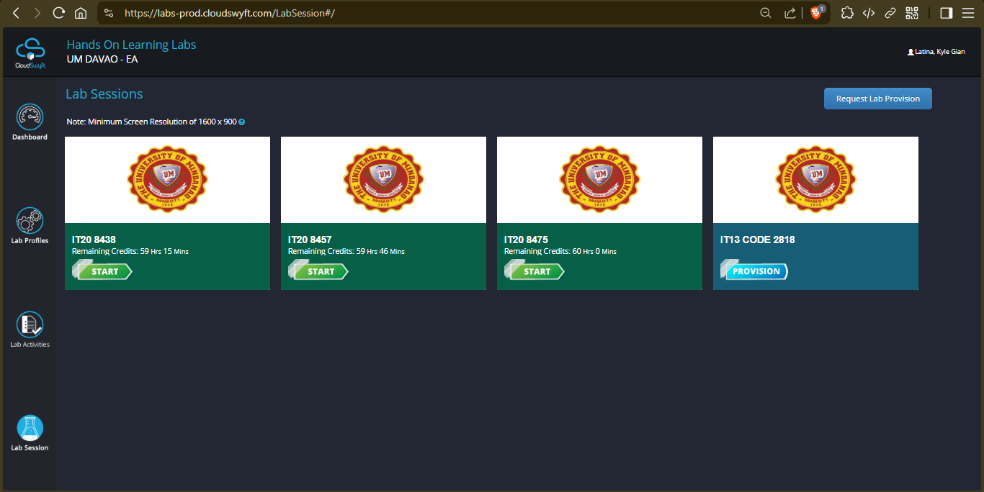
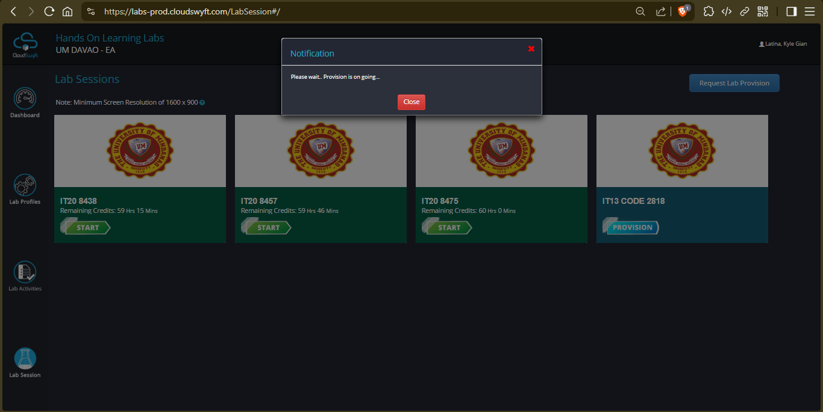
You can close this modal. The provisioning will continue.
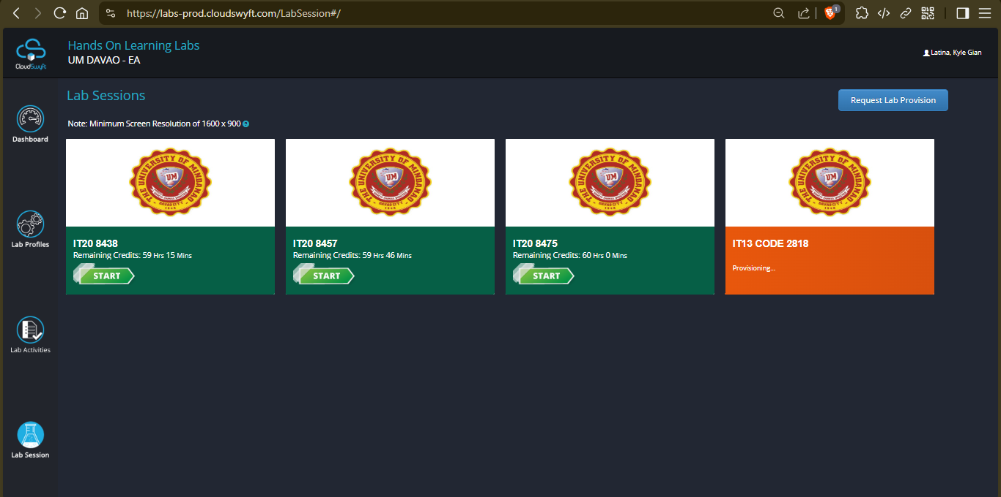

- After provisioning is done, you can now start your lab session. (NOTE: This will start the countdown for your lab session credits.)
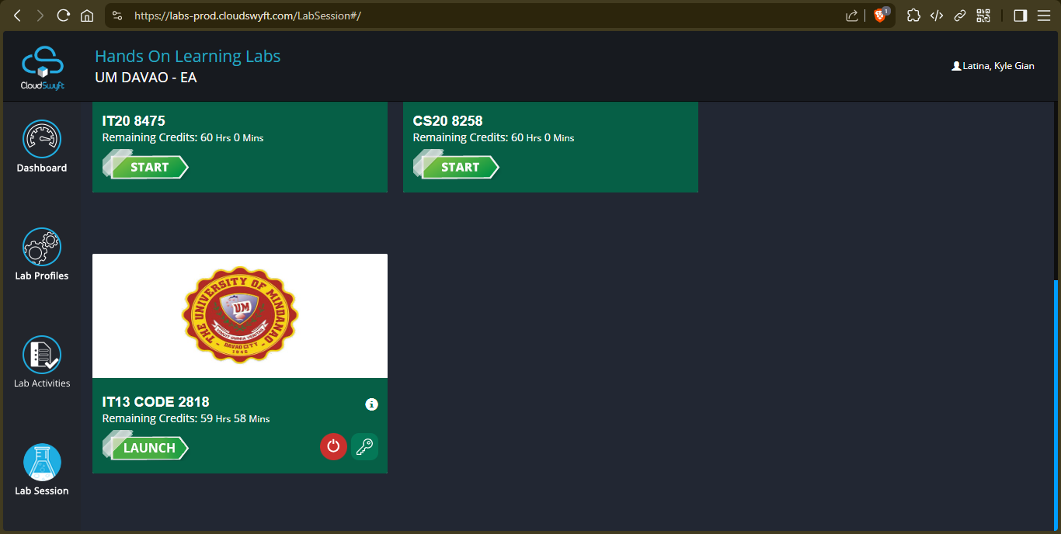

Launching Lab Sessions

Launching your lab session in the browser
- Press the Launch button. This will launch the lab session in your browser.
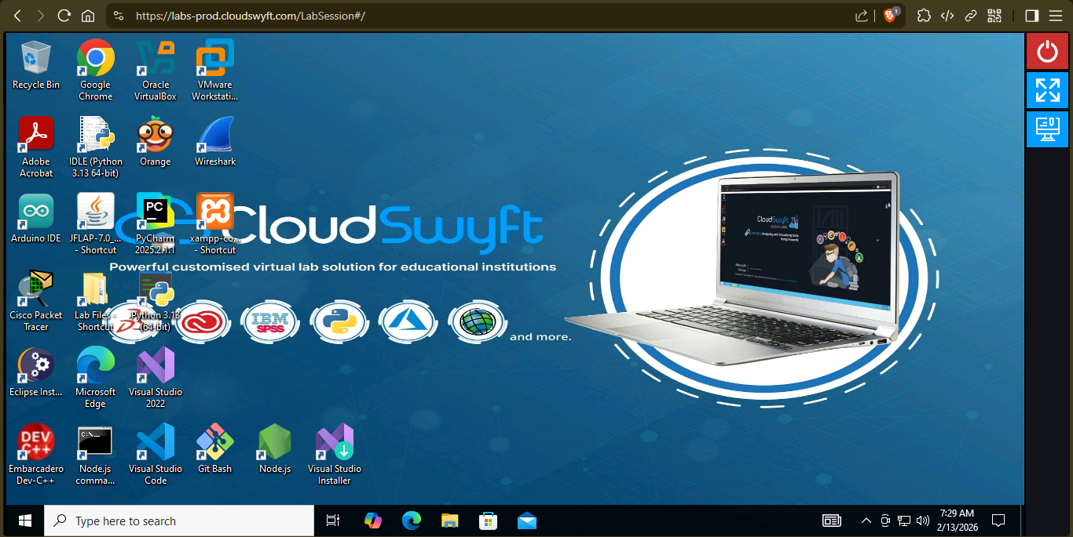

Launching your lab session through Remote Desktop Connection
DISCLAIMER: This guide will focus on the Windows OS
For Linux users: You can refer to FreeRDP (Terminal-based), Remmina (GUI-based), or other related applications (see “linux rdp”)
For macOS users: You can refer to the following:
- https://learn.microsoft.com/en-us/previous-versions/remote-desktop-client/remote-desktop-macos
- https://apps.apple.com/us/app/windows-app/id1295203466?mt=12

- Press the credentials button for your lab session (the key button).
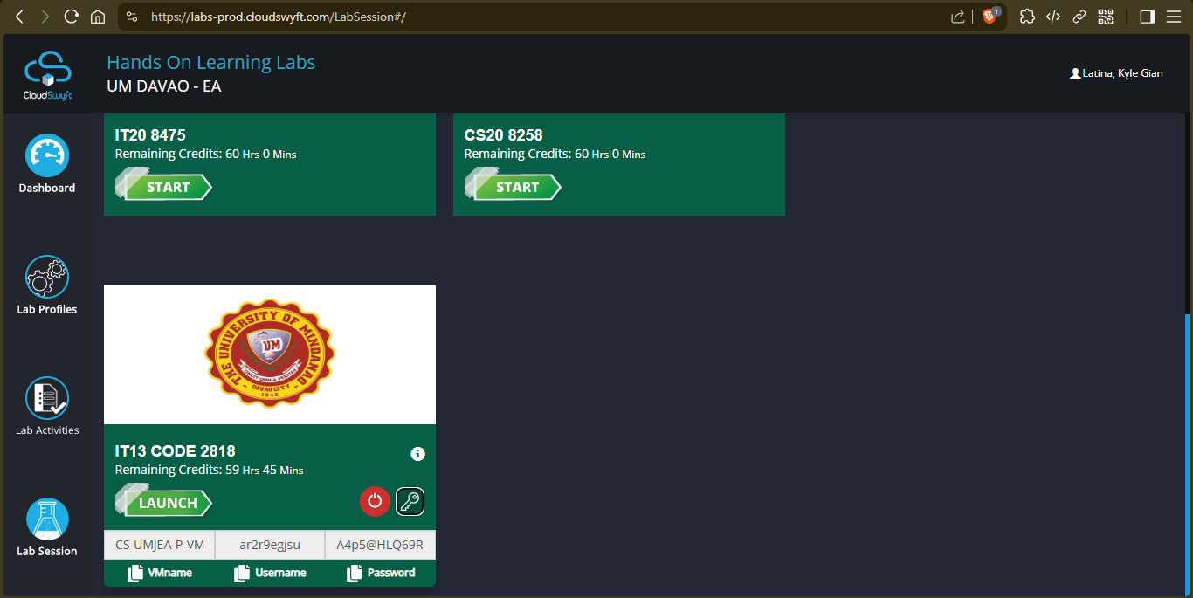

- Open the Remote Desktop Connection app.
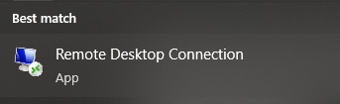
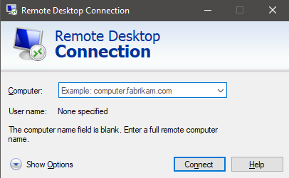
- Press the text above the VMname label to copy it.
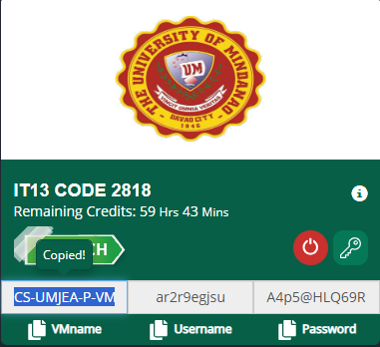

- Paste it on the dropdown field beside the computer label.
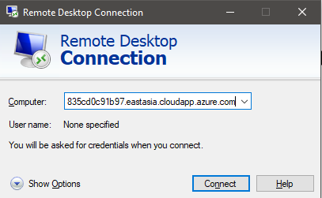
- Press the Connect button. If it is your first time connecting, you will be prompted for a username and password.
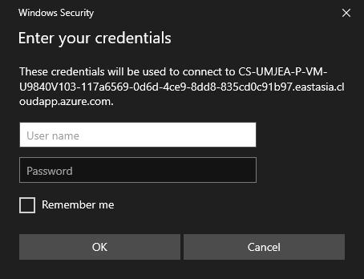

- Input the user credentials provided by your lab session.
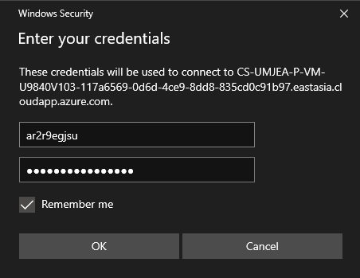
- Once you press Ok, you will be prompted about verification.
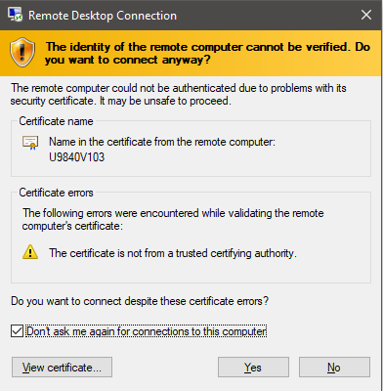

- Once you press Yes, you will be connected to your lab session.
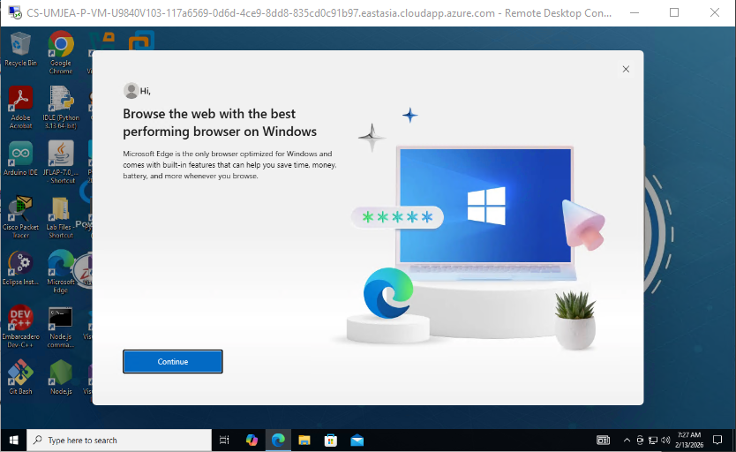
- If you close the connection, don’t forget to shut down the lab session in the Cloudswyft dashboard.

