PL/0 Parser errors :

var x, y;

begin

y = 3;

x := y + 56;

end.

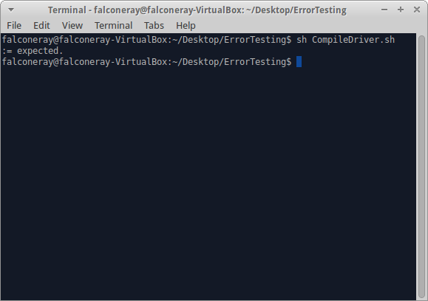

const;

var x, y;

begin

y := 3;

x := y + 56;

end.

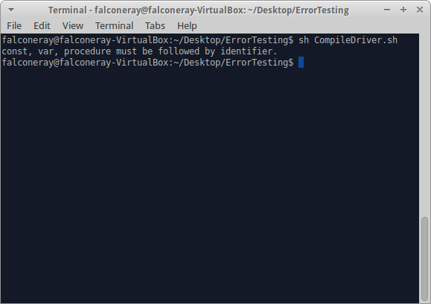

var x, y

begin

y := 3;

x := y + 56;

end.

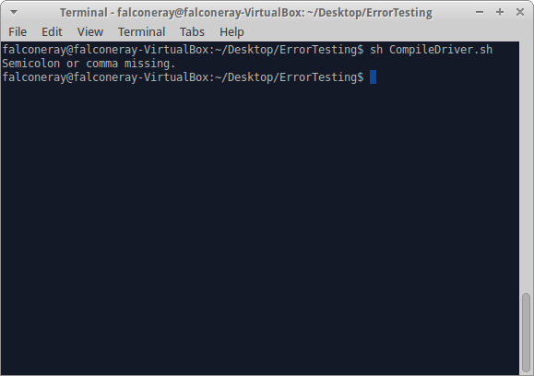

var x, y;

begin

y := 3;

x := y + 56;

end

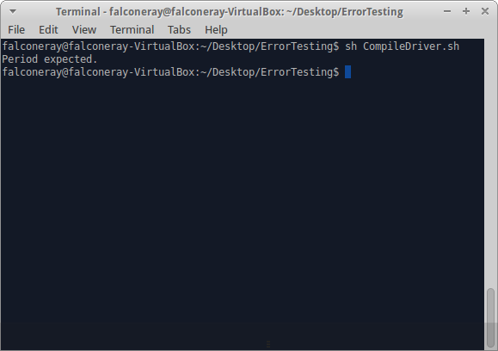

var x, y;

begin

y := 3

x := y + 56;

end.

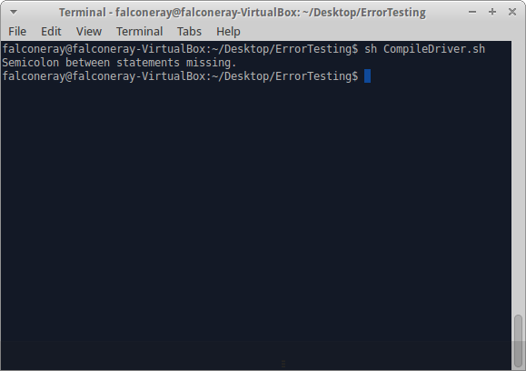

var y;

begin

y := 3;

x := y + 56;

end.

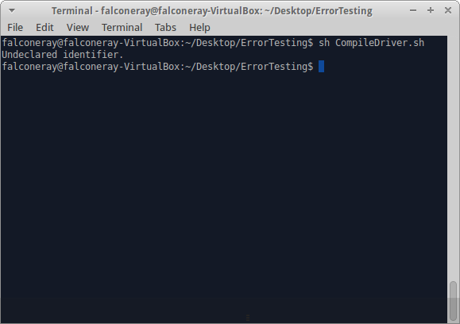

const x;

var y;

begin

y := 3;

x := y + 56;

end.

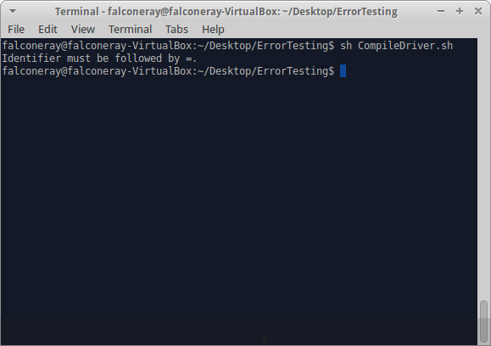

const x = 0;

var y;

begin

y := 3;

x := y + 56;

end.

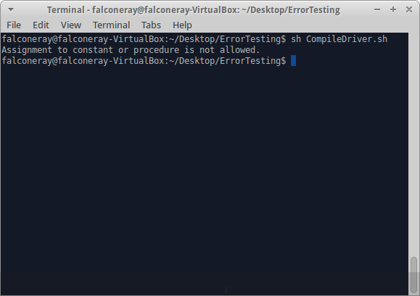

var x, y;

begin

y = 2;

x := y + 56;

end.

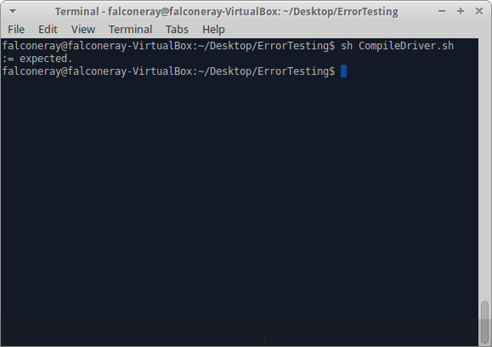

var x, y;

begin

y := 3;

x := y + 56;

.

