Create a14 days trial dynatrace a/c
1-Download OneAgent
wget -O Dynatrace-OneAgent-Linux-x86-1.335.58.20260423-145051.sh "https://sbh26735.live.dynatrace.com/api/v1/deployment/installer/agent/unix/default/latest?arch=x86" --header="Authorization: Api-Token dt0c01.HXMTA3EZQ3O6HYPZYYQURRB6.HU4HV4WXNVMCCYJHXPPVPZYDB42HM3B226ZUHKFXDGKVBQJLIPDLCDJ5LXRQFE3U"

2- Verify signature
wget https://ca.dynatrace.com/dt-root.cert.pem ; ( echo 'Content-Type: multipart/signed; protocol="application/x-pkcs7-signature"; micalg="sha-256"; boundary="--SIGNED-INSTALLER"'; echo ; echo ; echo '----SIGNED-INSTALLER' ; cat Dynatrace-OneAgent-Linux-x86-1.335.58.20260423-145051.sh ) | openssl cms -verify -CAfile dt-root.cert.pem > /dev/null

3- Install OneAgent as the privileged user
/bin/sh Dynatrace-OneAgent-Linux-x86-1.335.58.20260423-145051.sh --set-monitoring-mode=fullstack --set-app-log-content-access=true

1- Download ActiveGate
wget -O Dynatrace-ActiveGate-Linux-x86-1.335.20.20260403-154514.sh "https://sbh26735.live.dynatrace.com/api/v1/deployment/installer/gateway/unix/latest?arch=x86" --header="Authorization: Api-Token dt0c01.J3T7RU4VL4D2SNNFNVN32JNP.YHK3MQSVUOBAOSKJJF53VNDWKRCE5TSPSAE2R2DJ2BDAQYBFG5J53N6GVIBYOQQ4"

2-Verify signature

wget https://ca.dynatrace.com/dt-root.cert.pem ; ( echo 'Content-Type: multipart/signed; protocol="application/x-pkcs7-signature"; micalg="sha-256"; boundary="--SIGNED-INSTALLER"'; echo ; echo ; echo '----SIGNED-INSTALLER' ; cat Dynatrace-ActiveGate-Linux-x86-1.335.20.20260403-154514.sh ) | openssl cms -verify -CAfile dt-root.cert.pem > /dev/null

3-Install ActiveGate as the privileged user
/bin/bash Dynatrace-ActiveGate-Linux-x86-1.335.20.20260403-154514.sh

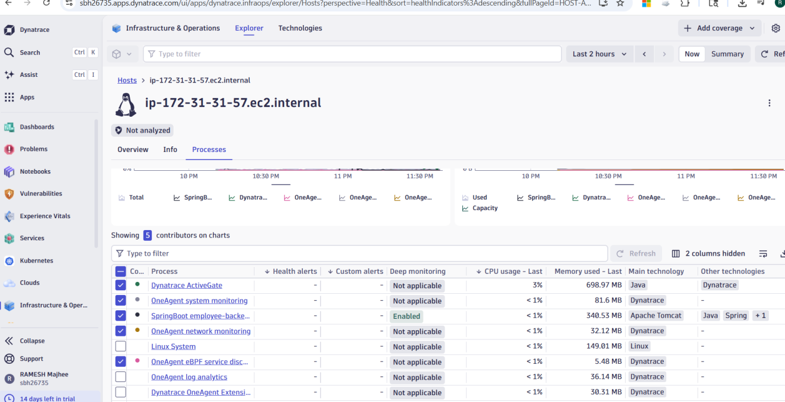

sudo yum install -y stress
sudo dnf install -y stress-ng
stress-ng --cpu 2 --timeout 300
stress --vm 2 --vm-bytes 512M --timeout 300
stress-ng --cpu 4 --vm 2 --vm-bytes 1G --timeout 600s

