AUTOMATED SCHOLARSHIP RECORDS MANAGEMENT
SYSTEM FOR THE LGU OF SAN ENRIQUE
NEGROS OCCIDENTAL

RICHARD C. MANAGUIT
ABDUL RAFI D. BOTAWAN
ELLEN ROSE B. ROBEJE

SUBMITTED TO THE ADMINISTRATION, FACULTY AND STAFF
OF THE CENTRAL PHILIPPINES STATE UNIVERSITY
IN PARTIAL FULFILLMENT OF THE
REQUIREMENTS FOR THE
DEGREE

BACHELOR OF SCIENCE IN INFORMATION TECHNOLOGY

MARCH 2026

CHAPTER I
THE PROBLEM AND ITS SCOPE

Introduction
Around the world, scholarship programs play an important role in helping students gain access to education, especially those who face financial difficulties. As scholarship programs continue to expand, many governments and educational institutions have turned to web-based and automated systems to manage applications, records, and communication more effectively. Research shows that automating these processes helps reduce manual workload, minimize errors, improve transparency, and ensure that information is delivered to applicants in a timely and organized manner (Al-Ayyubi & Maulana, 2023).
In the Philippines, Local Government Units (LGUs) actively support education by offering locally funded scholarship programs. The Municipality of San Enrique, Negros Occidental reflects this commitment by providing financial assistance to qualified students. However, the current scholarship process still depends largely on manual practices such as posting announcements on social media, using handwritten application forms, maintaining records in spreadsheets, and requiring physical submission of documents. Studies indicate that these manual methods often lead to delays, miscommunication, repeated submissions, and difficulties in monitoring and retrieving scholarship records (Prijayanti et al., 2020).
To respond to these challenges, this study proposes the development of a web-based Automated Scholarship Records Management System for the LGU of San Enrique, Negros Occidental. The proposed system is designed to centralize scholarship records, streamline application processing, track application status, and improve communication through SMS notifications. While physical document verification remains necessary for accounting, auditing, and approval purposes, the system aims to improve efficiency, transparency, and accessibility, resulting in a more organized and reliable scholarship management process for both LGU staff and scholarship applicants.
Problem Statement
The researchers aim to analyze the technical requirements needed to develop an Automated Scholarship Records Management System and to design and implement a functional and accessible system for both scholarship applicants and LGU staff. Specifically, the present study seeks to address the following problems:
- What are the difficulties or challenges encountered by the LGU of San Enrique in the aspect of:
- Processing of scholarship applicants;
- Archiving and retrieval of scholar records; and
- Dissemination of scholarship announcements and updates?
- What are the specific system and technical requirements needed to develop the Automated Scholarship Records Management System?
- What technical features must the Automated Scholarship Records Management System possess to support effective scholarship management as required by the LGU and project advisers?
- What is the level of usability of the Automated Scholarship Records Management System as evaluated by the end users in terms of efficiency, accessibility, and user satisfaction?
- What is the level of system quality of the Automated Scholarship Records Management System as assessed by IT experts in terms of functionality, reliability, and performance?
Objectives
To design, develop, and implement a web-based Automated Scholarship Records Management System for the LGU of San Enrique, Negros Occidental, that will improve the efficiency, organization, and management of scholarship records while supporting existing government procedures.
Specifically, this project aims to:
1. Develop a web-based Automated Scholarship Records Management System specifically designed for the LGU of San Enrique, Negros Occidental.
2. Develop a web-based Automated Scholarship Records Management System that effectively automates key scholarship processes, including application submission, document monitoring, status tracking, and scholarship record management.
3. Develop a web-based Automated Scholarship Records Management System that addresses the inefficiencies of the current manual scholarship program by reducing administrative workload, improving communication processes, and providing a more convenient and organized experience for both LGU staff and scholarship applicants..
Significance of the Study
The Automated Scholarship Records Management System for the LGU of San Enrique, Negros Occidental, will benefit the following:
To The LGU Of San Enrique. This study will provide a more efficient and accurate system for managing scholarship records, reducing administrative workload and improving overall program administration. It will enable faster processing of applications, better tracking of student data, and streamlined communication with scholars.
To The Scholarship Applicants and Scholars. This study will provide a more accessible and transparent platform for accessing scholarship information and application forms. It will also facilitate timely communication regarding application status and scholarship updates, reducing the need for frequent visits to the LGU office.
To The Future Researchers. This study will serve as a valuable reference for future researchers interested in developing similar scholarship management systems or other local government management systems. It will provide insights into the challenges and solutions involved in automating administrative processes.
Scope and Limitations
This study focuses on the design, development, and implementation of a web-based Automated Scholarship Records Management System for the Local Government Unit (LGU) of San Enrique, Negros Occidental. The system covers online scholarship announcements, applicant registration, digital application submission, document uploading and monitoring, application status tracking, and SMS notifications with mobile number verification through One-Time Password (OTP). It also supports bulk SMS sending for scholarship announcements, interview schedules, approval notices, and disbursement updates. Additionally, the system includes applicant and scholar record management, interview scheduling, approval monitoring, and the recording of scholarship disbursement details.
The system is designed to support the existing scholarship process of the LGU and is accessible to scholarship applicants, LGU staff, and administrators. It aims to improve efficiency, organization, communication, and record management by centralizing scholarship data and reducing reliance on purely manual procedures. However, the system does not replace government-mandated processes such as physical document submission, verification, accounting review, auditing, and approval by authorized offices. These procedures remain manual and are only supported by the system through digital pre-screening, bulk notifications, and record organization.
This study is limited by factors such as the accuracy of data entered by users and the availability of internet connectivity for online access, and SMS delivery. The system does not handle actual financial transactions or provide real-time chat between applicants and LGU staff; communication is limited to system notifications and individual or bulk SMS alerts. Furthermore, the system is developed specifically for the LGU of San Enrique, Negros Occidental and is not intended for use by other LGUs without further customization.

Definition of Terms
API (Application Programming Interface). A software intermediary or set of rules that allows two separate applications to communicate and exchange data or functionality. In this study, it refers specifically to the use of external services integrated into the system.
Bootstrap. A popular, free, and open-source front-end framework containing pre-written HTML, CSS, and JavaScript components and tools for creating responsive, mobile-first websites and web applications efficiently. The specific front-end framework utilized in the development of the Automated Scholarship Records Management System, as listed in the software requirements. It provides the foundational code for the design, layout, and responsiveness of the system's user interfaces (like the admin dashboard and applicant portal).
Dashboard. A homepage on a website giving access to different elements of the site's functionality. The primary graphical user interface (GUI) of the Automated Scholarship Records Management System intended for LGU staff use.
Database. An organized collection of structured information or data, typically stored electronically in a computer system. Within the study, this refers to the centralized digital storage system created to securely hold all relevant information about scholarship applicants and recipients, including personal details, academic background, application status, submitted documents, and disbursement details, ensuring organized record-keeping and easy access for authorized LGU staff.
Disbursement. The act of paying out money especially from a fund. In this study, it refers to the process and record of paying out scholarship funds to a qualified and approved scholar.
SMS Notification. A notification received on a mobile device indicating a new text message has arrived via the Short Message Service (SMS). A feature integrated into the system to automatically send text messages to applicants informing them about application confirmations, status updates, interview schedules, and disbursement announcements. It includes bulk SMS capabilities for wider notifications.
CHAPTER 2
REVIEW OF RELATED LITERATURE AND SYSTEMS
This chapter presents the related literature, studies, and systems that are pertinent to this study. The present study is anchored on these related literature and systems which give relevant information and better enlightenment for the readers to understand clearly the development of an Automated Scholarship Records Management System for the LGU of San Enrique, Negros Occidental. This review explores existing scholarship management approaches, the automation of administrative tasks in LGUs or similar institutions, and the application of web-based technologies and notification systems in such contexts.
Review of Related Literature
QR-Code Tracking and SMS Notification Transaction Interface for Scholarship Management System Secugal, K. A., Sermeno, J. P., and Mistio, N. E. (2021) developed a system which aimed to address issues in tracking and communication within the scholarship processing workflow. Implemented at the University of Antique, the system was specifically designed to improve the handling of scholarship documentation by incorporating QR code functionality to streamline document verification and enable accurate, real-time tracking of submitted requirements. Additionally, SMS notifications were integrated to provide timely updates to scholars regarding their application status and document verifications. The researchers reported that the system significantly reduced administrative delays and human errors in document handling. It also improved transparency by keeping scholars informed about their application progress. In relation to the present study, this system demonstrates how technology can be leveraged not only for data storage but also for real-time communication and efficient document monitoring. These features are highly relevant to the proposed Automated Scholarship Records Management System for the LGU of San Enrique, which similarly aims to incorporate document tracking and notification features to reduce miscommunication, delays, and redundant follow-ups between the LGU and its scholars.
​Tertiary Education Subsidy (TES) Tracker System The Commission on Higher Education (CHED) introduced the TES Tracker System in 2021 as a digital tool to monitor the distribution of Tertiary Education Subsidy (TES) stipends, particularly in the Davao Region. This system enables real-time tracking of fund disbursement to grantees by requiring scholarship coordinators to regularly update an online form with details such as the number of beneficiaries and the amounts released. This initiative aligns with the objectives of the proposed Automated Scholarship Records Management System for the LGU of San Enrique, Negros Occidental. Both systems aim to enhance transparency, efficiency, and accountability in scholarship management through digital solutions. By adopting similar real-time monitoring and data updating features, the LGU's system can ensure timely fund distribution and accurate record-keeping, thereby improving service delivery to scholarship beneficiaries.
APPly Blancaflor et al. (2022) created a web-based system which aimed to improve how students apply for scholarships at the tertiary level. The system was developed in response to the growing number of applications and the need to make the process more organized and efficient. It allowed students to apply online and enabled administrators to evaluate and manage applications more easily. Based on user feedback through a usability survey, the system was found to be effective and easy to use. The researchers also recommended adding mobile access and SMS features in future versions. This study supports the current research, as it shares the same goal of digitizing scholarship processes. Just like APPly, the proposed system for the LGU of San Enrique aims to reduce manual work, improve access, and simplify scholarship tracking for both students and administrators.
Designing a Web-Based Information System for Scholarship Management: Supporting Access and Rapid Dissemination of Information The development of web-based information systems for scholarship management is a crucial area of focus for improving the efficiency and effectiveness of scholarship programs (Al-Ayyubi & Maulana, 2023). As indicated in the study, there is a recognized need to move away from traditional, manual processes towards centralized, automated platforms. Such systems aim to streamline the management of scholar information, including applications and administrative tasks, by providing centralized data storage, facilitating online application processing, automating record-keeping, and enhancing communication between stakeholders. These objectives closely align with the goals of the proposed Automated Scholarship Records Management System for the LGU of San Enrique, which seeks to address similar inefficiencies through the development of a web-based solution.
Web-Based Monitoring Information System for scholarship holder. The study by Prijayanti et al (2020) addresses the challenges of monitoring scholarship recipients in an institution, Universitas Muhammadiyah Magelang. The traditional method of collecting hard files face-to-face led to data loss and duplication. The related study emphasized the need for automated systems to improve data management, reduce data loss and duplication, and facilitate communication between stakeholders. Similarly, the proposed study aims to automate and enhance scholarship processes for the LGU of San Enrique, Negros Occidental through a web-based platform.
Optimizing scholarship distribution: a management information system approach. The study by Orgianus et al., (2024) introduced a web-based Management Information System (MIS) designed to optimize scholarship distribution for a philanthropic institution in Indonesia. The system featured automated scholar profiling, academic performance monitoring, document tracking, and real-time report generation—functions that directly align with the goals of the present study. Specifically, the MIS addressed inefficiencies in manual processing, delayed reporting, and a lack of transparency, which are also challenges identified in the current scholarship operations of the LGU of San Enrique. By centralizing scholarship data and enabling quota monitoring, the system supported fair and data-driven allocation of funds, similar to what the proposed LGU system aims to achieve.
Smart Scholarship System. The study by Khelifi et al. (2023) introduced a Smart Scholarship System aimed at streamlining the scholarship application and management process at Abu Dhabi University (ADU). This system addressed challenges such as the need for physical presence during applications, non-specific scholarship systems, and time-consuming application reviews. Key features included enabling students to apply for various scholarships online, verify their application status, update personal data, and receive administrative assistance through live chat. These functionalities align closely with the objectives of the proposed Automated Scholarship Records and Management System for the LGU of San Enrique, which seeks to enhance efficiency, transparency, and accessibility in scholarship management through automation and centralized data handling.

CHAPTER III
METHODOLOGY
This chapter details the methodology employed in the development of the Automated Scholarship Records Management System for the LGU of San Enrique, Negros Occidental. It discusses research design, including the Agile development methodology chosen as the system development life cycle (SDLC) model for this project. The chapter will also outline the flow of the study, specify the functional and non-functional requirements of the system, describe the respondents and the environment in which the study was conducted, and explain the instruments and procedures utilized for data gathering, along with the statistical treatment applied to the collected data.
a. Design Method
The researchers will employ an Agile development methodology to ensure flexibility, collaboration, and iterative progress throughout the project lifecycle. The process, illustrated in Figure 1. Agile Development Methodology, consists of several key phases executed iteratively:
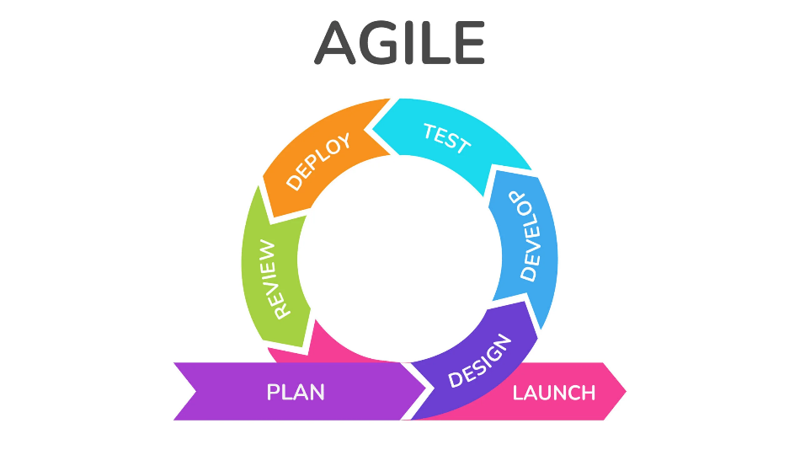
Figure 1. Agile Development Methodology
https://ar.inspiredpencil.com/pictures-2023/agile-methodology-logo
Phase 1: Plan
This initial phase defines the project's vision. It involves understanding the main problems, identifying key features for the LGU of San Enrique and applicants, and outlining a development roadmap. This plan guides the work cycles.
Phase 2: Design
Features are designed in detail, including system parts, user, database structure, and how data and notifications will work.
Phase 3: Develop
The system components are coded and built. This includes backend logic, frontend interfaces, database setup, and adding necessary tools like SMS and login authenticators.
Phase 4: Test
Developed parts are tested to find and fix errors. This includes checking individual components and how they work together.
Phase 5: Deploy
The tested part of the system is deployed to a test environment for the adviser and LGU staff to see. This is not the final launch.
Phase 6: Review
The working software is shown to adviser and LGU staff at the end of each sprint. Their feedback helps guide further development.
Phase 7: Launch
After several sprints of building, testing, and refining the system based on feedback, the Automated Scholarship Records Management System is prepared for final release. This involves final testing, any needed data migration, training LGU staff, and making the system live for users.
b. Flow of the Study The development of the Automated Scholarship Records Management System for the LGU of San Enrique, Negros Occidental, will primarily be based on the Input-Process-Output (IPO) model, providing a clear framework for the project's progression from initial requirements gathering to the final system deployment and evaluation.
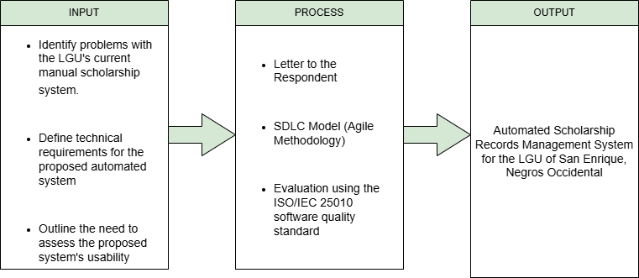
Figure 2. Flow of the Study
c. Functional and Non-Functional Requirements
c.1. Software Requirements Table 2 shows the software requirements in the development of the system. It specified the version of the software used in the development. Table 1. Software Requirements
Software | Version
Visual Studio Code | 1.100.2
XAMPP | 8.2.12
Google Chrome | 137.0.7151.41
PHP | 8.2.12
Composer | 2.8.8
Bootstrap | 5.3.6
Textbee SMS API
c.2. Hardware Requirements The following table outlines the minimum and recommended hardware specifications necessary for the development, deployment, and optimal operation of the Automated Scholarship Records Management System. These specifications ensure that the system can perform efficiently and reliably.
Table 2. Hardware Requirements
Device | Specifications
Central Processing Unit (CPU) | Intel Core i5 8th Gen
Monitor | 13” 1920x1080 Resolution
Keyboard | Standard Keyboard
Mouse | Standard Mouse
Solid State Drive (SSD) | 256 GB
RAM | 16 GB

c.3. System Flowchart
The system flowchart illustrates how data is inputted, processed, and outputted, detailing the various steps and decision points involved in the system's operation from the perspective of different users. Figure 3 depicts the user authentication and public access workflow; Figure 4 depicts the applicant workflow; and Figure 5 depicts the admin workflow.
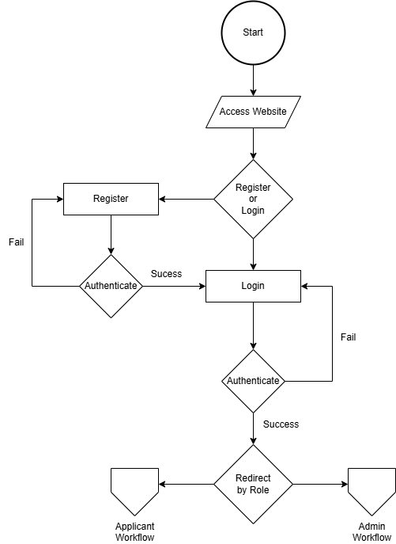
Figure 3. User Authentication and Public Access
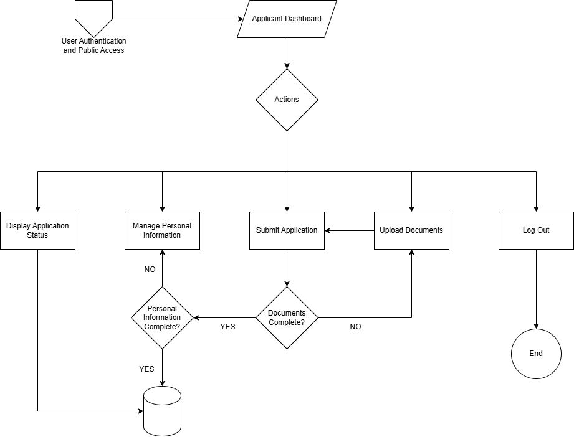
Figure 4. Applicant Workflow

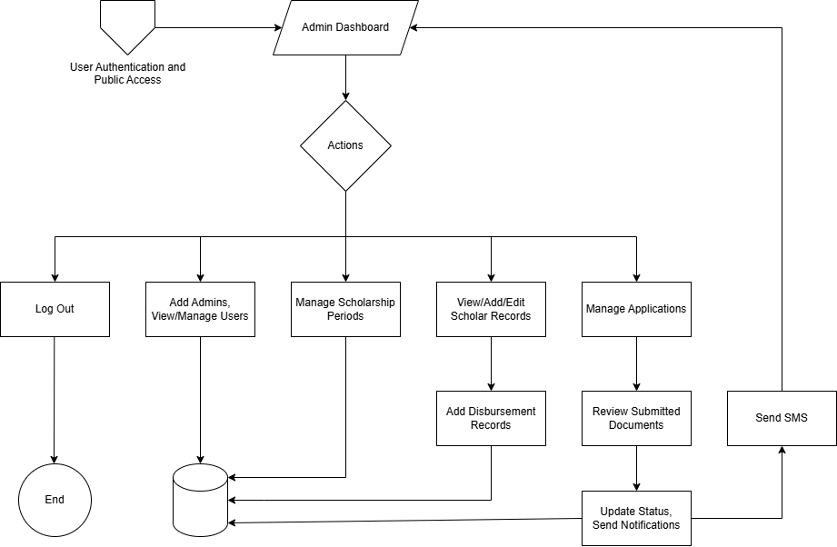
Figure 5. Admin Workflow
c.4. System Architecture
Figure 6 details the architectural design of the Automated Scholarship Records Management System. It describes the high-level structure, key components, and their interrelationships, outlining how they work together to deliver the system's functionalities and meet the project objectives. The architecture is designed to ensure efficiency, scalability, and maintainability.

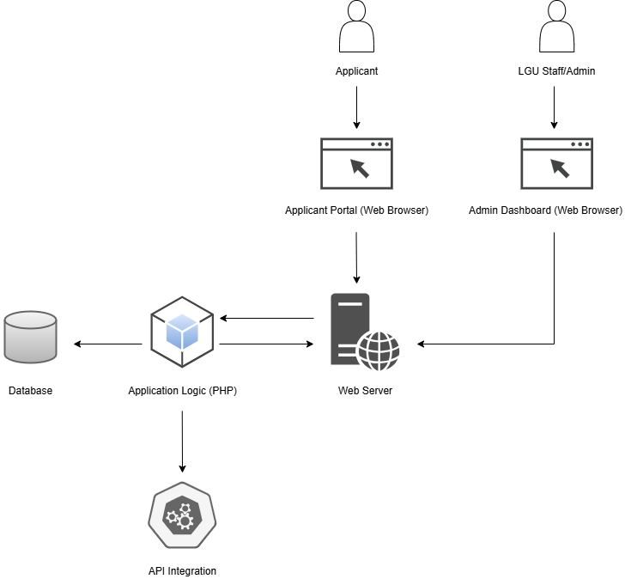
Figure 6. System Architecture
c.6. Context Diagram
The Context Diagram, presented in Figure 7, illustrates the boundary and scope of the Automated Scholarship Records Management System. It provides a high-level overview of the system as a single process, identifying the external entities that interact with it and the primary data flows between the system and these entities.
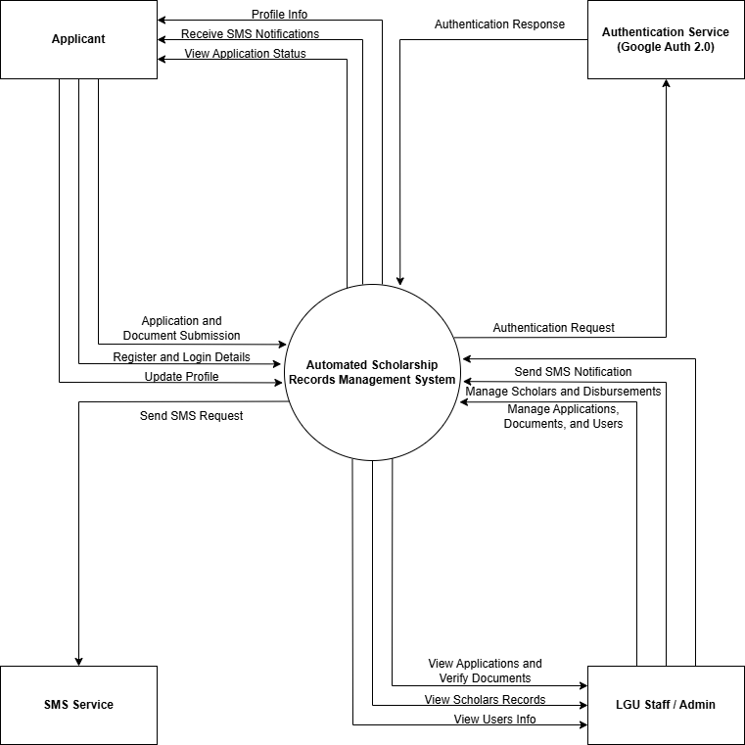
Figure 7. Context Diagram
c.7. Data Flow Diagram
The Level 1 Data Flow Diagram, shown in Figure 8, illustrates the main processes within the Automated Scholarship Records Management System and how data moves between these processes, data stores, and external entities.

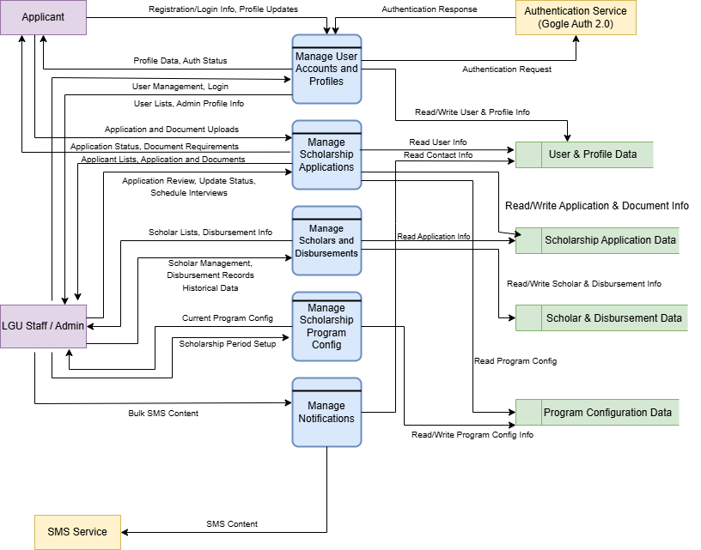
Figure 8. Data Flow Diagram

c.8. Entity Relationship Diagram (ERD)
A well-structured database is fundamental to the functionality and efficiency of the proposed Automated Scholarship Records Management System. To model the data requirements and relationships effectively, an Entity Relationship Diagram (ERD) was developed. Each entity represents a table in the database, containing specific attributes that store relevant information. The relationships between entities are depicted using Crow's Foot notation.
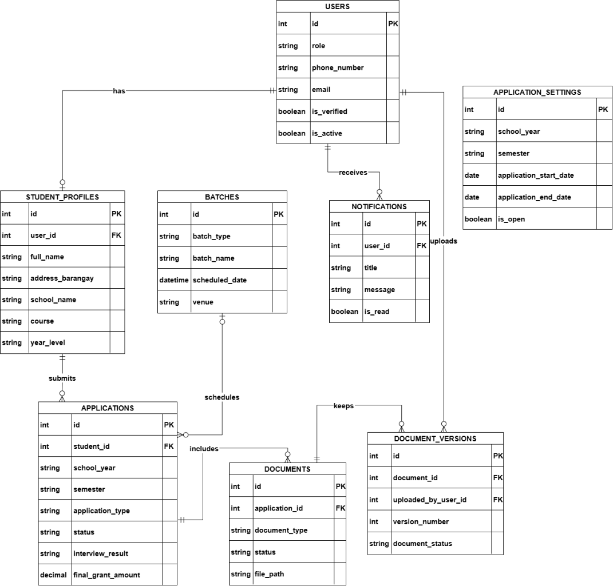
Figure 9. Entity Relationship Diagram
c.9. Use Case Diagram
Figure 10 displays the Use Case Diagram for the Automated Scholarship Records Management System, showing how different users will interact with the system and its core features.
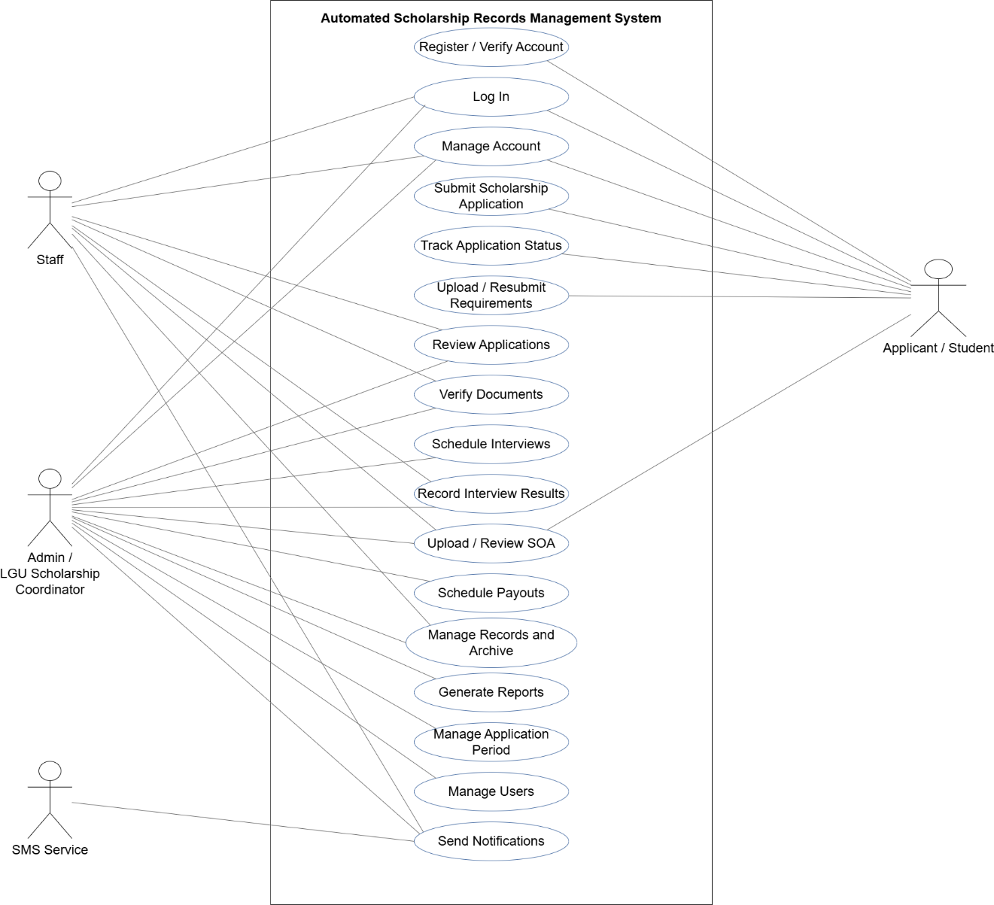
Figure 10. Use Case Diagram
d. Respondents The respondents for this study are primarily the scholarship applicants and the LGU staffs for the scholarship program of the LGU of San Enrique, Negros Occidental, which are the beneficiaries and users of the proposed system.
Table 3. Distribution of Respondents
Respondents | Frequency | Percentage
Scholarship Applicants | 20 | 80.00
LGU Staffs | 5 | 20.00
Total | 25 | 100.00

e. Environment
The study for the Automated Scholarship Records Management System was primarily conducted within the context of the Local Government Unit (LGU) of San Enrique, Negros Occidental. This encompasses the administrative offices and operational environment where the existing manual scholarship program is currently managed.
The specific environment of the study focuses on the LGU office in San Enrique, Negros Occidental, where the scholarship program's official announcements, scholar information management, and physical document submissions currently take place. The research aims to understand and address the challenges inherent in this manual operational environment, such as time-consuming manual data entry, inefficient physical record-keeping, and communication issues due to reliance on social media and multiple in-person trips for applicants.
The development and proposed implementation of the Automated Scholarship Records Management System are designed to directly enhance the efficiency and transparency within this LGU environment, transitioning from traditional methods to a modern, centralized digital platform. This includes streamlining processes for LGU staff in managing applications, documents, and scholars, and improving convenience for scholarship applicants.
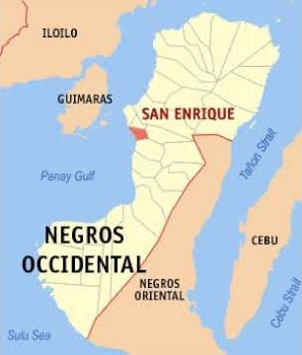
Figure 3. Environment of the Study
https://i.ytimg.com/vi/-QKqngAmibU/hqdefault.jpg
f. Instrument
When discussing the instrument in this capstone project, it is crucial to thoroughly describe the tools employed for data gathering and how they will be utilized. For the Automated Scholarship Records Management System, a mixed-methods approach will be adopted for data collection, primarily utilizing survey questionnaires and structured interviews.
The instrument was divided into two (2) parts. The first part collected basic demographic information relevant to the study, such as the respondent's role (LGU Staff, Scholarship Applicant) and, if applicable, their level of experience with similar systems. Personal identification like names will be optional to ensure anonymity and encourage candid responses. The second part included the questions designed to assess various aspects of the Automated Scholarship Records Management System. The questions were structured using the Likert Scale. The Scale was used to validate the effectiveness, usability, sustainability and maintainability of the system.
Table 4. Likert Scale for Usability
Range Scale (1-4)
1.00 | 1.75 | Not Usable (NU)
1.76 | 2.50 | Slightly Usable (SU)
2.51 | 3.25 | Moderately Usable (MU)
3.26 | 4.00 | Very Usable (VU)

g. Data Gathering Procedures
The researchers will gather primary data by first submitting a formal letter to the LGU of San Enrique to request permission and seek approval for conducting the study. Upon approval, LGU staff involved in the scholarship program and scholarship applicants will be identified and selected as respondents. Throughout the process, ethical conduct will be paramount, ensuring informed consent is secured from all participants, and maintaining the confidentiality and anonymity of their responses. The survey questionnaires and interview guides will then be finalized and, if feasible, pilot-tested to ensure clarity and relevance. Before the evaluation phase, respondents will be oriented with and allowed to interact with the Automated Scholarship Records Management System. Subsequently, questionnaires will be administered to the LGU staff and applicants to gather quantitative data on system usability and effectiveness. To obtain in-depth qualitative feedback on the Automated Scholarship Records Management System, structured interviews will be conducted with selected LGU staff and applicants. Finally, all collected survey responses will be tallied, and interview data will be organized for thorough analysis. These procedures are designed to collect comprehensive and reliable data to effectively evaluate the Automated Scholarship Records Management System.
h. Statistical Treatment of Data
The following statistical prescription was used in the treatment of data gathered from the respondents. The data was evaluated using weighted mean using the formula below adapted from Likert Scale.

The following statistical prescription was used in the treatment of data gathered from the respondents. The data was evaluated using weighted mean using the formula below adapted from Likert Scale.

W𝑀=(𝑓4∗4)+(𝑓3∗3)+(𝑓2 ∗2)+(𝑓1∗1)
N

Where,
WM = weighted mean
f = frequency
N = population

CHAPTER IV
RESULTS, CONCLUSION & RECOMMENDATIONS
This chapter presents the results, discussion, conclusions, and recommendations of the study entitled Automated Scholarship Records Management System for the LGU of San Enrique, Negros Occidental. It discusses the findings of the study based on the data gathered, analyzed, and interpreted in relation to the objectives, respondents, and evaluation framework of the study. The system was assessed by scholarship applicants and LGU staff as end users, while the technical soundness and functionality of the system was evaluated by IT experts.
a. Results and Discussions
This section presents the evaluation results of the Automated Scholarship Records Management System based on feedback collected from end-users and IT experts. The assessment involved the use of two structured survey instruments based on the ISO 25010 quality model to assess user-specific experience. Both questionnaires utilized a 4-point Likert scale, where 4 indicated the highest level of agreement or satisfaction.

b. Implementation Plan

REFERENCES (In alphabetical Order)
Al-Ayyubi, M. S. A.-A., & Maulana, B. (2023). Designing a web-based information system for scholarship management: Supporting access and rapid dissemination of information. Information Technology Engineering Journals (ITEJ), 8(1), 14–33. https://doi.org/10.24235/itej.v8i1.111
Prijayanti, D., Artha, E. U., & Arumi, E. R. (2020). Web-based monitoring information system for scholarship holder. In Proceedings of the 1st Borobudur International Symposium on Humanities, Economics and Social Sciences (BIS-HESS 2019). https://doi.org/10.2991/assehr.k.200529.256

Orboc, C. C. (2025). Transforming Academic Administration: Development of a Streamlined Student Information and Grading System for Surigao del Norte College of Agriculture and Technology. International Journal of Research and Innovation in Social Science, IX(I), 5019–5025. https://doi.org/10.47772/ijriss.2025.9010388

Enad, F. & Balicoco, N. (2023). Management Information System of Public Secondary Schools in Sagbayan District: A Proposed Implementation. Psychology and Education: A Multidisciplinary Journal, 13(1), 1-8. http://dx.doi.org/10.5281/zenodo.8309728

Secugal, K. a. S., Sermeno, J. P., & Mistio, N. E. (2021). QR-Code tracking and SMS notification transaction interface for scholarship management system. International Journal of Applied Science and Engineering, 18(4), 1–8. https://doi.org/10.6703/ijase.202106_18(4).004

Commission on Higher Education. (2021, June 24). TES stipends now available to more than 14,000 ongoing grantees in Davao Region [Press release]. CHED Regional Office XI. https://ro11.ched.gov.ph/2021/06/24/tes-stipends-now-available-to-more-than-14000-ongoing-grantees-in-davao-region/487/press-release/

Blancaflor, E., Casenas, P. A. I., Rocamora, L. J. H., Rosete, J. I. Y., & Rey, W. (2022). APPly: A Design of an Online Tertiary Level Scholarship Application Management System. In 2022 International Communication Engineering and Cloud Computing Conference (CECCC). IEEE. https://doi.org/10.1109/CECCC56460.2022.10069218

Al-Ayyubi, M. S. A.-A., & Maulana, B. (2023). Designing a Web-Based Information System for Scholarship Management: Supporting Access and Rapid Dissemination of Information. ITEJ (Information Technology Engineering Journals), 8(1), 14–33. https://doi.org/10.24235/itej.v8i1.111

Prijayanti, D., Artha, E. U., & Arumi, E. R. (2020). Web-Based Monitoring Information System for scholarship holder. Proceedings of the 1st Borobudur International Symposium on Humanities, Economics and Social Sciences (BIS-HESS 2019). https://doi.org/10.2991/assehr.k.200529.256

Orgianus, Y., Lapalanti, F. R., Tarmizi, H., & Oemar, H. (2024). Optimizing scholarship distribution: a management information system approach. Acta Logistica, 11(2), 197-209.

Khelifi, A., Ehtesham, H., Al-Mansoori, M., Hasan, A. T., & Tamim, S. B. (2023). Smart scholarship system. In Studies in systems, decision and control (pp. 821–830). https://doi.org/10.1007/978-3-031-28314-7_70

