AUTOMATED SCHOLARSHIP RECORDS MANAGEMENT
SYSTEM FOR THE LGU OF SAN ENRIQUE
NEGROS OCCIDENTAL

RICHARD C. MANAGUIT
ABDUL RAFI D. BOTAWAN
ELLEN ROSE B. ROBEJE

SUBMITTED TO THE ADMINISTRATION, FACULTY AND STAFF
OF THE CENTRAL PHILIPPINES STATE UNIVERSITY
IN PARTIAL FULFILLMENT OF THE
REQUIREMENTS FOR THE
DEGREE

BACHELOR OF SCIENCE IN INFORMATION TECHNOLOGY

MARCH 2026

APPROVAL SHEET

DEDICATION

ACKNOWLDGEMENT
ABSTRACT

The Automated Scholarship Records Management System was developed to make the scholarship process in the Local Government Unit of San Enrique faster, more organized, and easier to manage. Before the system was created, scholarship applications were handled mostly through manual recording, paper-based submissions, and repeated checking of documents. Because of this, staff had to spend more time sorting records, tracking applicant progress, and updating statuses, while students had limited ways to monitor their applications.
To solve these problems, the researchers created a web-based system that simplifies the scholarship process from application up to payout scheduling. Students can register, fill out their application online, upload requirements, submit their digital signature, track their status, and receive notifications about updates such as document review, interview schedules, Statement of Account (SOA) submission, and payout schedules. On the other hand, staff and administrators can verify documents, schedule interviews, process SOA submissions, manage payouts, post announcements, and generate reports more efficiently.
With the system in place, scholarship records can be handled in a more accurate, secure, and organized way. It helps lessen manual work, avoids repetitive tasks, improves transparency, and provides a more convenient experience for both applicants and LGU personnel. Overall, the system serves as a practical solution for improving scholarship management in the municipality.

TABLE OF CONTENTS
 |  | PAGE
TITLE PAGE |  | i
APPROVAL SHEET  DEDICATION |  | ii
ACKNOWLEDGMENT |  | iii
ABSTRACT |  | iv
TABLE OF CONTENTS |  | v
LIST OF FIGURES |  | vi
LIST OF TABLES |  | vii
EXECUTIVE SUMMARY |  | ix
CHAPTER I. THE PROBLEM AND ITS SCOPE
 | Introduction | 2
 | Problem Statement | 2
 | Objectives | 3
 | Significance of the Study
Scope and Limitations
Definition of Terms
CHAPTER II. REVIEW OF RELATED LITERATURES AND SYSTEMS
 | Review of Related Literatures | 4

 | Review of Related Systems | 4
CHAPTER III. METHODOLOGY
 | Design Method | 8
 | Flow of the Study  Functional and Non-Functional Requirements  Respondents  Environment  Instrument  Data Gathering Procedures  Statistical Treatment of Data | 9
CHAPTER IV. RESULTS, CONCLUSIONS, AND RECOMMENDATIONS
 | Implementation Plan | 24
 | Budget Recommendation
 | Testing and Evaluation
 | Findings
 | Conclusions
 | Recommendations
REFERENCES |  | 28
APPENDICES |  | 30
USER GUIDE |  | 31
BIOGRAPHICAL SKETCH |  | 49

CHAPTER I
THE PROBLEM AND ITS SCOPE

Introduction
Around the world, scholarship programs play an important role in helping students gain access to education, especially those who face financial difficulties. As scholarship programs continue to expand, many governments and educational institutions have turned to web-based and automated systems to manage applications, records, and communication more effectively. Research shows that automating these processes helps reduce manual workload, minimize errors, improve transparency, and ensure that information is delivered to applicants in a timely and organized manner (Al-Ayyubi & Maulana, 2023).
In the Philippines, Local Government Units (LGUs) actively support education by offering locally funded scholarship programs. The Municipality of San Enrique, Negros Occidental reflects this commitment by providing financial assistance to qualified students. However, the current scholarship process still depends largely on manual practices such as posting announcements on social media, using handwritten application forms, maintaining records in spreadsheets, and requiring physical submission of documents. Studies indicate that these manual methods often lead to delays, miscommunication, repeated submissions, and difficulties in monitoring and retrieving scholarship records (Prijayanti et al., 2020).
To respond to these challenges, this study proposes the development of a web-based Automated Scholarship Records Management System for the LGU of San Enrique, Negros Occidental. The proposed system is designed to centralize scholarship records, streamline application processing, track application status, and improve communication through SMS notifications. While physical document verification remains necessary for accounting, auditing, and approval purposes, the system aims to improve efficiency, transparency, and accessibility, resulting in a more organized and reliable scholarship management process for both LGU staff and scholarship applicants.

Problem Statement
The researchers aim to analyze the technical requirements needed to develop an Automated Scholarship Records Management System and to design and implement a functional and accessible system for both scholarship applicants and LGU staff. Specifically, the present study seeks to address the following problems:
- What are the difficulties or challenges encountered by the LGU of San Enrique in the aspect of:
- Processing of scholarship applicants;
- Archiving and retrieval of scholar records; and
- Dissemination of scholarship announcements and updates?
2. What Is the level of assessment of IT expert on Automated Scholarship Records Management System in terms of:
  - Functional suitability
  - Performance efficiency
  - Compatibility
  - Usability
  - Reliability
  - Security
  - Maintainability
  - Portability
3. What is the level of assessment of end-user in terms of:
a. Functional suitability
b. Performance efficiency
c. Usability

Objectives
To design, develop, and implement a web-based Automated Scholarship Records Management System for the LGU of San Enrique, Negros Occidental, that will improve the efficiency, organization, and management of scholarship records while supporting existing government procedures.
Specifically, this project aims to:
1. Develop a web-based Automated Scholarship Records Management System specifically designed for the LGU of San Enrique, Negros Occidental.
2. Determine the level of assessment of IT experts on Automated Scholarship Records Management System in terms of:
  - Functional suitability
  - Performance efficiency
  - Compatibility
  - Usability
  - Reliability
  - Security
  - Maintainability
  - Portability
3. Identify the level of assessment of end-user in terms of:
  - Functional suitability
  - Performance efficiency
  - Usability

Significance of the Study
The Automated Scholarship Records Management System for the LGU of San Enrique, Negros Occidental, will benefit the following:
To The LGU Of San Enrique. This study will provide a more efficient system that can help the LGU to improve the management of scholarship applications, records, and announcements through a centralized and organized platform. It can also support faster retrieval of information, better monitoring of applicants and scholars, and more efficient handling of scholarship-related processes.
To The Scholarship Applicants and Scholars. This study can provide students with a more convenient way to register, submit application requirements, monitor their application status, and receive important updates through SMS notifications. This may reduce confusion, save time, and lessen the need for repeated personal follow-ups at the LGU office.
To The Future Researchers. The study will serve as a useful reference for future researchers who plan to develop similar web-based information systems, particularly in the areas of scholarship management, records management, and digital services in local government units.

Scope and Limitations
This study focuses on the design, development, and implementation of a web-based Automated Scholarship Records Management System for the Local Government Unit (LGU) of San Enrique, Negros Occidental. The system is intended to support and improve the existing scholarship management process by providing a centralized platform for applicant registration, online scholarship application, document upload, application status tracking, applicant and scholar record management, interview scheduling, and notification delivery through SMS with One-Time Password (OTP) mobile number verification. It also includes features for monitoring application progress, managing scholarship-related announcements, organizing submitted records, and recording scholarship disbursement details for documentation and tracking purposes.
The system is designed for use by scholarship applicants, LGU staff, and scholarship coordinators of the Municipality of San Enrique. Its main purpose is to improve efficiency, organization, accessibility, and communication in handling scholarship records and applicant information. Specifically, it reduces reliance on manual record-keeping and supports faster dissemination of updates such as application results, interview schedules, and payout-related announcements.
However, the system is limited to records management, monitoring, and notification functions only. It does not replace government-mandated and office-based procedures such as the physical submission of required documents, actual document verification, accounting review, auditing, final approval by authorized personnel, and the actual release of scholarship funds. Uploaded documents in the system are intended only for digital submission, pre-screening, and reference, while official validation may still require physical copies and manual checking by the responsible offices.
The study is further limited by the accuracy and completeness of the data provided by users, the availability and stability of internet connectivity, and the reliability of third-party SMS services for OTP and notification delivery. In addition, the system does not provide real-time chat or direct messaging between applicants and LGU personnel, since communication is limited to system-generated and SMS-based notifications. Lastly, the system is developed specifically for the scholarship procedures of the LGU of San Enrique, Negros Occidental, and is not intended for direct implementation in other LGUs without further modification and customization.

Definition of Terms
API (Application Programming Interface). A software intermediary or set of rules that allows two separate applications to communicate and exchange data or functionality. In this study, it refers specifically to the use of external services integrated into the system.
Bootstrap. A popular, free, and open-source front-end framework containing pre-written HTML, CSS, and JavaScript components and tools for creating responsive, mobile-first websites and web applications efficiently. The specific front-end framework utilized in the development of the Automated Scholarship Records Management System, as listed in the software requirements. It provides the foundational code for the design, layout, and responsiveness of the system's user interfaces (like the admin dashboard and applicant portal).
Dashboard. A homepage on a website giving access to different elements of the site's functionality. The primary graphical user interface (GUI) of the Automated Scholarship Records Management System intended for LGU staff use.
Database. An organized collection of structured information or data, typically stored electronically in a computer system. Within the study, this refers to the centralized digital storage system created to securely hold all relevant information about scholarship applicants and recipients, including personal details, academic background, application status, submitted documents, and disbursement details, ensuring organized record-keeping and easy access for authorized LGU staff.
Disbursement. The act of paying out money especially from a fund. In this study, it refers to the process and record of paying out scholarship funds to a qualified and approved scholar.
SMS Notification. A notification received on a mobile device indicating a new text message has arrived via the Short Message Service (SMS). A feature integrated into the system to automatically send text messages to applicants informing them about application confirmations, status updates, interview schedules, and disbursement announcements. It includes bulk SMS capabilities for wider notifications.
CHAPTER II
REVIEW OF RELATED LITERATURE AND SYSTEMS

This chapter presents the related literature and systems that are pertinent to the present study. These related literature and systems give relevant information and better understanding to the researchers in developing the Automated Scholarship Records Management System for the LGU of San Enrique, Negros Occidental. The review includes studies and systems concerning scholarship management, records management, monitoring, digitization, and the use of web-based technologies in managing applications, records, and communication.

Review of Related Literature
Fajardo et al. (2024) proposed a data-driven approach in predicting scholarship grants of a local government unit in the Philippines using machine learning. The study addressed inefficiencies in manual scholarship selection by using predictive models to improve the matching of applicants to scholarship programs. Wagan et al. (2025) examined digital transformation in the records management of a private higher education institution in the Philippines and emphasized that digital records management improves efficiency, data accuracy, and access to records. Falolo et al. (2022) assessed student registration and records management services towards digitization and found that digitization improves service quality and reduces problems in manual recordkeeping. Purcia and Velarde (2022) examined student registration and records management services of three private universities in the Philippines as basis for academic records digitization and showed that improving records management services is necessary to support reliable academic records and efficient transactions. Belardo and Belardo (2023) assessed the records management practices of a state university library system in the Philippines using ISO 9001 documentation requirements and found a very satisfactory level of compliance in quality policy, procedures, work instructions, and records. Casimiro et al. (2026) evaluated a scholarship application information system using the DeLone and McLean Information Systems Success Model and found that information quality, system quality, and service quality had positive relationships with user satisfaction and net system benefits. Daluyon and Bilog (2025) developed a scholarship management information system using machine learning models and found that the system was highly acceptable based on ISO/IEC 25010 standards. Dizon et al. (2025) developed a scholarship monitoring system with data analytics that allowed students to apply online, upload requirements, and monitor their application status, while administrators could manage applications and track scholar performance. Remegio and Casquejo (2025) developed the Scholarship and Grants Management System (SchoGMS) for state universities and colleges and emphasized automation of workflows, centralized records, and improved reporting. Orboc (2025) discussed the development of a streamlined student information and grading system and emphasized the importance of digital transformation in academic administration through better record organization and improved access to information. Al-Ayyubi and Maulana (2023) discussed the development of a web-based information system for scholarship management and emphasized the need to move away from manual processes toward centralized automated platforms. Mutevere et al. (2024) evaluated a scholarship program for underprivileged students and found that financial aid alone is not enough to ensure academic success, showing that scholarship effectiveness is strengthened when programs also address broader student needs and support mechanisms. Salazar-Fernandez et al. (2025) examined the effects of losing a need- and merit-based scholarship on students’ educational trajectories and found that scholarship loss is associated with slower academic progress and a higher likelihood of dropout. Wei (2023) reviewed scholarship evaluation practices in Chinese colleges and identified issues such as static criteria, unfair assessment of non-academic factors, and overreliance on summative evaluation. Tsabedze (2020) discussed the management of electronic records in higher education institutions and found that weak policies, insufficient procedures, and limited staff capability reduce the effectiveness of electronic records management. Arslantaş et al. (2023) examined scholarship recipient selection in higher education using AHP, SAW, and TOPSIS and showed that multi-criteria decision-making methods can improve the consistency and objectivity of scholarship selection processes. Li and Yang (2022) examined scholarship management for international students in China and emphasized the need for more effective and organized scholarship administration in higher education. Yang (2025) discussed the mechanisms and behavioral impacts of university scholarship systems on undergraduate students and explained that scholarship systems influence not only administration but also student motivation, academic behavior, and educational outcomes. Sowndhariyaa (2021) presented an advanced scholarship application system that used content-based filtering techniques to improve scholarship matching and communication. Eslami et al. (2021) reviewed the state of the art in electronic records management and identified key issues, gaps, and trends in digital records handling. Abu Bakar et al. (2024) proposed a framework for improving records management in the public sector and emphasized secure storage, retrieval efficiency, and systematic information control. These studies support the present study because they show the importance of organized records management, efficient scholarship processing, systematic evaluation, digital monitoring, and centralized information handling in developing an effective scholarship records management system.
Review of Related Systems
Secugal et al. (2021) developed a scholarship management system with QR-code tracking and SMS notification features to address issues in tracking and communication within scholarship processing. The system improved document verification, real-time tracking, and timely updates to scholars regarding their application status. Bagaporo and Espinosa (2025) developed an online scholarship management system for Camarines Sur Polytechnic Colleges to address the inefficiencies of manual scholarship processing through digitized records, automation, role-based access, online self-service, status monitoring, document submission, and audit logging. Blancaflor et al. (2022) created APPly, a web-based system designed to improve how students apply for scholarships at the tertiary level by allowing students to apply online and enabling administrators to evaluate and manage applications more easily. Ablen et al. (2025) developed SMART-Scholar, a scholarship management and tracking system designed to address inefficiencies in the manual administration of scholarship programs in Ormoc City, particularly delayed processing, inaccurate recordkeeping, and poor communication among scholarship stakeholders. Samillano et al. (2025) developed the LYDO Scholarship Management System to address slow and unorganized manual processing of scholarship applications through online application submission, centralized record storage, in-system announcements, and status notifications. Khelifi et al. (2023) introduced a Smart Scholarship System aimed at streamlining the scholarship application and management process at Abu Dhabi University by enabling students to apply online, verify their application status, update personal data, and receive administrative assistance. Prijayanti et al. (2020) developed a web-based monitoring information system for scholarship holders to replace face-to-face submission and manual recapitulation of monitoring data, reducing data loss, duplication, and inefficiencies in scholarship monitoring. Orgianus et al. (2024) introduced a web-based management information system designed to optimize scholarship distribution for a philanthropic institution in Indonesia through scholar profiling, academic performance monitoring, document tracking, and real-time report generation. Prasetyo et al. (2025) developed a web-based scholarship registration information system for Politeknik Lamandau in Indonesia to replace conventional registration procedures that relied on flyers, paper forms, and face-to-face submission. Raya (2021) developed a web-based scholarship information system using the waterfall model to improve scholarship registration and management, enabling students to access scholarship information and register online more efficiently while helping administrators manage scholarship data in a computerized manner. Tasrif et al. (2021) developed a website-based scholarship management application that applies the Analytical Hierarchy Process in decision support system instruction, using academic and socioeconomic criteria to generate decision-supporting information for scholarship management. These related systems support the present study because they show that web-based scholarship platforms can improve application processing, document submission, records organization, status monitoring, reporting, and communication through centralized and automated processes.

CHAPTER III
METHODOLOGY

This chapter details the methodology employed in the development of the Automated Scholarship Records Management System for the LGU of San Enrique, Negros Occidental. It discusses research design, including the Rapid Application Development (RAD) methodology chosen as the system development life cycle (SDLC) model for this project. The chapter will also outline the flow of the study, specify the functional and non-functional requirements of the system, describe the respondents and the environment in which the study was conducted, and explain the instruments and procedures utilized for data gathering, along with the statistical treatment applied to the collected data.

a. Design Method
The researchers will employ a Rapid Application Development (RAD) methodology to ensure fast iteration, continuous user feedback, and rapid prototyping. The process consists of several key phases executed iteratively to build the system:
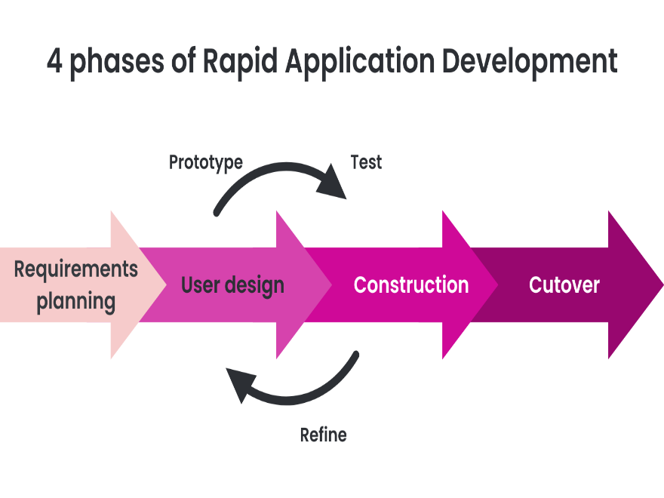
Figure 1. Rapid Application Development Methodology

Phase 1: Requirements planning
This initial phase defines the project's vision. It involves understanding the main problems, identifying key features for the LGU of San Enrique and applicants, and outlining a development roadmap.
Phase 2: User design
Features are designed in detail, including system parts, user roles, database structure, and how data and notifications will work. This phase works closely with the construction phase to create early models of the system.
Phase 3: Construction
The system components are coded and built, including backend logic, frontend interfaces, database setup, and necessary tools like SMS. As illustrated in Figure 1, this phase involves a continuous loop with User Design where the system is continuously prototyped, tested, and refined based on user and LGU staff feedback until it meets all requirements.
Phase 4: Cutover
After the iterative refinement cycle is complete, the Automated Scholarship Records Management System is prepared for final release. This involves final testing, data migration, training LGU staff, and making the live system accessible to applicants.

b. Flow of the Study The development of the Automated Scholarship Records Management System for the LGU of San Enrique, Negros Occidental, will primarily be based on the Input-Process-Output (IPO) model, providing a clear framework for the project's progression from initial requirements gathering to the final system deployment and evaluation.
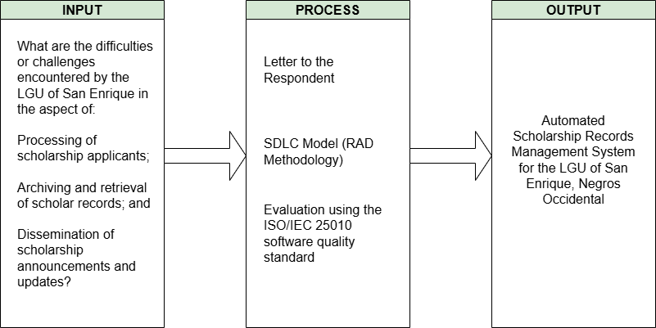
Figure 2. Flow of the Study

c. Functional and Non-Functional Requirements
c.1. Software Requirements Table 2 shows the software requirements in the development of the system. It specified the version of the software used in the development. Table 1. Software Requirements
Software | Version
Visual Studio Code | 1.100.2
XAMPP | 8.2.12
Google Chrome | 137.0.7151.41
PHP | 8.2.12
Composer | 2.8.8
Bootstrap | 5.3.6
Textbee SMS API

c.2. Hardware Requirements The following table outlines the minimum and recommended hardware specifications necessary for the development, deployment, and optimal operation of the Automated Scholarship Records Management System. These specifications ensure that the system can perform efficiently and reliably.
Table 2. Hardware Requirements
Device | Specifications
Central Processing Unit (CPU) | Intel Core i5 8th Gen
Monitor | 13” 1920x1080 Resolution
Keyboard | Standard Keyboard
Mouse | Standard Mouse
Solid State Drive (SSD) | 256 GB
RAM | 16 GB

c.3. System Flowchart
The system flowchart illustrates how data is inputted, processed, and outputted, detailing the various steps and decision points involved in the system's operation. Figure 3 depicts the overall system workflow.
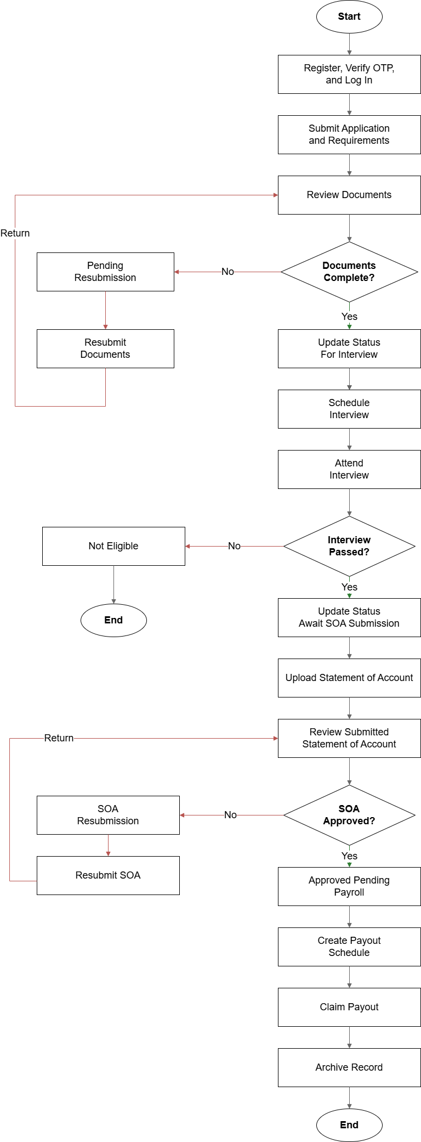
Figure 3. System Flowchart

c.4. System Architecture
Figure 6 details the architectural design of the Automated Scholarship Records Management System. It describes the high-level structure, key components, and their interrelationships, outlining how they work together to deliver the system's functionalities and meet the project objectives. The architecture is designed to ensure efficiency, scalability, and maintainability.

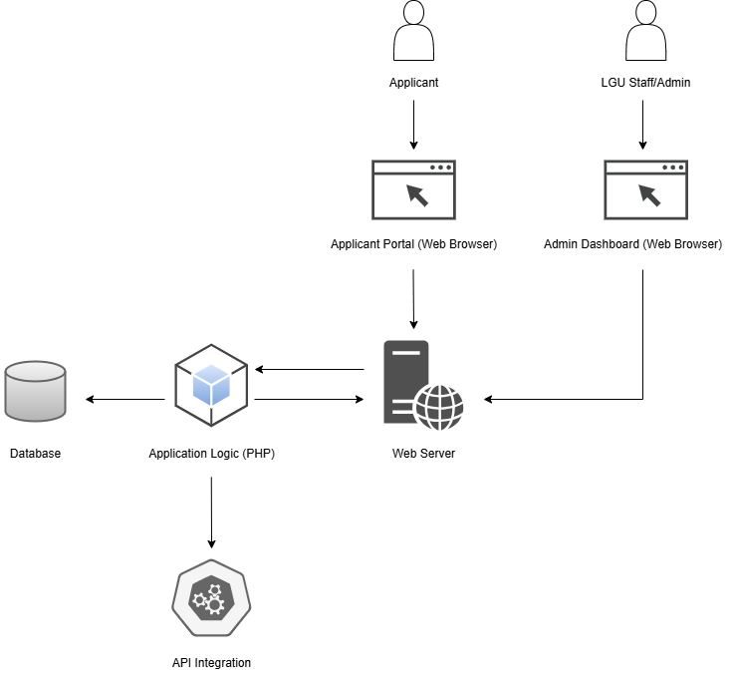
Figure 4. System Architecture
c.6. Context Diagram
The Context Diagram, presented in Figure 7, illustrates the boundary and scope of the Automated Scholarship Records Management System. It provides a high-level overview of the system as a single process, identifying the external entities that interact with it and the primary data flows between the system and these entities.

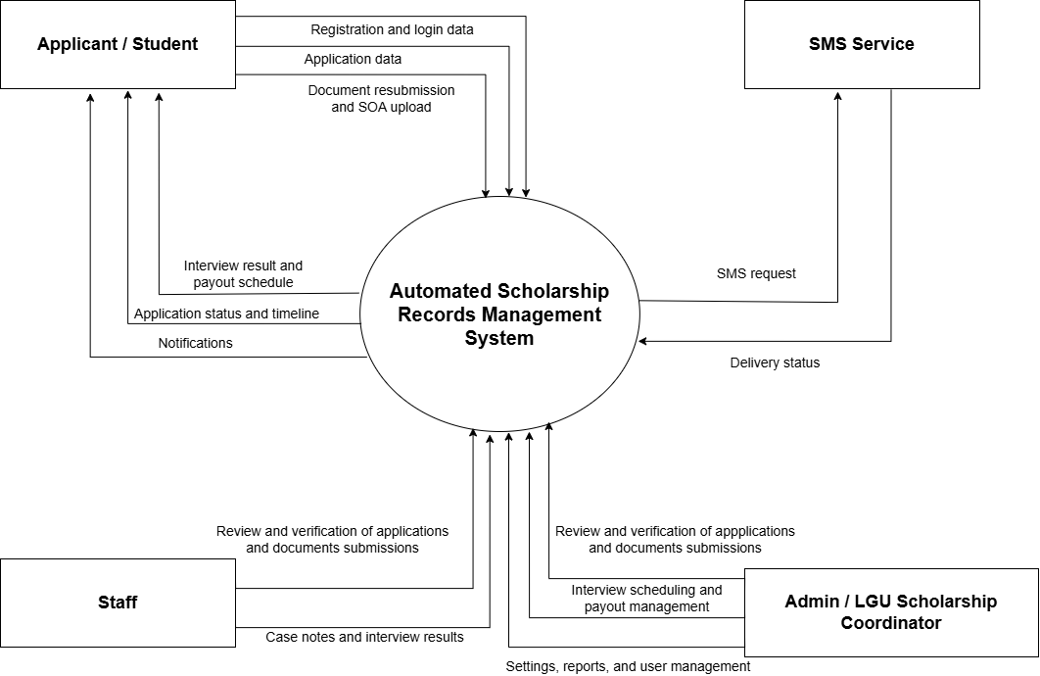
Figure 5. Context Diagram

c.7. Data Flow Diagram
The Level 1 Data Flow Diagram, shown in Figure 6, illustrates the main processes within the Automated Scholarship Records Management System and how data moves between these processes, data stores, and external entities.
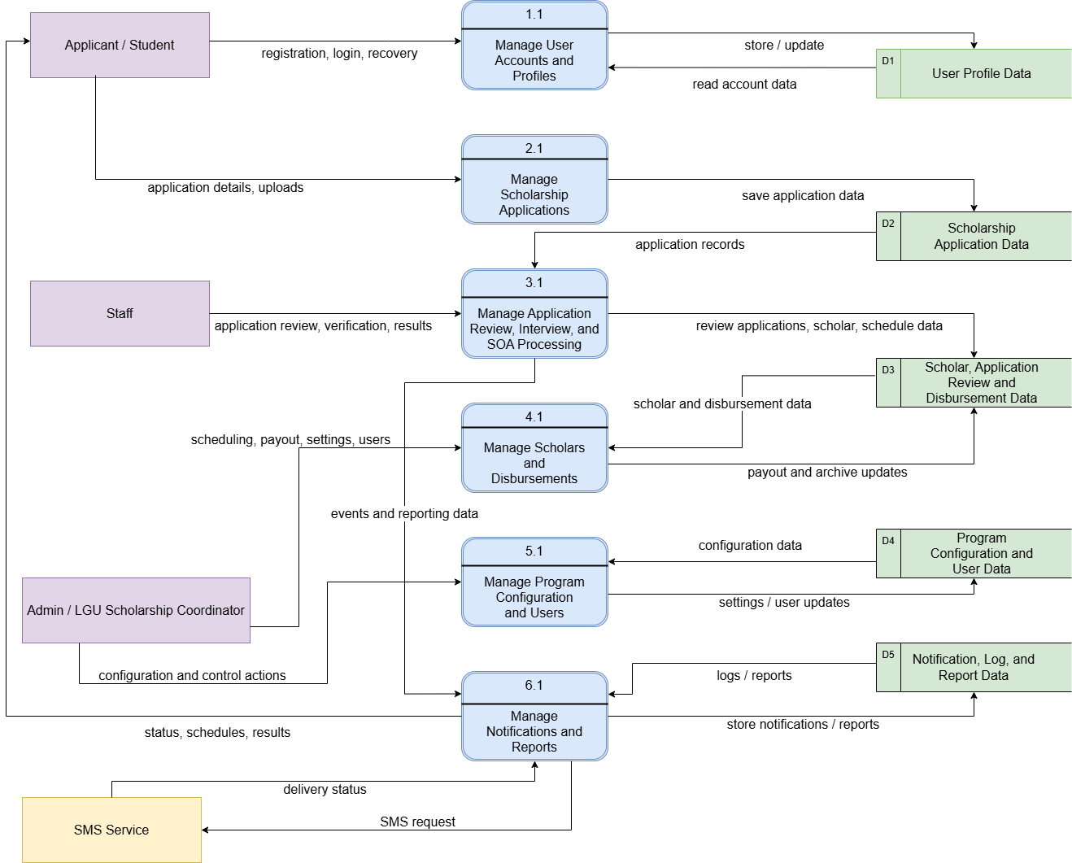
Figure 6. Data Flow Diagram

c.8. Entity Relationship Diagram (ERD)
A well-structured database is fundamental to the functionality and efficiency of the proposed Automated Scholarship Records Management System. To model the data requirements and relationships effectively, an Entity Relationship Diagram (ERD) was developed. Each entity represents a table in the database, containing specific attributes that store relevant information. The relationships between entities are depicted using Crow's Foot notation.
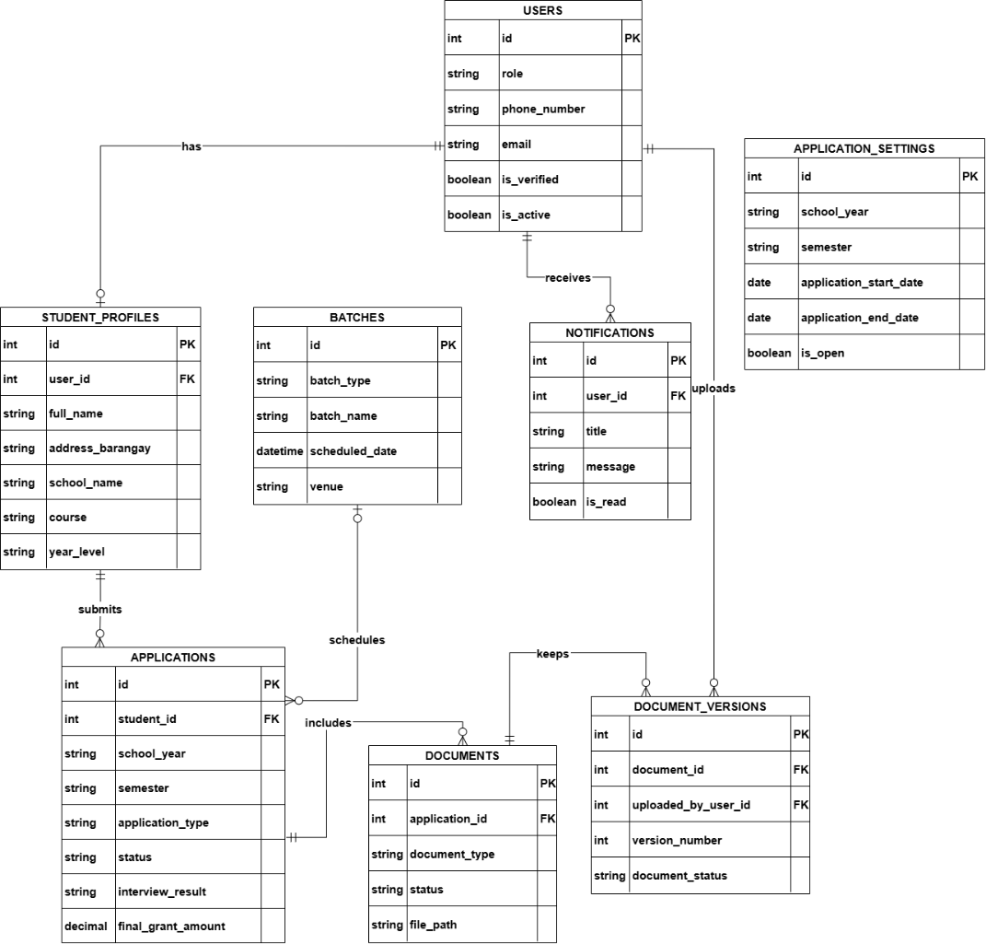
Figure 7. Entity Relationship Diagram
c.9. Use Case Diagram
Figure 10 displays the Use Case Diagram for the Automated Scholarship Records Management System, showing how different users will interact with the system and its core features.
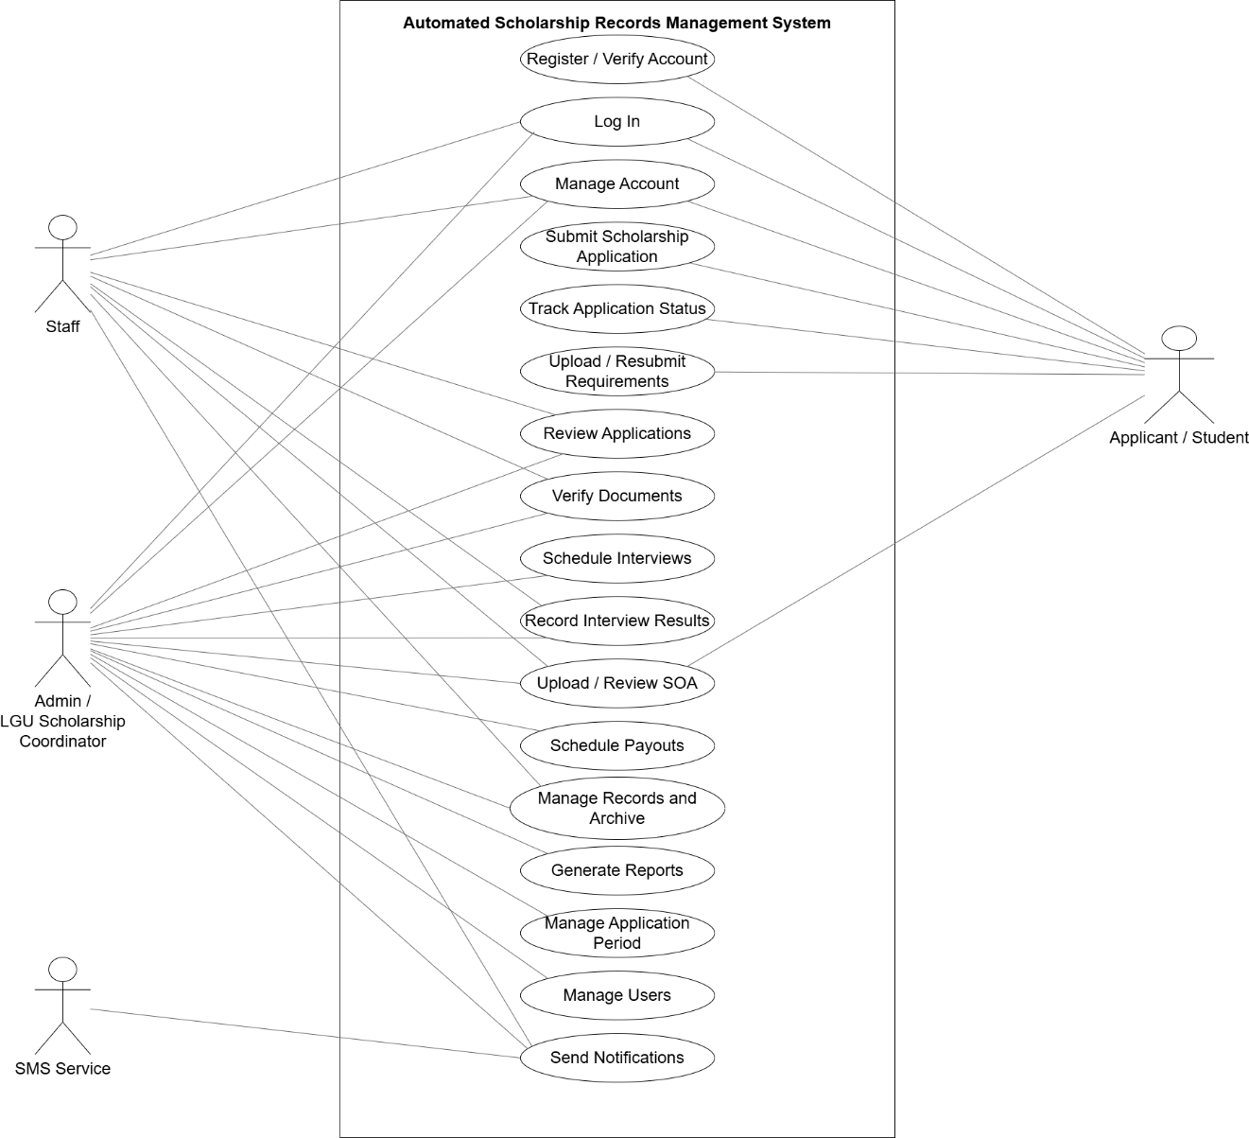
Figure 8. Use Case Diagram
d. Respondents The respondents for this study are primarily the scholarship applicants and the LGU staffs for the scholarship program of the LGU of San Enrique, Negros Occidental, which are the beneficiaries and users of the proposed system.
Table 3. Distribution of Respondents
Respondents | Frequency | Percentage
Scholarship Applicants | 20 | 80.00
LGU Staffs | 5 | 20.00
Total | 25 | 100.00

e. Environment
The study for the Automated Scholarship Records Management System was primarily conducted within the context of the Local Government Unit (LGU) of San Enrique, Negros Occidental. This encompasses the administrative offices and operational environment where the existing manual scholarship program is currently managed.
The specific environment of the study focuses on the LGU office in San Enrique, Negros Occidental, where the scholarship program's official announcements, scholar information management, and physical document submissions currently take place. The research aims to understand and address the challenges inherent in this manual operational environment, such as time-consuming manual data entry, inefficient physical record-keeping, and communication issues due to reliance on social media and multiple in-person trips for applicants.
The development and proposed implementation of the Automated Scholarship Records Management System are designed to directly enhance the efficiency and transparency within this LGU environment, transitioning from traditional methods to a modern, centralized digital platform. This includes streamlining processes for LGU staff in managing applications, documents, and scholars, and improving convenience for scholarship applicants.
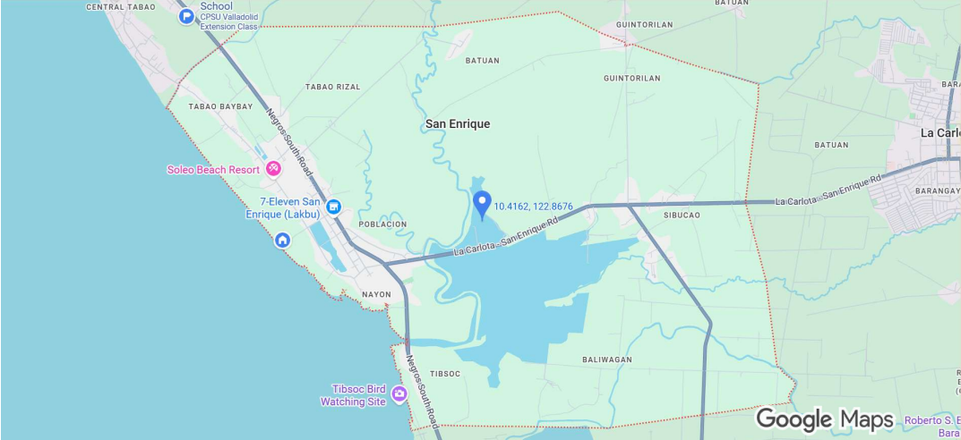
Figure 9. Environment of the Study

f. Instrument
Two standard instruments based on ISO 25010 software Quality Evaluation Survey were administered to the end-users (scholar applicants and LGU staff) and IT experts. Both instruments were divided into three (3) parts. The first part collected basic demographic information relevant to the study, such as the respondent's role (LGU Staff, Student/Scholar Applicant). Personal identification like names and age will be optional to ensure anonymity and encourage candid responses. The second part included the software quality evaluation to assess various aspects of the Automated Scholarship Records Management System. The third part included the feedback and suggestions. Both survey questionnaires were structured using the 4-point Likert Scale. The Scale was used to validate the functional suitability, performance efficiency, compatibility, usability, reliability, security, maintainability, and portability of the system.

Table 4: Scale for End-Users
Scale | Functional Stability | Performance Efficiency | Usability
3.25-4.00 | Very Functional | Very Efficient | Very Usable
2.50-3.24 | Functional | Efficient | Usable
1.75-2.49 | Moderately Functional | Moderately Efficient | Moderately Usable
1.00-1.74 | Poorly Functional | Poorly Efficient | Poorly Usable

Table 5. Scale for IT Experts
Scale | Functional Stability | Performance Efficiency | Compatibility
3.25-4.00 | Very Functional | Very Efficient | Very Compatible
2.50-3.24 | Functional | Efficient | Compatible
1.75-2.49 | Moderately Functional | Moderately Efficient | Moderately Compatible
1.00-1.74 | Poorly Functional | Poorly Efficient | Poorly Compatible
Table 6. Scale for IT Experts
Scale | Usability | Reliability | Security
3.25-4.00 | Very Usable | Very Reliable | Very Secure
2.50-3.24 | Usable | Reliable | Secure
1.75-2.49 | Moderately Usable | Moderately Reliable | Moderately Secure
1.00-1.74 | Poorly Usable | Poorly Reliable | Poorly Secure
Table 7. Scale for IT Experts
Scale | Maintainability | Portability
3.25-4.00 | Very Maintainable | Very Portable
2.50-3.24 | Maintainable | Portable
1.75-2.49 | Moderately Maintainable | Moderately Portable
1.00-1.74 | Poorly Maintainable | Poorly Portable

g. Data Gathering Procedures
The researchers will gather primary data by first submitting a formal letter to the LGU of San Enrique to request permission and seek approval for conducting the study. Upon approval, LGU staff involved in the scholarship program and scholarship applicants will be identified and selected as respondents. Throughout the process, ethical conduct will be paramount, ensuring informed consent is secured from all participants, and maintaining the confidentiality and anonymity of their responses. The survey questionnaires and interview guides will then be finalized and, if feasible, pilot-tested to ensure clarity and relevance. Before the evaluation phase, respondents will be oriented with and allowed to interact with the Automated Scholarship Records Management System. Subsequently, questionnaires will be administered to the LGU staff and applicants to gather quantitative data on system usability and effectiveness. To obtain in-depth qualitative feedback on the Automated Scholarship Records Management System, structured interviews will be conducted with selected LGU staff and applicants. Finally, all collected survey responses will be tallied, and interview data will be organized for thorough analysis. These procedures are designed to collect comprehensive and reliable data to effectively evaluate the Automated Scholarship Records Management System.

h. Statistical Treatment of Data
The following statistical prescription was used in the treatment of data gathered from the respondents. The data was evaluated using weighted mean using the formula below adapted from Likert Scale.
The following statistical prescription was used in the treatment of data gathered from the respondents. The data was evaluated using weighted mean using the formula below adapted from Likert Scale.

W𝑀=(𝑓4∗4)+(𝑓3∗3)+(𝑓2 ∗2)+(𝑓1∗1)
N
Where,
WM = weighted mean
f = frequency
N = population

CHAPTER IV
RESULTS, CONCLUSION & RECOMMENDATIONS

This chapter presents the results, discussion, conclusions, and recommendations of the study entitled Automated Scholarship Records Management System for the LGU of San Enrique, Negros Occidental. It discusses the findings of the study based on the data gathered, analyzed, and interpreted in relation to the objectives, respondents, and evaluation framework of the study. The system was assessed by scholarship applicants and LGU staff as end users, while the technical soundness and functionality of the system was evaluated by IT experts.

a. Results and Discussions
This section presents the evaluation results of the Automated Scholarship Records Management System based on feedback collected from end-users and IT experts. The assessment involved the use of two structured survey instruments based on the ISO 25010 quality model to assess user-specific experience. Both questionnaires utilized a 4-point Likert scale, where 4 indicated the highest level of agreement or satisfaction.

Indicator | IT Expert Mean | Verbal Description | Interpretation
1. Functional Stability | 3.8000 | Strongly Agree | Excellent
2. Performance Efficiency | 3.8000 | Strongly Agree | Excellent
3. Compatibility | 3.8000 | Strongly Agree | Excellent
4. Usability | 3.7333 | Strongly Agree | Excellent
5. Reliability | 3.6500 | Strongly Agree | Excellent
6. Security | 3.7600 | Strongly Agree | Excellent
7. Maintainability | 3.8000 | Strongly Agree | Excellent
8. Portability | 3.8667 | Strongly Agree | Excellent

Indicator | End-user Mean | Verbal Description | Interpretation
1. Functional Suitability | 3.8333 | Strongly Agree | Excellent
2. Performance Efficiency | 3.7500 | Strongly Agree | Excellent
3. Usability | 3.7667 | Strongly Agree | Excellent

Indicator | Overall Mean | Verbal Description | Interpretation
IT Experts | 3.7763 | Strongly Agree | Excellent
End-users | 3.7833 | Strongly Agree | Excellent
Total Mean | 3.7798 | Strongly Agree | Excellent

The evaluation results given by the IT experts show that the Automated Scholarship Records Management System performed very well in all eight ISO 25010 software quality characteristics. Functional Suitability, Performance Efficiency, Compatibility, and Maintainability each obtained a mean of 3.8000, while Usability obtained 3.7333, Reliability obtained 3.6500, Security obtained 3.7600, and Portability obtained the highest mean of 3.8667. The overall mean for IT experts was 3.7763, verbally described as Strongly Agree and interpreted as Excellent. These results indicate that the system was able to meet the required technical and functional expectations of the evaluators. The findings suggest that the system is capable of supporting scholarship operations in a dependable, secure, and usable manner.
These findings are similar to the study of Casimiro et al. (2026), who found that information quality, system quality, and service quality positively influenced user satisfaction and net system benefits in a scholarship application information system. In the same way, Dizon et al. (2025) reported high evaluation results for their scholarship monitoring system with data analytics, showing that web-based scholarship systems can perform well when they are designed to improve efficiency, transparency, and information management. The strong ratings given by the IT experts in the present study show that the developed system possesses the software quality characteristics needed for actual implementation.
The evaluation results given by the end-users also show a very favorable assessment of the system. Functional Suitability obtained a mean of 3.8333, Performance Efficiency obtained 3.7500, and Usability obtained 3.7667. The overall mean for end-users was 3.7833, verbally described as Strongly Agree and interpreted as Excellent. These results indicate that the respondents found the system easy to use, useful in performing scholarship-related tasks, and effective in improving the management of records and applications. The high rating in Functional Suitability suggests that the users believed the system was able to perform the tasks expected from it, while the high rating in Performance Efficiency indicates that the system responded well and helped reduce delays in scholarship processing. The result for Usability further shows that the users were able to understand and operate the system with convenience.
This result is consistent with the study of Bagaporo and Espinosa (2025), whose online scholarship management system improved efficiency, information management, control, and service delivery through centralized digital processes. It is also similar to the findings of Ablen et al. (2025), who reported that a scholarship management and tracking system helped address delayed processing, inaccurate recordkeeping, and weak communication among scholarship stakeholders. In the same manner, Samillano et al. (2025) found that the LYDO Scholarship Management System improved the accuracy, efficiency, and organization of scholarship processing while reducing staff workload and helping applicants stay informed of important updates. The positive assessment of the end-users in the present study shows that the system was able to provide practical benefits to both scholarship applicants and LGU staff.
The total mean of the system evaluation was 3.7798, which was verbally described as Strongly Agree and interpreted as Excellent. This indicates that both IT experts and end-users had a consistently positive evaluation of the Automated Scholarship Records Management System. The closeness of the IT expert mean and end-user mean further suggests that the system was able to satisfy both technical standards and actual user needs. This result shows that the system is not only technically acceptable, but also useful and responsive in the context where it will be applied. Since the system obtained excellent evaluation ratings from both technical experts and actual users, it can be said that the developed system successfully addressed the need for a more organized, efficient, and user-friendly scholarship records management platform.
Overall, the results of the study show that the Automated Scholarship Records Management System is highly acceptable in terms of both software quality and user experience. The system was able to meet the functional and operational needs of scholarship applicants and LGU staff while also satisfying technical evaluation standards. The results further show that a centralized and automated scholarship system can improve records organization, tracking, communication, and administrative efficiency. These findings support the implementation of the system in the LGU of San Enrique, Negros Occidental as a practical tool for improving scholarship operations.
b. Implementation Plan
To ensure the successful adoption of the Automated Scholarship Records Management System for the LGU of San Enrique, Negros Occidental, the researchers plan to conduct a structured implementation process. This process will begin with an orientation and hands-on training session for the intended users of the system, particularly the scholarship staff, coordinators, and authorized LGU personnel. The training will cover user account access, applicant record management, document monitoring, interview scheduling, status updating, notification handling, and basic troubleshooting procedures. User guides and instructional materials will also be provided to help users become familiar with the system’s functions and navigation.
The researchers plan to implement the system through a phased roll-out approach. In the initial phase, the system will be deployed for pilot use within the scholarship office to allow selected staff and coordinators to test its core functions, such as applicant registration, application review, document tracking, and SMS-based notification delivery. Feedback gathered during this phase will be used to identify necessary adjustments and improvements before full implementation. After successful pilot testing, the system will be fully deployed for regular use in managing scholarship applications and records within the LGU. Throughout the rollout period, the researchers will provide technical assistance to address user concerns and ensure smooth operation.
Upon full implementation, the researchers will establish a maintenance and monitoring plan to sustain the performance and reliability of the system. This will include routine database backup, system updates, correction of identified errors, and continuous monitoring of usability and functionality. A designated system administrator or authorized LGU personnel will oversee the regular operation of the system, including user account management, record monitoring, and coordination of technical concerns. Through this implementation plan, the researchers aim to ensure that the system will be effectively adopted and maintained as a reliable tool for scholarship records management in the LGU of San Enrique.

c. Gantt chart
PARTICULARS
 | QUARTER 1 |  |  |  |  | QUARTER 2 |  |  |  |  |  | QUARTER 3 |  |  |  |  |  | QUARTER 4
 | JAN | FEB |  | MAR |  | APR |  | MAY |  |  | JUN | JUL |  | AUG |  | SEP |  | OCT |  | NOV |  | DEC
TITLE HEARING

PLANNING

CONDUCT AN INTERVIEW

SYSTEM DEVELOPMENT

PRE-ORAL

REVISION

CHAPTER I
INTRODUCTION

PROBLEM STATEMENT

OBJECTIVES

SIGNIFICANCE OF THE STUDY

SCOPE AND LIMITATIONS

DEFINITION OF TERMS

CHAPTER II

REVIEW OF RELATED LITERATURE
REVIEW OF RELATED SYSTEMS
CHAPTER III

DESIGN METHOD

FLOW OF THE STUDY

FUNCTIONAL AND NON-FUNCTIONAL REQUIREMENTS
RESPONDENTS

ENVIRONMENT

INSTRUMENT

DATA GATHERING PROCEDURES
STATISTICAL STATEMENT OF DATA
CHAPTER IV

IMPLEMENTATION PLAN

BUDGET
RECOMMENDATION

TESTING AND EVALUATION
FINDINGS

CONCLUSION

RECOMMENDATION

REFERENCES

APPENDICES

d. Budget Recommendation
PARTICULARS | SPECIFICATION |  | QUANTITY | COST/UNIT  (Php) |  | TOTAL  (Php)
Hardware:
Desktop | Intel i5 8th Gen |  | 1 | 12,000 |  | 12,000
Solid State Drive | 256 GB M.2 NVME |  | 1 | 3,600 |  | 3,600
Random Access Memory | 16 GB DDR4 |  | 1 | 9,000 |  | 9,000
Subtotal: |  |  |  |  |  | 24,600
Software:
Visual Studio code | Version 1.113.0 |  | 1 | 0 |  | 0
Browser | Latest Build |  | 1 | 0 |  | 0
XAMPP Server | v3.3.0 |  | 1 | 0 |  | 0
PHP | 8.2 |  | 1 | 0 |  | 0
Textbee SMS API |  |  | 1 | 600 |  | 600
Subtotal: |  |  |  |  |  | 600
Grandtotal: |  |  |  |  |  | 25,200
Peopleware |  | QUALIFICATION |  |  | MONTHLY SALARY (Php)
Programmer |  | Entry-Level |  |  | 20,000

e. Testing and Evaluation
e.1. Testing
The Automated Scholarship Records Management System was tested to determine whether it performs according to its intended functions and requirements. The testing process focused on verifying the accuracy, reliability, usability, and security of the system in handling scholarship-related transactions. Specifically, the researchers examined whether the system could properly manage applicant registration, login with OTP verification, scholarship application submission, document uploading, status monitoring, announcement posting, notification delivery, interview scheduling, and record management.
The researchers conducted testing in several stages. First, individual modules of the system were checked to confirm that each feature worked correctly on its own. These included user authentication, applicant profile management, application processing, document handling, and notification functions. Second, integration testing was performed to ensure that related modules worked properly when used together. For example, the researchers verified whether applicant registration correctly connected to profile creation, whether uploaded documents were linked to the correct application records, and whether status updates triggered the proper notifications. Lastly, overall system testing was carried out to assess the performance of the entire system in a simulated real-use environment.
In addition, usability testing was conducted to determine whether the system was easy to understand and operate for its intended users, particularly scholarship applicants, staff, and coordinators. The researchers observed how users navigated the system, completed tasks, and interpreted the interface. Minor issues such as confusing labels, navigation difficulties, or unclear instructions were noted for improvement. Security and access control were also checked to ensure that only authorized users could access restricted features and sensitive scholarship records.
Through this testing process, the researchers were able to identify errors, validate system functions, and confirm whether the proposed system was ready for implementation. The results of the testing served as the basis for refining the system and ensuring that it could provide dependable support for the scholarship operations of the LGU of San Enrique, Negros Occidental.

e.2. Evaluation
The Automated Scholarship Records Management System was evaluated to determine whether it met the intended functional and non-functional requirements of the study. The evaluation focused on the system’s ability to provide an organized, efficient, accurate, and user-friendly platform for managing scholarship applications and records in the LGU of San Enrique, Negros Occidental. It also examined whether the system could support the needs of its intended users, particularly scholarship applicants, LGU staff, and scholarship coordinators.
The evaluation was based on how well the system performed its major functions, including applicant registration, OTP-based login verification, scholarship application processing, document uploading and monitoring, interview scheduling, notification delivery, status tracking, and scholarship record management. The researchers also considered the system’s usability, reliability, security, and overall responsiveness during actual use and simulated operations. These aspects were assessed to determine whether the system could consistently support scholarship-related tasks with minimal errors and acceptable performance.
In addition, the evaluation examined the effectiveness of the system in reducing the difficulties commonly experienced in manual scholarship processing, such as delayed record retrieval, disorganized files, repetitive encoding, and slow dissemination of updates. Through the evaluation process, the researchers were able to determine whether the system could improve workflow efficiency, support better data organization, and provide a more convenient experience for both applicants and administrators.
The results of the evaluation served as the basis for identifying the strengths and limitations of the system. They also helped determine whether the proposed system was acceptable and suitable for implementation in the scholarship operations of the LGU of San Enrique. Overall, the evaluation provided evidence that the system can serve as a practical and reliable tool for improving scholarship records management.

f. Findings
The following are the key findings of the study based on the testing and evaluation of the Automated Scholarship Records Management System for the LGU of San Enrique, Negros Occidental.
The system was found capable of performing its intended core functions. These include applicant registration, OTP-based verification, scholarship application submission, document uploading, application status monitoring, interview scheduling, announcement posting, notification delivery, and scholar record management. During system testing, these functions operated according to the intended workflow of the scholarship process and were able to support both applicant-side and administrator-side transactions.
In terms of record organization, the system was found to provide a more structured and centralized method of storing scholarship-related information. Applicant personal details, educational background, submitted requirements, application progress, and scholarship records were stored in a single database environment, making retrieval and monitoring more efficient compared to the previous manual process. This finding indicates that the system can help reduce the problem of scattered records and repetitive manual encoding.
The findings also showed that the application monitoring feature improved the tracking of applicants throughout the scholarship process. By using defined status levels such as Submitted, Initial Review, Pending Resubmission, For Interview, Eligible Awaiting SOA, Approved Pending Payroll, and Approved Finished, the system enabled staff to clearly determine the current standing of each applicant. This made monitoring more systematic and reduced confusion in identifying incomplete, pending, or completed applications.
Another important finding of the study was the effectiveness of the document management feature. The system was able to link uploaded files, such as grades, barangay residency, and statement of account, to the appropriate application records. It was also found that the document status and versioning functions supported better monitoring of pending, verified, rejected, and resubmitted requirements. This helped improve document tracking and reduced the difficulty of reviewing scholarship requirements using purely manual procedures.
In terms of communication, the system was found to improve the dissemination of scholarship-related updates. Through OTP verification, in-system notifications, announcement posting, and SMS-based alerts, applicants were provided with more direct access to important information such as application updates, interview schedules, and other notices. This finding suggests that the system can lessen reliance on delayed or inconsistent manual announcement practices.
The study further found that the role-based access of the system supported better security and control over scholarship records. The distinction between student, staff, and administrator accounts ensured that access to sensitive information and administrative functions was limited to authorized users only. The inclusion of audit logs, case notes, and notification records also strengthened accountability in system usage and transaction monitoring.
Overall, the findings of the study showed that the Automated Scholarship Records Management System is capable of improving the scholarship management process of the LGU of San Enrique, Negros Occidental. The system addressed major issues related to record organization, application monitoring, document tracking, and communication. Although it does not replace manual procedures such as physical document verification, accounting review, and actual fund release, it was found to be a functional and reliable support system for scholarship records management.

Conclusions
Based on the findings of the study, it is concluded that the Automated Scholarship Records Management System can effectively support the scholarship operations of the LGU of San Enrique, Negros Occidental in a more organized, efficient, and systematic way. The system successfully carried out its intended functions, particularly in applicant registration, OTP-based verification, scholarship application processing, document uploading and monitoring, interview scheduling, notification delivery, and scholarship record management.
The study also concludes that the system was able to address several challenges found in the existing manual process. By centralizing applicant records, application details, document submissions, and status tracking, the system improved the organization and accessibility of scholarship-related information. It also created a clearer and more manageable workflow for monitoring applicants through the various stages of scholarship processing.
In addition, the study concludes that the inclusion of features such as document status monitoring, version tracking, announcements, SMS notifications, role-based access, case notes, and audit logs strengthened the system’s functionality and reliability. These features helped improve communication, accountability, and control in managing scholarship transactions and records.
However, it is also concluded that the system mainly serves as a support tool for scholarship records management and does not replace manual and government-required procedures such as physical document verification, accounting review, final approval, and the actual release of scholarship funds. Despite these limitations, the developed system was found to be a practical and dependable solution that can greatly improve the scholarship management process of the LGU.
Overall, the researchers conclude that the Automated Scholarship Records Management System is an acceptable and effective solution for managing scholarship records and related processes in the LGU of San Enrique, Negros Occidental. Its implementation can help improve efficiency, strengthen record organization, and support more effective communication between the LGU and scholarship applicants.

Recommendations
Based on the study’s findings and conclusions, the following recommendations are presented.
The Local Government Unit (LGU) of San Enrique, Negros Occidental is encouraged to adopt the Automated Scholarship Records Management System as a support tool for handling scholarship applications, applicant information, document submissions, notifications, and other related transactions. Using the system may improve the efficiency, organization, and accessibility of scholarship operations compared to the current manual process.
It is also recommended that authorized LGU personnel, especially scholarship staff and coordinators, receive proper training before the system is fully implemented. Sufficient orientation and hands-on practice may help users better understand the system’s functions and reduce errors in data entry, status updates, and records management.
In addition, regular system maintenance and monitoring should be carried out after implementation. This should include periodic database backups, checking system performance, reviewing user access, and addressing any technical issues that may occur during actual use. Continuous monitoring may help maintain the system’s reliability, security, and long-term functionality.
The researchers further recommend the continued use of physical verification and government-required procedures alongside the digital system, particularly for official document validation, accounting review, auditing, final approval, and scholarship fund release. Since these processes are still beyond the scope of the developed application, proper coordination between manual and digital procedures remains important.
Lastly, future researchers are encouraged to enhance the system further by adding more advanced features such as online report generation, expanded analytics, automated qualification screening, email notifications, and wider interoperability for use in other local government units. Additional studies may also be conducted to improve the system’s scalability, usability, and overall functionality in similar institutional settings.

REFERENCES

Ablen, R. T., Flores, S. C., Pasturan, M. V. D., & Bertulfo, E. B. (2025). SMART
Scholar: A scholarship management and tracking system. Business, Education, Social Sciences, and Technology, 1(2), 71-76. https://doi.org/10.69478/BEST2025v1n2a011
Abu Bakar, N., Zahibi, M. F. H. M., Marzuki, N. F. N., Hamidon, H., & Afandi, N. A.
(2024). Theoretical framework for improving the records management of retirees in public sector. Journal of Information and Knowledge Management, 15(SI1). https://doi.org/10.24191/jikm.v15iSI1.6139
Al-Ayyubi, M. S. A.-A., & Maulana, B. (2023). Designing a web-based information
system for scholarship management: Supporting access and rapid dissemination of information. Information Technology Engineering Journals (ITEJ), 8(1), 14–33. https://doi.org/10.24235/itej.v8i1.111
Arslantaş, O., Gümüş, M., & Özder, E. H. (2023). Scholarship recipient selection
for higher education with AHP, SAW and TOPSIS. Journal of Turkish Operations Management, 7(2), 1685-1700. https://doi.org/10.56554/jtom.1
140823
Bagaporo, M. D. L., & Espinosa, M. L. (2025). Online scholarship management
system for Camarines Sur Polytechnic Colleges. Global Scientific Journal, 13(2), 573-575. https://www.globalscientificjournal.com/researchpaper/ON LINE_SCHOLARSHIP_MANAGEMENT_SYSTEM_FOR_CAMARINES_SUR_POLYTECHNIC_COLLEGES.pdf
Belardo, L. A., & Belardo, S. B. (2023). Library quality management system of a
state university in the Philippines. American Journal of Educational Research, 11(5), 265-272. https://doi.org/10.12691/education-11-5-3
Blancaflor, E., Casenas, P. A. I., Rocamora, L. J. H., Rosete, J. I. Y., & Rey, W.
(2022). APPly: A Design of an Online Tertiary Level Scholarship Application Management System. In 2022 International Communication Engineering and Cloud Computing Conference (CECCC). IEEE. https://doi.org/10.1109/CECCC56460.2022.10069218
Casimiro, J. B., Modelo, J. C. E., & Natividad, R. L. (2026). Empirical evaluation of
a scholarship application information system using the DeLone and McLean I.S. success model. International Journal of Computing Sciences Research, 10, 4142-4160. https://doi.org/10.25147/ijcsr.2017.001.1.263
Commission on Higher Education. (2021, June 24). TES stipends now available to
more than 14,000 ongoing grantees in Davao Region [Press release]. CHED Regional Office XI. https://ro11.ched.gov.ph/2021/06/24/tes-stipends-now-available-to-more-than-14000-ongoing-grantees-in-davao-region/487/press-release/
Daluyon, M. A. O., & Bilog, R. J. (2025). Scholarship management information
system using machine learning models. Business, Education, Social Sciences, and Technology, 1(2). https://doi.org/10.69478/BEST2025v1n2a024
Dizon, C. E., Abogado, J. D., Babaran, C. L., Jr., & Estil, Z. T. (2025). Scholarship
monitoring system with data analytics. The Light Explorer. https://doi.org/10.57180/tmmv1724
Enad, F. & Balicoco, N. (2023). Management Information System of Public
Secondary Schools in Sagbayan District: A Proposed Implementation. Psychology and Education: A Multidisciplinary Journal, 13(1), 1-8. http://dx.doi.org/10.5281/zenodo.8309728
Eslami, Z., Amini, M., & Omran, E. S. (2021). Electronic records management: A
state of the art review. Records Management Journal, 31(1), 74-88. https://doi.org/10.1108/RMJ-09-2019-0059
Fajardo, R. C. A., Yara, F. B., Ardeña, R. F., Hernandez, M. K. L., & Arroyo, J. C.
T. (2024). A data-driven approach in predicting scholarship grants of a local government unit in the Philippines using machine learning. International Journal of Engineering Trends and Technology, 72(6), 74-81. https://doi.org/10.14445/22315381/IJETT-V72I6P108
Falolo, V. M., Capillas, K. T., Vergarra, N. A., & Cerbito, A. F. (2022). Student
registration and records management services towards digitization. International Journal of Educational Management and Development Studies, 3(1), 131-147. https://doi.org/10.53378/352867
Khelifi, A., Ehtesham, H., Al-Mansoori, M., Hasan, A. T., & Tamim, S. B. (2023).
Smart scholarship system. In Studies in systems, decision and control (pp. 821–830). https://doi.org/10.1007/978-3-031-28314-7_70
Li, H., & Yang, Y. (2022). Research on the scholarship management for
international students in China in the post-pandemic era. Journal of Education and Educational Research, 1(1). https://doi.org/10.54097/jeer.v1i1.2668
Mutevere, M., Dzinamarira, T. R., Muzenda, L., Nyoka, S., Chokudinga, V.,
Mugoniwa, T., Moyo, E., Kakumura, F., & Dzinamarira, T. (2024). Empowering underprivileged students beyond financial aid: Insights from a scholarship program's monitoring and evaluation. Evaluation and Program Planning, 105, 102448. https://doi.org/10.1016/j.evalprogplan.2024.102448
Orboc, C. C. (2025). Transforming Academic Administration: Development of a Streamlined Student Information and Grading System for Surigao del Norte College of Agriculture and Technology. International Journal of Research and Innovation in Social Science, IX(I), 5019–5025. https://doi.org/10.47772/ijriss.2025.9010388
Orgianus, Y., Lapalanti, F. R., Tarmizi, H., & Oemar, H. (2024). Optimizing scholarship distribution: a management information system approach. Acta
Logistica, 11(2), 197-209.
Prasetyo, G. A. A., Irmayanti, A., & Setiawan, W. (2025). Sistem informasi
pendaftaran beasiswa berbasis web. Jurnal Ilmiah Teknik Informatika (TEKINFO), 26(1). https://doi.org/10.37817/tekinfo.v26i1.4692
Prijayanti, D., Artha, E. U., & Arumi, E. R. (2020). Web-based monitoring
information system for scholarship holder. In Proceedings of the 1st Borobudur International Symposium on Humanities, Economics and Social Sciences (BIS-HESS 2019). https://doi.org/10.2991/assehr.k.200529.256
Purcia, E., & Velarde, A. B. (2022). Student registration and records management
services of the three private universities in the Philippines: Basis for academic records digitization. American Journal of Multidisciplinary Research and Innovation, 1(4), 1-10. https://doi.org/10.54536/ajmri.v1i4.447
Raya, A. (2021). Penerapan model waterfall pada sistem informasi beasiswa
berbasis web. JURSIMA, 9(1), 82-88. https://doi.org/10.47024/jrs.v9i1.245
Remegio, F. M. C., & Casquejo, M. N. S. (2025). Development of a comprehensive
scholarship and grants management system (SchoGMS) for state universities and colleges. International Journal of Research and Innovation in Social Science, 9(4), 3643-3653. https://doi.org/10.47772/IJRISS.2025.90400261
Salazar-Fernandez, J. P., Munoz-Gama, J., & Sepúlveda, M. (2025). Implications
of losing a need- and merit-based scholarship on the educational trajectory: A curricular analytics approach. Higher Education, 89, 441-464. https://doi.org/10.1007/s10734-024-01230-0
Samillano, S. G. Q., Rabino, M., Arias, J. M., Palmones, L., Cagatan, M., Jimenez,
A., Jr., & Del Rosario, J. (2025). Development of LYDO scholarship management system. International Journal of Engineering Research & Technology, 14(12). https://doi.org/10.17577/IJERTV14IS120406
Secugal, K. a. S., Sermeno, J. P., & Mistio, N. E. (2021). QR-Code tracking and
SMS notification transaction interface for scholarship management system. International Journal of Applied Science and Engineering, 18(4), 1–8. https://doi.org/10.6703/ijase.202106_18(4).004
Sowndhariyaa, T. (2021). Advanced application system for student scholarship
using content based filtering technique. International Journal for Modern Trends in Science and Technology, 7(8), 110-115. https://doi.org/10.46501/IJMTST0708020
Tasrif, E., Saputra, H. K., Kurniadi, D., Hidayat, H., & Mubai, A. (2021). Designing
website-based scholarship management application for teaching of analytical hierarchy process (AHP) in decision support systems (DSS) subjects. International Journal of Interactive Mobile Technologies, 15(9), 179-191. https://doi.org/10.3991/ijim.v15i09.23513
Tsabedze, V. W. (2020). Managing electronic records in higher education
institutions. In Management training programs in higher education for the fourth industrial revolution (pp. 36-61). IGI Global. https://doi.org/10.4018/978-1-7998-1875-5.ch003
Wagan, M. A. A., Briones, J., Baldovino, F. P., & Refozar, R. F. G. (2025). Digital
transformation in the records management of a private higher education institution in the Philippines. International Journal of Marketing and Digital Creative, 3(1), 18-33. https://doi.org/10.31098/ijmadic.v3i1.2878
Wei, L. (2023). Research review on the improvement of scholarships evaluation in
Chinese colleges. Lecture Notes in Education Psychology and Public Media, 26, 71-75. https://doi.org/10.54254/2753-7048/26/20230843
Yang, Y. (2025). The mechanisms and behavioral impacts of university scholarship
systems on undergraduate students. Journal of Sociology and Education, 1(7). https://doi.org/10.63887/jse.2025.1.7.61

APPENDICES

Appendix A. Letter Requests

Appendix B. Sample Input-Output Reports
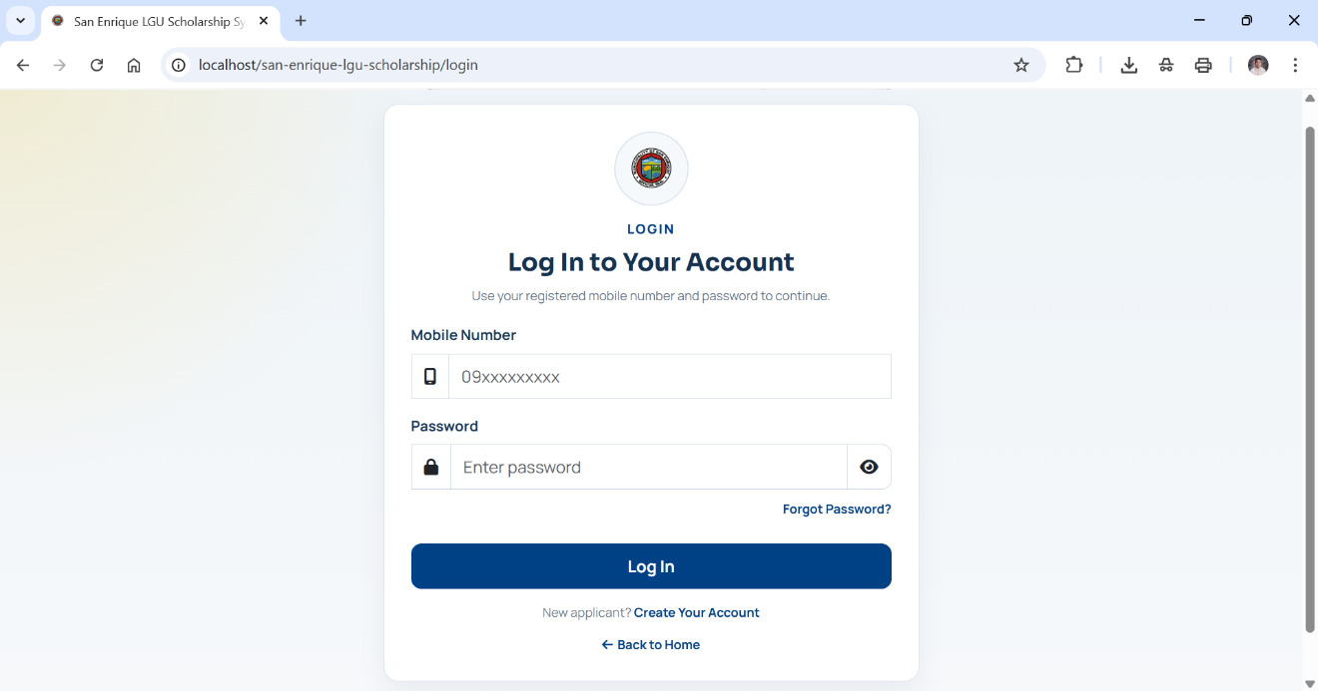
User inputs login details.
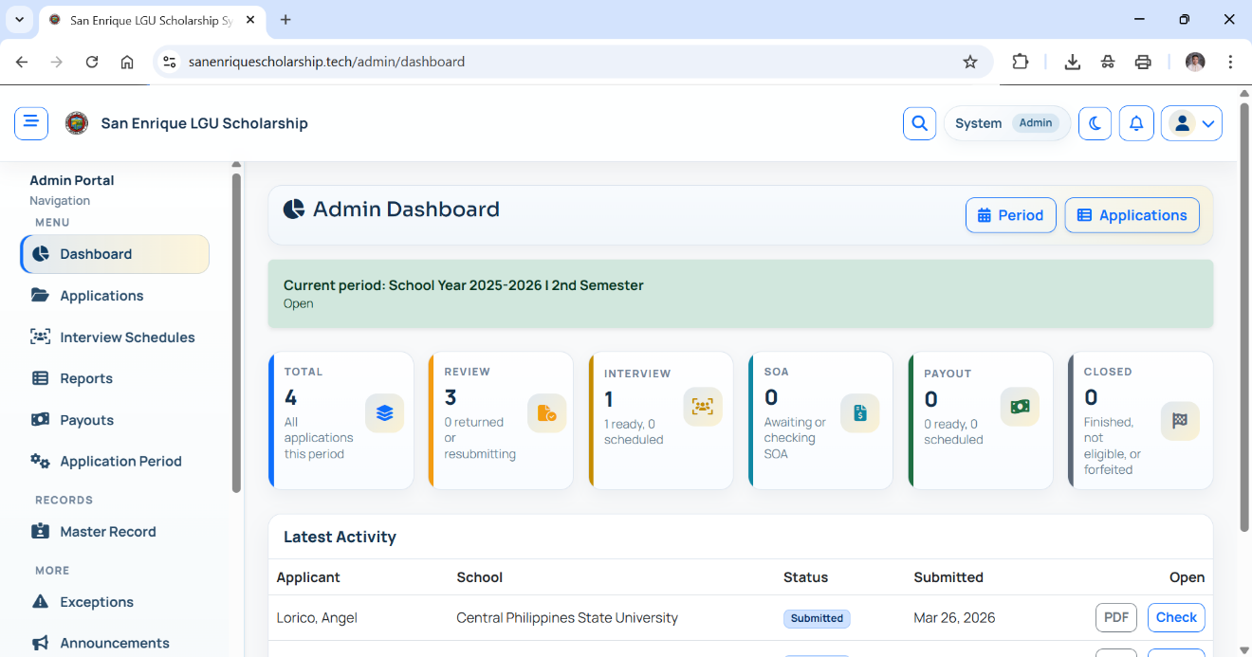
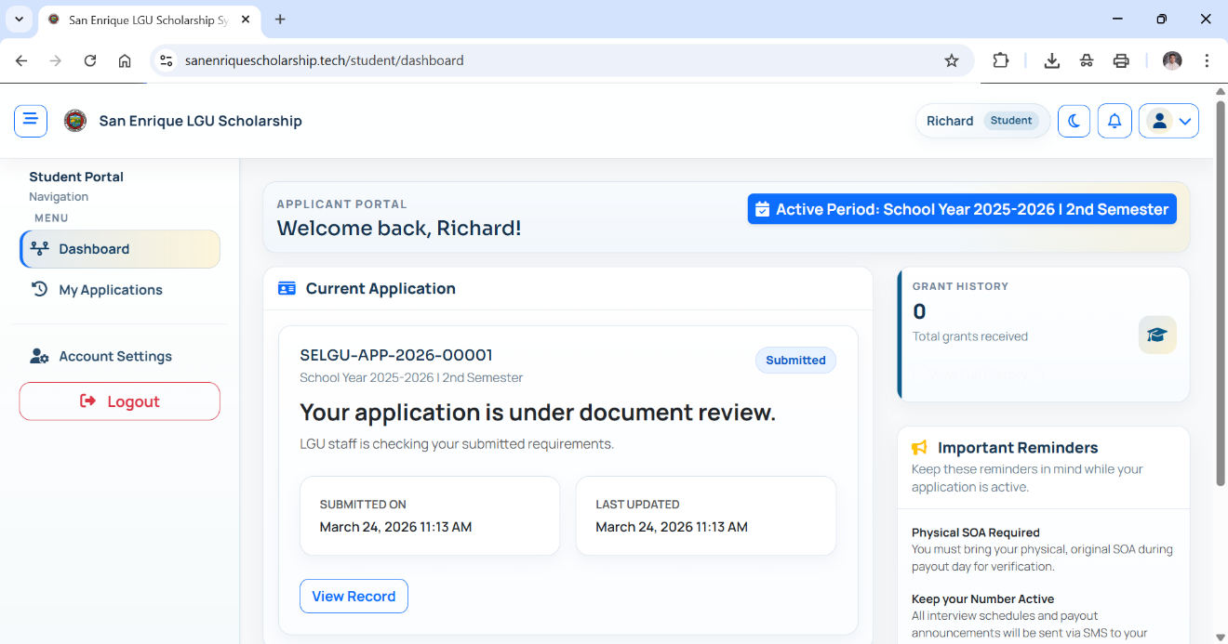
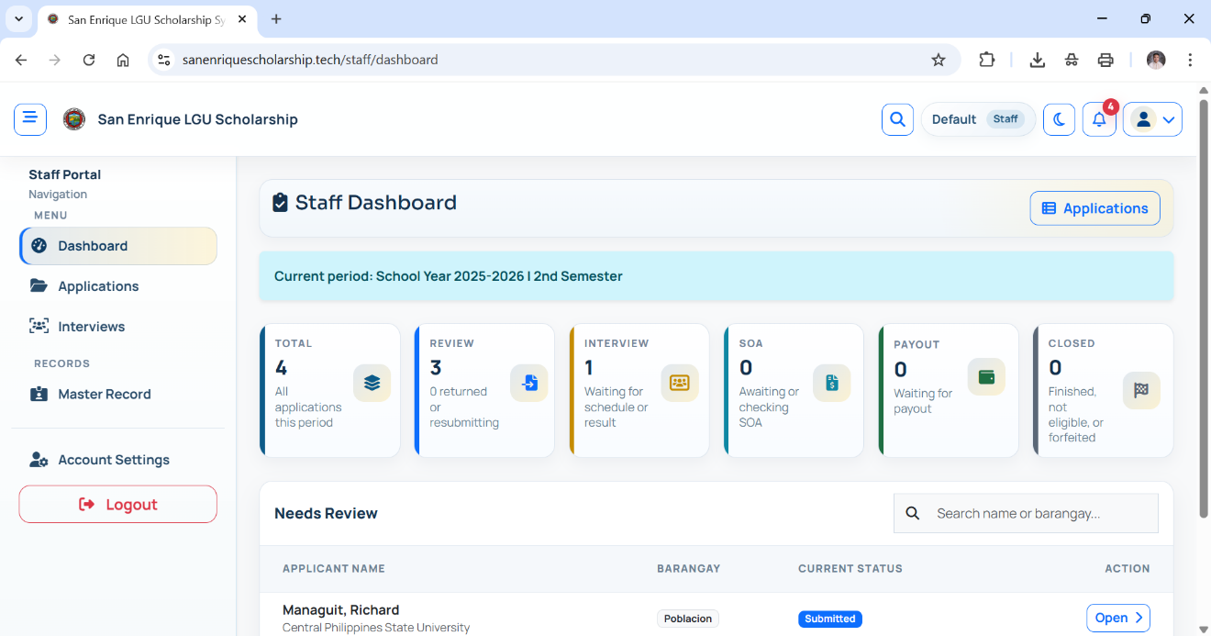
Displays the dashboard based on user role.

Appendix C. Evaluation Tool
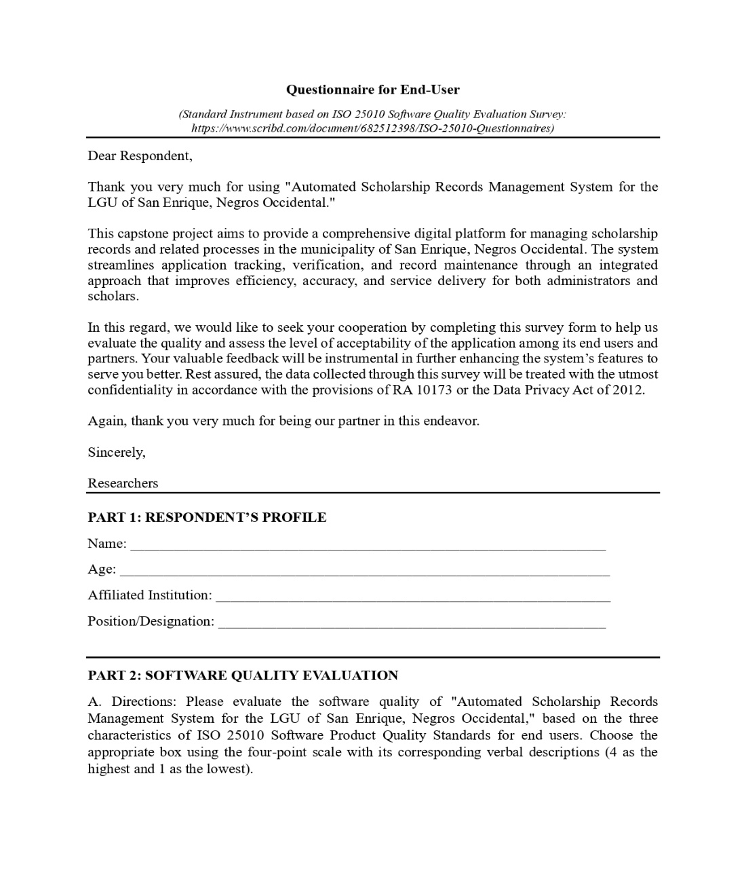
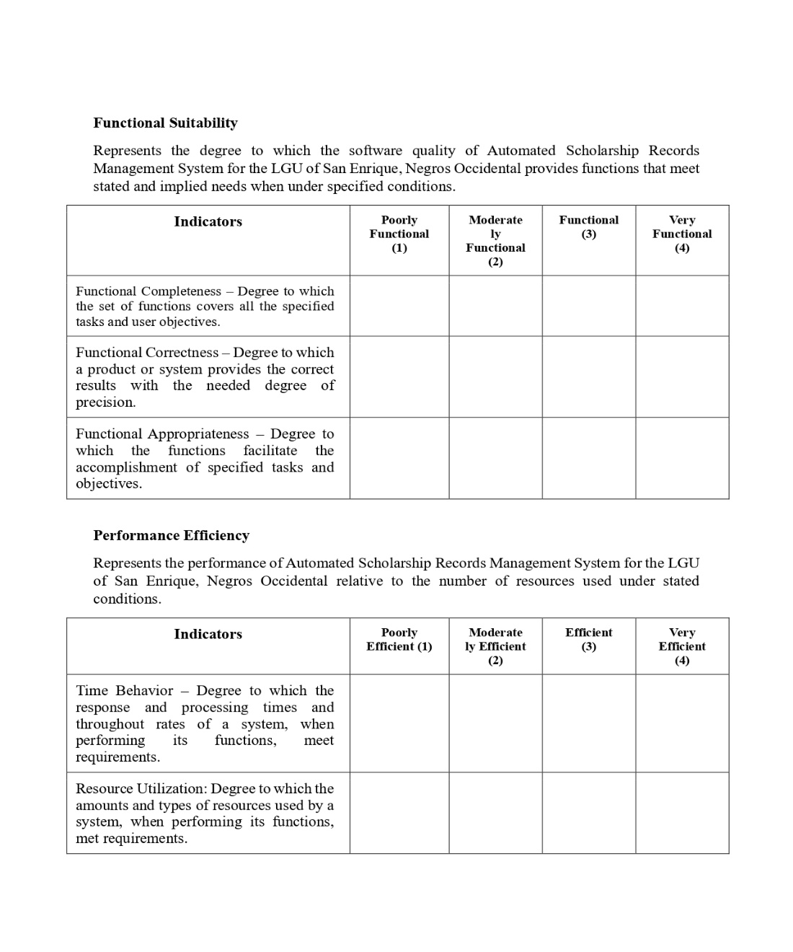
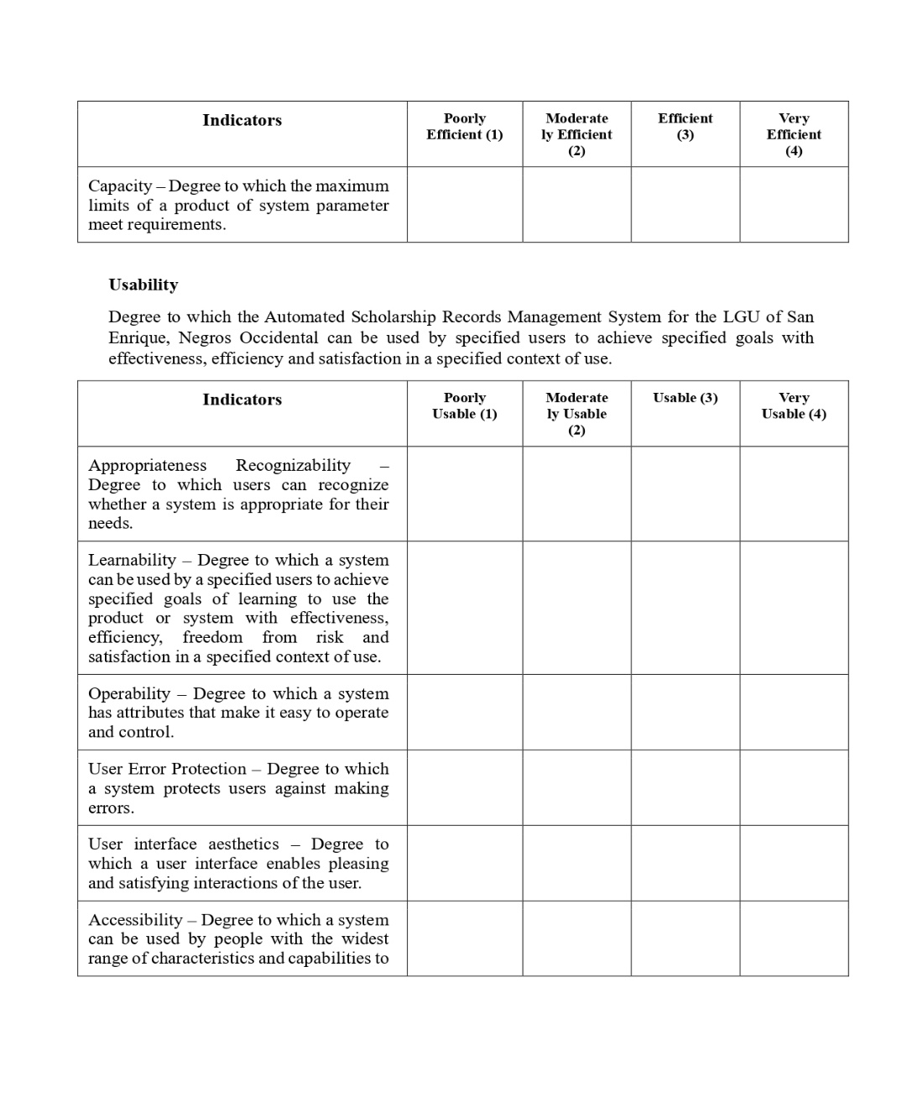
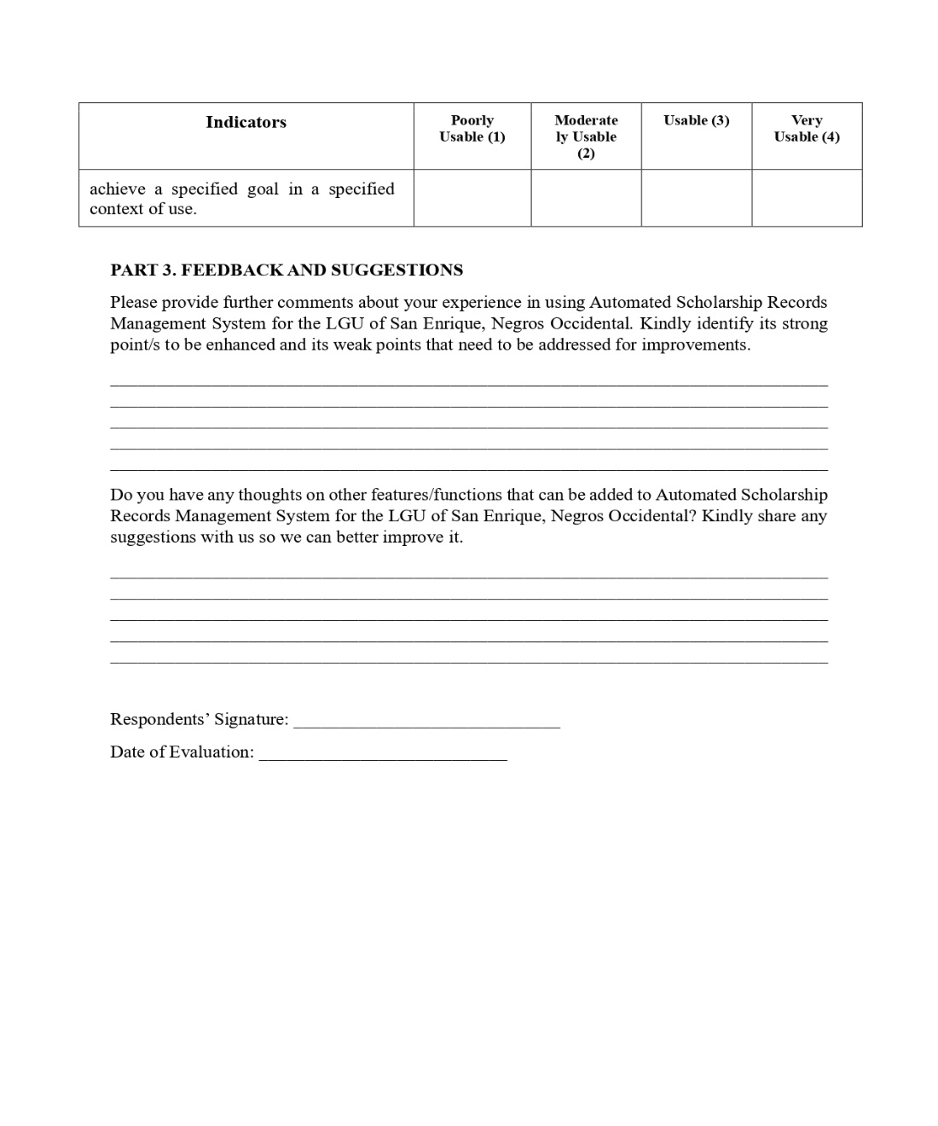
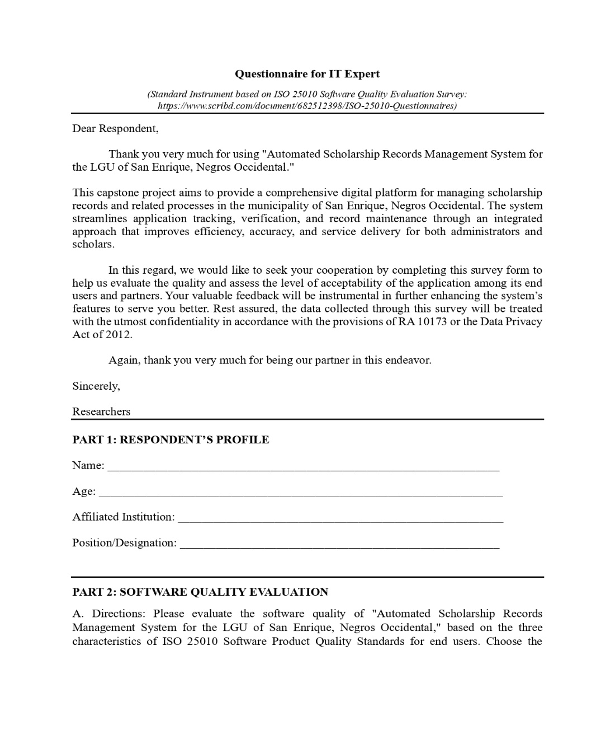
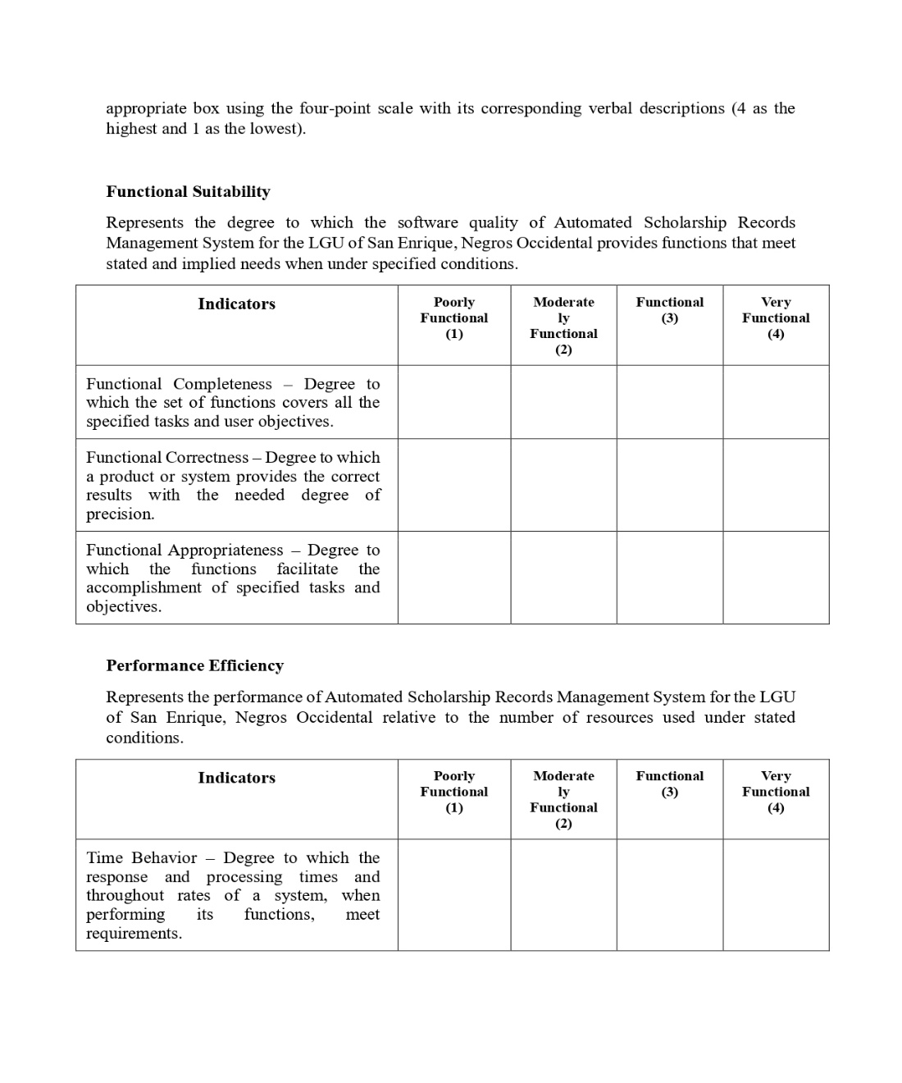
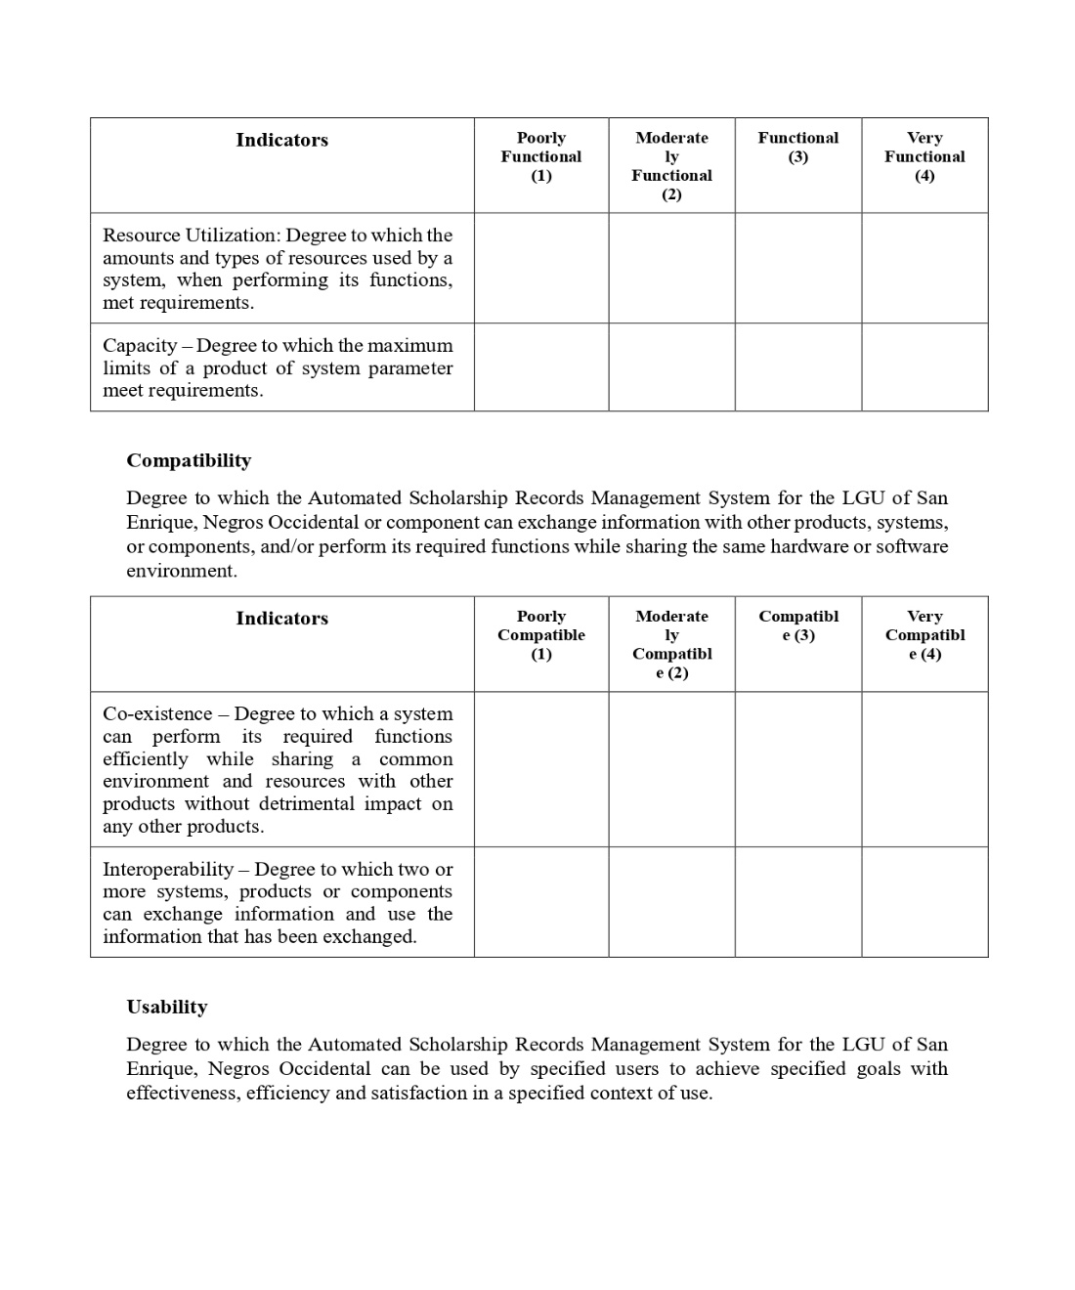
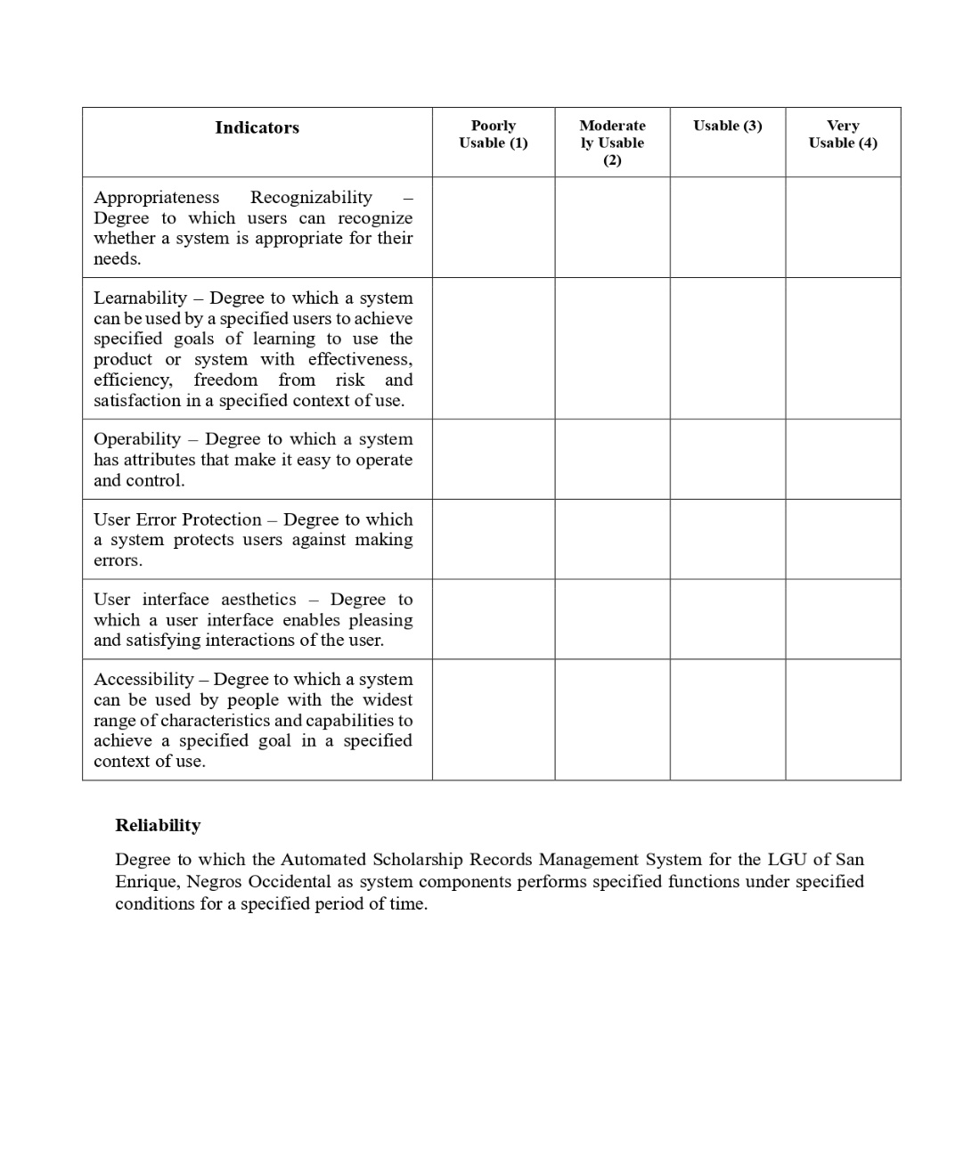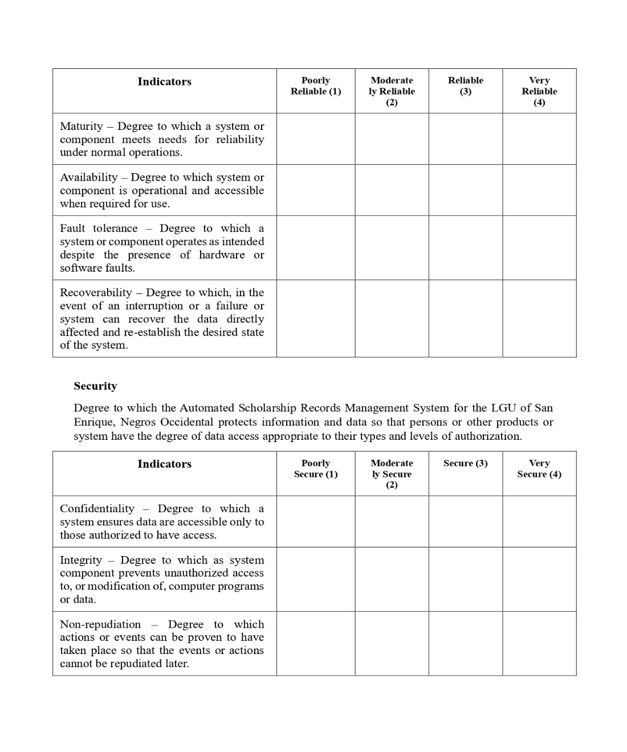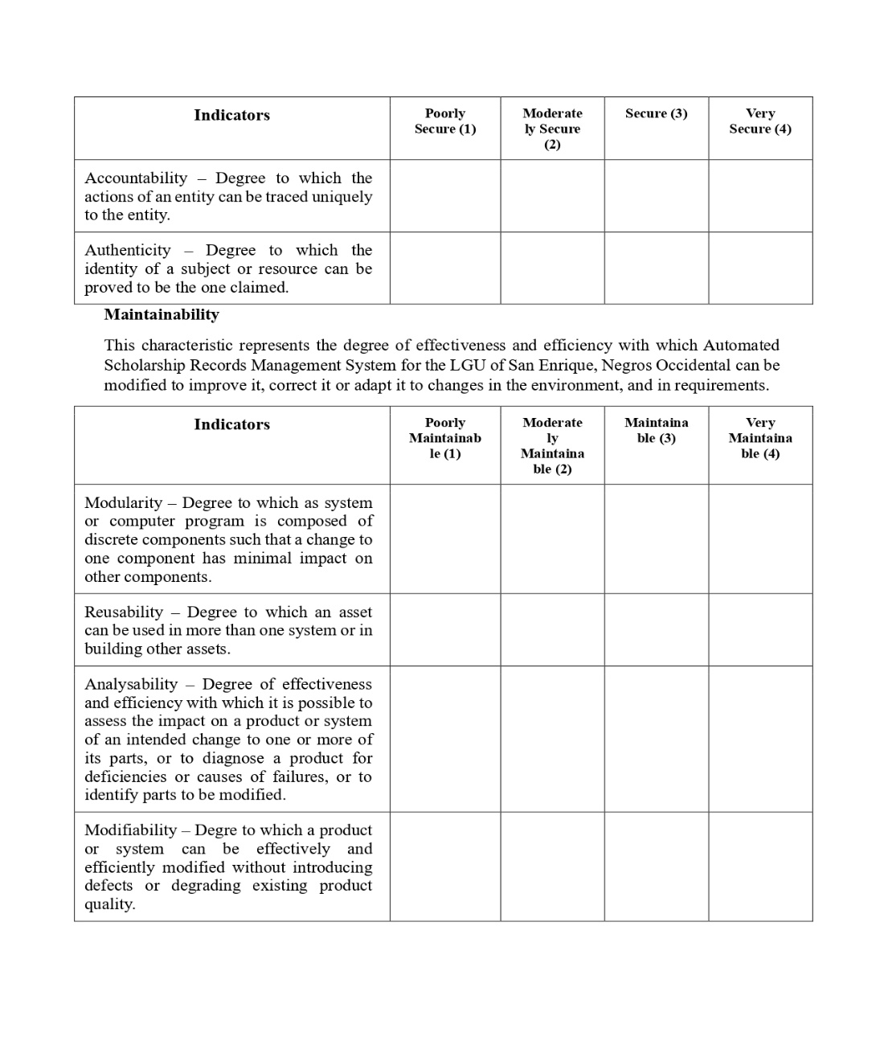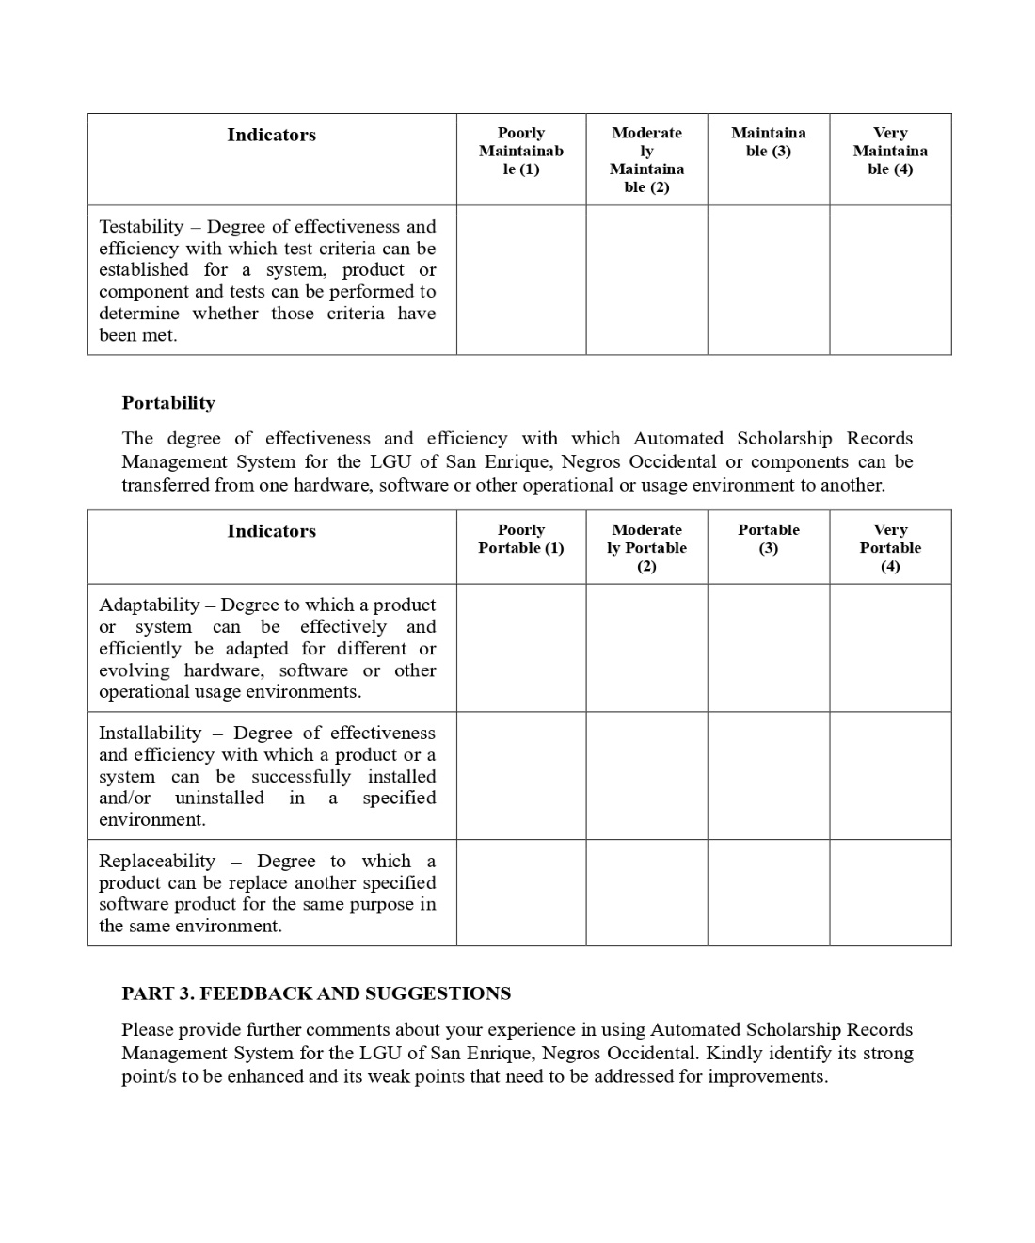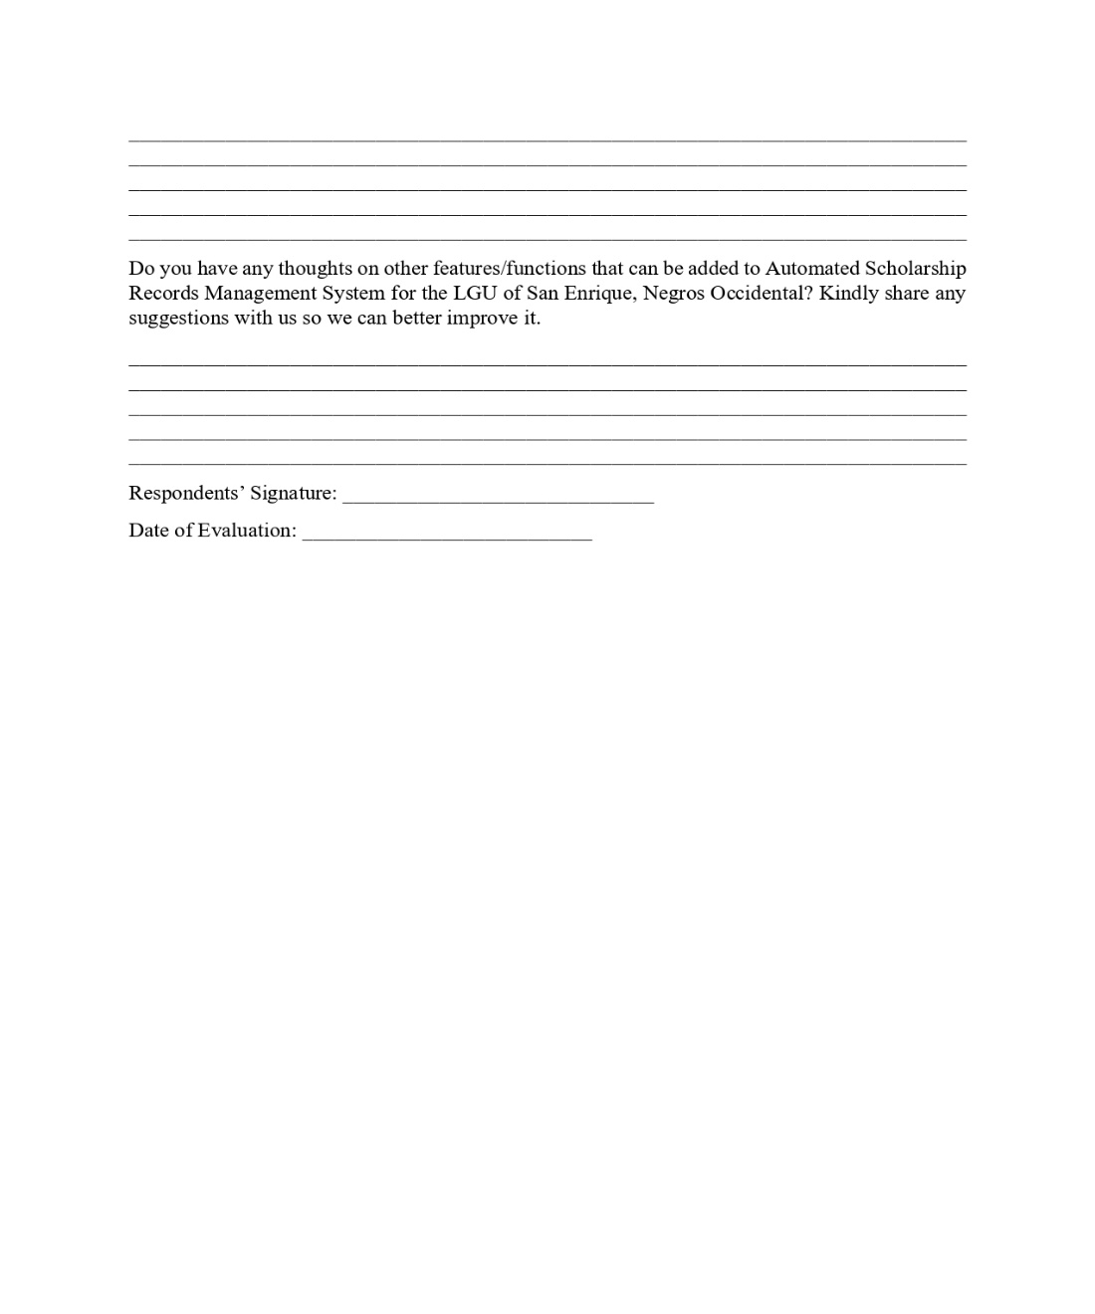

Appendix D. Evaluation Results

Appendix E. Photos During the Conduct of Evaluation with the System Beneficiaries

Appendix F. Screen Layouts

Appendix G. Source Code

