CHAPTER I
Introduction
In today’s dynamic educational environment, efficient management of office supplies is essential to ensure smooth daily operations in schools. At Central Philippines State University - Valladolid Extension Class, where Faculty, Administrative staff, the Supreme Student Government, and the Future Leaders of the Philippines work together, the availability of necessary supplies greatly affects their ability to perform their tasks effectively.
According to Arlene Wilson (2022), this research examines inventory management techniques for small and medium-sized retail office supply stores (SMROSS) in Ontario, Canada. The research identified four main themes: operational efficiency, fostering relationships with supply chain partners, implementing information technology in inventory management, and being responsive to customer needs. The suggestions include keeping stock levels with low storage costs while meeting demand, which could assist SMROSS owners in staying competitive, growing their businesses, and generating job opportunities.
The CPSU VEC Office Supplies Inventory System effectively combines inventory management with user-driven requests to enhance efficiency and transparency at Central Philippines State University – Valladolid Extension Class. At the heart of the system, stock levels are continuously monitored, and real-time alerts for low stock are generated, allowing administrators to proactively restock supplies before they run out; it also maintains comprehensive records of both active and obsolete items, providing a clear audit trail for accountability. Administrators can quickly add new items, modify inventory counts, approve distributions, and generate printable reports or archived records with just a few clicks, significantly reducing manual paperwork and the potential for human error. In addition, end users enjoy an easy-to-use purchase request interface that simplifies departmental orders, a tool for reporting defects that highlights damaged items for prompt replacement, and rapid access to archived histories or printable forms—together facilitating timely decision-making, reducing delays from missing or defective materials, and ultimately ensuring smooth academic and administrative operations.
Problem Statement
The present undertaking aims to assess the technical requirements for the development of the CPSU - VEC Office Supply Inventory Management System, and to design and implement a system tailored for the needs of the Supply Office of the Central Philippines State University – Valladolid Extension Class. Specifically, this study-seeks to answer the following questions:
- How effective is the proposed inventory management system in automating the tracking and monitoring of office supplies and equipment?
- What are the specific technical and functional requirements needed in the development of the proposed system?
- What features must the system include to ensure accuracy, real-time monitoring, and user satisfaction?
- How beneficial is the School Office Supply Inventory Management System to the administrative operations of Central Philippines State University – Valladolid Extension Class?
Objectives
General Objective
This study aims to develop an efficient and reliable School Office Supply Inventory Management System that enhances resource management, boosts user accessibility, and ensures the timely fulfillment of supply requests.
Specific Objectives
- Develop a User-Friendly Platform: Create a system where School Administrator/Coordinator, Faculty, Staff, Supreme Student Government, and Future Leaders of the Philippines can easily submit and track office supply view real-time updates on inventory status.
- Enhance Administrative Efficiency: Enable administrators to monitor supply levels, generate comprehensive reports, and receive automated notifications for low-stock items.
- Improve Operational Effectiveness: Streamline the supply management process to reduce manual errors and ensure timely processing of supply requests within Central Philippines State University - Valladolid Extension Class.
Significance of the study
The implementation of this system is expected to have a significant impact on various groups:
To the School Administrator/Coordinator. The automated platform will streamline their tasks, reduce processing times, and enhance inventory accuracy.
To the Faculty. A user-friendly system will simplify the process of requesting supplies, thereby reducing downtime and allowing them to focus on their teaching responsibilities.
To the Administrative Staff. Improved management and prompt processing of supply requests will lead to a more organized and efficient office environment.
To the Supreme Student Government and Future Leaders of the Philippines. The system will ensure that resources needed for their activities are readily available, thereby supporting their leadership roles and initiatives.
To the Researchers and Future Researchers. This study contributes valuable insights into the integration of technology in school administration and can serve as a foundation for further studies in this area.
Scope and Limitations
The system is designed to manage general office supplies used within Central Philippines State University - Valladolid Extension Class, targeting all relevant stakeholders such as teachers, administrative staff, and student organizations. Key functionalities include:
- Tracking of supply requests.
- Real-time inventory tracking.
- Automated reporting and notifications.
It is important to note that this system does not cover specialized equipment or supplies outside the general category. Additionally, the effectiveness of the system is dependent on accurate initial data input and continuous updates by the users.
Definition of Terms
Inventory Management System. A systematic approach to manage a school’s office supplies from procurement to usage, ensuring that supplies are available when needed.
Operationally, this study refers to the digital system developed to monitor and manage office supplies within Central Philippines State University - Valladolid Extension Class.
Supply Request. A formal request made by faculty, administrative staff, or student representatives for office supplies.
Practically, the mechanism through which users submit their supply needs to the system ensures timely replenishment.
Real-Time Tracking. Continuous monitoring and immediate updating of inventory levels as supplies are dispensed or restocked.
Operationally, the system’s ability to provide up-to-date inventory information to all users enhances decision-making.
User Friendly. A system designed for effortless navigation and usability, accommodating users of all technical skill levels.
Effectively, it was designed with a simple interface to facilitate smooth interaction for all stakeholders.
Automated Notifications. A system generated-alerts that will inform the users of critical-inventory events, such as low-stock levels, supply status, and a damage item report.
Functionally, the function automatically sends alerts to ensure proactive management of office supplies.
CHAPTER II
REVIEW OF RELATED LITERATURE & SYSTEMS
This chapter presents a comprehensive review of both related literature and existing systems relevant to inventory management. It aims to provide a solid foundation and contextual understanding of the current study by highlighting key concepts, technological advancements, and practical challenges found in previous research.
Review of Related Literature
According to Wilson, Arlene (2022) Leveraging IT was found to be critical in managing inventory effectively, suggesting that technological tools can enhance decision-making processes. Another study suggest that it was crucial to recognize how vital effective inventory management is for maintaining smooth operations and compliance Mahamud, Fabio (2024). According to another study,to ensure precise details on stock levels, sales, and other key metrics, an automated inventory system should process data instantly. Efficient algorithms and data handling techniques are essential to manage high data volumes without lag Okotie. P. M. (2023). Another study, the shift toward digital supply data integration is driven by the need for real-time visibility and the demand to address challenges such as limited storage space and disruptions in the supply chain Niaz M. (2022). Another study highlights the essential role of inventory management in helping organizations achieve a proper balance of stock, thereby reducing the chances of overstocking or running out of inventory MADAMIDOLA, Olugbenga Ayomide (2024). Another study found that the most common inventory errors reported by participants included inaccurate inventory counts, waste caused by using incorrect components in production, and mispricing across all inventory categories. The participants perceived that senior leadership’s reluctance toward change and concerns about automation costs would persist in hindering efficiency and postponing strategies aimed at reducing inventory errors (Wynn, S., 2021). Another study, inaccurate inventory records in a manufacturing company's inventory system can lead to disruptions in production, shortages of necessary parts, and the urgent need to expedite component deliveries Matica et al. (2021). The study in inventory management, maintaining safety stocks is widely recognized as an effective approach to address uncertainties in demand and supply, ensuring the prevention of stock-outs Gonçalves, J. N. et al. (2020). According to Alim et al. (2023), the study shown that proposed system facilitates real-time cafeteria inventory updates, allowing inventory status to be tracked and recorded effectively (Srivastava et al., 2020). The proposed system facilitates real-time cafeteria inventory updates, allowing inventory status to be tracked and recorded effectively. Study Paul, S. et al. (2019) This system offers significant benefits over traditional methods and shows promising potential for future advancement. Aa study of Anderson, J. R. (2020) Irregular and manual inventory management methods led to increased inventory levels, reduced customer service quality, and elevated operational costs compared to the efficiencies attainable through standardized and structured management practices. A study of Okorie, S. N. et al. (2023) as a result of these challenges, the researchers suggested implementing a computerized inventory management system to address the issues associated with the paper-based approach. Study of Karim, A. M. et al. (2020) This digital system assists laboratory personnel in determining lab capacity and obtaining crucial asset availability data. It eliminates the need for labor-intensive manual record-keeping, thereby providing the university with a strategic advantage through improved operational efficiency. Study Nwaiku, M. et al. (2022) The study analyzed inventory management approaches, focusing on inventory record precision, lean inventory methods, reserve stock handling, and the use of Information and Communication Technology. Pagayunan, S. M. S. (2021) This article specifically aimed to build and construct the Record Management System with Document Control and assessed how well it performed and how usable the target users thought it was. Duranti, L. (2022) Every organization needs its records to be able to support the facts they contain, meaning that their information must be reliable. Study of Adam, A. (2020) Organizations must transition from traditional paper files and storage to more contemporary electronic ways in light of the global shift toward online service delivery. A study of Xiandond, Z. (2024) The school can decrease needless waiting times, enhance internal document handling, and increase job efficiency with the help of the document management system. A study of Saleem, M. et al. (2024) Moreover, automated systems improve the precision of inventory records by reducing mistakes commonly linked to manual operations.
he transitions from manual to digital inventory and document management systems has significantly improved operational efficiency, accuracy, and service quality across various sectors.
Review of Relates Systems
According to Agboola, F.F. et al. (2022) The development of a computerized inventory management system aims to assist storekeepers in making informed decisions about their stock. It offers solutions to existing challenges by maintaining records, monitoring employee salaries, and updating sales and transaction data. Chukomin, A. et al. (2023) The flexibility and adaptability of warehouse environments are becoming increasingly vital for achieving cost-effective production of small batch sizes. Ge, X. et all. (2024) The Intelligent Inventory System marks a notable leap forward in inventory management by overcoming the shortcomings of traditional approaches through the incorporation of cutting-edge technology. Jangale, V. (2024) Users will be notified about their inventory levels and automatically alerted when stock levels decrease. Odili, J. B. et al. (2022) Traditional inventory control methods are time-consuming, expensive, and prone to errors, often failing to keep inventory accurate due to oversight and internal shrinkage. Atieh, A. M. et al. This study examines the effects of an inventory management system on supply chain performance, focusing on reducing resource effort while enhancing efficiency and reliability. Vaka, D. K. (2024) The primary objective is to achieve a competitive advantage by lowering expenses and improving the quality of service. Irene (2023) This inventory system faces several difficulties, including disorganized procedures that result in duplicate records and redundant data. Furthermore, item tracking lacks efficiency, excessive paperwork takes up significant space, and restocking decisions are inadequately handled. These challenges undermine the system's effectiveness in delivering structured and dependable item management for personal or community use, such as libraries, educational institutions, or private collections. Ugbebor, F. et al. (2024) Automated inventory systems utilizing Internet of Things (IoT) technology offer a groundbreaking solution for Small and Medium-sized Enterprises (SMEs), enabling them to efficiently manage stock levels and lower carrying expenses. Madamidola, O. A. et al. (2020) In response to these challenges, a cutting-edge web-based system has been launched. It efficiently computes the most suitable reorder levels and securely communicates this information to a central hub via Java RMI secured with SSL. By utilizing technologies such as MySQL, HTML, JavaScript, PHP, and XAMPP, the system transforms the conventional single-store approach into a distributed framework, enabling real-time inventory tracking and significantly enhancing overall efficiency. Ikhwan, A. et al. (2025) Effective inventory management of infrastructure facilities positively influences schools by ensuring optimal learning conditions for students, enabling teachers to engage disinterested students through appealing facilities, improving overall school quality through efficient administration, and garnering greater public interest and recognition.

CHAPTER III
METHODOLOGY
This section provides an outline of the tasks and measures researcher will undertake to complete the project. A brief encounter of all the activities starting from Preproposal to Final Document Writing is also discussed. This also mentions the research method employed, as well as the first consideration of the pattern of the SDLC model that is to be adopted.
- Design Method
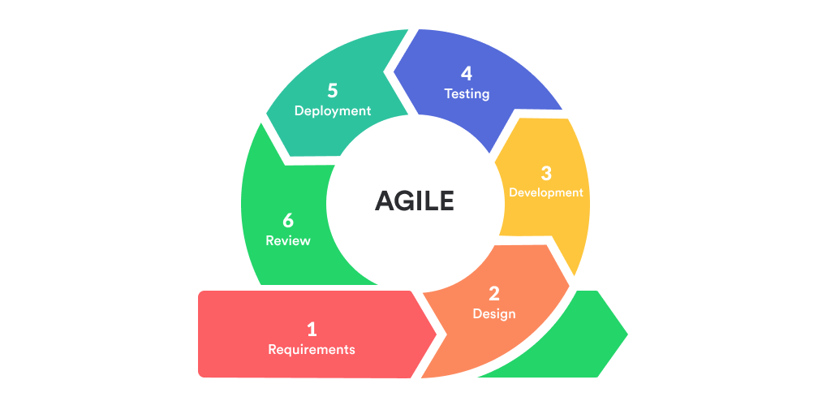
The researcher adopted the Agile Model Software Development Life Cycle to ensure iterative progress, adaptability, and stakeholder collaboration. This methodology emphasizes incremental delivery, continuous feedback, and cross-functional teamwork to align development with user needs and evolving requirements.

Figure 1. Agile Model
Phase 1. Requirements
During the Requirements Phase, the researcher conducted semi-structured interviews with key stakeholders to map existing workflows, identify pain points in current inventory management processes, and define functional and non-functional system requirements. This phase established critical features such as real-time tracking, and reporting modules, technical constraints, and acceptance criteria. A preliminary project road map was drafted, including tool selection, infrastructure planning, and sprint timelines.
Phase 2. Design
In this phase, it involves creating high fidelity prototypes and system architecture diagrams to visualize user interfaces, database schema, and core workflows. The researcher prioritized user-centric design by developing wireframes (using Figma) to finalize the system’s layout, navigation, and interactive elements. A relational database schema (MySQL) was designed to ensure data integrity, while RESTful APIs were planned for seamless integration with external tools. Security protocols (e.g., role-based access control) and scalability considerations (e.g., cloud hosting on AWS) were incorporated into the architectural design.
Phase 3. Development
In the Development Phase, the team collaborated in two-week sprints using Scrum practices. Stand-up meetings ensured alignment, while pair programming and code reviews-maintained code quality. The front-end was built with CSS and JavaScript for dynamic interfaces, while the back-end used PHP, MySQL and AJAX.
Phase 4. Testing
The testing phase followed a multi-layered approach to ensure the system's reliability and functionality. Unit Testing was conducted to validate individual components, allowing developers to verify the integrity of specific features. Integration Testing to assess the interoperability of modules, ensuring seamless interactions within the system. System Testing took a broader perspective by logging identified bugs in the backlog for immediate resolution, enhancing the system's stability.
Phase 5. Deployment
During the Deployment Phase, the system was introduced in a structured manner to ensure a seamless roll-out. The process began with a Pilot Launch, where a limited release was made available to a small user group for final validation, allowing for last-minute refinements. Following this, Full Deployment was carried.
Phase 6. Review
The Review Phase included a sprint retrospective to evaluate system performance and a post-implementation review with relevant stakeholders.
- Flow of the Study
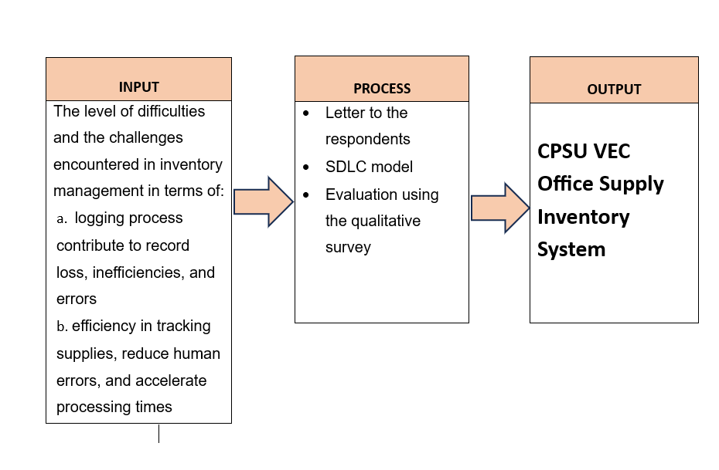
This flowchart illustrates the systematic flow of the study, guiding researchers from the inception of their research concept to the completion and presentation of their results.

Figure 2. Flow of the Study
c. Functional and Non- Functional Requirements
c.1. Software Requirements
The software requirements needed to develop the system are listed in Table 1. It identifies the minimum software version that was utilized during the development stage.
Table 1. Software Requirements
Software | Version
Visual Studio Code | Version: 1.99.3
Browser for Desktop | Latest Build
XAMPP Server | v.3.3.0
PHP | version: 8.0.30
JavaScript | ES14
PHPUnit | PHPUnit 11

c.1.2. Hardware Requirements
The hardware needed to construct and use the system is shown in Table2.
Table 2. Hardware Requirements
Device | Specification
Central Processing Unit (CPU) | 11th Gen Intel(R) Core (TM) i5-1135G7 @ 2.40 GHz
Monitor | 17’’ 1024x768 resolution
Keyboard | Standard
Mouse | Standard
Solid State Drive | 1Tb
Random Access Memory (RAM) | 8GB
c.3. System/Application Flowchart
A flowchart illustrating the system’s workflow was created to visualize user interactions, decision points, and process sequences. This diagram clarifies how users navigate through features like inventory management, view inventory logs, and data entry.
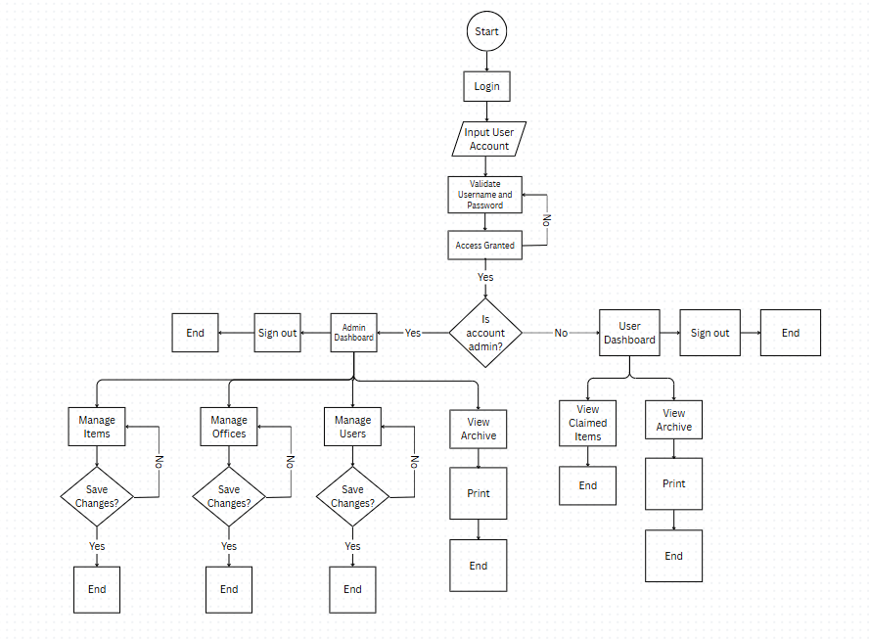
Figure 3. System/Application Flowchart
c.4. System Architecture
The system adopts the following system architecture: a front-end layer (JavaScript/CSS), and back-end layer (PHP/MySQL).
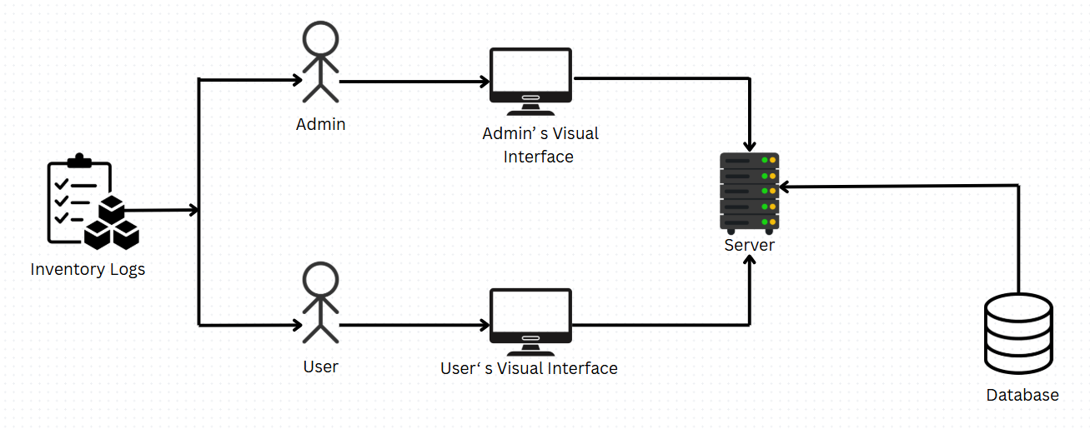
Figure 5. System Architecture
c.6. Context Diagram
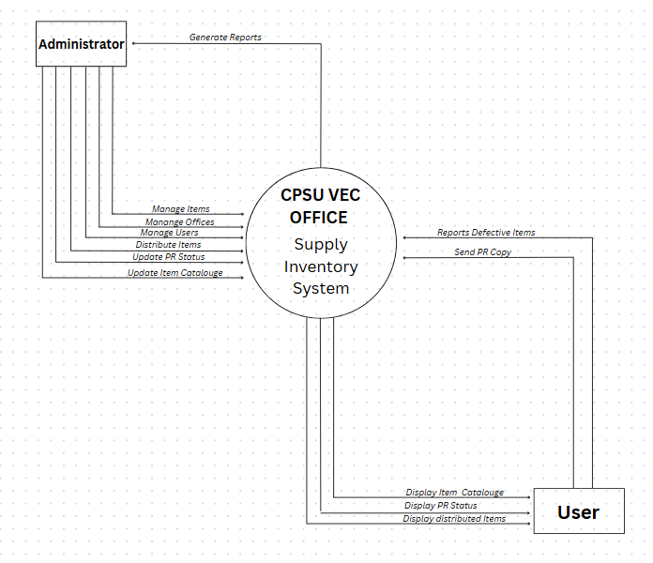
The context diagram defines the system’s boundaries, highlighting interactions between the admin, users, and the system

Figure 6. Context Diagram
c.7. Data Flow Diagram
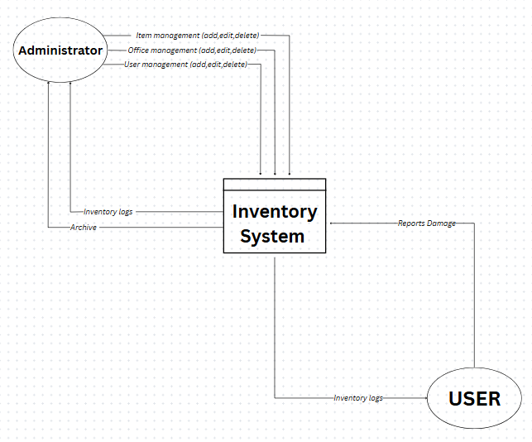
This diagram maps the flow of data across system modules, including inputs, processing steps, and outputs.

Figure 7. Dataflow Diagram
c.8. Entity Relationship Diagram
In the office inventory database, a clear relational structure is established between specific tables to enforce data consistency and represent logical associations. The items table is intrinsically linked to the item_categories table through the category_id foreign key, which references the id column of the latter. This relationship ensures that each item recorded in the inventory is systematically categorized, promoting efficient classification and retrieval of items based on predefined categories. Furthermore, the condemned_items table exhibits a direct relationship with the offices table via the office_id foreign key, which also references the id column of its parent table. This association accurately tracks the office to which each condemned item belongs, enabling precise accountability and facilitating administrative oversight over asset disposition. Through these carefully designed relationships, the database schema underscores a robust framework for maintaining data integrity a operational traceability within the office inventory system.
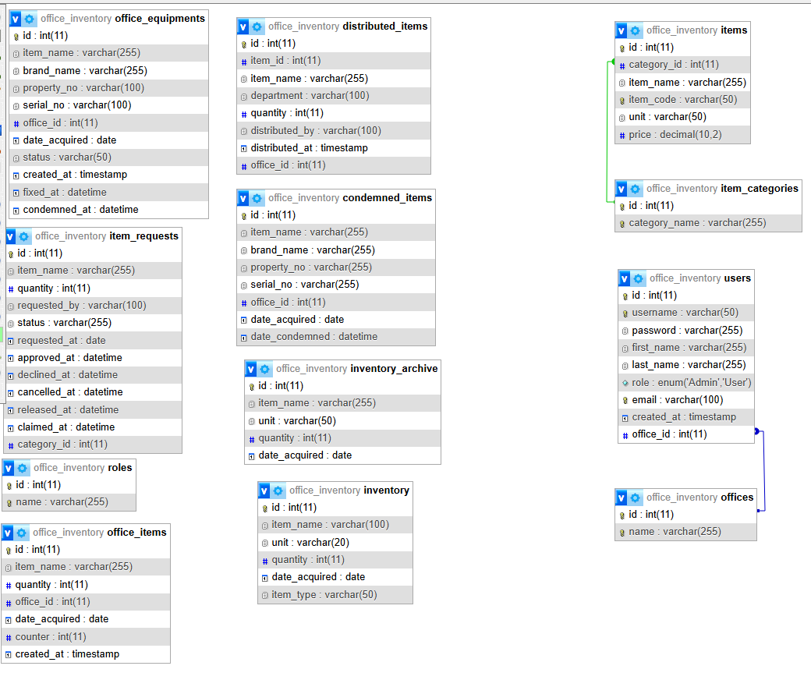
Figure 8. Entity Relationship Diagram
c.9. Use case Diagram
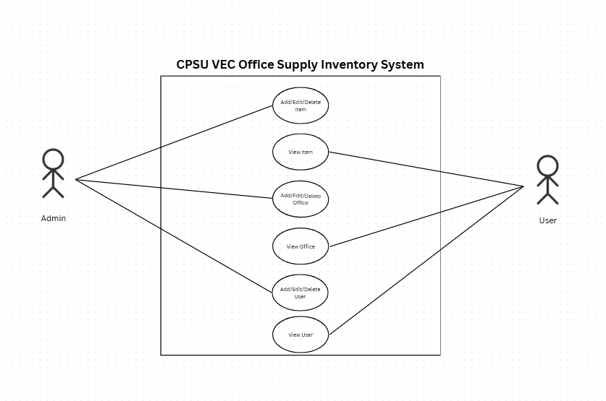
Use cases such as “Update Inventory,” “Generate Report,” and “Manage User Access” illustrate key functionalities from the perspective of different user roles.

Figure 9. Use Case Diagram
- Respondents
The study involved two respondent groups: (1) IT Experts, and (2) Student Government Officers, who validated system effectiveness and usability in addressing the difficulties and challenges posed by the current inventory management processes.
Table 3. Distribution of Respondents
Respondents | Frequency | Percentage
IT Experts | 5
Student Government Officers | 14
Head Office
Total | 19

- Environment
The researcher conducted the study at Central Philippines State University – Valladolid Extension Class located at Barangay Bagumbayan, Valladolid, Negros Occidental. The study is centered on the school where the system will be used.


Figure 10. Environment of the Study
- Instrument
A self-developed questionnaire was administered to the Student Government Officers, while ISO 25010 was utilized for the IT Experts. Both assessments employed a 5-point Likert scale to evaluate the system’s effectiveness and usability in addressing the challenges and complexities of the existing inventory management processes.
Table 4. Likert Scale for Usability
Rating | Range | Verbal Description | Interpretation
5 | 4.21-5.00 | Very Good | Very Usable
4 | 3.41-4.20 | Good | Usable
3 | 2.61-3.40 | Average | Moderately Usable
2 | 1.81-2.60 | Fair | Not Usable
1 | 1.00-1.80 | Poor | Very Unusable

- Data Gathering Procedures
The primary data was gathered by the researcher directly from sources. Data was gathered through comprehensive interviews, ensuring detailed insights from participants. In order to collect primary data from the respondents, the researcher employed the survey method during the study's execution. Personal information, such as the respondent's system rating, was linked to the data in the questionnaire.
- Statistical Treatment of Data
The statistical analysis for this study employed descriptive statistics to analyze data collected through structured questionnaires, utilizing a 5-point Likert scale (1 = "Very Difficult" to 5 = "Very Easy"). The data was derived from two respondent groups: experts evaluating system attributes (e.g., functionality, usability, reliability) and users (students/faculty) assessing system performance.
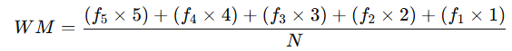
Descriptive statistics, including frequencies, means, percentages, and standard deviations, were computed to summarize responses. These metrics provided insights into central tendencies, variability, and distribution of scores across survey items. The mean and standard deviation for variables such as pc1 (Mean = 4.79, SD = 0.43) and ps1 (Mean = 4.71, SD = 0.47) demonstrated response consistency. Additionally, frequency tables (e.g., 64.29% male respondents, 78.57% holding position "2.00") provided insights into demographic patterns. The weighted mean formula, adapted for the 5-point Likert scale, was applied to evaluate responses:
Were,
WM = weighted mean N = population
f = frequency
CHAPTER IV
RESULTS, CONCLUSIONS & RECOMMENDATIONS
- Results and Discussions
This section presents the evaluation results of the CPSU - VEC Office Supply Inventory Management System based on feedback collected from end-users and experts. The assessment involved the use of two structured survey instruments: one based on the ISO 25010 quality model and another designed by the researchers to assess user-specific experience. Both questionnaires utilized a 5-point Likert scale, where 5 indicated the highest level of agreement or satisfaction.
Range | Verbal Description | Interpretation
4.21-5.00  3.41-4.20  2.62-3.40  1.81-2.60  1.00-1.80 | Strongly Agree  Agree  Moderately Agree  Disagree  Strongly Disagree | Excellent  Very Good  Good  Poor  Very Poor
Table 1. Likert Scale
Indicator | IT Expert Mean | Verbal Description | Interpretation
1. Functionality | 5 | Strongly Agree | Excellent
2. Performance Efficient | 5 | Strongly Agree | Excellent
3. Compatibility | 4.9 | Strongly Agree | Excellent
4. Usability | 5 | Strongly Agree | Excellent
5. Reliability | 5 | Strongly Agree | Excellent
6. Security | 5 | Strongly Agree | Excellent
7. Maintainability | 5 | Strongly Agree | Excellent
8. Portability | 5 | Strongly Agree | Excellent
Table 2. Response of IT Experts
Indicator | Student Mean | Verbal Description | Interpretation
Part I. Current Practices and Challenges in Inventory Management | 4.78571428571429 | Strongly Agree | Excellent
Part II. Effectiveness of the System | 4.78571428571429 | Strongly Agree | Excellent
Part III. System Usability and Relevance | 4.76190476192857 | Strongly Agree | Excellent
Table 3. Response of Students
Indicator | Overall Mean | Verbal Description | Interpretation
IT Experts | 4.9875 | Strongly Agree | Excellent
Student | 4.77777777778571 | Strongly Agree | Excellent
Total Mean | 4.882638888892855 | Strongly Agree | Excellent
Table 4. Evaluation Summary
The results from the ISO 25010 evaluation reveal that the CPSU - VEC Office Supply Inventory Management System is highly rated across all eight software quality characteristics. Functional Suitability, Performance Efficiency, Compatibility, Usability, Reliability, Security, and Portability all received perfect scores of 5.00, indicating unanimous expert agreement on the excellence of these features. The slightly lower scores in Maintainability (4.99) suggest minor areas for improvement, possibly related to interoperability with other systems or future scalability considerations.
These findings are consistent with the study by Adewumi, Misra, and Omoregbe (2015), which assessed open-source software quality models using the ISO 25010 standard. The study found high ratings in functionality, usability, and reliability, highlighting the effectiveness of such systems in various environments. Additionally, they proved valuable for providing technical support and addressing issues in real time.
In comparison, the user evaluation using the self-made questionnaire shows equally favorable results. The average ratings for Current Practices and Challenges in Inventory Management and Effectiveness of the System were both at 4.79, while System Usability and Relevance slightly trailed at 4.76. These findings suggest that the system provides a comfortable and efficient environment for users to manage inventory tasks, with a high overall satisfaction level.
The benefits of automated inventory systems in reducing human error and improving efficiency are well-documented. For instance, the implementation of automation in inventory management has been shown to minimize errors and enhance productivity (Calabrese et al., 2018).
Moreover, the system addresses critical pain points in the current manual processes as outlined in the self-made questionnaire. The high scores in areas like task completion ease and error reduction align with literature emphasizing the advantages of automation in inventory management, such as real-time tracking and improved accuracy (Molnar & Motogna, 2020).
In summary, the CPSU - VEC Office Supply Inventory Management System has been validated both through international standards (ISO 25010) and local contextual relevance (user-specific feedback). The consistently high ratings indicate a successful implementation that meets both technical and functional requirements, supporting the university's administrative efficiency and resource management.
- Implementation Plan
To facilitate effective user adoption of the CPSU – VEC Office Supply Inventory Management System, the researchers will conduct a comprehensive training program. This program will comprise hands-on workshops tailored to key stakeholders—including administrative staff, faculty members, and student organization officers—covering system navigation, inventory logging procedures, report generation, and basic troubleshooting. The researchers will develop and distribute user manuals and instructional videos, and each training session will incorporate real-world scenarios to reinforce practical application. A feedback mechanism will be embedded within the training process so that any areas of confusion can be promptly identified and addressed by the research team.
The researchers plan to implement the system through a phased roll-out approach. In the initial phase, the system will be deployed within the Supply Office for pilot testing, enabling staff to evaluate core functionalities such as item logging and stock monitoring. Following successful pilot validation and any necessary refinements, the system will be systematically introduced to other university departments and student organizations. Collaboration with the institution’s IT department will guarantee a secure and stable deployment environment, while a dedicated help desk, managed by the research team, will be available throughout the rollout to offer technical support and promptly address any issues.
Upon full deployment, the researchers will establish a maintenance regimen to sustain system performance and user satisfaction. This regimen will include scheduled software updates, routine data backups, and continuous monitoring for bugs or performance degradations. A designated system administrator—appointed by the researchers—will oversee the application of patches, the updating of inventory templates, and the triage of user feedback. Additionally, the researchers will conduct an annual evaluation of system performance and usability, using the findings to guide further enhancements aligned with evolving user needs and institutional requirements.
- Gantt Chart
The CPSU-VEC Office Supply Inventory Management System implementation schedule from February 2024 to April 2025 is illustrated in a Gantt Chart. The project began with the Title Hearing and initial planning in February, followed by the Conduct Interview phase in March, which laid the foundation for System Development. Major milestones included the Pre-Oral Defense in June and subsequent revisions in July. Documentation progressed through Chapters I, II, and III-IV, with color coding indicating completed tasks and upcoming ones. The chart's organized timeline facilitated comprehensive data gathering, iterative development, and systematic refinements, all in line with the 2024-2025 academic calendar.
PARTICULARS | 2024
 | QUARTER 1 |  |  |  |  |  |  | QUARTER 2 |  |  |  |  | QUARTER3
 | JAN | FEB |  | MAR |  | APR |  | MAY |  | JUN | JUL | AUG | SEP | OCT | NOV | DEC
TITLE HEARING
PLANNING
CONDUCT AN INTERVIEW
SYSTEM DEVELOPMENT
PRE-ORAL
REVISION
Legend: BLUE -Completed; YELLOW -Incomplete
PARTICULARS | 2024
 | QUARTER 1 |  |  |  |  |  |  | QUARTER 2 |  |  |  |  | QUARTER3
 | JAN | FEB |  | MAR |  | APR |  | MAY |  | JUN | JUL | AUG | SEP | OCT | NOV | DEC
CHAPTER I
INTRODUCTION
PROBLEM STATEMENT
OBJECTIVES
SIGNIFICANCE OF THE STUDY
SCOPE AND LIMITATION
DEFINITION OF TERMS
Legend: BLUE -Completed; YELLOW -Incomplete
PARTICULARS | 2024
 | QUARTER 1 |  |  |  | QUARTER 2 |  |  |  | QUARTER3
 | JAN | FEB | MAR | APR | MAY | JUN | JUL | AUG | SEP | OCT | NOV | DEC
CHAPTER II
REVIEW OF RELATED LITERATURE
REVIEW OF RELATED SYSTEM
Legend: BLUE -Completed; YELLOW -Incomplete
PARTICULARS | 2025
 | QUARTER 1 |  |  |  | QUARTER 2 |  |  |  | QUARTER3
 | JAN | FEB | MAR | APR | MAY | JUN | JUL | AUG | SEP | OCT | NOV | DEC
CHAPTER III
DESIGN METHOD
FLOW OF THE STUDY
FUNCTIONAL AND NON-FUNCTIONAL REQUIREMENTS
RESPONDENTS
ENVIRONMENT
INSTRUMENT
DATA GATHERING PROCEDURES
STATISTICAL STATEMENT OF DATA
Legend: BLUE -Completed; YELLOW -Incomplete
PARTICULARS | 2025
 | QUARTER 1 |  |  |  | QUARTER 2 |  |  |  | QUARTER3
 | JAN | FEB | MAR | APR | MAY | JUN | JUL | AUG | SEP | OCT | NOV | DEC
CHAPTER IV
IMPLEMENTATION PLAN
BUDGET RECOMMENDATION
TESTING AND EVALUATION
FINDINGS
CONCLUSION
RECOMMENDATION
REFERENCES
APPENDICES
Legend: BLUE -Completed; YELLOW -Incomplete
- Budget Recommendation
PARTICULARS | SPECIFICATION |  | QUANTITY |  | COST/UNIT (Php) | TOTAL (Php)
Hardware:
Desktop | 11th Gen Intel i5 @2.40 GHz |  | 1 |  | 17,000 | 17,000
Solid State Drive | 1Tb |  | 1 |  | 2,500 | 2,500
Random Access Memory | 8 Gb |  | 2 |  | 1,200 | 2,400
Sub-Total |  |  |  |  |  | 21, 900
Software:
Visual Studio Code | Version: 1.99.3 |  | 1 |  | 0 | 0
Browser | Latest Build |  | 1 |  | 0 | 0
XAMPP Server | v.3.3.0 |  | 1 |  | 0 | 0
PHP | 8.2.12 |  | 1 |  | 0 | 0
JavaScript | ES14 |  | 1 |  | 0 | 0
PHPUnit | PHPUnit 11 |  | 1 |  | 0 | 0
Subtotal |  |  |  |  |  | 0
GRANDTOTAL |  |  |  |  |  | 21,900
Peopleware |  | QUALIFICATION |  | MONTHLY SALARY (Php)
Programmer |  | Entry-Level |  | 20,000

- Testing and Evaluation
d.1. Testing
The testing phase began with the researchers using PHPUnit 11 to construct a thorough suite of unit tests, ensuring that every individual component of the CPSU–VEC Office Supply Inventory Management System functioned correctly in isolation. For each module—whether the inventory‐logging component, the report‐generation engine, or the user‐authentication service—they devised test cases addressing valid inputs, edge conditions, and invalid data. This approach guaranteed that each unit yielded the expected results and managed errors gracefully, establishing a reliable base for subsequent integration work.
Once unit testing was complete, the team moved on to integration testing, combining modules with inter dependencies—such as the logging and stock‐level monitoring components—and executing them together under controlled scenarios. This phase was essential for detecting interface or data‐flow defects that could not appear in standalone tests, allowing the researchers to resolve communication issues and confirm smooth interoperability between components.
Finally, testing was conducted in a fully integrated environment that mirrored the production setting. End-to-end workflows—like logging incoming supplies, triggering low-stock alerts, and generating monthly inventory reports—were run to validate overall system behavior against the original specifications. By simulating real-world usage, including concurrent user sessions and high data volumes, the researchers verified that the CPSU–VEC Office Supply Inventory Management System met its performance and functional requirements prior to deployment.
d.2. Evaluation
The researchers assessed the quality and value of the implemented CPSU – VEC Office Supply Inventory Management System by reviewing the outcomes of the testing phase alongside user feedback, focusing on each key functionality in turn. Inventory logging was examined first: the unit tests for create, read, update, and delete operations all passed without defects, and subsequent integration tests confirmed that real-time stock adjustments remained accurate even when multiple users logged entries simultaneously. This rigorous validation demonstrated a marked improvement over manual processes, ensuring that the core logging mechanism functioned reliably under realistic conditions.
Next, the team evaluated the system’s capacity to reduce errors. Through boundary-value testing, the researchers verified that the application gracefully rejected invalid entries—such as negative quantities or malformed item codes—thereby preventing data corruption. Compared with paper-based records, this automated validation offered stronger safeguards against common mistakes and underscored the system’s potential to enhance data integrity in daily operations.
The evaluation of report generation focused on both correctness and performance. System tests confirmed that summary and detailed reports rendered accurately in PDF and CSV formats, matching the specified layout and content requirements. Load testing further demonstrated that report generation remained within acceptable time-frames, even when processing large datasets. This performance validation assured stakeholders that the system could meet reporting demands without introducing delays or bottlenecks.
Finally, security, access control, and usability were scrutinized. Penetration-style tests revealed that session management and role-based permissions effectively prevented unauthorized access to sensitive functions, fulfilling the security requirements defined during design. Meanwhile, a heuristic usability evaluation by the researchers showed that all navigational paths worked as intended; based on tester observations, minor interface refinements—such as relabeling certain buttons—were made to improve clarity and efficiency. Collectively, these evaluation activities confirmed that the CPSU – VEC Office Supply Inventory Management System meets its functional, performance, and security objectives, while also providing a user-friendly experience.
- Findings
The following are the key findings from the testing and evaluation of the CPSU – VEC Office Supply Inventory Management System, organized according to the prescribed elements.
- Overview of Testing Process
The testing effort aimed to verify that the system met its functional, performance, and security requirements. Its scope encompassed unit testing of individual modules (inventory logging, report generation, user authentication), integration testing of component interactions (e.g., logging with stock‐level monitoring), and full system testing under simulated real‐world conditions. A combination of automated test scripts and manual scenario executions was employed, along with a heuristic usability review and targeted penetration‐style security checks.
- Test Results and Defect Summary
  - Inventory Logging Module: All create, read, update, and delete operations passed unit tests. During integration testing, two minor data‐formatting defects were uncovered when concurrent entries used special characters in item codes.
  - Report Generation Engine: Reports rendered correctly in both PDF and CSV formats. However, under peak load (simulating 1,000 inventory records), the average report‐generation time rose to 7.8 seconds—exceeding the 5-second threshold.
  - Security and Access Control: Penetration‐style tests revealed one medium-severity session management issue whereby idle sessions remained active for up to 45 minutes instead of the intended 15. All other role-based access checks passed without incident.
  - Usability and Interface Flow: Heuristic evaluation identified three minor navigational ambiguities (e.g., unlabeled action buttons) that were quickly resolved with relabeling and tooltip additions.
- Severity Categorization and Impact
  - High Severity: None detected. No defects were found that prevented core functionality or exposed sensitive data.
  - Medium Severity: Session timeout misconfiguration—could allow unauthorized access if a user leaves a kiosk unattended.
  - Low Severity: Data‐formatting defects in item codes and report-generation latency under extreme load. These issues have minimal impact on day-to-day operations and are unlikely to cause data loss.
- Root Cause Analysis
  - Data-Formatting Defects: Caused by insufficient input‐validation rules in the inventory-logging module, which failed to sanitize special characters.
  - Report-Generation Latency: Traced to non-optimized database queries that lacked proper indexing on large transaction tables.
  - Session Management Issue: Originated from a configuration oversight in the web-server security settings, where the session timeout parameter was not propagated to the application layer.
  - Usability Ambiguities: Stemmed from initial interface mockups that prioritized feature access over clarity, a trade-off quickly addressed once tester feedback was incorporated.
These findings demonstrate that the CPSU – VEC Office Supply Inventory Management System is robust and reliable for its intended use, with only minor issues that can be addressed in the next maintenance cycle. The absence of critical defects underscores the system’s readiness for production deployment, while the identified low- and medium-severity items offer clear targets for ongoing optimization.
CONCLUSIONS
This study confirms that the CPSU–VEC Office Supply Inventory Management System effectively automates the tracking and monitoring of office supplies, replacing labor-intensive manual processes with accurate, real-time updates. Through extensive unit and integration testing, all core modules—inventory logging, report generation, and access control—met their functional and performance requirements, demonstrating reliable error handling and secure user access.
By systematically deriving and validating technical and functional requirements, the system incorporates the essential features for accuracy, real-time monitoring, and user satisfaction. System testing under realistic workloads showed that end-to-end processes—from recording incoming supplies to generating monthly usage reports—operate smoothly, with no high-severity defects and only minor issues (session timeout settings, occasional latency in complex reports, and small UI refinements) that do not hinder core functionality.
Overall, the CPSU–VEC Office Supply Inventory Management System provides clear administrative benefits to Central Philippines State University – Valladolid Extension Class by streamlining supply management, reducing errors, and freeing staff to focus on higher-value tasks. Its alignment with the identified technical specifications and end-user needs underscores its value as a reliable, efficient solution for the university’s office supply operations.
RECOMMENDATIONS
To address the medium- and low-severity issues identified during testing, the researchers recommend several targeted improvements. First, session management should be hardened by enforcing server-side invalidation and reducing the idle timeout to the intended 15-minute interval, thereby minimizing the risk of unauthorized access on unattended workstations. Second, input validation logic for inventory codes must be strengthened to sanitize or reject special characters at the point of entry, preventing data-formatting defects and ensuring consistent record quality. Third, performance optimizations should be applied to the database layer—specifically, by adding indexes to high-volume tables and refactoring report-generation queries—so that even under peak loads, report-generation times reliably meet the 5-second target.
Beyond these immediate fixes, the researchers advise an ongoing program of usability refinement and system monitoring. Additional iterative usability testing should be conducted to surface any remaining navigational ambiguities, supplemented by contextual help features or guided tutorials for new users. At the same time, automated monitoring of key performance indicators—such as report-generation latency, error-rate logs, and session-timeout events—should be established, with quarterly reviews scheduled to deploy patches, update dependencies, and incorporate user feedback. By implementing these recommendations, the CPSU – VEC Office Supply Inventory Management System will sustain its high levels of reliability, security, and user satisfaction over the long term.

