Overview

IREVOLUTION: The Data-Driven Exploration Of

Apple’s iPhone Impact In India

The word has changed as a consequence of the increasing

use of smartphones, which have improved communication,

connected people and revolutionized many different businesses. With its main product, the iPhone, capturing markets around the world, Apple Inc. Has emerged as a prominent player among the tip smartphone markers. India, one of the economies with the greatest economic growth, has seen a tremendous increase in smartphone usage, making it an interesting market to study the effects of Apple’s iPhone.

Purpose

* Apple’s decision to manufacture iPhone in India is a robust alignment with the Indian government.
* Apple is contributing to the nation’s industrial growth, inculcating technological innovation, and creating thousands of jobs.
* Apple is growing its ambitions in India through stores and iPhone assemblies.

Problem Definition & Design Thinking

Empathy Map

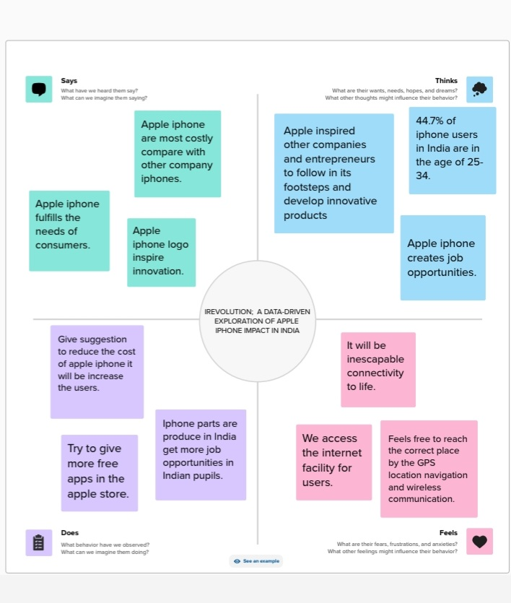

Ideation & Brainstroming Map

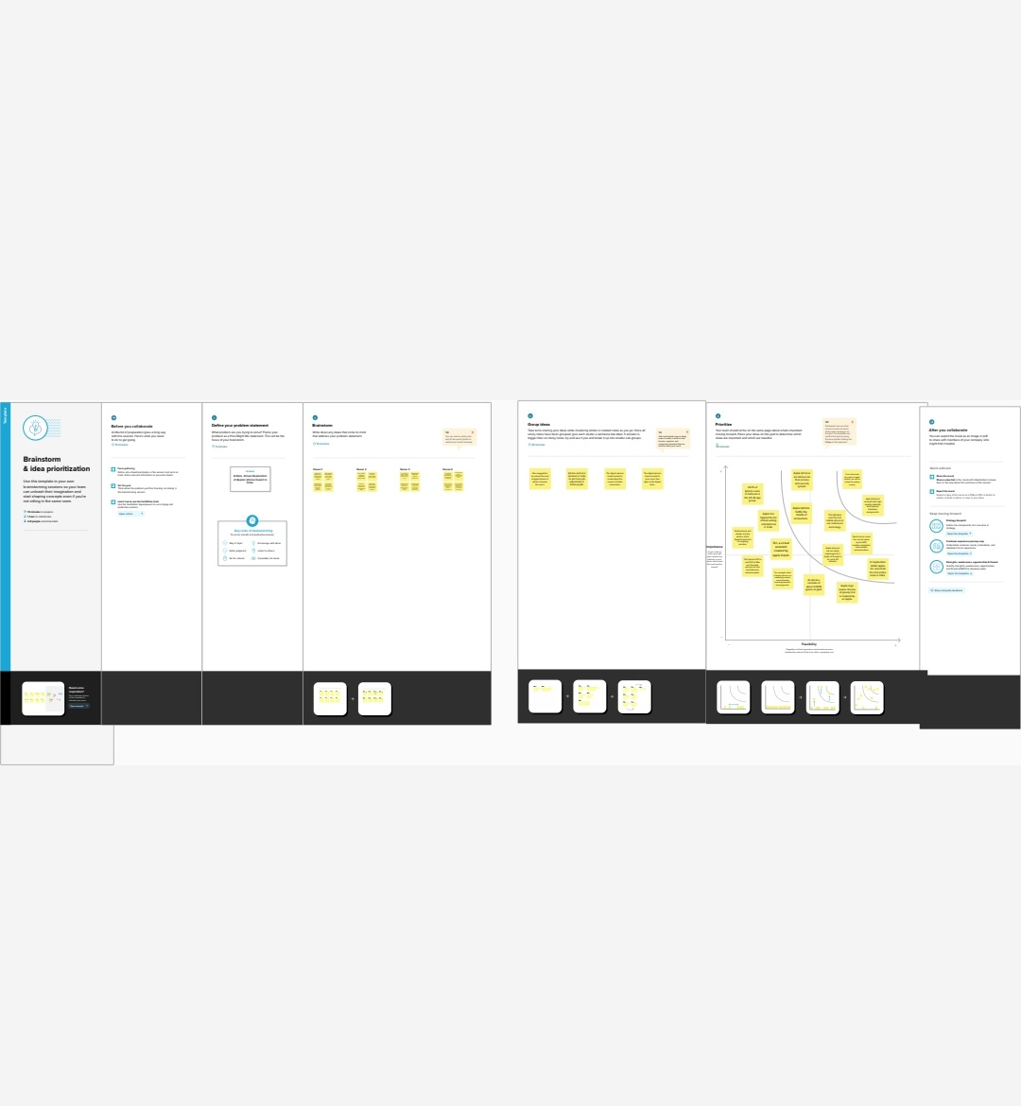

Result

Apple has rapidly expanded its manufacturing operations in India, making it one of its largest iPhone export India. Apple Inc has reached $6 billion (50,000 crores) in revenues in India in 2020-23 (FY23).

Advantages

* India’s vast population and increasing technological adoption make it’s a prime market for Apple. As more Indian consumers look towards premium smartphones, Apple’s market share is poised to rise.
* As per the reported projection by Morgan Stanley, Within the next five years, India could contribute 15 per cent of Apple’s revenue growth. This highlights India’s strategic importance in Apple’s global landscape and emphasises the potential of this emerging market.
* India is also projected to amount for 20 per cent of Apple’s installed base growth. This refers to the cumulative number of devices using Apple’s services, including iPhones, iPads and Macs, and highlights the potential for extended engagement with Indian consumers.

Disadvantages

* Apples’s journey in India hasn’t been without challenges. High tariffs, competition from brands offering more budget-friendly options, and the complex retail landscape have been roadblocks.
* However, Apple’s strategic alliances, such as its collaboration with Foxconn and now its focus on local manufacturing, signal a clear understanding of the unique challenges and opportunities in the Indian market.
* Foxconn’s proposal to establish a supplementary plant in Karnataka is more than just another business venture. It represents a significant stride in Apple’s manufacturing strategy, India’s ‘Make in India’ initiative and the broader implications for technological growth and local employment.

Application

Apple’s alignment with India’s manufacturing and technological goals, such as the ‘Make in India’ initiative, indicates a strategic partnership that goes beyond mere sales. It’s about collaboration, growth, and shared values. By increasing iPhone manufacturing in India and investing in manufacturing plants like the one proposed by Foxconn, Apple not only ensures a more cost-effective production line but also fosters local employment and technological advancement. This reflects a vision that transcends short-term gains and looks at long-term engagement with the Indian market.

Conclusion

Apple’s $40 billion projection becomes a reality or remains an unfulfilled promise. What is certain, though, is that the tech giant’s increased focus on India will have a lasting impact on the country’s technology landscape, possibly influencing other global players to invert in the world’s largest democracy.

Future scope

The factors that are going to affect ios application development in the coming years are as follows:

1. Globalization

App studios are going to face increased competition, globally.

1. Cross-Device Development

App for television, cars, smartphones and others are on the boom.

1. Developer Tools

The prevalence of easily application programming interfaces and software developer kits will make it easier to stitch top-end app functionality together.

1. Supply & Demand

The startups and enterprises app demands are not going to be an abate, however, studios will be pressed by both the international and independent markets with minimizes profit margins.

1. Monetization

The viability of paid app downloads will be mitigated by different business models, inclusive of in-app purchases and subscription services.