Clinicopathological findings of the cats included in the study
 |  | Cats included in the study | Reference interval
Haematology
 | RBCs (x10⁶/µL) | 9.07 (6.73 – 10.18) | 7 – 11
 | WBCs (x10³/µL) | 6.2 (2.9 – 12.5) | 4.8 – 14.93
 | Hb (g/dL) | 13.7 (10 – 15.7) | 10 – 16
 | Hct (%) | 39.8 (31.5 – 47.1) | 32 – 48
 | MCV (fL) | 43.2 (40.9 – 52.9) | 36 – 55
 | MCH (pg) | 15 (14.3 – 16.5) | 12.3 – 16.2
 | MCHC (g/dL) | 35 (31.3 – 36.3) | 31 – 36
 | RDW (%) | 15.4 (14.7 – 19.7) | 13 – 17
 | MPV (fL) | 14.2 (10.8 – 28.2) | 8 – 26
 | Platelets (x10³/µL) | 226 (28 – 480) | 150 – 500
 | Reticulocytes (x10³/µL) | 24.5 (13.5 – 70.4) | 0 – 80
 | Neutrophils (/µL) | 2700 (1240 – 6380) | 1600 – 10000
 | Monocytes (/µL) | 100 (40 – 270) | 0 – 650
 | Lymphocytes (/µL) | 2140 (1100 – 6920) | 900 – 5600
 | Basophils (/µL) | 10 (0 – 210) | 0 – 60
 | Eosinophil (/µL) | 250 (0 – 605) | 60 – 1470
Serum Chemistry
 | ALT (U/L) | 48 (13 – 71) | 20 – 72
 | AST (U/L) | 27 (15 – 38) | 9 – 40
 | ALP (U/L) | 28 (13 – 64) | 20 – 140
 | GGT (U/L) | 0.1 (0.1 – 0.5) | 0 – 4
 | Total Bilirubin (mg/dL) | 0.17 (0.07 – 0.24) | 0 – 0.35
 | Cholesterol (mg/dL) | 176 (100 – 338) | 59 – 230
 | Glucose (mg/dL) | 120 (65 – 278) | 65 – 148
 | Albumin (g/dL) | 3.67 (3.38 – 4.26) | 2.6 – 4
 | Total Protein (g/dL) | 7.7 (6.93 – 8.79) | 6.5 – 8.8
 | A:G (g:g) | 0.94 (0.71 – 1.19) | 0.52 – 1.2
 | Creatinine (mg/dL) | 1.54 (0.95 – 2.11) | 0.8 – 1.8
 | Urea (mg/dL) | 49 (37 – 82) | 30 – 65
 | Phosphate (mg/dL) | 4.33 (2.66 – 7.22) | 2.5 – 6.2
 | Potassium (mEq/L) | 4.3 (3.6 – 5.2) | 3.4 – 5.1
 | Sodium (mEq/L) | 154 (149 – 160) | 145 – 155
 | Chloride (mEq/L) | 117.2 (113.2 – 122.9) | 110 – 123
 | Magnesium (mg/dL) | 2.33 (1.98 – 2.75) | 1.9 – 2.8
 | Total Calcium (mg/dL) | 10.2 (9.6 – 11.2) | 8.5 – 10.5
Urinalysis
 | USG | 1052 (1015 – 1080) | >1040
 | pH | 6 (6 – 7)
 | Glucose (mg/dL) | Negative* | Negative
 | Bilirubin (mg/dL) | Negative | Negative
 | Microscopic sediment examination | 11/19 cats had erythrocytes and/or leucocytes. Among these 11 cats, other findings included: struvite crystals (2/11), lipid droplets (2/11), amorphous crystals (1/11) and urothelial cells (1/11). 1/19 cat showed only the presence of rare lipid droplets and 1/19 cat only had spermaturia. No other microscopic findings were present in the remaining 6/19 cats

Data are reported as median and range (min – max). Blood samples were collected by standard venipuncture using a blood vacuum collection system (Vacutest Kima, Arzergrande, Italy), and concomitant urine samples were obtained using ultrasound-guided cystocentesis. For each cat, a K3 ethylene diamine tetra-acetic acid (K3EDTA) blood sample was used for the complete blood count (CBC), and the serum sample underwent a chemical profile. CBC was carried out using an automated haematology analyzer (ADVIA 2120, Siemens Healthcare Diagnostics, Erlangen, Germany). Haematological evaluation was completed with a microscopic blood smear examination using May-Grünwald Giemsa staining. Serum chemistry profile was determined as reported previously (Urbani et al., 2020). Urinalysis included urine specific gravity, dipstick (Combur10TestUX, Roche, Basel, Switzerland) and microscopic sediment examination. Serum chemical analysis was carried out using an automated analyser (AU480, Beckman Coulter-Olympus, Brea, CA, USA).
A:G, albumin to globulin ratio; ALP, alkaline phosphatase level; ALT, alanine aminotransferase; AST, aspartate aminotransferase; GGT, gamma(γ)-glutamyl transferase; Hb, hemoglobin; Hct, hematocrit value; MCH, mean corpuscular haemoglobin; MCHC, mean corpuscular haemoglobin concentration; MCV, mean corpuscular volume; MPV, mean platelet volume; RBCs, red blood cells; RDW, red cell distribution width; USG, urine specific gravity; WBCs, white blood cells.
*Urinary glucose concentration was negative in all the cats included in the study, only one cat resulted positive for a urinary glucose concentration of 50 mg/dL.

Within subject absolute and relative abundance of the taxa present in different orders (colour coded)
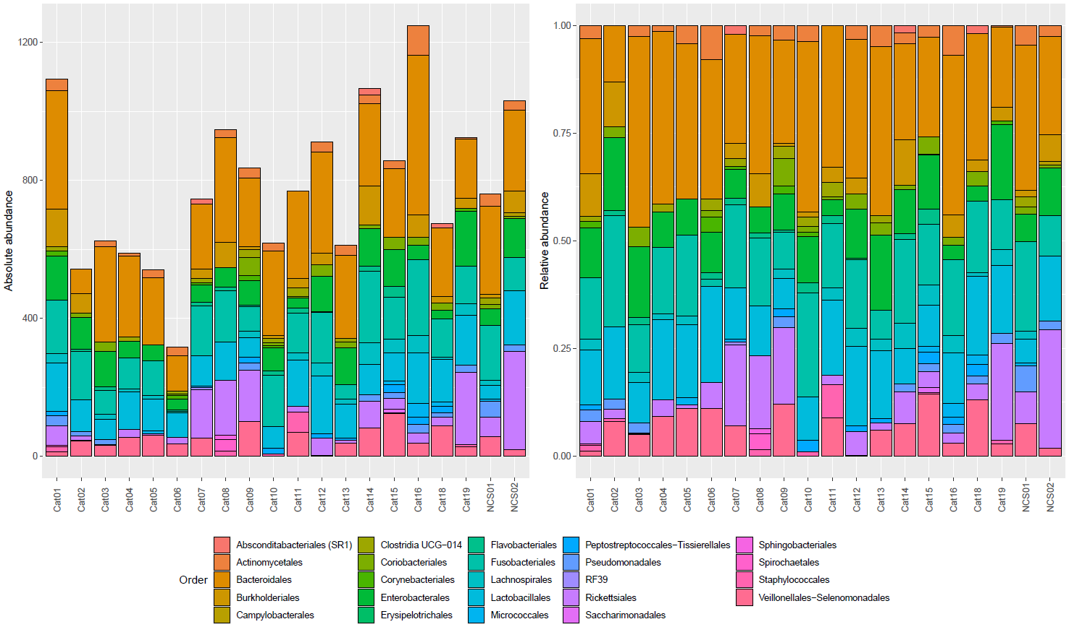
The taxonomy was assigned to the sequence variants using the naive Bayesian classifier method implemented in DADA2 version 1.26.0 pipeline (Callahan et al., 2016). To this purpose, the Silva taxonomic training data formatted for DADA2 (version 138; McLaren, 2020) was used as a reference.
NCS01 and NCS02, negative controls to 16S rRNA gene sequencing carried out at the beginning and at the end of the study, respectively.
Within subject absolute and relative abundance of the taxa present in different genera (colour coded)
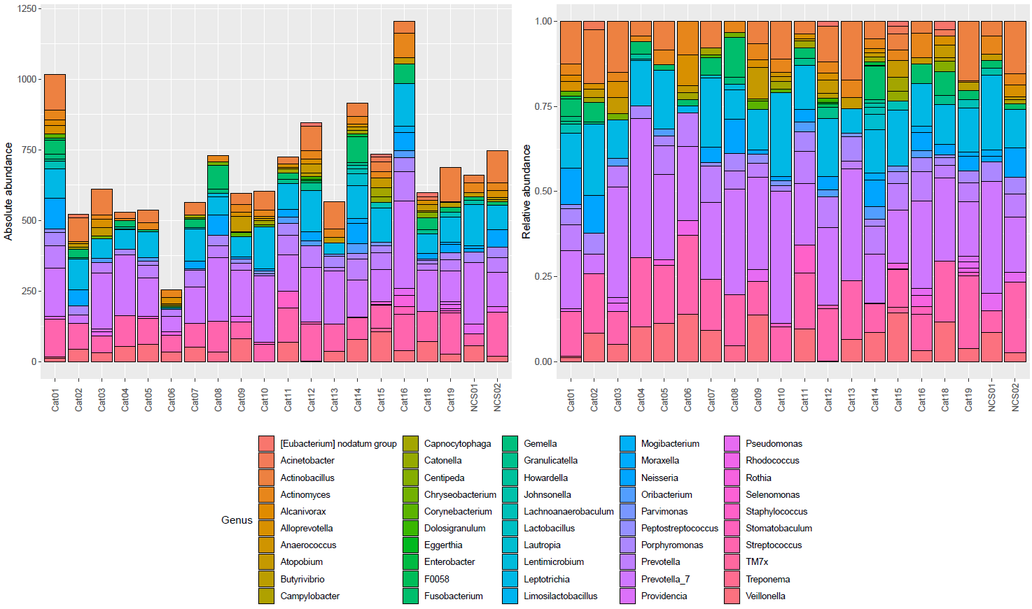
The taxonomy was assigned to the sequence variants using the naive Bayesian classifier method implemented in DADA2 version 1.26.0 pipeline (Callahan et al., 2016). To this purpose, the Silva taxonomic training data formatted for DADA2 (version 138; McLaren, 2020) was used as a reference.
NCS01 and NCS02, negative controls to 16S rRNA gene sequencing carried out at the beginning and at the end of the study, respectively.

