News search layout update proposal

Purpose
Updating the news search so that it is more user-centric and the web audience can find what they are looking for easily.

Recommendations

News search
Recommended changes to the news search were based on user needs assessments, best practices and research of the news on the following websites: RCMP.ca, Government of Canada, UK government, and other non-government resources.
- Placemats at the top of the web page can be added to link to related news and communication topics as shown on Government of Canada news landing page template. Based on categories, these placemats may include:
  - Read the latest communications from the Commissioner will provide the list of Statements, Speeches, etc. There are not many Communications from the Commissioner currently listed in the News search - I only located 3 Statements from the Commissioner. However, it can be developed further.
  - Subscribe to news and communications – Link to a subscription form. A key finding of the UK Government news survey showed that users over-subscribed to get the latest news as an alternative to searching the news. This may not be able to be done soon. However, we may be able to link to this current content:
    - Web feeds
    - Media relations offices
    - Canada.ca news
    - Public Safety Canada news
  - Search the archived news and communications – If we need to differentiate the news by recent or archived, we will need a cut-off date to identify news that is no longer current.
- Studies showed that users did not really separate the news into distinct types. It did not matter whether the news item was a news release, media advisory, etc. I decided to remove this from the left-hand search and filtres.
Following this line of research, I realized that we may not need to differentiate whether the news was archived or not. The News becomes more dynamic and user-centric by defining the classification methods of the Search, Filtre and Sort elements. Sort can be added as an element above the listed results. The results would default to listing items by most recent on page load. Other filtres included in the Sort are:
  - Recent
  - Oldest
  - Most viewed
  - Relevance (Shown when the search and filtres are used (left-hand))
Note: Currently the two types of filtres in two separate locations on the news search page seems very confusing.
- Adding Search and Filtres on the left-hand side
  - The user can search by keyword anytime
  - Topic – The listed items to be determined. Example:
    - Assault
    - Break and enter
    - Disturbance
    - Fraud – money, identity, scams
    - Homicide
    - Illegal border crossing
    - Illicit drugs
    - Missing person
    - Organized crime
    - Property damage - vandalism
    - Community interest – reports, campaigns, highlighting community work
    - Media relations
    - Theft – robbery, stolen
    - Traffic services – all vehicles
    - Trafficking – human, drug
    - Wanted
    - Weapons – firearms, laser, drones
  - Province and Territories remain the same
  - Division or Federal Policing region remains the same
  - Publishing date range remains the same
Notes: Using Filters and Sort elements to narrow down news results by date, category, keywords, topics, divisions, location and recent to oldest, helps the users control the way they sort through news and find exactly what they are looking for (left-hand). As a result, this may alleviate the need for an advanced search. It would become more of a one-stop search for news.
When the Filtres are applied, they will display above the Sort list, so the user can easily dismiss them if they do not need to be applied.
If the user applies filtres to the search, they will display above the Sort list. This will give the user the option to dismiss them right there or return apply different filtres (left-hand)
- Since we will already have a Sort list that includes displaying news results by oldest/recent, I would recommend removing the need for “Archived news and communications” and “Archived news and communications results” pages.
- Findings show that users of news gravitate toward visuals. With this is mind, the layout of each news item can be identified by an optional image (thumbnail-generated when an image is available)
If the News and communications results appear on this page, there is no need for an additional results page.
- Pagination following the UK Government news pagination as well as the new Government of Canada style for usability and mobility
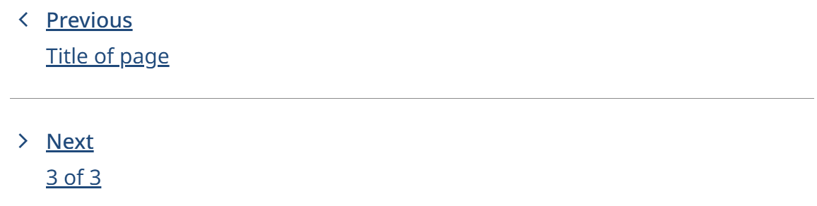
- A Features section can be added to the bottom of the page to highlight most current noteworthy news. (Following the Government of Canada news landing page template)

News/Communication item page
Recommended changes to the news/communication web page were based on user needs assessments, best practices and research of the news on the following websites: RCMP.ca, Government of Canada, UK government, and other non-government resources.
- Proposing the breadcrumbs point to News and communication landing page.
Note: Link to the division/detachment in the details section of the page.
- Content type can still be located as a sub-title
- Amendments (Optional)- Mark the amendment in the title and summarize/list the changes by date in alert – Change the content (Example: Consort RCMP requests assistance in locating person reported missing – Update # 4 | Royal Canadian Mounted Police)
Name the amendment (Optional) in the heading 1. For example: Missing Persons and Wanted – Located, Others – Updated, etc. option
- Lead sentence would be the same as the summary in the results page. Stylized as a lead paragraph.
- Details section would include the topic label (consistent identifier), date of original publication and detachment
- Can link to the divisional homepage
- The divisions and community detachment would still have the canned news results on their websites as they do now.
- Body and Contact signature would remain the same
- Canned search results according to topic in the Explore related topics section when there is more than one topic
Explore related topics section would contain information if there were more than one topic. For example: RCMP charge Enfield man with assault; multiple weapons seized:
  - Assault
  - Weapons

Resources
- GC Design System
- Royal Canadian Mounted Police
- Canada.ca
- News and communications - GOV.UK
- Design - Service Manual - GOV.UK
- Design Guide: News Section of Your Website | Three Seven
- ‘Give it to me straight’: what people need from news on GOV.UK – Inside GOV.UK
- Best practices in digital accuracy and corrections

