* What will be included in your app’s description and what kind of icon will best represent your app once it is made available in the app store?

The description of the app should mention that it is a weight monitoring application with the ability to add daily metrics to help chart weight loss. It has the ability to amend previous entries as well as to delete them entirely. I made a temporary icon to add in the UI as it looked very blank without it. I think something like a scale would be a good icon. Something to show the user as a glance what the app is meant to be used for.

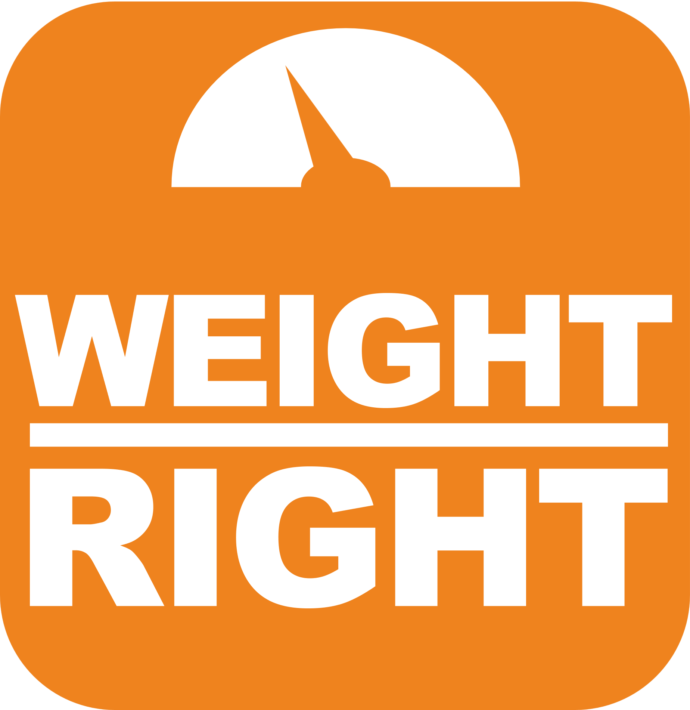

* Which version(s) of Android will your app successfully run on? Have you included the most current version? Note that with each version of Android, new components are introduced that add considerations and challenges in the development.

The minimum SDK version my app will run on is 28 with the target being version 33. On version 28 (according to android studio) this app will run on approximately 81.2% of devices.

* What permissions will your app ask for? Be sure these are only permissions that are necessary for your app to run. For example, does your manifest ask for permission to record phone audio when your app does not use it?

As it stands, with the features that are currently implemented the only permission we are asking for is SMS notifications. This is because that was a requirement. If I were to take this app further, I would reconfigure it to just use push notifications, as SMS for an app that is on your phone anyways seems like overkill to me, but also this being my first android app…I am probably wrong. I have included in the manifest to ask for SMS permissions only.

* What is your plan for monetization of the app? Consider whether your app will include ads, require a one-time payment, both, or neither.

In the state that it is in (which isn’t bad just nothing that I think anyone would pay for) I think free is the way to go. However, if I were to work on this more or enlist a couple others to work on it as well, it might be something that would fill a niche. If that were the case, I would monetize it by having a banner ad on top and bottom of the application for the free version which would have less features. I would also offer a paid version that has no ads and all the features.