Tutorial 4 – Muscle-tendon Personalization
Tutorial Developer: Robert Salati, B.J. Fregly, Rice Computational Neuromechanics Lab, Rice University
The Muscle–tendon Model Personalization tool finds an optimal set of subject-specific muscle–tendon properties and muscle activations from EMG, joint kinematic, and joint moment data by balancing optimization cost function terms related to muscle properties, similarity of properties among grouped muscles, and matching of EMG-driven and experimental inverse dynamics joint moments. Muscle activation and force predictions are sensitive to optimal muscle fiber length and tendon slack length. Therefore, reliable personalization of these parameters is essential for generating reliable predictions of muscle activations and forces during predictive simulations of movement.
The inputs to the MTP tool are a post-JMP OpenSim model as well as IK motion, ID load, muscle–tendon length and velocity, and muscle moment arm data from one or more motion trials of interest.
Before running MTP:
- Open the OpenSim model UF_Subject_3_reduced_muscles.osim in the OpenSim GUI.
- Under the Forces tab on the model, explore the muscles available.
- Take note of the extra groups added.
  - These are added for organization so that MTP/NCP knows which model muscles to group together in the optimization.
  - The four important groups are:
    - Activation Muscle Groups – Muscles that we would expect to have similar activation profiles (ie lateral hamstrings; BFSH and BFLH will have similar activations to each other)
    - Normalized Fiber Length Muscle Groups – Muscles that we would expect to have similar normalized fiber lengths.
    - Collected EMG Muscle Groups – Muscle groups that we do have experimental EMG data for. These must have the same name as the respective EMG channel name your EMG data file (preprocessed\EMGData\gait_1.sto)
    - Missing EMG Muscle Groups – Muscle groups that we do not have experimental EMG data for.
  - These groups need to be created manually in a text editor such as Notepad++, but we have example groups for lower limb models in the NMSM Article download on SimTK: https://simtk.org/frs/?group_id=2397

Setting up an MTP settings file:
- Activate the NMSM GUI in OpenSim by navigating to Tools>User Plugins, and click rcnlPlugin.dll.
- With UF_Subject_3_reduced_muscles.osim selected in the OpenSim GUI, navigate to Tools>Model Personalization>Muscle-tendon Personalization.
  - The following window should be opened:
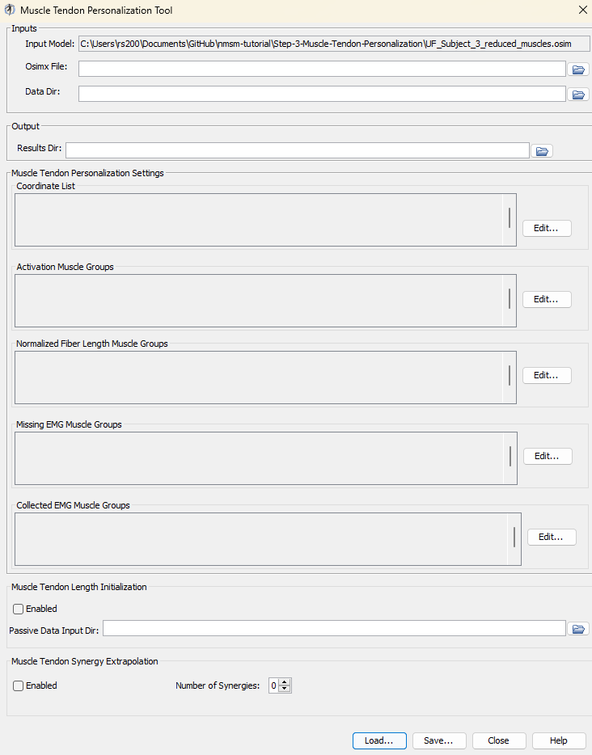
- Leave the Osimx File field empty. This tool outputs an Osimx file, but we do not have one to work with yet. If this field is filled out, the MTP tool will concatenate new elements to the existing Osimx file.
- Set the data directory to be preprocessed.
- Set the results directory to be MTPResultsV1.
- For the coordinate list, select: (hip_flexion_r, knee_angle_r, ankle_angle_r).
- For activation muscle groups, select (HipFlexorsActivationGroupR, GlutmaxActivationGroupR, HamslatActivationGroupR, VasActivationGroupR, GasActivationGroupR).
  - Tip: The filter box at the top is very helpful to filter only activation groups.
- For normalized fiber length groups, select (GlutmaxNormalizedFiberLengthGroupR, HamsNormalizedFiberLengthGroupR, VasNormalizedFiberLengthGroupR, GasNormalizedFiberLengthGroupR).
- For missing EMG muscle groups, select (HipFlexorsMissingEMGChannelGroup)
- For collected EMG muscle groups, select (GlutMaxLat, RecFem, BicFemLong, BicFemShort, VastMed, GasMed, Sol, TibAnt).
- Enable Muscle Tendon Length Initialization (MTLI).
- Set the passive data input directory to passive_moment_data.
- Enable Muscle tendon Synergy Extrapolation (SynX) with 3 synergies.
- Save this settings file as MTPSettingsV1.xml.
- Open MTPSettingsV1.xml in a text editor of your choice and explore the settings file.

Running MTP:
- Open MATLAB and open runMTP.m in your tutorial directory.
- Open the project file (Project.prj inside your installation of nmsm-core).
- Run the MATLAB section labelled Run MTP V1.
  - With the section selected, press shift+enter to run a section.

Post MTP Analysis:
- Look through the plots created by the script. If everything was done correctly, there should be 6 plots.
  - Plot 1 – Joint Moment Matching: Joint moments generated by muscle forces (with and without SynX) compared to Inverse Dynamics joint moments.
  - Plot 2 – Muscle Activations: Muscle excitations and activations (with and without SynX) for all muscles included in the MTP run.
  - Plot 3 – Normalized Fiber Lengths: Normalized fiber lengths for all muscles included in the MTP run. Red dashed lines at 1.0 and 0.6 indicate the optimal working range for muscles.
  - Plot 4 – Muscle Force: The active, passive, and total force generated by each muscle in the MTP run.
  - Plot 5 – Passive Joint Moment Matching: The passive moment matching achieved by the MTLI optimization.
  - Plot 6 – Hill-type Muscle Model Parameters: The muscle model parameters for all optimized muscles in this MTP run. These parameters are the primary output of the MTP tool.
- Using a text editor, explore UF_Subject_3_reduced_muscles_mtp.osimx in MTPResultsV1. This file is used as an input for the Neural Control Personalization (NCP) tool, and for Treatment Optimization tools if using synergy controls.

Experiment with different numbers of synergies:
- Create a copy of MTPSettingsV1.xml and name it MTPSettingsV2.xml.
- Open MTPSettingsV2.xml in a text editor of your choice.
- Change <results_directory> to MTPResultsV2.
- Inside <MTPSynergyExtrapolation>, change <number_of_synergies> to 4.
- Run the MATLAB section labelled Run MTP V2.

Run MTP without SynX:
- Create a copy of MTPSettingsV1.xml and name it MTPSettingsV3.xml
- Open MTPSettingsV3.xml in a text editor of your choice.
- Change the <results_directory> to MTPResultsV3.
- Inside <MTPSynergyExtrapolation>, change <is_enabled> to false.
- Save this settings file as MTPSettingsV3.xml.
- Run the MATLAB section labelled Run MTP V3.

