Apply filters to SQL queries

Project description
Utilizing SQL a CS analyst is able to pinpoint specific events that are flags for possible malicious activity and to identify vulnerabilities in the system (such as machines that have not had security patches installed). Using specific command strings in SQL an analyst is able to find specific sets of data within large databases consisting of petabytes of data. In this project I searched a database for failed login attempts after a certain time, ones that occurred outside of a certain geographical location, as well as, locating specific machines that belong to specific departments.

Retrieve after hours failed login attempts
Using Select I chose to display all columns using *. Then From to choose the location or file log_in_attempts. The Where operator to choose the column login_times and > to indicate a larger variable than ‘18:00’ (making sure to utilize apostrophes to indicate to the system to process the input as a time string or text rather than a number. Then used AND operator to tell the system that the following criteria needs to be applied to the output data as well. Success is given to indicate whether the action was successful and requires a boolean character either 1 for true or 0 for false.

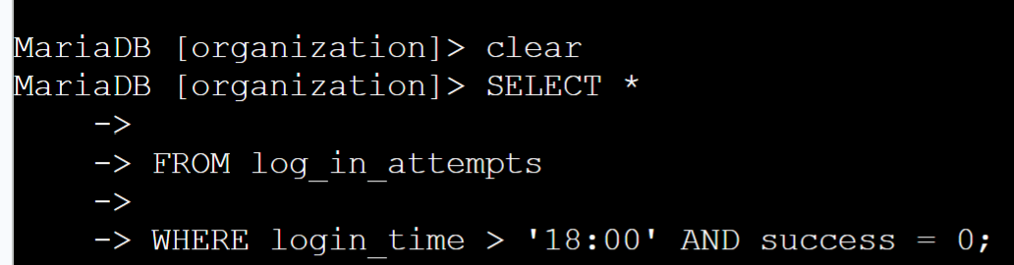

Retrieve login attempts on specific dates
In this section I used different operators to find login attempts on 2 specific days. The = indicates the output must be exact to the dates as the following string of data. Then I utilized OR to indicate I want the output to have attempts on with one date or the other.
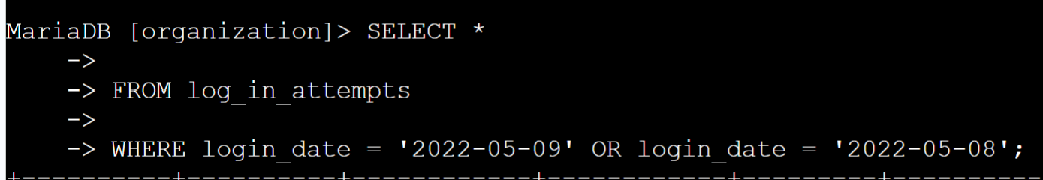

Retrieve login attempts outside of Mexico
Here I used the NOT operator to indicate that I want lines that did not contain items beginning with MEX under the country column. I used the % as wildcard indicating 0 or more characters following MEX.

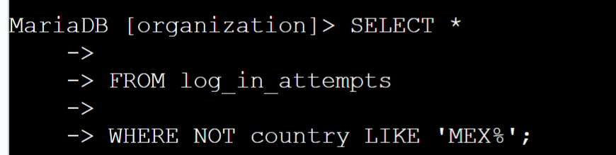

Retrieve employees in Marketing
Here I use the = operator to indicate that the output of the command should be all rows with marketing in the department column.
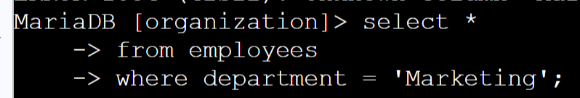

Retrieve employees in Finance or Sales
Here I do the same thing as the last section. However I want the output to inclue 2 different departments and since there are 2 different values being requested I put in the column name individually and operator individually. Separating the 2 requests by OR to indicate the out put should include either one or the other.
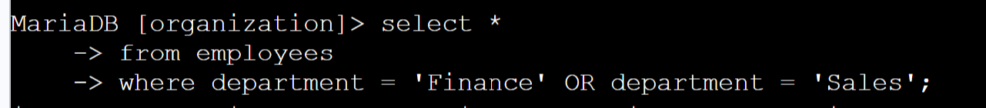

Retrieve all employees not in IT
In this section of the project I used the same operators and column name but included NOT in front of the column name department to indicate that I do not what anyone in this department to be displayed.

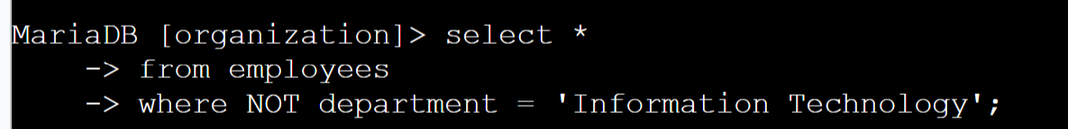

Summary
In this project it is demonstrated how and you use the operators OR, AND, Like, and NOT to achieve the desired output of information when querying an SQL database within MariaDB.

