Foundation Deep Learning
Kaggle Competition
Romain COLLEDANI
Théo COSTES
Antoine GALLIER
Abstract
This small report presents our work for the Kaggle competition of foundation deep learning: Nuclei Instance Segmentation and Classification. We will detail in each step of this report our method for the choice of the model, the training and how we manage to improve the accuracy.
This report works as a complement of what has been done in the notebooks, there is no code here.
- Presentation of the competition dataset
The aim of the competition is to do binary segmentation of nuclei from cell images. For that we got a dataset of 2656 images and mask to train a model that will finally predict the mask of 5245 cell images (test set). You can fin below an example of images and mask from the training set:

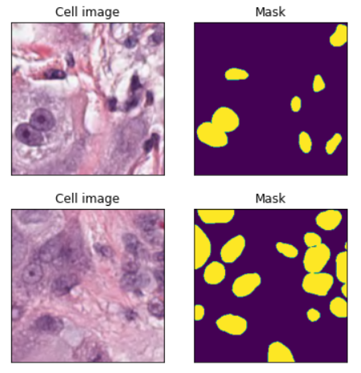
Figure 1: Visualization of a training set sample
- Model
After a period of research about different techniques of images segmentation, it appears that U-net model was one of the best. The U-net model is based on a classification on every pixel of the input, that allows it to be able to detect the borders. This model was the one that was closest to the course and therefore the most understandable for us.
This model is built in 2 parts:
- A first one based on a general convolutional process, that catch the pattern of images.
- A second one named the transpose convolution, that perform up sampling of an image with learnable parameters from the first part.
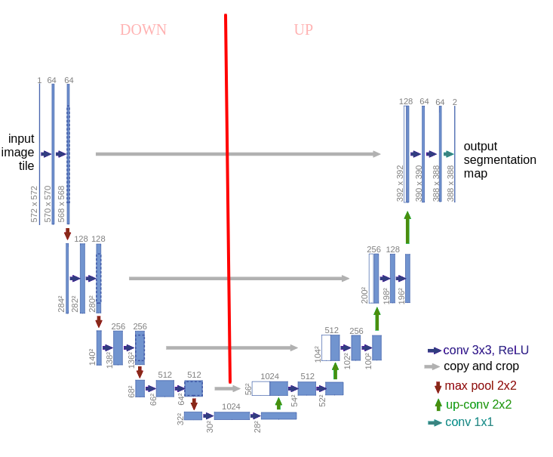
Figure 2: U-net architecture
One first major part of this project was to fully understand each part of this model, so that we could then tune all the hyperparameters and augment input to boost its performance.
- Data augmentation
After several tries with normal input and some changes of the hyper parameters we figure out that the key to improve the accuracy of U-net was to pre-process the images before using it in the model. We use for our best performance two techniques of data augmentation, one based on the geometric transformation of images, and the other one based on the color transformation of images.
- The geometrics transformations: One of the first observations we made by observing the dataset is that many images had similarities. This fact pushes us to randomly perform some modification on images so that we limit this redundancy in the dataset and avoid overfitting. We select the classical transformation such that rotation, flip or cropping. For evident reason, we apply those transformation on both images and masks of the training set.
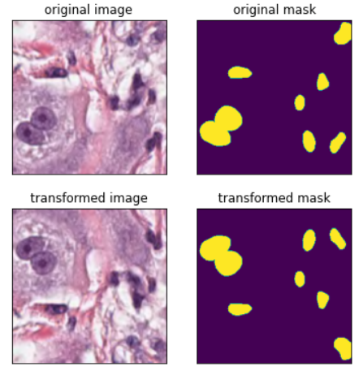
Figure 3: Geometric transformation
- The “color” transformation: After this step we got a slight improvement on our accuracy (Dice around 0.5 in the scoring), but we wanted to get better performance than the reference score (0.635). So, we decided to add some transformation on the image’s colors itself. In the documentation we find out that with the same ideas of the geometric transformation, by randomly changing the color property of images, we could make our model more robust. We decide to use the following transformation: image blurring, and randomly modify the brightness and contrast of images.
Transformed
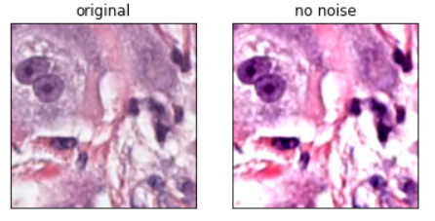
Figure 4: Color transformation
All those data augmentation made on input allow us to significatively improve our accuracy, and it allow us to realize the impact of this step in a deep learning images problem, in the general case.
- Model Training and Post-processing
  - Hyper-parameters
For the model training, some hyper-parameters well defined allow us to improve a bit the performance of our model. Firstly, we split the train dataset in that way: 75% training and 25% validation. Thus, we got a consequent part on the validation so that we can follow the performance on a real dataset.
After many try, we reach a combination of hyper parameters that give us the best performance with U-net. The configuration is the following:
- Batch size = 10
- Epoch = 60
- Optimizer: Adam with Lr = 0.001
- Criterion: combination of the BCE Loss and the Dice loss (scoring method), this combination to leverage the flexibility of Dice loss of class imbalance and use BCE Loss for curve smoothing.
You can find below the learning graph of our model with this configuration:
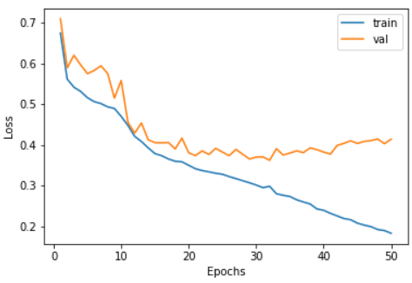
Figure 5: Train/Val loss of U-net during Training
  - Post-processing
Before submitting, we need to put the prediction in a mask format, with binary pixels. The idea is to find the optimal threshold value where the prediction mask match with the true mask. For these parts, the only way we find it was to compute the mean of pixels value of images, and then with few iterations reach to the optimal one. One way to improve our accuracy would be to find a better process for the post-processing.
- Conclusion
This project allows us to fully apply all we learn during the foundation deep learning course and discover new techniques in images segmentation. We learnt the importance of pre-processing for a deep learning problem and methods to learn efficiently a model. Unfortunately, we fail in getting a better accuracy than the reference. At the end, our best score was 0.5851.
Some ideas of improvement that we do not have time to put in practice:
- Find more technical ways of data augmentation.
- Simplify the model (simple fully convolutional network with a pretrained model like vgg16.

