Bob Colts

Dr. Shaik

CIST – 0150 / 2020

23 January 2024

WK1 Homework: GIT Tutorial

* GitHub Repo
  + A screenshot of a computer

    Description automatically generated<https://github.com/rcolts34/Intro-to-Web-Project.git>
* Cd
  + 
  + Changes directory
* Git init
  + 
  + Initializes a new Git repository
* Git add
  + 
  + Stages a file so that it can be committed and pushed to GitHub
* Git Status
  + 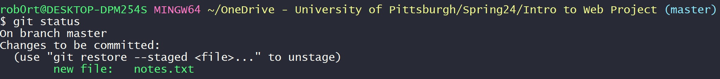
  + Shows changed files, stages files, and untracked files
* Git add
  + 
  + Stages a file so that it can be committed and pushed to GitHub
* Git commit -m
  + 
  + Saves changes locally
* Git remote add origin “repo link”
  + 
  + Links to remote repository
* Git push origin
  + A screen shot of a computer

    Description automatically generated
  + Uploads local repository to remote repository
* Git log
  + A screen shot of a computer code

    Description automatically generated
  + Shows a log of commits
* Git branch
  + 
  + Displays current branch
* Git branch “name”
  + 
  + Creates new branch
* Git checkout “name”
  + 
  + Switches branches
* Git branch -d “name”
  + 
  + Deletes branch
* Git merge “name”
  + 
  + Merges branch with current branch
* Git config credential.helper store
  + 
  + Stores user login credentials
* Git diff
  + 
  + Shows difference between two commits
* Git fetch
  + A screen shot of a computer

    Description automatically generated
  + Shows the latest changes in the remote repo
* Git pull origin “branch”
  + A screen shot of a computer

    Description automatically generated
  + Updates local repo from remote repo
* Git reset –hard “commit id”
  + 
  + Resets to that id (removes all commits after that ID
* Git push -f origin “branch”
  + 
  + Forces update to remote repo
* Git clone “repo”
  + A screen shot of a computer

    Description automatically generated
  + Get a copy of remote repository in local
* Git revert head “commit”
  + 
  + Reverts commits without deleting them
* Git stash
  + 
  + Temporarily saves changes
* Git stash pop
  + A screen shot of a computer

    Description automatically generated
  + Removes latest stash
* Git reset head
  + A screen shot of a computer

    Description automatically generated
  + Undo changes after staging