SCAO case for testing :  Now the Strehl ratio for the direct method are:  - CalibDm.m x wfs.slopes method:  - 100 iterations (cond 1e1) = 0.6830  - 300 iterations (cond 1e1) = 0.7220  - 300 iterations (cond 1e3) = 0.6823  The Strehl for the theoretical case: $Strehl \approx exp(-sigma_{fit}^2) = 0.74 | Tomography case:  dAsterism = 0.1; % 0.5, 0.75, 1.0, 1.5, 2 diameter in arcmin  guideStarWavelength = photometry.R;  guideStarMagnitude = 14;%[14,14.5,15,15.5,16,16.5,17]; % lower later  %% Guide Stars with Regular asterism  astNGS = source('asterism',{[3,arcmin(dAsterism/2),0]},...  'wavelength',guideStarWavelength,...  'magnitude',guideStarMagnitude);
Case of maxRadDeg=3, maxRadDegProj=10  The Strehl results:  - Z2U x pinv(Dz) x wfs.slopes:  - 100 iterations (cond 1e1) = 0.1757  - Z2U x Rmv x wfs.slopes:  - 100 iterations (cond 1e1) =0.1846  - Fz x pinv(Dz) x wfs.slopes:  - 100 iterations (cond 1e1) = 0.1648 (some vertical tilt | DAsterism = 0.1;  Case of maxRadDeg=3, maxRadDegProj=10  - Z2U x Rmv x StackSlopeLarge, 100 iterations: Strehl = 0.1794  Case of maxRadDeg=6, maxRadDegProj=20  - Z2U x Rmv x StackSlopeLarge, 100 iterations: Strehl = 0.4219  Case of maxRadDeg=9, maxRadDegProj=30  - Z2U x Rmv x StackSlopeLarge, 100 iterations: Strehl = 0.6109 | DAsterism = 0.5;  Case of maxRadDeg=3, maxRadDegProj=10  - Z2U x Rmv x StackSlopeLarge, 100 iterations: Strehl = 0.1862  Case of maxRadDeg=6, maxRadDegProj=20  - Z2U x Rmv x StackSlopeLarge, 100 iterations: Strehl = 0.4047
Case of maxRadDeg=6, maxRadDegProj=20  The Strehl results:  - Z2U x pinv(Dz) x wfs.slopes:  - 100 iterations (cond 1e1) = 0.4566  - 100 iterations (cond 1e3) = 0.4654  - Z2U x Rmv x wfs.slopes:  - 100 iterations (cond 1e1) = 0.4246  - 100 iterations (cond 1e3) = 0.4223  - Fz x pinv(Dz) x wfs.slopes:  - 100 iterations (cond 1e1) = 0.3527 |  | 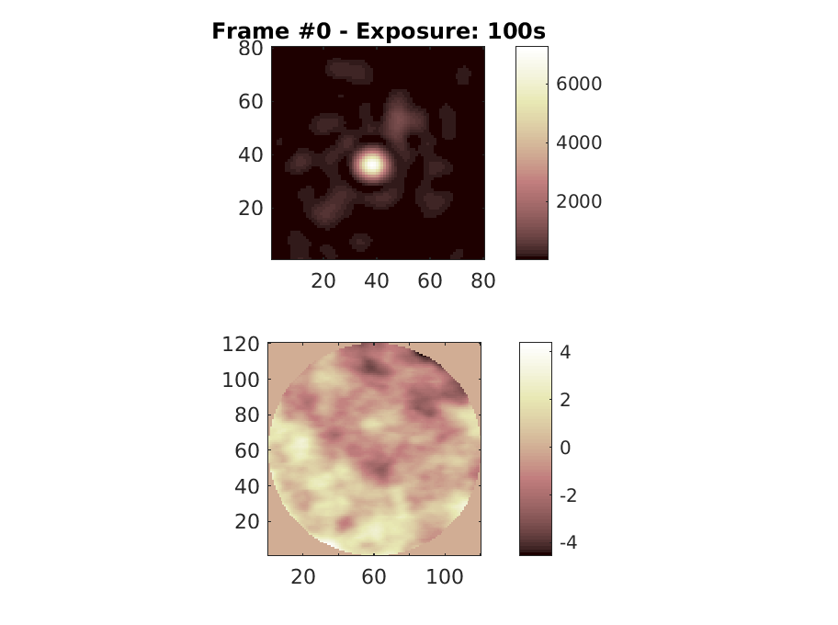

Case of maxRadDeg=9, maxRadDegProj=30
The Strehl results:
- Z2U x pinv(Dz) x wfs.slopes:
  - 100 iterations (cond 1e1) = 0.6314
  - 300 iterations (cond 1e1) = 0.6787
- Z2U x Rmv x wfs.slopes:
  - 100 iterations (cond 1e1) = 0.6154
  - 300 iterations (cond 1e3) = 0.6534
- Fz x pinv(Dz) x wfs.slopes:
  - 100 iterations (cond 1e1) = 0.4882
  - 300 iterations (cond 1e1) = 0.5345

