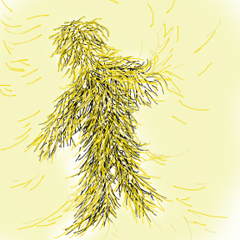

Strawoman

Program Outcomes  Name your process:  Curriculum Mapping  Course Mapping  Course Integration  Curriculum Matrix  Assessment Matrix  Crosswalking  ________________  ________________  Sources of  Program Outcomes:  Mission statements  Professional standards  Accrediting body  Licensure requirements  Catalog descriptions  Syllabi/Course Inventory  Previous IE reports  Previous GPR docs  Advisory boards  Industry  ________________  ________________  ________________ | Course: | Course: | Course: | Course: | Course: | Course: | Course: | Course: | Course: | Course: | Course: | Course: | Course:

Products that may serve as embedded assessments:
Paper / Curriculum Project / Project / Survey / Position Paper / Synchronous+Asynchronous Communication / Exam Pool / Dissertation or Thesis / Exit Portfolio
____________ / ____________ / ____________ / ____________ / ____________ / ____________ / ____________ / ____________ / ____________ /

© 2006 Mary Bold, Ph.D., CFLE, and Lillian Chenoweth, Ph.D.

