TaskStream: Folio Assessment Programs
Generating Reports
Multi-Program Status Report
Shows completion status for single or multiple programs by individual with drill down to specific requirements. May run report on one or multiple students.

From the Folio Assessment Programs: Generating Reports Menu, select Multi-Program Status Report
- Enter Individual's name OR Select Add/Edit Individuals to create a group
Creating a group:
  - Select Add/Edit Individuals
  - Search for member name
  - Check member to add to group, Repeat as necessary
  - Select Save to submit group
- Select programs to run report on from list of programs.
1b
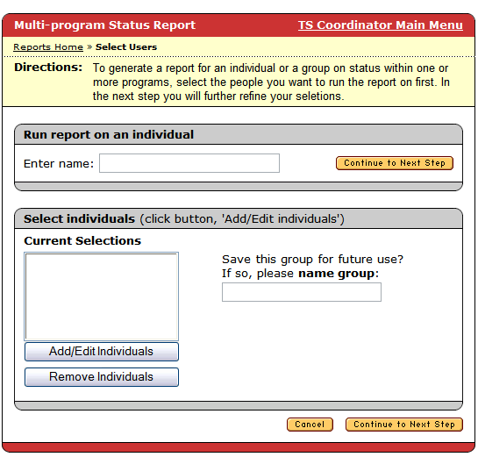
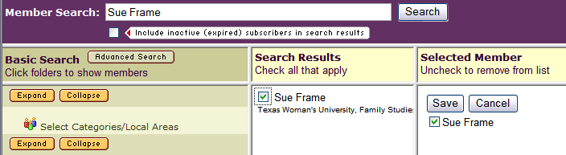

1d
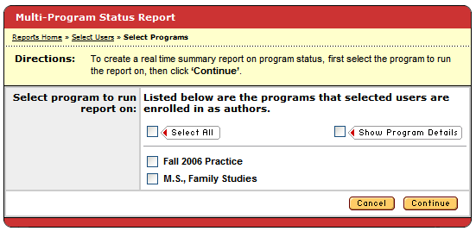
1c

1a
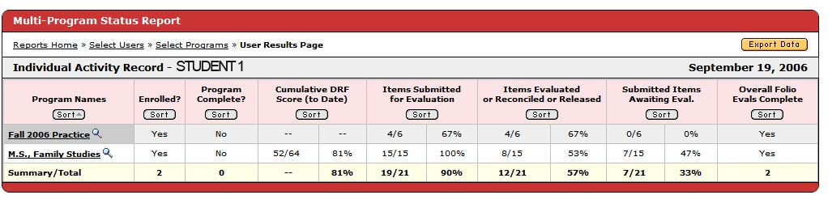
2
Final Report

