Durham Restaurant Listings

For its size, Durham contains a large number of restaurants offering a broad range of cuisines. From traditional British fare to spicy Mexican, there is sufficient variety to suit all tastes. Here we have provided a listing of a few of our favourite restaurants in and around the city centre. All relative directions are from Market Square. A ʻ(c)ʼ denotes national chain. ʻ£ʼ-signs denote relative prices.

Pub Food & British Cuisine

The Court Inn (Pub)
Behind Barclays opposite the Studentsʼ Union.
Tel: 0191 384 7350; £
A wide range of very hearty pub food. Generous portions.

The Cellar Door
On Saddler St., roughly opposite Waterstones.
Tel: 0191 3831856, £
As the name suggests, from the outside this just looks like a door between two other buildings. Larger groups can enjoy their great pizzas and pasta in the cellar dining room.

Rose Tree Inn
Tel: 0191 386 8512
A little outside the city past the University Sports Centre. Good food and beer in a countryside setting. Nice combined with a walk by the river banks.

The Market Tavern (Pub)
On Market Square
Tel: 0191 386 2069; £
Traditional British Pub serving traditional British Food at reasonable prices.

The New Inn (Pub)
Just across the road from the Science Site.
Tel: 0191 384 7308; £
Located just across the road from campus, has standard pub fare for low prices.

Fallen Angel Hotel
On your left, toward the end of Old Elvet.
Tel: 0191 384 1037; £££
Excellent meals in a refined atmosphere. Particularly known for steaks and hamburgers, although with vegetarian options as well.

French

Cafe Rouge (c)
Bottom of Silver Street
Tel: 01913 843429; ££
A touch of Paris in the centre of Durham. French cuisine served in a Parisian-style cafe.

Indian

The Capital
Past the traffic lights on Claypath
Tel: 01913 843429; ££
Often regarded as the best curry house in Durham. Very wide selection of dishes and sundries.

Spice Lounge
Behind the Church on Market Square
Tel: 0191 383 0927; ££
Another great curry house tucked away down the alleyway behind the church on Market Square. Again, a full range of Indian food on offer ranging from mild to ʻblow your head offʼ spicy!!

Rajpooth
Near the traffic lights on Claypath
Tel: 0191 386 1496; ££
Situated just down the road from The Capital, if you canʼt get a table in one just try the other!

Alishaan
On the roundabout at the end of North Road
Tel: 0191 370 9180; ££
New Indian restaurant, with modern decor and atmosphere and excellent food.
Italian
Capriccio
On your left on Saddler St
Tel: 0191 370 9550; £
Relatively new restaurant serving good classic Italian cuisine, more authentic than some of the large chains.

Bistro Italiano
On Claypath, near The Capital (see above).
Tel: 0191 383 0374, ££
Consistently and reliably considered the best Italian restaurant in Durham.

Ask (c)
Part of the Millennium/Gala Complex
Tel: 0191 383 2567; £
Chain Italian restaurant serving up traditional pizzas, pasta and other Mediterranean food.

Pizza Express (c)
On your right on Saddler St.
Tel: 0191 383 2661; ££
Chain Italian restaurant serving up traditional pizzas, pasta and other Mediterranean food.

Mexican/Tex Mex
Tiaʼs
Up Claypath Street, before the traffic lights.
Tel: 0191 383 9001; ££
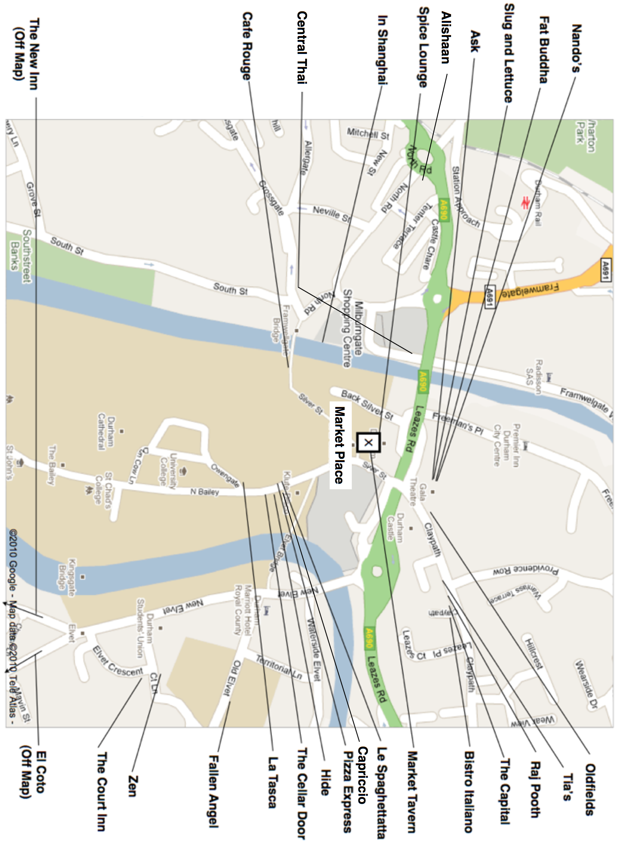
More than your just your typical Mexican fare. Tasty Fajitas and burritos plus other, less spicy options. Make sure you try the “Tiaʼs Rose” - a local speciality!
Nandoʼs (c)
Part of the Millennium/Gala Complex
Tel: 0191 384 5424; £
Chicken, chicken, chicken is on the menu for a meal at Nandoʼs. Choose one of their hot sauces to spice up your pirri pirri chicken (Vegetarian options are also available!).

Spanish & Tapas
La Tasca (c)
Saddler St., just before turn for the Cathedral
Tel: 0845 126 2958; ££
The UKʼs leading chain of tapas bars. Good quality tapas thatʼs great for large groups.

El Coto
Halgarth St., Opposite the Victoria pub
Tel: 0191 384 4007; £££
Small, independent tapas bar serving authentic Spanish cuisine. Excellent food and good service, well worth a visit and caters well for groups.

East Asian
Thai River
The Gates Centre, across Framwellgate Bridge
Tel: 0191 597 8774; ££
Very good Thai restaurant with classic Thai dishes and a nice location overlooking the river Wear.

Nadon Thai
Just off North Road up Crossgate, opposite(ish) the church.
Tel: 0191 3741157; ££
Funky, modern restaurant serving up Asian Fusion cuisine. Excellent food and good service.

Zen
Opposite The Court (see above).
Tel: 0191 384 9588; ££
A lovely restaurant set in a beautiful Victorian building serving up delicious Thai fusion cuisine. Classy decor and good service make this a popular choice.

In Shanghai
Below The Gates Centre, facing river.
Tel: 0191 375 7333; ££
Buffet-style Chinese Restaurant. As well as providing a wide range of choice from the buffet, individually prepared side orders are also included with the meal.

