

Data Technician

Name: Rocio Corcoles Vallejo
Course Date: 17/11/2025
Table of contents
Day 1: Task 1 3
Day 1: Task 2 6
Day 2: Task 1 9
Day 2: Task 2 14
Day 3: Task 1 23
Day 3: Task 2 24
Day 4: Task 1 25
Day 4: Task 2 26
Course Notes 27
Additional Information 27

Day 1: Task 1

Please research the different versions of Tableau, compare them below and explain the limited functionality on ‘Tableau Public’.

Different Tableau versions | Tableau has a selection of products for data visualisation and analysis, each of them designed for different users and purposes. Tableau Desktop provides full-featured analytics and dashboard creation, while Tableau Public is a free version focused on learning and sharing work publicly.  For organizations, Tableau Server and Tableau Cloud enable secure publishing and collaboration at scale, and Tableau Reader allows offline viewing of dashboards. Table 1 below summarizes the key features, uses, connectivity, costs and privacy of each Tableau product.  Tableau Public limitations:  Here there is key points describing the limitations of this free tableau version.  - No data privacy: dashboards/ workbooks can only be published to Tableau Public and are therefore visible to everyone. They cannot be kept private or saved locally on your own computer.  - Limited data connections: cannot connect to servers or live databases. Only able to connect to files like Excel, CSV or google sheets.  - Data size limited: Maximum of 15 million rows per workbook, no able to work with very large data sets.  - Reduce analytics features: Compared to advanced ones in tableau desktop. Has limited calculations options and modelling.  - Not suitable for business use: it’s mainly for students learning portfolios and personal projects due to public sharing and limited security.
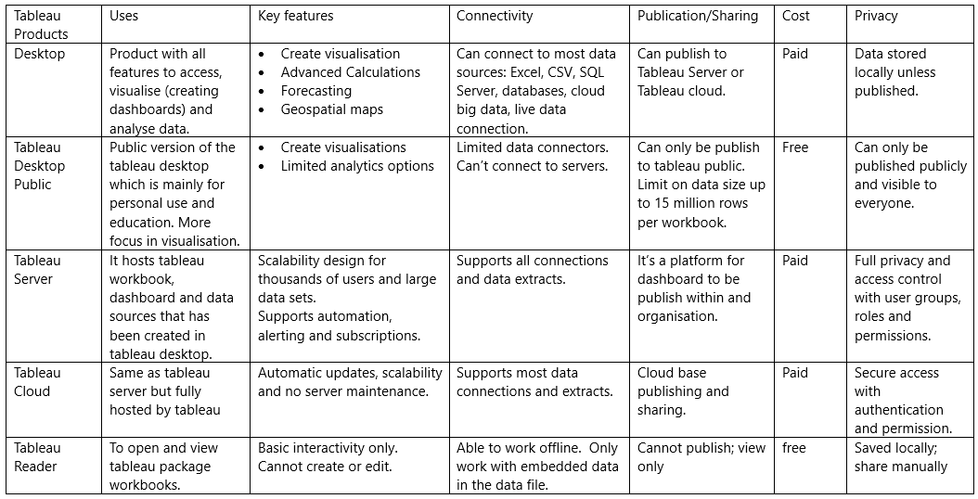
Table 1. Tableau Products

Day 1: Task 2

Using the EMSI_JobChange_UK dataset, create your own dashboard, I want to see a bar chart showing percentage change and a UK based map showing the key city locations impacted.

Paste your print screen here | 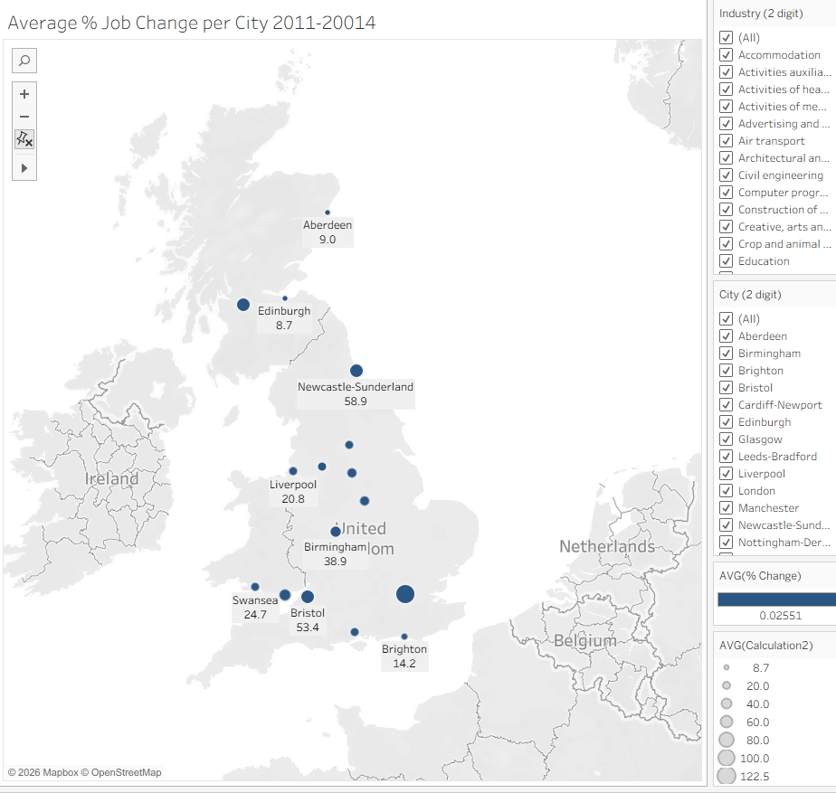  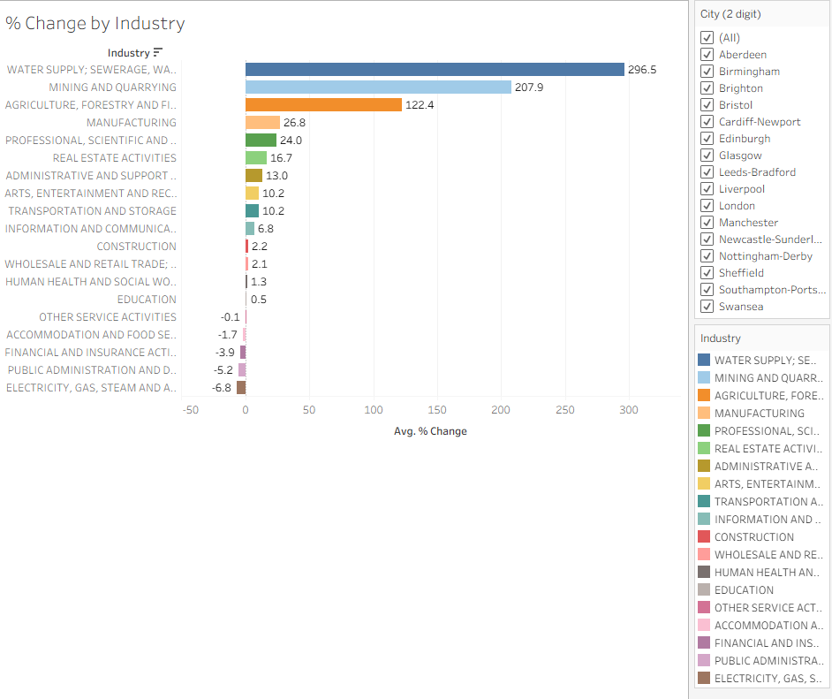  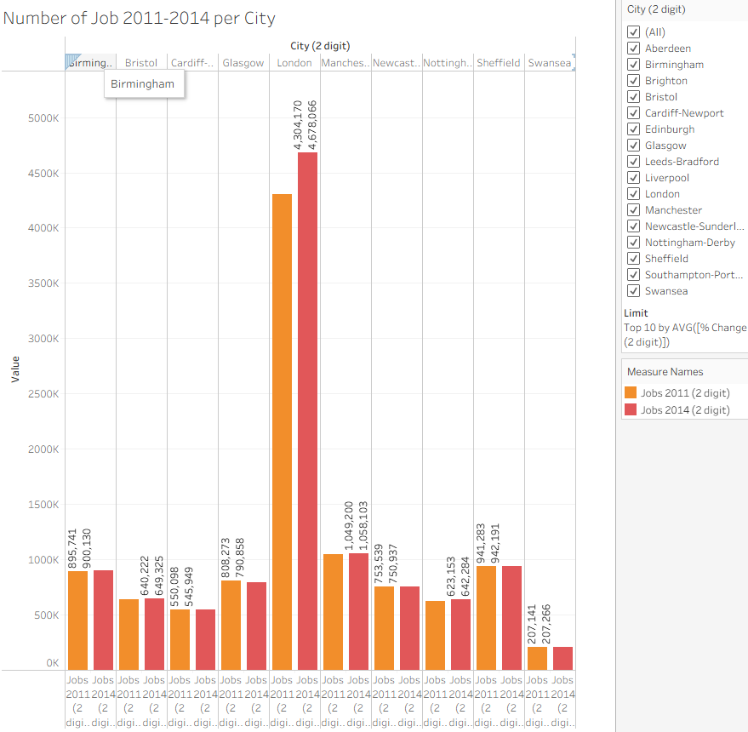

Day 2: Task 1

Using the Spotify data set, conduct an analysis to find trends and key information that could be used by an organisation for future projects.

There is no set scope for the analysis, simply to find trends and document them below:

Paste your print screens here | 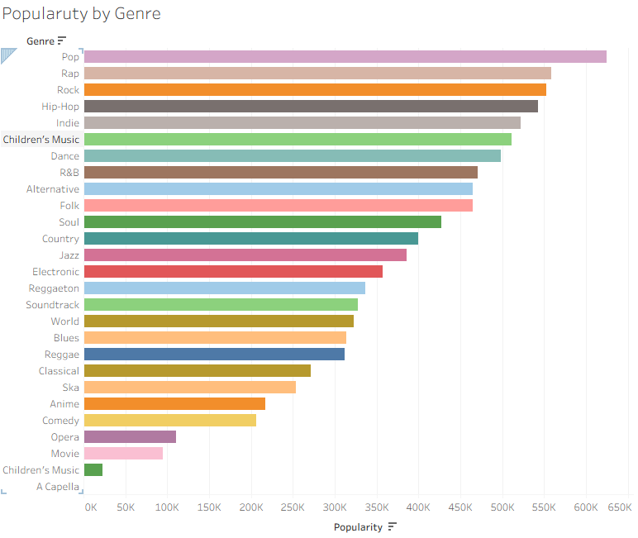  Figure 1_Popularity by Genre  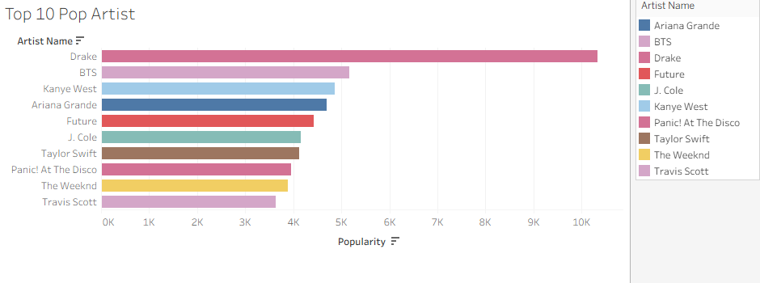  Figure 2_Top Ten most Popular Pop Artists  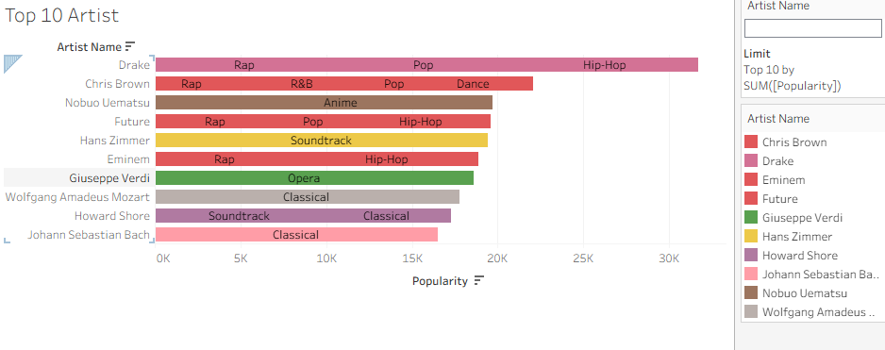  Figure 3_Top Ten Most Popular Artists  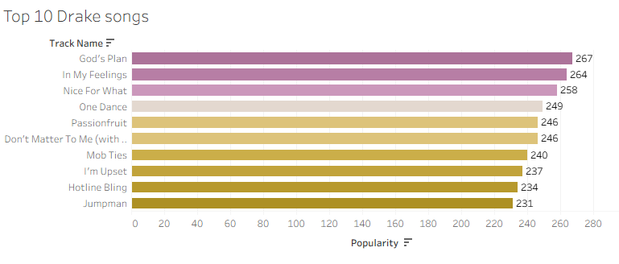  Figure 4_ Top 10 Drake Songs  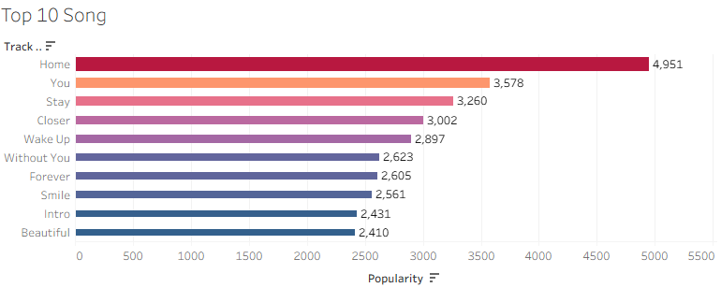  Figure 5_Top Ten Songs  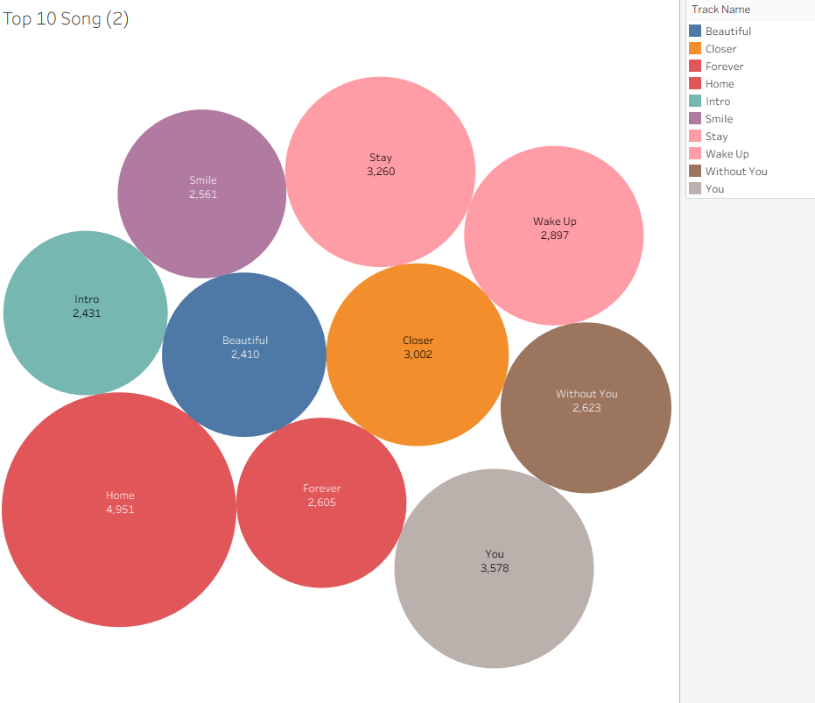  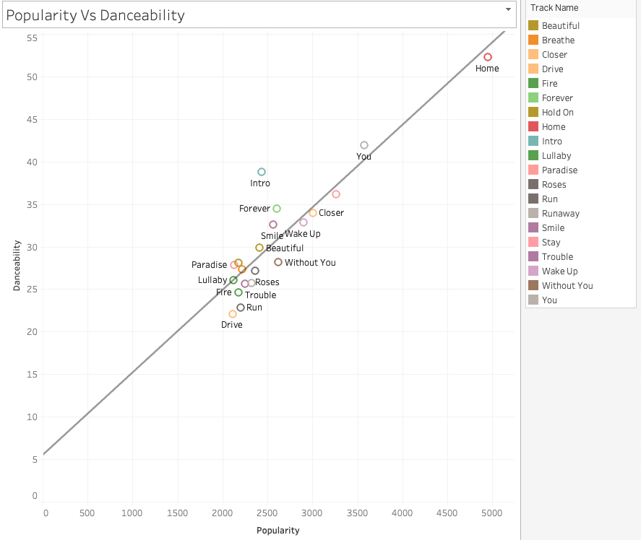  Figure 6_ Danceability Vs Popularity

What did you find? | From this data, a quick overview shows that pop music is the most popular genre, followed closely by rap and rock (Figure 1). It is interesting to note that children’s music appears within the top ten, indicating that music for very young audiences also enjoys a significant level of popularity.  Drake is identified as the most popular pop artist (Figure 2) and the most popular artist overall (Figure 3). It is also worth mentioning that the top rankings include Verdi, an opera composer, as well as Mozart and Bach, both classical composers. This suggests that classical music is timeless and continues to remain popular today.  Looking more closely at Drake’s songs (Figure 4), none of them appear in the top ten individually (Figure 5).  Finally, the plot of the 30 most popular songs versus their danceability shows a noticeable correlation. While it cannot be concluded that higher danceability directly leads to greater popularity, it appears to have some influence on audience appeal (Figure 6).

Day 2: Task 2

Using the Health, conduct an analysis to find trends and key information that could be used by an organisation for future support.

There is no set scope for the analysis, simply to find trends and document them below.

- Data can be lifesaving and is being used more within the NHS, reflect on how this data could support decision making for the NHS.

Paste your print screens here | 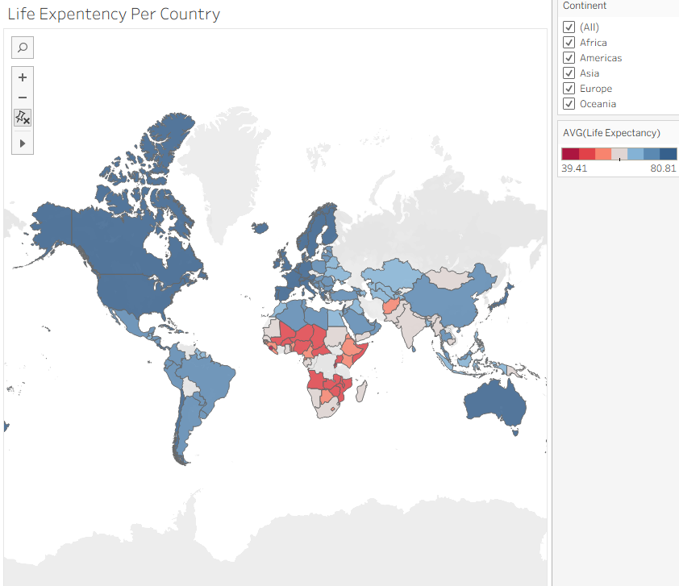  Figure 7_Life expectancy per Country  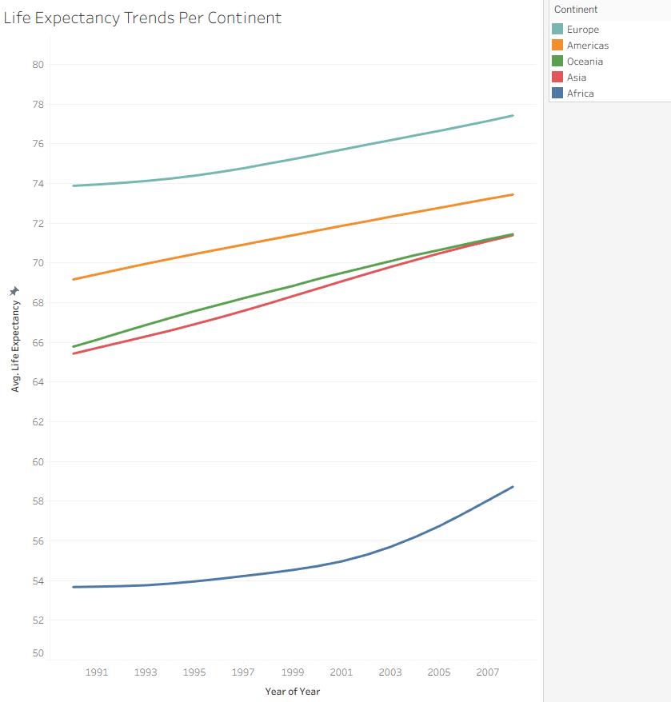  Figure 8_Life expectancy per Continent  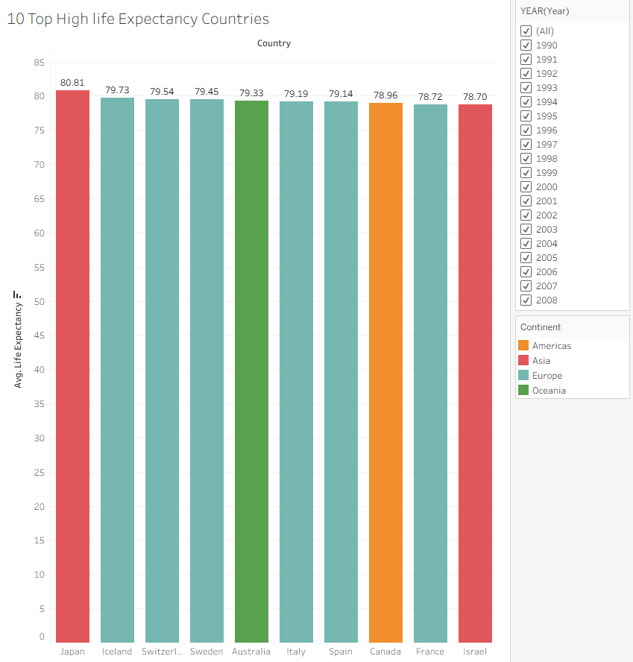  Figure 9_Average life Expectancy Country_ Top 10  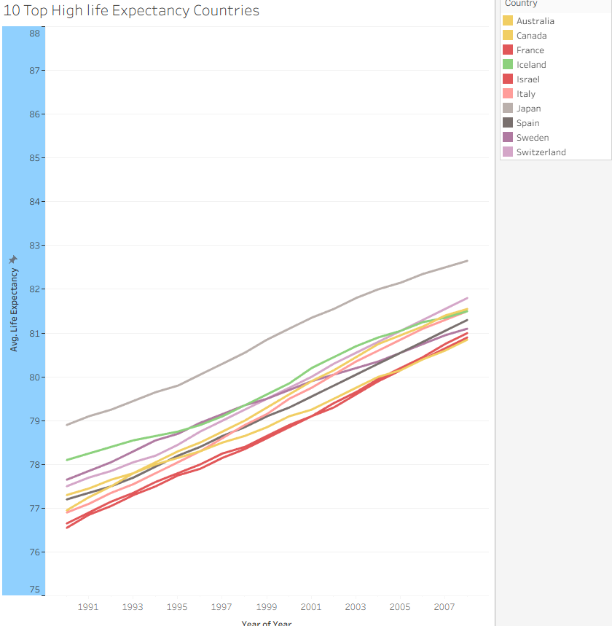  Figure 10_ Life Expectancy Change over years_ Top Ten average life expectancy countries  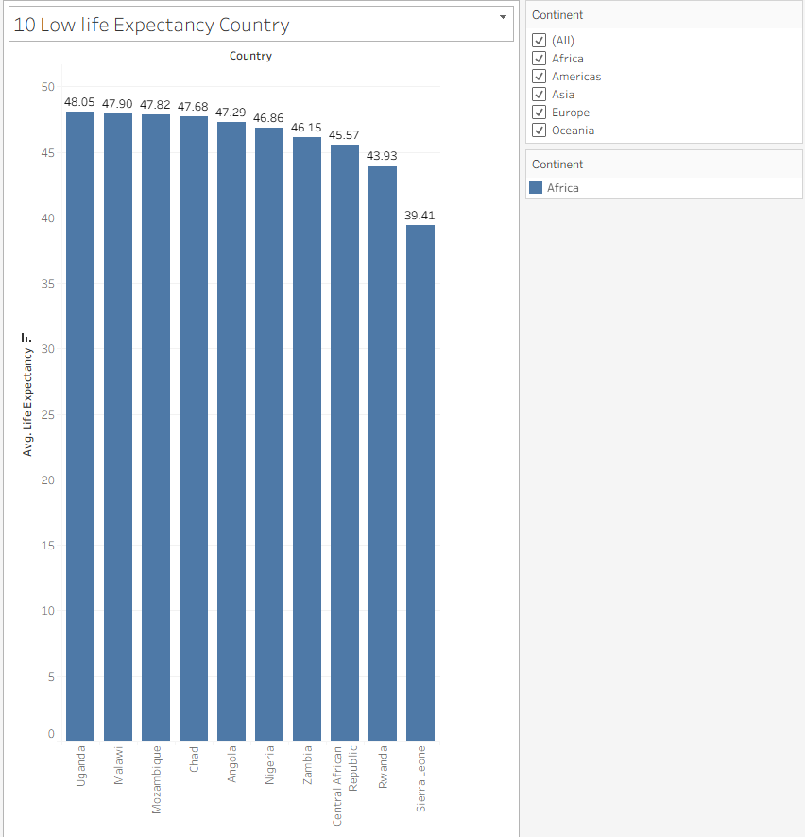  Figure 11_Low 10 life Expectancy  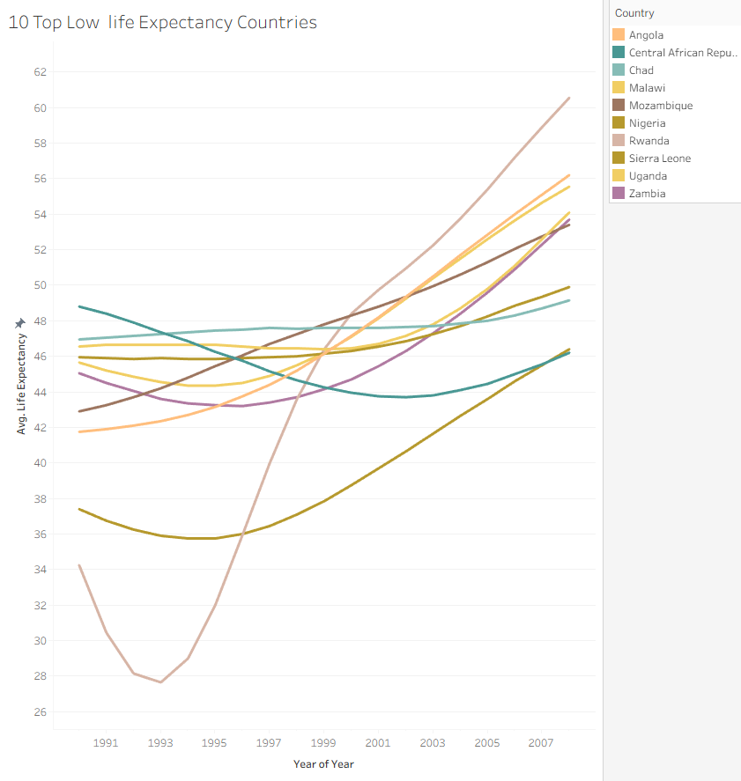  Figure 12_ Low Ten life expectancy from 1991-2008  UK Data  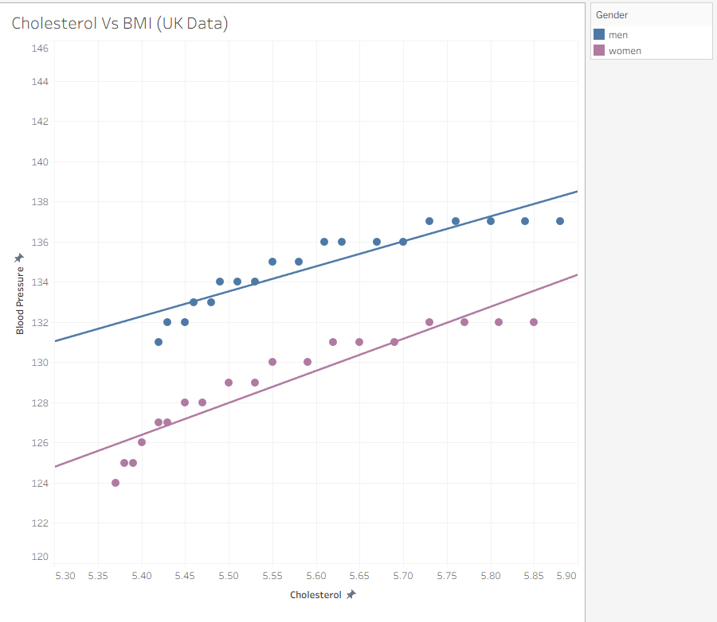  Figure 13_Cholesterol Vs BMI UK Data by Gender  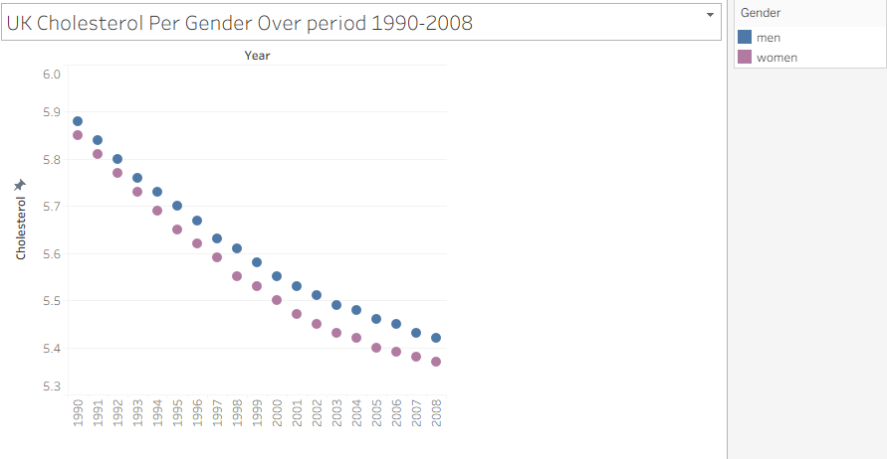  Figure 14_Cholesterol trend over period 1990-2008  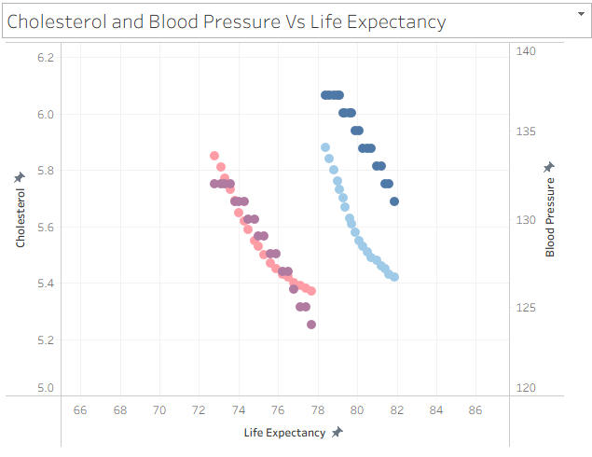
What did you find and any reflections on how the NHS could use this? | Figures 7 to 12 summarise life expectancy around the world. Figure 7 shows the average life expectancy per country on a map, while Figure 8 illustrates changes in life expectancy over the years by continent. Europe has the highest life expectancy, and Africa the lowest, although all continents have shown a steady increase over time, with Africa experiencing the most rapid growth from 2008 to 2021. Figure 9 presents the top 10 countries with the highest life expectancy, led by Japan, with six European countries also included, and no African countries appearing in this chart. Conversely, the top 10 countries with the lowest life expectancy are all from Africa. Figure 12 shows the trend in life expectancy between 1991 and 2008, highlighting Rwanda’s low peak in the early nineties, which correlates with the civil war in the country.  Figures 13 to 15 explore health indicators. Figure 13 shows the relationship between blood pressure and cholesterol by gender, suggesting that women have lower blood pressure than men and that cholesterol and blood pressure have a direct relationship: as cholesterol increases, so does blood pressure. Figure 14 shows that over the years, cholesterol levels have consistently decreased, likely due to new drugs, better control, or changes toward a healthier lifestyle in the population. Finally, Figure 15 indicates that as blood pressure and cholesterol decrease, life expectancy increases.  For the NHS, measuring and controlling these key indicators, among others, by encouraging a healthy lifestyle and diet for patients with above-optimum levels, or managing those levels with medication, can improve population health and potentially increase life expectancy.

Day 3: Task 1

Please complete Lab 1 ‘Get Data in Power Bi Desktop’. Once complete, paste a print screen below and in the collaboration board.

“Teaching is the best way to learn, so please listen out for support requests from the class and we’ll work through the challenges together”

Paste your completed lab here | 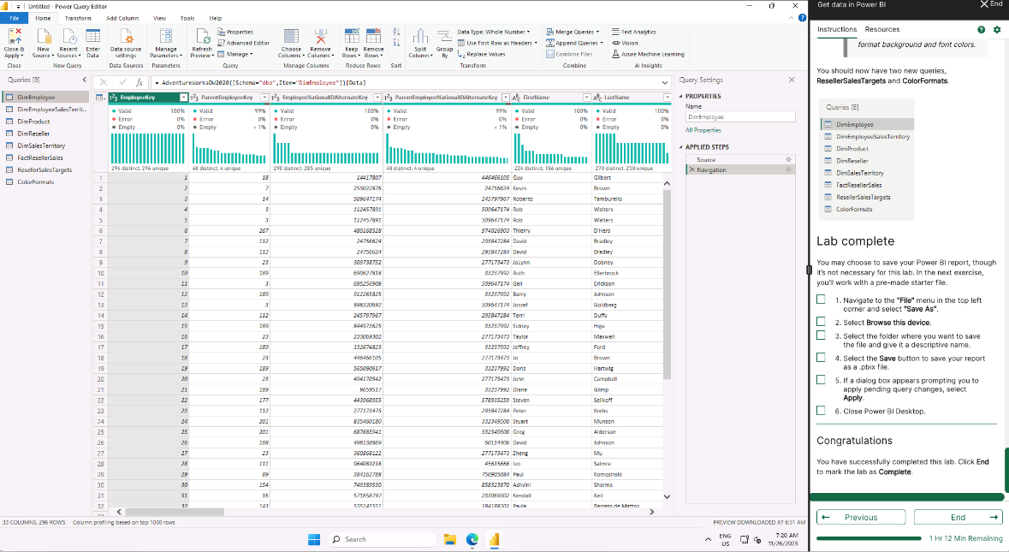

Day 3: Task 2

Please complete Lab 2 ‘Load Transformed Data in Power BI Desktop’. Once complete, paste a print screen below and in the collaboration board.

“Teaching is the best way to learn, so please listen out for support requests from the class and we’ll work through the challenges together”

Paste your completed lab here | 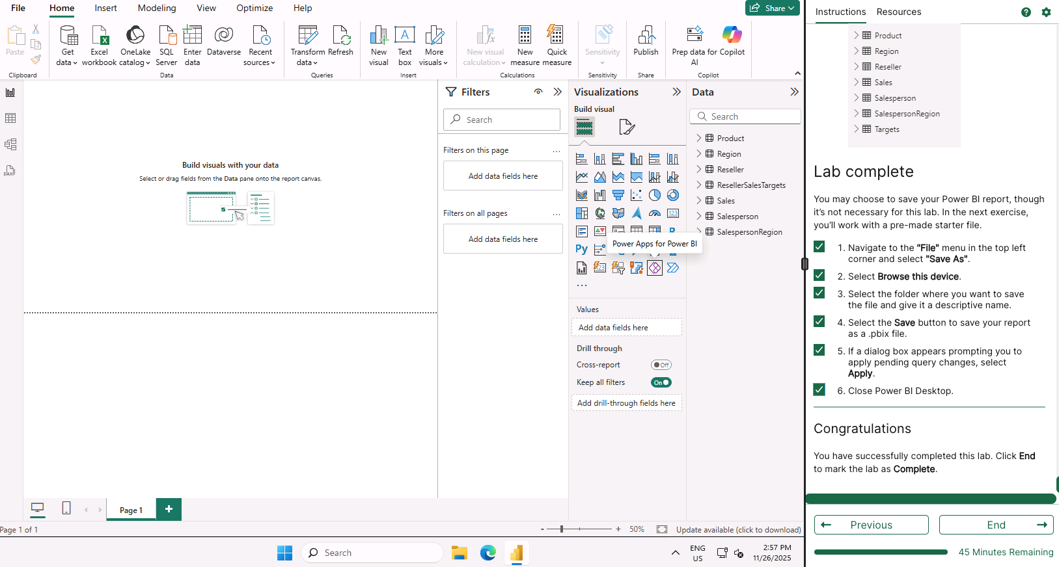

Day 4: Task 1

Please complete Lab 8 ‘Design a Report in Power BI Desktop’. Once complete, paste a print screen below and in the collaboration board.

“Teaching is the best way to learn, so please listen out for support requests from the class and we’ll work through the challenges together”

Paste your completed lab here

Day 4: Task 2

Please complete Lab 12 ‘Create a Power BI Dashboard’. Once complete, paste a print screen below and in the collaboration board.

“Teaching is the best way to learn, so please listen out for support requests from the class and we’ll work through the challenges together”

Paste your completed lab here | 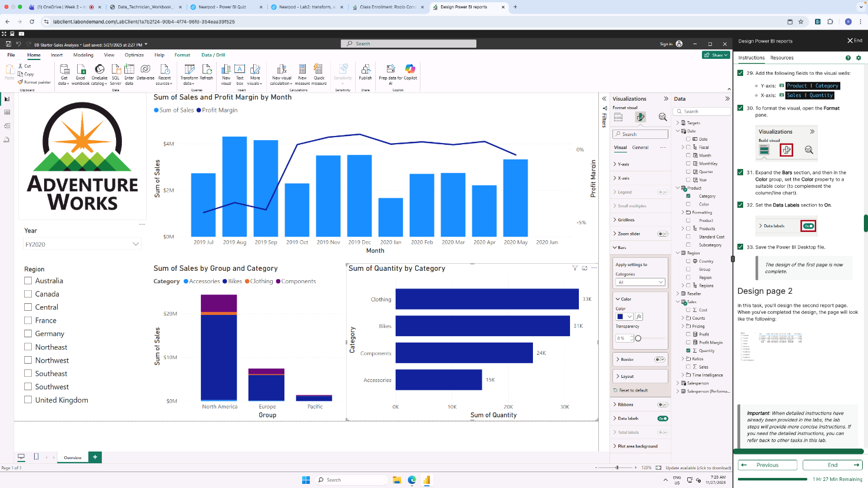

Course Notes

It is recommended to take notes from the course, use the space below to do so, or use the revision guide shared with the class.

We have included a range of additional links to further resources and information that you may find useful, these can be found within your revision guide.

END OF WORKBOOK

Please check through your work thoroughly before submitting and update the table of contents if required.

Please send your completed work booklet to your trainer.

Information

