

Data Technician

Name: Rocio Corcoles
Course Date: 17/11/25
Table of contents
Day 1: Task 1 2
Day 2: Task 1 2
Day 2: Task 2 3
Day 2: Task 3 4
Day 3: Task 1 4
Day 3: Task 2 5
Dataset: 5
Step 1: Create a Pivot Table 5
Step 2: Use the SWITCH Function 5
Submission: 6
Day 3: Task 3 6
Day 4: Task 1 7
Course Notes 9
Additional Information 10

Day 1: Task 1

Please complete the below boxes on commons laws and regulations that must be followed when working with customers data, use the below bulleted list to support your answers.

- What is it
- Why is it important
- Provide a real-world example of how you can follow it
- How does it impact working with data
- What could happen if you breached it

Data Protection Act | - It’s a UK law that regulates how collect, Stored and use and share personal data. Applies to any organisation handling data.  - Look after personal information, keep it safe and prevent to be misused.  - Only collect the personal information needed and keep it secured in secured folders, passwords.  - The duty to keep data secured and only use it if necessary and with a reason to do and not be shared without permission. For example, in a hospital only healthcare staff involve in patient’s care are allowed to view the patient’s records.  - Fines from Information Commissioner’s officer (ICO), legal action by individuals, loss of employer and public trust, disciplinary action at work, possibly job loss.
GDPR | - An EU law that protects personal data by controlling how is collected, used and stored, Gives individuals strong rights over their personal data. Allowing them to delete, change and give permission over it. Applies to any organisation dealing with EU/UK personal data.  - It makes sure organisations respect individual privacy and only use their data fairly.  - In real world an example would be a company asking customer for consent before is added to a mailing list or a cookie notice on a website explaining how user data will be use.  - The need to ask for permission before using their data, keep it safe and report any breaches.  - Penalties for breaking GDPR can be very large investigations, and you could be disciplined or lose your job.
Freedom of Information Act | - A law that allows the public to ask for information from public organisations (schools, NHS, councils, police). Records, reports, emails, statistics, etc.  - Transparency and public trust, allows to see how public money is spent it supports democracy.  - A council is requested to give data bout money spend on a project he responds within 20 days with the data removing any personal data.  - Public organisation must keep records organised and accessible and staff need to understand what information can and cannot release.  - Breaching the law could lead to enforcement notices from the ICO or corrective actions. Organisation may face investigations, reputational damage. Staff may face disciplinary action if breached dur to inappropriate request handling.
Computer Misuse Act | - A UK law designed to prevent cybercrime. It makes the illegal; unauthorised access to computer systems (hacking), Unauthorised modification of data, creating or distributing malware, using computers to commit further crimes and It protects individuals and organisations from misuse of computer systems.  - It protects individuals and organisations from hacking, cyber-attacks, and data theft.  - Only logging into systems with accounts you are authorised to use. Not attempting to access confidential files you don’t have permission for. An employee uses only their assigned login and avoids attempting to access restricted areas of the network.  - Saff must only access to data necessary for their role and organisations must implement proper authentication, passwords or other access controls. Monitoring unauthorised access attempts.  - Criminal charges, loss of jobs, reputation damage, financial loss or legal claims.

Day 2: Task 1

Please research and complete the following tasks within the retail-sales_dataset.xlsx document, paste a print screen into the provided boxes below:

- In the sheet ‘retail_sales_dataset’ add all available data between columns A –J into a ‘table’
- Using the ‘sort’ function, sort ‘Age’ to ‘largest to smallest’
- Using the ‘SUM’ function, show me the commission total in cell ‘L10’
- Using the ‘AVERAGE’ function, show me the average commission in cell ‘L11’

Print screen 1 | 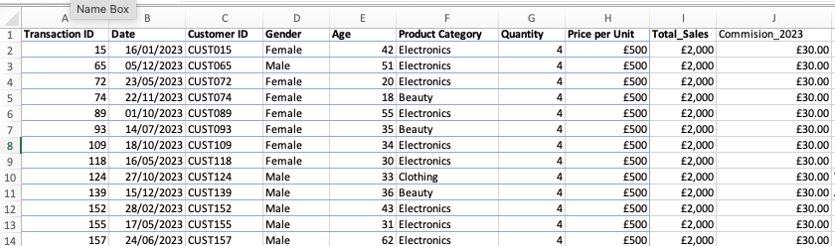
Print screen 2 | 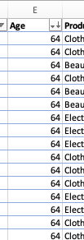
Print screen 3 | 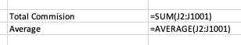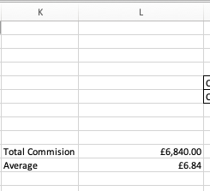
Print screen 4

Day 2: Task 2

Please research and complete the following tasks within the retail-sales_dataset.xlsx document, paste print screens into the provided box below:



Print screen 1 | English  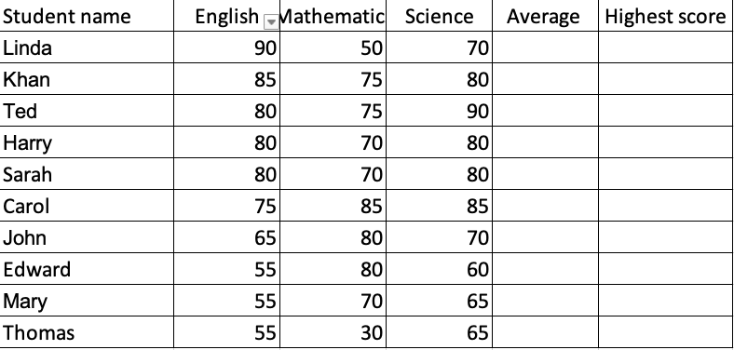  Mathematics  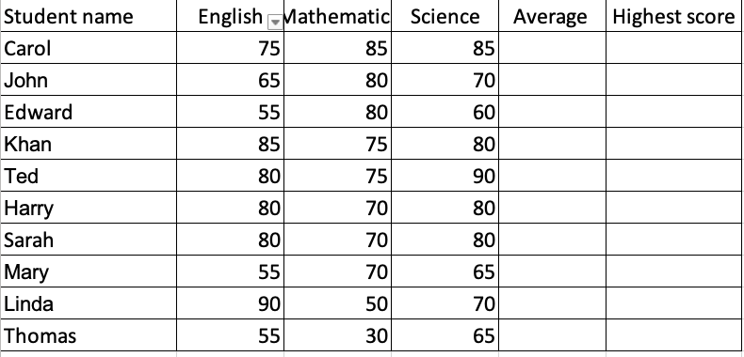  Science  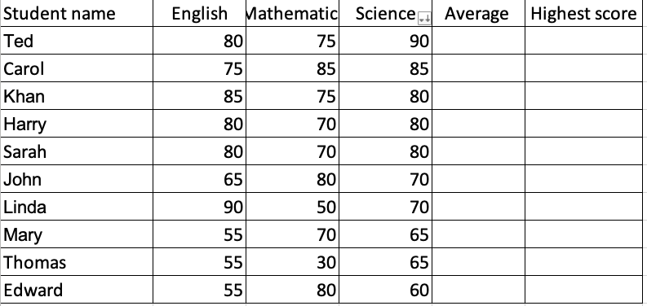
Print screen 2 | 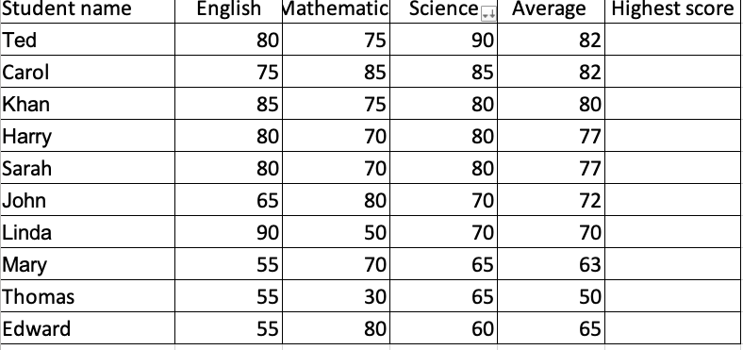
Print Screen 3 | 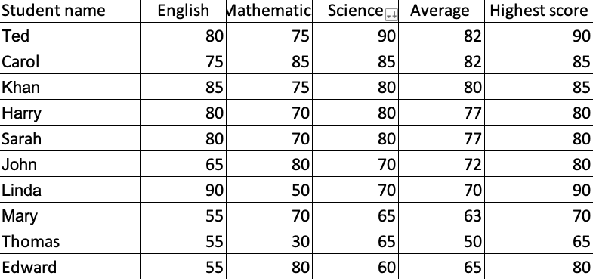
Print screen 4 | 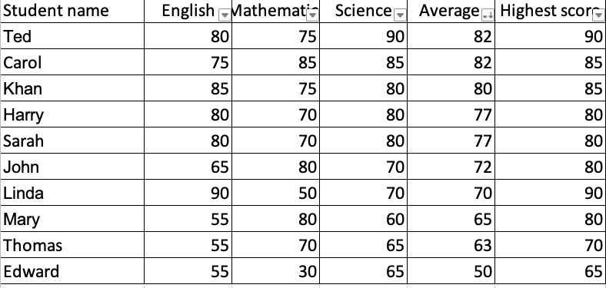
Print Screen 5 | 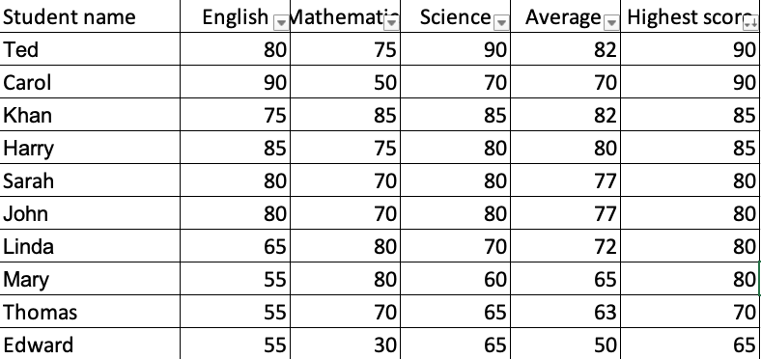
Print Screen 6 | 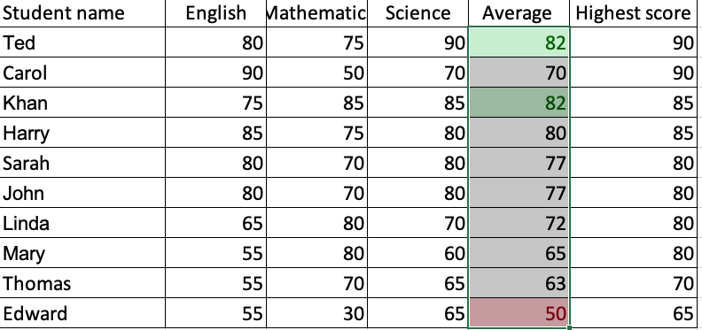

Day 2: Task 3

Using the skills developed today, have some fun with the data set you have imported. Paste your work below and enjoy!

Print screen 1

Day 3: Task 1

Please download the dataset ‘Day_3_Task_1_Bike_Sales_Pivot_Lab.xlsx’ and the lab instructions.

Do not worry if you do not complete the lab, just working with data and playing with the pivot table will be good experience.

Please paste your final pivot table below and complete the reflection questions:

Print screen 1 | 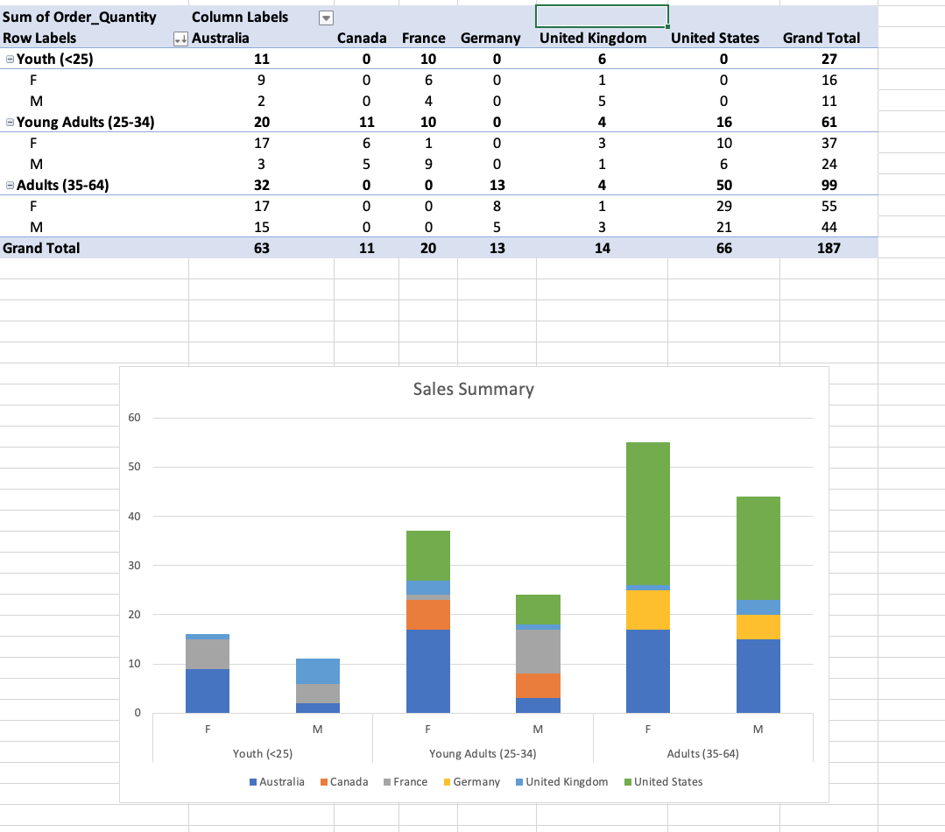
In which markets does Germany have customers? | In Germany, the adult market is the strongest and among females than males. Data also indicates that there is no market for the youth and young adult groups.
What country has sales in all markets? | UK
What are the most profitable markets by country, age group, and gender? | Most Profitable:  By country: United Stated followed closely by Australia.  Age Group: Adutls  Gender: Female
Any other findings?

Day 3: Task 2
The dataset below tracks the sales performance of different products in various counties in England. Please paste the dataset into a blank Excel workbook. Your task is to:
- Create a Pivot Table to summarise the data by county and product.
- Use the SWITCH function to categorise products based on their sales volume.

Dataset:
County | Product | Sales Volume
Yorkshire | Laptops | 500
Yorkshire | Smartphones | 200
Cornwall | Laptops | 700
Cornwall | Printers | 400
Lancashire | Smartphones | 150
Lancashire | Laptops | 600
Essex | Printers | 800
Essex | Smartphones | 300
Durham | Laptops | 250
Durham | Printers | 300
Greater Manchester | Smartphones | 600
Greater Manchester | Laptops | 400

Step 1: Create a Pivot Table
- Select the dataset (columns A to C).
- Insert a Pivot Table to summarise the data by County in the rows and Products in the columns. Use Sales Volume as the value to be summarised.

Step 2: Use the SWITCH Function
In a new column next to your data, use the SWITCH function to categorise products based on Sales Volume as follows:
  - For sales greater than 600: "High"
  - For sales between 300 and 600: "Medium"
  - For sales less than 300: "Low"
SWITCH Function Example:
=SWITCH(TRUE, C2 > 600, "High", C2 >= 300, "Medium", "Low")
- Apply this formula to each row, and check if the products are categorised correctly.

Submission:
- A completed Pivot Table summarising sales by county and product.
- A new column in the dataset categorising products by sales volume using the SWITCH function.
  - Please paste your completed work below

Print screen 1 | 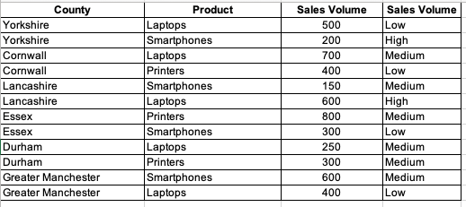  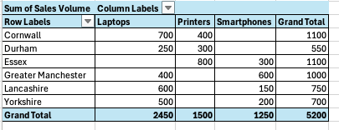

Day 3: Task 3

Please download the dataset ‘Day_3_Task_3_Bike_Sales_Visualisations_Lab.xlsx’ and the the lab instructions. Do not worry if you do not complete the lab, just working with data and playing with the charts will be good experience.

Please paste your results below:

Print screen 1 | 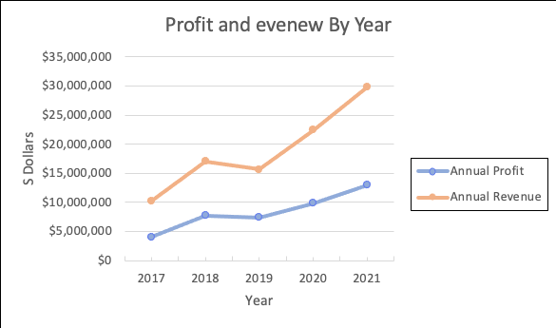  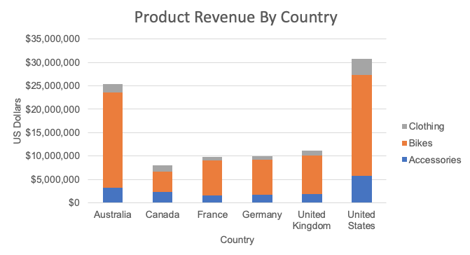  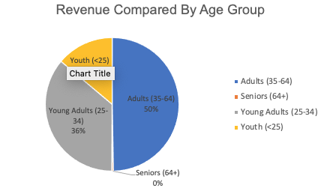

Day 4: Task 1

You have been asked to deliver your analysis findings to the board of directors, with your analysis you have identified that customers are leaving your company at the 12-month point, this is typically when they receive their renewal price.

Conduct research and complete the below questions:

How would you prepare for the delivery? | - Understand the audience, the board of directors, and what matters to them.  - Validate the analysis: customers are leaving the company at the 12-month point.  - Built a clear path to showcase the matter. What has been found, why it is important, what is the cause and recommendations.  - Anticipate potential board questions (impact, cost, risks) so can prepare for potential challenges or abjections.  - Rehearse delivery and timing.
What tools would you use for the delivery? | - Presentation tools: PowerPoint or Google slides.  - Data visualisation tools: Power BI or Tableau to create cohort and churn charts to support clear way to show findings and effect of recommendations.  - Supporting materials: PDF summary, speaker notes, and optionally a live dashboard.
What is prospecting and why would you complete this before your delivery? | Prospecting is the process of identifying and qualifying the audience that might be interested in the topic being presented. This should be completed before delivery to tailor the presentation to the target audience, engage them effectively, and determine the appropriate depth and detail required to achieve the presentation’s purpose.
Tell me best practices for public speaking and providing updates to senior leaders | - Start with headline, Main finding “Customers are leaving the company at the 12-month point”.  - Keep slides, simple, visual and concise and tailor content to the audience identified during prospecting process.  - Speak at a controlled pace and confidently.  - Focus on the impact and decisions, not technical or irrelevant details.  - Prepare for tough questions, keeping answers short and to the point.
What will you show the board in your delivery? | - Executive summary.  - Retention/churn chart showing the 12-month drop.  - Evidence of renewal price shock or value perception issues.  - Financial impact (lost revenue, reduced lifetime value).  - Root causes and recommended changes.  - Execution plan, timeline, and what you need the board to approve.
How will you articulate the changes that are needed? | - Link every recommendation to business outcomes (retention, revenue, value).  - Clearly explain what needs to change: renewal pricing, communication, customer engagement, segmentation.  - Provide timeline, Return on Investment (ROI) estimate, risks, and expected impact.  - Be direct about what decisions you need from the board.
Provide a list of online resources and videos that will support your preparation for public speaking | - “The Key to Presenting to Senior Executives” – Forbes  Link: forbes.com – The Key to Presenting to Senior Executives Forbes  Why: Covers the kinds of questions senior leaders ask and how to tailor your presentation accordingly.  - “10 Tips For Impressive Presentations To Senior Leadership & Executives” – Moxie Institute  Link: moxieinstitute.com – 10 Tips Moxie Institute  Why: Practical tips (prepare, begin with end in mind, minimal slides, storytelling, etc.) that help you polish your delivery and message clarity for high‑stakes meetings.  - 7 Public Speaking Tips for Beginers.  https://www.youtube.com/watch?v=Ns_z4wEtdRM&t=1s. Why: It’s tailored to beginners, meaning it will cover foundational skills (such as voice control, body language, handling nerves) that are often overlooked but critical for a strong performance.
Evaluate tools that provide visualisation.  Tell me what they are.  Tell me what you would choose when delivering your presentation and why | - Tableau: advanced analytics, polished visuals.  - Power BI: strong integration with Microsoft and business data.  - Looker Studio: free, simple dashboards.  - Infogram/Data wrapper: clean charts and infographics.  What I’d choose:  Power BI (or Tableau) for accurate, professional-grade charts, then embed them in a simple presentation deck.

Course Notes

It is recommended to take notes from the course, use the space below to do so, or use the revision guide shared with the class:

Additional Information

We have included a range of additional links to further resources and information that you may find useful, these can be found within your revision guide.

END OF WORKBOOK

Please check through your work thoroughly before submitting and update the table of contents if required.

Please send your completed work booklet to your trainer.

