Riley Payung

CDS 130

WA05

09/30/2019

Part 1:

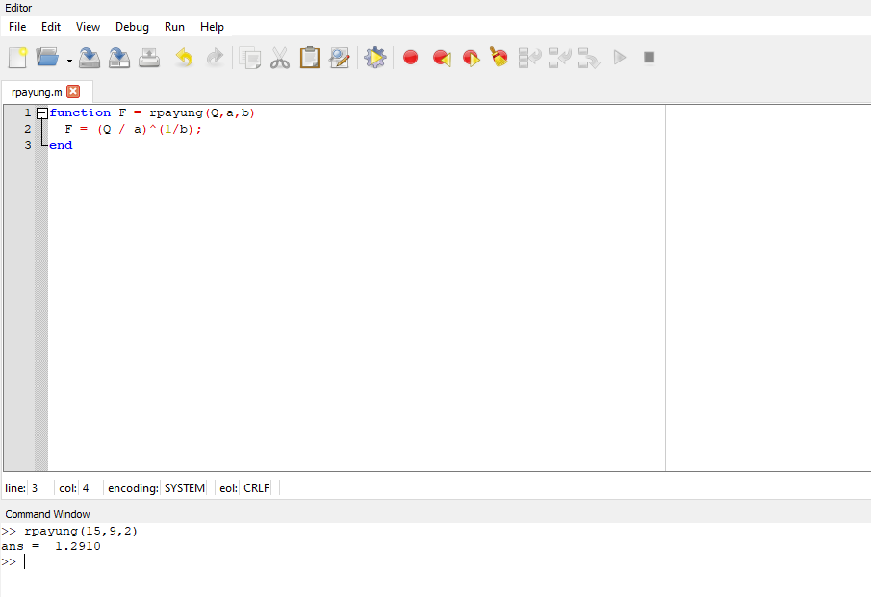

I created a function that would allow me to just simply input the values and get a result.

Part 2:

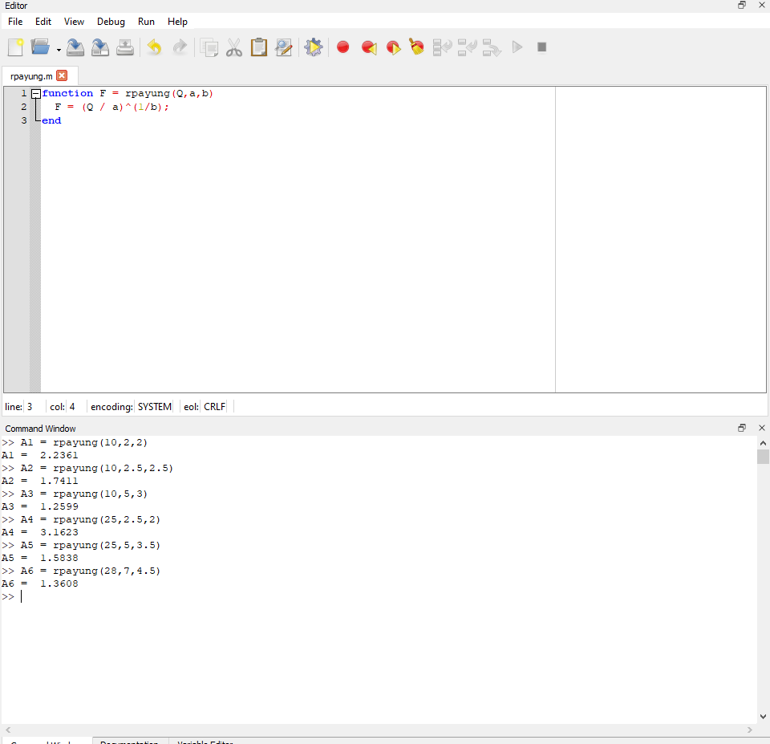

I set the variables A1:6 to be equal to the result of the function at different values.

Part 3:

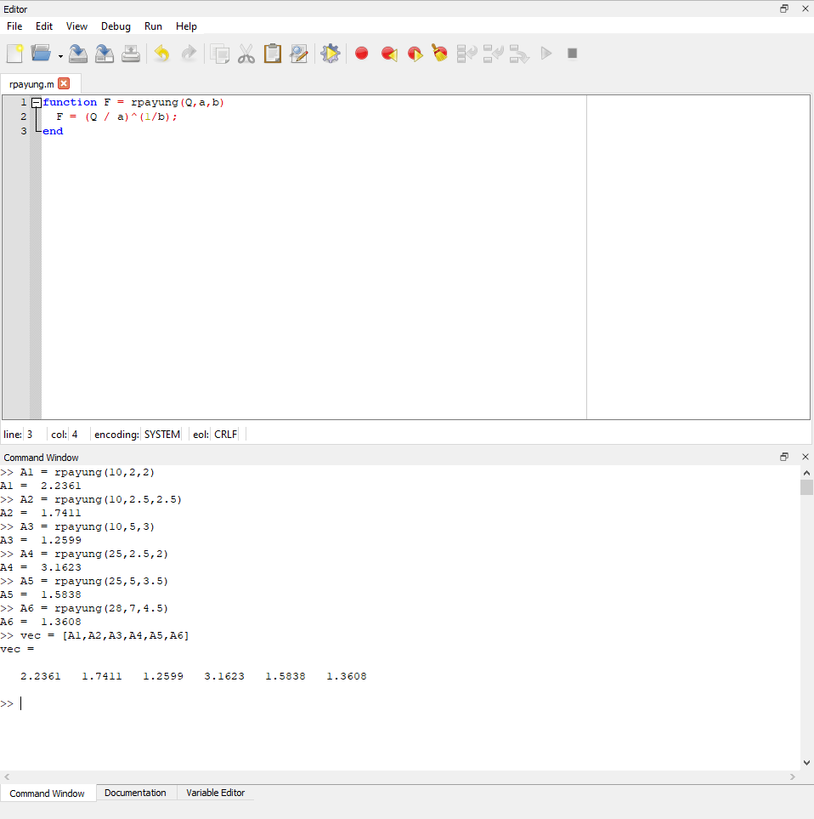

As you can see, I created the vector using the function as my inputs.

Part 4:

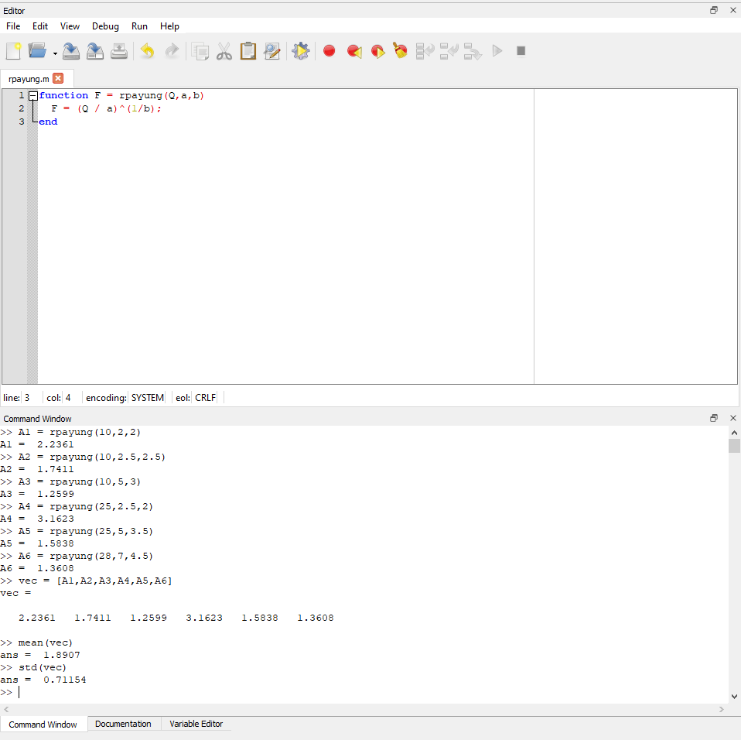

Mean of the vector I created: 1.8907, Standard Deviation: 0.71154.

Part 5:

