Riley Payung

CDS 251

04/23/2020

Lab 11 and Homework 11

# Lab 11

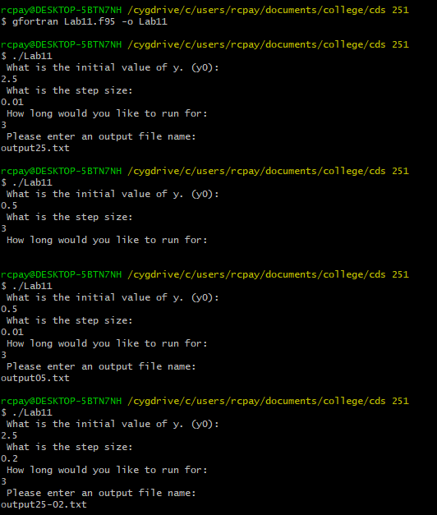

# Homework 11



