Riley Payung

CDS 251

03/05/2020

Homework 6

## Comments on Speed

The Quick sort algorithm is approximately 39.5 (39.57013) times faster than the Bubble sort algorithm

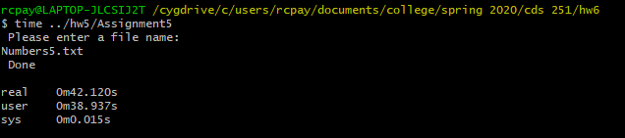

Figure Shows the time taken from Bubble Sort

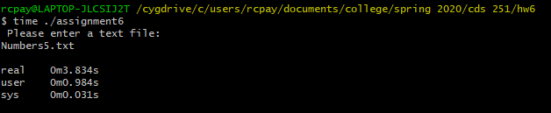

Figure Shows the time taken from Quick Sort

It does not surprise me that this is much faster, since I have 1. Seen it before and 2. It uses recursion and linear-timed looping O(n log(n)) meaning half the work remains as we go through each iteration.

## Extra Credit

Based on the time complexity of the time it took bubble sort to sort 60,000 numbers, the computational time it should take quick sort to sort 500,000 numbers is approximately 6.5 seconds (6.4501 seconds).

It took 8.0000 seconds. This is due to the computed time being closer to the best-case time complexity. 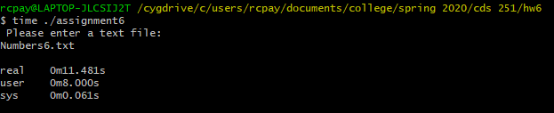

Figure Shows the time taken from Quick Sort for 500,000 Numbers

The Time that Bubble Sort would take to compute 500,000 Numbers would be: approx. **112.665 days.**