Riley Payung

CDS 251

03/26/2020

Assignment 7

# Exponential Regression

## CYGWIN

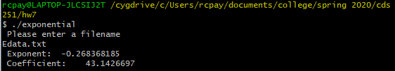

## GNU PLOT

I used GNUPLOT to plot the regression and data points.