Riley Payung

CDS 303

03/16/2020

Redos

# Quiz 2

## Q2.

I did not actually get anything wrong on this question, just chose the wrong option, where two options were the same. 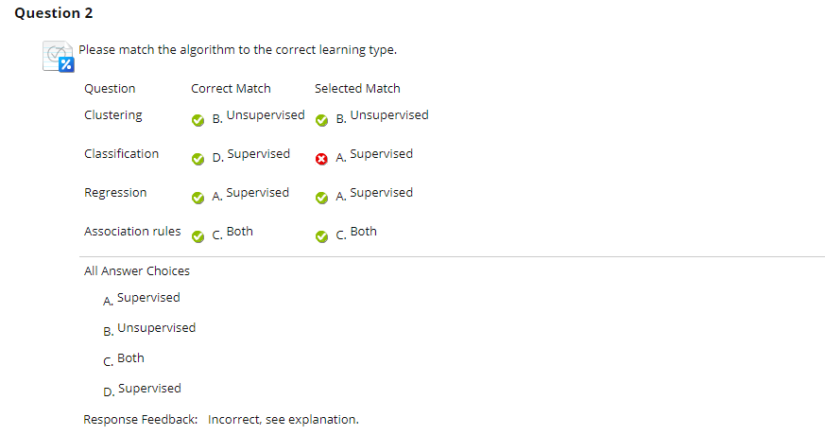

## Q3.

Simple Mistake, I chose Classification when I should have chosen Association Rules.

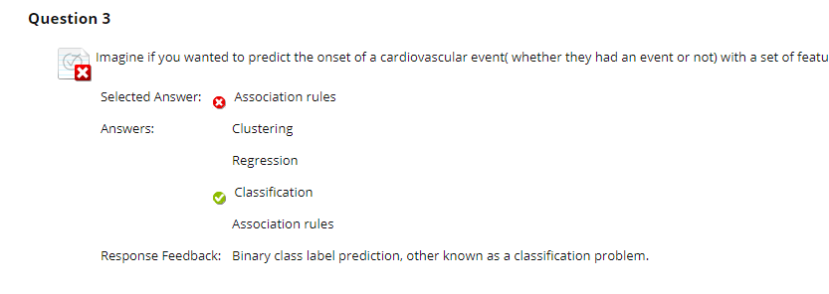

## Q4.

I chose only Ordinal and Nominal, when I should have chosen Ordinal, Nominal, AND binary.

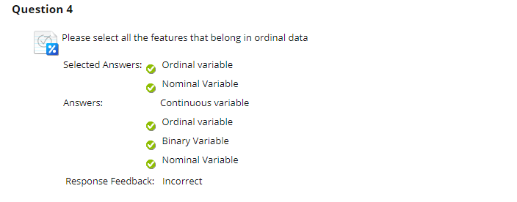

## Q6.

I chose Bar chart instead of Histogram. I think that I was frantically trying to get this quiz done because that was just a dumb mistake on my part.

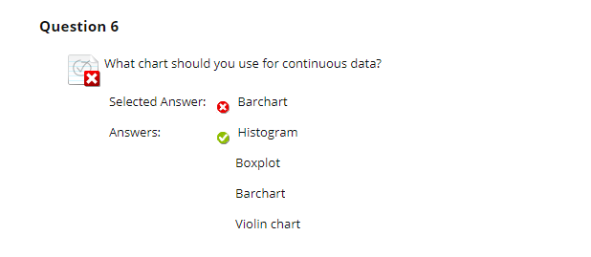

## Q7.

Again, just a dumb mistake that I should not have made. I chose Standard Deviation when I should have chosen median.

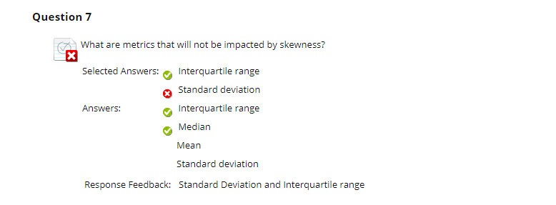

# Quiz 3

## Q1.

I did the same thing I did in Quiz 2. I should have also chosen Binary.

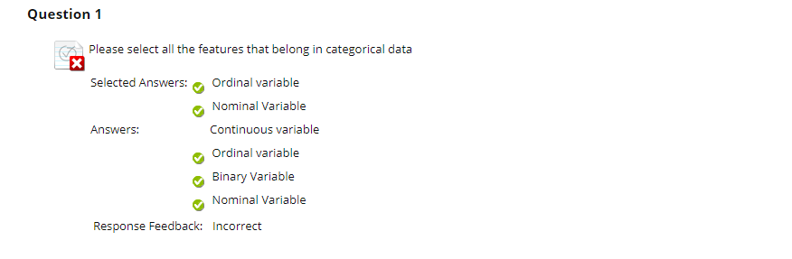

## Q2.

Same as Quiz 2 except for Association Rules, I should have chosen both. I believe that I had issues with time management on this one.

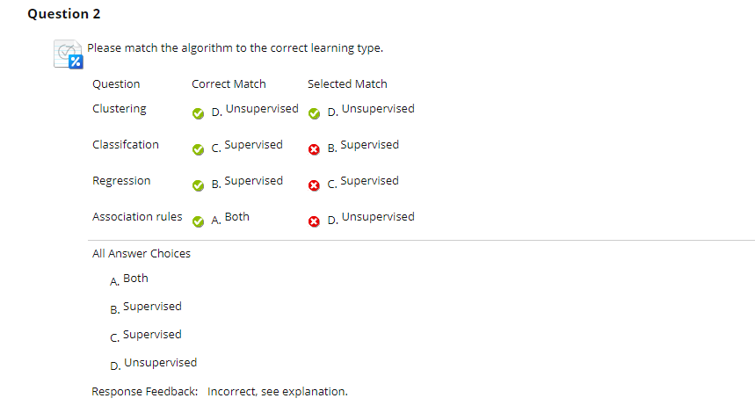

For Questions 5 through 10, I did not do well on them because I took the quiz without going through the notes, and later when I was studying for the midterm, I found what I needed to complete these questions in the notes. Until that point, I was completely ignorant.

## Q5.

I somehow messed up Euclidean Distance, which is the generic distance formula we use. I don’t remember how I calculated it or how I managed to get it wrong, but I got 28.72281 when I should have got 22.912.

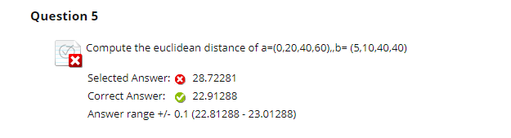

## Q6.

This one was kind of interesting because I’ve never seen the Manhattan Distance (L1 Norm) before. I should have been able to figure this one out though, but again, not really sure what I was thinking at the time of taking this quiz.

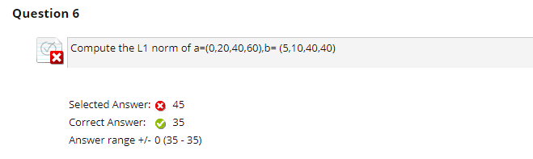

## Q8.

I should have wrote out the formula but I did not; When I was answering this question, I think that I was confused as to what to use for p, but seeing the answer made me realize that I should have just wrote out the formula.

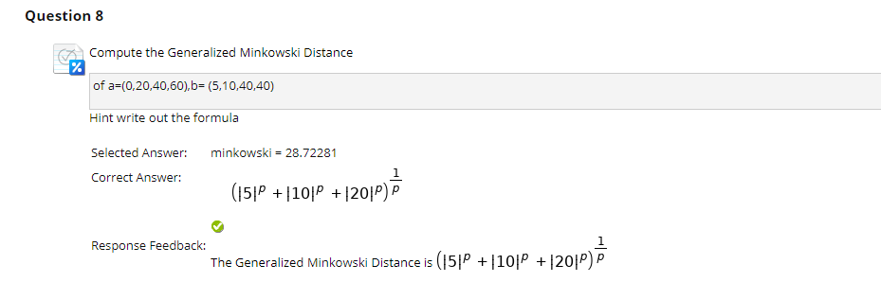

## Q10.

Again, I did not pay enough attention to the notes. I did not understand the idea of proximity measures as well as I thought I did.

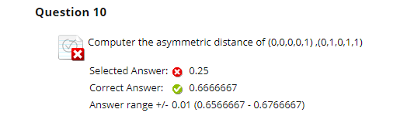

# Quiz 4

## Q1

I chose the wrong formula, when I should have chosen Circumference~age. The new model does in fact fit better.

Call:

lm(formula = Orange$circumference ~ Orange$age, data = Orange)

Residuals:

Min 1Q Median 3Q Max

-46.310 -14.946 -0.076 19.697 45.111

Coefficients:

Estimate Std. Error t value Pr(>|t|)

(Intercept) 17.399650 8.622660 2.018 0.0518 .

Orange$age 0.106770 0.008277 12.900 1.93e-14 ***

---

Signif. codes: 0 ‘***’ 0.001 ‘**’ 0.01 ‘*’ 0.05 ‘.’ 0.1 ‘ ’ 1

Residual standard error: 23.74 on 33 degrees of freedom

Multiple R-squared: 0.8345, Adjusted R-squared: 0.8295

F-statistic: 166.4 on 1 and 33 DF, p-value: 1.931e-14

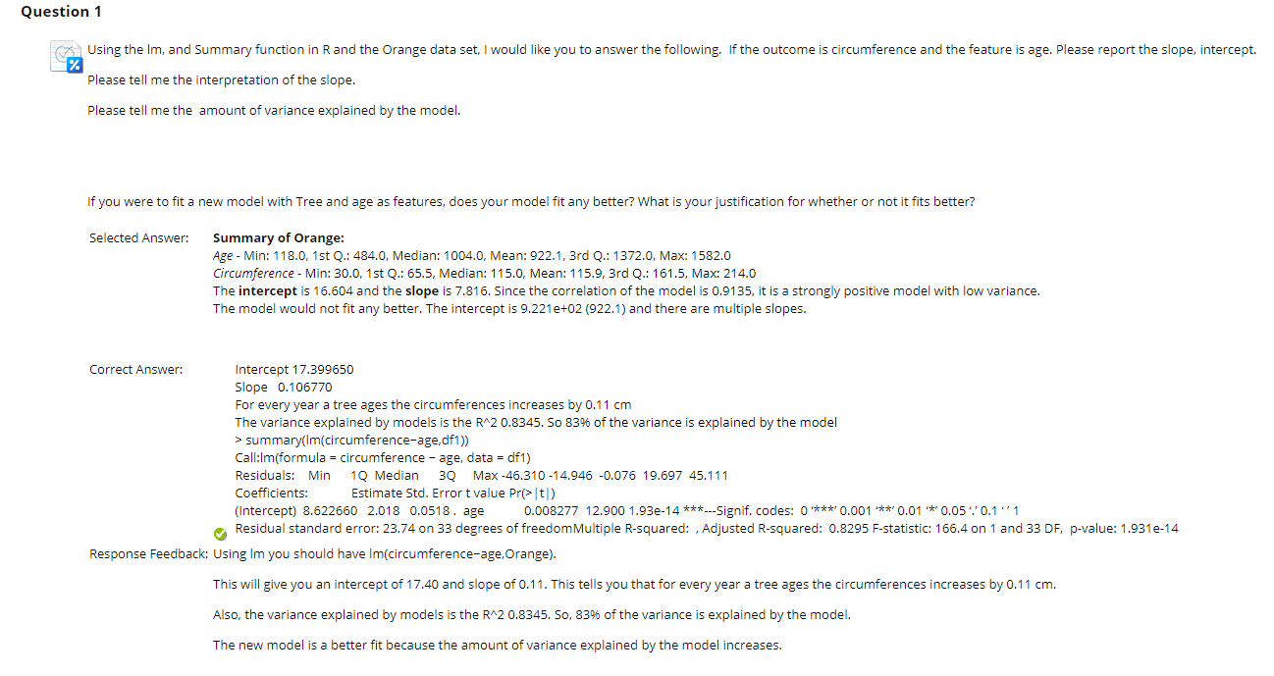

# Quiz 5

## Q2.

This is another question in which I should have followed the notes a little more carefully, but I did not choose one of the options that I should have. I should have also chosen Logistic Regression, but I did not.

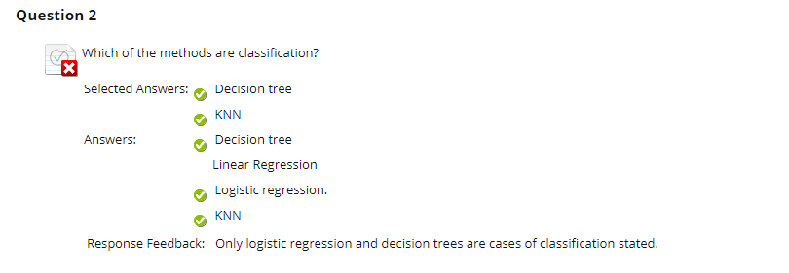

# Lab #3

I did not do the lab. I should have done the lab, because now that I am doing it, it seems quite easy to do, and I missed out on a whole extra 5 points that I could have received from finishing it on time. I think this was a week that I had very poor time management.

I have submitted the lab under the original assignment and will upload the same pdf along with this document.

# Week #3 Discussion Article

I did not do the discussion article because I was attempting to mitigate damage to my grade.

# Week #6 Discussion Article

I did not do the discussion article because the discussion board was not available at the time. I should have emailed Professor Valko about this when I saw it, but I did not.