Riley Payung

CDS 301

04/20/2020

Homework 8

Figure Global Plastics By Ocean in 2013 Data: <https://ourworldindata.org/plastic-pollution>

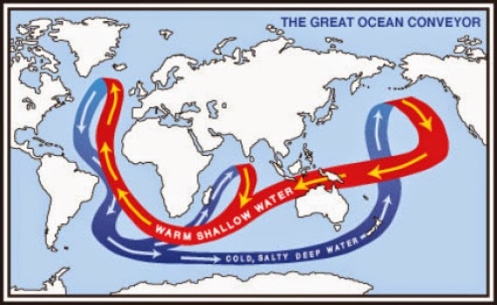

Figure The Deep Ocean Currents, which circulate water throughout the oceans in the world. The time it takes for one full cycle to complete is 1000 years. Source: <http://www.geologypage.com/2014/06/ancient-ocean-currents-may-have-changed-pacing-and-intensity-of-ice-ages.html>

## Analysis

Based on Figure 2, we can speculate that the Great Pacific Garbage Patch (GPGP) will move in location overtime, moving toward Australia, since its current location is between Hawaii and the mainland United States, its next destination should be the pacific islands and Indonesia/Australia, Oceania. We can also see from Figure 1 that the total plastic pollution into our oceans has easily contributed to the GPGP. The Pacific is the number one ocean for plastics to end up, so we can easily assume that most of this garbage generation is coming directly from Asia and North America.