Riley Payung

CDS 301

03/02/2020

Assignment 5

# Problem 1

I wrote a function for selecting based on the year that visualizes the life-expectancy and fertility rate of ALL countries by the year:

def scatterYear(year):  
 df2 = pd.read_csv("./data/gapminder-1.csv")  
 df2.dropna()  
 df2 = df2.loc[df2['year'] == year];  
 fig = plt.figure(figsize=(12,6))  
 sns.scatterplot(df2['life-expectancy'],df2['fertility-rate'])  
 plt.title("Fertility Rate vs Life Expectancy in all countries during the year of " + str(year))  
 plt.xlabel("Life Expectancy (Years)")  
 plt.ylabel("Fertility Rate")  
 plt.show()

scatterYear(2010)

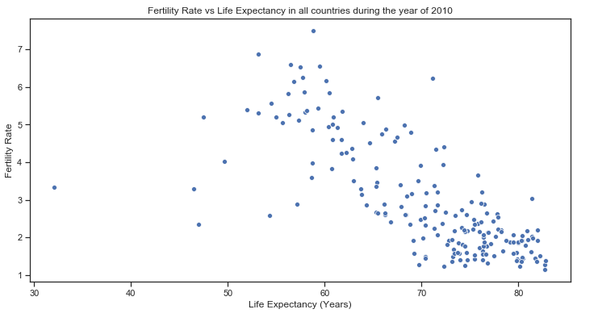

Interestingly, the year 2010 had the best rate, if we were to apply a linear regression, we would likely find that 2010 had the best fit.

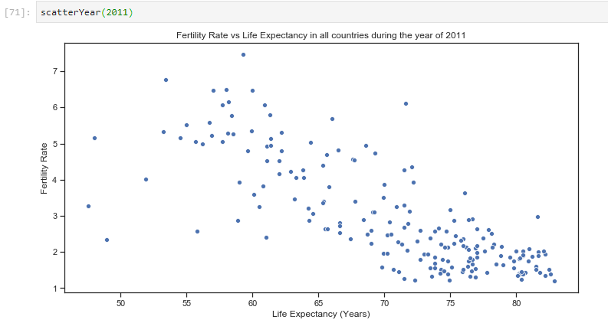

Straight after the year of the best rate, it went back to normal.