DOHMH Roadmap: DALY and Cost Estimates

Background 2

Objective 2

DALYs 3

Definition of Key Terms 3

DALY 3

YLL 3

YLD 3

Methods 3

Data Sources 3

DALY Estimation 4

YLLs 4

YLDs 4

Disease Rankings 5

Estimation of Substance Use Dependence 5

Estimation of Major Depressive Disorder Using PHQ-9 6

Sensitivity Analysis 6

DALY Estimation 6

Michaud YLD Approach 6

Prevalence-Based YLD Approach 6

Results 6

Michaud YLD Approach 6

2013 NYC DALY Estimates, Total 6

2013 NYC DALY Estimates, Male 10

2013 NYC DALY Estimates, Female 13

Prevalence-Based YLD Approach 16

2013 NYC DALY Estimates, Total 16

2013 NYC DALY Estimates, Male 19

2013 NYC DALY Estimates, Female 22

Michaud YLDs vs. Prevalence-Based YLDs: Side-by-Side Comparison 25

Total 25

Male 26

le 26

Female 27

Disease Conditions with Small Sample Sizes 28

Sensitivity Analysis 29

2005 NYC DALY Estimates, Total 29

2005 NYC DALY Estimates, Male 32

2005 NYC DALY Estimates, Female 35

Discussion 38

Limitations 38

Sensitivity Analysis 38

References 38

Economic Loss Estimates 40

Methods 40

Selection 40

Extraction 40

Findings 41

Major Depression 41

Alcohol Use 41

Illicit Drug Use 42

Non-Medical Use of Prescription Opioids 42

Discussion 42

References 43

# Background

## Objective

The objective of this analysis is to estimate DALYs lost and economic losses in New York City due to the following major categories of conditions (with about 100 conditions in total within these categories):

* Major depression
* Alcohol use
* Marijuana use
* Heroin use
* Cocaine use
* Stimulant use
* Sedative use
* Tranquilizer use

It will not be possible to estimate economic losses for all 100 conditions because of inadequate data. As such, marijuana, heroin, cocaine, stimulant, sedative, and tranquilizer use are included in two alternate major categories of conditions:

* Illicit drug use
* Non-medical use of prescription opioids

# DALYs

## Definition of Key Terms

### DALY

**Disability-adjusted life years.** The DALY is a year of life lived in perfect health and consists of two elements: YLLs and YLDs. The DALY is a measure of overall disease burden, expressed as the number of years lost due to ill-health, disability or early death. It was developed in the 1990s as a way of comparing the overall health and life expectancy of different countries.

### YLL

**Years of life lost.** Years of life lost is an estimate of the average years a person would have lived if he or she had not died prematurely.

### YLD

**Years of life lost due to disability.** This is the morbidity component of the DALY score. To estimate YLD for a particular cause in a particular time period, the number of incident cases in that period is multiplied by the average duration of the disease and a weight factor that reflects the severity of the disease on a scale from 0 (perfect health) to 1 (dead). The basic formula for YLD is the following:

# Methods

## Data Sources

* 2013 NYCHANES - prevalence estimates
* 2002-2008 NSDUH - drug use prevalence estimates
* 2013 NYC Vital Statistics - mortality estimates
* 2010 Global Burden of Disease Study - national YLD/YLL rates
* 2013 NYC American Community Survey - population estimates

The challenge with using NYCHANES and NSDUH data to estimate the prevalence of a condition is that the n may be too small. To increase their utility of these surveys, we will aggregate age groups into the following strata: childhood (0-14), late adolescence/early adulthood (15-24), adulthood (25-64), and later life (65+).

## DALY Estimation

### YLLs

To estimate compute NYC YLLs, we will use NYC mortality counts stratified by age, sex, and race. In concodrance with the literature on DALY estimation, life expectancy estimates based on the life expectancy in Japan (82.5 years for women and 80.0 years for men) were used for the calculation of YLL. In order to remain consistent with the methodology of the 2010 Global Burden Disease Study, no age weighting or discounting was applied.

### YLDs

To compute NYC YLDs, we will use the two approaches described below:

#### 2005 NYC DOHMH / Michaud (2006)

In order to compare the magnitude of the DALY scores to the [2005 NYC DOHMH study](http://www.nyc.gov/html/doh/downloads/pdf/epi/datatable11.pdf), we will replicate the previous study's methodology, which was based on [Michaud CM, et al](http://www.pophealthmetrics.com/content/4/1/11). The burden of disease and injury in the United States 1996. Population Health Metrics 2006,4:11.

"For NYC YLD, U.S. Census Bureau population estimates for New York City in 2005 by sex were used to calculate years lived with disability (YLD) by applying national YLD rates and ratios from the Michaud et al. study. If the national YLL:YLD ratio was less than 10, then the NYC YLD was equal to the national YLD:YLL ratio multiplied by NYC YLL. If the national YLD:YLL ratio was greater than or equal to 10 (producing unreliable City estimates), then NYC YLD was equal to the national YLD rate multiplied by the NYC population."

Implementing the Michaud approach will thus require the following data elements:

* NYC Population by age, sex
* National YLD rates by age, sex
* NYC YLLs by age, sex

In order to remain consistent with the demographic weighting approach used by NYC DOHMH for the 2013 NYCHANES data, NYC population estimates were obtained from the [2013 American Community Survey](http://www.nyc.gov/html/dcp/download/census/boro_demo_2013_acs.xlsx), which is available on the NYC Department of City Planning website. Since the data from the Michaud study are from 1996 and patterns of disease and disability have changed, we will update the approach using national YLD/YLL rates from the 2010 Global Burden of Disease Study.

#### Prevalence-based YLDs

Years lived with a disability (YLD) due to each disease can be calculated on the basis of either the incidence or the prevalence of the disease. The initial GBD studies estimated YLD on the basis of the incidence of each disease. Thus, in the 1990 study for example, the YLD estimates measured the future loss of health resulting from disease episodes that began in 1990. One advantage of this approach is that it is consistent with that used for mortality: YLL measure the future loss of life resulting from deaths in a particular year.

The 2010 GBD study adopted the alternative approach and calculated YLD based on the prevalence of the impairments resulting from each disease in the year for which the estimates are made. This approach has the advantage that it assigns YLD to the ages at which they are lived, rather than to the age at which the disease episode that produced them began.

Because prevalence is approximately incidence x duration, prevalence YLD for a condition (across all ages) is approximately the same as the no frills incidence YLD. As such, we can estimate YLDs using the following formula:

We can estimate the number of prevalent cases for each condition using survey data from 2013 NYCHANES. Annual prevalence for drug use can be estimated using data from 2002-2008 NSDUH. Disability weights can be extracted from the 2010 Global Burden of Disease study. However, we should note that the prevalence YLD for a condition may be quite different in magnitude to the incidence-based YLD, depending on how age weighting and discounting are applied. As such, comparisons to previous NYC DALY studies should be done with caution.

Further information about estimating DALYs can be found from the Global Burden of Disease concept paper ([WHO, 2006](http://www.who.int/quantifying_ehimpacts/publications/en/9241546204chap3.pdf)).

## Disease Rankings

Since our goal is to communicate the burden of diseases in New York City, we will rank each condition in decreasing order of the DALY score. We will also test the stability of the rankings by comparing the results generated from the Michaud approach and the prevalence-based YLDs approach. Moreover, since the 2010 GBD study also provides 95% confidence intervals around point estimates for disability weights and national YLD/YLL rates, further stability checks can be conducted by reporting DALY estimations with their respective upper and lower bounds.

However, we should note that since the DALY estimations are not inclusive of all disease conditions, we will not be able to report our findings as the "top X conditions contributing to DALYs." Instead, we can only report mental health DALYs in reference to other highly prevalent chronic diseases.

## Estimation of Substance Use Dependence

Prevalence estimates of substance use cannot be directly substituted for prevalence of drug dependence or abuse disorders. We make the following assumptions about the average proportion of dependence among users ([National Addiction Centre, 2003](http://www.nta.nhs.uk/uploads/dangerousnessofdrugsdh_4086293.pdf)):

* Alcohol - 15.4%
* Cocaine - 16.7%
* Heroin - 23.1%
* Cannabis - 9.1%

## Estimation of Major Depressive Disorder Using PHQ-9

Prevalence estimates for 2-week depression was obtained for 2013 NYCHANES. While 2-week depression prevalence would lead to underestimation of 1-year depression, the use of PHQ-9 scores can also overestimate both MDD and any depressive disorder due to its low positive predictive value (~55%) for PHQ-9 scores below 10, the cutoff between mild and moderate depression ([Kroenke, 2002](http://www.lphi.org/LPHIadmin/uploads/.PHQ-9-Review-Kroenke-63754.PDF)). To adjust for this in the prevalence-based YLD approach, we did not consider PHQ-9 scores below 10 and assumed - from expert opinion - that only half of those with PHQ-9 scores above 10 were actually diagnosed with MDD.

## Sensitivity Analysis

In order to validate the Michaud approach, we will use 2005 NYC mortality estimates from the previous DOHMH to test the stability of our DALY rankings. However, since age-weighting is no longer used by the 2010 GBD due to ethical concerns, we suspect the magnitude of 2013 NYC DALYs to be slightly higher than that of the 2005 NYC DALYs.

## DALY Estimation

### Michaud YLD Approach

This section contains an implementation of the Michaud approach described in the above methods section. We first create a search index containing all the disease conditions of interest.

This search index is then fed through the calculateDALY workhorse function to estimate DALYs for each disease condition. The result is a data.frame object containing the following columns: cause_name, sex, yll, yld, yld_upper, yld_lower, daly, daly_upper, daly_lower.

### Prevalence-Based YLD Approach

Similar to the section, we implement the prevalence-based YLD approach here using the same search index.

# Results

## Michaud YLD Approach

Raw results for this approach can be found under the results directory under the filename nyc_daly_michaud.csv. The file can be opened in Excel and manipulated with a pivot table for aggregation and stratification purposes.

### 2013 NYC DALY Estimates, Total

|  |  |  |  |  |  |  |  |
| --- | --- | --- | --- | --- | --- | --- | --- |
| cause_name | yll | yld | yld_upper | yld_lower | daly | daly_upper | daly_lower |
| Ischemic heart disease | 142893 | 13658 | 19810 | 8966 | 156550 | 162703 | 151859 |
| Major depressive disorder | 0 | 83953 | 121100 | 55076 | 83953 | 121100 | 55076 |
| Other musculoskeletal disorders | 2885 | 74223 | 89073 | 58852 | 77108 | 91957 | 61737 |
| Anxiety disorders | 0 | 52051 | 75105 | 34951 | 52051 | 75105 | 34951 |
| HIV/AIDS | 29554 | 6239 | 10198 | 3244 | 35793 | 39752 | 32798 |
| Chronic obstructive pulmonary disease | 12759 | 21453 | 34059 | 11961 | 34212 | 46818 | 24720 |
| Lung cancer | 32684 | 485 | 883 | 225 | 33169 | 33567 | 32909 |
| Diabetes mellitus | 17422 | 15059 | 21862 | 9929 | 32481 | 39284 | 27351 |
| Asthma | 3187 | 24307 | 38885 | 13140 | 27494 | 42073 | 16327 |
| Osteoarthritis | 149 | 26968 | 41201 | 16316 | 27117 | 41350 | 16465 |
| Hypertensive heart disease | 25274 | 835 | 1519 | 384 | 26108 | 26792 | 25658 |
| Lower respiratory infections | 24303 | 1312 | 1981 | 809 | 25615 | 26284 | 25112 |
| High blood pressure | 0 | 23051 | 31082 | 15615 | 23051 | 31082 | 15615 |
| Alcohol use disorders | 4921 | 15510 | 23839 | 9449 | 20431 | 28761 | 14370 |
| Breast cancer | 17147 | 3054 | 4732 | 1956 | 20201 | 21880 | 19103 |
| Bipolar affective disorder | 0 | 16820 | 25727 | 10012 | 16820 | 25727 | 10012 |
| Colon and rectum cancers | 14606 | 1055 | 1774 | 618 | 15661 | 16380 | 15224 |
| Poisonings | 15023 | 88 | 230 | 13 | 15111 | 15253 | 15036 |
| Homicide | 14663 | NA | NA | NA | 14663 | NA | NA |
| Cannabis use disorders | 0 | 14303 | 21780 | 8642 | 14303 | 21780 | 8642 |
| Cocaine use disorders | 0 | 13584 | 24968 | 6554 | 13584 | 24968 | 6554 |
| Ischemic stroke | 0 | 12250 | 14808 | 9752 | 12250 | 14808 | 9752 |
| Cerebrovascular disease | 8046 | 2585 | 3094 | 2076 | 10630 | 11139 | 10122 |
| Drug use disorders | 2326 | 6231 | 8780 | 4202 | 8557 | 11106 | 6528 |
| Alzheimer's disease and other dementias | 4452 | 3053 | 4060 | 2154 | 7505 | 8512 | 6606 |
| Congenital anomalies | 5859 | 1111 | 1741 | 672 | 6971 | 7600 | 6531 |
| Amphetamine use disorders | 0 | 5547 | 9689 | 2694 | 5547 | 9689 | 2694 |
| Motor vehicle accidents | 3135 | 512 | 775 | 325 | 3647 | 3910 | 3460 |

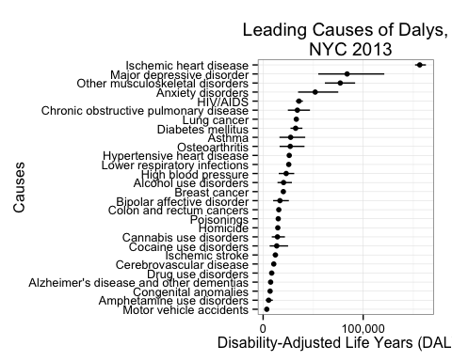 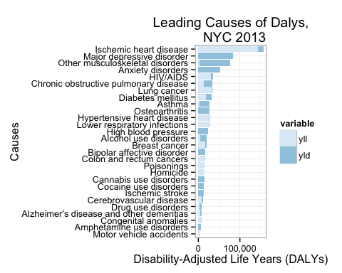

### 2013 NYC DALY Estimates, Male

|  |  |  |  |  |  |  |  |  |
| --- | --- | --- | --- | --- | --- | --- | --- | --- |
| cause_name | sex | yll | yld | yld_upper | yld_lower | daly | daly_upper | daly_lower |
| Ischemic heart disease | Male | 62241 | 5253 | 7628 | 3433 | 67494 | 69869 | 65674 |
| Major depressive disorder | Male | 0 | 29122 | 42380 | 19172 | 29122 | 42380 | 19172 |
| Other musculoskeletal disorders | Male | 604 | 22433 | 28657 | 15884 | 23036 | 29261 | 16487 |
| HIV/AIDS | Male | 17948 | 4244 | 6583 | 2371 | 22192 | 24532 | 20319 |
| Alcohol use disorders | Male | 4438 | 13308 | 20434 | 8139 | 17747 | 24873 | 12577 |
| Lung cancer | Male | 17348 | 238 | 411 | 121 | 17586 | 17759 | 17469 |
| Anxiety disorders | Male | 0 | 16888 | 24380 | 11291 | 16888 | 24380 | 11291 |
| Chronic obstructive pulmonary disease | Male | 5605 | 10302 | 16528 | 5655 | 15907 | 22133 | 11260 |
| Diabetes mellitus | Male | 8440 | 6526 | 9561 | 4265 | 14967 | 18002 | 12705 |
| Hypertensive heart disease | Male | 11866 | 268 | 491 | 120 | 12134 | 12357 | 11986 |
| Homicide | Male | 11903 | NA | NA | NA | 11903 | NA | NA |
| Asthma | Male | 1409 | 10463 | 16739 | 5641 | 11871 | 18148 | 7050 |
| Lower respiratory infections | Male | 10657 | 513 | 786 | 311 | 11170 | 11443 | 10968 |
| Poisonings | Male | 11035 | 70 | 176 | 12 | 11105 | 11210 | 11047 |
| High blood pressure | Male | 0 | 10872 | 14946 | 7183 | 10872 | 14946 | 7183 |
| Osteoarthritis | Male | 59 | 9384 | 14597 | 5661 | 9443 | 14656 | 5720 |
| Bipolar affective disorder | Male | 0 | 7449 | 11473 | 4414 | 7449 | 11473 | 4414 |
| Colon and rectum cancers | Male | 6478 | 421 | 680 | 250 | 6899 | 7158 | 6728 |
| Ischemic stroke | Male | 0 | 5693 | 6885 | 4521 | 5693 | 6885 | 4521 |
| Cocaine use disorders | Male | 0 | 4601 | 8347 | 2259 | 4601 | 8347 | 2259 |
| Cocaine use disorders | Male | 0 | 4601 | 8347 | 2259 | 4601 | 8347 | 2259 |
| Cannabis use disorders | Male | 0 | 4486 | 6858 | 2705 | 4486 | 6858 | 2705 |
| Cannabis use disorders | Male | 0 | 4486 | 6858 | 2705 | 4486 | 6858 | 2705 |
| Cerebrovascular disease | Male | 3085 | 1042 | 1250 | 834 | 4126 | 4334 | 3918 |
| Congenital anomalies | Male | 3108 | 550 | 855 | 333 | 3658 | 3963 | 3441 |
| Drug use disorders | Male | 1620 | 1512 | 2134 | 1006 | 3132 | 3755 | 2626 |
| Motor vehicle accidents | Male | 2060 | 323 | 489 | 206 | 2383 | 2549 | 2267 |
| Alzheimer's disease and other dementias | Male | 1280 | 832 | 1114 | 589 | 2112 | 2395 | 1869 |
| Amphetamine use disorders | Male | 0 | 1711 | 2950 | 839 | 1711 | 2950 | 839 |
| Amphetamine use disorders | Male | 0 | 1711 | 2950 | 839 | 1711 | 2950 | 839 |

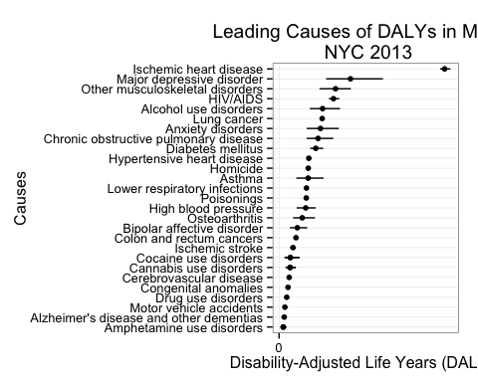 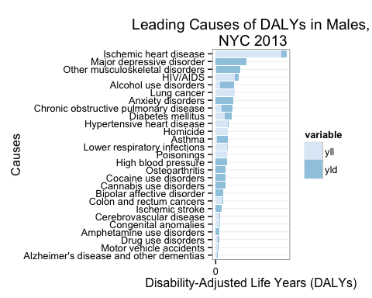

* Alcohol use disorders rises to the #5 slot
* Homicide and accidental deaths such as poisonings and motor vehicle accidents rise in rankings

### 2013 NYC DALY Estimates, Female

|  |  |  |  |  |  |  |  |  |
| --- | --- | --- | --- | --- | --- | --- | --- | --- |
| cause_name | sex | yll | yld | yld_upper | yld_lower | daly | daly_upper | daly_lower |
| Ischemic heart disease | Female | 80652 | 8404 | 12182 | 5533 | 89056 | 92834 | 86184 |
| Major depressive disorder | Female | 0 | 54832 | 78719 | 35904 | 54832 | 78719 | 35904 |
| Other musculoskeletal disorders | Female | 2281 | 51790 | 60415 | 42969 | 54071 | 62696 | 45250 |
| Anxiety disorders | Female | 0 | 35163 | 50725 | 23660 | 35163 | 50725 | 23660 |
| Breast cancer | Female | 17147 | 3054 | 4732 | 1956 | 20201 | 21880 | 19103 |
| Chronic obstructive pulmonary disease | Female | 7154 | 11151 | 17530 | 6307 | 18305 | 24685 | 13461 |
| Osteoarthritis | Female | 90 | 17585 | 26605 | 10655 | 17674 | 26694 | 10745 |
| Diabetes mellitus | Female | 8982 | 8533 | 12301 | 5665 | 17514 | 21282 | 14646 |
| Asthma | Female | 1779 | 13844 | 22146 | 7499 | 15623 | 23925 | 9277 |
| Lung cancer | Female | 15336 | 247 | 472 | 104 | 15583 | 15808 | 15440 |
| Lower respiratory infections | Female | 13646 | 799 | 1196 | 498 | 14445 | 14841 | 14144 |
| Hypertensive heart disease | Female | 13407 | 567 | 1028 | 264 | 13974 | 14436 | 13671 |
| HIV/AIDS | Female | 11606 | 1995 | 3615 | 873 | 13601 | 15221 | 12479 |
| High blood pressure | Female | 0 | 12180 | 16136 | 8433 | 12180 | 16136 | 8433 |
| Bipolar affective disorder | Female | 0 | 9371 | 14254 | 5598 | 9371 | 14254 | 5598 |
| Colon and rectum cancers | Female | 8128 | 634 | 1095 | 368 | 8762 | 9223 | 8496 |
| Ischemic stroke | Female | 0 | 6556 | 7923 | 5231 | 6556 | 7923 | 5231 |
| Cerebrovascular disease | Female | 4961 | 1543 | 1844 | 1242 | 6504 | 6805 | 6203 |
| Drug use disorders | Female | 706 | 4719 | 6645 | 3197 | 5424 | 7351 | 3902 |
| Alzheimer's disease and other dementias | Female | 3172 | 2221 | 2946 | 1565 | 5393 | 6118 | 4737 |
| Poisonings | Female | 3988 | 18 | 54 | 1 | 4006 | 4042 | 3989 |
| Congenital anomalies | Female | 2751 | 562 | 886 | 339 | 3313 | 3637 | 3090 |
| Homicide | Female | 2760 | NA | NA | NA | 2760 | NA | NA |
| Alcohol use disorders | Female | 483 | 2202 | 3405 | 1310 | 2685 | 3888 | 1793 |
| Cannabis use disorders | Female | 0 | 2665 | 4032 | 1616 | 2665 | 4032 | 1616 |
| Cannabis use disorders | Female | 0 | 2665 | 4032 | 1616 | 2665 | 4032 | 1616 |
| Cocaine use disorders | Female | 0 | 2191 | 4138 | 1017 | 2191 | 4138 | 1017 |
| Cocaine use disorders | Female | 0 | 2191 | 4138 | 1017 | 2191 | 4138 | 1017 |
| Motor vehicle accidents | Female | 1074 | 189 | 287 | 119 | 1264 | 1361 | 1193 |
| Amphetamine use disorders | Female | 0 | 1062 | 1895 | 508 | 1062 | 1895 | 508 |
| Amphetamine use disorders | Female | 0 | 1062 | 1895 | 508 | 1062 | 1895 | 508 |

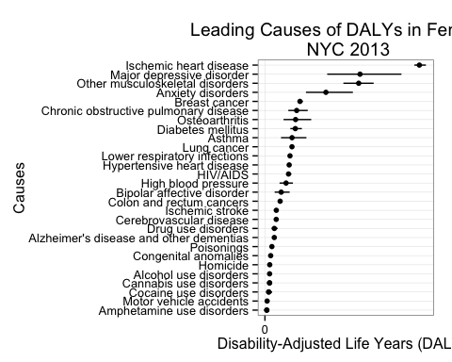 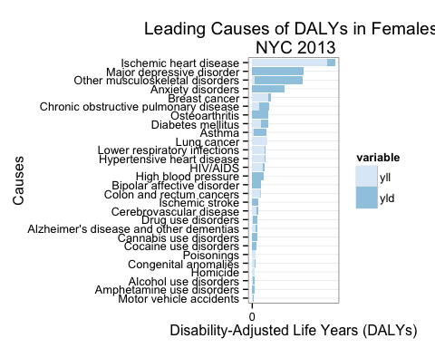

## Prevalence-Based YLD Approach

Raw results for this approach can be found under the results directory under the filename nyc_daly_prevalence.csv. The file can be opened in Excel and manipulated with a pivot table for aggregation and stratification purposes.

### 2013 NYC DALY Estimates, Total

|  |  |  |  |  |  |  |  |
| --- | --- | --- | --- | --- | --- | --- | --- |
| cause_name | yll | yld | yld_upper | yld_lower | daly | daly_upper | daly_lower |
| Ischemic heart disease | 142893 | 30186 | 34498 | 24197 | 173078 | 177391 | 167089 |
| Alcohol use disorders | 4921 | 136164 | 188737 | 92528 | 141085 | 193658 | 97450 |
| Major depressive disorder | NA | 125830 | 168883 | 86154 | 125830 | 168883 | 86154 |
| Other arthritis | NA | 88591 | 123561 | 59838 | 88591 | 123561 | 59838 |
| Chronic obstructive pulmonary disease | 12759 | 64253 | 90690 | 43170 | 77012 | 103449 | 55929 |
| Arthritis | NA | 57587 | 80319 | 38896 | 57587 | 80319 | 38896 |
| Cocaine use | NA | 44665 | 65691 | 27916 | 44665 | 65691 | 27916 |
| Breast cancer | 17269 | 24769 | 34626 | 16765 | 42038 | 51895 | 34035 |
| Lung cancer | 32684 | 4937 | 6902 | 3342 | 37622 | 39587 | 36026 |
| Heroin use | NA | 36139 | 45272 | 25878 | 36139 | 45272 | 25878 |
| Anxiety | NA | 30752 | 49203 | 17426 | 30752 | 49203 | 17426 |
| Diabetes mellitus | 17422 | 10119 | 12143 | 8095 | 27541 | 29565 | 25517 |
| Cannabis use | NA | 24991 | 34562 | 16939 | 24991 | 34562 | 16939 |
| Asthma | 3187 | 20058 | 33430 | 11143 | 23245 | 36617 | 14331 |
| Colon and rectum cancers | 14606 | 4471 | 6251 | 3027 | 19077 | 20857 | 17633 |
| Amphetamine use | NA | 8050 | 11972 | 4903 | 8050 | 11972 | 4903 |
| Stimulant use | NA | 2549 | 3790 | 1552 | 2549 | 3790 | 1552 |
| Ischemic stroke | NA | 1820 | 3207 | 953 | 1820 | 3207 | 953 |
| High blood pressure | NA | 0 | 0 | 0 | 0 | 0 | 0 |
| Sedative use | NA | 0 | 0 | 0 | 0 | 0 | 0 |
| Tranquilizer use | NA | 0 | 0 | 0 | 0 | 0 | 0 |

* Major depressive disorder ranks number one, beating out the number two slot by almost twice the number of DALYs However, DALY estimates appear to be unstable, taking a wide range of possible values.
* Not enough information to calculate DALY estimates for sedative use, sedative use, tranquilizer use, high blood pre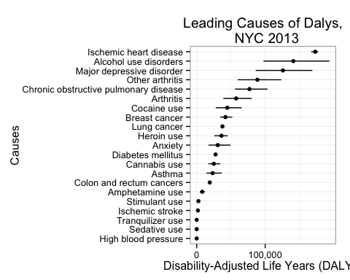 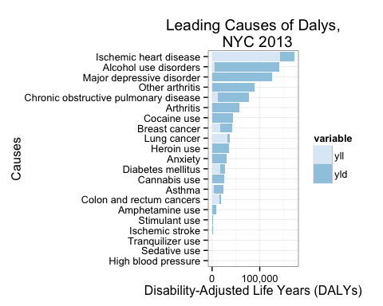

### 2013 NYC DALY Estimates, Male

|  |  |  |  |  |  |  |  |  |
| --- | --- | --- | --- | --- | --- | --- | --- | --- |
| cause_name | sex | yll | yld | yld_upper | yld_lower | daly | daly_upper | daly_lower |
| Alcohol use disorders | Male | 4438 | 72958 | 101127 | 49577 | 77396 | 105565 | 54016 |
| Ischemic heart disease | Male | 62241 | 13079 | 14947 | 10484 | 75320 | 77188 | 72725 |
| Major depressive disorder | Male | NA | 40352 | 54452 | 27533 | 40352 | 54452 | 27533 |
| Chronic obstructive pulmonary disease | Male | 5605 | 32495 | 45865 | 21833 | 38100 | 51470 | 27438 |
| Other arthritis | Male | NA | 31037 | 43288 | 20963 | 31037 | 43288 | 20963 |
| Lung cancer | Male | 17348 | 1926 | 2692 | 1304 | 19274 | 20041 | 18652 |
| Arthritis | Male | NA | 18723 | 26114 | 12647 | 18723 | 26114 | 12647 |
| Diabetes mellitus | Male | 8440 | 4770 | 5724 | 3816 | 13210 | 14164 | 12256 |
| Cocaine use | Male | NA | 12568 | 18484 | 7855 | 12568 | 18484 | 7855 |
| Cocaine use | Male | NA | 12568 | 18484 | 7855 | 12568 | 18484 | 7855 |
| Anxiety | Male | NA | 11399 | 18238 | 6459 | 11399 | 18238 | 6459 |
| Heroin use | Male | NA | 9980 | 12502 | 7146 | 9980 | 12502 | 7146 |
| Heroin use | Male | NA | 9980 | 12502 | 7146 | 9980 | 12502 | 7146 |
| Asthma | Male | 1409 | 7269 | 12115 | 4038 | 8678 | 13523 | 5447 |
| Colon and rectum cancers | Male | 6478 | 1835 | 2565 | 1242 | 8313 | 9043 | 7720 |
| Cannabis use | Male | NA | 8054 | 11138 | 5459 | 8054 | 11138 | 5459 |
| Cannabis use | Male | NA | 8054 | 11138 | 5459 | 8054 | 11138 | 5459 |
| Amphetamine use | Male | NA | 2514 | 3740 | 1531 | 2514 | 3740 | 1531 |
| Amphetamine use | Male | NA | 2514 | 3740 | 1531 | 2514 | 3740 | 1531 |
| Stimulant use | Male | NA | 1610 | 2394 | 980 | 1610 | 2394 | 980 |
| Ischemic stroke | Male | NA | 608 | 1071 | 318 | 608 | 1071 | 318 |
| Breast cancer | Male | 122 | 0 | 0 | 0 | 122 | 122 | 122 |
| High blood pressure | Male | NA | 0 | 0 | 0 | 0 | 0 | 0 |
| Sedative use | Male | NA | 0 | 0 | 0 | 0 | 0 | 0 |
| Tranquilizer use | Male | NA | 0 | 0 | 0 | 0 | 0 | 0 |

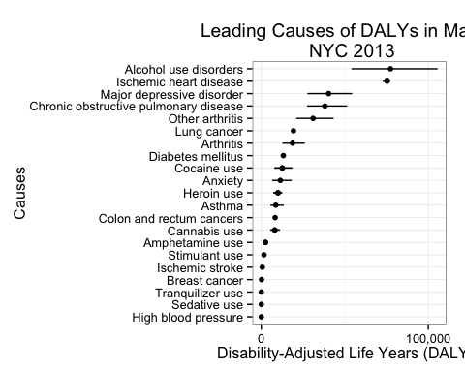 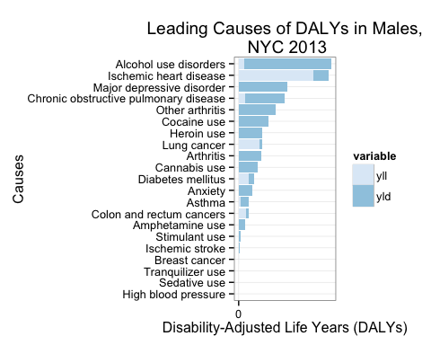

### 2013 NYC DALY Estimates, Female

|  |  |  |  |  |  |  |  |  |
| --- | --- | --- | --- | --- | --- | --- | --- | --- |
| cause_name | sex | yll | yld | yld_upper | yld_lower | daly | daly_upper | daly_lower |
| Ischemic heart disease | Female | 80652 | 17107 | 19551 | 13713 | 97758 | 100202 | 94364 |
| Major depressive disorder | Female | NA | 85478 | 114432 | 58621 | 85478 | 114432 | 58621 |
| Alcohol use disorders | Female | 483 | 63206 | 87610 | 42951 | 63689 | 88093 | 43434 |
| Other arthritis | Female | NA | 57555 | 80274 | 38875 | 57555 | 80274 | 38875 |
| Breast cancer | Female | 17147 | 24769 | 34626 | 16765 | 41916 | 51773 | 33913 |
| Chronic obstructive pulmonary disease | Female | 7154 | 31758 | 44824 | 21337 | 38912 | 51979 | 28491 |
| Arthritis | Female | NA | 38863 | 54204 | 26250 | 38863 | 54204 | 26250 |
| Anxiety | Female | NA | 19353 | 30965 | 10967 | 19353 | 30965 | 10967 |
| Lung cancer | Female | 15336 | 3011 | 4210 | 2038 | 18347 | 19546 | 17374 |
| Asthma | Female | 1779 | 12789 | 21315 | 7105 | 14568 | 23094 | 8884 |
| Diabetes mellitus | Female | 8982 | 5349 | 6419 | 4279 | 14331 | 15401 | 13261 |
| Colon and rectum cancers | Female | 8128 | 2636 | 3685 | 1784 | 10764 | 11814 | 9912 |
| Cocaine use | Female | NA | 9765 | 14361 | 6103 | 9765 | 14361 | 6103 |
| Cocaine use | Female | NA | 9765 | 14361 | 6103 | 9765 | 14361 | 6103 |
| Heroin use | Female | NA | 8090 | 10134 | 5793 | 8090 | 10134 | 5793 |
| Heroin use | Female | NA | 8090 | 10134 | 5793 | 8090 | 10134 | 5793 |
| Cannabis use | Female | NA | 4442 | 6142 | 3010 | 4442 | 6142 | 3010 |
| Cannabis use | Female | NA | 4442 | 6142 | 3010 | 4442 | 6142 | 3010 |
| Amphetamine use | Female | NA | 1510 | 2246 | 920 | 1510 | 2246 | 920 |
| Amphetamine use | Female | NA | 1510 | 2246 | 920 | 1510 | 2246 | 920 |
| Ischemic stroke | Female | NA | 1212 | 2136 | 635 | 1212 | 2136 | 635 |
| Stimulant use | Female | NA | 939 | 1396 | 572 | 939 | 1396 | 572 |
| High blood pressure | Female | NA | 0 | 0 | 0 | 0 | 0 | 0 |
| Sedative use | Female | NA | 0 | 0 | 0 | 0 | 0 | 0 |
| Tranquilizer use | Female | NA | 0 | 0 | 0 | 0 | 0 | 0 |

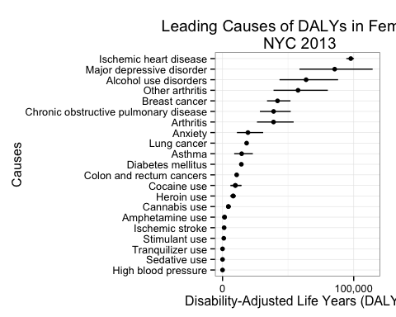 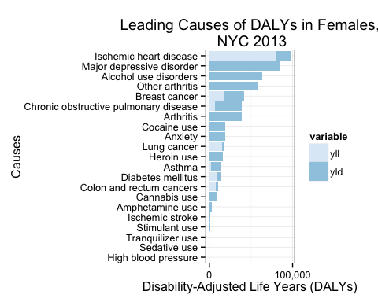

## Michaud YLDs vs. Prevalence-Based YLDs: Side-by-Side Comparison

### Total

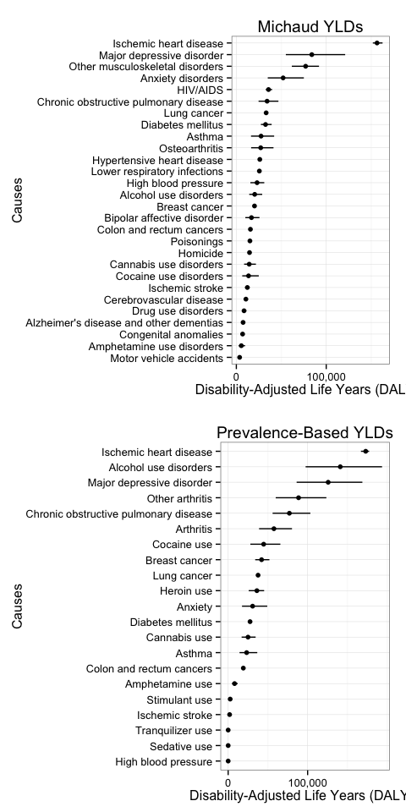

### Male

### le

### Female

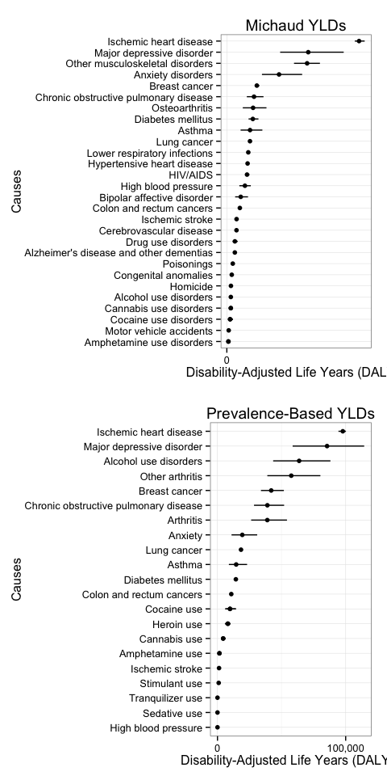

## Disease Conditions with Small Sample Sizes

## cause_name sequlae sex age  
## 25 Breast cancer Breast cancer Male 20-39   
## 26 Breast cancer Breast cancer Male 40-59   
## 27 Breast cancer Breast cancer Male 60+   
## 28 Breast cancer Breast cancer Female 20-39   
## 36 Cocaine use Cocaine use Female 60+   
## 37 Colon and rectum cancers Colon and rectum cancers Male 20-39   
## 38 Colon and rectum cancers Colon and rectum cancers Male 40-59   
## 39 Colon and rectum cancers Colon and rectum cancers Male 60+   
## 40 Colon and rectum cancers Colon and rectum cancers Female 20-39   
## 41 Colon and rectum cancers Colon and rectum cancers Female 40-59   
## 42 Colon and rectum cancers Colon and rectum cancers Female 60+   
## 55 Heroin use Heroin use Male 20-39   
## 56 Heroin use Heroin use Male 40-59   
## 57 Heroin use Heroin use Male 60+   
## 58 Heroin use Heroin use Female 20-39   
## 59 Heroin use Heroin use Female 40-59   
## 60 Heroin use Heroin use Female 60+   
## 67 Ischemic heart disease Ischemic heart disease Male 20-39   
## 70 Ischemic heart disease Ischemic heart disease Female 20-39   
## 73 Lung cancer Lung Male 20-39   
## 74 Lung cancer Lung Male 40-59   
## 75 Lung cancer Lung Male 60+   
## 76 Lung cancer Lung Female 20-39   
## 77 Lung cancer Lung Female 40-59   
## 78 Lung cancer Lung Female 60+   
## 87 Amphetamine use Methamphetamine use Male 20-39   
## 88 Amphetamine use Methamphetamine use Male 40-59   
## 89 Amphetamine use Methamphetamine use Male 60+   
## 90 Amphetamine use Methamphetamine use Female 20-39   
## 91 Amphetamine use Methamphetamine use Female 40-59   
## 92 Amphetamine use Methamphetamine use Female 60+   
## 101 Major depressive disorder moderate depression Male 60+   
## 105 Major depressive disorder moderately severe depression Male 20-39   
## 106 Major depressive disorder moderately severe depression Male 40-59   
## 107 Major depressive disorder moderately severe depression Male 60+   
## 111 Other arthritis Other arthritis Male 20-39   
## 125 Major depressive disorder severe depression Male 20-39   
## 126 Major depressive disorder severe depression Male 40-59   
## 127 Major depressive disorder severe depression Male 60+   
## 128 Major depressive disorder severe depression Female 20-39   
## 130 Major depressive disorder severe depression Female 60+   
## 139 Ischemic stroke Ischemic stroke Male 20-39   
## 140 Ischemic stroke Ischemic stroke Male 40-59   
## 141 Ischemic stroke Ischemic stroke Male 60+   
## 142 Ischemic stroke Ischemic stroke Female 20-39

# Sensitivity Analysis

### 2005 NYC DALY Estimates, Total

|  |  |  |  |  |  |  |  |
| --- | --- | --- | --- | --- | --- | --- | --- |
| cause_name | yll | yld | yld_upper | yld_lower | daly | daly_upper | daly_lower |
| Ischemic heart disease | 142893 | 13658 | 19810 | 8966 | 156550 | 162703 | 151859 |
| Major depressive disorder | 0 | 83953 | 121100 | 55076 | 83953 | 121100 | 55076 |
| Other musculoskeletal disorders | 2885 | 74223 | 89073 | 58852 | 77108 | 91957 | 61737 |
| Anxiety disorders | 0 | 52051 | 75105 | 34951 | 52051 | 75105 | 34951 |
| HIV/AIDS | 29554 | 6239 | 10198 | 3244 | 35793 | 39752 | 32798 |
| Chronic obstructive pulmonary disease | 12759 | 21453 | 34059 | 11961 | 34212 | 46818 | 24720 |
| Lung cancer | 32684 | 485 | 883 | 225 | 33169 | 33567 | 32909 |
| Diabetes mellitus | 17422 | 15059 | 21862 | 9929 | 32481 | 39284 | 27351 |
| Asthma | 3187 | 24307 | 38885 | 13140 | 27494 | 42073 | 16327 |
| Osteoarthritis | 149 | 26968 | 41201 | 16316 | 27117 | 41350 | 16465 |
| Hypertensive heart disease | 25274 | 835 | 1519 | 384 | 26108 | 26792 | 25658 |
| Lower respiratory infections | 24303 | 1312 | 1981 | 809 | 25615 | 26284 | 25112 |
| High blood pressure | 0 | 23051 | 31082 | 15615 | 23051 | 31082 | 15615 |
| Alcohol use disorders | 4921 | 15510 | 23839 | 9449 | 20431 | 28761 | 14370 |
| Breast cancer | 17147 | 3054 | 4732 | 1956 | 20201 | 21880 | 19103 |
| Bipolar affective disorder | 0 | 16820 | 25727 | 10012 | 16820 | 25727 | 10012 |
| Colon and rectum cancers | 14606 | 1055 | 1774 | 618 | 15661 | 16380 | 15224 |
| Poisonings | 15023 | 88 | 230 | 13 | 15111 | 15253 | 15036 |
| Homicide | 14663 | NA | NA | NA | 14663 | NA | NA |
| Cannabis use disorders | 0 | 14303 | 21780 | 8642 | 14303 | 21780 | 8642 |
| Cocaine use disorders | 0 | 13584 | 24968 | 6554 | 13584 | 24968 | 6554 |
| Ischemic stroke | 0 | 12250 | 14808 | 9752 | 12250 | 14808 | 9752 |
| Cerebrovascular disease | 8046 | 2585 | 3094 | 2076 | 10630 | 11139 | 10122 |
| Drug use disorders | 2326 | 6231 | 8780 | 4202 | 8557 | 11106 | 6528 |
| Alzheimer's disease and other dementias | 4452 | 3053 | 4060 | 2154 | 7505 | 8512 | 6606 |
| Congenital anomalies | 5859 | 1111 | 1741 | 672 | 6971 | 7600 | 6531 |
| Amphetamine use disorders | 0 | 5547 | 9689 | 2694 | 5547 | 9689 | 2694 |
| Motor vehicle accidents | 3135 | 512 | 775 | 325 | 3647 | 3910 | 3460 |

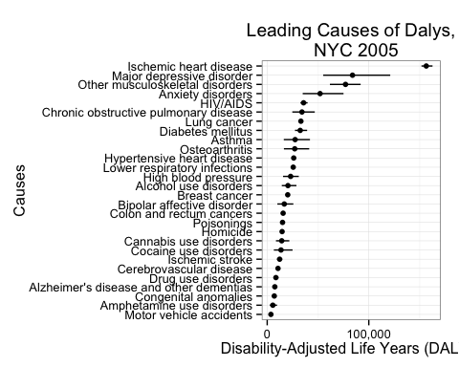 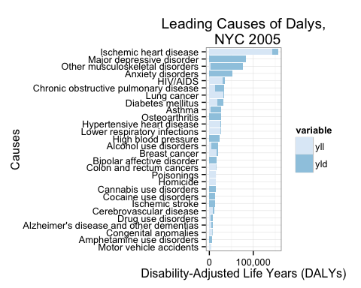

### 2005 NYC DALY Estimates, Male

|  |  |  |  |  |  |  |  |  |
| --- | --- | --- | --- | --- | --- | --- | --- | --- |
| cause_name | sex | yll | yld | yld_upper | yld_lower | daly | daly_upper | daly_lower |
| Ischemic heart disease | Male | 62241 | 5253 | 7628 | 3433 | 67494 | 69869 | 65674 |
| Major depressive disorder | Male | 0 | 29122 | 42380 | 19172 | 29122 | 42380 | 19172 |
| Other musculoskeletal disorders | Male | 604 | 22433 | 28657 | 15884 | 23036 | 29261 | 16487 |
| HIV/AIDS | Male | 17948 | 4244 | 6583 | 2371 | 22192 | 24532 | 20319 |
| Alcohol use disorders | Male | 4438 | 13308 | 20434 | 8139 | 17747 | 24873 | 12577 |
| Lung cancer | Male | 17348 | 238 | 411 | 121 | 17586 | 17759 | 17469 |
| Anxiety disorders | Male | 0 | 16888 | 24380 | 11291 | 16888 | 24380 | 11291 |
| Chronic obstructive pulmonary disease | Male | 5605 | 10302 | 16528 | 5655 | 15907 | 22133 | 11260 |
| Diabetes mellitus | Male | 8440 | 6526 | 9561 | 4265 | 14967 | 18002 | 12705 |
| Hypertensive heart disease | Male | 11866 | 268 | 491 | 120 | 12134 | 12357 | 11986 |
| Homicide | Male | 11903 | NA | NA | NA | 11903 | NA | NA |
| Asthma | Male | 1409 | 10463 | 16739 | 5641 | 11871 | 18148 | 7050 |
| Lower respiratory infections | Male | 10657 | 513 | 786 | 311 | 11170 | 11443 | 10968 |
| Poisonings | Male | 11035 | 70 | 176 | 12 | 11105 | 11210 | 11047 |
| High blood pressure | Male | 0 | 10872 | 14946 | 7183 | 10872 | 14946 | 7183 |
| Osteoarthritis | Male | 59 | 9384 | 14597 | 5661 | 9443 | 14656 | 5720 |
| Bipolar affective disorder | Male | 0 | 7449 | 11473 | 4414 | 7449 | 11473 | 4414 |
| Colon and rectum cancers | Male | 6478 | 421 | 680 | 250 | 6899 | 7158 | 6728 |
| Ischemic stroke | Male | 0 | 5693 | 6885 | 4521 | 5693 | 6885 | 4521 |
| Cocaine use disorders | Male | 0 | 4601 | 8347 | 2259 | 4601 | 8347 | 2259 |
| Cocaine use disorders | Male | 0 | 4601 | 8347 | 2259 | 4601 | 8347 | 2259 |
| Cannabis use disorders | Male | 0 | 4486 | 6858 | 2705 | 4486 | 6858 | 2705 |
| Cannabis use disorders | Male | 0 | 4486 | 6858 | 2705 | 4486 | 6858 | 2705 |
| Cerebrovascular disease | Male | 3085 | 1042 | 1250 | 834 | 4126 | 4334 | 3918 |
| Congenital anomalies | Male | 3108 | 550 | 855 | 333 | 3658 | 3963 | 3441 |
| Drug use disorders | Male | 1620 | 1512 | 2134 | 1006 | 3132 | 3755 | 2626 |
| Motor vehicle accidents | Male | 2060 | 323 | 489 | 206 | 2383 | 2549 | 2267 |
| Alzheimer's disease and other dementias | Male | 1280 | 832 | 1114 | 589 | 2112 | 2395 | 1869 |
| Amphetamine use disorders | Male | 0 | 1711 | 2950 | 839 | 1711 | 2950 | 839 |
| Amphetamine use disorders | Male | 0 | 1711 | 2950 | 839 | 1711 | 2950 | 839 |

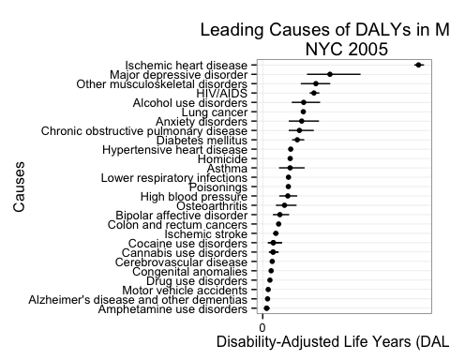 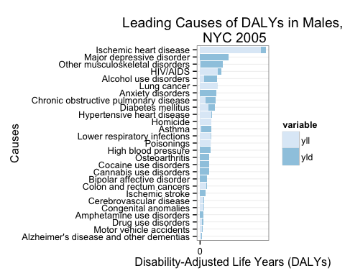

### 2005 NYC DALY Estimates, Female

|  |  |  |  |  |  |  |  |  |
| --- | --- | --- | --- | --- | --- | --- | --- | --- |
| cause_name | sex | yll | yld | yld_upper | yld_lower | daly | daly_upper | daly_lower |
| Ischemic heart disease | Female | 80652 | 8404 | 12182 | 5533 | 89056 | 92834 | 86184 |
| Major depressive disorder | Female | 0 | 54832 | 78719 | 35904 | 54832 | 78719 | 35904 |
| Other musculoskeletal disorders | Female | 2281 | 51790 | 60415 | 42969 | 54071 | 62696 | 45250 |
| Anxiety disorders | Female | 0 | 35163 | 50725 | 23660 | 35163 | 50725 | 23660 |
| Breast cancer | Female | 17147 | 3054 | 4732 | 1956 | 20201 | 21880 | 19103 |
| Chronic obstructive pulmonary disease | Female | 7154 | 11151 | 17530 | 6307 | 18305 | 24685 | 13461 |
| Osteoarthritis | Female | 90 | 17585 | 26605 | 10655 | 17674 | 26694 | 10745 |
| Diabetes mellitus | Female | 8982 | 8533 | 12301 | 5665 | 17514 | 21282 | 14646 |
| Asthma | Female | 1779 | 13844 | 22146 | 7499 | 15623 | 23925 | 9277 |
| Lung cancer | Female | 15336 | 247 | 472 | 104 | 15583 | 15808 | 15440 |
| Lower respiratory infections | Female | 13646 | 799 | 1196 | 498 | 14445 | 14841 | 14144 |
| Hypertensive heart disease | Female | 13407 | 567 | 1028 | 264 | 13974 | 14436 | 13671 |
| HIV/AIDS | Female | 11606 | 1995 | 3615 | 873 | 13601 | 15221 | 12479 |
| High blood pressure | Female | 0 | 12180 | 16136 | 8433 | 12180 | 16136 | 8433 |
| Bipolar affective disorder | Female | 0 | 9371 | 14254 | 5598 | 9371 | 14254 | 5598 |
| Colon and rectum cancers | Female | 8128 | 634 | 1095 | 368 | 8762 | 9223 | 8496 |
| Ischemic stroke | Female | 0 | 6556 | 7923 | 5231 | 6556 | 7923 | 5231 |
| Cerebrovascular disease | Female | 4961 | 1543 | 1844 | 1242 | 6504 | 6805 | 6203 |
| Drug use disorders | Female | 706 | 4719 | 6645 | 3197 | 5424 | 7351 | 3902 |
| Alzheimer's disease and other dementias | Female | 3172 | 2221 | 2946 | 1565 | 5393 | 6118 | 4737 |
| Poisonings | Female | 3988 | 18 | 54 | 1 | 4006 | 4042 | 3989 |
| Congenital anomalies | Female | 2751 | 562 | 886 | 339 | 3313 | 3637 | 3090 |
| Homicide | Female | 2760 | NA | NA | NA | 2760 | NA | NA |
| Alcohol use disorders | Female | 483 | 2202 | 3405 | 1310 | 2685 | 3888 | 1793 |
| Cannabis use disorders | Female | 0 | 2665 | 4032 | 1616 | 2665 | 4032 | 1616 |
| Cannabis use disorders | Female | 0 | 2665 | 4032 | 1616 | 2665 | 4032 | 1616 |
| Cocaine use disorders | Female | 0 | 2191 | 4138 | 1017 | 2191 | 4138 | 1017 |
| Cocaine use disorders | Female | 0 | 2191 | 4138 | 1017 | 2191 | 4138 | 1017 |
| Motor vehicle accidents | Female | 1074 | 189 | 287 | 119 | 1264 | 1361 | 1193 |
| Amphetamine use disorders | Female | 0 | 1062 | 1895 | 508 | 1062 | 1895 | 508 |
| Amphetamine use disorders | Female | 0 | 1062 | 1895 | 508 | 1062 | 1895 | 508 |

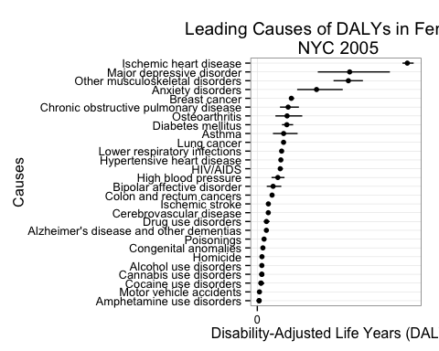 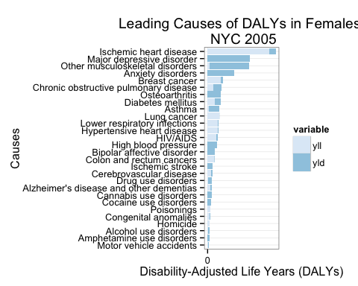

# Discussion

## Limitations

There are key limitations to this analysis. First and foremost, the magnitude of the DALY scores should be interpreted and reported with caution. Due to the small sample size of NYC prevalence estimates and the uncertainty around disability weights and national YLL/YLD rates for some conditions, DALY estimates can assume a wide range of values, changing how one condition ranks against the others (for example, alcohol use disorders and diabetes mellitus). For this reason, DALY magnitudes obtained via Michaud approach and the Prevalence-based YLDs cannot be directly compared.

Moreover, the accuracy of DALY estimations suffers from potential biases introduced in the data collection and computation processes. For example, comorbidities with respect to chronic diseases means that DALY estimates based on Vital Statistics mortality counts are overestimating the contribution of YLLs. Summation of prevalence YLDs across all causes can result in overestimation of the total average severity-weighted health state prevalence because of comorbidity between conditions ([Mathers, 2006](http://www.ncbi.nlm.nih.gov/pmc/articles/PMC547900/)). Over-reporting of some conditions due to misclassification (e.g. where symptoms such as joint pain are labeled as osteoarthritis or occasional wheezing as asthma), under-reporting of undiagnosed conditions (e.g. most mental health problems), and lack of information on condition severity (resulting in high prevalences due to inclusion of very minor conditions or minor symptoms) may also contribute to biased DALY estimates.

In order to convey the uncertainty around our estimates, we visualize the range of values that NYC DALY estimates can take for each condition.

## Sensitivity Analysis

NYC DALY rankings and magnitudes using the Michaud approach are fairly consistent using both 2005 and 2013 NYC mortality counts. Moreover, the Michaud approach implemented in this analysis replicated the 2005 NYC DALY estimates from the previous NYC DOHMH study, producing comparable rankings. However, since age-weighting is no longer used due to ethical concerns, the 2013 NYC DALYs are slightly larger in magnitude. Recommendations for future work include running simulations to test the stability of DALY rankings for an even wider range of assumptions.

# References

Jiang, Yongwen, and Jana Earl Hesser. “Using Disability-Adjusted Life Years to Assess the Burden of Disease and Injury in Rhode Island.” Public Health Reports 127, no. 3 (2012): 293–303.

Lozano, Rafael, Mohsen Naghavi, Kyle Foreman, Stephen Lim, Kenji Shibuya, Victor Aboyans, Jerry Abraham, et al. “Global and Regional Mortality from 235 Causes of Death for 20 Age Groups in 1990 and 2010: A Systematic Analysis for the Global Burden of Disease Study 2010.” The Lancet 380, no. 9859 (December 15, 2012): 2095–2128. <doi:10.1016/S0140-6736(12)61728-0>.

Michaud, Catherine M, Matthew T McKenna, Stephen Begg, Niels Tomijima, Meghna Majmudar, Maria T Bulzacchelli, Shahul Ebrahim, et al. “The Burden of Disease and Injury in the United States 1996.” Population Health Metrics 4 (October 18, 2006): 11. <doi:10.1186/1478-7954-4-11>.

Kroenke, Kurt, and Robert L. Spitzer. “The PHQ-9: A New Depression Diagnostic and Severity Measure.” Psychiatric Annals 32, no. 9 (2002): 509–15.

Schroeder, S Andrew. “Incidence, Prevalence, and Hybrid Approaches to Calculating Disability-Adjusted Life Years.” Population Health Metrics 10 (September 12, 2012): 19. <doi:10.1186/1478-7954-10-19>.

U.S. Department of Health and Human Services, Substance Abuse and Mental Health Services Administration, and Center for Behavioral Health Statistics and Quality. “Results from the 2012 NSDUH: Summary of National Findings, SAMHSA, CBHSQ.” Accessed April 18, 2015. <http://archive.samhsa.gov/data/NSDUH/2012SummNatFindDetTables/NationalFindings/NSDUHresults2012.htm>. Üstün, T. B., J. L. Ayuso-Mateos, S. Chatterji, C. Mathers, and C. J. L. Murray. “Global Burden of Depressive Disorders in the Year 2000.” The British Journal of Psychiatry 184, no. 5 (May 1, 2004): 386–92. <doi:10.1192/bjp.184.5.386>.

# Economic Loss Estimates

# Methods

Within the major categories of conditions, cost data will be collected from literature reviews on the following variables:

* Lost productivity and leisure time
* Medical system costs
* Criminal justice system costs / social service costs

Cost estimates are limited by previous estimates published either in the medical literature and accessible on online databases (Google Scholar, PubMed) or from grey literature provided by the NYC DOHMH.

# Selection

Eligible studies will be identified using keywords in various combinations (e.g. “depression”, “economic costs”, “economic burden”, “caregiving costs”, “substance use”, “alcohol misuse”, “health care system costs”, “productivity loss” etc.). Searches are limited to English language, full-text articles focused specifically on New York City and/or the United States. Where possible, multiple studies will be reviewed.

# Extraction

Prevalence-based cost data estimates will be extracted and standardized by adjusting costs to 2014 dollars using the consumer price index and then applying a multiplier to reflect New York City costs. The cost per capita (per condition and variable) will be calculated by dividing the total cost estimate by the total population at-risk.

# Findings

Highlights of selected cost data on the major categories of conditions are presented below in Table 1 and summarized:

**Table 1 – Extracts of Cost Data Estimates**

All amounts in USD; per capita costs are in constant 2014 USD

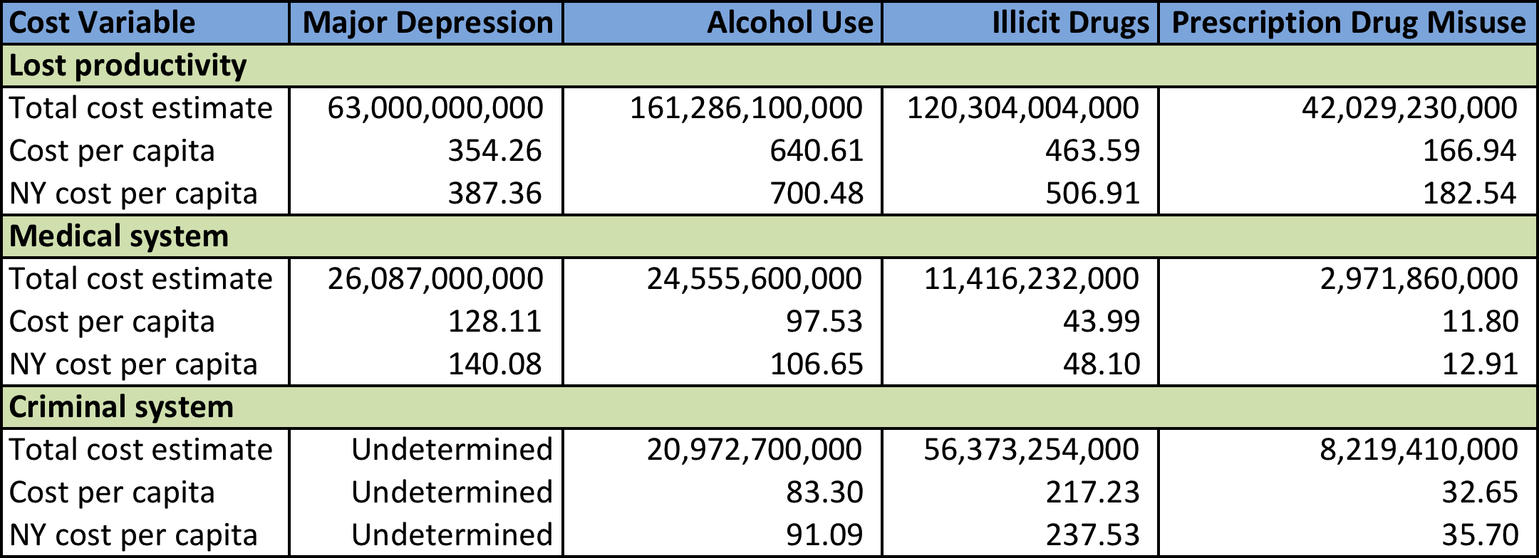

## Major Depression

The per capita economic cost of lost productivity in New York City due to major depressive disorder is estimated at $387.36, including lost productivity resulting from premature death, incarceration, and informal caregiving (The President’s New Freedom Commission on Mental Health, 2003).

With lost productivity in the workplace, approximately 70% is attributable to absenteeism (i.e. days missed from work due to depression), and the remaining 30% to presenteeism (i.e. reduced productivity at work due to depression) (Greenberg et al., 2003).

Medical system costs per capita related to the treatment of depression is estimated at $140.08, with direct costs including inpatient (34%), outpatient (26%), and pharmaceutical (40%) costs (Greenberg et al., 2003).

The criminal justice system and social service costs for depression are difficult to ascertain as a result of inadequate data.

## Alcohol Use

Economic costs of excessive alcohol consumption are extracted and adjusted from a study by Bouchery et al. (2011). Lost productivity per capita in New York City due to alcohol use disorder is estimated at $700.48, including economic costs for premature mortality, impaired productivity, work absenteeism, crime, and health conditions such as fetal alcohol syndrome.

Presenteeism accounts for 46% of total lost productivity at cost per capita of $321.83. A further breakdown indicates that binge drinking drives 68% of impaired productivity at work.

Medical system costs per capita of $106.65 for alcohol use disorder includes special treatment for alcohol dependence and abuse, treatment costs for health conditions such as fetal alcohol syndrome, hospitalizations, and health insurance administration costs, among others. Costs arising from binge drinking have a large impact on health care costs overall.

The per capita cost of alcohol-attributable crime is $91.09, including costs for policing (21%), legal and adjudication (18%), correctional institutions (60%), and others.

## Illicit Drug Use

Illicit drugs included in the scope of the report issued by the U.S. Department of Justice National Drug Intelligence Center (2011) are Schedule I drugs (heroin and marijuana) and Schedule II-IV drugs (cocaine, methamphetamine, tranquilizers, stimulants, and sedatives).

Productivity lost to illicit drug use in New York City amounts to a cost per capita of $506.91 in the context of labor participation, specialty drug treatment, hospitalization, incarceration, and premature mortality. Two factors – reduced labor participation and being incarcerated due to illicit drug use – reflect 81% of total productivity losses.

The estimated medical system cost per capita from illicit drug use is $48.10. Treatment in specialty centers ($15.60) and hospital emergency departments ($24.01) account for 83% of health care costs incurred.

Criminal justice system costs include police protection, adjudication, and corrections expenditures, which are estimated at $237.53 per capita.

## Non-Medical Use of Prescription Opioids

The economic burden of the non-medical use of prescription opioids in New York City was estimated using cost data from a study by Hansen et al. (2010).

Lost productivity cost per capita is $182.54, with costs included for the impact of the non-medical use of prescription opioids on mortality, unemployment and subemployment, and incarceration.

Medical system cost per capita is $12.91, of which treatment at substance abuse facilities ($4.87) is the largest cost component.

The per capita cost of the criminal justice system is $35.70. The estimate is based on the costs of police services, the legal system, and incarceration.

# Discussion

Lost productivity is consistently the highest economic burden across the major categories of major depression, alcohol use disorder, illicit drug use, and the non-medical use of prescription opioids. Criminal justice system costs are higher than medical system costs in most instances, although other indirect costs (aside from productivity losses) such as reduced quality of life are not included due to a lack of data.

As previously noted, the literature review is limited by the sparse data on cost estimates of productivity, health, and crime, as they relate to the major categories of conditions. As well, differences in cost definitions and calculation methodology limit our ability to make direct comparisons of cost variables across the major conditions. Combined with the lack of cost data available, it is also not possible to assess cost variables together from different studies on the same condition.

However, the literature review suggests that the economic costs of productivity, health, and crime associated with the major categories of conditions are substantial, highlighting the importance of investment in prevention and treatment interventions in New York City.

# References

Arno, P. S., Levine, C., & Memmott, M. M. (1999). The economic value of informal caregiving. Health Affairs, 18(2), 182-188.

Bouchery, E. E., Harwood, H. J., Sacks, J. J., Simon, C. J., & Brewer, R. D. (2011). Economic costs of excessive alcohol consumption in the US, 2006. American journal of preventive medicine, 41(5), 516-524.

Greenberg, P. E., Kessler, R. C., Birnbaum, H. G., Leong, S. A., Lowe, S. W., Berglund, P. A., & Corey-Lisle, P. K. (2003). The economic burden of depression in the United States: how did it change between 1990 and 2000?. Journal of clinical psychiatry, 64(12), 1465-1475.

Hansen, R. N., Oster, G., Edelsberg, J., Woody, G. E., & Sullivan, S. D. (2011). Economic costs of nonmedical use of prescription opioids. The Clinical journal of pain, 27(3), 194-202.

Harwood, H. J. (2000). Updating estimates of the economic costs of alcohol abuse in the United States: Estimates, update methods, and data. US Department of Health and Human Services, Public Health Service, National Institutes of Health, National Institute on Alcohol Abuse and Alcoholism.

Hogan, M. F. (2003). New Freedom Commission report: the President's New Freedom Commission: recommendations to transform mental health care in America. Psychiatric Services, 54(11), 1467-1474.

Mark, T. L., Woody, G. E., Juday, T., & Kleber, H. D. (2001). The economic costs of heroin addiction in the United States. Drug and alcohol dependence, 61(2), 195-206.

National Drug Intelligence Center. (2011). The Economic Impact of Illicit Drug Use on American Society. Washington D.C.: United States Department of Justice.