DOHMH Roadmap: Cost Estimates

Background 2

Objective 2

Economic Loss Estimates 2

Methods 2

Selection 2

Extraction 3

Findings 4

Major Depression 4

Alcohol Use 4

Illicit Drug Use 5

Non-Medical Use of Prescription Opioids 5

Discussion 5

References 6

# Background

## Objective

The objective of this analysis is to estimate DALYs lost and economic losses in New York City due to the following major categories of conditions (with about 100 conditions in total within these categories):

* Major depression
* Alcohol use
* Marijuana use
* Heroin use
* Cocaine use
* Stimulant use
* Sedative use
* Tranquilizer use

It will not be possible to estimate economic losses for all 100 conditions because of inadequate data. As such, marijuana, heroin, cocaine, stimulant, sedative, and tranquilizer use are included in two alternate major categories of conditions:

* Illicit drug use
* Non-medical use of prescription opioids

# 

# Economic Loss Estimates

# Methods

Within the major categories of conditions, cost data will be collected from literature reviews on the following variables:

* Lost productivity and leisure time
* Medical system costs
* Criminal justice system costs / social service costs

Cost estimates are limited by previous estimates published either in the medical literature and accessible on online databases (Google Scholar, PubMed) or from grey literature provided by the NYC DOHMH.

# Selection

Eligible studies will be identified using keywords in various combinations (e.g. “depression”, “economic costs”, “economic burden”, “caregiving costs”, “substance use”, “alcohol misuse”, “health care system costs”, “productivity loss” etc.). Searches are limited to English language, full-text articles focused specifically on New York City and/or the United States. Where possible, multiple studies will be reviewed.

# Extraction

Prevalence-based cost data estimates will be extracted and standardized by adjusting costs to 2014 dollars using the consumer price index and then applying a multiplier to reflect New York City costs. The cost per capita (per condition and variable) will be calculated by dividing the total cost estimate by the total population at-risk.

# Findings

Highlights of selected cost data on the major categories of conditions are presented below in Table 1 and summarized:

**Table 1 – Extracts of Cost Data Estimates**

All amounts in USD; per capita costs are in constant 2014 USD

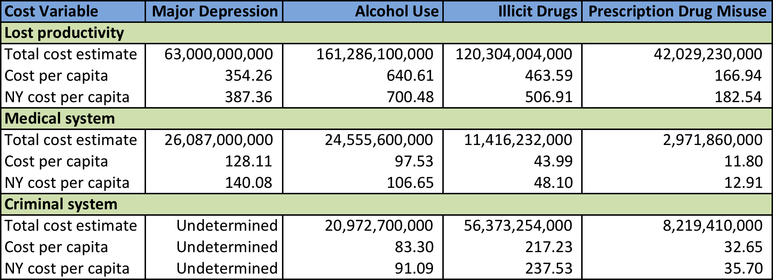

## Major Depression

The per capita economic cost of lost productivity in New York City due to major depressive disorder is estimated at $387.36, including lost productivity resulting from premature death, incarceration, and informal caregiving (The President’s New Freedom Commission on Mental Health, 2003).

With lost productivity in the workplace, approximately 70% is attributable to absenteeism (i.e. days missed from work due to depression), and the remaining 30% to presenteeism (i.e. reduced productivity at work due to depression) (Greenberg et al., 2003).

Medical system costs per capita related to the treatment of depression is estimated at $140.08, with direct costs including inpatient (34%), outpatient (26%), and pharmaceutical (40%) costs (Greenberg et al., 2003).

The criminal justice system and social service costs for depression are difficult to ascertain as a result of inadequate data.

## Alcohol Use

Economic costs of excessive alcohol consumption are extracted and adjusted from a study by Bouchery et al. (2011). Lost productivity per capita in New York City due to alcohol use disorder is estimated at $700.48, including economic costs for premature mortality, impaired productivity, work absenteeism, crime, and health conditions such as fetal alcohol syndrome.

Presenteeism accounts for 46% of total lost productivity at cost per capita of $321.83. A further breakdown indicates that binge drinking drives 68% of impaired productivity at work.

Medical system costs per capita of $106.65 for alcohol use disorder includes special treatment for alcohol dependence and abuse, treatment costs for health conditions such as fetal alcohol syndrome, hospitalizations, and health insurance administration costs, among others. Costs arising from binge drinking have a large impact on health care costs overall.

The per capita cost of alcohol-attributable crime is $91.09, including costs for policing (21%), legal and adjudication (18%), correctional institutions (60%), and others.

## Illicit Drug Use

Illicit drugs included in the scope of the report issued by the U.S. Department of Justice National Drug Intelligence Center (2011) are Schedule I drugs (heroin and marijuana) and Schedule II-IV drugs (cocaine, methamphetamine, tranquilizers, stimulants, and sedatives).

Productivity lost to illicit drug use in New York City amounts to a cost per capita of $506.91 in the context of labor participation, specialty drug treatment, hospitalization, incarceration, and premature mortality. Two factors – reduced labor participation and being incarcerated due to illicit drug use – reflect 81% of total productivity losses.

The estimated medical system cost per capita from illicit drug use is $48.10. Treatment in specialty centers ($15.60) and hospital emergency departments ($24.01) account for 83% of health care costs incurred.

Criminal justice system costs include police protection, adjudication, and corrections expenditures, which are estimated at $237.53 per capita.

## Non-Medical Use of Prescription Opioids

The economic burden of the non-medical use of prescription opioids in New York City was estimated using cost data from a study by Hansen et al. (2010).

Lost productivity cost per capita is $182.54, with costs included for the impact of the non-medical use of prescription opioids on mortality, unemployment and subemployment, and incarceration.

Medical system cost per capita is $12.91, of which treatment at substance abuse facilities ($4.87) is the largest cost component.

The per capita cost of the criminal justice system is $35.70. The estimate is based on the costs of police services, the legal system, and incarceration.

# Discussion

Lost productivity is consistently the highest economic burden across the major categories of major depression, alcohol use disorder, illicit drug use, and the non-medical use of prescription opioids. Criminal justice system costs are higher than medical system costs in most instances, although other indirect costs (aside from productivity losses) such as reduced quality of life are not included due to a lack of data.

As previously noted, the literature review is limited by the sparse data on cost estimates of productivity, health, and crime, as they relate to the major categories of conditions. As well, differences in cost definitions and calculation methodology limit our ability to make direct comparisons of cost variables across the major conditions. Combined with the lack of cost data available, it is also not possible to assess cost variables together from different studies on the same condition.

However, the literature review suggests that the economic costs of productivity, health, and crime associated with the major categories of conditions are substantial, highlighting the importance of investment in prevention and treatment interventions in New York City.

# References

Arno, P. S., Levine, C., & Memmott, M. M. (1999). The economic value of informal caregiving. Health Affairs, 18(2), 182-188.

Bouchery, E. E., Harwood, H. J., Sacks, J. J., Simon, C. J., & Brewer, R. D. (2011). Economic costs of excessive alcohol consumption in the US, 2006. American journal of preventive medicine, 41(5), 516-524.

Greenberg, P. E., Kessler, R. C., Birnbaum, H. G., Leong, S. A., Lowe, S. W., Berglund, P. A., & Corey-Lisle, P. K. (2003). The economic burden of depression in the United States: how did it change between 1990 and 2000?. Journal of clinical psychiatry, 64(12), 1465-1475.

Hansen, R. N., Oster, G., Edelsberg, J., Woody, G. E., & Sullivan, S. D. (2011). Economic costs of nonmedical use of prescription opioids. The Clinical journal of pain, 27(3), 194-202.

Harwood, H. J. (2000). Updating estimates of the economic costs of alcohol abuse in the United States: Estimates, update methods, and data. US Department of Health and Human Services, Public Health Service, National Institutes of Health, National Institute on Alcohol Abuse and Alcoholism.

Hogan, M. F. (2003). New Freedom Commission report: the President's New Freedom Commission: recommendations to transform mental health care in America. Psychiatric Services, 54(11), 1467-1474.

Mark, T. L., Woody, G. E., Juday, T., & Kleber, H. D. (2001). The economic costs of heroin addiction in the United States. Drug and alcohol dependence, 61(2), 195-206.

National Drug Intelligence Center. (2011). The Economic Impact of Illicit Drug Use on American Society. Washington D.C.: United States Department of Justice.