DOHMH Roadmap: DALY Estimates

Ryan Quan ([rcq2102@columbia.edu](mailto:rcq2102@columbia.edu))

May 20, 2015

# Background

## Objective

The objective of this analysis is to estimate DALYs lost in New York City due to the following major categories of conditions (with about 100 conditions in total within these categories):

* Major depression
* Alcohol use
* Marijuana use
* Heroin use
* Cocaine use
* Stimulant use
* Sedative use
* Tranquilizer use

## Definition of Key Terms

### DALY

**Disability-adjusted life years.** The DALY is a year of life lived in perfect health and consists of two elements: YLLs and YLDs. The DALY is a measure of overall disease burden, expressed as the number of years lost due to ill-health, disability or early death. It was developed in the 1990s as a way of comparing the overall health and life expectancy of different countries.

### YLL

**Years of life lost.** Years of life lost is an estimate of the average years a person would have lived if he or she had not died prematurely.

### YLD

**Years of life lost due to disability.** This is the morbidity component of the DALY score. To estimate YLD for a particular cause in a particular time period, the number of incident cases in that period is multiplied by the average duration of the disease and a weight factor that reflects the severity of the disease on a scale from 0 (perfect health) to 1 (dead). The basic formula for YLD is the following:

# Methods

## Data Sources

* 2013 NYCHANES - prevalence estimates
* 2002-2008 NSDUH – drug use and alcohol use disorders prevalence estimates
* 2013 NYC Vital Statistics - mortality estimates
* 2010 Global Burden of Disease Study - national YLD/YLL rates
* 2013 NYC American Community Survey - population estimates

The challenge with using NYCHANES and NSDUH data to estimate the prevalence of a condition is that the n may be too small. To increase their utility of these surveys, we will aggregate age groups into the following strata: childhood (0-14), late adolescence/early adulthood (15-24), adulthood (25-64), and later life (65+).

## DALY Estimation

### YLLs

To estimate compute NYC YLLs, we will use NYC mortality counts stratified by age, sex, and race. In concodrance with the literature on DALY estimation, life expectancy estimates based on the life expectancy in Japan (82.5 years for women and 80.0 years for men) were used for the calculation of YLL. In order to remain consistent with the methodology of the 2010 Global Burden Disease Study, no age weighting or discounting was applied.

### YLDs

To compute NYC YLDs, we will use the two approaches described below:

#### 2005 NYC DOHMH / Michaud (2006)

In order to compare the magnitude of the DALY scores to the [2005 NYC DOHMH study](http://www.nyc.gov/html/doh/downloads/pdf/epi/datatable11.pdf), we will replicate the previous study's methodology, which was based on [Michaud CM, et al](http://www.pophealthmetrics.com/content/4/1/11). The burden of disease and injury in the United States 1996. Population Health Metrics 2006,4:11.

"For NYC YLD, U.S. Census Bureau population estimates for New York City in 2005 by sex were used to calculate years lived with disability (YLD) by applying national YLD rates and ratios from the Michaud et al. study. If the national YLL:YLD ratio was less than 10, then the NYC YLD was equal to the national YLD:YLL ratio multiplied by NYC YLL. If the national YLD:YLL ratio was greater than or equal to 10 (producing unreliable City estimates), then NYC YLD was equal to the national YLD rate multiplied by the NYC population."

Implementing the Michaud approach will thus require the following data elements:

* NYC Population by age, se
* National YLD rates by age, sex
* NYC YLLs by age, sex

In order to remain consistent with the demographic weighting approach used by NYC DOHMH for the 2013 NYCHANES data, NYC population estimates were obtained from the [2013 American Community Survey](http://www.nyc.gov/html/dcp/download/census/boro_demo_2013_acs.xlsx), which is available on the NYC Department of City Planning website. Since the data from the Michaud study are from 1996 and patterns of disease and disability have changed, we will update the approach using national YLD/YLL rates from the 2010 Global Burden of Disease Study.

#### Prevalence-based YLDs

Years lived with a disability (YLD) due to each disease can be calculated on the basis of either the incidence or the prevalence of the disease. The initial GBD studies estimated YLD on the basis of the incidence of each disease. Thus, in the 1990 study for example, the YLD estimates measured the future loss of health resulting from disease episodes that began in 1990. One advantage of this approach is that it is consistent with that used for mortality: YLL measure the future loss of life resulting from deaths in a particular year.

The 2010 GBD study adopted the alternative approach and calculated YLD based on the prevalence of the impairments resulting from each disease in the year for which the estimates are made. This approach has the advantage that it assigns YLD to the ages at which they are lived, rather than to the age at which the disease episode that produced them began.

Because prevalence is approximately incidence x duration, prevalence YLD for a condition (across all ages) is approximately the same as the no frills incidence YLD. As such, we can estimate YLDs using the following formula:

We can estimate the number of prevalent cases for each condition using survey data from 2013 NYCHANES. Annual prevalence for drug use can be estimated using data from 2002-2008 NSDUH. Disability weights can be extracted from the 2010 Global Burden of Disease study.However, we should note that the prevalence YLD for a condition may be quite different in magnitude to the incidence-based YLD, depending on how age weighting and discounting are applied. As such, comparisons to previous NYC DALY studies should be done with caution.

Further information about estimating DALYs can be found from the Global Burden of Disease concept paper ([WHO, 2006](http://www.who.int/quantifying_ehimpacts/publications/en/9241546204chap3.pdf)).

## Disease Rankings

Since our goal is to communicate the burden of diseases in New York City, we will rank each condition in decreasing order of the DALY score. We will also test the stability of the rankings by comparing the results generated from the Michaud approach and the prevalence-based YLDs approach. Moreover, since the 2010 GBD study also provides 95% confidence intervals around point estimates for disability weights and national YLD/YLL rates, further stability checks can be conducted by reporting DALY estimations with their respective upper and lower bounds.

However, we should note that since the DALY estimations are not inclusive of all disease conditions, we will not be able to report our findings as the "top X conditions contributing to DALYs." Instead, we can only report mental health DALYs in reference to other highly prevalent chronic diseases.

## Estimation of Substance Use Dependence

Prevalence estimates of substance use cannot be directly substituted for prevalence of drug dependence or abuse disorders. We make the following assumptions about the average proportion of dependence among users ([National Addiction Centre, 2003](http://www.nta.nhs.uk/uploads/dangerousnessofdrugsdh_4086293.pdf)):

* Cocaine - 16.7%
* Heroin - 23.1%
* Cannabis - 9.1%

## Estimation of Major Depressive Disorder

Prevalence of Major Depressive Disorder (MDD) was obtained by projecting New York City estimates using data from NHAES 2011-12. Specifically, we first assessed three-level depressive disorders (moderate depression, moderately severe depression, and severe depression) using PHQ-9 scores and built age group- and sex-specific logistic regression models with each of depression outcomes and socioeconomic status (education and household income) as covariates. For each age group and sex, we then entered NYC information about socioeconomic status into the regression equations, which in turn generated projected estimates of NYC prevalence of MDD.

## Sensitivity Analysis

In order to validate the Michaud approach, we will use 2005 NYC mortality estimates from the previous DOHMH to test the stability of our DALY rankings. However, since age-weighting is no longer used by the 2010 GBD due to ethical concerns, we suspect the magnitude of 2013 NYC DALYs to be slightly higher than that of the 2005 NYC DALYs.

## DALY Estimation

### Michaud YLD Approach

This section contains an implementation of the Michaud approach described in the above methods section. We first create a search index containing all the disease conditions of interest.

This search index is then fed through the calculateDALY workhorse function to estimate DALYs for each disease condition. The result is a data.frame object containing the following columns: cause_name, sex, yll, yld, yld_upper, yld_lower, daly, daly_upper, daly_lower.

### Prevalence-Based YLD Approach

Similar to the section, we implement the prevalence-based YLD approach here using the same search index.

# Results

## Michaud YLD Approach

Raw results for this approach can be found under the results directory under the filename nyc_daly_michaud.csv. The file can be opened in Excel and manipulated with a pivot table for aggregation and stratification purposes.

### 2013 NYC DALY Estimates, Total

|  |  |  |  |  |  |  |  |
| --- | --- | --- | --- | --- | --- | --- | --- |
| cause_name | daly | daly_lower | daly_upper | yll | yld | yld_lower | yld_upper |
| Ischemic heart disease | 133895 | 129915 | 139112 | 122326 | 11569 | 7589 | 16786 |
| Major depressive disorder | 83953 | 55076 | 121100 | 0 | 83953 | 55076 | 121100 |
| Other musculoskeletal disorders | 77027 | 61660 | 91872 | 2837 | 74190 | 58823 | 89035 |
| Anxiety disorders | 52051 | 34951 | 75105 | 0 | 52051 | 34951 | 75105 |
| Chronic obstructive pulmonary disease | 35083 | 25374 | 47970 | 13123 | 21960 | 12251 | 34847 |
| Diabetes mellitus | 32985 | 27896 | 39684 | 17984 | 15001 | 9912 | 21700 |
| Lung cancer | 30107 | 29869 | 30449 | 29658 | 449 | 211 | 791 |
| Hypertensive heart disease | 28092 | 27630 | 28749 | 27201 | 891 | 429 | 1549 |
| Osteoarthritis | 27097 | 16445 | 41330 | 129 | 26968 | 16316 | 41201 |
| Ischemic stroke | 26881 | 24443 | 29478 | 15957 | 10924 | 8485 | 13521 |
| Asthma | 26025 | 15373 | 39953 | 2863 | 23162 | 12510 | 37090 |
| High blood pressure | 23051 | 15615 | 31082 | 0 | 23051 | 15615 | 31082 |
| Alzheimer's disease and other dementias | 22899 | 20168 | 25956 | 13613 | 9286 | 6555 | 12343 |
| Lower respiratory infections | 21649 | 21225 | 22215 | 20554 | 1095 | 671 | 1661 |
| Alcohol use disorders | 19615 | 13757 | 27665 | 4673 | 14942 | 9083 | 22992 |
| Opioid use disorders | 17925 | 14953 | 21588 | 10654 | 7272 | 4299 | 10935 |
| Bipolar affective disorder | 16820 | 10012 | 25727 | 0 | 16820 | 10012 | 25727 |
| Breast cancer | 16321 | 15420 | 17629 | 13773 | 2548 | 1647 | 3856 |
| HIV/AIDS | 15881 | 14539 | 17604 | 13117 | 2764 | 1422 | 4487 |
| Colon and rectum cancers | 15362 | 14944 | 16022 | 14377 | 985 | 567 | 1645 |
| Cocaine use disorders | 13792 | 10059 | 19883 | 6738 | 7054 | 3321 | 13145 |
| Poisonings | 12459 | 12400 | 12573 | 12390 | 69 | 10 | 182 |
| Homicide | 10945 | 0 | 0 | 10945 | 0 | 0 | 0 |
| Other drug use disorders | 10619 | 8202 | 14273 | 5373 | 5245 | 2829 | 8900 |
| Cannabis use disorders | 7151 | 4321 | 10890 | 0 | 7151 | 4321 | 10890 |
| Congenital anomalies | 6801 | 6383 | 7400 | 5752 | 1049 | 631 | 1648 |
| Motor vehicle accidents | 6542 | 6100 | 7163 | 5318 | 1224 | 783 | 1846 |
| Amphetamine use disorders | 2773 | 1347 | 4845 | 0 | 2773 | 1347 | 4845 |

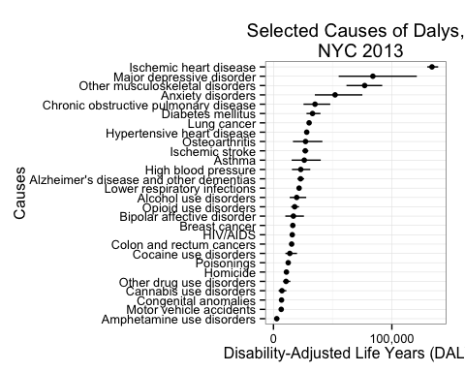 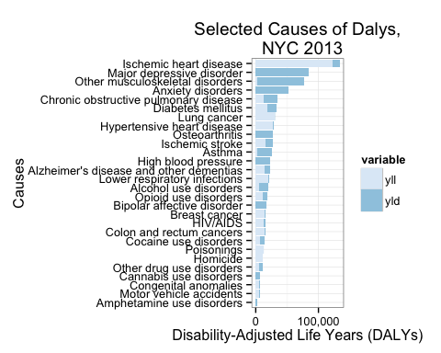

### 2013 NYC DALY Estimates, Male

|  |  |  |  |  |  |  |  |
| --- | --- | --- | --- | --- | --- | --- | --- |
| cause_name | daly | daly_lower | daly_upper | yll | yld | yld_lower | yld_upper |
| Ischemic heart disease | 64158 | 62425 | 66417 | 59171 | 4986 | 3254 | 7246 |
| Major depressive disorder | 29122 | 19172 | 42380 | 0 | 29122 | 19172 | 42380 |
| Other musculoskeletal disorders | 23417 | 16861 | 29650 | 971 | 22446 | 15890 | 28679 |
| Anxiety disorders | 16888 | 11291 | 24380 | 0 | 16888 | 11291 | 24380 |
| Chronic obstructive pulmonary disease | 16229 | 11535 | 22514 | 5818 | 10412 | 5717 | 16696 |
| Diabetes mellitus | 15706 | 13338 | 18889 | 8870 | 6836 | 4468 | 10019 |
| Lung cancer | 15560 | 15456 | 15713 | 15346 | 215 | 110 | 367 |
| Alcohol use disorders | 15308 | 10799 | 21536 | 3694 | 11614 | 7105 | 17842 |
| Hypertensive heart disease | 13668 | 13503 | 13912 | 13357 | 310 | 145 | 555 |
| Opioid use disorders | 12837 | 10797 | 15324 | 7701 | 5136 | 3096 | 7623 |
| Asthma | 11927 | 7105 | 18203 | 1464 | 10463 | 5641 | 16739 |
| Ischemic stroke | 11863 | 10730 | 13073 | 6876 | 4987 | 3854 | 6197 |
| High blood pressure | 10872 | 7183 | 14946 | 0 | 10872 | 7183 | 14946 |
| HIV/AIDS | 10413 | 9543 | 11512 | 8508 | 1906 | 1036 | 3004 |
| Lower respiratory infections | 10219 | 10035 | 10466 | 9756 | 463 | 279 | 710 |
| Cocaine use disorders | 9734 | 7214 | 13805 | 4910 | 4824 | 2304 | 8895 |
| Osteoarthritis | 9445 | 5722 | 14658 | 62 | 9384 | 5661 | 14597 |
| Homicide | 9185 | NA | NA | 9185 | NA | NA | NA |
| Poisonings | 8934 | 8890 | 9015 | 8881 | 53 | 9 | 134 |
| Colon and rectum cancers | 7452 | 7271 | 7733 | 7021 | 432 | 250 | 712 |
| Bipolar affective disorder | 7449 | 4414 | 11473 | 0 | 7449 | 4414 | 11473 |
| Other drug use disorders | 7393 | 5789 | 9823 | 3874 | 3519 | 1914 | 5948 |
| Alzheimer's disease and other dementias | 6352 | 5612 | 7215 | 3823 | 2529 | 1788 | 3391 |
| Motor vehicle accidents | 4634 | 4338 | 5057 | 3805 | 830 | 533 | 1252 |
| Cannabis use disorders | 4486 | 2705 | 6858 | 0 | 4486 | 2705 | 6858 |
| Congenital anomalies | 3579 | 3367 | 3877 | 3042 | 537 | 325 | 834 |
| Amphetamine use disorders | 1711 | 839 | 2950 | 0 | 1711 | 839 | 2950 |

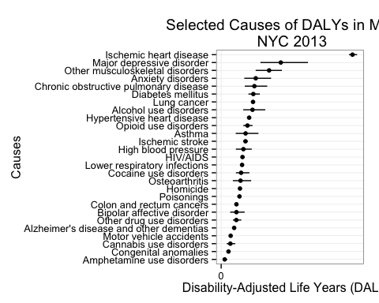 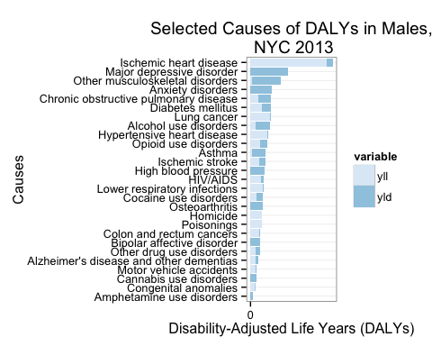

### 2013 NYC DALY Estimates, Female

|  |  |  |  |  |  |  |  |
| --- | --- | --- | --- | --- | --- | --- | --- |
| cause_name | daly | daly_lower | daly_upper | yll | yld | yld_lower | yld_upper |
| Ischemic heart disease | 69737 | 67490 | 72695 | 63155 | 6582 | 4335 | 9540 |
| Major depressive disorder | 54832 | 35904 | 78719 | 0 | 54832 | 35904 | 78719 |
| Other musculoskeletal disorders | 53609 | 44799 | 62223 | 1866 | 51743 | 42933 | 60357 |
| Anxiety disorders | 35163 | 23660 | 50725 | 0 | 35163 | 23660 | 50725 |
| Chronic obstructive pulmonary disease | 18854 | 13840 | 25457 | 7306 | 11548 | 6534 | 18151 |
| Osteoarthritis | 17652 | 10722 | 26672 | 67 | 17585 | 10655 | 26605 |
| Diabetes mellitus | 17279 | 14558 | 20795 | 9114 | 8165 | 5444 | 11681 |
| Alzheimer's disease and other dementias | 16547 | 14557 | 18741 | 9790 | 6757 | 4767 | 8951 |
| Breast cancer | 16321 | 15420 | 17629 | 13773 | 2548 | 1647 | 3856 |
| Ischemic stroke | 15018 | 13713 | 16405 | 9081 | 5937 | 4632 | 7324 |
| Lung cancer | 14547 | 14413 | 14737 | 14313 | 234 | 100 | 424 |
| Hypertensive heart disease | 14424 | 14127 | 14837 | 13843 | 581 | 284 | 994 |
| Asthma | 14099 | 8268 | 21750 | 1399 | 12699 | 6869 | 20350 |
| High blood pressure | 12180 | 8433 | 16136 | 0 | 12180 | 8433 | 16136 |
| Lower respiratory infections | 11430 | 11189 | 11748 | 10798 | 632 | 391 | 951 |
| Bipolar affective disorder | 9371 | 5598 | 14254 | 0 | 9371 | 5598 | 14254 |
| Colon and rectum cancers | 7910 | 7673 | 8289 | 7356 | 554 | 317 | 933 |
| HIV/AIDS | 5468 | 4995 | 6092 | 4609 | 859 | 386 | 1483 |
| Opioid use disorders | 5088 | 4156 | 6264 | 2953 | 2135 | 1203 | 3311 |
| Alcohol use disorders | 4307 | 2958 | 6129 | 980 | 3327 | 1978 | 5149 |
| Cocaine use disorders | 4058 | 2845 | 6078 | 1828 | 2230 | 1017 | 4250 |
| Poisonings | 3525 | 3510 | 3557 | 3509 | 16 | 1 | 48 |
| Other drug use disorders | 3225 | 2413 | 4450 | 1499 | 1726 | 915 | 2951 |
| Congenital anomalies | 3222 | 3015 | 3524 | 2710 | 513 | 305 | 814 |
| Cannabis use disorders | 2665 | 1616 | 4032 | 0 | 2665 | 1616 | 4032 |
| Motor vehicle accidents | 1907 | 1762 | 2107 | 1513 | 394 | 249 | 594 |
| Homicide | 1760 | NA | NA | 1760 | NA | NA | NA |
| Amphetamine use disorders | 1062 | 508 | 1895 | 0 | 1062 | 508 | 1895 |

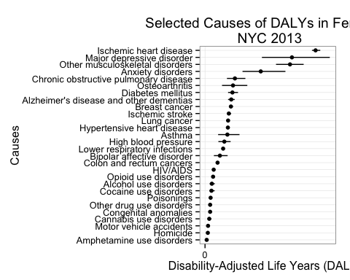 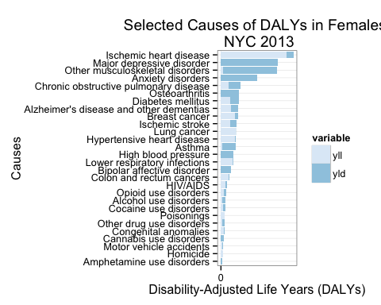

## Prevalence-Based YLD Approach

Raw results for this approach can be found under the results directory under the filename nyc_daly_prevalence.csv. The file can be opened in Excel and manipulated with a pivot table for aggregation and stratification purposes.

### 2013 NYC DALY Estimates, Total

|  |  |  |  |  |  |  |  |
| --- | --- | --- | --- | --- | --- | --- | --- |
| cause_name | daly | daly_lower | daly_upper | yll | yld | yld_lower | yld_upper |
| Ischemic heart disease | 152512 | 146523 | 156824 | 122326 | 30186 | 24197 | 34498 |
| Other musculoskeletal disorders | 91428 | 62675 | 126398 | 2837 | 88591 | 59838 | 123561 |
| Chronic obstructive pulmonary disease | 77376 | 56293 | 103813 | 13123 | 64253 | 43170 | 90690 |
| Major depressive disorder | 75910 | 52087 | 101535 | 0 | 75910 | 52087 | 101535 |
| Osteoarthritis | 57716 | 39025 | 80447 | 129 | 57587 | 38896 | 80319 |
| Breast cancer | 38542 | 30539 | 48399 | 13773 | 24769 | 16765 | 34626 |
| Lung cancer | 34596 | 33000 | 36561 | 29658 | 4937 | 3342 | 6902 |
| Cocaine use disorders | 29071 | 20696 | 39584 | 6738 | 22333 | 13958 | 32846 |
| Opioid use disorders | 28723 | 23593 | 33290 | 10654 | 18069 | 12939 | 22636 |
| Diabetes mellitus | 28104 | 26080 | 30127 | 17984 | 10119 | 8095 | 12143 |
| Asthma | 22922 | 14007 | 36294 | 2863 | 20058 | 11143 | 33430 |
| Colon and rectum cancers | 18848 | 17403 | 20628 | 14377 | 4471 | 3027 | 6251 |
| Alcohol use disorders | 18514 | 14079 | 23858 | 4673 | 13840 | 9405 | 19184 |
| Ischemic stroke | 17777 | 16911 | 19164 | 15957 | 1820 | 953 | 3207 |
| Amphetamine use disorders | 4025 | 2451 | 5986 | 0 | 4025 | 2451 | 5986 |
| Stimulant use disorders | 2549 | 1552 | 3790 | 0 | 2549 | 1552 | 3790 |

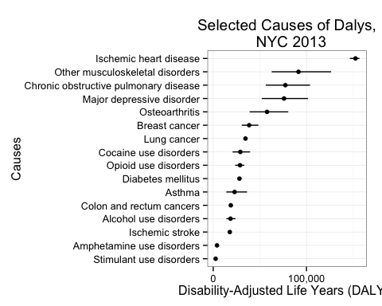 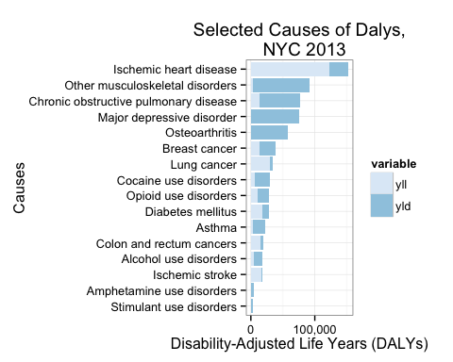

### 2013 NYC DALY Estimates, Male

|  |  |  |  |  |  |  |  |
| --- | --- | --- | --- | --- | --- | --- | --- |
| cause_name | daly | daly_lower | daly_upper | yll | yld | yld_lower | yld_upper |
| Ischemic heart disease | 72250 | 69655 | 74119 | 59171 | 13079 | 10484 | 14947 |
| Chronic obstructive pulmonary disease | 38313 | 27650 | 51683 | 5818 | 32495 | 21833 | 45865 |
| Other musculoskeletal disorders | 32008 | 21934 | 44259 | 971 | 31037 | 20963 | 43288 |
| Major depressive disorder | 22152 | 15159 | 29756 | NA | 22152 | 15159 | 29756 |
| Osteoarthritis | 18785 | 12708 | 26176 | 62 | 18723 | 12647 | 26114 |
| Opioid use disorders | 17681 | 14847 | 20203 | 7701 | 9980 | 7146 | 12502 |
| Cocaine use disorders | 17478 | 12765 | 23394 | 4910 | 12568 | 7855 | 18484 |
| Lung cancer | 17271 | 16649 | 18038 | 15346 | 1926 | 1304 | 2692 |
| Diabetes mellitus | 13640 | 12686 | 14594 | 8870 | 4770 | 3816 | 5724 |
| Alcohol use disorders | 12907 | 9955 | 16465 | 3694 | 9214 | 6261 | 12771 |
| Colon and rectum cancers | 8856 | 8263 | 9586 | 7021 | 1835 | 1242 | 2565 |
| Asthma | 8733 | 5502 | 13579 | 1464 | 7269 | 4038 | 12115 |
| Ischemic stroke | 7484 | 7195 | 7947 | 6876 | 608 | 318 | 1071 |
| Amphetamine use disorders | 2514 | 1531 | 3740 | NA | 2514 | 1531 | 3740 |
| Stimulant use disorders | 1610 | 980 | 2394 | NA | 1610 | 980 | 2394 |

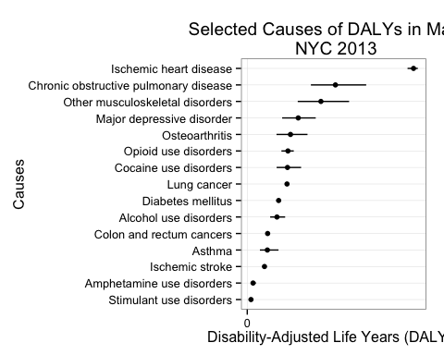 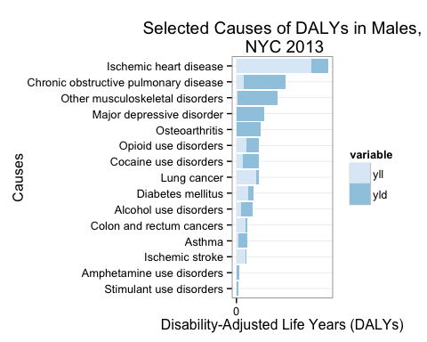

### 2013 NYC DALY Estimates, Female

|  |  |  |  |  |  |  |  |
| --- | --- | --- | --- | --- | --- | --- | --- |
| cause_name | daly | daly_lower | daly_upper | yll | yld | yld_lower | yld_upper |
| Ischemic heart disease | 80262 | 76867 | 82705 | 63155 | 17107 | 13713 | 19551 |
| Other musculoskeletal disorders | 59420 | 40740 | 82139 | 1866 | 57555 | 38875 | 80274 |
| Major depressive disorder | 53758 | 36928 | 71779 | NA | 53758 | 36928 | 71779 |
| Chronic obstructive pulmonary disease | 39063 | 28643 | 52130 | 7306 | 31758 | 21337 | 44824 |
| Osteoarthritis | 38931 | 26317 | 54271 | 67 | 38863 | 26250 | 54204 |
| Breast cancer | 38542 | 30539 | 48399 | 13773 | 24769 | 16765 | 34626 |
| Lung cancer | 17324 | 16351 | 18523 | 14313 | 3011 | 2038 | 4210 |
| Diabetes mellitus | 14464 | 13394 | 15533 | 9114 | 5349 | 4279 | 6419 |
| Asthma | 14189 | 8505 | 22715 | 1399 | 12789 | 7105 | 21315 |
| Cocaine use disorders | 11593 | 7931 | 16189 | 1828 | 9765 | 6103 | 14361 |
| Opioid use disorders | 11042 | 8745 | 13087 | 2953 | 8090 | 5793 | 10134 |
| Ischemic stroke | 10294 | 9716 | 11217 | 9081 | 1212 | 635 | 2136 |
| Colon and rectum cancers | 9992 | 9140 | 11041 | 7356 | 2636 | 1784 | 3685 |
| Alcohol use disorders | 5607 | 4124 | 7393 | 980 | 4627 | 3144 | 6413 |
| Amphetamine use disorders | 1510 | 920 | 2246 | NA | 1510 | 920 | 2246 |
| Stimulant use disorders | 939 | 572 | 1396 | NA | 939 | 572 | 1396 |

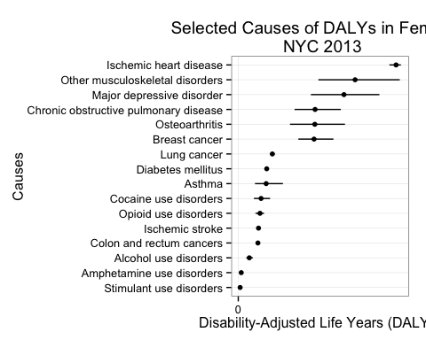 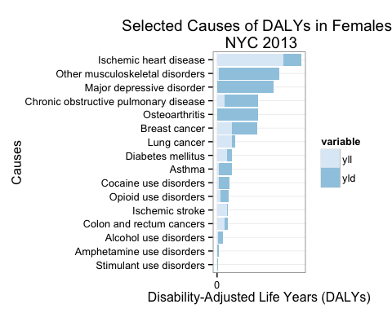

## Michaud YLDs vs. Prevalence-Based YLDs: Side-by-Side Comparison

### Total

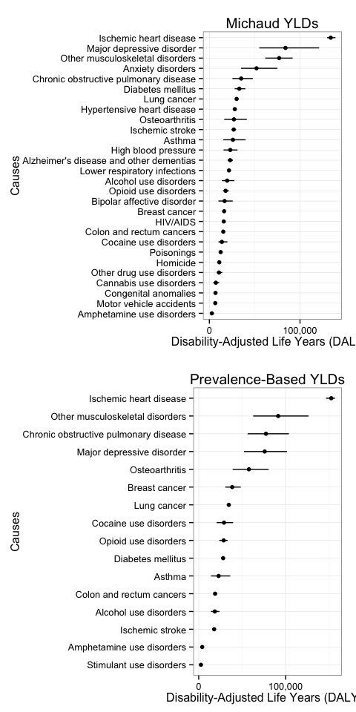

### Male

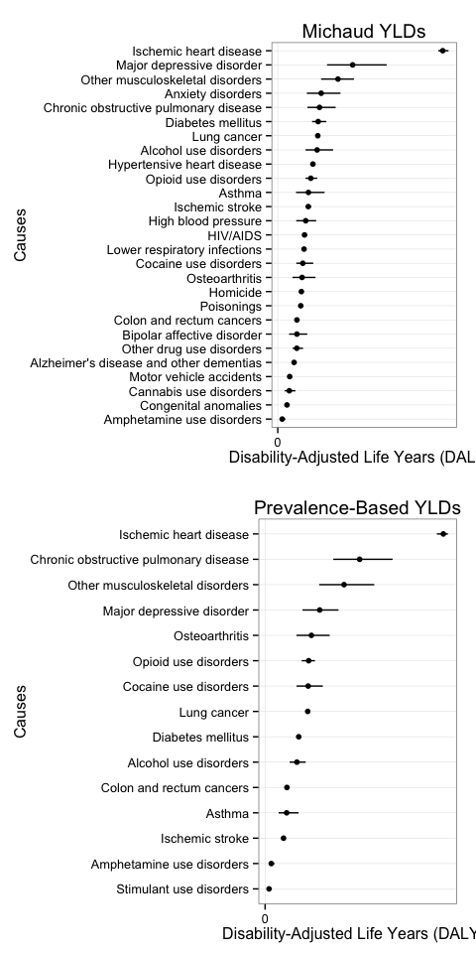

### Female

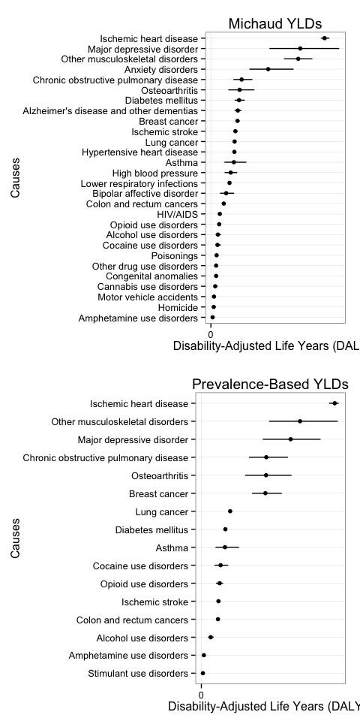

## Disease Conditions with Small Sample Sizes

|  |  |  |  |  |
| --- | --- | --- | --- | --- |
|  | cause_name | sequlae | sex | age |
| 21 | Breast cancer | Breast cancer | Male | 20-39 |
| 22 | Breast cancer | Breast cancer | Male | 40-59 |
| 23 | Breast cancer | Breast cancer | Male | 60+ |
| 24 | Breast cancer | Breast cancer | Female | 20-39 |
| 32 | Cocaine use disorders | Cocaine use | Female | 60+ |
| 33 | Colon and rectum cancers | Colon and rectum cancers | Male | 20-39 |
| 34 | Colon and rectum cancers | Colon and rectum cancers | Male | 40-59 |
| 35 | Colon and rectum cancers | Colon and rectum cancers | Male | 60+ |
| 36 | Colon and rectum cancers | Colon and rectum cancers | Female | 20-39 |
| 37 | Colon and rectum cancers | Colon and rectum cancers | Female | 40-59 |
| 38 | Colon and rectum cancers | Colon and rectum cancers | Female | 60+ |
| 51 | Opioid use disorders | Heroin use | Male | 20-39 |
| 52 | Opioid use disorders | Heroin use | Male | 40-59 |
| 53 | Opioid use disorders | Heroin use | Male | 60+ |
| 54 | Opioid use disorders | Heroin use | Female | 20-39 |
| 55 | Opioid use disorders | Heroin use | Female | 40-59 |
| 56 | Opioid use disorders | Heroin use | Female | 60+ |
| 57 | Ischemic heart disease | Ischemic heart disease | Male | 20-39 |
| 60 | Ischemic heart disease | Ischemic heart disease | Female | 20-39 |
| 63 | Lung cancer | Lung | Male | 20-39 |
| 64 | Lung cancer | Lung | Male | 40-59 |
| 65 | Lung cancer | Lung | Male | 60+ |
| 66 | Lung cancer | Lung | Female | 20-39 |
| 67 | Lung cancer | Lung | Female | 40-59 |
| 68 | Lung cancer | Lung | Female | 60+ |
| 69 | Amphetamine use disorders | Methamphetamine use | Male | 20-39 |
| 70 | Amphetamine use disorders | Methamphetamine use | Male | 40-59 |
| 71 | Amphetamine use disorders | Methamphetamine use | Male | 60+ |
| 72 | Amphetamine use disorders | Methamphetamine use | Female | 20-39 |
| 73 | Amphetamine use disorders | Methamphetamine use | Female | 40-59 |
| 74 | Amphetamine use disorders | Methamphetamine use | Female | 60+ |
| 97 | Other musculoskeletal disorders | Other arthritis | Male | 20-39 |
| 119 | Ischemic stroke | Ischemic stroke | Male | 20-39 |
| 120 | Ischemic stroke | Ischemic stroke | Male | 40-59 |
| 121 | Ischemic stroke | Ischemic stroke | Male | 60+ |
| 122 | Ischemic stroke | Ischemic stroke | Female | 20-39 |

# Sensitivity Analysis

|  |  |  |  |  |  |  |  |
| --- | --- | --- | --- | --- | --- | --- | --- |
| cause_name | daly | daly_lower | daly_upper | yll | yld | yld_lower | yld_upper |
| Ischemic heart disease | 133895 | 129915 | 139112 | 122326 | 11569 | 7589 | 16786 |
| Major depressive disorder | 83953 | 55076 | 121100 | 0 | 83953 | 55076 | 121100 |
| Other musculoskeletal disorders | 77027 | 61660 | 91872 | 2837 | 74190 | 58823 | 89035 |
| Anxiety disorders | 52051 | 34951 | 75105 | 0 | 52051 | 34951 | 75105 |
| Chronic obstructive pulmonary disease | 35083 | 25374 | 47970 | 13123 | 21960 | 12251 | 34847 |
| Diabetes mellitus | 32985 | 27896 | 39684 | 17984 | 15001 | 9912 | 21700 |
| Lung cancer | 30107 | 29869 | 30449 | 29658 | 449 | 211 | 791 |
| Hypertensive heart disease | 28092 | 27630 | 28749 | 27201 | 891 | 429 | 1549 |
| Osteoarthritis | 27097 | 16445 | 41330 | 129 | 26968 | 16316 | 41201 |
| Ischemic stroke | 26881 | 24443 | 29478 | 15957 | 10924 | 8485 | 13521 |
| Asthma | 26025 | 15373 | 39953 | 2863 | 23162 | 12510 | 37090 |
| Alzheimer's disease and other dementias | 22899 | 20168 | 25956 | 13613 | 9286 | 6555 | 12343 |
| Lower respiratory infections | 21649 | 21225 | 22215 | 20554 | 1095 | 671 | 1661 |
| Alcohol use disorders | 19615 | 13757 | 27665 | 4673 | 14942 | 9083 | 22992 |
| Opioid use disorders | 17925 | 14953 | 21588 | 10654 | 7272 | 4299 | 10935 |
| Bipolar affective disorder | 16820 | 10012 | 25727 | 0 | 16820 | 10012 | 25727 |
| Breast cancer | 16321 | 15420 | 17629 | 13773 | 2548 | 1647 | 3856 |
| HIV/AIDS | 15881 | 14539 | 17604 | 13117 | 2764 | 1422 | 4487 |
| Colon and rectum cancers | 15362 | 14944 | 16022 | 14377 | 985 | 567 | 1645 |
| Cocaine use disorders | 13792 | 10059 | 19883 | 6738 | 7054 | 3321 | 13145 |
| Poisonings | 12459 | 12400 | 12573 | 12390 | 69 | 10 | 182 |
| Homicide | 10945 | 0 | 0 | 10945 | 0 | 0 | 0 |
| Other drug use disorders | 10619 | 8202 | 14273 | 5373 | 5245 | 2829 | 8900 |
| Cannabis use disorders | 7151 | 4321 | 10890 | 0 | 7151 | 4321 | 10890 |
| Congenital anomalies | 6801 | 6383 | 7400 | 5752 | 1049 | 631 | 1648 |
| Motor vehicle accidents | 6542 | 6100 | 7163 | 5318 | 1224 | 783 | 1846 |
| Amphetamine use disorders | 2773 | 1347 | 4845 | 0 | 2773 | 1347 | 4845 |

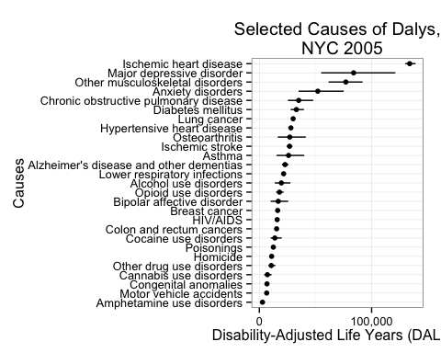 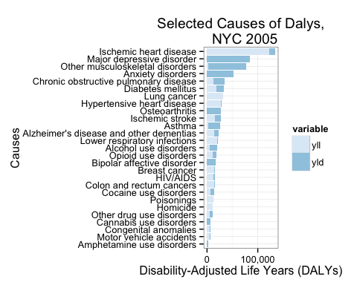

### 2005 NYC DALY Estimates, Male

|  |  |  |  |  |  |  |  |
| --- | --- | --- | --- | --- | --- | --- | --- |
| cause_name | daly | daly_lower | daly_upper | yll | yld | yld_lower | yld_upper |
| Ischemic heart disease | 64158 | 62425 | 66417 | 59171 | 4986 | 3254 | 7246 |
| Major depressive disorder | 29122 | 19172 | 42380 | 0 | 29122 | 19172 | 42380 |
| Other musculoskeletal disorders | 23417 | 16861 | 29650 | 971 | 22446 | 15890 | 28679 |
| Anxiety disorders | 16888 | 11291 | 24380 | 0 | 16888 | 11291 | 24380 |
| Chronic obstructive pulmonary disease | 16229 | 11535 | 22514 | 5818 | 10412 | 5717 | 16696 |
| Diabetes mellitus | 15706 | 13338 | 18889 | 8870 | 6836 | 4468 | 10019 |
| Lung cancer | 15560 | 15456 | 15713 | 15346 | 215 | 110 | 367 |
| Alcohol use disorders | 15308 | 10799 | 21536 | 3694 | 11614 | 7105 | 17842 |
| Hypertensive heart disease | 13668 | 13503 | 13912 | 13357 | 310 | 145 | 555 |
| Opioid use disorders | 12837 | 10797 | 15324 | 7701 | 5136 | 3096 | 7623 |
| Asthma | 11927 | 7105 | 18203 | 1464 | 10463 | 5641 | 16739 |
| Ischemic stroke | 11863 | 10730 | 13073 | 6876 | 4987 | 3854 | 6197 |
| HIV/AIDS | 10413 | 9543 | 11512 | 8508 | 1906 | 1036 | 3004 |
| Lower respiratory infections | 10219 | 10035 | 10466 | 9756 | 463 | 279 | 710 |
| Cocaine use disorders | 9734 | 7214 | 13805 | 4910 | 4824 | 2304 | 8895 |
| Osteoarthritis | 9445 | 5722 | 14658 | 62 | 9384 | 5661 | 14597 |
| Homicide | 9185 | NA | NA | 9185 | NA | NA | NA |
| Poisonings | 8934 | 8890 | 9015 | 8881 | 53 | 9 | 134 |
| Colon and rectum cancers | 7452 | 7271 | 7733 | 7021 | 432 | 250 | 712 |
| Bipolar affective disorder | 7449 | 4414 | 11473 | 0 | 7449 | 4414 | 11473 |
| Other drug use disorders | 7393 | 5789 | 9823 | 3874 | 3519 | 1914 | 5948 |
| Alzheimer's disease and other dementias | 6352 | 5612 | 7215 | 3823 | 2529 | 1788 | 3391 |
| Motor vehicle accidents | 4634 | 4338 | 5057 | 3805 | 830 | 533 | 1252 |
| Cannabis use disorders | 4486 | 2705 | 6858 | 0 | 4486 | 2705 | 6858 |
| Congenital anomalies | 3579 | 3367 | 3877 | 3042 | 537 | 325 | 834 |
| Amphetamine use disorders | 1711 | 839 | 2950 | 0 | 1711 | 839 | 2950 |

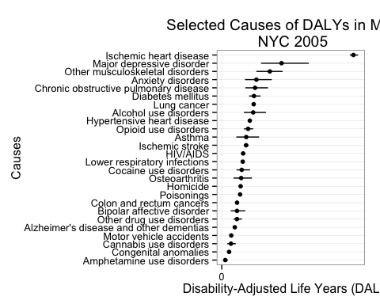 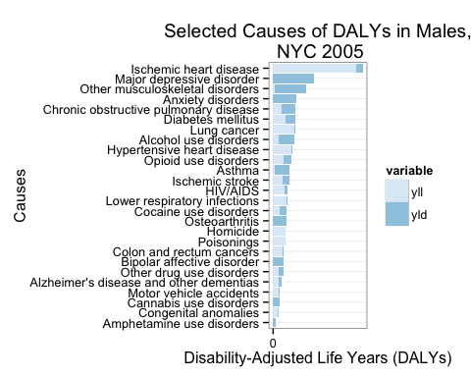

### 2005 NYC DALY Estimates, Female

|  |  |  |  |  |  |  |  |
| --- | --- | --- | --- | --- | --- | --- | --- |
| cause_name | daly | daly_lower | daly_upper | yll | yld | yld_lower | yld_upper |
| Ischemic heart disease | 69737 | 67490 | 72695 | 63155 | 6582 | 4335 | 9540 |
| Major depressive disorder | 54832 | 35904 | 78719 | 0 | 54832 | 35904 | 78719 |
| Other musculoskeletal disorders | 53609 | 44799 | 62223 | 1866 | 51743 | 42933 | 60357 |
| Anxiety disorders | 35163 | 23660 | 50725 | 0 | 35163 | 23660 | 50725 |
| Chronic obstructive pulmonary disease | 18854 | 13840 | 25457 | 7306 | 11548 | 6534 | 18151 |
| Osteoarthritis | 17652 | 10722 | 26672 | 67 | 17585 | 10655 | 26605 |
| Diabetes mellitus | 17279 | 14558 | 20795 | 9114 | 8165 | 5444 | 11681 |
| Alzheimer's disease and other dementias | 16547 | 14557 | 18741 | 9790 | 6757 | 4767 | 8951 |
| Breast cancer | 16321 | 15420 | 17629 | 13773 | 2548 | 1647 | 3856 |
| Ischemic stroke | 15018 | 13713 | 16405 | 9081 | 5937 | 4632 | 7324 |
| Lung cancer | 14547 | 14413 | 14737 | 14313 | 234 | 100 | 424 |
| Hypertensive heart disease | 14424 | 14127 | 14837 | 13843 | 581 | 284 | 994 |
| Asthma | 14099 | 8268 | 21750 | 1399 | 12699 | 6869 | 20350 |
| Lower respiratory infections | 11430 | 11189 | 11748 | 10798 | 632 | 391 | 951 |
| Bipolar affective disorder | 9371 | 5598 | 14254 | 0 | 9371 | 5598 | 14254 |
| Colon and rectum cancers | 7910 | 7673 | 8289 | 7356 | 554 | 317 | 933 |
| HIV/AIDS | 5468 | 4995 | 6092 | 4609 | 859 | 386 | 1483 |
| Opioid use disorders | 5088 | 4156 | 6264 | 2953 | 2135 | 1203 | 3311 |
| Alcohol use disorders | 4307 | 2958 | 6129 | 980 | 3327 | 1978 | 5149 |
| Cocaine use disorders | 4058 | 2845 | 6078 | 1828 | 2230 | 1017 | 4250 |
| Poisonings | 3525 | 3510 | 3557 | 3509 | 16 | 1 | 48 |
| Other drug use disorders | 3225 | 2413 | 4450 | 1499 | 1726 | 915 | 2951 |
| Congenital anomalies | 3222 | 3015 | 3524 | 2710 | 513 | 305 | 814 |
| Cannabis use disorders | 2665 | 1616 | 4032 | 0 | 2665 | 1616 | 4032 |
| Motor vehicle accidents | 1907 | 1762 | 2107 | 1513 | 394 | 249 | 594 |
| Homicide | 1760 | NA | NA | 1760 | NA | NA | NA |
| Amphetamine use disorders | 1062 | 508 | 1895 | 0 | 1062 | 508 | 1895 |

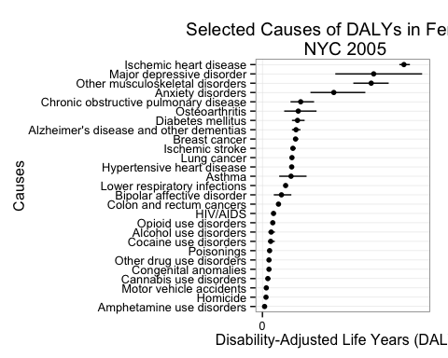 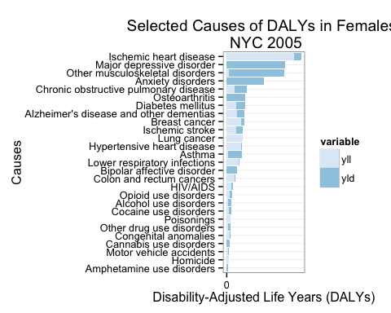

# Discussion

## Limitations

There are key limitations to this analysis. First and foremost, the magnitude of the DALY scores should be interpreted and reported with caution. Due to the small sample size of NYC prevalence estimates and the uncertainty around disability weights and national YLL/YLD rates for some conditions, DALY estimates can assume a wide range of values, changing how one condition ranks against the others (for example, diabetes mellitus). For this reason, DALY magnitudes obtained via Michaud approach and the Prevalence-based YLDs cannot be directly compared.

Moreover, the accuracy of DALY estimations suffers from potential biases introduced in the data collection and computation processes. For example, comorbidities with respect to chronic diseases means that DALY estimates based on Vital Statistics mortality counts are overestimating the contribution of YLLs. Summation of prevalence YLDs across all causes can result in overestimation of the total average severity-weighted health state prevalence because of comorbidity between conditions ([Mathers, 2006](http://www.ncbi.nlm.nih.gov/pmc/articles/PMC547900/)). Over-reporting of some conditions due to misclassification (e.g. where symptoms such as joint pain are labeled as osteoarthritis or occasional wheezing as asthma), under-reporting of undiagnosed conditions (e.g. most mental health problems), and lack of information on condition severity (resulting in high prevalences due to inclusion of very minor conditions or minor symptoms) may also contribute to biased DALY estimates.

In order to convey the uncertainty around our estimates, we visualize the range of values that NYC DALY estimates can take for each condition.

## Sensitivity Analysis

NYC DALY rankings and magnitudes using the Michaud approach are fairly consistent using both 2005 and 2013 NYC mortality counts. Moreover, the Michaud approach implemented in this analysis replicated the 2005 NYC DALY estimates from the previous NYC DOHMH study, producing comparable rankings. However, since age-weighting is no longer used due to ethical concerns, the 2013 NYC DALYs are slightly larger in magnitude. Recommendations for future work include running simulations to test the stability of DALY rankings for an even wider range of assumptions.

# References

Jiang, Yongwen, and Jana Earl Hesser. “Using Disability-Adjusted Life Years to Assess the Burden of Disease and Injury in Rhode Island.” Public Health Reports 127, no. 3 (2012): 293–303.

Lozano, Rafael, Mohsen Naghavi, Kyle Foreman, Stephen Lim, Kenji Shibuya, Victor Aboyans, Jerry Abraham, et al. “Global and Regional Mortality from 235 Causes of Death for 20 Age Groups in 1990 and 2010: A Systematic Analysis for the Global Burden of Disease Study 2010.” The Lancet 380, no. 9859 (December 15, 2012): 2095–2128. <doi:10.1016/S0140-6736(12)61728-0>.

Michaud, Catherine M, Matthew T McKenna, Stephen Begg, Niels Tomijima, Meghna Majmudar, Maria T Bulzacchelli, Shahul Ebrahim, et al. “The Burden of Disease and Injury in the United States 1996.” Population Health Metrics 4 (October 18, 2006): 11. <doi:10.1186/1478-7954-4-11>.

Schroeder, S Andrew. “Incidence, Prevalence, and Hybrid Approaches to Calculating Disability-Adjusted Life Years.” Population Health Metrics 10 (September 12, 2012): 19. <doi:10.1186/1478-7954-10-19>.

U.S. Department of Health and Human Services, Substance Abuse and Mental Health Services Administration, and Center for Behavioral Health Statistics and Quality. “Results from the 2012 NSDUH: Summary of National Findings, SAMHSA, CBHSQ.” Accessed April 18, 2015. <http://archive.samhsa.gov/data/NSDUH/2012SummNatFindDetTables/NationalFindings/NSDUHresults2012.htm>.

Üstün, T. B., J. L. Ayuso-Mateos, S. Chatterji, C. Mathers, and C. J. L. Murray. “Global Burden of Depressive Disorders in the Year 2000.” The British Journal of Psychiatry 184, no. 5 (May 1, 2004): 386–92. <doi:10.1192/bjp.184.5.386>.