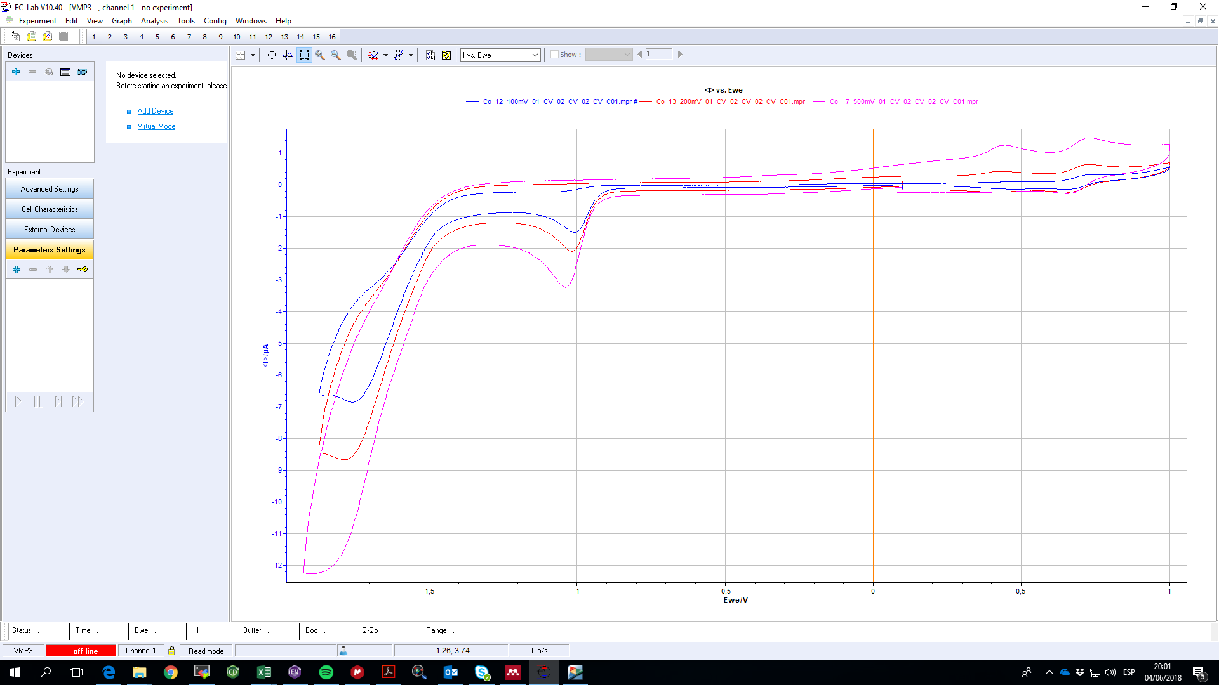The idea is to obtain a plot of the current i(uA) vs. the redox potential E(V). To find automatically the minima in a given domain of redox potential and its intensity value.