Executive Summary ? Shell Overview?

The Unicorn Shell (working title) will be a cross platform POSIX style shell, which will be released for linux, OSX and Windows.

aimed at new users, people who are not particularly skilled at using a shell, and possibly those who have never used one before.

New noob friendly features will be focused on usability. Basic shell operations will be natural interactions, anyone will be able to pickup unicorn very quickly, even those from differing OS backgrounds.

Despite the target audience of our Shell, it will still provide the full feature set that advanced users would expect out of a modern POSIX style shell.

Such features will include advanced tab-completion, stream redirection, fine grained multi process control, several predefined macros and aliases for things like accessing the command history. And almost everything will be able to be customized.
It will also look pretty with proportional width font. All graphical elements on screen will be varying shades of pink and magenta, for a pleasing aesthetic.

NOOB FEATURES
Our shell will provide several intuitive ways to interact with the mouse, these interactions will be very similar to the actions in a standard GUI OS environment (i.e. double click for open).
But most of our actions wont actually perform the action outright, instead it will paste the command that would perform the requested action into the current prompt,
i.e. clicking "open file" in a GNOME environment will paste the command "gnome-open <file-name>" into the prompt, the user will then have to press "return" to execute the command.
The purpose of this is to both help the user when they do not know the exact text command, and then teach the user that text command.
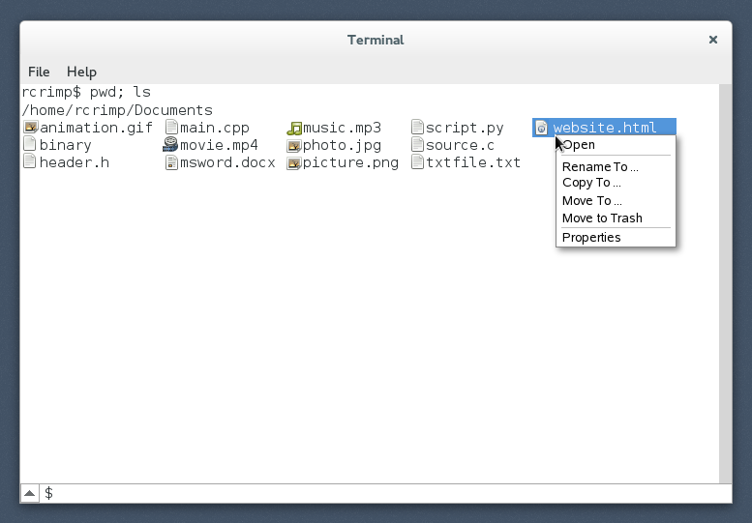
Fig 1: graphical ls, and context menu
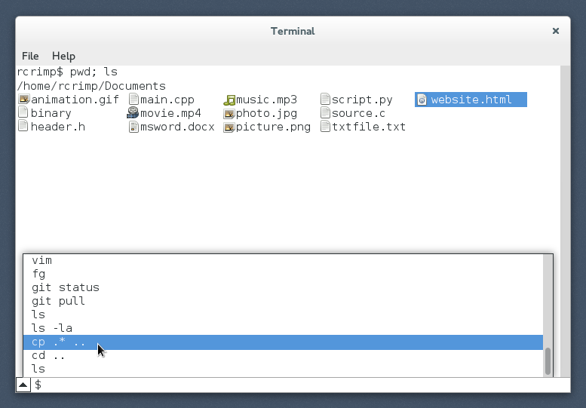
Fig 2: interactive command history

Our shell will come with an inbuilt 'ls' function, designed for specifically to aid beginners (the default OS ls/dir will be able to exist alongside or even replace our inbuilt function)
1: file-names will be preceded by a filetype icon, like a GUI shell (fig.1)
2: Intuitive directory navigation.
Single clicking on some directory "x/" will paste the command "cd x/" into the prompt.
Double clicking on some directory "x/" will execute the command "cd x/"
Right clicking on some directory "x/" will open a context menu (see fig.1), which will list basic directory commands
e.g "open (cd)" will execute the command "cd x/"
"move to .. (mv), will paste the command "mv x/ " into the prompt, allowing the user to type in a new name for the file.
etc...

3: Intuitive file interaction
Single clicking on some file will paste the filename into the current prompt, i.e if I were to type "emacs" into my prompt, and then click "textfile.txt", this will result in having "emacs result.txt" left in my prompt.
Double clicking on some file will open the file with the OS default application. e.g if I were in a GNU/linux enviroment, and pdf files were associated with evince, double clicking on "document.pdf" will open the pdf file in evince.
Right clicking a file will open a context menu (see fig.1), which will list basic file operations
e.g "GUI open (open)" will perform the same operation as double clicking the file.
"Rename To .. (mv)" will paste the string "mv <filename> ", then allowing the user to choose a new name"
"Move to Trash" will perform the command "mv <filename> ./Trash/" or something similar"
etc...

4: Interactive viewing of the command history
clicking the small arrow to the left of the prompt, will open a drop down menu (upwards), showing the last commands executed in ascending/descending? order (i.e last on bottom).
The stanard bash style keyboard shortuts to access your history will also exist for the more advanced user.
(up, down, "!!", !str" etc...)

Hastags
That's right, wer're hip, we're with it
We will allow users to set temporay (and permanent) directory flags with a quick command.
usage:
executing "#work" will set a flag in the current directory called "work", and succsive execution of the command "#work" will change the users directory back to the first driectory in which it was called. allowing for quick navigation between directories when working on a project. These check-points are not stored be default when the shell is closed, but there will be an option to save these "hastags" so that they persist over sperate sessions.

ADVANCED FEATURES
The various forms of “Tab completion”
tab completion will index: (--decide on an order of precedence--)
- $PATH
- Path-name completion in the working directory.
- File-name completion in the working directory.
- Path-name completion of all the parent directories of the working directory.
- Variable-name completion
- Man-page completion
- Command history
wild card *
Tab-Tab lists all possibilities once for each completion, subsequent tabbing will cycle the prompt through the possibilities.
inline prediction, like googles live search

GOOGLE
Fish Shell
HotWire-Shell
script parsing http://aosabook.org/en/bash.html
piping http://en.wikipedia.org/wiki/Pipeline_(Unix)
redirection/piping http://en.wikipedia.org/wiki/Redirection_(computing)
common shells http://en.wikipedia.org/wiki/Comparison_of_command_shells
advanced shell usage http://herbert.the-little-red-haired-girl.org/en/cstechnology/docs/3_advanced_shell.pdf
POSIX http://en.wikipedia.org/wiki/POSIX
bash inbuilt commands http://tldp.org/LDP/Bash-Beginners-Guide/html/x7243.html
bash shortcuts http://ss64.com/bash/syntax-keyboard.html

BUZZ STATEMENTS
Graphical enhancements
GUI style mouse interactions
Allow the user to perform basic operations, without prior education in shell usage.
Our shell will not come with a quick-start guide, the user will not need to be taught how to perform basic shell operations.
High usability
Features to teach users how to use a shell efficiently

Operations be very similar to those found on the graphical interface on common OS environments, i.e. double click to open a file, right click for a context menu etc...

This is so that operations will feel natural, and will not require the user to be taught how to use our shell.

The human mind is able to recognize complex visual patterns quickly, so there's no need to limit our shell to highlighted text to differ between files, we will

highlight text in command history, right click context menu, cut copy paste
mouse interaction in the prompt, i.e click anywhere, edit any part of the current command

the mockup images are merely an indication of the final program's final look,

