University of Puerto Rico

Mayagüez Campus

Electrical and Computer Engineering Department



***AgriMeter*: A GPS-based computer system used to survey large terrains**

**Progress Report**



**R2E Measuring Gadgets**

Roberto C. Rivera-Berríos – Project Manager

Rogelio Vázquez-Rivera

Eddrick S. Berríos-Bonilla

For: Drs. Nayda G. Santiago, J. Fernando Vega, and Kejie Lu

Course: ICOM5047-031

Date: March 10, 2013

# Executive Summary – RRB

The development of the AgriMeter project is under continuous progress. The project is looking forward to bring surveyors low-cost equipment that will allows them to obtain horizontal distance and sea level elevation difference between two straight points that are at a length greater than 1000 m. The AgriMeter will also aid surveyors to take their measurements easier and efficiently compared to current methods and technologies for surveying. As time passes by, the AgriMeter is becoming a reality. The team just concluded the design phase. The design phase comprises the design of three components: the embedded system, the Android software, and the web application. Various technologies and ideas were evaluated to conceive the design, but several aspects influenced final decisions: availability of components, price, experience, skills and quality. Many of the components necessary for the hardware were already ordered. Some of them already shipped. Regarding the software, the graphical user interfaces, database software components and functionality were clearly defined and designed.

According to the schedule for tasks established on the Gantt chart, by March 8, 2013, the team must have completed the design, which was done on time.

The deliverables for this phase are a progress report that contains the current status, the expenditures and the design documentation for the embedded system, Android application, web application and database, which are all contained within this report.

The total of work hours spent during the project design is 228.8 hours and 15 days to complete the design phase. This resembles approximately $4,572.12 in work hours, which is under the budget agreed. The total actual cost of the components is $321.99, that compared to the expected costs, $346.85, represents savings of $24.86. The current project cost is $4894.11, while the expected total cost for the project completion is $11,203.72.

Table of Contents

Executive Summary – RRB i

Introduction – RVR 1

Progress – RRB 2

Budget Analysis – RRB 2

Embedded System Design – RVR 3

System Block Diagram 3

Schematics 3

Features 3

Core System Components 3

Communication Options 4

Communication Module Selection 4

Electrical Characteristics 5

Power Analysis 5

Timing Analysis and Communication Settings 7

Embedded System’s User Interface 7

Embedded System Progress Assessment 8

Android Application Design – EBB 8

Behavioral Flowcharts 8

User Interface 8

Software Design 9

Software Architecture and Components 9

Class Diagram 11

Sequence Diagrams 11

Android Application Progress Assessment 12

Web Application Design – RRB 12

Software Architecture and Components 12

User Interface 13

Diagrams 13

Data Base Entity Relationship Diagram – EBB 14

Webpages 14

Design Justifications 15

Web Application Progress Assessment 15

Future Work – EBB 15

Android Application 15

Web Application 15

Embedded System 15

Bibliography 16

Appendix A – Gantt Chart – RRB i

Appendix B – Detailed Budget Analysis – RRB i

Appendix C – System Block Diagram – RVR i

Appendix D – Detailed Schematics – RVR i

Appendix E – Embedded System User Interface Mock-Up Screens – RVR i

Appendix F – Detailed Electrical Characteristics – RVR i

μLCD-32PTU Display Module with Resistive Touch i

12-Channel Copernicus II GPS Receiver DIP Module i

Antenna GPS Embedded SMA i

RN-42 – Class 2 Bluetooth module i

Appendix G – Project’s Progress Assessment – Team i

Appendix H – Android Application Flowcharts – EBB i

Appendix I – Android Application Layout Design – EBB i

Appendix J – Vincenty’s Iterative Algorithm – EBB i

Appendix K – Android Application’s Class Diagram – EBB i

Appendix L – Android Application’s Sequence Diagrams – EBB i

Appendix M – Web Application User Interface – RRB i

Appendix N – Web Application Class and Navigation Diagrams – RRB i

Web Application Class Diagram i

Web Application Flowchart ii

Appendix O – Database Entities and Entity Relationship Diagram – EBB i

Entities i

ER Diagram ii

Queries iii

Appendix P - Android Application Use Case Diagram – EBB i

# Introduction – RVR[1]

Through an interview with surveyor Luis Adhel Rivera early in the project’s life cycle, R2E identified a current problem surveyors have when taking their measurements. A surveyor needs to subcontract another surveyor because there needs to be at least two surveyors present and the distance range between any two points must practically be between 500 and 1000 m. for measurements longer than this range, the surveyor must divide the distance in shorter paths in order to take the whole measurement. Because of this problem, R2E is proposing a solution to this problem known as AgriMeter. AgriMeter is a low-cost GPS-based computer system that allows the user to obtain horizontal distance and sea level elevation difference between two straight points that are at a length greater than 1000 m.

The objective of our project is to provide a computer system that aids surveyors in obtaining the data required by their profession, without having the complexity and cost of other equipment currently in the market. The project’s specific objectives are the following:

1. Design and implement a **GPS-based embedded system** that will be used to obtain coordinates and sea level altitudes for the locations to be measured. The system will be composed of the following modules:
   1. a dedicated GPS receiver with an internal active antenna
   2. an LCD touchscreen that will serve as the user interface of the system
   3. a microprocessor that handles all the information of the system
   4. a Bluetooth communication module to communicate information to an Android device running AgriMeter’s app
   5. a micro-SD card module used for data storage
   6. Li-Po battery with battery monitor and charging circuitry
2. Design and implement an **Android application** that:
   1. receives the coordinates and sea level altitudes from the embedded system
   2. calculates the distances and sea level altitude differences
   3. sends the data through a server to be stored in a database

The Android application must communicate with the embedded system because the coordinates will be taken from the system and not directly from the Android device because of the higher accuracy provided by dedicated GPS modules when compared to GPS modules in smartphones.

1. Design and implement a **Web application** that aids the user to:
   1. create/edit their account
   2. view their recorded project measurements in an organized way using folder hierarchy
   3. share their measurements with other colleagues

The web app will use a GIS (Geographic Information System) as a visual aid to display the coordinates and measurements taken on a map.

Since the proposal, some aspects have arisen in regards to the specifications of the project. The aspects during the design phase that have changed include the following:

* GPS modules with an accuracy of 1.8 m was not found, so the team decided to order the most accurate module found, which states a horizontal position accuracy of less than 2.5 m. This will adversely affect the accuracy of our system when compared to the calculated accuracy in the proposal. This change becomes negligible when applied to large distances, so the overall effect it has on the system is not recalculated.
* It is important to note that the embedded system will not calculate distances and elevations because of the hardware and software limitations of the processor, although this was not previously perceived in the proposal. The processor used has a special programming language that does not support the trigonometric functions used to implement the distance formulas.
* The system will use Bluetooth instead of GSM/GPRS and will also use a Li-Po rechargeable battery. These design decisions will be explained throughout the report.

The progress report has been divided into several sections that portray the thought process that the team used in order to conceptualize the design of the system. After introducing the changes the system suffered through the design phase, the current progress of the project is assessed, along with the budget. The report then proceeds to detail the technical plan used in the design, including both hardware and software components. In terms of hardware, the block diagram, schematics, power analysis, among other topics are covered. In software, the team presents the class diagrams, sequence diagrams, flow charts, and mock-up screens, among others. The report is concluded with how the team is performing in terms of the schedule and the future work that needs to be done. Appendices containing complex diagrams, such as schematics and detailed sequence diagrams are provided.

# Progress – RRB

The AgriMeter project was approved on February 26, 2013. The approval period got extended for a few days, but either way the team worked on the design as scheduled in the Gantt chart. The Gantt chart did not change in terms of the schedule, but some tasks scheduled to be sequential were changed to execute in parallel. Based on the Gantt chart, to this date all the designs should have been completed. This includes the hardware and software design. To be more specific, on the hardware side, the components like the microcontroller and the LCD have been chosen, and a power and timing analysis has been done. On the software side, the database structure has been designed using ER modeling. The system architecture has been designed, along with the graphical user interface for both the Android and the Web applications, created flowcharts, use cases, class diagrams, navigation diagrams, and sequence diagrams. Based on the current status, the team is on schedule to proceed to the implementation phase. In the next few weeks, the team will implement each module designed during the previous phase. These include database, web application, Android application, and the hardware components. Refer to Appendix A for a detailed depiction of the project’s Gantt chart.

# Budget Analysis – RRB

During the development of the proposal we had estimated a total cost of $346.85 in components for the AgriMeter system, including shipping and handling. However, during the technical analysis of our project we acknowledged various technical aspects that were not considered during the proposal and appropriate changes were made to comply with the requirements of the project. The following changes have been added to our scope:

* Li-Po 3.7V rechargeable battery
* GPS Antenna
* The LCD touchscreen includes the microcontroller, SD card, and development board

The budget regarding components and parts is highly controlled and always looking for alternatives to reduce variable costs. Comparing the budget expected for materials in the proposal and actual costs, it can be concluded that the estimate done in the proposal is close to the actual cost. The total cost of the components at the moment is $321.99. The expected cost of the components was $346.85. It can be concluded that, at this moment, the components cost was reduced by $24.86.

Software licenses at this moment were not necessary because open source software and software trials were used for our design and the development of the different components demonstrated in this report.

The personnel costs did not change during this time period. With a total of 228.8 hours of work, the personnel cost is $4,572.12. Up to this point, the total cost of the project is $11,203.72. Refer to Appendix B for a detailed description of the budget.

# Embedded System Design – RVR

## System Block Diagram

Throughout the design process, the team faced various options and had to make decisions based on the system’s characteristics we wanted to provide. Throughout the following sections, these options were analyzed in order to select the final components for the design of the system. Refer to Appendix C for a detailed description of the system’s block diagram.

The specs and features of these components will be presented in the following sections. It is important to note that the μLCD-32PTU Display Module contains additional embedded components but only the ones pertinent to our system have been highlighted in the block diagram. Their interconnections are internal to the module and thus they are not presented in the diagram.

## Schematics

The system’s schematics are divided into three separate files. The first schematic displays the overview of the interconnections of the system although the display module is referenced by the headers it provides to access its pins. It was designed using the Eagle CAD tool. The second schematic has been taken from the datasheets from the display module in order to show the internal interconnections of the module. The third schematic has been taken from the designers of the evaluation board for the GPS receiver. Refer to Appendix D to where the schematics are located.

## Features

### Core System Components

#### μLCD-32PTU Display Module with Resistive Touch

The display module is a complete module that offers several features and applications. At the heart of the module lies a PICASO graphics processor driven by a virtual core engine called EVE (Extensible Virtual Engine) with several software and hardware features that have been embedded into the design. Some of these features include a3.2” LCD-TFT display with integrated 4-wire resistive touch panel, 240x320 VGA resolution; 5-pin interface to host device: VCC, RX,TX, GND, RESET; powered by a PICASO processor; built-in extensive graphics and system library functions; 14KB of flash memory (code storage) and 14KB of SRAM (user variables); 2 asynchronous hardware serial ports; 1 I²C interface; 8 16-bit timers; 13 general purpose I/O ports; on-board micro-SD memory card adaptor (FAT16 format); Lithium battery support, with built-in battery charger; 4.0V to 5.5V operation range; RoHS compliant.

#### 12-Channel Copernicus II GPS Receiver DIP Module

The Copernicus II GPS receiver module acquired has been conveniently packaged in a DIP breakout board that allows easy access to the receiver’s pins. The module contains features such as dual serial ports with reconfigurable UART rates; standard female SMA connector for an antenna; ultra-low power usage, less than 132mW (typical); supports NAD83; horizontal accuracy is less than 2.5m; elevation accuracy is less than 5.0m; RoHS compliant.

#### Antenna GPS Embedded SMA

The antenna is for the GPS receiver which doesn’t contain an integrated antenna in the module. The antenna uses a standard male SMA connector which can be connected to the GPS receiver module through the female SMA connector located on the module.

### Communication Options

In terms of communication, the team is considering two options: having a Bluetooth module to enable communication between the embedded system and the Bluetooth-enabled Android device or having a GSM/GPRS module to enable the embedded system to communicate with the central server to store data obtained on the field.

#### Option A: RN-42 – Class 2 Bluetooth Module

The Bluetooth module is intended to provide communication between the embedded system and the user’s Android device. Data obtained from the device will be sent through Bluetooth to be processed in the Android app. The RN-42 Bluetooth module contains the following features: fully qualified Bluetooth 2.1/2.0/1.2/1.1 module with on-board chip antenna; low power consumption; UART and USB interfaces; 3.3V operation; average current consumption: 45 mA; RoHS compliant.

#### Option B: GSM/GPRS Module - SM5100B

The GSM/GPRS module is intended to provide the system with communication through a GSM network. This enables the embedded system to upload the data obtained in the field directly through the network to the server and database. The GSM/GPRS module has the following characteristics: quad-band GSM; SMS messages, GSM/GPRS, TCP/IP; 2 UART ports; 1 SPI interface; 2 10-bit ADCs; 3.3V to 4.2V range, 3.6V typical; average current consumption: 350mA; RoHS compliant.

### Communication Module Selection

|  |  |  |  |
| --- | --- | --- | --- |
| **Component** | **Unit Price** | **Shipping and Handling** | **Total Price** |
| *RN-42 – Class 2 Bluetooth Module* | $39.00 | $5.00 | $44.00 |
| **Total** | | | $44.00 |

Table 1 - Prices for the Bluetooth Module

|  |  |  |  |
| --- | --- | --- | --- |
| **Component** | **Unit Price** | **Shipping and Handling** | **Total Price** |
| GSM/GPRS Module – SM5100B | $59.95 | $16.00 | $75.95 |
| *SM5100B Evaluation Board* | $59.95 | $16.00 | $75.95 |
| *SIM Card* | Varies | Varies | Varies |
| **Total (without SIM card and fees)** | | | $151.90 |

Table 2 - Prices for the GSM/GPRS Module

When deciding on which communication module to use, the team has to point out the benefits of each communication option and then decide based on those factors. The benefits for each communication option are analyzed in the table below:

|  |  |
| --- | --- |
| **Bluetooth** | **GSM/GPRS** |
| * Lower price * No additional monthly fees caused by acquiring a SIM card * Less power consumption * Previous experience using the technology | * Data synchronization directly from the device to the database * No additional device is required |

Table 3 - Communication Modules Benefits Comparison

Based on the features, characteristics, and benefits of each of the communication options, the team has decided to use the Bluetooth module for communication instead of the GSM/GPRS module. The factors that influenced this decision include having no additional costs after product is acquired; keeping development costs as low as possible; previous experience with the technology; and designing a system that consumes less power.

## Electrical Characteristics

The components in the system all operate within the 3.3V range, thus no special interfacing is required for the components to be able to operate and communicate with each other. Refer to Appendix F where the detailed electrical characteristics for the different components have been displayed.

## Power Analysis

When doing the power analysis for our system, we take into account the power consumption of each of the individual components in our system. For components with varying operating currents, we calculate the maximum power consumed. The power consumption for the system will be the sum of the power consumed by each individual component. The following table summarizes power requirements for the system:

|  |  |  |  |
| --- | --- | --- | --- |
| **Component** | **Operating Voltage (V)** | **Operating Current (mA)** | **Consumed Power (mW)** |
| μLCD32-PTU | 5.0 | 155 | 775 |
| RN-42 Bluetooth Module | 3.3 | 45 | 148.5 |
| Copernicus II GPS Receiver | 3.3 | 44 | 145.2 |
| GPS Antenna | 3.3 | 12 | 39.6 |
| **System Total** | | 256 | 1108.3 |

Table 4 - Power Requirements for each Individual Component

Although the display module states regulated 5.0V as its operating voltage, it has support for connecting to a 3.7V Lithium polymer (Li-Po) battery, including an on-board Lithium charge management controller. The other option for supplying power to the system would be using the more common AA alkaline batteries. Each of these batteries commonly has a nominal voltage of 1.5V, so a minimum of 4 AA alkaline batteries in series would be needed in order to supply the highest required voltage. The following table summarizes the characteristics of these two options:

|  |  |  |
| --- | --- | --- |
| **Characteristic** | **LiPo** | **AA** |
| Quantity | 1 | 4 |
| Voltage | 3.7V | 6.0V (1.5V each) |
| Capacity | 2000mAh | 1800-2600mAh |
| Regulators Needed | * 1 for the regulated 3.3V used for the Bluetooth, GPS, and antenna * Battery will be used to directly supply the display module | * 1 for the regulated 3.3V used for the Bluetooth, GPS, and antenna * 1 for the regulated 5.0V used to supply the display module |
| Price | $16.95 | Approximately $3.99-$5.99 for a 4-pack |
| Recharge ability | Yes | No (usually) |
| Power Loss[2] |  |  |

Table 5 - Comparison of Power Sources for the System

Based on the characteristics presented above, the Lithium polymer battery has been selected as the power source for our system. In order to calculate the approximate duration of the battery, we must first analyze the efficiency of the linear voltage regulator. The electrical characteristics of the TLV70033 LDO appear on the following table:

|  |  |  |  |  |
| --- | --- | --- | --- | --- |
| **TLV70033 LDO[3]** | | | | |
| **VIN** | | **VOUT** | **VDO @ IOUT = 100mA** | **IGND @ IOUT = 100mA** |
| *Min.* | *Max.* | 3.3V | 85mV | 175μA |
| 2.0V | 5.5V |

Table 6 - Electrical Characteristics of the TLV70033 Linear Voltage Regulator

This regulator complies with the minimum voltage level for the unregulated power source, as indicated by the following equation:

In this equation, VNR represents the voltage from the battery source; VR represents the regulator’s output voltage; and VDO represents the regulator’s dropout voltage. After reviewing the electrical characteristics for the regulator, we can proceed to analyze its efficiency using the following formula:

In the previous formula, IR represents the regulator’s load current, and IGND represents the current lost in the regulator. The efficiency for the regulator is:

Thus, the expected duration of the battery in the system is approximately[4]:

## Timing Analysis and Communication Settings

In our system, timing isn’t a critical factor for operation. The PICASO processor is sourced with a 12MHz crystal, which sets the clock rate. In terms of receiving and transmitting serial data, the baud rate must be set for successful communication, along with several other parameters. The baud rate is selected according to the supported rates by the specific module, the supported rates of the processor, and the error percentages of communication for the specified baud rate selected in the module and processor. The following table summarizes the chosen baud rates and communication settings for the modules and the error percentages according to the processor’s communication specifications:

|  |  |  |  |  |  |  |
| --- | --- | --- | --- | --- | --- | --- |
| **Module** | **Baud Rate** | **Data Bits** | **Parity** | **Stop Bit** | **Flow Control** | **% Error** |
| Bluetooth | 9600 | 8 | None | 1 | No | 0.33% |
| GPS | 9600 | 8 | None | 1 | No | 0.33% |

Table 7 - Selected Settings for the Communication Modules

## Embedded System’s User Interface

The embedded system’s user interface consists of a series of views and interactions between these views. These views and interactions are explained below but refer to Appendix E to view the mock-ups of the screens.

1. This is the home screen that appears once the system is turned on. When turning on, the system must verify if the SD card is installed. If not, the system shall not proceed. It must also initialize all I/O ports and UART communication ports. When the *Start Project* button is pressed and a name is entered for the new project, the system moves to view #2. When the *View Projects* button is pressed, the system moves to view #3.
2. This view presents the option to obtain data for the project. The *Obtain Point* will get the data from the GPS and display it to the user. The user then has the option to store this point, obtain another point without saving the previous one, or simply closing the project while saving the data currently in the view. The *BACK TO HOME* arrow changes the view to #1 and doesn’t save the data currently in the view, unless the *Store Point* button was pressed.
3. This view represents the projects currently stored in the logs. The user can scroll through the projects, view the contents of a project (moving to view #4), and delete a project. The *BACK TO HOME* arrow works as in the previous view.
4. This view has a similar layout as view #3 but displays the points currently logged under the same project. When the user wants to view information regarding a specific point, the system moves to view #5.
5. This view displays the information regarding the point selected in view #4. It has only one button that returns the system to view #3.

## Embedded System Progress Assessment

For the GPS-based embedded system, the design phase has been completed. This equates to a 40% completion of the module. For a detailed description of the tasks completed to achieve this 40%, please refer to Appendix G.

# Android Application Design – EBB

## Behavioral Flowcharts

The inclusion of an Android application in the AgriMeter system is to bring the user another alternative to take, store, and view surveying data. The mobile application helps to emulate the surveyor’s experience when they use the data collector electronic device to store their measurements, but this application will allow the user to take the surveying data via Bluetooth technology connecting it with the AgriMeter embedded system and also helps to view previous data by connecting it with an external database.

In order to design the mobile application, we first developed a general behavior flowchart. Refer to appendix H for the general Android application flowchart.

This flowchart establishes the general features that the mobile application needs to have in order to be useful for a surveyor. A personal account allows the user to have control of the obtained data under his/her account. Because of this, a username and password will be required in order to use the mobile application. In case the user does not have an account, the application will allow the user to create one by supplying some information like name, last name, organization where the user works, phone number, and e-mail. Once a user is signed in, he will have the opportunity to view information regarding projects and data owned by the user, create new projects under his name, and connect to the AgriMeter embedded system to obtain information about a point like latitude, longitude, and sea level elevation.

## User Interface

With the general function of the Android application in mind, we created a user interface to concrete this. We use the sketchy mock up design technique to simulate Android layouts. This allows us to create a first impression of the product to the client, and give flexibility to make recommendations about modifications at the same time. Figure 1 shows a preview about this layout design.[5]

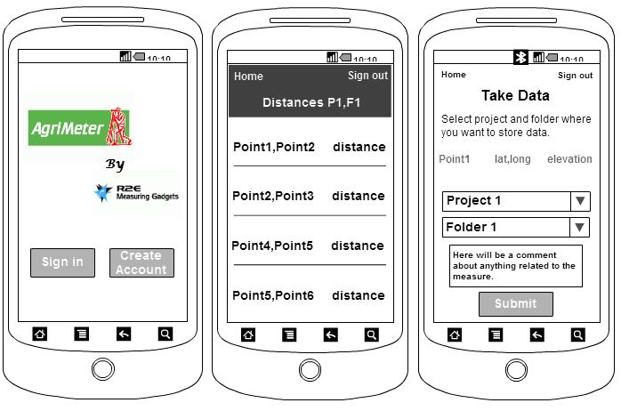

Figure 1 - Android Application Preview

From this mobile user interface preview we can observe that the layout design is based on basic widgets available in the Android SDK (Buttons, List Views, and Text Views). An important remark is that the mobile application’s purpose in this project is to have a quick and precise access to information that a client needs at the moment. To view how the user can interact with the Android application we create a use case diagram, Refer to Appendix P.

From this use case diagram we can see that the user has eight ways to interact with the application. The user can view a project, create a project, turn on Bluetooth, connect to the AgriMeter embedded system, and acquire data only if the user is signed in on the application. If the user does not have an account, the application brings a layout to create one.

## Software Design

### Software Architecture and Components

From the designed user interface we can appreciate that AgriMeter’s Android Application structure is based on three principal components: ***Bluetooth Communication & Data Acquisition***, ***Calculations***, and ***Data Base Interaction***. Figure 2 shows a diagram of the Android application architecture and its three principal components.

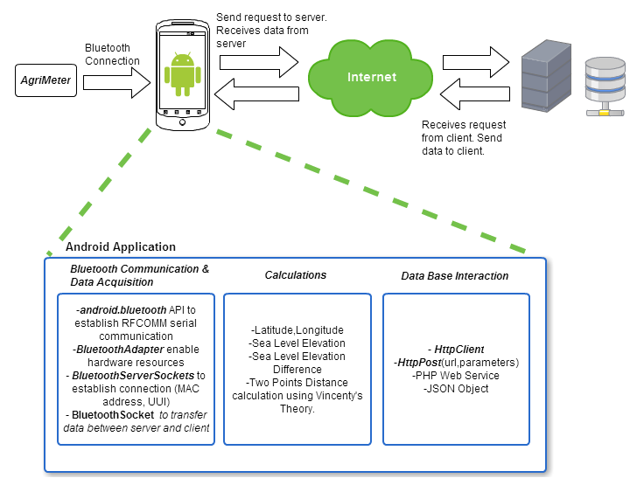

Figure 2 - Android Application Structure

In order to have a Bluetooth communication between the AgriMeterembedded system and an Android device, it is necessary that the mobile device implement this technology. Android Bluetooth communication is based on Bluetooth radio frequency communications protocol (RFCOMM), and is present on Android devices since ***Android 2.0 SDK***. This serial communication protocol allows the Android device to establish a peer-to-peer network to transfer encrypted information [1]. To configure this communication technology, we are going to use ***android.bluetooth*** application programming interface (API). This package includes the ***BluetoothAdapter*** object that helps the Android device to enable its hardware resources and makes it discoverable by other Bluetooth devices. The connection will be established using a ***BluetoothServerSocket*** including the MAC address of both devices and Unique Universal Identifier (UUI) for the Android application. This will permit to have a client-server connection. Once the connection is established, ***BluetoothSockets*** will be used to transfer data between the two sides.

Once all data is collected on the Android device via Bluetooth, the device can use it to makes sea level elevation difference, and distance calculation between any two points. To accomplish this, a calculation component was designed. This component includes a module that with two sea level elevation parameters calculates the difference between them. Another module included on the calculation component is the distance calculation. It takes two points (latitude, longitude) as parameters and give the distance between them. This module will contain Vincenty’s iterative algorithm to calculate the distance.[6] We chose this method to calculate distance between two points versus Haversine’s formula because it uses a realistic elliptical model of the Earth comparing it with a perfect sphere model implemented by Haversine’s.

In terms of the connection of the Android application with the database, the design is as follows. Since the Android SDK does not allow connecting to an external database directly from the project code, a web service, with a necessary query, previously stored on a server needs to be invoked from the Android project code. To accomplish that, a PHP web service is going to be used to query the database. The decision to use this type of web service is explain on the design justification for web page design part of this document. An ***HTTP client*** is going to be used in order to access the server. This client uses an ***http post*** to access a specific web service using a *Uniform Resource Locator* (url), and the necessary values to complete a query as parameters. When the PHP web service finishes serving the request, a Java Script Object Notation (JSON) object is created and sends data back to the Android application. This object is going to be parse on the mobile application in order to show the information to the user.

### Class Diagram

Since the development of Android applications is created using object oriented programming technique, a class diagram was created to have a concrete implementation plan.[7] The development of Android applications is based on classes named activities. Each activity is responsible of giving functionality to a graphical user interface named layout, which is created using Extensible Markup Language (XML). The created class diagram is divided into two principal categories: the classes that extend the Android *Activity* class and the ones that extend the Android *ListActivity* class. The activities that need to interact with the database implement a helper class that assists with the request of the web service to the server. Each helper class also implements a common class that helps to handle JSON objects that come from the web service. This JSON object class extends an Android *AsynkTask* class in order to use multiple threads during data base connection time. While the http request is currently executing, another thread can be used to create notifications to the user to maintain the user informed at all times.

### Sequence Diagrams

A sequence diagram for three principal actions that a user can do with the Android Application was created to illustrate the sequence of events that occurs in the system. Figure 3 shows the sequence diagram for ***Crate a Project*** action.

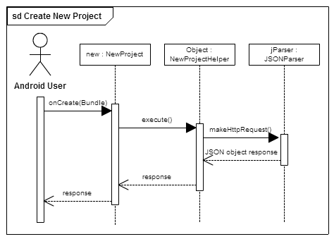

Figure 3 - Create New Project Sequence Diagram

The create a new project action will be initialized with the *onCreate()* method invoking a *New Project* layout. This layout will create a *NewProjectHelper* object, with the parameters entered by the user that is going to handle the data base connection. To accomplish this, a JSONParser object will be created in order to make the Http request to the server to access the web service. Since the web service returns a JSON object from the query result, the *NewProjectHelper* class will parse the object in order to adapt the data to be presentable to an Android layout. To view sequence diagrams for ***View Project*** and ***Take Data from AgriMeter*** go to Appendix L.

## Android Application Progress Assessment

For the Android app, the design phase has been completed. This equates to a 40% completion of the module. For a detailed description of the tasks completed to achieve this 40%, please refer to Appendix G.

# Web Application Design – RRB

The main purpose of AgriMeter is to help surveyors collect measurements for their projects. All those measurements will be uploaded, managed and organized in the “AgriMeter Web Platform”. This web application shall let the users organize their measurements into projects and folders. The user shall be able to visualize the measurements in a map at the simultaneously when he/she browse through folders. The web application will workflow is as follows: (1) the web application reads data from the SD card that was used in the embedded system for storing measurements, (2) those measurements will be uploaded to the database and organized into a project/folder and (3) the user will be able to access from the web application all the stored measurements. A general web application block diagram is shown on Figure 4.

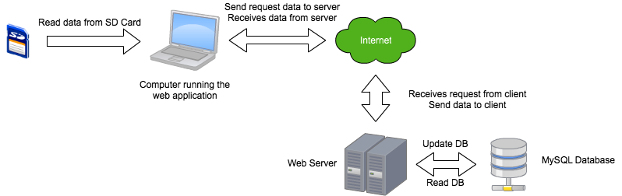

Figure 4 - Web Application Block Diagram

The web application is designed for two types of users; both users have different scopes of the web application.

* Surveyor - this user utilizes the data collector (embedded system) to take measurements and uploads it via the Android device or the SD card using the web application. Surveyors can create projects and share them collaborators within its same organization to contribute on it.
* Organization – this user represents a group of surveyors. The organization can add or removes surveyors from it. An organization can view all the projects of the surveyors within the organization, but can’t make any modifications on them. Surveyors within the same organization can view and collaborate on each other projects with authorization of the owner of the project. The number of surveyors that can belong to an organization is constrained by the number of user licenses that the organization has, by default an organization is given 5 licenses, this means that only 5 surveyors can be subscribed in that organization. The organization can request more licenses for extra cost.

## Software Architecture and Components

The web application functionality can be described by its components, which are identified in the software architecture shown in Figure 5.

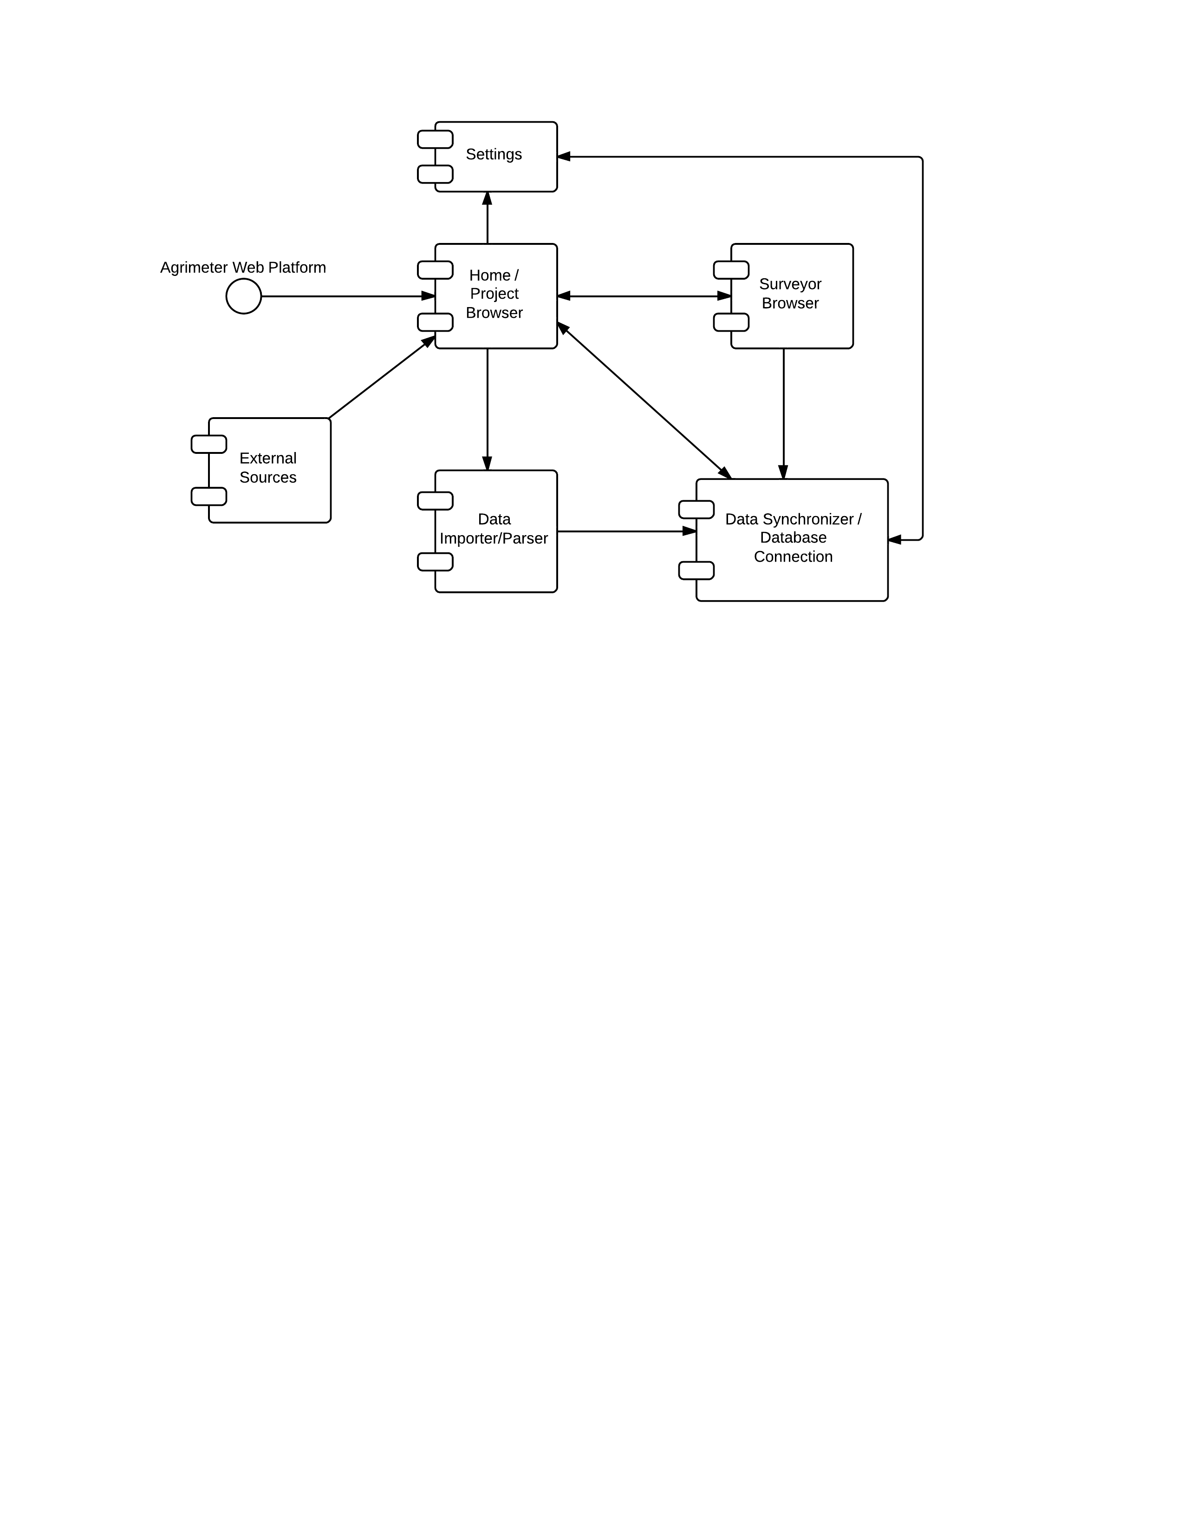

Figure 5 - Software Architecture

The components are described as follows:

* Home - This is the main component for all users. It is the main screen. If the user is a surveyor, the main screen will be the project browser. The project browser let the user navigate through the projects that the user belongs. The projects are organized in hierarchy. If the user is an organization, the main screen will be directed to the Surveyor’s browser.
* Data Importer and Parser- Read data from the SD card and convert it to a format that can be organized under a selected project or folder. Only surveyors can upload data.
* Surveyors’ Browser – Let an organization browse through all surveyors that belong to that organization. An organization can eject any of the surveyors that belong to it. Surveyors can also request to belong to an organization or disaffiliate from it. Surveyors also browse other surveyors within the same organization to add collaborators to their projects
* Settings - Let the user change it’s personal/organization information.
* Data Synchronizer/Database Connection - Connects to the database and synchronize information for the: Project Browser, Data uploaded through the Data importer and parser, Surveyors’ browser, and the settings.
* External resources - Get information from Google maps, mapping service application, to visualize the measurements collected by the surveyor.

## User Interface

The user interface has been designed to be attractive, organized and intuitive. It has been developed to show the user only the necessary information that he/she is looking for. Refer to appendix M for the graphical user interface views.

## Diagrams

For web design, class diagrams are not so intuitive since scripting languages are not object oriented; but for the design of the application, five classes were identified: Organization, Surveyor, Project, Folder and Point. The organization class will contain all relevant information about it. It can add or remove surveyors to the organization. An organization can contain many surveyors. The surveyor will contain its credentials and will be able to create projects and request or disaffiliate from an organization. A surveyor can be member of one organization. Project will contain information about the project, and can create or remove folders, import measurements from SD card and generate a map with the measurements. A surveyor can own many projects. A folder is a subset of a project. A project can contain many projects. Points are contained inside folders; a folder can contain many points. A navigation (flowchart) diagram was also created to visualize more in detail what is the navigation flow in the web application. Refer to Appendix N for detailed information about the class and navigation diagrams.

## Data Base Entity Relationship Diagram – EBB

In order to create the database for the ***AgriMeter*** system we create an entity relationship diagram (ERD)[8]. It is compose of five entities, with its respective primary key, and seven relationships between these entities. Table 1 thru 5 shows the five entities with its respective attributes data type. The entities are: ***User***, ***Project***, ***Organization***, ***Folder*** and ***Point***. A relation between a ***User*** and a ***Project*** is many-to-many and this relation has a Boolean attribute named ***Is_Creator***. ***User*** and ***Organization*** entities are related between them using one-to-many ***Work_At*** relation with a Boolean attribute named ***Is_Active. O_Contains_P*** is a many-to-many relation that involves ***Organization*** and ***Project*** entities. ***Project*** and ***Folder*** entities are related between them using a one-to-many relation named ***Is_Compose. F_Includes_P*** is a one-to-many relation that includes ***Folder*** and ***Point*** entities. ***Point*** entity has a one-to-one relation with itself name ***P_Needs_P*** including distance and elevation difference as attributes. In the same form, ***Folder*** entity has a one-to-one auto relation named ***Is_Parent***. Preliminary queries have been defined to fulfill the web application needs. Refer to appendix O, for detailed information about queries.

## Webpages

As mentioned in the software components section, the web application is designed for two different scopes: Surveyor and Organization accounts. Each page in the web application shall be designed according to these user account type that access it. The next table describes each web page with their respective scope.

|  |  |  |
| --- | --- | --- |
| **Page** | **Surveyor Scope** | **Organization Scope** |
| Login | Create a new session for surveyor scope. | Create a new session for organization scope. |
| Registration | The user creates a new surveyor account. Requires insertion of personal information. The user can request membership for an organization. | The user creates a new organization account. Requires insertion of information about the organization. |
| Home | Principal screen of the surveyor. It shall have the “Project Browser” embedded on it. The user shall be able to create, edit and delete projects, and folders inside projects as well. The user can upload measurements to projects. | Principal screen of the organization. It shall have the “Organization Members Browser” embedded on it. The user shall be able to respond membership requests from users. It can also remove users from the organization. |
| Settings | The user can view and modify his/her personal information and settings. | The user can view and modify the organization information and settings. Requests for extra licenses for surveyor memberships also can be made. |
| Project Browser | Home page. | The user can explore the projects of the surveyor subscribed to the organization. |
| Organization Members Browser | The user shall be able to add collaborators for his/her projects. | Home page. |
| Logout | Close session | Close session |

Table 8 - Web Application Pages

## Design Justifications

A good design leads to an excellent implementation. For the design, some aspects were considered:

* Scripting language to use for dynamic generated content.

PHP and JSP were considered. Decided for PHP for the following reasons: (1) PHP is the most widely used web development platform in the world; have lot of support. (2) PHP is easier to code and deploy. (3) In the real world, PHP hosting services are more popular and low cost compared to JSP hosting, since the JVM for JSP requires more server resources than PHP.

* Which relational database management system to incorporate.

MySQL and PostgreSQL. Decided for MySQL after for the following reasons: (1) MySQL is closely related to PHP. Both are included in the XAMPP Apache Distribution package. (2) XAMPP is installed by default when a virtual machine is created in a server at ECE UPRM, which is the “AgriMeter Web Platform” host server.

* The end user: (1) the web application is designed for intuitive and easy usage. (2) It is designed to fit most of the screens; the application will fit correctly on screen resolutions over 1024 x 728 pixels[9].

## Web Application Progress Assessment

The design phase for the web application has been completed. This equates to a 40% completion of the module. For a detailed description of the tasks completed to achieve this 40%, refer to Appendix G.

# Future Work – EBB

Taking into account the current status of our project, new tasks have been identified for completion. The principal tasks from the next phase for each of the three basic components of the project are listened below.

## Android Application

* Implementation of all XML layouts according to the designed mock-up screens
* Implementation of each helper class that assists in the database web service request
* Implementation of JSON Parser class that handles JSON objects between web service and Android Application

## Web Application

* Configure the web server and crate database according to Entity Relationship Diagram
* Implements web pages according to mock-up screens previously designed and upload it to web server
* Create PHP web service and store on web server

## Embedded System

* Interface Bluetooth module, GPS module, and battery with 3.2” μLCD PICASO Display Module
* Implement display views on LCD touch screen module according to mock-up screens previously designed
* Begin to implement module that allows storage of information on μ-SD card

# Bibliography

|  |  |
| --- | --- |
| [1] | R. Meier, Professional Android 4 Application Development, Indianapolis, Indiana: John Wiley & Son, Inc., 2012. |

# Appendix A – Gantt Chart – RRB

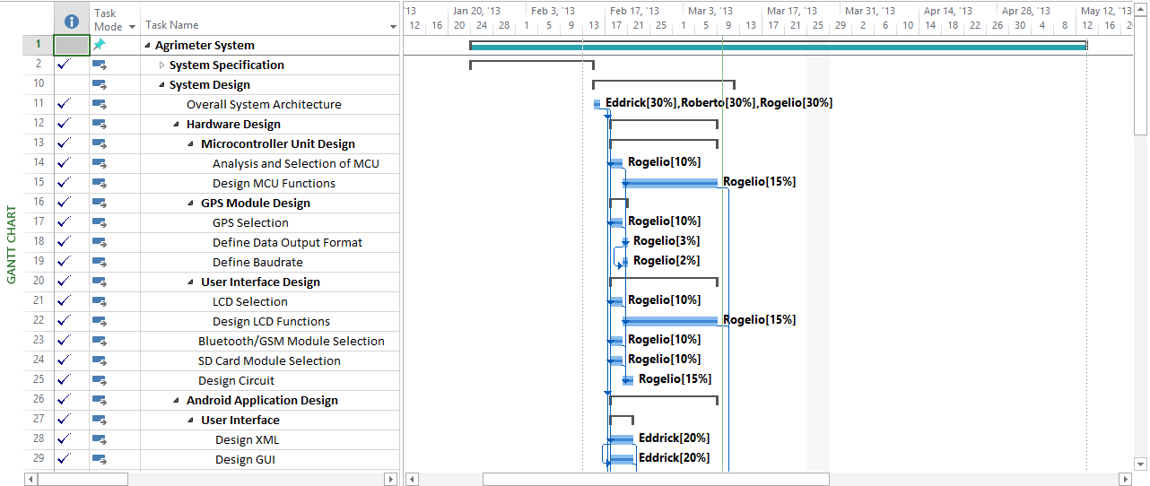

Figure 6 - Gantt Chart (1)

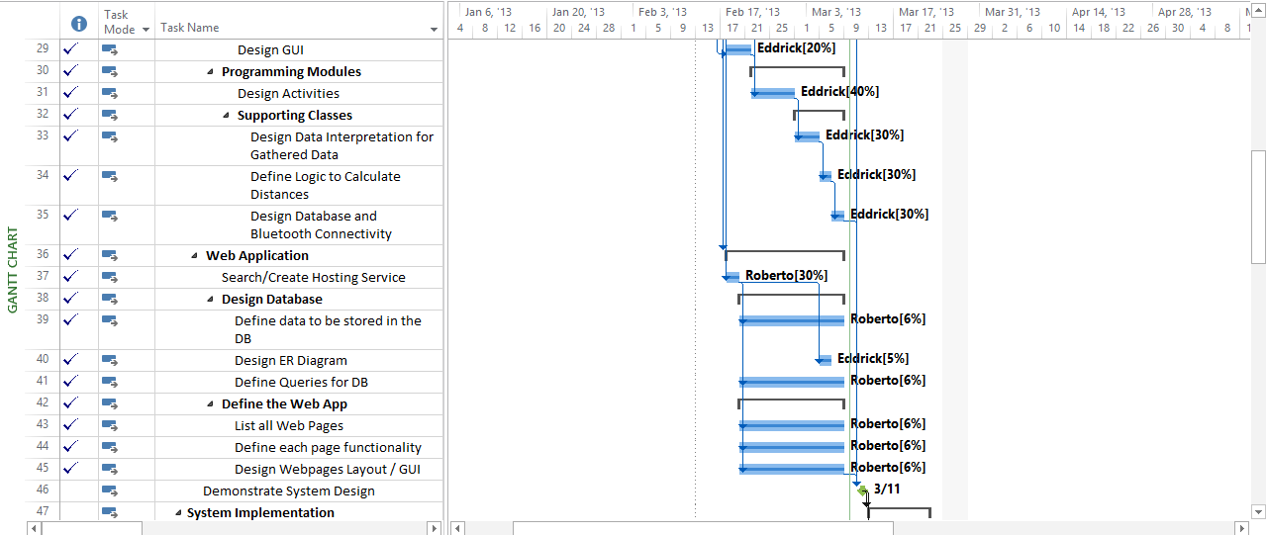

Figure 7 - Gantt Chart (2)

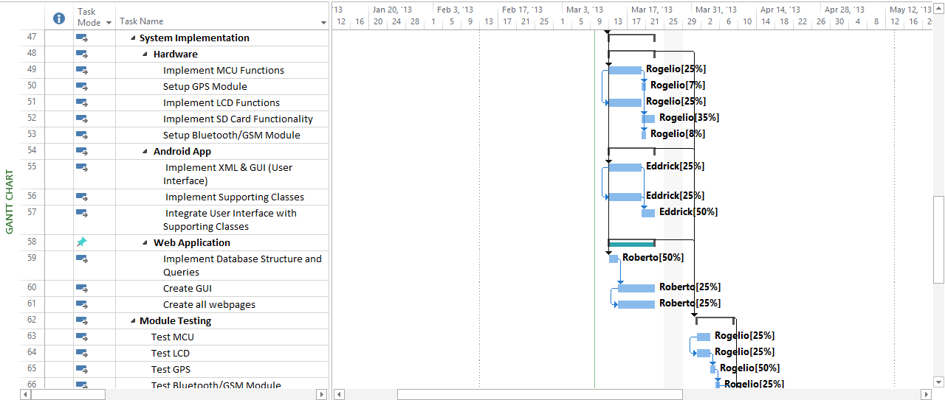

Figure 8 - Gantt Chart (3)

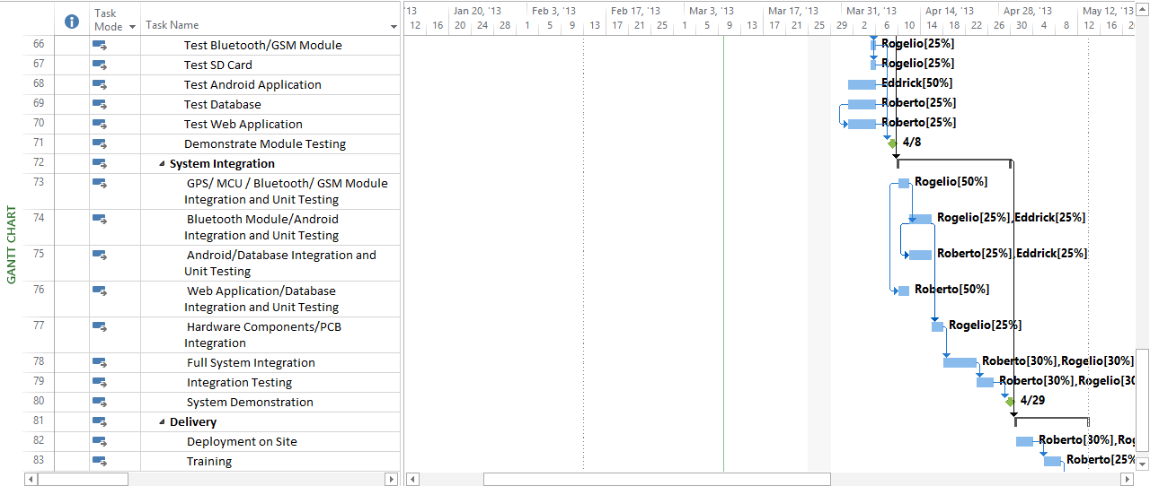

Figure 9 - Gantt Chart (4)

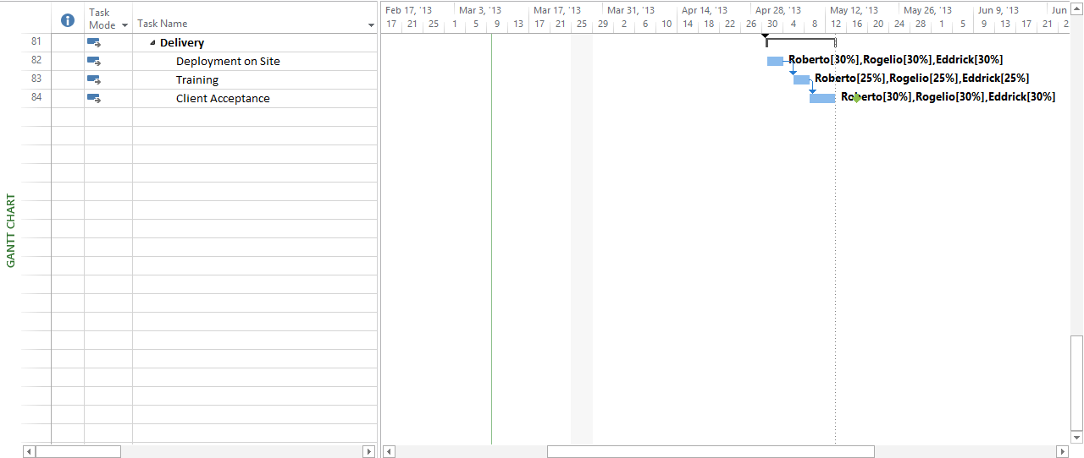

Figure 10 - Gantt Chart (5)

# Appendix B – Detailed Budget Analysis – RRB

|  |  |  |
| --- | --- | --- |
| **Component** | **Expected Cost** | **Actual Cost** |
| Copernicus II GPS Receiver | $39.95 | $82.95 |
| RN-42 Bluetooth Module | $39.95 | $44.00 |
| 2GB μ-SD Card | $9.95 | Included in LCD |
| PICASO processor | $4.00 | Included in LCD |
| Development Board | $75.00 | Included in LCD |
| μLCD 32PTU Display Module Starter Kit | $138.00 | $138.00 |
| 3.7V Li-Po Battery | Not Included | $16.95 |
| GPS Internal Active Antenna VTGPSIA-3 | Not Included | $19.95 |
| Other Electrical Components   * TLV70033 Voltage Regulator * Tlv70033EVM-503 Voltage Regulator Evaluation Board | $40.00 | $20.14 |
| **Total** | **$346.85** | **$321.99** |

Table 9 - Costs Regarding Hardware Components

|  |  |  |  |  |
| --- | --- | --- | --- | --- |
| **Name** | **Actual Work (hrs.)** | **Actual Cost** | **Standard Rate** | **Remaining Cost** |
| Roberto | 71.6 | $1,549.04 | $45,000.00/y | $2,301.92 |
| Eddrick | 79.6 | $1,530.77 | $40,000.00/y | $1,969.23 |
| Rogelio | 77.6 | $1,492.31 | $40,000.00/y | $2,038.46 |
| **Total** | | **$4,572.12** |  | **$6,309.61** |

Table 10 - Costs Regarding Personnel

# Appendix C – System Block Diagram – RVR

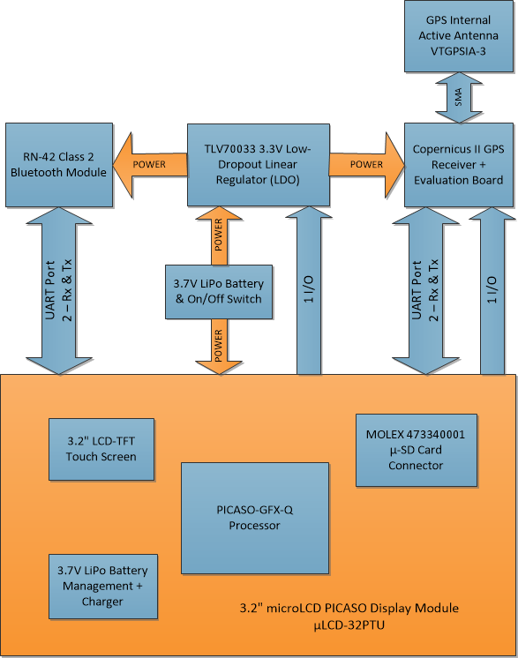

Figure 11 - Block Diagram for the Embedded System

# Appendix D – Detailed Schematics – RVR

The detailed schematics for the system are located in this section. There are three separate files which have been appended in this section. They are the following:

1. *Schematic_System.bmp* – this schematic displays the connections for the system. The display module has been represented by the three headers provided.
2. *Schematic_uLCD_32PTU*.*bmp* – this schematic displays the interconnections available in the display module. These contain the interface for the μ-SD card, the LCD touchscreen, Li-Po battery charger and monitor, etc.
3. *Schematic_GPS_Eval_Board.bmp* – this schematic displays the evaluation board on which the Copernicus II GPS receiver is mounted. The antenna connection is also presented.

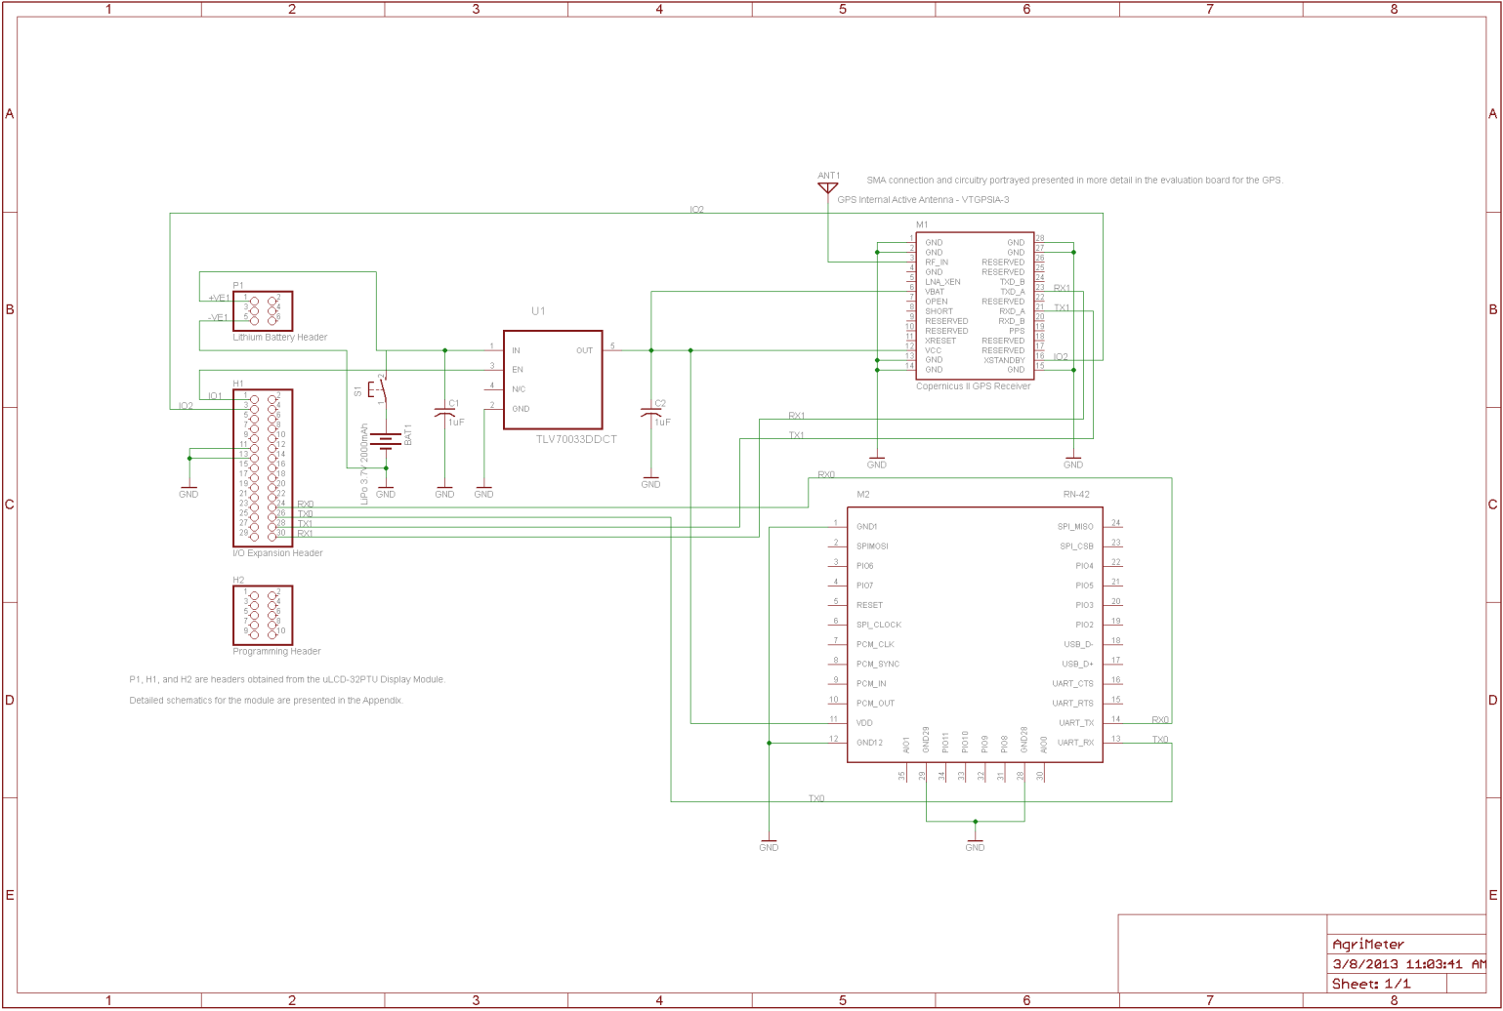

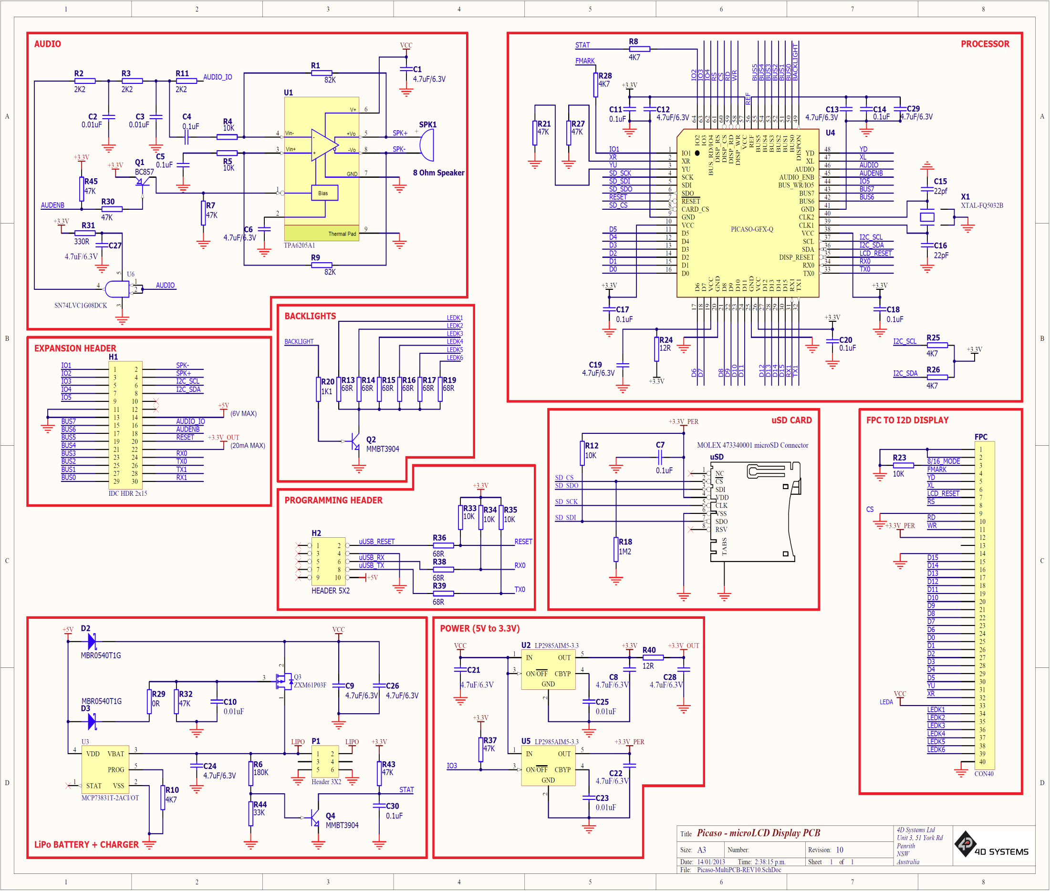

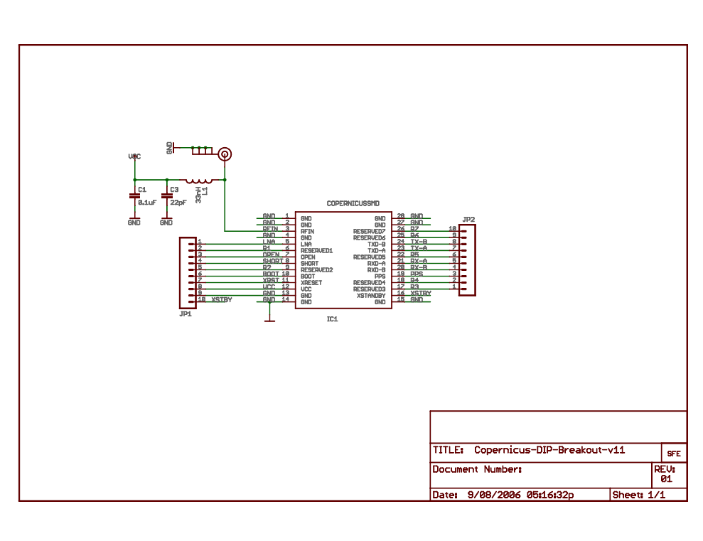

# Appendix E – Embedded System User Interface Mock-Up Screens – RVR

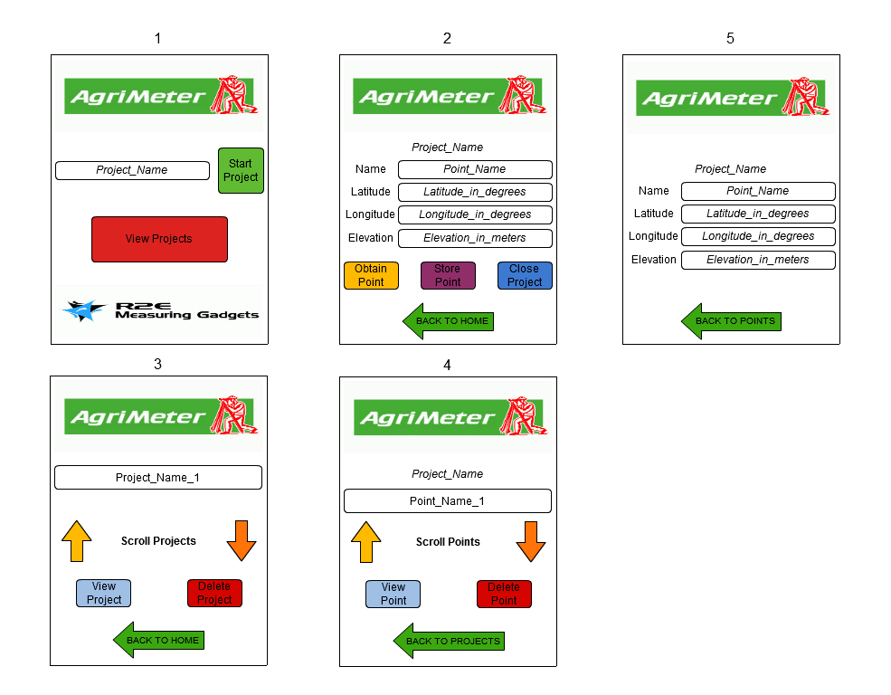

Figure 12 - Mock-Up Screens for the Embedded System

# Appendix F – Detailed Electrical Characteristics[10] – RVR

## μLCD-32PTU Display Module with Resistive Touch[11]

|  |  |  |  |  |  |  |  |  |  |  |  |
| --- | --- | --- | --- | --- | --- | --- | --- | --- | --- | --- | --- |
| **Supply Voltage (VCC)** | | | **Supply Current (ICC)** | | | **Digital I/O Characteristics** | | | | | |
| *Min.* | *Typ.* | *Max.* | *Min.* | *Typ.* | *Max.* | **VCC = 3.3 V** | | | | **VCC = 5.0 V** | |
| *VIL* | | *VIH* | | *VOL* | *VOH* |
| 4.0 | 5.0 | 5.5 | -- | 155 | -- | *Min.* | *Max.* | *Min.* | *Max.* | *Max.* | *Min.* |
| VGND | 0.2VCC | 0.8VCC | VCC | 0.4 | 3.2 |

Table 11 - Electrical Characteristics for the Display Module

## 12-Channel Copernicus II GPS Receiver DIP Module

|  |  |  |  |  |  |  |  |  |  |  |  |  |  |
| --- | --- | --- | --- | --- | --- | --- | --- | --- | --- | --- | --- | --- | --- |
| **Supply Voltage (VCC)** | | | **Supply Current (ICC)** | | | **Digital I/O Characteristics** | | | | | | | |
| *Min.* | *Typ.* | *Max.* | *Min.* | *Typ.* | *Max.* | *VIL* | | *VIH* | | *VOL* | | *VOH* | |
| 2.7 | -- | 3.3 | -- | 44 | -- | *Min.* | *Max.* | *Min.* | *Max.* | *Min.* | *Max.* | *Min.* | Max. |
| 0 | 0.8 | 2.0 | 3.6 | 0 | 0.2VCC | 0.8 VCC | VCC |

Table 12 - Electrical Characteristics for the GPS Module

## Antenna GPS Embedded SMA

|  |  |  |  |  |  |
| --- | --- | --- | --- | --- | --- |
| **Supply Voltage (VCC)** | | | **Supply Current (ICC)** | | |
| *Min.* | *Typ.* | *Max.* | *Min.* | *Typ.* | *Max.* |
| 2.7 | -- | 5.0 | 8 | -- | 14 |

Table 13 - Electrical Characteristics for the GPS Antenna

## RN-42 – Class 2 Bluetooth module

|  |  |  |  |  |  |  |  |  |  |  |  |
| --- | --- | --- | --- | --- | --- | --- | --- | --- | --- | --- | --- |
| **Supply Voltage (VCC)** | | | **Supply Current (ICC)** | | | **Digital I/O Characteristics** | | | | | |
| **Connected with data transfer** | | |
| *Min.* | *Typ.* | *Max.* | *Min. (Radio ON)* | *Typ.* | *Max.* | *VIL* | | *VIH* | | *VOL* | *VOH* |
| 3.0 | 3.3 | 3.6 | 40 | 45 | 50 | *Min.* | *Max.* | *Min.* | *Max.* | *Max.* | *Min.* |
| -0.4 | +0.8 | 0.7VCC | VCC+0.4 | 0.2 | VCC-0.2 |

Table 14 - Electrical Characteristics for the Bluetooth Module

# Appendix G – Project’s Progress Assessment – Team

|  |  |  |
| --- | --- | --- |
| **GPS-based embedded system – 100% Module Completion** | | |
| **Milestone** | **Percentage For Completion** | **Percentage Completed** |
| Successful design of the LCD touchscreen’s interface | **5%** | **5%** |
| Successful design of the microcontroller unit’s (MCU) firmware | **15%** | **15%** |
| Successful design of the GPS module’s interface and communication protocol | **5%** | **5%** |
| Successful design of the data storage and communication module/s   1. Successful design of the Bluetooth module’s interface and communication protocol to communicate with the Android device’s application 2. Successful design of the SD card module’s interface and storage protocol to store measurements in the embedded system | **15%** | **15%** |
| Successful implementation of the LCD touchscreen’s interface | **5%** | **0%** |
| Successful implementation of the microcontroller unit’s (MCU) firmware | **10%** | **0%** |
| Successful implementation of the GPS location module | **5%** | **0%** |
| Successful implementation of the data storage and communication module/s (please refer to milestone iv in this module) | **10%** | **0%** |
| Successful testing of all the individual modules | **4%** | **0%** |
| Successful interfacing of all the individual modules with the MCU | **6%** | **0%** |
| Successful integration of all components of the embedded system | **7%** | **0%** |
| Successful testing of the integrated embedded system | **6%** | **0%** |
| Successful integration with the Android application and web application | **3%** | **0%** |
| Successful testing of the integration with the Android application and web application | **4%** | **0%** |
| **Total** | **100%** | **40%** |

Table 15 - Level of Completion for the Embedded System

|  |  |  |
| --- | --- | --- |
| **Android Application – 100% Module Completion** | | |
| **Milestone** | **Percentage For Completion** | **Percentage Completed** |
| Successful design of preliminary mock up screens | **30%** | **30%** |
| Successful meetings with the client to obtain recommendations about the screens’ layout | **10%** | **10%** |
| Successful implementation of all screen layouts | **4%** | **0%** |
| Successful implementation of module in charge of Bluetooth communication with the embedded system | **6%** | **0%** |
| Successful implementation of module in charge of calculating distances between points and sea level altitudes | **10%** | **0%** |
| Successful implementation of modules in charge of inserting and reading information from the database | **10%** | **0%** |
| Successful testing of all modules | **30%** | **0%** |
| **Total** | **100%** | **40%** |

Table 16 - Level of Completion for the Android App

|  |  |  |
| --- | --- | --- |
| **Web application – 100% Module Completion** | | |
| **Milestone** | **Percentage For Completion** | **Percentage Completed** |
| Successful design of database structure | **10%** | **10%** |
| Successful definition of queries for database | **15%** | **15%** |
| Successful design of web pages | **8%** | **8%** |
| Successful design of the graphical user interface | **7%** | **7%** |
| Successful implementation of the database structure and the queries | **15%** | **0%** |
| Successful creation of the GUI | **7%** | **0%** |
| Successful creation of the web pages | **8%** | **0%** |
| Successful testing of database | **7%** | **0%** |
| Successful testing of web pages | **5%** | **0%** |
| Successful integration of database with web pages | **10%** | **0%** |
| Successful testing of integration of database with web pages | **8%** | **0%** |
| **Total** | **100%** | **40%** |

Table 17 - Level of Completion for the Web Application

# Appendix H – Android Application Flowcharts – EBB

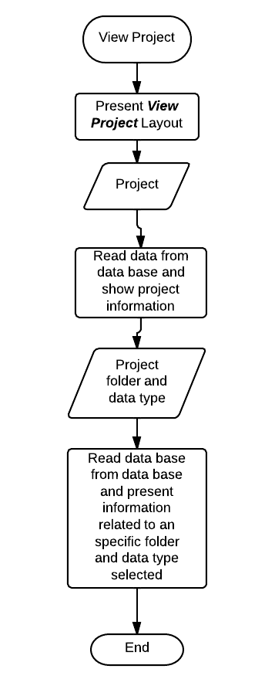

Figure 13 - View Project Flowchart

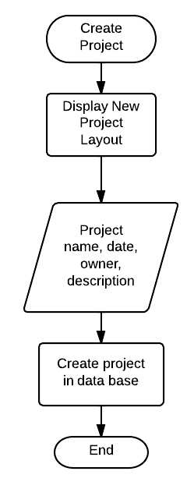

Figure 14 - Create Project Flowchart

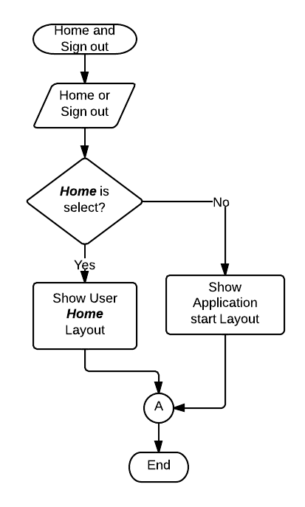

Figure 15 - Home and Sign Out Flowchart

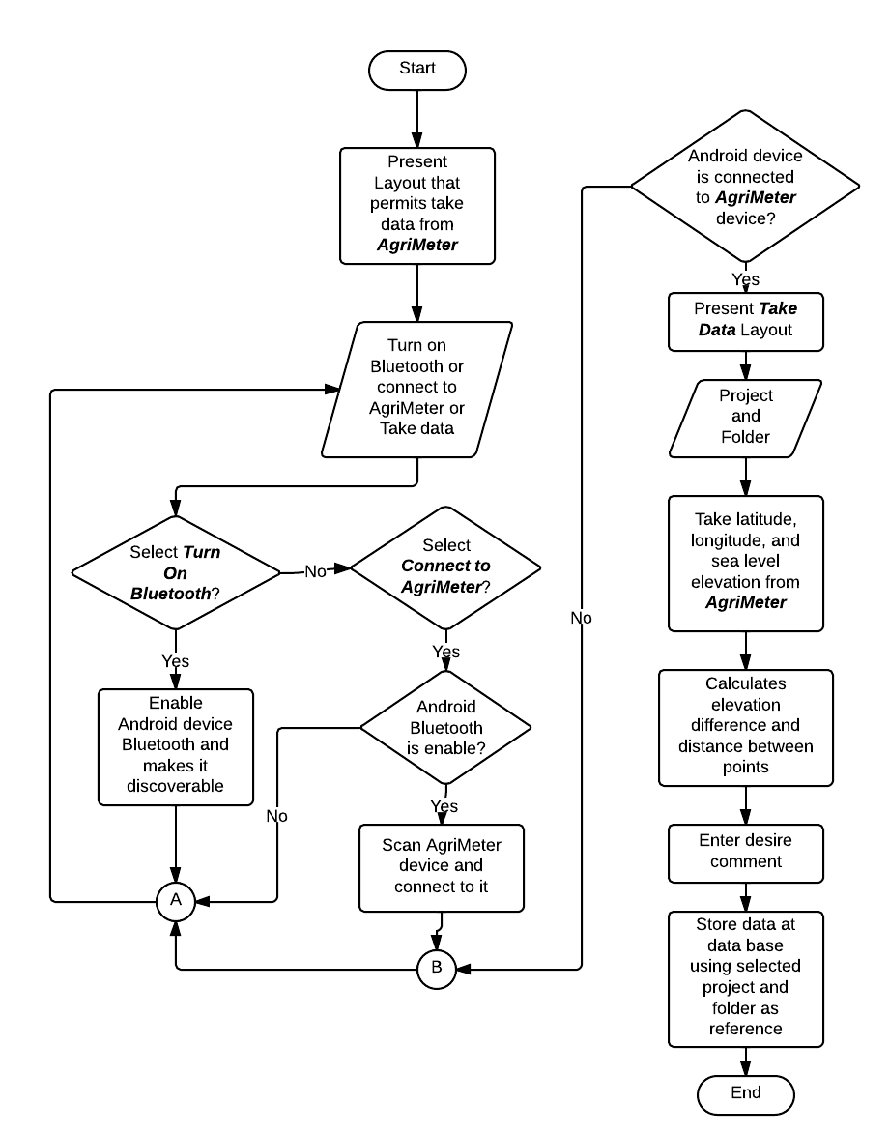

Figure 16 - Flowchart for Turning On Bluetooth, Connecting to AgriMeter, and Obtaining Data

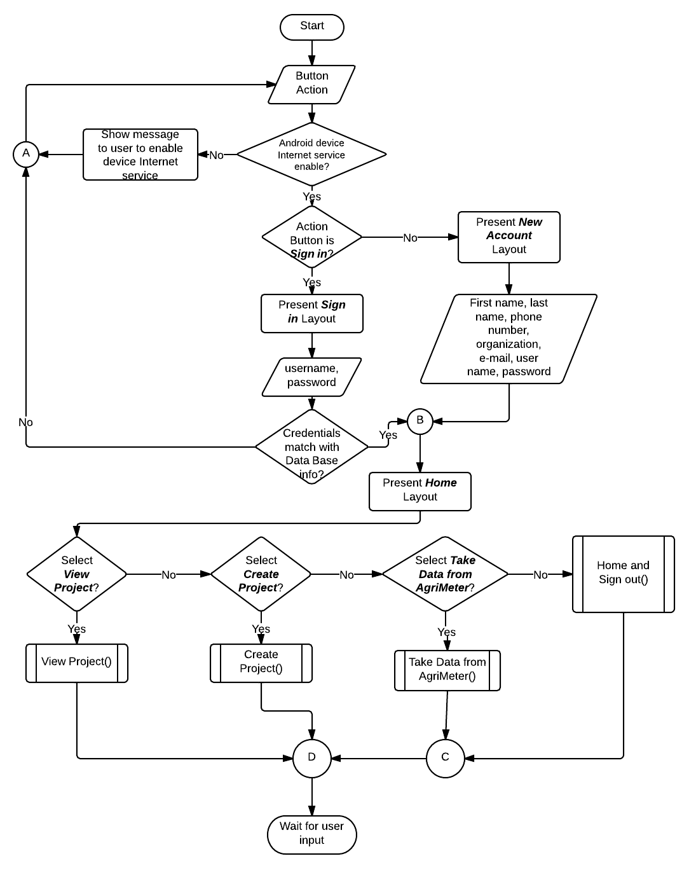

Figure 17 - General Android Application Flowchart

# Appendix I – Android Application Layout Design – EBB

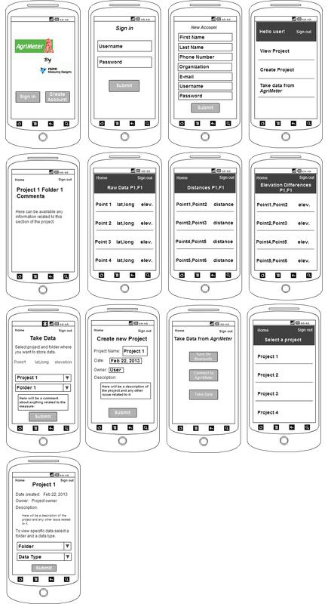

Figure 18 - Layout Design for the Android Application

# Appendix J – Vincenty’s Iterative Algorithm – EBB

)

Iteration until

# Appendix K – Android Application’s Class Diagram – EBB

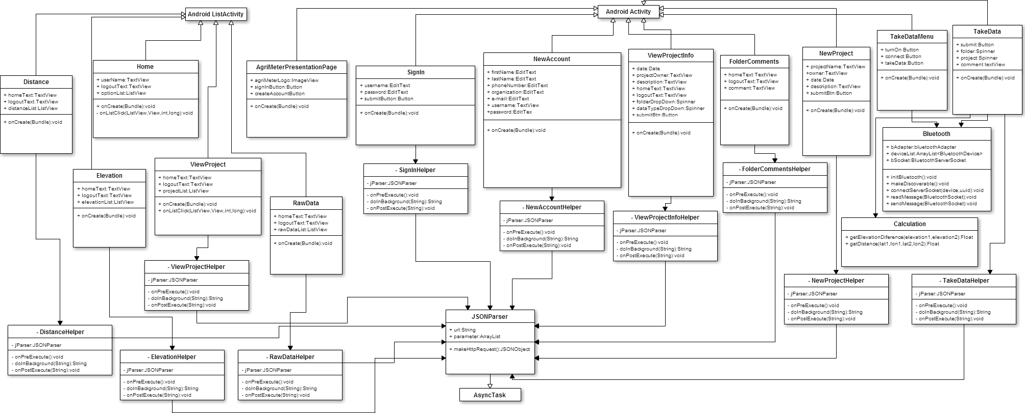

Figure 19 - Class Diagram for the Android Application

# Appendix L – Android Application’s Sequence Diagrams – EBB

Figure 20 - Sequence Diagram for Viewing Projects

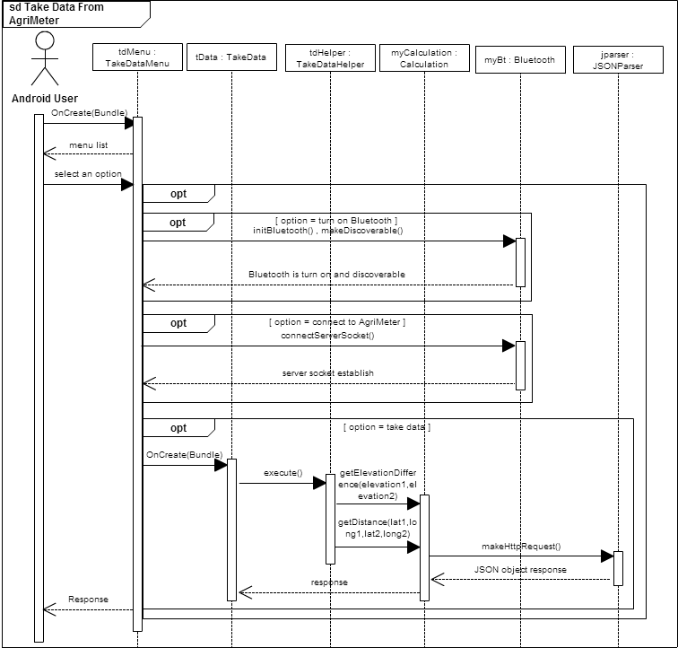

Figure 21 - Sequence Diagram for Taking Data from AgriMeter

# Appendix M – Web Application User Interface – RRB

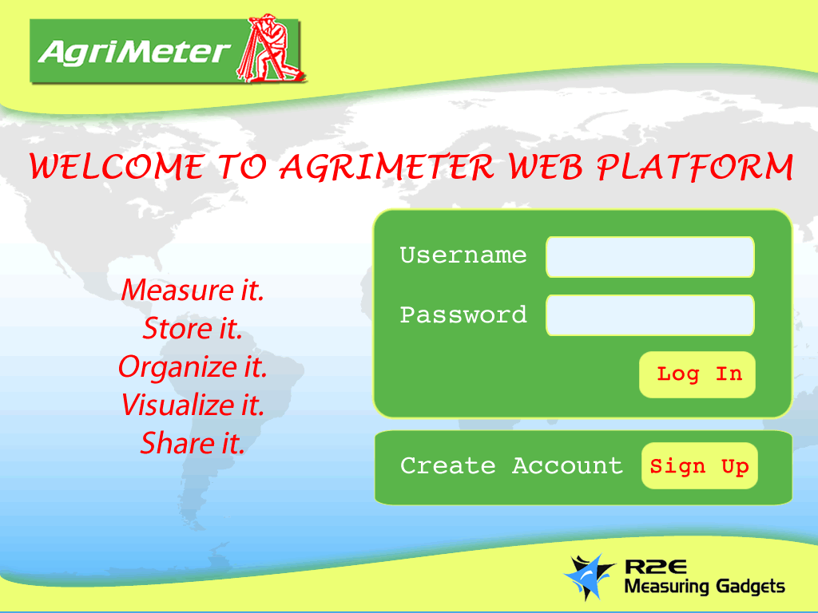

Figure 22 – Login

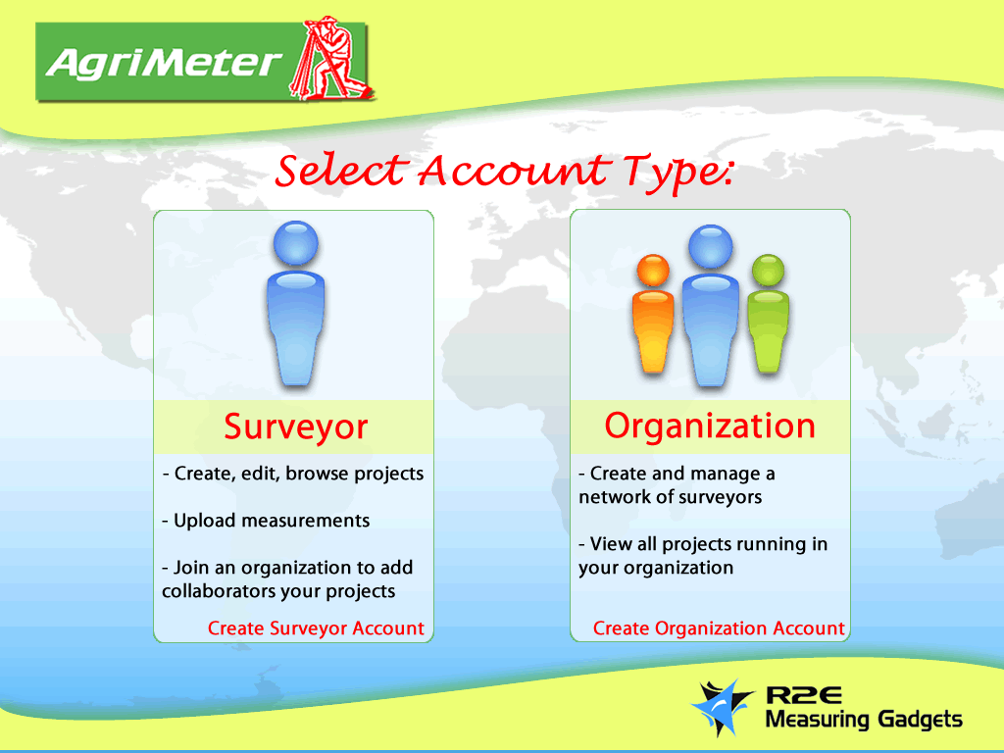

Figure 23 - Select Account Type

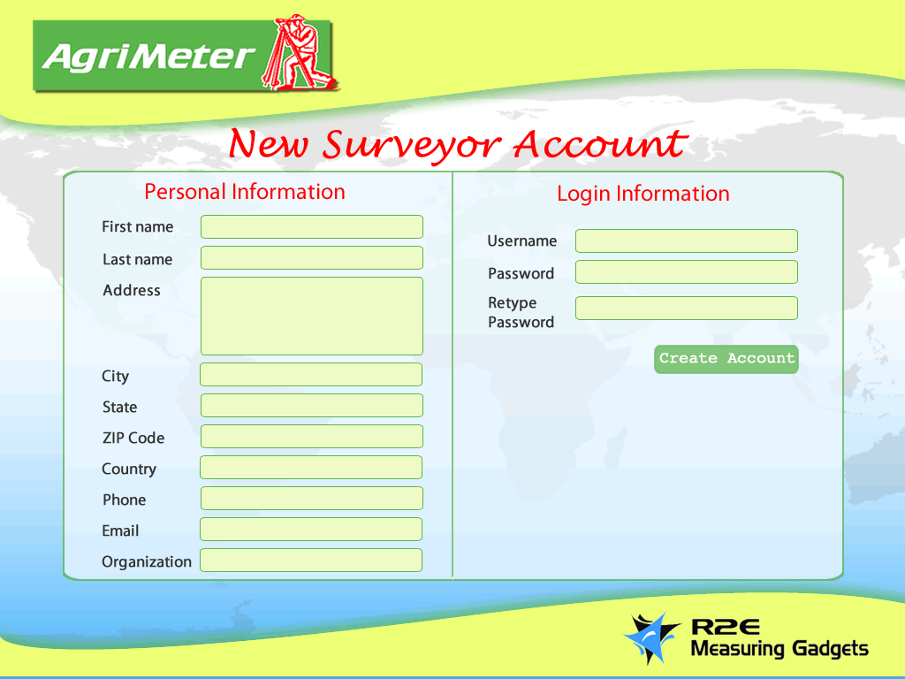

Figure 24 - New Surveyor Account

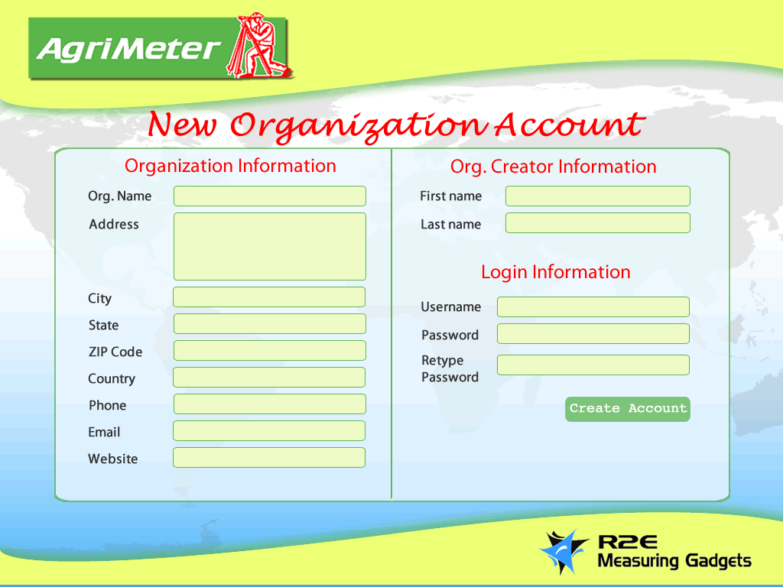

Figure 25 - New Organization Account

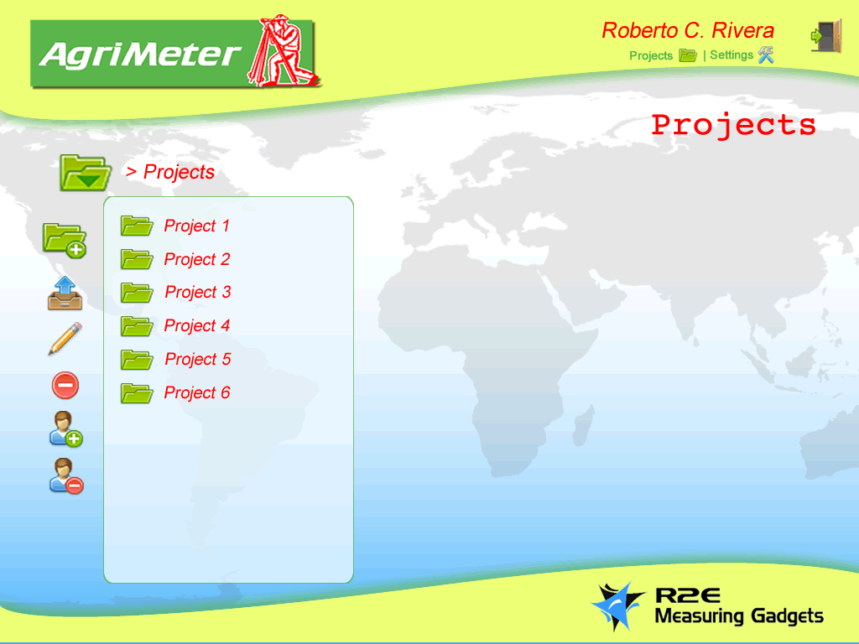

Figure 26 - Surveyor Home Page / Project Browser

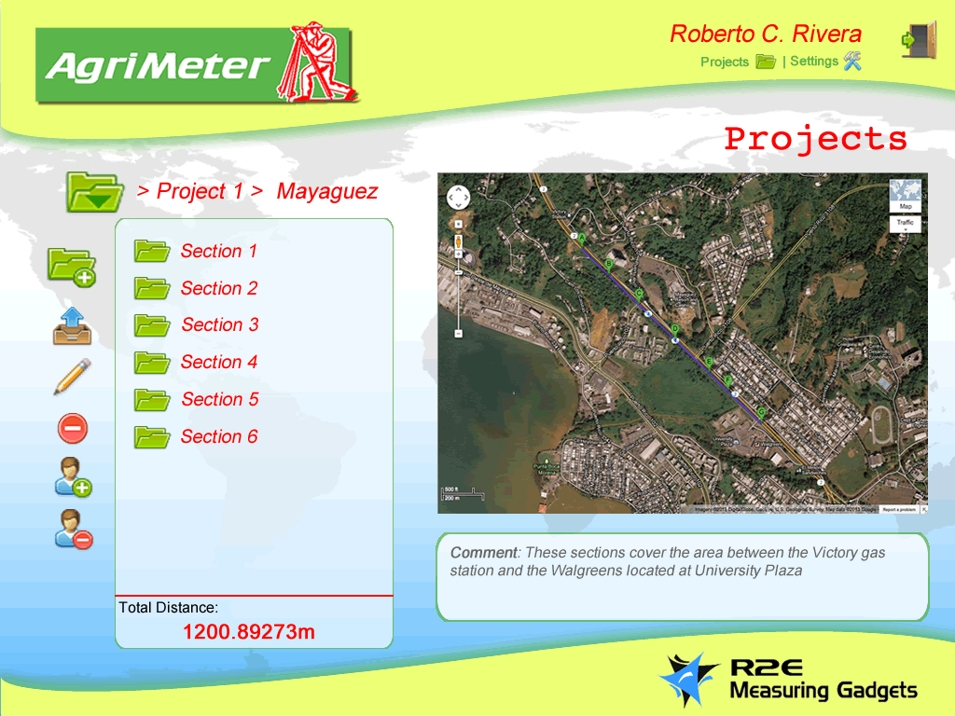

Figure 27 - Surveyor Project Browser (2)

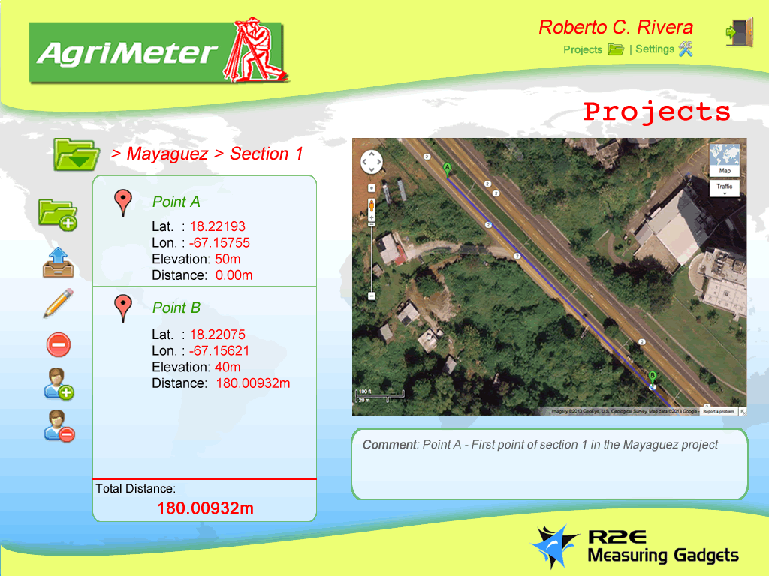

Figure 28 - Surveyor Project Browser (3)

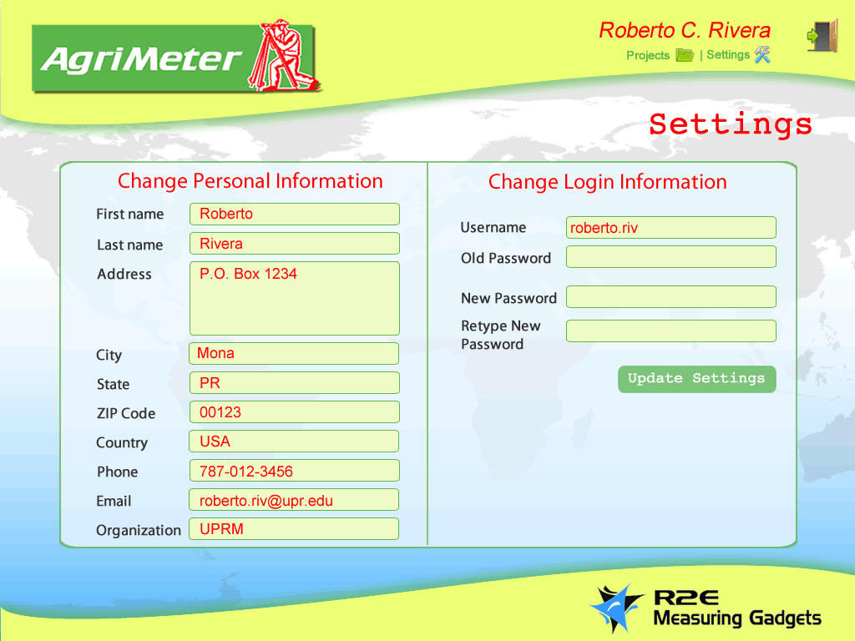

Figure 29 - Surveyor Settings

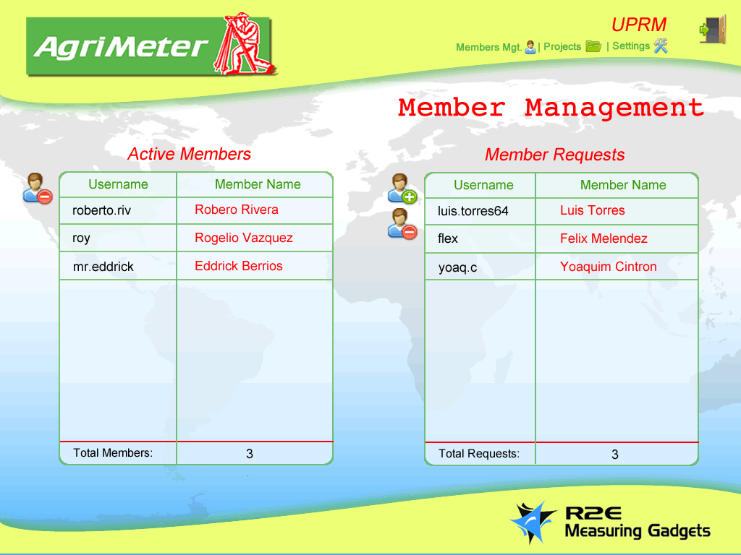

Figure 30 - Organization Home / Members Management

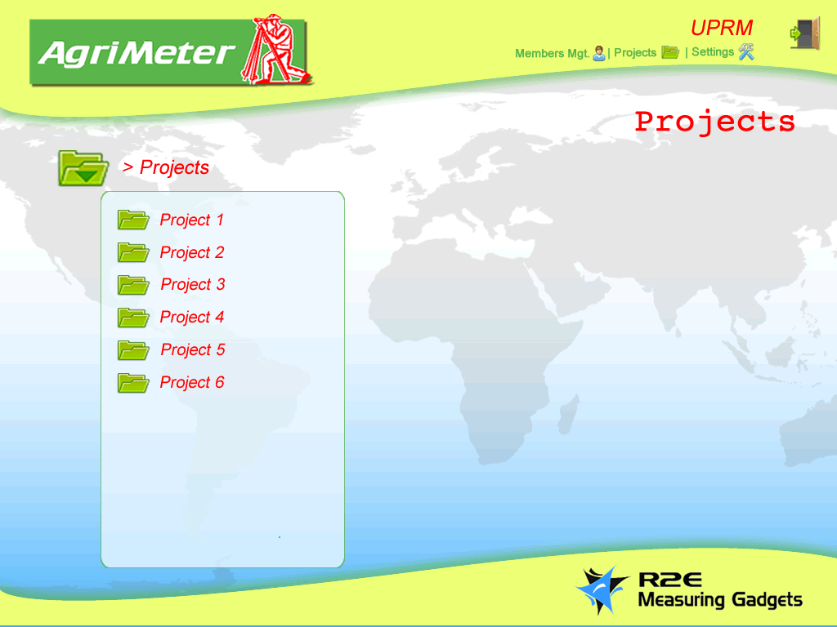

Figure 31 - Organization Project Browser

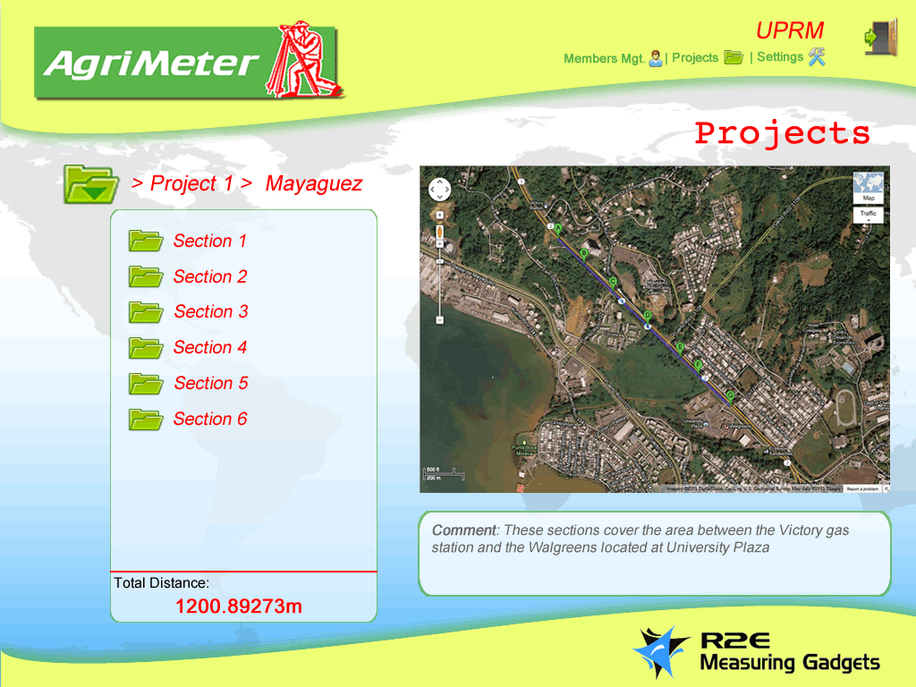

Figure 32 - Organization Project Browser (2)

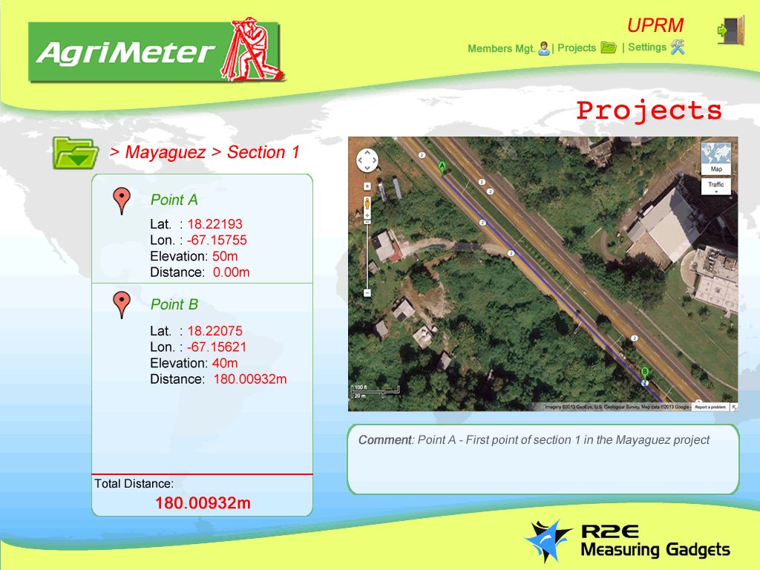

Figure 33 - Organization Project Browser (3)

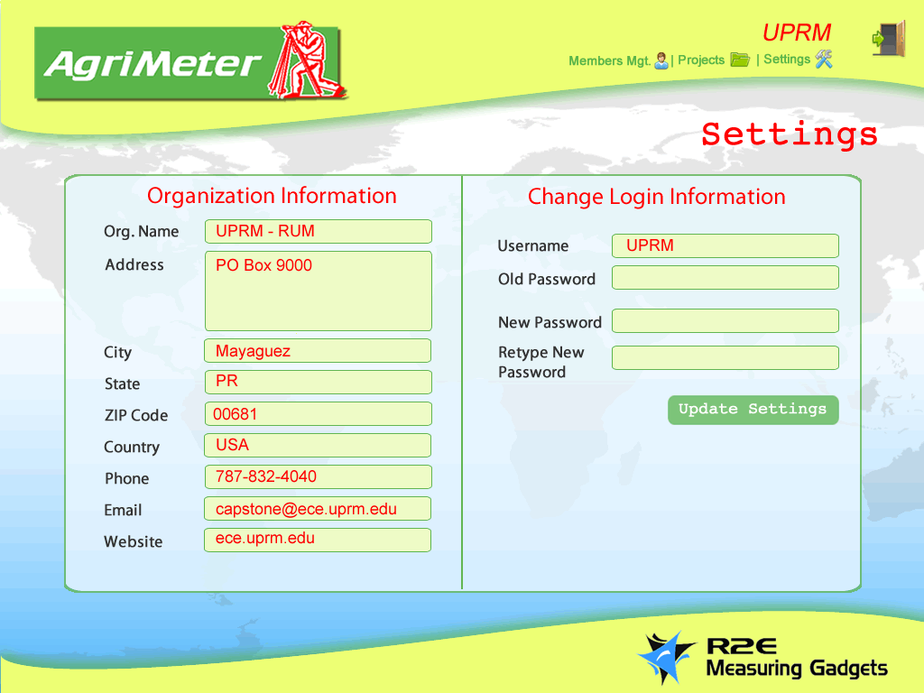

Figure 34 - Organization Settings

# Appendix N – Web Application Class and Navigation Diagrams – RRB

## Web Application Class Diagram

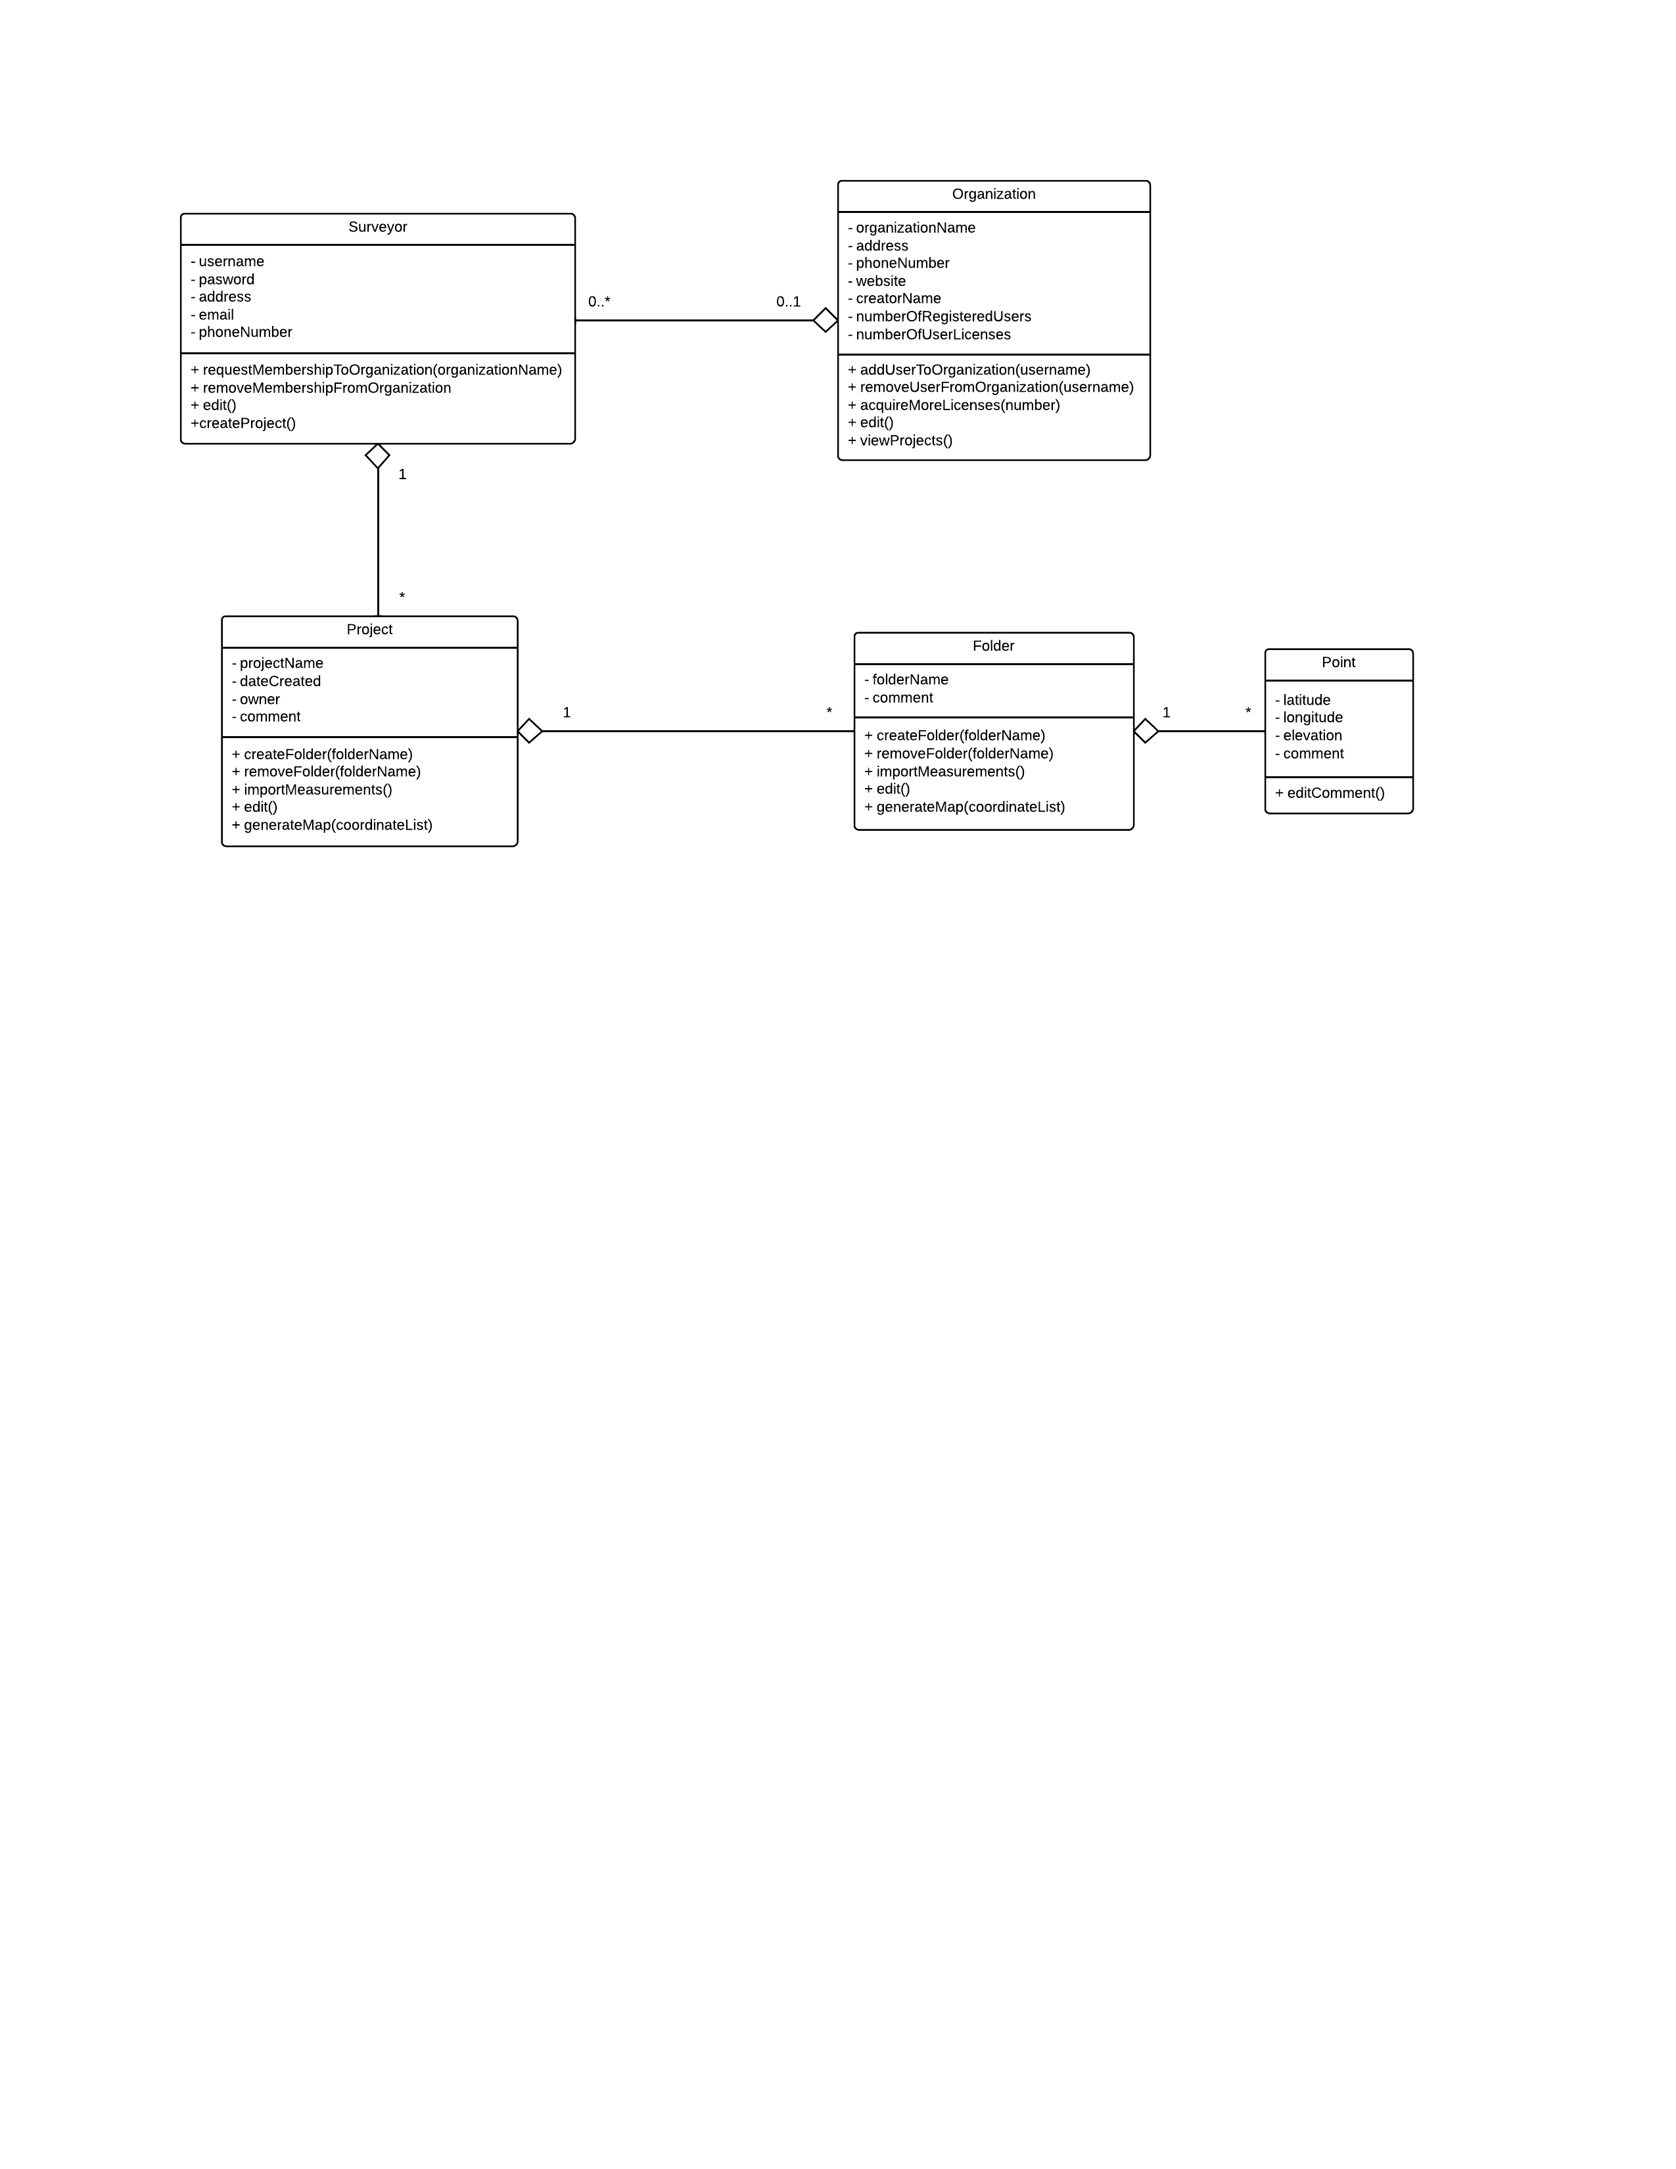

Figure 35 - Web Application Class Diagrams

## Web Application Flowchart

## 

Figure 36 - Web Application Navigation Diagram (Flowchart)

# Appendix O – Database Entities and Entity Relationship Diagram – EBB

## Entities

|  |  |
| --- | --- |
| **User** | **Data Type** |
| User id | Auto increment primary key |
| Name (compose) | Varchar |
| Phone number | Varchar(10) |
| Organization | Varchar |
| Email | Varchar |
| Username | Varchar |
| Password | Varchar |

Table 18 - User Entity

|  |  |
| --- | --- |
| **Organization** | **Data type** |
| Organization id | Auto increment primary key |
| Name | Varchar |
| Address (compose) | Varchar |
| Phone number | Varchar(10) |
| Email | Varchar |
| Website | Varchar |
| Creator name (compose) | Varchar |

Table 19 - Organization Entity

|  |  |
| --- | --- |
| **Project** | **Data Type** |
| Project id | Auto increment primary key |
| Project name | Varchar |
| Date created | Date |
| Owner(multivalue) | Varchar |
| Description | Varchar |

Table 20 - Project Entity

|  |  |
| --- | --- |
| **Folder** | **Data Type** |
| Folder id | Auto increment primary key |
| Folder name | Varchar |

Table 21 - Folder Entity

|  |  |
| --- | --- |
| **Point** | **Data Type** |
| Point id | Auto increment primary key |
| Point name | Varchar |
| Latitude | Float |
| Longitude | Float |
| Elevation | Float |

Table 22 - Point Entity

## ER Diagram

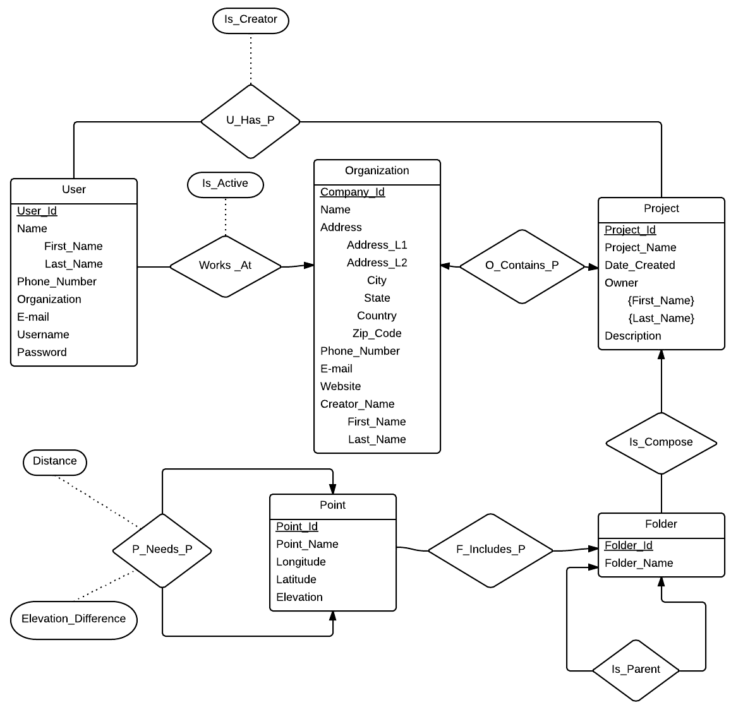

Figure 37 - Entity Relationship Diagram

## Queries

* Create new user (username, password, first name, last name…)
* Create new organization (org name)
* Validate user credentials (username, password)
* Edit surveyor’s personal information (address, phone number, email…)
* Browse project (project name)
* Browse folder (folder name)
* Edit project (project name)
* Edit folder (project name, folder name)
* Delete project (project name)
* Delete folder (username)
* Insert coordinates (folder name, latitude, longitude, elevation, comment…)
* Edit comment of coordinate (coordinate id)
* Read all coordinates inside folder (project, folder name)
* Browse surveyors (organization name)
* Add surveyor to project (project name, surveyor name)
* Remove surveyor from project (project name, username)
* Add surveyor to organization (username, organization name)
* Remove surveyor from organization (username, organization name)
* View organization licenses (organization name)

# Appendix P - Android Application Use Case Diagram – EBB

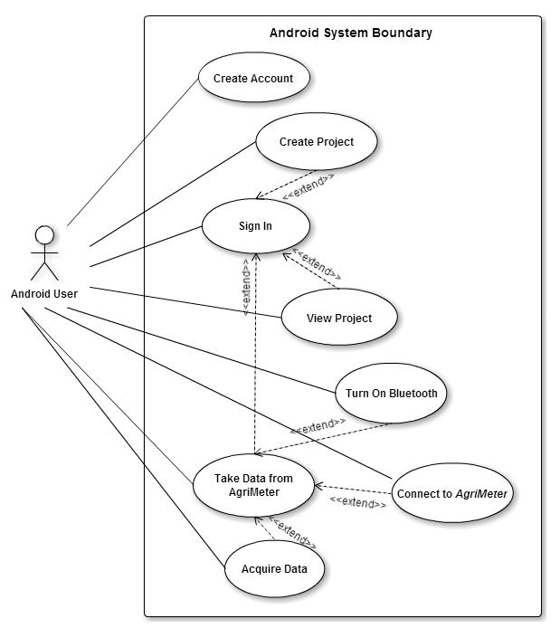

Figure 38 - Android Application Use Case Diagram

1. Throughout the document, each section contains the initials of the team member that worked on that section.
2. Uses the formula: .
3. This component has been acquired from Texas Instrument as a sample.
4. It is important to note that the efficiency of the regulator was also applied to the current supplied directly from the battery to the display module although this is not the case. This has been done because there is not sufficient information in the module’s documentation to account for power lost in its internal regulator.
5. View Appendix I to appreciate all layouts designs.
6. To view Vincenty’s algorithm, see Appendix J.
7. To view the Android application’s full class diagram see Appendix K.
8. See Appendix O to view database Entities, full ERD, and Queries
9. Source: Hobo Internet Marketing: <http://www.hobo-web.co.uk/best-screen-size/>
10. The electrical characteristics for the components are presented with the following units: volts (V) for all the voltage levels and milliamps (mA) for all current levels. Supply voltages are regulated sources.
11. The module has a built-in 5-3.3V DC-to-DC converter to regulate the voltage levels appropriate to the embedded processor from the supplied voltage.