GUI > Model > Description

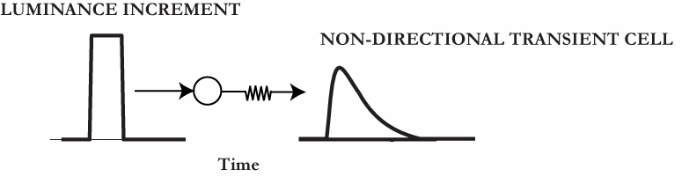
Figure 1. A luminance increment at a given spatial location elicits a transient response in the non-directional transient cell layer.

Non-directional transient cells
Non-directional transient cells (Grossberg et al., 2001) simplify how magnocellular cells in Retina and lateral geniculate nucleus transiently respond to temporal luminance changes in the visual input. Two kinds of these magnocellular cells, ON and OFF, give transient responses to bright stimulus onset and offset or dark stimulus offset and onset, respectively (Baloch et al., 1999; Schiller, 1992). Non-directional ON transient cell activities 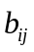 at each spatial location 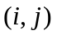 that respond to bright stimulus onset are modeled as follows:
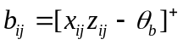. (1)
In Equation (1), cell activities 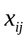 perform shunted, and thus bounded, leaky integration of input luminance increments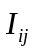:
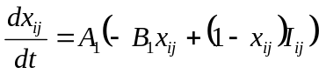. (2)
The output from cell activity 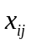 is gated by a habituative transmitter 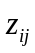, which is initially fully accumulated at 1. Non-zero activation results in habituation, or depression, of the transmitter gate according to the following equation (Grossberg, 1972, 1980):
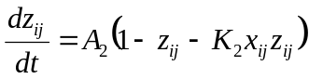. (3)
When a non-zero input turns on, in Equation (2) approaches 1 with a rate proportional to 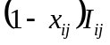, balanced by passive decay to 0 at a rate proportional to 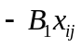. As grows, the transmitter begins to habituate or depress. When shuts off, 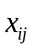 returns to 0, whereas 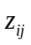 recovers to 1. These inverse changes in 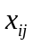 and 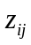 create a transient pulse of activation in their product 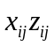 in Equation (1). The output threshold 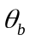 in Equation (1) ensures that the duration of a typical non-directional transient cell signal is roughly about 50 ms (Kaplan & Benardete, 2001). Parameters are 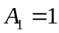, 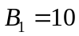, 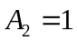, 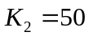, and 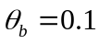.
These transient responses are sensitive to the contrast of the moving dots; i.e., the magnitude of 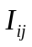, but are insensitive to the duration for which stimulus stays on or off beyond a critical duration (see Figure 2 in Grossberg & Pilly, 2008). ON and OFF transient cells code the leading and trailing edges, respectively, of a moving bright object (Schiller, 1992). Here, only ON transient cells sensitive to luminance increments are simulated for simplicity. Modeling OFF cells and their cross talk with ON cells becomes crucial if the model primate were to judge the direction of contrast polarity-reversing or reverse-phi motion stimuli (Anstis, 1970; Anstis & Rogers, 1975; Baloch et al., 1999; Chubb & Sperling, 1989).

Reference
Grossberg, S., Mingolla, E., & Viswanathan, L. (2001). Neural dynamics of motion integration and segmentation within and across apertures. Vision Research, 41, 2521-2553.

