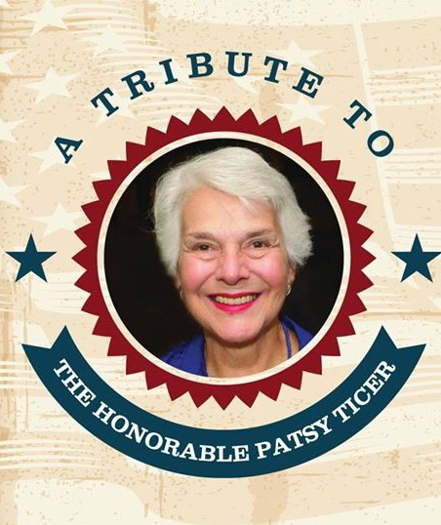

Monday, March 19, 2018 6:30pm to 8:30pm

The George Washington Masonic Memorial

Hosted by The Alexandria

Commission for Women

*and*

The Friends of the Alexandria

Commission for Women

Dear Friend,

There are few women who have had a more profound influence on Alexandria than our beloved Patsy Ticer. As the first female Mayor of Alexandria and as a Virginia State Senator, Patsy dedicated her life to those less fortunate; to improving the quality of education, especially for our youngest learners; and to making our community a better place to live and work. The Alexandria Commission for Women and the Friends of the Alexandria Commission for Women are very honored to be recognizing Patsy and her many contributions at a very special Tribute to Patsy Ticer. We hope you will be part of it.

The event, which will include a cocktail reception and program highlighting her life, will be held on Monday, March 19, 2018 at the George Washington Masonic National Memorial, located at 101 Callahan Dr., Alexandria, VA.

To show your support of Patsy’s work and the programs she supported, you can become one of our valued sponsors. Proceeds from the event will support the issues that Patsy believed in and worked tirelessly for during her impressive career in public service. Sponsorships available for the Tribute to Patsy Ticer are:

n Platinum Sponsor: $2,500

n Gold Sponsor: $1,000 n Silver Sponsor: $500 n Bronze Sponsor: $250 n Friend Sponsor: $100 n Individual Ticket: $50

Please see the following page for details on what each level includes, or visit [**www.FriendsofAlexWomen.org**](http://www.FriendsofAlexWomen.org/) to sign up. Please note: in order have your information included in our event materials, we need your response by February 25. If you have questions about sponsorship or the work of the Friends of the Alexandria Commission for Women, please feel free to contact Pat Miller at [pmiller1806@comcast.net](mailto:pmiller1806@comcast.net) or at 703-258-4516.

For those who have been loyal supporters of the annual Salute to Women Awards, this one-time Tribute will replace the awards program for 2018.

We appreciate your support and look forward to seeing you at the event.

Sincerely,

Kendra Martello, Chair Pat Miller, Chair Alexandria Commission for Women Friends of the Alexandria

Commission for Women

**The Friends of the Alexandria Commission for Women is a 501(c)3 tax-exempt organization. Donations are tax deductible to the extent permitted by law.**

## The Alexandria Commission for Women and

The Friends of the Alexandria Commission for Women present

**A Tribute To The Honorable Patsy Ticer**

Monday, March 19, 2018

# Sponsorship Opportunities

|  |  |  |  |
| --- | --- | --- | --- |
|  | **Platinum** | **Gold** | **Silver Bronze Friend** |
| $2,500 | $1,000 | $500 $250 $100 |
| Preferred seating at event | 6 tickets | 4 tickets |  |
| General seating at event |  |  | 2 tickets 2 tickets 1 ticket |

### Name on pre-event marketing materials Name on website

Two consecutive Full page 1/2 page

pages

Ad in printed program

Name listed in program  

 Name & logo in video tribute at reception Name in video tribute at reception   

 Acknowledgement from podium

**Individual Tickets $50 per person**

#### Tickets can be purchased online at [www.FriendsofAlexWomen.org](http://www.FriendsofAlexWomen.org/) or mail a check to 111 East Alexandria, Alexandria, VA 22301

Half page: $200

4.25” X 5.5”

**Please submit**

Quarter page: $125

2.125” X 2.75”

**Advertising Opportunites**

Full page: $350

8.5” X 5.5”

**your camera-ready ads electronically in .pdf,**

**.jpeg, or .eps format to**

[**pmiller1806@comcast.net**](mailto:pmiller1806@comcast.net) **Thank you!**