Python – Questions for Practice

- Calculate Body Mass Index (BMI)
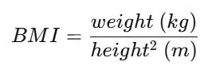
- Calculate Simple Interest
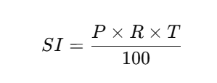
- Calculate Area of a Circle
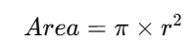
- Convert Temperature (Celsius to Fahrenheit)
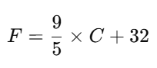
- Calculate Total and Average of Three Subjects
- Calculate Gross Salary - Write a program to calculate Gross Salary.
- Convert Minutes into Hours and Minutes – for example if 130 minutes are inputted then it should give 2 hrs and 10 minutes
- Calculate Perimeter and Area of a Rectangle
- Write a program to Calculate Speed
- Convert Rupees to Dollars
- Calculate Electricity Bill (Fixed Formula)
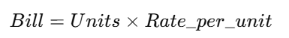
- Calculate Volume of a Cuboid
- Calculate Net Salary After Multiple Deductions
- Basic Salary
- HRA = 20% of Basic
- DA = 15% of Basic
- PF = 12% of Basic
- Calucate Loan EMI Calculation
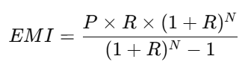
- Convert Seconds into Days, Hours, Minutes, and Seconds
- Fuel Consumption Calculation - A car travels a certain distance using some fuel.
Write a program to calculate fuel efficiency.
- Calculate Final Price After adding GST.
- Calculate Total Cart Price with Discount and Tax
Use cases
- EMI + Total Interest + Total Payment (Multi-Step Financial Logic)
Problem:
Write a Python program to calculate:
- Monthly EMI
- Total amount paid
- Total interest paid
Input:
- Principal (P)
- Annual interest rate (%)
- Loan tenure (years)
Logic Required:
- Convert annual rate to monthly rate
- Convert years to months
- Apply EMI formula
- Derive total payment and interest
- Salary Structure with Allowances, Deductions & Annual CTC
Problem:
An employee’s salary structure is:
- HRA = 25% of Basic
- DA = 18% of Basic
- Special Allowance = 10% of Basic
- PF = 12% of Basic
- Professional Tax = ₹200/month
Write a program to calculate:
- Monthly Gross Salary
- Monthly Net Salary
- Annual CTC
- Electricity Bill with Fixed Charge + GST (No Conditions)
Problem:
Write a Python program to calculate the electricity bill.
Given:
- Energy charge = Units × Rate per unit
- Fixed charge = ₹150
- GST = 18% on (Energy charge + Fixed charge)
Output:
- Total payable amount
- Vehicle Trip Cost Analysis
Problem:
A vehicle trip involves:
- Distance traveled (km)
- Mileage (km/litre)
- Fuel cost per litre
- Toll charges
- Parking charges
Write a Python program to calculate:
- Fuel consumed
- Fuel cost
- Total trip cost
- Cost per kilometer

