Waveform Identity and Reproducible Source-Grouped Evaluation of Seismic Phase Pickers
Rahmat Catur Wibowo¹*, Razki Alfatah Khairu Mahli², Karyanto³, Hendra Amijaya⁴, Aristoteles⁵, Maman Hermana⁶, Muh Sarkowi⁷
¹ Geological Engineering Department, Engineering Faculty, Universitas Lampung, Jl. Prof. Dr. Soemantri Brojonegoro No. 1, Bandar Lampung 35145, Indonesia; ORCID: 0000-0003-2754-1803
² Geophysics Engineering Department, Engineering Faculty, Universitas Lampung, Jl. Prof. Dr. Soemantri Brojonegoro No. 1, Bandar Lampung 35145, Indonesia; ORCID: 0009-0008-9676-7842
³ Geophysics Engineering Department, Engineering Faculty, Universitas Lampung, Jl. Prof. Dr. Soemantri Brojonegoro No. 1, Bandar Lampung 35145, Indonesia; ORCID: 0000-0003-0189-4109
⁴ Geological Engineering Department, Engineering Faculty, Universitas Gadjah Mada, Jl. Grafika No. 2, Yogyakarta 55284, Indonesia; ORCID: 0000-0002-9602-2903
⁵ Computer Science Department, Mathematics and Natural Science Faculty, Universitas Lampung, Jl. Prof. Dr. Soemantri Brojonegoro No. 1, Bandar Lampung 35145, Indonesia; ORCID: 0000-0002-9369-4528
⁶ Geosciences Department, Universiti Teknologi Petronas, Bandar Seri Iskandar, 32610 Perak, Malaysia; ORCID: 0000-0002-0205-4446
⁷ Geophysics Engineering Department, Engineering Faculty, Universitas Lampung, Jl. Prof. Dr. Soemantri Brojonegoro No. 1, Bandar Lampung 35145, Indonesia; ORCID: 0000-0001-8554-3407
*Corresponding author: rahmat.caturwibowo@eng.unila.ac.id

Abstract
Reliable comparison of seismic phase pickers requires traceable data identities and inspectable relationships between training observations and derived predictions. We present a reproducible evaluation workflow linking waveform fingerprints, earthquake-source groups, out-of-fold feature construction, model provenance and numerical verification. An exhaustive audit of the local STanford EArthquake Dataset archive uniquely matches 2,234 retained waveforms to 1,477 sources. A tested export profile also regenerates all 2,234 retained CSV byte hashes. A fixed source-disjoint split contains 330 test records from 221 sources. Fresh replay loads all 106 checkpoints, reproduces 18,528 out-of-fold and 1,980 test feature tensors, and recovers 70 test prediction sets; independent calculations reproduce 1,260 metric rows. Synthetic examples demonstrate rejection of invalid source membership, augmentation lineage, feature order and artifact bytes. Temporal stacking and a PhaseNet-style baseline provide a case study of component access. On this fixed split, stacking achieves accepted-pick F1 scores within 100 ms of 0.8268/0.5536 for compressional/shear arrivals with three components and 0.8134/0.2686 with vertical input alone. The shear-phase difference is 0.2850, with a conditional source-cluster 95% interval of 0.2293–0.3418. The baseline has a supported compressional-phase advantage; primary shear-phase method-comparison intervals include zero. The contribution is an executable connection between identity, data lineage and evaluation, rather than a new stacking algorithm. Historical development exposure prevents an independent-confirmation claim. One fixed split, limited unseen-station observations and unresolved historical selection decisions constrain predictive interpretation.
Keywords: seismic phase picking; waveform identity; data provenance; source-grouped evaluation; reproducibility; temporal stacking

1. Introduction
Seismic phase-picking results are only interpretable when the evaluated waveforms, their earthquake sources and their roles in model development can be traced. Arrival times of compressional (P) and shear (S) waves support earthquake location and subsurface analysis, but a reproducible performance number also depends on record identity, partition membership and decoding rules. Earth science data identification therefore concerns both locating an archived object and determining whether differently represented objects contain the same scientific information (Duerr et al. 2011). In a learned processing pipeline, these identifiers must remain connected to augmentation, fitted models and derived predictions.
Classical onset detectors use energy changes or change-point criteria (Allen 1978; Baer and Kradolfer 1987; Maeda 1985; Sleeman and van Eck 1999), while adaptive characteristic functions extend automatic P-wave estimation (Cheng et al. 2024). Neural pickers learn probability sequences from waveforms (Zhu and Beroza 2019; Mousavi et al. 2020). Physically driven feature engineering offers another route for detection and phase picking in seismo-volcanic data (Vargas-Zamudio et al. 2026). Shared benchmarks and software make the dependence of performance on data distribution and evaluation protocol explicit (Münchmeyer et al. 2022; Woollam et al. 2022). These approaches motivate inspecting evaluation inputs and outputs alongside model architecture.
Validation design can change the interpretation of seismic machine-learning results. Jover-Alfaro et al. (2026) examined random, temporal and cross-location evaluation in earthquake forecasting. Their forecasting task differs from arrival-time picking, and their findings are not evidence of leakage in the pickers considered here. The relevant informatics problem is how to make the dependencies between observations, training and evaluation inspectable. For phase picking, repeated recordings of the same earthquake require a source identifier; chronological ordering alone does not express every such dependency. Source grouping also does not remove station or regional dependence, or erase earlier development exposure.
Leakage in scientific machine learning can arise from dependencies between observations and research decisions, not only direct inclusion of test labels in fitting (Kapoor and Narayanan 2023). Cross-validation must respect the dependence structure relevant to the intended prediction task (Roberts et al. 2017). Repeated optimization of a finite validation criterion can itself produce selection bias (Cawley and Talbot 2010), which motivates explicit disclosure of outer-validation reuse here.
Scientific provenance describes entities, activities and their derivations (Moreau and Missier 2013), while FAIR principles emphasize findability, accessibility, interoperability and reuse (Wilkinson et al. 2016). SeisBench provides dataset and model interfaces for seismology (Woollam et al. 2022). Our narrower contribution is to connect recovered exported-waveform identities to group memberships, feature producers and frozen outputs in a tested workflow. We do not claim that metadata toolkits or general provenance standards lack these capabilities; we document the specific invariants and observed failures in this case.
Stacked generalization trains a second-level learner from base-model predictions (Wolpert 1992). Temporal stacking retains probability sequences, exposing disagreement in timing and confidence to a fusion model. It introduces additional data lineage: the meta-training inputs depend on which observations fitted each base model. We implement source-grouped out-of-fold (OOF) construction with separate inner validation for each held fold, a canonical 15-channel interface, augmentation-parent checks, source-membership assertions and input/output hashes. The final base and meta stages reuse outer validation for selection; this dependency is documented rather than represented as independent selection.
Recent fusion approaches combine complementary representations. TwoStream-EQT uses time-domain and time-frequency inputs and evaluates STEAD, DiTing and Geysers data (Peng et al. 2025). SeismoDual combines waveforms and spectrograms for P-phase picking across STEAD, INSTANCE and CWA (Tang and Chen 2026). Here, fusion uses temporal outputs of heterogeneous pickers together with waveform context. We compare it with a PhaseNet-style MATLAB baseline under matched data-access and decoding rules. The study does not infer missing controls in those published approaches, establish superiority over their reported scores, or claim a new neural architecture.
The study addresses three questions: RQ1, can retained exports be linked uniquely to waveform records and earthquake sources in the local archive; RQ2, can those identities be followed through grouped fitting, out-of-fold features and fixed-model replay; and RQ3, what component-access and method comparisons are supported on the fixed split? The contribution is a case-tested integration of identity resolution, executable membership and feature contracts, and numerical verification. These established techniques are connected across the pipeline rather than proposed as new algorithms. Successful replay is distinguished from independent predictive confirmation.
Figure 1 shows data and model flow alongside the checks applied at each stage. Results first answer RQ1 and RQ2, then report the expanded base/meta-seed comparison for RQ3. Base-42 ablations and detailed error diagnostics are secondary analyses in Online Resource 1. Three base initializations crossed with three meta initializations characterize variation on one fixed source split; they do not represent nine independent pipelines.
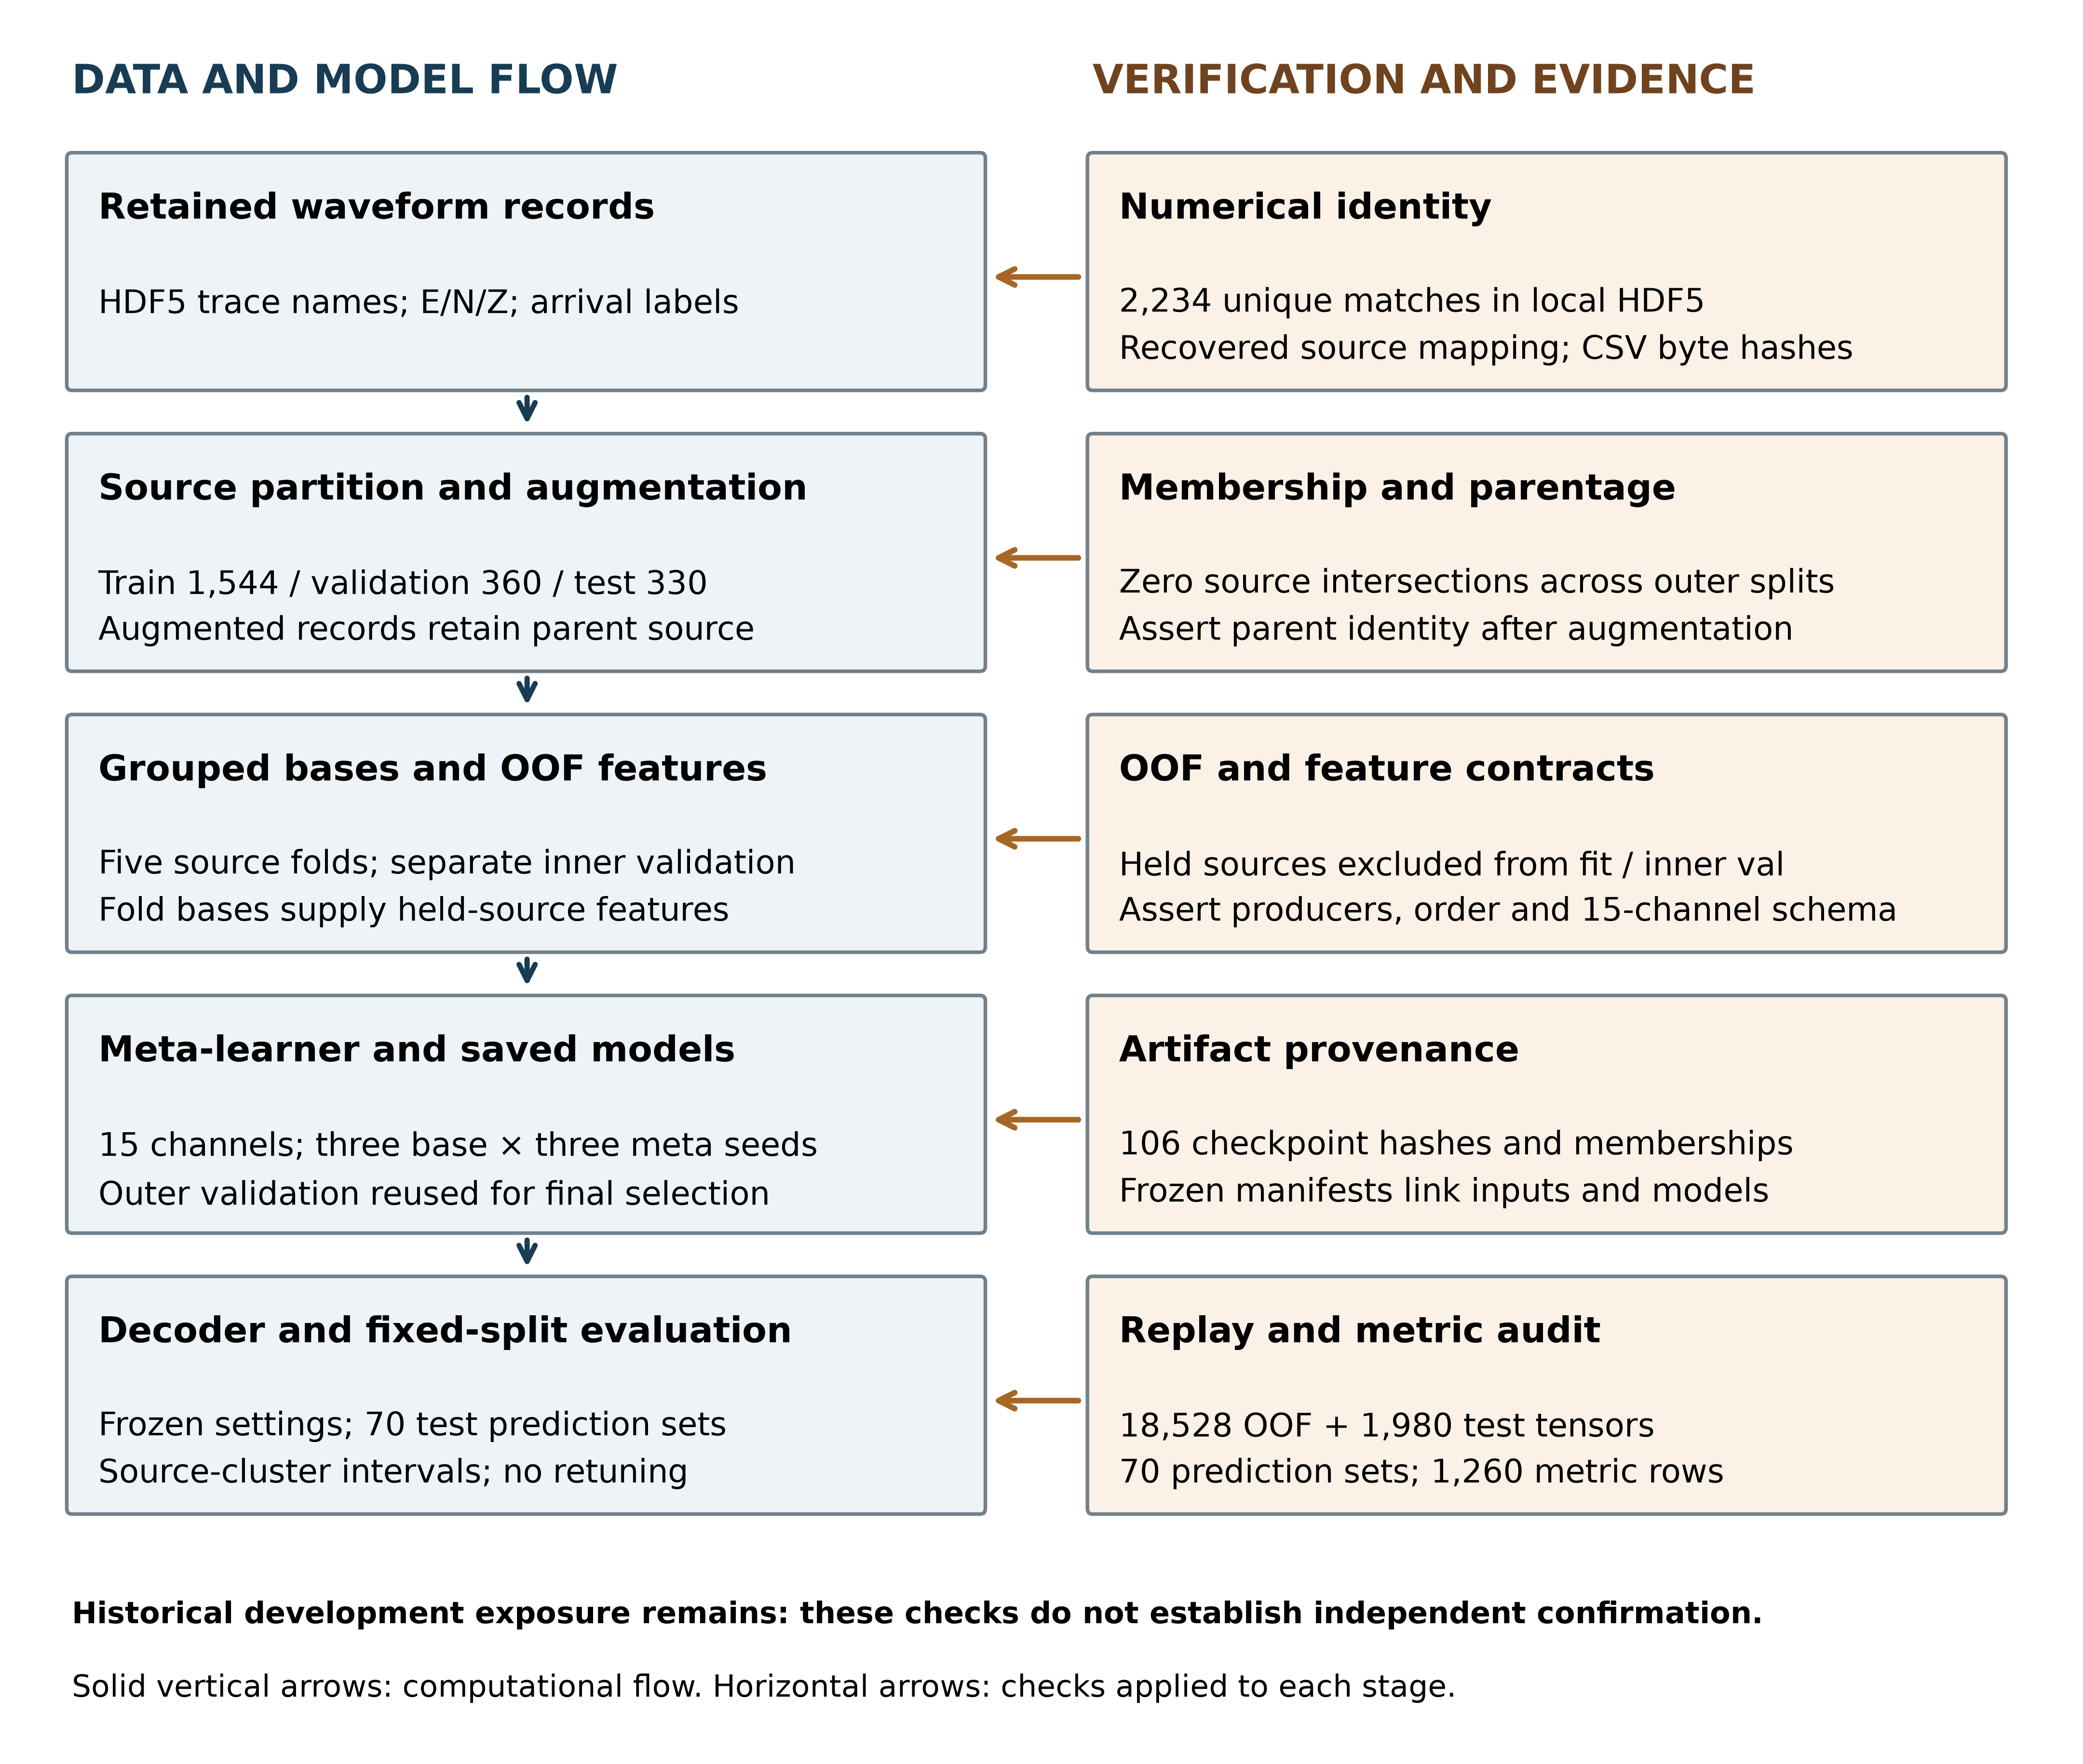
Fig. 1. Data/model flow and verification layer. Checks connect numerical waveform identity, source partitions, augmentation parentage, OOF membership, feature order, saved artifacts and reported metrics. Outer validation is reused for final base selection, meta selection and ensemble weighting. Historical development exposure remains outside the exclusions established by the corrected run. Evidence types and enforcement scope are distinguished in Table 3.

2. Data and dataset curation

2.1. Source dataset
We used the STanford EArthquake Dataset (STEAD; Mousavi et al. 2019). The retained population comprises 2,234 previously exported local-earthquake waveform records whose identities were recovered by matching their numerical content to the upstream HDF5 data. It contains 1,477 earthquake sources. Recovered metadata show magnitude 2.5–5.9, source distance 0–49.99 km, and minimum component SNR −1.70–103.60 dB (median 44.70 dB; Fig. 2; Table 1). The original extraction index and selection script were unavailable; these are measured population characteristics, not a reconstructed selection rule. Only 484 records have distance ≤15 km and 2,172 have minimum component SNR ≥10 dB. We therefore do not characterize the entire subset by those previously stated filters.

2.2. Waveform representation and record format
Each event–station observation contains 6000 samples at 100 Hz (60 s), with ordered E, N, and Z components and reference arrivals in seconds. The waveform representation is given in equation 1; equation 2 converts an arrival time to a zero-based sample index.
$X_{i}=\left[\begin{matrix}E_{i}(t_{1}) & N_{i}(t_{1}) & Z_{i}(t_{1}) \\ E_{i}(t_{2}) & N_{i}(t_{2}) & Z_{i}(t_{2}) \\ ⋮ & ⋮ & ⋮ \\ E_{i}(t_{6000}) & N_{i}(t_{6000}) & Z_{i}(t_{6000})\end{matrix}\right]$ (1)
where $X_{i}∈ℝ^{6000×3}$ is the three-component waveform for record $i$. The associated ground-truth arrival times are denoted by $t_{i}^{P}$ and $t_{i}^{S}$. Sample indices were derived only when required by the processing functions (equation 2):
$n_{i}^{P}=round\left(t_{i}^{P} f_{s}\right), n_{i}^{S}=round\left(t_{i}^{S} f_{s}\right)$ (2)
Here fs = 100 Hz. A zero-based sample n maps to MATLAB array index n+1; an array index j maps back to time (j−1)/fs. CSV arrival times in seconds remain authoritative, and evaluation does not replace them with rounded metadata indices.
Original STEAD source_id values recovered from waveform matches define grouping; event IDs identify individual exported records. All 2,234 CSV labels equal floor(upstream arrival sample)/100 for both phases. Fractional upstream samples differ from the retained CSV labels for 94 P and 124 S arrivals, by at most 9.01 ms. We preserve the historical CSV labels consistently across methods rather than silently replacing their rounding convention.

2.3. Metadata integration and identifier recovery
We matched 6,000×3 CSV waveforms to STEAD using SHA-256 hashes of little-endian float32 values in column-major E/N/Z order. Exhaustive hashing of all 1,265,657 local HDF5 waveform datasets found exactly one trace for each of the 2,234 distinct selected fingerprints, without conflicting source assignments. Upstream metadata agreed throughout. The mapping and partitions were frozen before training of the corrected source-verified run, termed v2; exhaustive uniqueness verification followed training. This establishes exact matches in this archive version, not near-duplicate absence or catalogue identity accuracy.
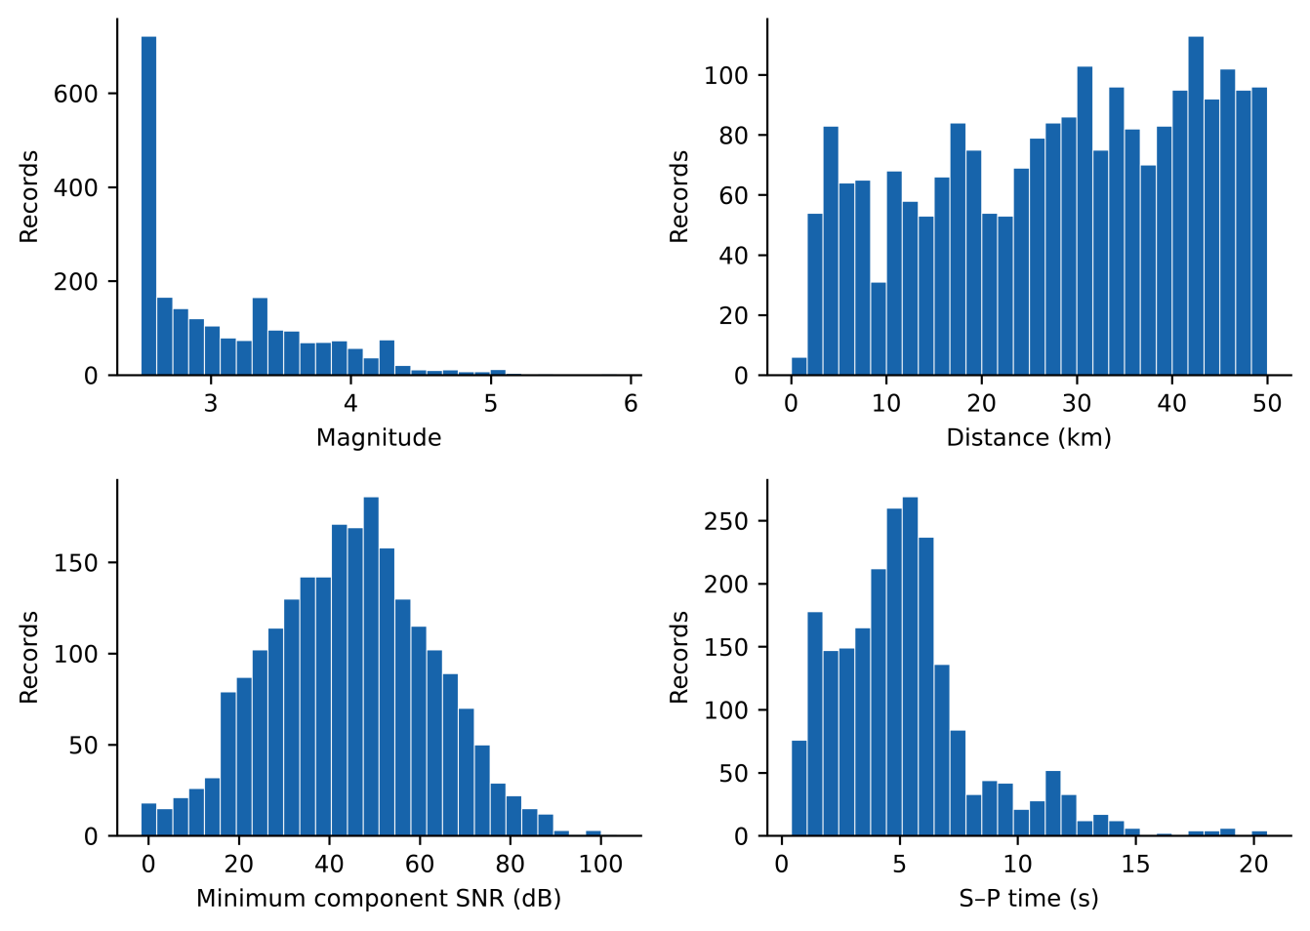
Fig. 2. Characteristics of the curated STEAD-derived dataset (N=2234 records): magnitude, epicentral distance, minimum component SNR, and S–P time. Each histogram uses 30 bins.
Table 1. Summary statistics of the curated STEAD-derived dataset used in this study.
Item | Value
Records / recovered sources | 2234 / 1477
Sampling / duration | 100 Hz / 60 s
Components | E, N, Z
Magnitude range; median | 2.5–5.9; 2.9
Distance range; median (km) | 0–49.99; 29.74
Minimum SNR range; median (dB) | −1.70–103.60; 44.70

Identity correction and rerun. The original ordinal metadata join misidentified waveforms: 151/335 historical test records shared physical sources with training. We corrected identities and reran all 106 fits. Current test records previously belonged to training (233), validation (46) or testing (51); 196/221 current test sources had historical training/validation membership. Thus source disjointness in v2 does not establish independent confirmation. Because population allocation and training also changed, old-to-new scores cannot isolate leakage-induced inflation (Online Resource 1, Tables S22–S23).

2.4. Waveform quality control
The corrected loader accepted all 2,234 records without missing files or read failures. Input checks cover waveform dimensions, finite values, the 100 Hz time grid and in-window ordered arrival labels. Numerical hashes connect these inputs to the recovered STEAD traces. No new filtering or label correction was applied after the verified population and source split were frozen.

2.5. Signal conditioning
Conditioning removes the component mean, detrends linearly, and applies a 1–45 Hz Butterworth band-pass filter using MATLAB butter with order argument 4 followed by filtfilt. Each component is normalized as (x−mean(x))/(std(x)+10⁻¹⁰), so an all-zero component remains zero. Explicit clipping was disabled. The same deterministic transforms were used in all subsets (equation 3). Supplementary Implementation Details specify the enhanced features and edge handling.
For an input component $x_{c}(t)$, where $c∈\{E,N,Z\}$, the conditioning operation can be summarized as (equation 3):
${\tilde{x}}_{c}(t)=N\left\{ℬ_{1\text{–}45\text{Hz}}\left[D\left(x_{c}(t)−{\overset{‾}{x}}_{c}\right)\right]\right\}$ (3)
where $D$ denotes detrending, $ℬ_{1\text{–}45\text{Hz}}$ denotes band-pass filtering, and $N$ denotes component normalization. The same deterministic conditioning parameters were applied to training, validation, and test records. Data augmentation was not part of dataset curation and was applied only after splitting, exclusively to training data.
Base CNN/TCN inputs contain eight channels: conditioned E/N/Z, their three envelopes, short-term Z energy, and a Z characteristic function. The final three waveform-context channels of the meta tensor retain conditioned E/N/Z; they are distinct from the eight-channel base representation.

2.6. Archive reference labels and target construction
Reference arrivals became Gaussian phase targets (equation 4; Zhu and Beroza 2019; Mousavi et al. 2020). Both arrivals have manual metadata status in 1,224/1,544 training, 306/360 validation and 287/330 test records. The other 417 records include automatic/autopicker status. Manual-only sensitivity restricts evaluation without retraining or independently validating annotations (Online Resource 1, Tables S24–S25). Reference labels come from archive metadata, not independent expert re-picking in this study.
For phase $k∈P,S$, the target at time $t$ was defined as (equation 4):
$y_{k}\left(t\right)=\exp\left[−\frac{{\left(t−t_{k}\right)}^{2}}{2σ_{k}^{2}}\right],$ (4)
Targets were truncated at ±4 standard deviations, with P/S widths of 0.06/0.08 s. The noise target is max(0, 1−max(yP,yS)); targets are not additionally normalized to sum to one where phase tails overlap (Fig. 3). Neural predictions, in contrast, use softmax. Target mass is 1+min(yP,yS). Overlapping masks occur in only 4 training, 0 validation, and 1 test records (Online Resource 1, Table S14). The implemented loss and its local weighting interpretation are given in Supplementary Implementation Details.
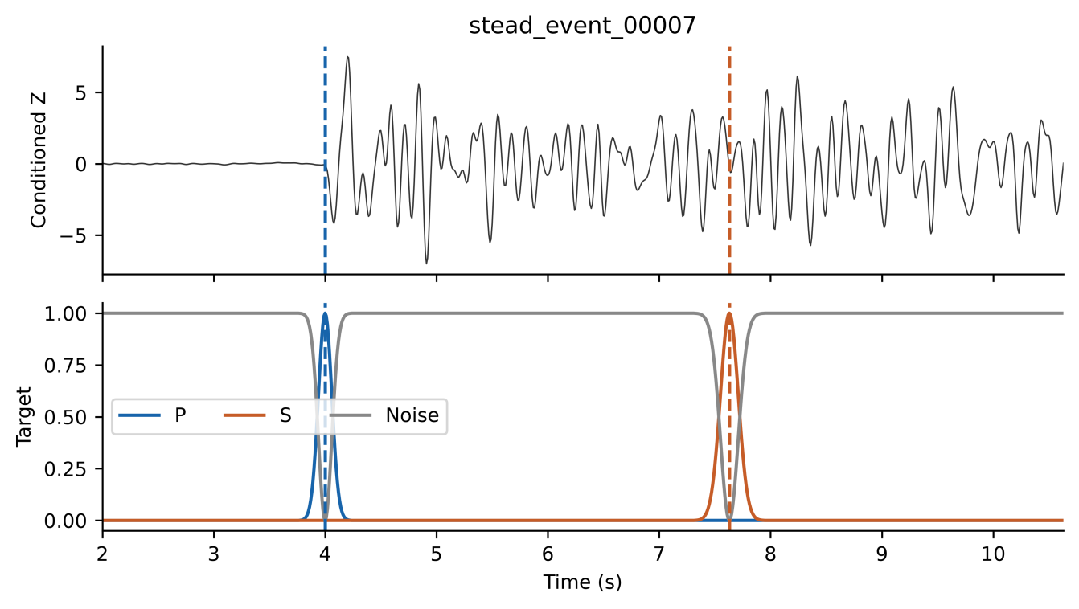
Fig. 3. Gaussian probability label formulation. (a) Vertical (Z) seismic component with true P- and S-wave arrival markers. (b) Gaussian probability masks used as training targets for the I-CNN meta-learner. The P-wave mask (blue) and S-wave mask (red) are centred on their respective true arrival times with standard deviations σP and σS (in samples). The noise/background mask (grey) equals max(0, 1−max(yP,yS)), the continuous complement of the larger phase mask.

2.7. Source-level partitioning
Unique recovered source IDs were deterministically ranked using SHA-256 stage/seed/source keys and allocated approximately 70%, 15% and 15% to train, validation and test. All records of one earthquake stay together (Table 2). Training contains 1,544 records from 1,034 sources, validation 360 records from 222 sources, and test 330 records from 221 sources. Pairwise source intersections are zero; station and regional overlap were not excluded. The same frozen outer split and five OOF assignments are used for both input modes and every base seed. Subset distributions appear in Online Resource 1, Fig. S2.
Test metadata contain 64 network–receiver keys across 23 networks; PB contributes 99/330 records. Fifty-five test keys also occur in training, covering 318 records. Nine keys absent from training and validation contain only 12 records from ten sources. These are retrospective strata, not a station-held-out design; keys do not distinguish station epochs (Online Resource 1, Tables S12 and S26).
Table 2. Source-level partitioning of the final curated dataset showing the number of unique earthquake sources and waveform records in each subset.
Subset | Sources | Records
Training | 1034 | 1544
Validation | 222 | 360
Test | 221 | 330
Total | 1477 | 2234

2.8. Leakage controls after dataset partitioning
Augmentation was restricted to training records: one augmented copy per original used additive noise at 20 dB target SNR, amplitude scaling in [0.5, 2.0], and horizontal-channel dropout with probability 0.20 (E, N, or both). Time shifting and polarity reversal were disabled. Validation and test records were not augmented. Source assignments were preserved throughout processing.
3. Methods
3.1. Workflow objects and executable contracts
A record is identified by its local record key, recovered STEAD trace name, source identifier and numerical waveform fingerprint. An augmented record also stores a parent relationship. A fold model has fitting and inner-validation source sets; a final model has recorded fitting and selection memberships. A feature tensor adds ordered producer/channel identities, and an artifact adds a byte hash. These objects are distinct: matching bytes alone does not validate a source key, and source disjointness alone does not remove earlier development exposure.
Table 3. Workflow contracts and observed evidence. Checks are stated as invariants; the evidence column distinguishes full-data audits from synthetic demonstrations.
Contract | Check and stage | Evidence and scope
Record identity | A retained record maps to one local HDF5 trace with the same numerical fingerprint. | 2,234 unique matches in the exhaustive local-archive scan; not a near-duplicate test.
Outer source exclusion | Source sets for train, validation and test have pairwise empty intersections. Check frozen protocol before fitting. | Zero intersections across 1,034 / 222 / 221 sources; historical exposure remains.
Augmentation parent | Child source equals parent source and child points to its parent record. | Training augmentation preserves membership; synthetic changed-parent case rejected. No claim of auditing every historical augmentation.
OOF exclusion | For fold f, held-source set Hf has empty intersection with Fitf and InnerValf. Audit memberships before interpreting OOF outputs. | Six mode/base membership manifests × 1,544 records; synthetic contaminated-fold case rejected.
Feature interface | 15 ordered channels from named producers; held originals and copies use their fold-specific bases. | Schema assertions and swapped-feature negative control; real OOF/test reconstruction checked separately.
Checkpoint and bytes | Recorded fit/validation sources exclude current test sources; artifact hashes match frozen manifests. | 106 checkpoints audited; 106 model and 89 code-file hashes unchanged across recorded replay.
Numerical output | Replayed features/picks and recomputed metrics agree with saved references under stated comparisons. | 18,528 OOF + 1,980 test tensors; 70 prediction sets; 1,260 metric rows. Selection history is not replayed.
The core invariants are pairwise exclusion of outer source sets, equality of child and parent source identity, and disjointness of each held fold from both fitting and inner-validation sources. The implementation checks these relationships using membership manifests and assertions. The synthetic demonstration exercises the same types of failure, but is not a substitute for audits of the fitted study artifacts. Table 3 records the scope of each evidence item.
Experiments used MATLAB R2024a with fixed source partitions. The corrected 40-fit main experiment used CNN/TCN base seed 42 and meta seeds 42, 43, and 44. An additional 66 fits repeated the complete base/OOF/meta workflow with base seeds 43 and 44 and trained six standalone PhaseNet-style baselines. Each base seed was crossed with all three meta seeds in both modes. OOF fold seed 42, inner split seeds 101–105, fold augmentation seeds 1001–1005, and final/OOF augmentation seed 4242 remained fixed. Thus initialization and training-order variability is examined conditional on the same partition and augmentation protocol; meta fits sharing a base are not independent full-pipeline replicates. Online Resource 1, Table S9 enumerates the 40 main invocations; Table S18 accounts for the full 106 fits. Full3C denotes access to all three waveform components; Z-only retains vertical input with E/N set to zero. I-CNN denotes the integrated convolutional meta-learner used for temporal stacking.
3.2. Base score generators and grouped fitting
Conditioning follows equation 3. STA/LTA and AIC supply deterministic probability-like scores rather than calibrated class probabilities (Allen 1978; Maeda 1985). Gaussian curves are centred on the global normalized STA/LTA peak or the AIC minimum. P uses Z; S uses the E/N resultant only when both horizontal components are nonzero, otherwise it falls back to Z. The AIC centre search is restricted to the first 10 s. Supplementary Implementation Details give the exact windows, normalization, fallback, and score construction. Learned bases emit P/S/noise softmax probabilities (equation 5). These classical channels are retained historical score generators, not optimized conventional-picker benchmarks; their restricted AIC centre search is evaluated as implemented.
The CNN has two convolutional blocks with 32/64 filters, kernel 7, batch normalization, ReLU, and dropout 0.30; its receptive field is 13 samples. TCN has four 32-filter blocks with kernel 3, dilations 1/2/4/8, dropout 0.20, and no residual connections; its receptive field is 31 samples (Bai et al. 2018). Both process the eight-channel representation at 100 Hz and finish with a 1×1 convolution and softmax. Base training used Adam at 10⁻³, batch size 16, at most 30 epochs, and validation patience of seven evaluations (Online Resource 1, Table S28).
$P_{P}\left(t\right)+P_{S}\left(t\right)+P_{N}\left(t\right)=1$ (5)
Five source-grouped OOF folds were formed within outer training. For each held fold, the other four were split by source into fitting and inner validation, reserving approximately 15% for checkpoint selection. Held sources entered neither subset. Those fold models supplied OOF features for held originals and their augmented copies. Final bases fitted weights using augmented outer training only; outer validation selected their checkpoints. Final bases then supplied outer-validation and test meta-features. Meta weights fitted OOF training features; the same outer validation selected meta checkpoints. This is adaptive validation reuse across levels, not an independent nested validation estimate. Current test sources were excluded from v2 fitting and checkpoint selection; this exclusion does not erase their historical roles before identity correction. Online Resource 1, Table S8 maps each role.
3.3. Feature interface and temporal models
The meta input is a 6000×15 tensor: twelve P/S/noise channels from four pickers, followed by conditioned E/N/Z (equation 6; Fig. 4). Channel count and order are asserted. Online Resource 1, Table S1 describes all held-out test tensors; Online Resource 1, Fig. S5 illustrates one record.
Table 4. Canonical temporal feature interface. Channel indices remain fixed in both input modes.
Channels | Producer and values | Z-only behavior
1–3 | STA/LTA: P, S, noise scores | P and S coincide under vertical fallback
4–6 | AIC: P, S, noise scores | P and S coincide under vertical fallback
7–9 | CNN: P, S, noise probabilities | Mode-specific fitted base
10–12 | TCN: P, S, noise probabilities | Mode-specific fitted base
13–15 | Conditioned E, N, Z waveforms | E/N zero; Z retained
$X_{\text{meta}}∈ℝ^{6000×15}$ (6)
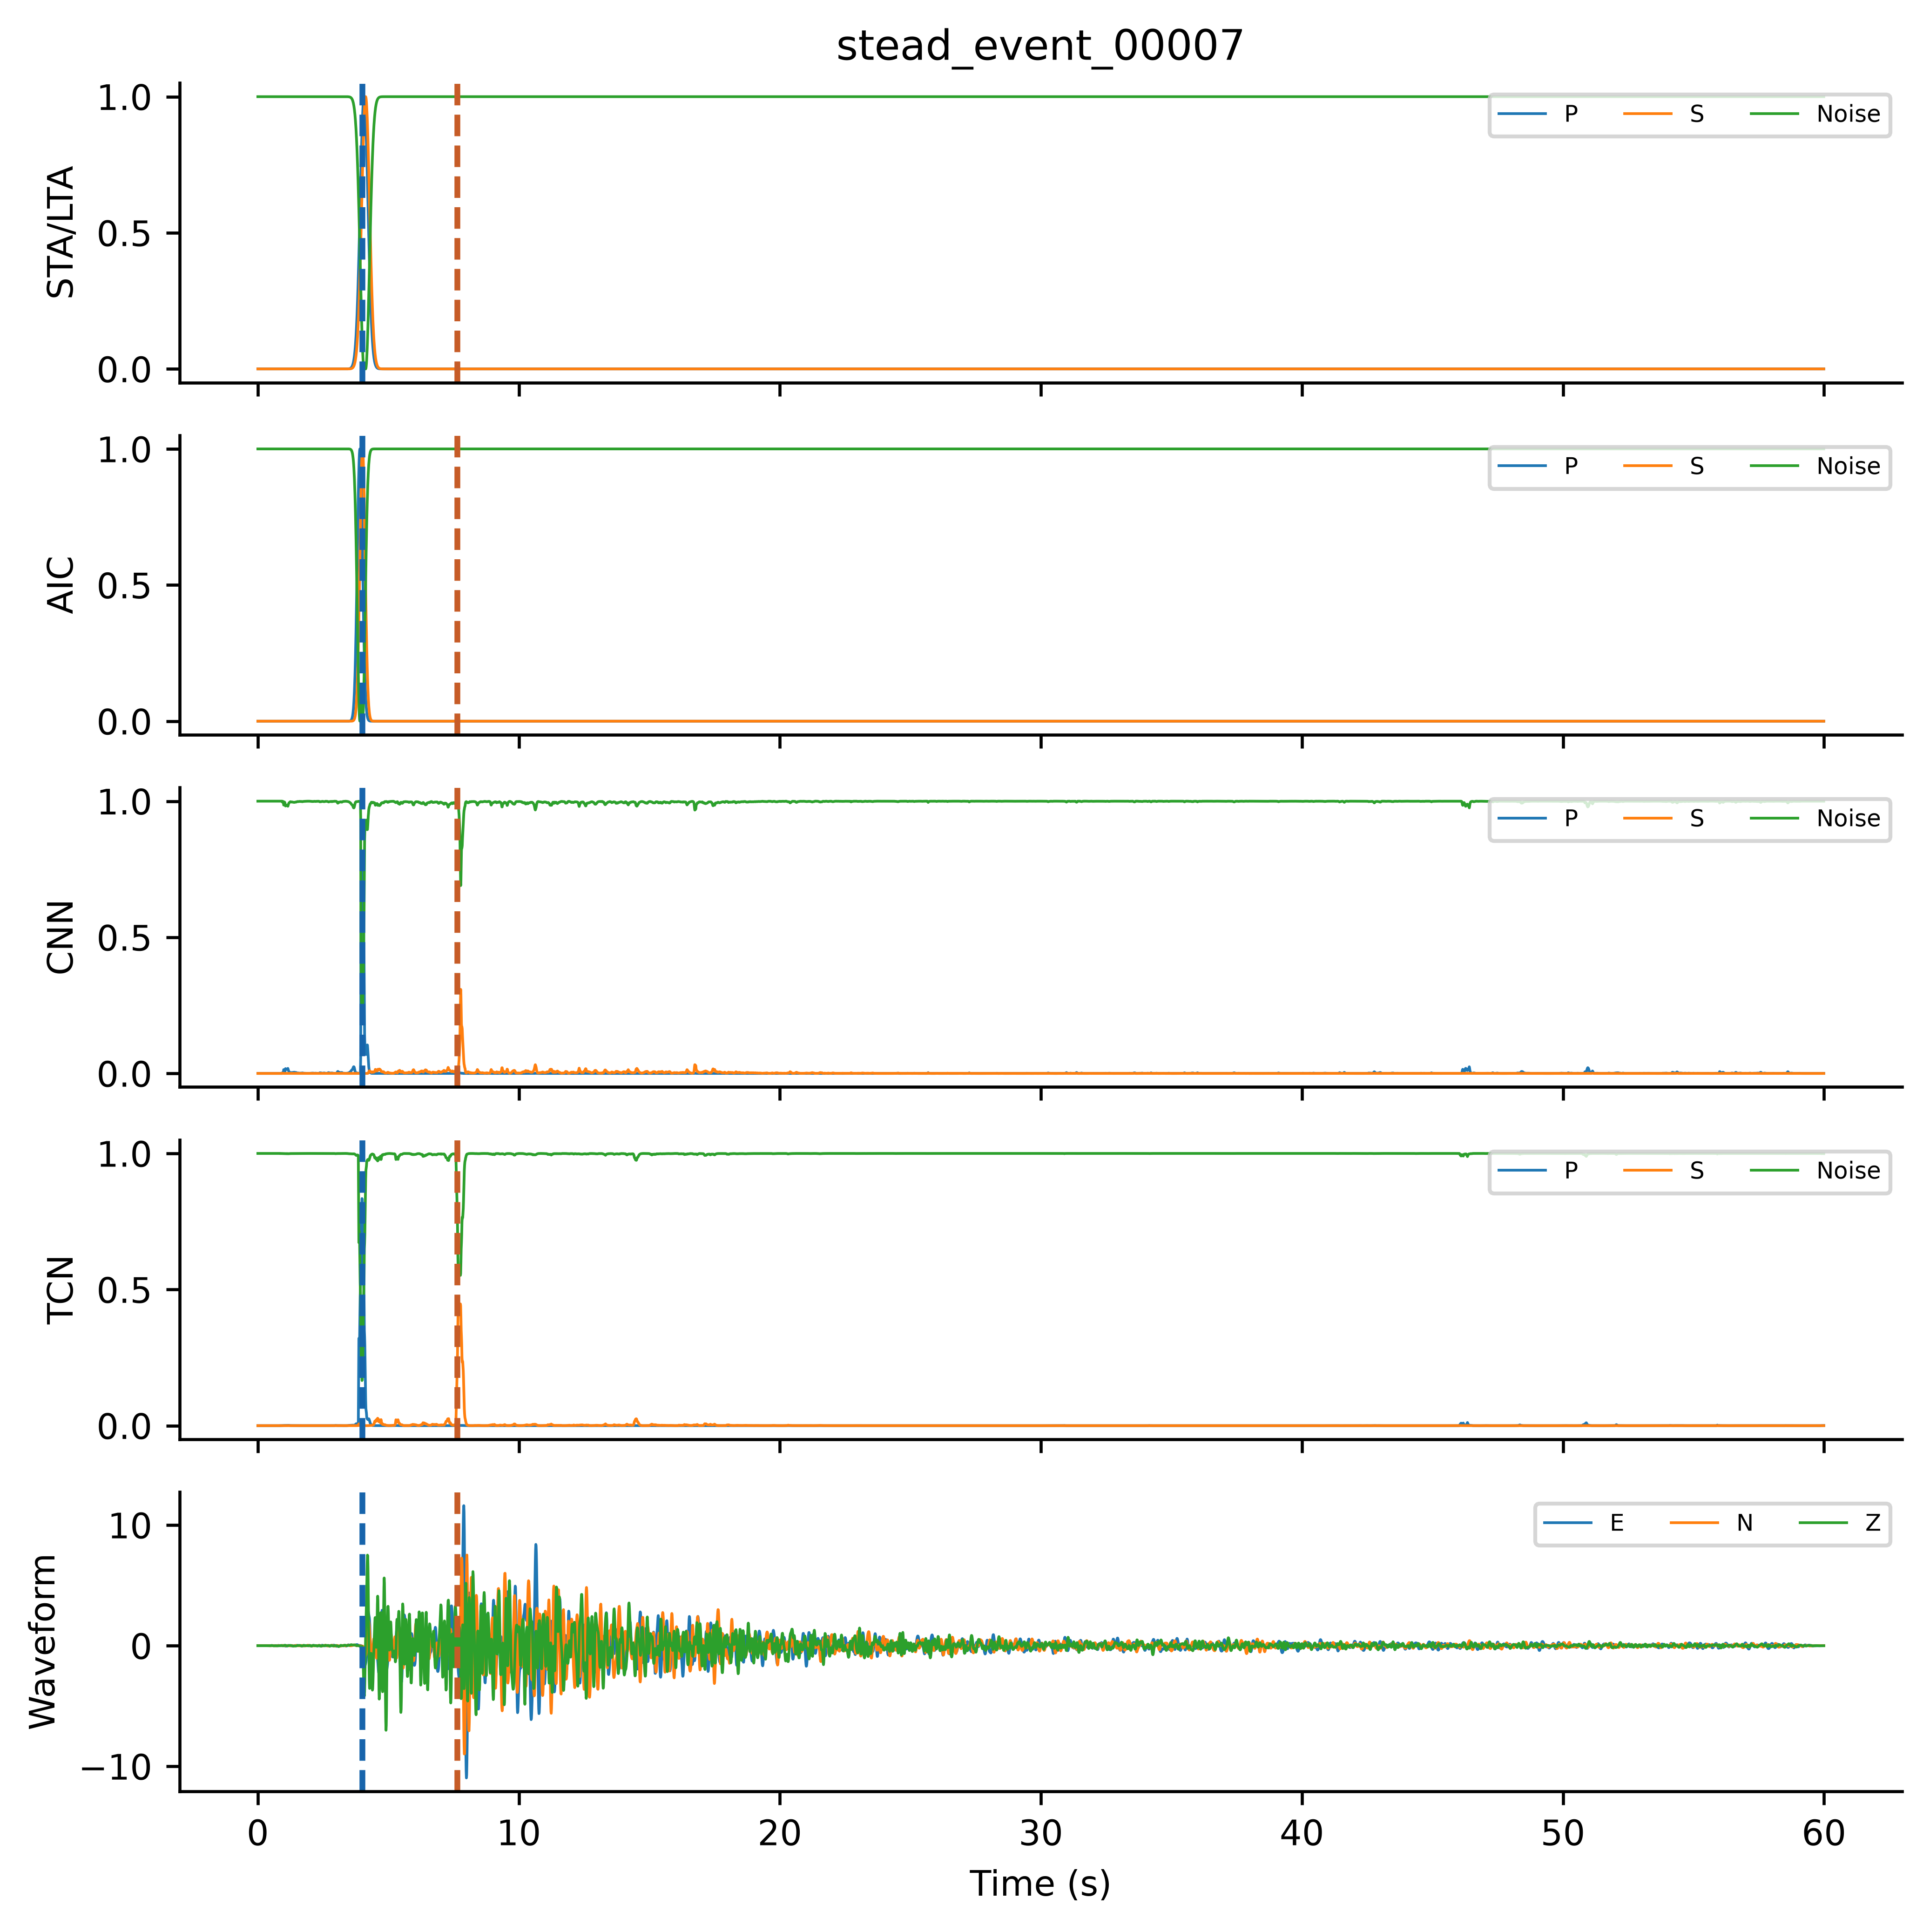
Fig. 4. Final 15-channel tensor for held-out stead_event_00007. Four groups contain P/S/noise from STA/LTA, AIC, CNN and TCN; the last group contains conditioned E/N/Z. Dashed lines mark true arrivals. These are current final-base test features, not OOF training features.
I-CNN has four sequential kernel-5 blocks with filters 64/128/64/64, dilations 1/1/2/4, batch normalization, ReLU, and dropout 0.30. With h0 = Xmeta, equations 7–8 define the blocks and head. Its receptive field is 33 samples (330 ms); architectural capacity alone does not establish an empirical benefit. The short-context stacker is a hierarchical testbed for lineage checks; no competitive-architecture claim is made.
For blocks i = 1,…,4, the forward operation is:
$h_{i}= Dropout({ReLU(BN}_{i}(W_{i}∗_{dᵢ}h_{i−1}+b_{i})))$ (7)
Here d = (1,1,2,4), the convolution uses dilation di and same padding, and dropout probability is 0.30 during training only. The 1×1 head returns three probabilities at each time:
$p(t) = softmax(W_{head}h_{4}(t) +b_{head})$ (8)
The I-CNN used Adam at 5×10⁻⁴, batch size 16, at most 50 epochs, and weighted cross-entropy with P/S/noise weights 1.5/2.5/0.5. All neural models used L2 = 10⁻⁴, learning-rate halving every 20 epochs, validation once per epoch, and the best-validation-loss checkpoint. Meta patience was ten evaluations. Histories appear in Online Resource 1, Fig. S1.
Training-only augmentation is specified in Section 2.8 and Online Resource 1, Table S28. Adam (Kingma and Ba 2015), batch normalization (Ioffe and Szegedy 2015), and dropout (Srivastava et al. 2014) were used for neural models. Online Resource 1, Table S4 records the final configuration, including disabled augmentation operations and seed scope. Horizontal dropout is triggered with total probability 0.20 per augmented copy; E-only, N-only, and both are then selected with equal probability. Losing either horizontal component activates the Z fallback in both classical bases.
For Z-only, E and N were zeroed before preprocessing and again after augmentation. Population, source partitions, labels, channel layout, architecture settings, and evaluation were unchanged; mode-specific bases and meta-learners were fitted. The comparison removes horizontal information throughout the pipeline, rather than masking only waveform-context channels after full-component base inference. For the audited base-seed cache, all 3,778 available Z-only meta tensors were finite with zero E/N channels; classical P/S score channels were identical under the specified fallback (Online Resource 1, Table S13).
The standalone comparator, termed PhaseNetMatched, is a PhaseNet-style MATLAB adaptation trained from scratch (Zhu and Beroza 2019; Woollam et al. 2022). It has five encoder levels with 8/16/32/64/128 filters, kernel 7, stride-4 downsampling, batch normalization, ReLU, transposed convolutions, and skip concatenation. MATLAB same padding and centre-cropped skips support 6,000-sample records. Padding, initialization, convolution biases, and batch-normalization defaults differ from the reference implementation. The input is the same conditioned E/N/Z waveform used in meta channels 13–15, without a second normalization; E/N remain zero in Z-only. Labels, augmentation, weighted loss, outer split, validation selection, decoder, and scoring are shared. Adam uses learning rate 5×10⁻⁴, batch size 2, at most 50 epochs, patience 10, L2=10⁻⁴, and learning-rate halving every 20 epochs. Three seeds (42–44) are fitted per mode. Data access is matched; feature inputs, minibatch statistics, and compute budgets are not equivalent. Online Resource 1, Table S18 accounts for all additional fits.
3.4. Arrival decoder
Let G = {0,0.01,…,59.99} s. Set DP = G. The P candidate maximizes pP over G. If it is accepted, the S search domain is restricted relative to that candidate; otherwise the S domain is empty:
$Dₛ =\left\{\begin{aligned}\{t ∈ G : 0.1 ≤ t − t̂ₚ ≤ 30\}, if P is accepted \\ ∅, otherwise\end{aligned}\right.$ (9)
DS is empty when P is not accepted. For each nonempty phase domain Dk, t̂k maximizes pk on Dk. Ties use the earliest sample, matching MATLAB max. The peak-to-mean quality score is computed on that phase domain:
$q_{k}=\frac{pₖ(t̂ₖ)}{mean[t ∈ Dₖ] pₖ(t) + 10⁻⁶}$ (10)
A candidate is detected when peak ≥0.30 and quality ≥3.0, otherwise uncertain when peak ≥0.15, and not detected below 0.15. Primary acceptance includes both detected and uncertain; strict reporting includes detected only.
Return tS = t̂S for accepted S and NaN otherwise; an empty DS returns no pick. The S–P rule constrains ordering rather than learning a physical objective. Detected-only scoring retains the accepted-P gate. Peak 0.30, quality 3 and the 0.1–30 s window occur in July and September configurations (Online Resource 1, Table S20), but their earliest calibration data remain unknown. No validation-only calibration is asserted. Before sensitivity calculations, we specified a 27-setting grid: peak {0.20, 0.30, 0.40}, tied P/S quality {2, 3, 4}, and maximum S–P {20, 30, 40} s. Minimum separation remains 0.1 s and the uncertain boundary half the peak threshold. All 18 full stackers and six baseline fits retain the original primary setting. Window changes also alter the S quality denominator; accepted scoring is invariant to quality threshold.
3.5. Evaluation and dependency-aware summaries
Evaluation used 330 test records from 221 sources and tolerances of ±50, ±100, and ±200 ms. The primary policy accepted finite detected or uncertain picks. Accepted picks within tolerance were true positives; accepted picks outside tolerance contributed both a false positive and a false negative. Missing picks contributed false negatives. Thus FP = Naccepted − TP and FN = N − TP. Detected-only sensitivity and seed-42 confusion counts are reported in Online Resource 1, Tables S10 and S7. The primary policy retains lower-confidence candidates to expose the coverage–timing tradeoff; accepted coverage must not be interpreted as accurate detection. Every test record contains P and S reference arrivals; there are no noise-only records. Here false positives count mistimed accepted picks, and precision is not a continuous-stream false-alarm measure.
The conventional F1-score is (equation 11):
$F1=\frac{2TP}{2TP+FP+FN}$ (11)
MAE was calculated over all accepted arrivals, including uncertain picks and errors outside the matching tolerance (equation 12):
$MAE=\frac{1}{N_{d}}\sum_{i=1}^{N_{d}}{\left|t_{i}−{\overset{ˆ}{t}}_{i}\right|,}$ (12)
In equation 12, Nd counts accepted finite picks; coverage Nd/N differs from recall and detected-only coverage. Expanded stacking summaries average meta seeds within each base and then the three base means. Between-base SD uses those three means, not nine independent replicates; baseline summaries use three fits. Paired intervals use 10,000 NumPy default_rng source-cluster draws (seed 42), retaining every record of each sampled source. Per-fit F1 is recomputed before averaging, with common draws across comparisons. Intervals condition on fixed models and split; they exclude training, partition and separate station-level uncertainty. Subset diagnostics resample their stated sources. Intervals are exploratory and pointwise, without family-wise or false-discovery-rate control. No configuration is selected from the threshold grid. Base-42 summaries retain their three-meta-seed scope.
3.6. Verification and reproduction levels
The verified workflow checks source disjointness, augmentation parentage, OOF exclusion, the 15-channel feature schema and file hashes. A retained synthetic example illustrates invalid source overlap, changed parent identity, OOF contamination, swapped feature order and altered bytes; it is an implementation demonstration rather than evidence of predictive accuracy. Fresh inference replay and an independent numerical audit check all current prediction identities, reference labels, source membership and reported metrics. Online Resource 1, Tables S19 and S21 separate current-run evidence from historical software demonstrations.
Reuse follows three explicit input/output steps. First, retained waveform files are associated with source identifiers and a frozen partition manifest; source membership and augmentation parentage are checked before model fitting or feature assembly. Second, fold-specific predictions are assigned to the canonical feature schema, with each OOF record excluded from the associated base fit. Third, replayed predictions are evaluated under saved decoder settings and compared with frozen output identities and metrics. The checks establish these specified invariants; they do not prove that the grouping key is scientifically correct for every new application.
Table 5 separates the levels of reproduction. The synthetic checks and metric verifier require no external waveforms. Fresh model replay additionally requires hash-matching CSVs, compatible MATLAB toolboxes and the saved checkpoints. A new deterministic HDF5-to-CSV reconstruction utility was checked against all retained file hashes (Section 4.2). It reconstructs the selected exports, not the missing historical filtering and selection procedure. For another application, the grouping key, record mapping, labels and decoder must be supplied and justified.
Table 5. Reproduction levels and their limits. The new reconstruction check is separate from the previously completed model replay.
Level and inputs | What can be checked | Boundary
A: package, Python | Hash integrity; five synthetic negative controls; 1,260 metric rows from supplied predictions | No waveform or MATLAB needed; does not rerun models
B: STEAD HDF5 + mapping + Python | Regenerate retained CSVs and compare frozen byte hashes; 2,234/2,234 matched | Tested serialization and local archive; original selection decisions not recovered
C: matching CSVs + checkpoints + MATLAB | Fresh OOF/test features and test predictions under saved settings | 106 checkpoints; recorded GPU replay. Validation tensors and selection process not rebuilt
D: retraining or independent confirmation | Not established by A–C | No bitwise retraining claim; no new unexposed population tested
Fresh GPU replay loaded all 106 checkpoints and rebuilt inputs from waveform CSVs. Across six mode/base combinations, 18,528 original/augmented OOF tensors and 1,980 test meta tensors had maximum absolute difference 0 from their caches (acceptance tolerance 10⁻⁶). All 70 prediction sets × 330 records reproduced constrained and unconstrained pick times and statuses without mismatches (time tolerance 1e-7 s). Saved validation-derived ensemble weights were retained. This verifies fixed-artifact inference and feature reconstruction, not retraining determinism or independent predictive validation (Online Resource 1, Table S21). Outer-validation feature tensors were not rebuilt in this replay; saved ensemble weights and selected checkpoints were reused. Thus replay does not revalidate the historical selection decisions.
The recorded inference replay used MATLAB R2024a, Deep Learning Toolbox, Signal Processing Toolbox and GPU support through Parallel Computing Toolbox, on an RTX 3060 Laptop GPU with 6 GiB VRAM and 32 GiB system RAM. These are observed resources, not measured minimum requirements. Cross-device or CPU equivalence is not established. CSV regeneration was tested with Python 3.12.14, NumPy 2.5.3, pandas 3.0.1 and h5py 3.16.0; it verifies output hashes rather than assuming serialization is stable across versions.
3.7. AI-assisted software development
AI-assisted software development and computational workflow. ChatGPT/Codex (OpenAI; accessed September 2026) assisted with software revision and debugging, workflow implementation, computational execution support, and numerical-output checking. Assistance included scripts for generating tables, data plots, and the workflow diagram. Figures were produced programmatically from study data, model outputs, or the documented workflow, without generative-image synthesis. AI tools did not generate seismic observations or reference phase labels. The authors reviewed and verified code changes, executed analyses, numerical results, and interpretations. Verification included source-membership assertions, numerical consistency checks, and comparison of frozen outputs with reported tables. The verified v2 package and numerical audit identify the respective scripts, configurations, predictions and provenance records.

4. Results
The evaluation contains 106 fits: 40 main/ablation fits, 60 additional base/OOF/meta fits and six PhaseNet-style fits. The principal presentation uses the expanded base/meta grid (Tables 6–7; Figs. 5–6). Base-42-only performance, ablations and error diagnostics are secondary analyses (Online Resource 1, Tables S5–S7 and S28–S30; Figs. S8–S14). These reporting priorities are retrospective, not preregistered hypotheses. The training code did not select checkpoints using current test scores.

4.1. Waveform identity and historical data roles
For RQ1, the exhaustive local-archive audit uniquely matched all 2,234 retained waveforms to 1,477 recovered sources. Current train, validation and test sources are disjoint, but historical exposure remains. Only 25 test sources (26 records) lack historical training/validation membership; all previously occurred in testing. No development-naive subset is established. Historical scores are not a valid source-held-out comparator, and the changed allocation and training prevent a controlled estimate of leakage inflation.

4.2. Feature reconstruction and numerical reproducibility
For RQ2, the identity mapping links 2,234 retained waveforms to checkpoint membership and fresh inference. OOF/test tensor differences were zero, with no pick/status mismatches across 70 prediction sets. Independent calculations reproduced 1,260 metric rows. The input audits cover 25,248 manifest entries across 2,336 unique input files; these are distinct from the 1,241 entries in the archived package-level manifest (Online Resource 1, Table S21).
Five deliberately invalid synthetic cases were rejected: source overlap, changed augmentation-parent identity, a held source included in an OOF fit, reordered feature channels and altered artifact bytes. These negative controls demonstrate the implemented checks, not robustness to every possible provenance error. Table 3 distinguishes synthetic demonstrations, retrospective real-data audits and replay evidence.
A deterministic serialization profile regenerated all 2,234 selected CSV byte streams directly from mapped HDF5 traces. Every source identifier, column-major little-endian float32 waveform fingerprint and complete CSV SHA-256 matched the frozen manifest, with zero errors. No original CSV content was used to generate these outputs. The check ran without training and without materializing the complete CSV collection. The utility can write only hash-matching files to a new output directory. This closes the tested retained-input reconstruction gap, while leaving the original selection/filtering history unresolved (Table 5; Online Resource 1, reconstruction verification).
4.3. Expanded component-access and method comparison
For RQ3, across three base-seed means, Full3C stacking F1@100 ms was 0.8268 ± 0.0069 for P and 0.5536 ± 0.0127 for S; Z-only values were 0.8134 ± 0.0073 and 0.2686 ± 0.0152. Each base mean averages three meta fits. Full3C exceeded Z-only S F1 in all nine paired fits. Table 6 separates these summaries from the three-seed standalone baseline. Fig. 5 compares methods, and Fig. 6 separates individual meta fits from base-specific means. These repetitions characterize initialization variability on one source split, not uncertainty across partitions or regions.
Table 6. Expanded results at ±100 ms. Stacking SD is across three base-seed means after averaging meta seeds; baseline SD is across three fits. MAE includes all accepted picks.
Method | Mode | P F1 | S F1 | P MAE ms | S MAE ms
Stack | Full3C | 0.8268 ± 0.0069 | 0.5536 ± 0.0127 | 166.62 | 610.29
Stack | Zonly | 0.8134 ± 0.0073 | 0.2686 ± 0.0152 | 178.30 | 1172.94
PhaseNetMatched | Full3C | 0.9833 ± 0.0015 | 0.5857 ± 0.0313 | 34.47 | 170.12
PhaseNetMatched | Zonly | 0.9833 ± 0.0045 | 0.2995 ± 0.0180 | 25.64 | 504.30
PhaseNetMatched achieved higher mean F1 and lower accepted-pick MAE in both modes. For P, stacker minus baseline ΔF1 was −0.1565 in Full3C and −0.1699 in Z-only, with both conditional intervals below zero. For S, the corresponding differences were −0.0320 and −0.0309, but both intervals included zero (Table 7). Full3C S accepted coverage was 98.01% for stacking and 99.39% for the baseline; Z-only values were 92.05% and 99.70%. These results support the standalone P advantage. They neither establish an S advantage nor demonstrate S equivalence.
Table 7. Expanded mean ΔF1@100 ms and paired source-cluster 95% intervals (10,000 draws). Differences follow the order shown. Intervals condition on fixed fits and one split and are not multiplicity-adjusted.
Comparison | Phase | Mean ΔF1 | 95% interval
Stack Full3C minus Zonly | P | +0.0134 | [-0.0016, 0.0295]
PhaseNet Full3C minus Zonly | P | +0.0000 | [-0.0102, 0.0112]
Stack minus PhaseNet Full3C | P | -0.1565 | [-0.2033, -0.1123]
Stack minus PhaseNet Zonly | P | -0.1699 | [-0.2178, -0.1244]
Stack Full3C minus Zonly | S | +0.2850 | [0.2293, 0.3418]
PhaseNet Full3C minus Zonly | S | +0.2862 | [0.2345, 0.3382]
Stack minus PhaseNet Full3C | S | -0.0320 | [-0.0720, 0.0066]
Stack minus PhaseNet Zonly | S | -0.0309 | [-0.0662, 0.0050]
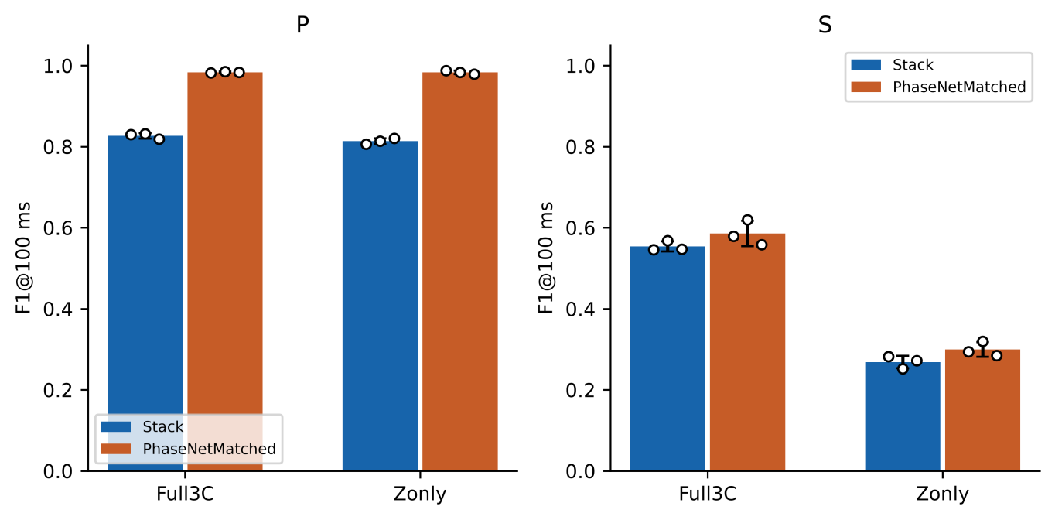
Fig. 5. Stacker versus PhaseNet-style MATLAB baseline on the same 330 test records from 221 sources: (left) P and (right) S F1 at ±100 ms, accepting detected and uncertain picks. Bars show means. For stacking, each white point is a mean over three meta seeds for one base seed; error bars are the sample SD of the three base-specific means. For the baseline, points are its three independently initialized fits and error bars are their sample SD. These are seed SDs, not confidence intervals; paired source-cluster intervals are reported in Table 7. Data and decoder are shared, but inputs and compute budgets differ.
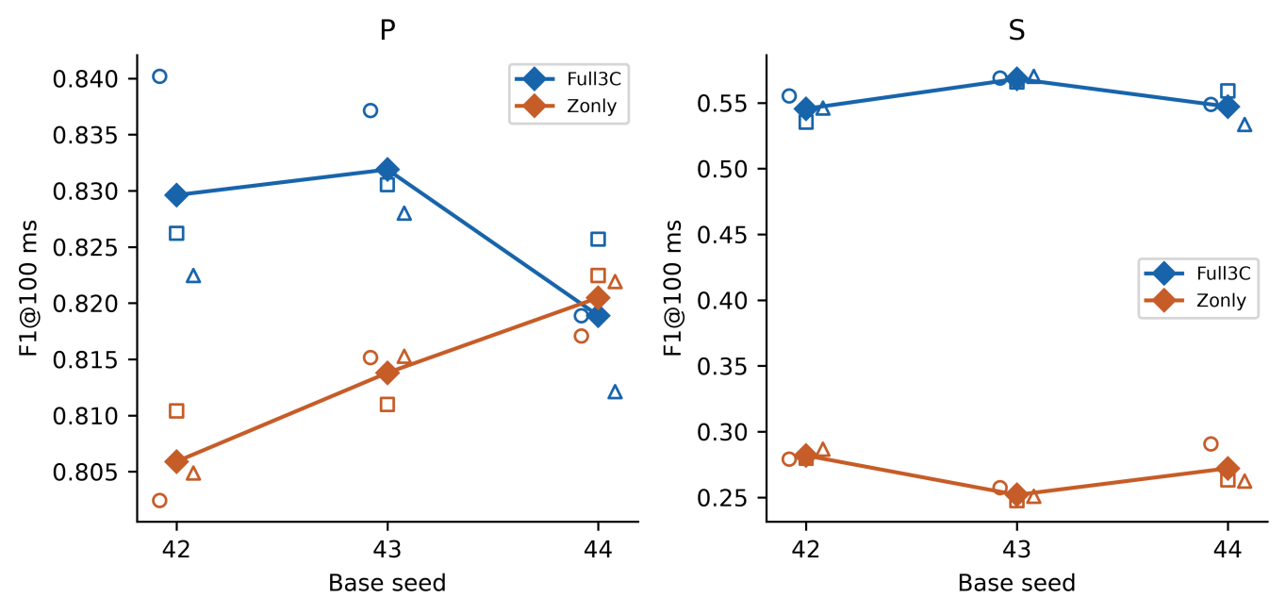
Fig. 6. Stacker initialization variability on one fixed source split: (left) P and (right) S F1 at ±100 ms. Colour identifies input mode, open symbols identify individual meta seeds, and filled diamonds show the three-meta-seed mean within each base seed. Horizontal offsets separate overlapping observations; lines connect means only as a visual guide. Panel y-axis ranges differ to expose the small P variations. Meta fits sharing a base are dependent. The source partition, OOF assignments and augmentation seeds remain fixed; this figure does not measure split or geographic uncertainty.
Across the expanded grid, the conditional Full3C-minus-Z-only S contrast was positive for both approaches (Table 7). The stacker S difference was positive in every matched base/meta combination. Base-42-only contrasts are retained in Online Resource 1, Table S30.
For the expanded stacking average, the paired 95% interval for Full3C minus Z-only F1@100 ms was −0.0016 to 0.0295 for P and 0.2293 to 0.3418 for S. The P interval does not establish equivalence; the S interval supports a component-access advantage conditional on these models and test sources. PhaseNetMatched also showed an S component-access difference of 0.2862 (interval 0.2345–0.3382), indicating that the finding is not unique to stacking.
4.4. Retrospective sensitivity analyses
On 287 both-phase manual records from 188 sources, stacking S Full3C-minus-Z-only ΔF1 was 0.2705 [0.2113, 0.3299], positive in all nine paired fits; PhaseNetMatched gave 0.2550 [0.2013, 0.3085]. This supports subset consistency, not annotation-error immunity. Both intervals included zero in the 20-record manual/no-historical-train-validation intersection, which still had historical test exposure (Online Resource 1, Table S25; Fig. S6).
Station stratification remains descriptive: the 12 records at nine currently unseen network–receiver keys provide only ten source clusters. Their S method-comparison intervals include zero and cannot establish station transfer (Online Resource 1, Table S26).
Across the predefined grid, accepted S Full3C-minus-Z-only ΔF1 ranged from 0.2839–0.2856 for stacking and 0.2862–0.2873 for PhaseNetMatched; all pointwise intervals were positive. Quality invariance reduces accepted scoring to nine peak/window combinations. Detected-only ranges were 0.2855–0.3031 and 0.2828–0.2875. The baseline P advantage persisted throughout. Accepted S method intervals included zero throughout, whereas 18/27 detected-only Z-only S intervals favoured the baseline. Stacking P component intervals depended on scoring policy (Online Resource 1, Table S27; Fig. S7). These fixed-model diagnostics neither select a new operating point nor establish historical calibration provenance.
Base-42 ablations are secondary. Their exploratory S contrasts favor the full temporal representation over probability-only, waveform-only and no-dilation variants, but full-minus-logistic intervals include zero for both phases. These results do not isolate nonlinearity or establish a universal architecture benefit (Online Resource 1, Tables S5–S6 and S29–S30).
5. Discussion
5.1. Informatics implications
The checks separate artifact consistency, exclusion of specified dependencies within the corrected workflow, and independent predictive confirmation. Only the first two are established here. Waveform fingerprints connect exported records to archive entries, while membership and feature contracts connect those identities to fitted models and predictions. This complements dataset interfaces such as SeisBench (Woollam et al. 2022) and the entity/activity/derivation perspective of PROV-DM (Moreau and Missier 2013); it is not a replacement for those tools or a claim of PROV conformance. For transfer, users must define a scientifically appropriate grouping key and test which dependencies remain outside it (Roberts et al. 2017).
The practical design principle is to preserve identity at each interface rather than rely on filenames or row order. A grouping manifest establishes what is excluded; a feature schema establishes what is passed between learners; an artifact manifest establishes what was executed; and replay tests the stored outputs. FAIR principles motivate reusable identifiers and metadata (Wilkinson et al. 2016), but this implementation is not a FAIR certification or a general provenance standard. No second-dataset portability benchmark was performed.
5.2. Seismic interpretation
The component-access difference is consistent with horizontal motion contributing useful shear-wave information and persists across the three tested base seeds. It also includes changes to the classical-base fallback and separately fitted learned bases, so it does not isolate any individual channel. Source-split, station, and regional stability remain untested.
Constrained and unconstrained outputs are diagnostic of the implemented decoder, not an isolated intervention on phase ordering: removing the S window also changes the quality-score domain. Record-level outputs and decoder diagnostics accompany the frozen result package. Ordered outputs do not show that the network learned a physical rule.
S timing remains a practical limitation: in the corrected Full3C base-42/meta-42 stacker, accepted S RMSE was 1596.78 ms and 6.21% of accepted errors exceeded 1 s. High candidate coverage is insufficient evidence for automatic catalogue use. PhaseNetMatched lowers mean accepted-pick MAE, but neither workflow has been validated for continuous monitoring or downstream location accuracy. Online Resource 1, Fig. S14 displays error tails; Fig. 7 shows selected waveform cases.
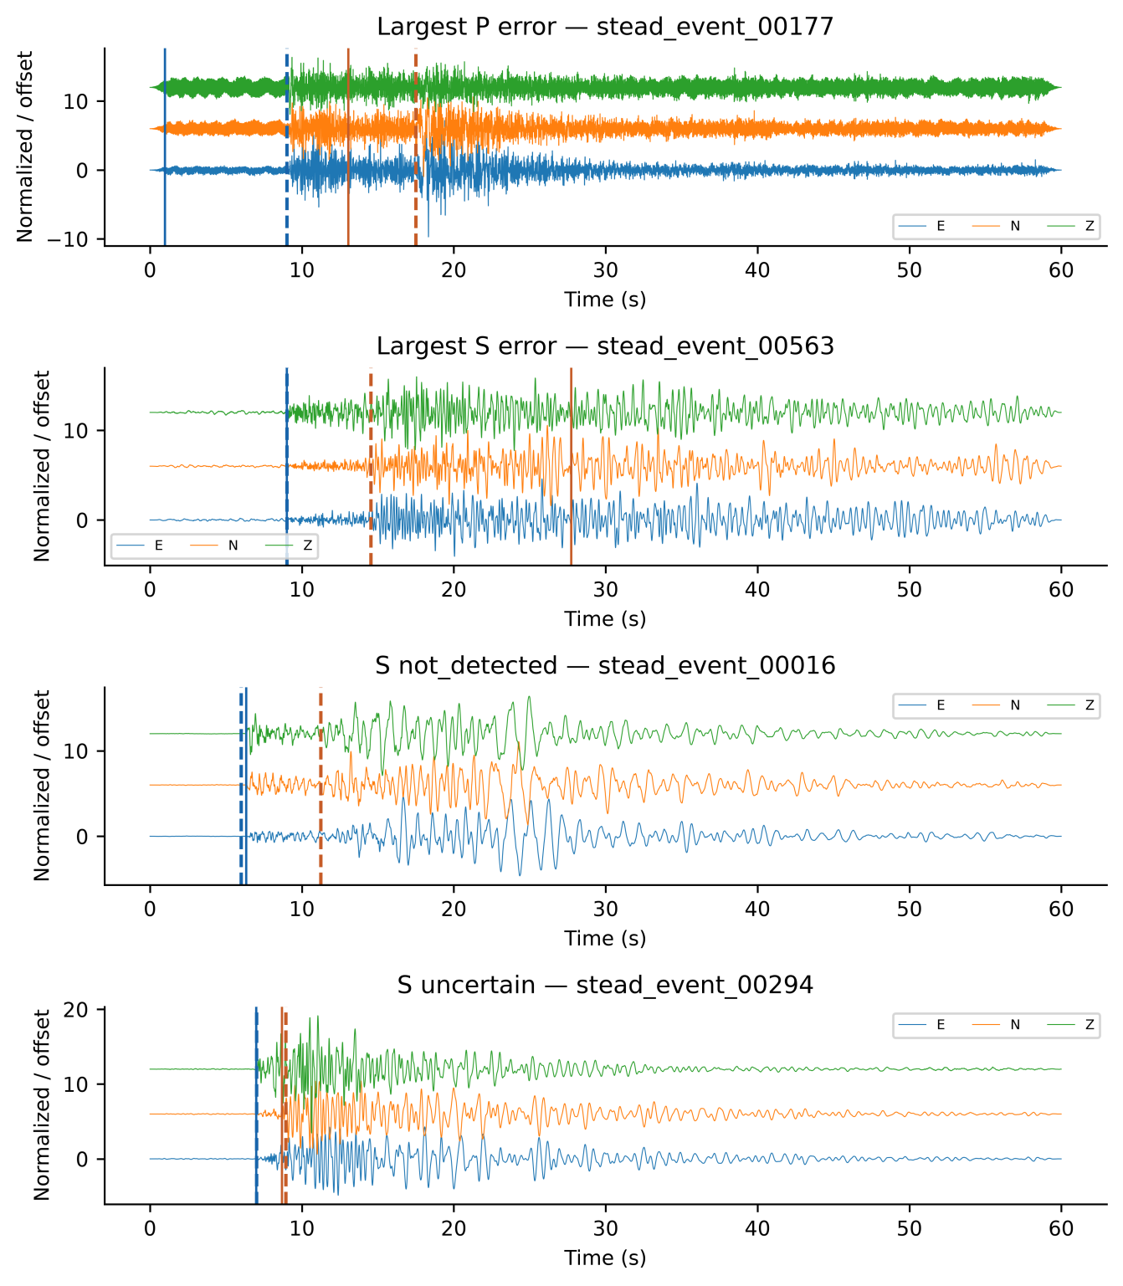
Fig. 7. Selected Full3C base-42/meta-42 cases: largest accepted P error, largest accepted S error, and first S not-detected and uncertain cases when present. Components are normalized individually and offset. Dashed lines mark true arrivals; solid lines mark reported predictions. Event IDs identify the selection.
5.3. Limits of inference
The study uses one retrospectively recovered STEAD subset and fixed split. Initialization repetitions and source bootstrapping exclude partition and training uncertainty; base-42 ablations lack replication at other base seeds. Meta fits share OOF features, and outer validation is reused for base selection, meta stopping and ensemble weighting. Most current test sources had historical training/validation exposure. Manual-status sensitivity does not quantify annotation error, and the unavailable historical selection recipe limits assessment of selection bias. Twelve unseen-key records cannot establish station transfer. Threshold sensitivity does not prove validation-only calibration; multiple intervals remain exploratory. Regional transfer, continuous-stream false alarms, overlapping events and operational latency were not evaluated. The regenerated CSVs restore byte-identical selected inputs in the tested archive; this does not restore independent validation, prove another archive version equivalent, or establish cross-hardware replay.
The additional comparator is a PhaseNet-style MATLAB adaptation, not the official PhaseNet implementation or a pretrained benchmark. It uses the same data and decoder but differs in architecture, input representation, minibatch size, and optimizer-step budget; the observed differences cannot be assigned to one design choice. TwoStream-EQT and SeismoDual report evaluation across additional datasets or acquisition settings (Peng et al. 2025; Tang and Chen 2026); their scores are not directly comparable here. The AIC score centre cannot exceed 9.99 s, whereas 234 of 330 test S arrivals and 15 test P arrivals occur later. This limits the classical comparator and supplied features; the study is not a general comparison against optimized AIC picking. These counts concern score centres before conditional decoding, not final error counts.
5.4. Future directions
Confirmation requires data outside prior research and development; another split of this population cannot erase historical exposure. Additional source splits can measure partition sensitivity, while nested validation separates selection stages. Independent datasets, matched official picker implementations, continuous-record false alarms, latency and controlled perturbations remain necessary tests of transfer and mechanism.

6. Conclusions
The study demonstrates an executable connection between waveform identity, grouped feature generation, model provenance and reproducible evaluation. Unique matches in the local STEAD archive define the retained records and sources; membership assertions and replay make their computational use inspectable. Synthetic failures show what the implemented checks reject. These outcomes establish artifact consistency and specified within-run exclusions. Historical development exposure prevents an independent-confirmation claim, and station, regional and independent-dataset generalization remain unestablished. A tested export profile now regenerates all 2,234 retained CSV byte hashes from their mapped HDF5 traces, while the original subset-selection history remains unavailable.
On this fixed split of 330 records from 221 sources held out from v2 fitting and validation, accepted stacking P/S F1@100 ms was 0.8268/0.5536 for Full3C and 0.8134/0.2686 for Z-only. Between-base SDs were 0.0069/0.0127 and 0.0073/0.0152. Full3C accepted-pick MAE was 166.62/610.29 ms, with coverage 99.06%/98.01%. Acceptance combines detected and uncertain picks.
The S component difference was 0.2850 (conditional 95% interval 0.2293–0.3418). PhaseNetMatched achieved P/S F1 of 0.9833/0.5857 (Full3C) and 0.9833/0.2995 (Z-only); primary conditional intervals support its P advantage but include zero for both S method differences. Base-42 ablations support exploratory S context/dilation gains without isolating nonlinearity. Confirmation requires data kept outside prior development.

Statements and Declarations

Author contributions
Rahmat Catur Wibowo: Conceptualization, Methodology, Software, Validation, Formal analysis, Investigation, Data curation, Writing – original draft, Writing – review & editing, Visualization, Supervision, Project administration. Razki Alfatah Khairu Mahli: Software, Investigation, Validation, Visualization, Writing – review & editing. Karyanto: Software, Data curation, Investigation, Writing – review & editing. Hendra Amijaya: Methodology, Resources, Writing – review & editing. Aristoteles: Formal analysis, Validation, Writing – review & editing. Maman Hermana: Validation, Writing – review & editing. Muh Sarkowi: Conceptualization, Methodology, Supervision, Writing – review & editing.

Code availability
The software is MIT licensed. The implementation repository is https://github.com/rcw3712/ICNN_MetaPicker_Curated_STEAD_MATLAB. Release source-verified-v2.0.0, Git commit 8e82c781a1641191b6b56b15688d68e269b24918, is archived at https://doi.org/10.5281/zenodo.22824997. Its source_verified_v2 directory contains the recovery mapping, frozen partition and OOF protocol, training scripts, 106 checkpoints, predictions, independent audits, inference receipts and threshold/station diagnostics, with an English user guide, runnable synthetic examples and hash manifests. The downloaded archive matches all 1,241 package-manifest entries. Earlier releases contain historical partitions and must not be used to reproduce these corrected results. The archived release retains the earlier manuscript title. The present ESI manuscript reorganizes the presentation and updates literature and availability wording after archiving; fitted models, frozen predictions and reported performance are unchanged. The subsequent revision adds a tested CSV-regeneration utility and its receipts; these additions are not claimed to be in the existing DOI archive. The archive is cited as Wibowo et al. (2026).

Data availability
The waveforms originate from STEAD (Mousavi et al. 2019), available through https://github.com/smousavi05/STEAD. The retained 2,234 records map to 1,477 recovered earthquake sources. Trace names, original source IDs and numerical waveform fingerprints specify the selected observations independently of their local ordinal filenames. Raw STEAD waveforms remain subject to the original distribution terms and are not redistributed here.
The retained trace mapping and waveform fingerprints identify the inputs. The accompanying regenerate_retained_csv.py utility reconstructs the retained CSV representation from STEAD HDF5 and rejects any file whose SHA-256 differs from the frozen CSV manifest. All 2,234 regenerated byte streams matched in the tested local archive. Raw waveforms are not bundled. This recovers the selected exports, not the unavailable original selection/filtering decisions; exhaustive uniqueness and reconstruction results apply to the tested archive version. Historical-role and threshold/station diagnostics remain available.

Competing interests
The authors declare that they have no known competing financial interests or personal relationships that could have appeared to influence the work reported in this paper. The development of the I-CNN MetaPicker framework was conducted solely for academic research purposes and did not receive commercial sponsorship or involve any commercial entity.

Funding
This research was conducted as part of ongoing academic activities of the authors and did not receive dedicated external funding. The authors received no financial support for the research, authorship, or publication of this article.

AI assistance in manuscript preparation
During manuscript preparation, the authors used ChatGPT/Codex (OpenAI) and Claude (Anthropic) for language editing, organization, and assistance drafting tables and captions. After using these tools, the authors reviewed and edited the text, verified references and consistency with the study results, and take full responsibility for the content of the publication. AI assistance with the computational workflow is described in Section 3.

Supplementary information
Online Resource 1 (ESM_1.pdf) contains supplementary figures S1–S14 and tables S1–S30, covering feature statistics, secondary base-42 results, hyperparameters, provenance, historical roles, replay and sensitivity diagnostics. The accompanying reconstruction script and receipts document the HDF5-to-CSV check.

References
Allen RV (1978) Automatic earthquake recognition and timing from single traces. Bulletin of the Seismological Society of America 68:1521–1532. https://doi.org/10.1785/BSSA0680051521
Baer M, Kradolfer U (1987) An automatic phase picker for local and teleseismic events. Bulletin of the Seismological Society of America 77:1437–1445. https://doi.org/10.1785/BSSA0770041437
Bai S, Kolter JZ, Koltun V (2018) An empirical evaluation of generic convolutional and recurrent networks for sequence modeling. arXiv preprint arXiv:1803.01271. https://doi.org/10.48550/arXiv.1803.01271
Cawley GC, Talbot NLC (2010) On over-fitting in model selection and subsequent selection bias in performance evaluation. Journal of Machine Learning Research 11:2079–2107. https://www.jmlr.org/papers/v11/cawley10a.html
Cheng A, Xu E, Yao P, Zhou Y, Huang S, Ye Z (2024) An automatic arrival time picking algorithm of P-wave based on adaptive characteristic function. Computers & Geosciences 185:105544. https://doi.org/10.1016/j.cageo.2024.105544
Duerr RE, Downs RR, Tilmes C, Barkstrom B, Lenhardt WC, Glassy J, Bermudez LE, Slaughter P (2011) On the utility of identification schemes for digital earth science data: an assessment and recommendations. Earth Science Informatics 4:139–160. https://doi.org/10.1007/s12145-011-0083-6
Ioffe S, Szegedy C (2015) Batch normalization: accelerating deep network training by reducing internal covariate shift. Proceedings of the 32nd International Conference on Machine Learning, PMLR 37:448–456. https://doi.org/10.48550/arXiv.1502.03167
Jover-Alfaro J, Arias-Antúnez E, Mateo-Cortés JA (2026) Forecasting earthquakes by Machine Learning techniques: lights and shadows. Earth Science Informatics 19:24. https://doi.org/10.1007/s12145-026-02078-x
Kapoor S, Narayanan A (2023) Leakage and the reproducibility crisis in machine-learning-based science. Patterns 4:100804. https://doi.org/10.1016/j.patter.2023.100804
Kingma DP, Ba J (2015) Adam: a method for stochastic optimization. Proceedings of the 3rd International Conference on Learning Representations (ICLR 2015). https://doi.org/10.48550/arXiv.1412.6980
Maeda N (1985) A method for reading and checking phase times in auto-processing system of seismic wave data. Zisin (Journal of the Seismological Society of Japan, Second Series) 38:365–379. https://doi.org/10.4294/zisin1948.38.3_365
Moreau L, Missier P (eds) (2013) PROV-DM: The PROV Data Model. W3C Recommendation, 30 April 2013. https://www.w3.org/TR/2013/REC-prov-dm-20130430/
Mousavi SM, Ellsworth WL, Zhu W, Chuang LY, Beroza GC (2020) Earthquake transformer—An attentive deep-learning model for simultaneous earthquake detection and phase picking. Nature Communications 11:3952. https://doi.org/10.1038/s41467-020-17591-w
Mousavi SM, Sheng Y, Zhu W, Beroza GC (2019) STanford EArthquake Dataset (STEAD): A global data set of seismic signals for AI. IEEE Access 7:179464–179476. https://doi.org/10.1109/ACCESS.2019.2947848
Münchmeyer J, Woollam J, Rietbrock A, Tilmann F, Lange D, Bornstein T, Diehl T, Giunchi C, Haslinger F, Jozinović D, Michelini A, Saul J, Soto H (2022) Which picker fits my data? A quantitative evaluation of deep learning based seismic pickers. Journal of Geophysical Research: Solid Earth 127:e2021JB023499. https://doi.org/10.1029/2021JB023499
Peng L, Li L, Mousavi SM, Zeng X, Beroza GC (2025) TwoStream-EQT: A microseismic phase picking model combining time and frequency domain inputs. Computers & Geosciences 204:105991. https://doi.org/10.1016/j.cageo.2025.105991
Roberts DR, Bahn V, Ciuti S, Boyce MS, Elith J, Guillera‐Arroita G, Hauenstein S, Lahoz‐Monfort JJ, Schröder B, Thuiller W, Warton DI, Wintle BA, Hartig F, Dormann CF (2017) Cross‐validation strategies for data with temporal, spatial, hierarchical, or phylogenetic structure. Ecography 40:913-929. https://doi.org/10.1111/ecog.02881
Sleeman R, van Eck T (1999) Robust automatic P-phase picking: An on-line implementation in the analysis of broadband seismogram recordings. Physics of the Earth and Planetary Interiors 113:265–275. https://doi.org/10.1016/S0031-9201(99)00007-2
Srivastava N, Hinton G, Krizhevsky A, Sutskever I, Salakhutdinov R (2014) Dropout: a simple way to prevent neural networks from overfitting. Journal of Machine Learning Research 15:1929–1958. https://www.jmlr.org/papers/v15/srivastava14a.html
Tang K-W, Chen K-Y (2026) SeismoDual: A dual-domain deep learning framework for robust seismic phase picking. Computers & Geosciences 207:106080. https://doi.org/10.1016/j.cageo.2025.106080
Vargas-Zamudio KA, Perton M, Legrand D, Sánchez-Sesma FJ (2026) Physically driven feature engineering for deep learning applications in seismo-volcanic signal analysis. Earth Science Informatics 19:11. https://doi.org/10.1007/s12145-025-02062-x
Wibowo RC, Mahli RAK, Karyanto, Amijaya H, Aristoteles, Hermana M, Sarkowi M (2026) Source-Grouped Evaluation of Temporal Stacking for Seismic Phase Picking with Three-Component Data. Version source-verified-v2.0.0. Zenodo. https://doi.org/10.5281/zenodo.22824997
Wilkinson MD, Dumontier M, Aalbersberg IJ, Appleton G, Axton M, Baak A, Blomberg N, Boiten JW, da Silva Santos LB, Bourne PE, Bouwman J, Brookes AJ, Clark T, Crosas M, Dillo I, Dumon O, Edmunds S, Evelo CT, Finkers R, Gonzalez-Beltran A, Gray AJG, Groth P, Goble C, Grethe JS, Heringa J, ’t Hoen PAC, Hooft R, Kuhn T, Kok R, Kok J, Lusher SJ, Martone ME, Mons A, Packer AL, Persson B, Rocca-Serra P, Roos M, van Schaik R, Sansone SA, Schultes E, Sengstag T, Slater T, Strawn G, Swertz MA, Thompson M, van der Lei J, van Mulligen E, Velterop J, Waagmeester A, Wittenburg P, Wolstencroft K, Zhao J, Mons B (2016) The FAIR Guiding Principles for scientific data management and stewardship. Scientific Data 3:160018. https://doi.org/10.1038/sdata.2016.18
Wolpert DH (1992) Stacked generalization. Neural Networks 5:241–259. https://doi.org/10.1016/S0893-6080(05)80023-1
Woollam J, Münchmeyer J, Tilmann F, Rietbrock A, Lange D, Bornstein T, Diehl T, Giunchi C, Haslinger F, Jozinović D, Michelini A, Saul J, Soto H (2022) SeisBench—A toolbox for machine learning in seismology. Seismological Research Letters 93:1695–1709. https://doi.org/10.1785/0220210324
Zhu W, Beroza GC (2019) PhaseNet: A deep-neural-network-based seismic arrival-time picking method. Geophysical Journal International 216:261–273. https://doi.org/10.1093/gji/ggy423

