Waveform Identity and Reproducible Source-Grouped Evaluation of Seismic Phase Pickers
Rahmat Catur Wibowo¹*, Razki Alfatah Khairu Mahli², Karyanto³, Hendra Amijaya⁴, Aristoteles⁵, Maman Hermana⁶, Muh Sarkowi⁷
¹ Geological Engineering Department, Engineering Faculty, Universitas Lampung, Jl. Prof. Dr. Soemantri Brojonegoro No. 1, Bandar Lampung 35145, Indonesia; ORCID: 0000-0003-2754-1803
² Geophysics Engineering Department, Engineering Faculty, Universitas Lampung, Jl. Prof. Dr. Soemantri Brojonegoro No. 1, Bandar Lampung 35145, Indonesia; ORCID: 0009-0008-9676-7842
³ Geophysics Engineering Department, Engineering Faculty, Universitas Lampung, Jl. Prof. Dr. Soemantri Brojonegoro No. 1, Bandar Lampung 35145, Indonesia; ORCID: 0000-0003-0189-4109
⁴ Geological Engineering Department, Engineering Faculty, Universitas Gadjah Mada, Jl. Grafika No. 2, Yogyakarta 55284, Indonesia; ORCID: 0000-0002-9602-2903
⁵ Computer Science Department, Mathematics and Natural Science Faculty, Universitas Lampung, Jl. Prof. Dr. Soemantri Brojonegoro No. 1, Bandar Lampung 35145, Indonesia; ORCID: 0000-0002-9369-4528
⁶ Geosciences Department, Universiti Teknologi Petronas, Bandar Seri Iskandar, 32610 Perak, Malaysia; ORCID: 0000-0002-0205-4446
⁷ Geophysics Engineering Department, Engineering Faculty, Universitas Lampung, Jl. Prof. Dr. Soemantri Brojonegoro No. 1, Bandar Lampung 35145, Indonesia; ORCID: 0000-0001-8554-3407
*Corresponding author: rahmat.caturwibowo@eng.unila.ac.id

Abstract
Reliable comparison of seismic phase pickers requires traceable data identities and inspectable relationships between training observations and derived predictions. We present a reproducible evaluation workflow linking waveform fingerprints, earthquake-source groups, out-of-fold feature construction, model provenance and numerical verification. An exhaustive audit of the local STanford EArthquake Dataset archive uniquely matches 2,234 retained waveforms to 1,477 sources. A fixed source-disjoint split contains 330 test records from 221 sources. Fresh replay loads all 106 checkpoints, reproduces 18,528 out-of-fold and 1,980 test feature tensors, and recovers 70 test prediction sets; independent calculations reproduce 1,260 metric rows. Synthetic examples demonstrate rejection of invalid source membership, augmentation lineage, feature order and artifact bytes. Temporal stacking and a PhaseNet-style baseline provide a case study of component access. On this fixed split, stacking achieves accepted-pick F1 scores within 100 ms of 0.8268/0.5536 for compressional/shear arrivals with three components and 0.8134/0.2686 with vertical input alone. The shear-phase difference is 0.2850, with a conditional source-cluster 95% interval of 0.2293–0.3418. The baseline has a supported compressional-phase advantage; primary shear-phase method-comparison intervals include zero. The contribution is an executable connection between identity, data lineage and evaluation, rather than a new stacking algorithm. Historical development exposure prevents an independent-confirmation claim. One fixed split, limited unseen-station observations and the unavailable original extraction recipe constrain predictive interpretation and reconstruction.
Keywords: seismic phase picking; waveform identity; data provenance; source-grouped evaluation; reproducibility; temporal stacking

1. Introduction
Seismic phase-picking results are only interpretable when the evaluated waveforms, their earthquake sources and their roles in model development can be traced. Arrival times of compressional (P) and shear (S) waves support earthquake location and subsurface analysis, but a reproducible performance number also depends on record identity, partition membership and decoding rules. Earth science data identification therefore concerns both locating an archived object and determining whether differently represented objects contain the same scientific information (Duerr et al. 2011). In a learned processing pipeline, these identifiers must remain connected to augmentation, fitted models and derived predictions.
Classical onset detectors use energy changes or change-point criteria (Allen 1978; Baer and Kradolfer 1987; Maeda 1985; Sleeman and van Eck 1999), while adaptive characteristic functions extend automatic P-wave estimation (Cheng et al. 2024). Neural pickers learn probability sequences from waveforms (Zhu and Beroza 2019; Mousavi et al. 2020). Physically driven feature engineering offers another route for detection and phase picking in seismo-volcanic data (Vargas-Zamudio et al. 2026). Shared benchmarks and software make the dependence of performance on data distribution and evaluation protocol explicit (Münchmeyer et al. 2022; Woollam et al. 2022). These approaches motivate inspecting evaluation inputs and outputs alongside model architecture.
Validation design can change the interpretation of seismic machine-learning results. Jover-Alfaro et al. (2026) examined random, temporal and cross-location evaluation in earthquake forecasting. Their forecasting task differs from arrival-time picking, and their findings are not evidence of leakage in the pickers considered here. The relevant informatics problem is how to make the dependencies between observations, training and evaluation inspectable. For phase picking, repeated recordings of the same earthquake require a source identifier; chronological ordering alone does not express every such dependency. Source grouping also does not remove station or regional dependence, or erase earlier development exposure.
Stacked generalization trains a second-level learner from base-model predictions (Wolpert 1992). Temporal stacking retains probability sequences, exposing disagreement in timing and confidence to a fusion model. It introduces additional data lineage: the meta-training inputs depend on which observations fitted each base model. We implement source-grouped out-of-fold (OOF) construction with separate inner validation for each held fold, a canonical 15-channel interface, augmentation-parent checks, source-membership assertions and input/output hashes. The final base and meta stages reuse outer validation for selection; this dependency is documented rather than represented as independent selection.
Recent fusion approaches combine complementary representations. TwoStream-EQT uses time-domain and time-frequency inputs and evaluates STEAD, DiTing and Geysers data (Peng et al. 2025). SeismoDual combines waveforms and spectrograms for P-phase picking across STEAD, INSTANCE and CWA (Tang and Chen 2026). Here, fusion uses temporal outputs of heterogeneous pickers together with waveform context. We compare it with a PhaseNet-style MATLAB baseline under matched data-access and decoding rules. The study does not infer missing controls in those published approaches, establish superiority over their reported scores, or claim a new neural architecture.
The study asks three connected questions: can retained waveform exports be linked uniquely to their source records in the local archive; can those identities be traced through grouped fitting, OOF feature assembly and fixed-model replay; and what conclusions about three-component versus vertical-only input survive the documented evaluation and development constraints? The informatics contribution is the executable connection between these stages and its observed verification on a retained seismic dataset. Grouped cross-validation, stacking and hashing are established techniques. Their individual novelty is not asserted, and successful replay is distinguished from independent predictive confirmation.
Figure 1 summarizes the workflow. We first describe waveform identity recovery and source grouping, then the feature and model interfaces and their executable checks. Results begin with provenance and replay evidence before presenting the seismic component-access comparison. Three base seeds crossed with three meta seeds characterize initialization variation on one fixed split. The primary conditional intervals support a PhaseNet-style P advantage but do not resolve the S method difference. The workflow exposes what can be reproduced, which data dependencies are controlled within the corrected run, and which conclusions remain limited by historical development exposure.
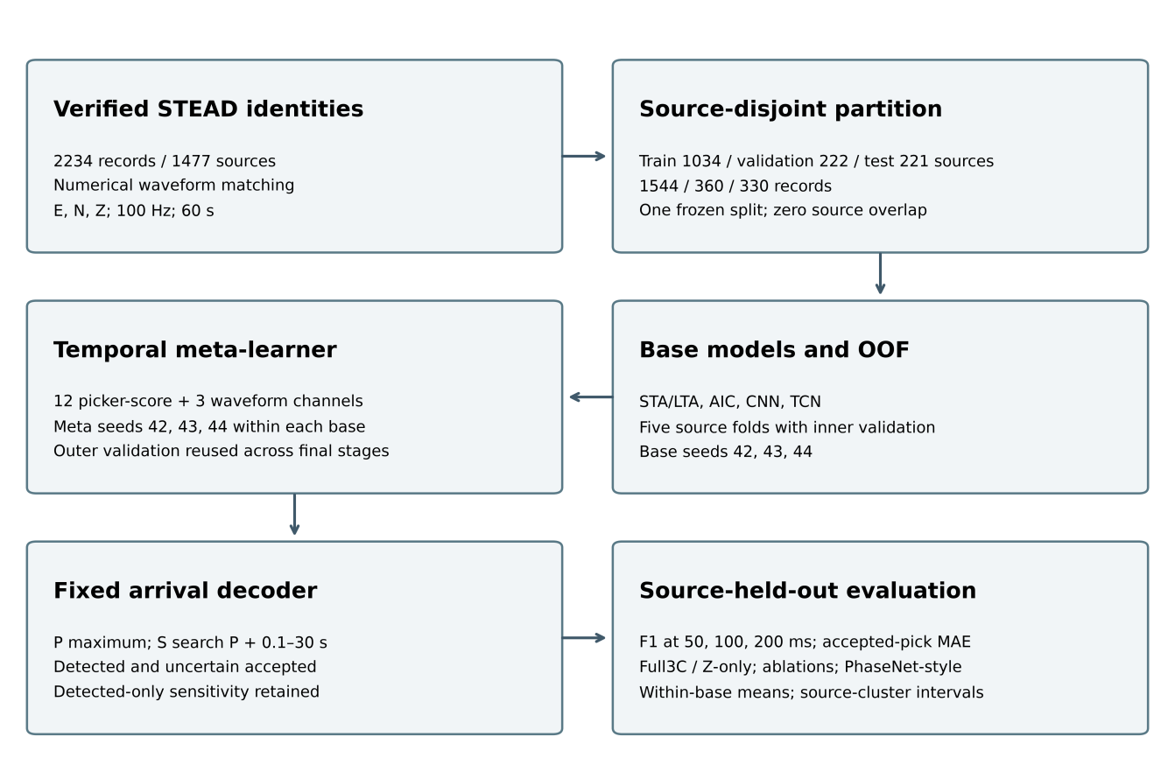
Fig. 1. Source-grouped evaluation workflow: curation, outer partitioning, OOF feature generation, canonical temporal inputs, I-CNN fusion, deterministic phase-ordering constraints, and held-out evaluation. Outer validation selects final base and meta checkpoints; it is reused across these levels. The diagram was drawn programmatically with scripting assistance from ChatGPT/Codex (OpenAI; accessed September 2026) and checked against the implemented workflow by the authors.

2. Data and dataset curation

2.1. Source dataset
We used the STanford EArthquake Dataset (STEAD; Mousavi et al. 2019). The retained population comprises 2,234 previously exported local-earthquake waveform records whose identities were recovered by matching their numerical content to the upstream HDF5 data. It contains 1,477 earthquake sources. Recovered metadata show magnitude 2.5–5.9, source distance 0–49.99 km, and minimum component SNR −1.70–103.60 dB (median 44.70 dB; Fig. 2; Table 1). The original extraction index and selection script were unavailable; these are measured population characteristics, not a reconstructed selection rule. Only 484 records have distance ≤15 km and 2,172 have minimum component SNR ≥10 dB. We therefore do not characterize the entire subset by those previously stated filters.

2.2. Waveform representation and record format
Each event–station observation contains 6000 samples at 100 Hz (60 s), with ordered E, N, and Z components and reference arrivals in seconds. The waveform representation is given in equation 1; equation 2 converts an arrival time to a zero-based sample index.
$X_{i}=\left[\begin{matrix}E_{i}(t_{1}) & N_{i}(t_{1}) & Z_{i}(t_{1}) \\ E_{i}(t_{2}) & N_{i}(t_{2}) & Z_{i}(t_{2}) \\ ⋮ & ⋮ & ⋮ \\ E_{i}(t_{6000}) & N_{i}(t_{6000}) & Z_{i}(t_{6000})\end{matrix}\right]$ (1)
where $X_{i}∈ℝ^{6000×3}$ is the three-component waveform for record $i$. The associated ground-truth arrival times are denoted by $t_{i}^{P}$ and $t_{i}^{S}$. Sample indices were derived only when required by the processing functions (equation 2):
$n_{i}^{P}=round\left(t_{i}^{P} f_{s}\right), n_{i}^{S}=round\left(t_{i}^{S} f_{s}\right)$ (2)
Here fs = 100 Hz. A zero-based sample n maps to MATLAB array index n+1; an array index j maps back to time (j−1)/fs. CSV arrival times in seconds remain authoritative, and evaluation does not replace them with rounded metadata indices.
CSV arrival times remain authoritative for evaluation. Original STEAD source_id values recovered from waveform matches define grouping; event IDs identify individual exported records. All 2,234 CSV labels equal floor(upstream arrival sample)/100 for both phases. Fractional upstream samples differ from the retained CSV labels for 94 P and 124 S arrivals, by at most 9.01 ms. We preserve the historical CSV labels consistently across methods rather than silently replacing their rounding convention.

2.3. Metadata integration and identifier recovery
We matched 6,000×3 CSV waveforms to STEAD using SHA-256 hashes of little-endian float32 values in column-major E/N/Z order. Exhaustive hashing of all 1,265,657 local HDF5 waveform datasets found exactly one trace for each of the 2,234 distinct selected fingerprints, without conflicting source assignments. Upstream metadata agreed throughout. The mapping and partitions were frozen before v2 training; exhaustive uniqueness verification followed training. This establishes exact matches in this archive version, not near-duplicate absence or catalogue identity accuracy.
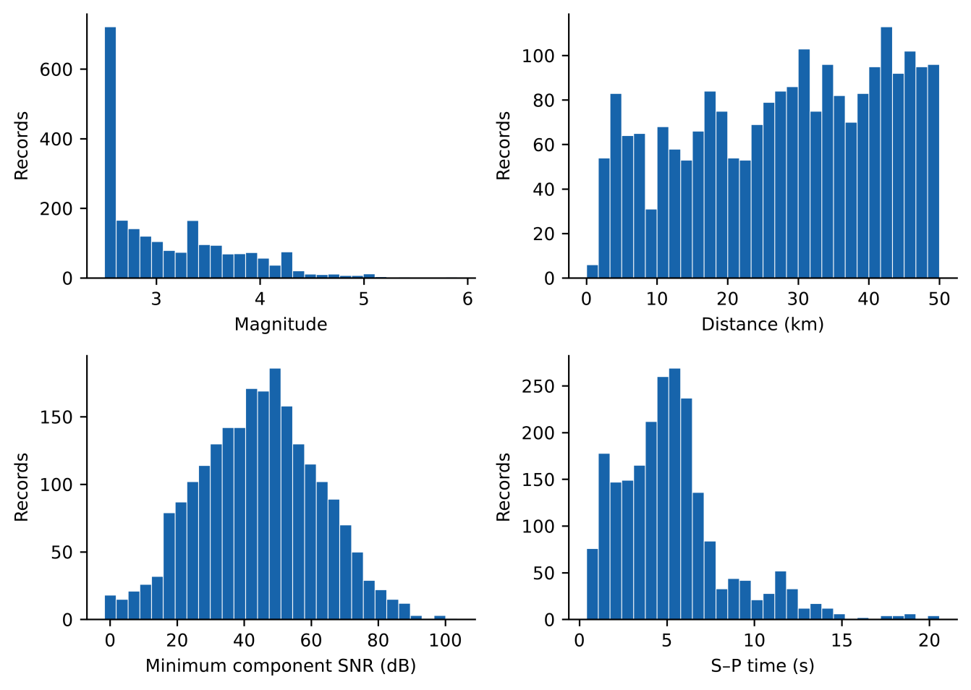
Fig. 2. Characteristics of the curated STEAD-derived dataset (N=2234 records): magnitude, epicentral distance, minimum component SNR, and S–P time. Each histogram uses 30 bins.
Table 1. Summary statistics of the curated STEAD-derived dataset used in this study.
Item | Value
Records / recovered sources | 2234 / 1477
Sampling / duration | 100 Hz / 60 s
Components | E, N, Z
Magnitude range; median | 2.5–5.9; 2.9
Distance range; median (km) | 0–49.99; 29.74
Minimum SNR range; median (dB) | −1.70–103.60; 44.70

Identity correction and rerun. The original ordinal metadata join misidentified waveforms: 151/335 historical test records shared physical sources with training. We corrected identities and reran all 106 fits. Current test records previously belonged to training (233), validation (46) or testing (51); 196/221 current test sources had historical training/validation membership. Thus source disjointness in v2 does not establish independent confirmation. Because population allocation and training also changed, old-to-new scores cannot isolate leakage-induced inflation (Online Resource 1, Tables S22–S23).

2.4. Waveform quality control
The corrected loader accepted all 2,234 records without missing files or read failures. Input checks cover waveform dimensions, finite values, the 100 Hz time grid and in-window ordered arrival labels. Numerical hashes connect these inputs to the recovered STEAD traces. No new filtering or label correction was applied after the verified population and source split were frozen.

2.5. Signal conditioning
Conditioning removes the component mean, detrends linearly, and applies a 1–45 Hz Butterworth band-pass filter using MATLAB butter with order argument 4 followed by filtfilt. Each component is normalized as (x−mean(x))/(std(x)+10⁻¹⁰), so an all-zero component remains zero. Explicit clipping was disabled. The same deterministic transforms were used in all subsets (equation 3). Supplementary Implementation Details specify the enhanced features and edge handling.
For an input component $x_{c}(t)$, where $c∈\{E,N,Z\}$, the conditioning operation can be summarized as (equation 3):
${\tilde{x}}_{c}(t)=N\left\{ℬ_{1\text{–}45\text{Hz}}\left[D\left(x_{c}(t)−{\overset{‾}{x}}_{c}\right)\right]\right\}$ (3)
where $D$ denotes detrending, $ℬ_{1\text{–}45\text{Hz}}$ denotes band-pass filtering, and $N$ denotes component normalization. The same deterministic conditioning parameters were applied to training, validation, and test records. Data augmentation was not part of dataset curation and was applied only after splitting, exclusively to training data.
Base CNN/TCN inputs contain eight channels: conditioned E/N/Z, their three envelopes, short-term Z energy, and a Z characteristic function. The final three waveform-context channels of the meta tensor retain conditioned E/N/Z; they are distinct from the eight-channel base representation.

2.6. Ground-truth label construction
Reference arrivals became Gaussian phase targets (equation 4; Zhu and Beroza 2019; Mousavi et al. 2020). Both arrivals have manual metadata status in 1,224/1,544 training, 306/360 validation and 287/330 test records. The other 417 records include automatic/autopicker status. Manual-only sensitivity restricts evaluation without retraining or independently validating annotations (Online Resource 1, Tables S24–S25).
For phase $k∈P,S$, the target at time $t$ was defined as (equation 4):
$y_{k}\left(t\right)=\exp\left[−\frac{{\left(t−t_{k}\right)}^{2}}{2σ_{k}^{2}}\right],$ (4)
Targets were truncated at ±4 standard deviations, with P/S widths of 0.06/0.08 s. The noise target is max(0, 1−max(yP,yS)); targets are not additionally normalized to sum to one where phase tails overlap (Fig. 3). Neural predictions, in contrast, use softmax. Target mass is 1+min(yP,yS). Overlapping masks occur in only 4 training, 0 validation, and 1 test records (Online Resource 1, Table S14). The implemented loss and its local weighting interpretation are given in Supplementary Implementation Details.
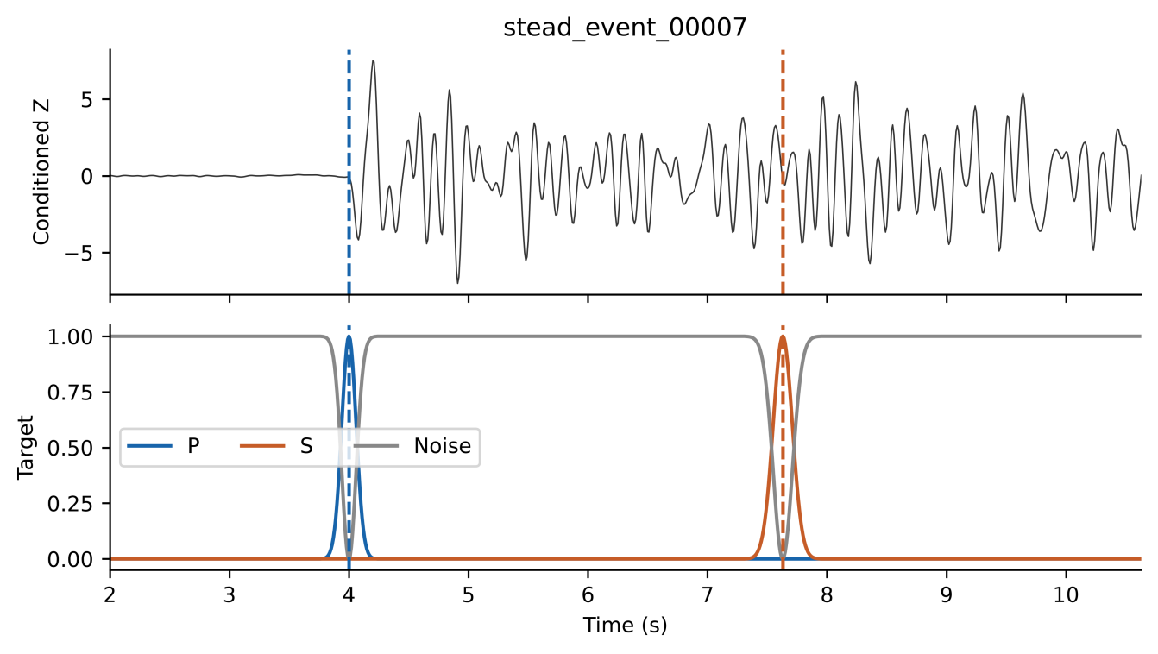
Fig. 3. Gaussian probability label formulation. (a) Vertical (Z) seismic component with true P- and S-wave arrival markers. (b) Gaussian probability masks used as training targets for the I-CNN meta-learner. The P-wave mask (blue) and S-wave mask (red) are centred on their respective true arrival times with standard deviations σP and σS (in samples). The noise/background mask (grey) equals max(0, 1−max(yP,yS)), the continuous complement of the larger phase mask.

2.7. Source-level partitioning
Unique recovered source IDs were deterministically ranked using SHA-256 stage/seed/source keys and allocated approximately 70%, 15% and 15% to train, validation and test. All records of one earthquake stay together (Table 2). Training contains 1,544 records from 1,034 sources, validation 360 records from 222 sources, and test 330 records from 221 sources. Pairwise source intersections are zero; station and regional overlap were not excluded. The same frozen outer split and five OOF assignments are used for both input modes and every base seed. Subset distributions appear in Online Resource 1, Fig. S2.
Test metadata contain 64 network–receiver keys across 23 networks; PB contributes 99/330 records. Fifty-five test keys also occur in training, covering 318 records. Nine keys absent from training and validation contain only 12 records from ten sources. These are retrospective strata, not a station-held-out design; keys do not distinguish station epochs (Online Resource 1, Tables S12 and S26).
Table 2. Source-level partitioning of the final curated dataset showing the number of unique earthquake sources and waveform records in each subset.
Subset | Sources | Records
Training | 1034 | 1544
Validation | 222 | 360
Test | 221 | 330
Total | 1477 | 2234

2.8. Leakage controls after dataset partitioning
Augmentation was restricted to training records: one augmented copy per original used additive noise at 20 dB target SNR, amplitude scaling in [0.5, 2.0], and horizontal-channel dropout with probability 0.20 (E, N, or both). Time shifting and polarity reversal were disabled. Validation and test records were not augmented. Source assignments were preserved throughout processing.

3. Methodology
Experiments used MATLAB R2024a with fixed source partitions. The corrected 40-fit main experiment used CNN/TCN base seed 42 and meta seeds 42, 43, and 44. An additional 66 fits repeated the complete base/OOF/meta workflow with base seeds 43 and 44 and trained six standalone PhaseNet-style baselines. Each base seed was crossed with all three meta seeds in both modes. OOF fold seed 42, inner split seeds 101–105, fold augmentation seeds 1001–1005, and final/OOF augmentation seed 4242 remained fixed. Thus initialization and training-order variability is examined conditional on the same partition and augmentation protocol; meta fits sharing a base are not independent full-pipeline replicates. Online Resource 1, Table S9 enumerates the 40 main invocations; Table S18 accounts for the full 106 fits.
Conditioning follows equation 3. STA/LTA and AIC supply deterministic probability-like scores rather than calibrated class probabilities (Allen 1978; Maeda 1985). Gaussian curves are centred on the global normalized STA/LTA peak or the AIC minimum. P uses Z; S uses the E/N resultant only when both horizontal components are nonzero, otherwise it falls back to Z. The AIC centre search is restricted to the first 10 s. Supplementary Implementation Details give the exact windows, normalization, fallback, and score construction. Learned bases emit P/S/noise softmax probabilities (equation 5).
The CNN has two convolutional blocks with 32/64 filters, kernel 7, batch normalization, ReLU, and dropout 0.30; its receptive field is 13 samples. TCN has four 32-filter blocks with kernel 3, dilations 1/2/4/8, dropout 0.20, and no residual connections; its receptive field is 31 samples (Bai et al. 2018). Both process the eight-channel representation at 100 Hz and finish with a 1×1 convolution and softmax. Base training used Adam at 10⁻³, batch size 16, at most 30 epochs, and validation patience of seven evaluations (Table 3).
$P_{P}\left(t\right)+P_{S}\left(t\right)+P_{N}\left(t\right)=1$ (5)
Five source-grouped OOF folds were formed within outer training. For each held fold, the other four were split by source into fitting and inner validation, reserving approximately 15% for checkpoint selection. Held sources entered neither subset. Those fold models supplied OOF features for held originals and their augmented copies. Final bases fitted weights using augmented outer training only; outer validation selected their checkpoints. Final bases then supplied outer-validation and test meta-features. Meta weights fitted OOF training features; the same outer validation selected meta checkpoints. This is adaptive validation reuse across levels, not an independent nested validation estimate. Current test sources were excluded from v2 fitting and checkpoint selection; this exclusion does not erase their historical roles before identity correction. Online Resource 1, Table S8 maps each role.
The meta input is a 6000×15 tensor: twelve P/S/noise channels from four pickers, followed by conditioned E/N/Z (equation 6; Fig. 4). Channel count and order are asserted. Online Resource 1, Table S1 describes all held-out test tensors; Online Resource 1, Fig. S5 illustrates one record.
$X_{\text{meta}}∈ℝ^{6000×15}$ (6)
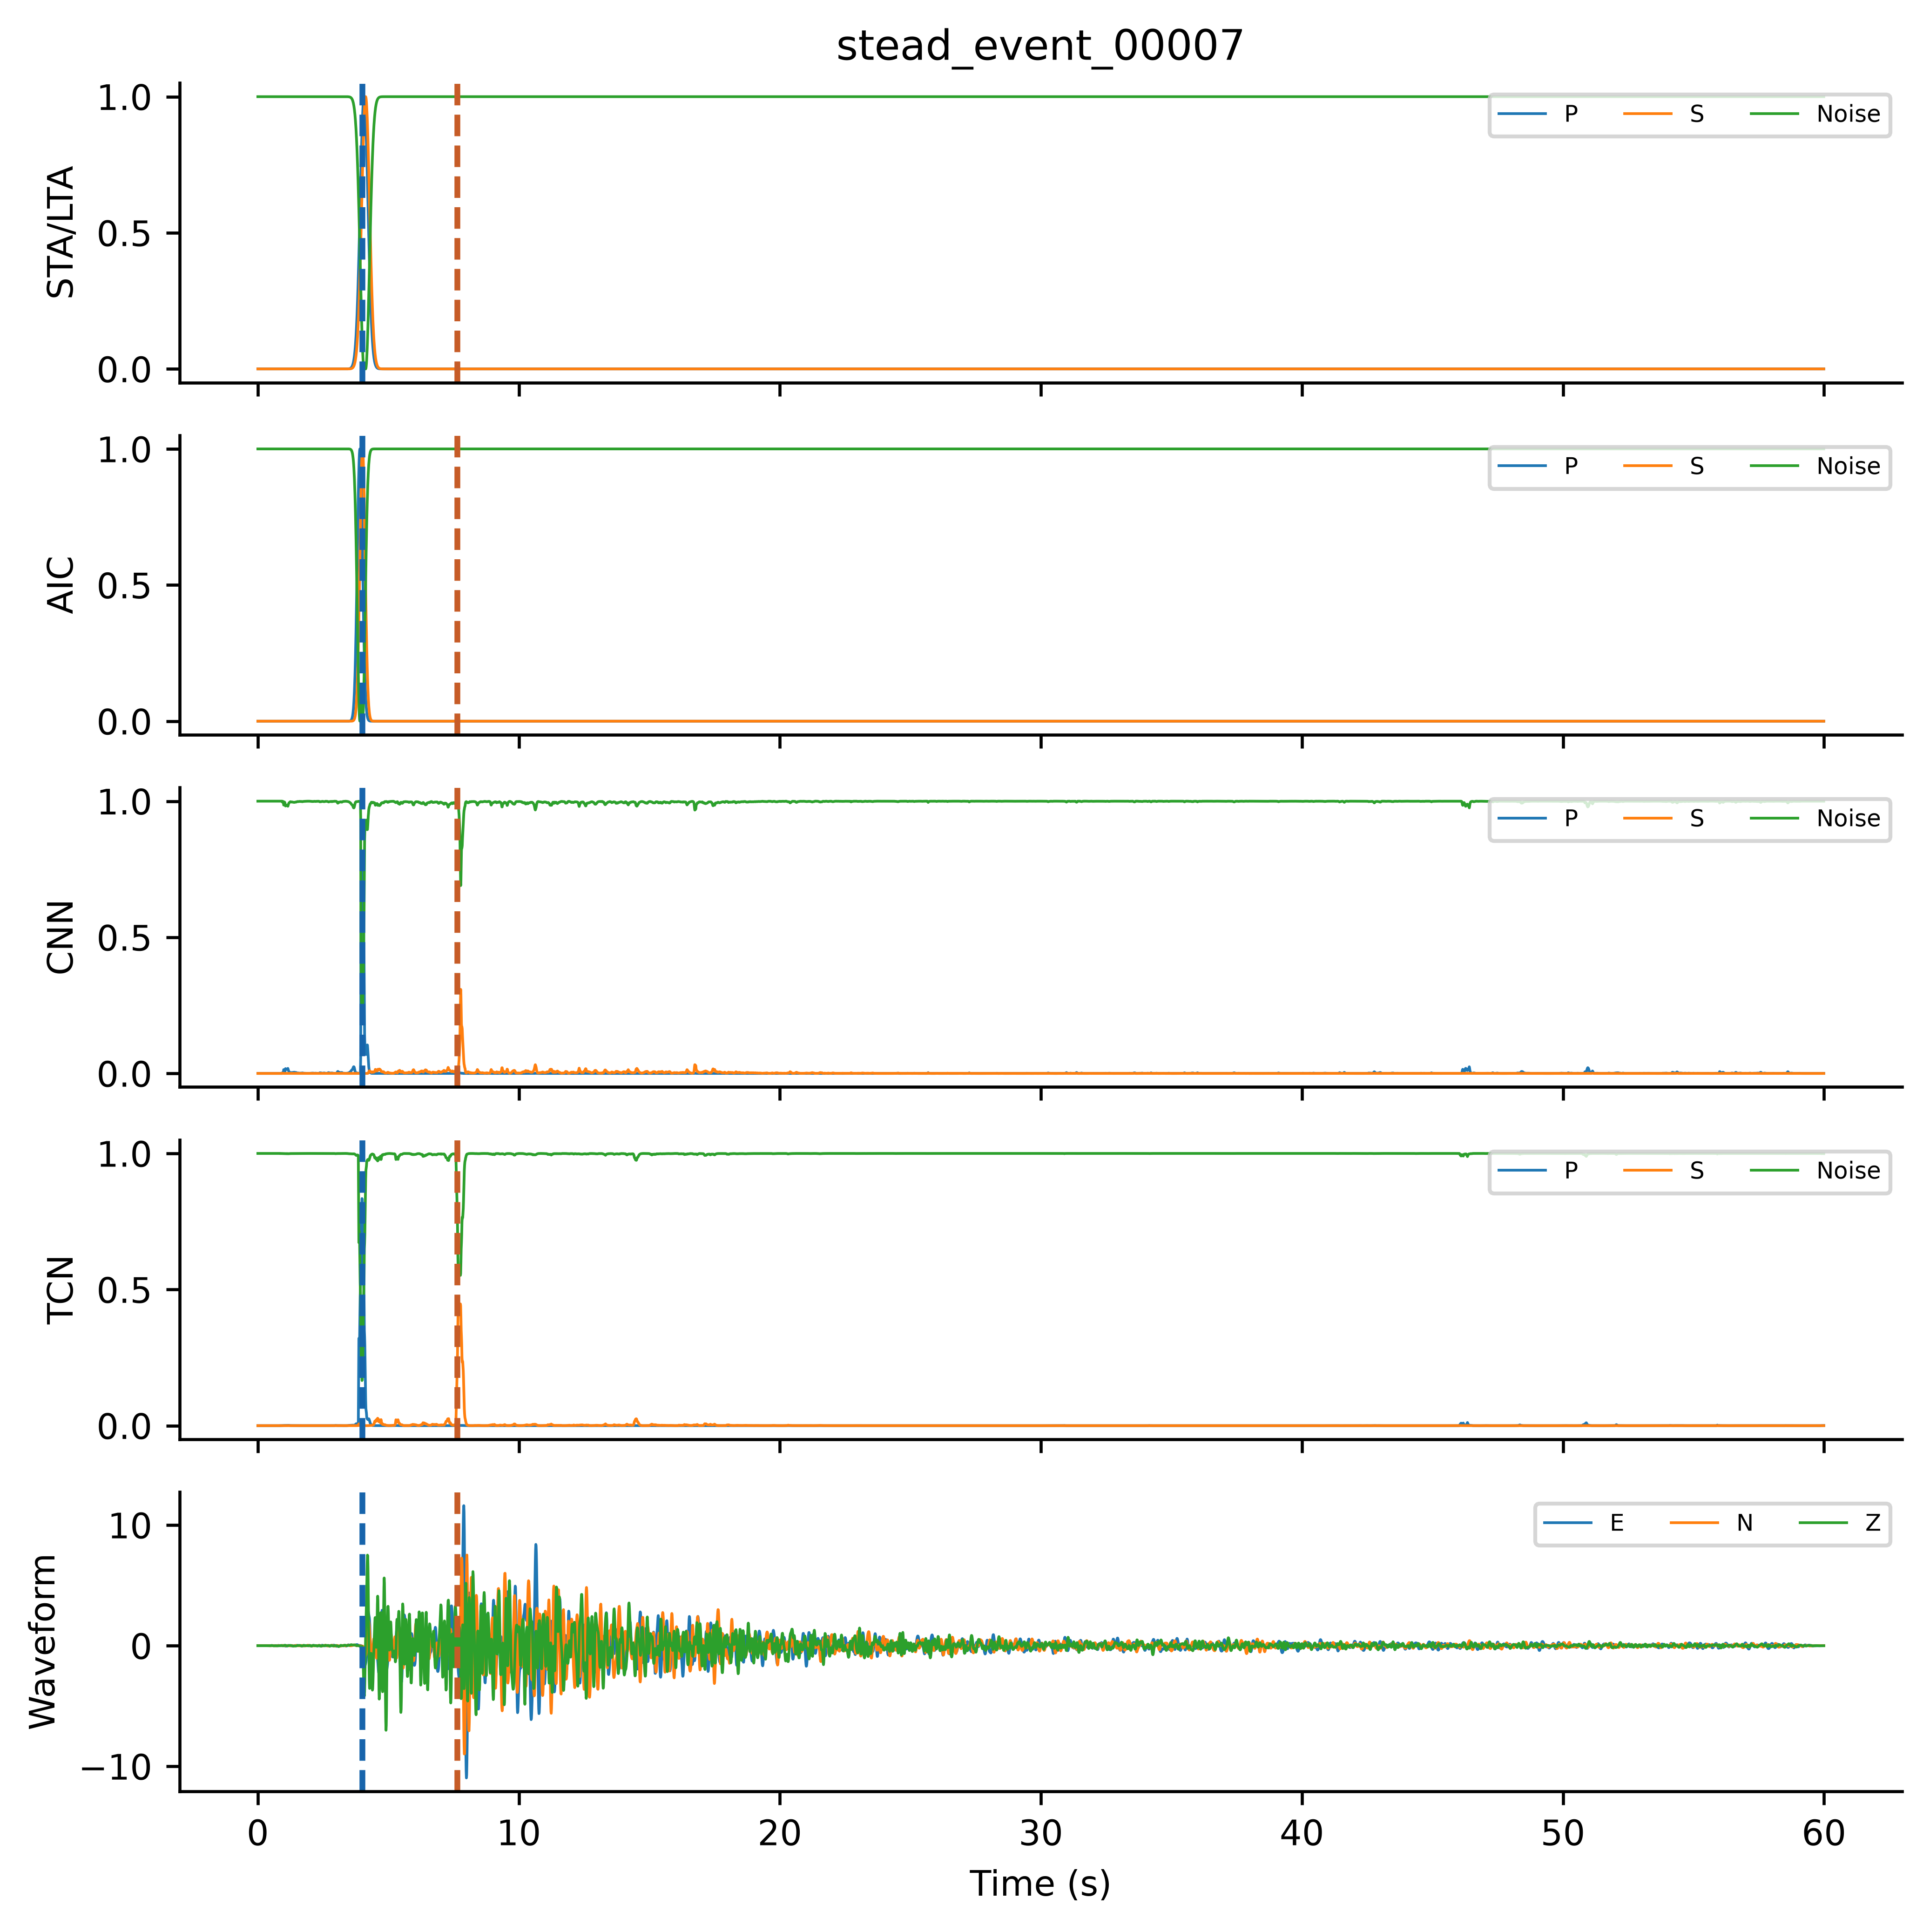
Fig. 4. Final 15-channel tensor for held-out stead_event_00007. Four groups contain P/S/noise from STA/LTA, AIC, CNN and TCN; the last group contains conditioned E/N/Z. Dashed lines mark true arrivals. These are current final-base test features, not OOF training features.
I-CNN has four sequential kernel-5 blocks with filters 64/128/64/64, dilations 1/1/2/4, batch normalization, ReLU, and dropout 0.30. With h0 = Xmeta, equations 7–8 define the blocks and head. Its receptive field is 33 samples (330 ms); architectural capacity alone does not establish an empirical benefit.
For blocks i = 1,…,4, the forward operation is:
$h_{i}= Dropout({ReLU(BN}_{i}(W_{i}∗_{dᵢ}h_{i−1}+b_{i})))$ (7)
Here d = (1,1,2,4), the convolution uses dilation di and same padding, and dropout probability is 0.30 during training only. The 1×1 head returns three probabilities at each time:
$p(t) = softmax(W_{head}h_{4}(t) +b_{head})$ (8)
Let G = {0,0.01,…,59.99} s. The P candidate maximizes pP over G. If it is accepted, the S search domain is restricted relative to that candidate; otherwise the S domain is empty:
$Dₛ =\left\{\begin{aligned}\{t ∈ G : 0.1 ≤ t − t̂ₚ ≤ 30\}, if P is accepted \\ ∅, otherwise\end{aligned}\right.$ (9)
DS is empty when P is not accepted. For each nonempty phase domain Dk, t̂k maximizes pk on Dk. Ties use the earliest sample, matching MATLAB max. The peak-to-mean quality score is computed on that phase domain:
The I-CNN used Adam at 5×10⁻⁴, batch size 16, at most 50 epochs, and weighted cross-entropy with P/S/noise weights 1.5/2.5/0.5. All neural models used L2 = 10⁻⁴, learning-rate halving every 20 epochs, validation once per epoch, and the best-validation-loss checkpoint. Meta patience was ten evaluations. Histories appear in Online Resource 1, Fig. S1. A candidate is detected when peak ≥0.30 and quality ≥3.0, otherwise uncertain when peak ≥0.15, and not detected below 0.15. Primary acceptance includes both detected and uncertain; strict reporting includes detected only.
The quality score and reported S time follow the actual conditional decoder:
$q_{k}=\frac{pₖ(t̂ₖ)}{mean[t ∈ Dₖ] pₖ(t) + 10⁻⁶}$ (10)
DP = G. Return tS = t̂S for accepted S and NaN otherwise; an empty DS returns no pick. The S–P rule constrains ordering rather than learning a physical objective. Detected-only scoring retains the accepted-P gate. Peak 0.30, quality 3 and the 0.1–30 s window occur in July and September configurations (Online Resource 1, Table S20), but their earliest calibration data remain unknown. No validation-only calibration is asserted. Before sensitivity calculations, we specified a 27-setting grid: peak {0.20, 0.30, 0.40}, tied P/S quality {2, 3, 4}, and maximum S–P {20, 30, 40} s. Minimum separation remains 0.1 s and the uncertain boundary half the peak threshold. All 18 full stackers and six baseline fits retain the original primary setting. Window changes also alter the S quality denominator; accepted scoring is invariant to quality threshold.
Training-only augmentation is specified in Section 2.8 and Table 3. Adam (Kingma and Ba 2015), batch normalization (Ioffe and Szegedy 2015), and dropout (Srivastava et al. 2014) were used for neural models. Online Resource 1, Table S4 records the final configuration, including disabled augmentation operations and seed scope. Horizontal dropout is triggered with total probability 0.20 per augmented copy; E-only, N-only, and both are then selected with equal probability. Losing either horizontal component activates the Z fallback in both classical bases.
Table 3. Hyperparameters and configuration settings used for training the CNN, TCN, and I-CNN MetaPicker framework. Base seeds 43–44 belong to the extension; base-42 ablations retain base seed 42. PhaseNetMatched architecture and optimization settings are stated separately in Methods.
Category | Parameter | Final setting
Input | Waveform / base / meta channels | 3 / 8 / 15
Input | Sampling; length | 100 Hz; 6000 samples
Partition | Outer grouping | source_id; 70/15/15%
OOF | Folds / inner validation | 5 / 15% of non-held sources
Conditioning | Band-pass; normalization | 1–45 Hz; per component
Labels | Gaussian P / S widths | 6 / 8 samples; truncation ±4σ
Base CNN | Filters; kernel; dropout | 32,64; 7; 0.30
Base TCN | Filters; kernel; dilation; dropout | 32×4; 3; 1,2,4,8; 0.20
Base training | Adam LR; max epochs | 1×10⁻³; 30
Base training | Batch; validation patience | 16; 7 evaluations
I-CNN | Filters; kernel; dilation | 64,128,64,64; 5; 1,1,2,4
I-CNN | Dropout; P/S/noise weights | 0.30; 1.5/2.5/0.5
Meta training | Adam LR; max epochs | 5×10⁻⁴; 50
Meta training | Batch; validation patience | 16; 10 evaluations
All neural models | LR schedule; L2 | Halve every 20 epochs; 1×10⁻⁴
Training | Output network | Best validation loss
Seeds | Base / neural meta / standalone baseline | Base 42–44; meta 42–44 crossed within each base; PhaseNetMatched 42–44. Base-42 ablations: base 42 only.
Augmentation | Training population | Original + one augmented copy
Augmentation | Noise; scale; dropout | 20 dB; 0.5–2.0; probability 0.20
Augmentation | Time shift / polarity flip | Disabled / disabled
Decoder | Detected / uncertain | ≥0.30 and quality≥3 / otherwise≥0.15
Decoder | S after accepted P | 0.1–30 s; within record
Evaluation | Primary / strict | Detected+uncertain / detected
Evaluation | Matching tolerances | ±50, ±100, ±200 ms
Uncertainty | Mean-F1 source bootstrap | 10,000 draws; NumPy seed 42
Evaluation used 330 test records from 221 sources and tolerances of ±50, ±100, and ±200 ms. The primary policy accepted finite detected or uncertain picks. Accepted picks within tolerance were true positives; accepted picks outside tolerance contributed both a false positive and a false negative. Missing picks contributed false negatives. Thus FP = Naccepted − TP and FN = N − TP. Detected-only sensitivity and seed-42 confusion counts are reported in Online Resource 1, Tables S10 and S7. The primary policy retains lower-confidence candidates to expose the coverage–timing tradeoff; accepted coverage must not be interpreted as accurate detection.
The conventional F1-score is (equation 11):
$F1=\frac{2TP}{2TP+FP+FN}$ (11)
MAE was calculated over all accepted arrivals, including uncertain picks and errors outside the matching tolerance (equation 12):
$MAE=\frac{1}{N_{d}}\sum_{i=1}^{N_{d}}{\left|t_{i}−{\overset{ˆ}{t}}_{i}\right|,}$ (12)
In equation 12, Nd counts accepted finite picks; coverage Nd/N differs from recall and detected-only coverage. Expanded stacking summaries average meta seeds within each base and then the three base means. Between-base SD uses those three means, not nine independent replicates; baseline summaries use three fits. Paired intervals use 10,000 NumPy default_rng source-cluster draws (seed 42), retaining every record of each sampled source. Per-fit F1 is recomputed before averaging, with common draws across comparisons. Intervals condition on fixed models and split; they exclude training, partition and separate station-level uncertainty. Subset diagnostics resample their stated sources. Intervals are exploratory and pointwise, without family-wise or false-discovery-rate control. No configuration is selected from the threshold grid. Base-42 summaries retain their three-meta-seed scope.
For Z-only, E and N were zeroed before preprocessing and again after augmentation. Population, source partitions, labels, channel layout, architecture settings, and evaluation were unchanged; mode-specific bases and meta-learners were fitted. The comparison removes horizontal information throughout the pipeline, rather than masking only waveform-context channels after full-component base inference. All 3,778 available Z-only meta tensors were finite with zero E/N channels; classical P/S score channels were identical under the specified fallback (Online Resource 1, Table S13).
The standalone comparator, termed PhaseNetMatched, is a PhaseNet-style MATLAB adaptation trained from scratch (Zhu and Beroza 2019; Woollam et al. 2022). It has five encoder levels with 8/16/32/64/128 filters, kernel 7, stride-4 downsampling, batch normalization, ReLU, transposed convolutions, and skip concatenation. MATLAB same padding and centre-cropped skips support 6,000-sample records. Padding, initialization, convolution biases, and batch-normalization defaults differ from the reference implementation. The input is the same conditioned E/N/Z waveform used in meta channels 13–15, without a second normalization; E/N remain zero in Z-only. Labels, augmentation, weighted loss, outer split, validation selection, decoder, and scoring are shared. Adam uses learning rate 5×10⁻⁴, batch size 2, at most 50 epochs, patience 10, L2=10⁻⁴, and learning-rate halving every 20 epochs. Three seeds (42–44) are fitted per mode. Data access is matched; feature inputs, minibatch statistics, and compute budgets are not equivalent. Online Resource 1, Table S18 accounts for all additional fits.

3.1. Executable workflow checks and numerical verification
The verified workflow checks source disjointness, augmentation parentage, OOF exclusion, the 15-channel feature schema and file hashes. A retained synthetic example illustrates invalid source overlap, changed parent identity, OOF contamination, swapped feature order and altered bytes; it is an implementation demonstration rather than evidence of predictive accuracy. Fresh inference replay and an independent numerical audit check all current prediction identities, reference labels, source membership and reported metrics. Online Resource 1, Tables S19 and S21 separate current-run evidence from historical software demonstrations.
Reuse follows three explicit input/output steps. First, retained waveform files are associated with source identifiers and a frozen partition manifest; source membership and augmentation parentage are checked before model fitting or feature assembly. Second, fold-specific predictions are assigned to the canonical feature schema, with each OOF record excluded from the associated base fit. Third, replayed predictions are evaluated under saved decoder settings and compared with frozen output identities and metrics. The checks establish these specified invariants; they do not prove that the grouping key is scientifically correct for every new application.
The archived package separates demonstrations that require no waveform data from waveform-dependent replay. The synthetic contract example and metric verifier can be run from the supplied package. Full replay requires the original CSV waveform bytes to match the supplied hashes, a compatible MATLAB environment and the saved checkpoints. Recovery of STEAD trace identity does not reconstruct the unavailable historical export recipe. For another dataset, users must supply an appropriate grouping key, record-to-group mapping, labels and decoder policy; the STEAD source grouping cannot simply be assumed to represent all forms of dependence.
Fresh GPU replay loaded all 106 checkpoints and rebuilt inputs from waveform CSVs. Across six mode/base combinations, 18,528 original/augmented OOF tensors and 1,980 test meta tensors matched their caches exactly (tolerance 1e-6). All 70 prediction sets × 330 records reproduced constrained and unconstrained pick times and statuses without mismatches (time tolerance 1e-7 s). Saved validation-derived ensemble weights were retained. This verifies fixed-artifact inference and feature reconstruction, not retraining determinism or independent predictive validation (Online Resource 1, Table S21).
AI-assisted software development and computational workflow. ChatGPT/Codex (OpenAI; accessed September 2026) assisted with software revision and debugging, workflow implementation, computational execution support, and numerical-output checking. Assistance included scripts for generating tables, data plots, and the workflow diagram. Figures were produced programmatically from study data, model outputs, or the documented workflow, without generative-image synthesis. AI tools did not generate seismic observations or reference phase labels. The authors reviewed and verified code changes, executed analyses, numerical results, and interpretations. Verification included source-membership assertions, numerical consistency checks, and comparison of frozen outputs with reported tables. The verified v2 package and numerical audit identify the respective scripts, configurations, predictions and provenance records.

4. Results and Discussion
The corrected evaluation contains 106 training invocations: 40 main fits at base seed 42, 60 additional base/OOF/meta fits at base seeds 43 and 44, and six PhaseNet-style standalone fits. Tables 4–5 and Figures 5–10 and 13–14 describe the corrected base-42 experiment; Tables 6–7 and Figures 11–12 describe the expanded experiment. Online Resource 1, Tables S9 and S15–S18 distinguish seed-level results, detected-only scoring and fit accounting. This rerun followed discovery of the input-identity error and inspection of historical results; it is not an independently preregistered confirmation. Test scores were not used by the training code for checkpoint selection.

4.1. Source identity and historical data roles
The exhaustive local-archive audit uniquely matched all 2,234 retained waveforms to 1,477 recovered sources. Current train, validation and test sources are disjoint, but historical exposure remains. Only 25 test sources (26 records) lack historical training/validation membership; all previously occurred in testing. No development-naive subset is established. Historical scores are not a valid source-held-out comparator, and the changed allocation and training prevent a controlled estimate of leakage inflation.

4.2. Feature reconstruction and numerical reproducibility
Real-data verification links 2,234 unique waveform matches to source-disjoint checkpoint memberships and fresh inference. OOF/test tensors matched exactly, with zero pick/status mismatches across 70 prediction sets. Independent calculations reproduced 1,260 metric rows; 25,248 manifest entries matched 2,336 input files (Online Resource 1, Table S21). These computational checks do not make historically reused observations independent validation data.
The reusable software elements are waveform-to-source identity recovery, explicit feature schemas, hash-verified artifacts and dependency-aware summaries. Adaptation to another geoscientific problem requires a scientifically meaningful grouping key. Their contribution is inspectable integration and documented verification rather than a new grouped-OOF algorithm or a demonstrated performance advantage over PhaseNetMatched. Five deliberately invalid synthetic cases were rejected: source overlap, changed augmentation-parent identity, inclusion of a held source in an OOF fit, reordered feature channels and changed artifact bytes. These examples demonstrate failure detection for the implemented checks, not robustness to every provenance error. Together, the real-data replay and synthetic checks provide complementary evidence of artifact consistency and specified error detection.

4.3. Fixed-split picker performance
At base seed 42, Full3C mean F1 at ±100 ms was 0.8296 ± 0.0093 for P and 0.5455 ± 0.0099 for S across three meta seeds. Mean per-run MAE was 182.78 ± 94.50 ms and 554.45 ± 62.72 ms. Accepted coverage averaged 99.19% and 97.37%; it includes uncertain picks and is not recall within 100 ms. Table 4 and Fig. 5 describe this base-specific result. Section 4.5.1 reports the expanded comparison.
Table 4. Corrected base-42 test performance at ±100 ms, mean ± sample SD across three meta seeds (330 records, 221 sources). MAE includes all accepted picks; coverage includes detected and uncertain picks. Expanded results appear in Table 6.
Mode | Phase | F1 mean ± SD | MAE ms mean ± SD | Accepted coverage %
Full3C | P | 0.8296 ± 0.0093 | 182.78 ± 94.50 | 99.19
Full3C | S | 0.5455 ± 0.0099 | 554.45 ± 62.72 | 97.37
Zonly | P | 0.8059 ± 0.0041 | 145.35 ± 21.01 | 98.79
Zonly | S | 0.2818 ± 0.0042 | 1180.40 ± 36.18 | 90.00
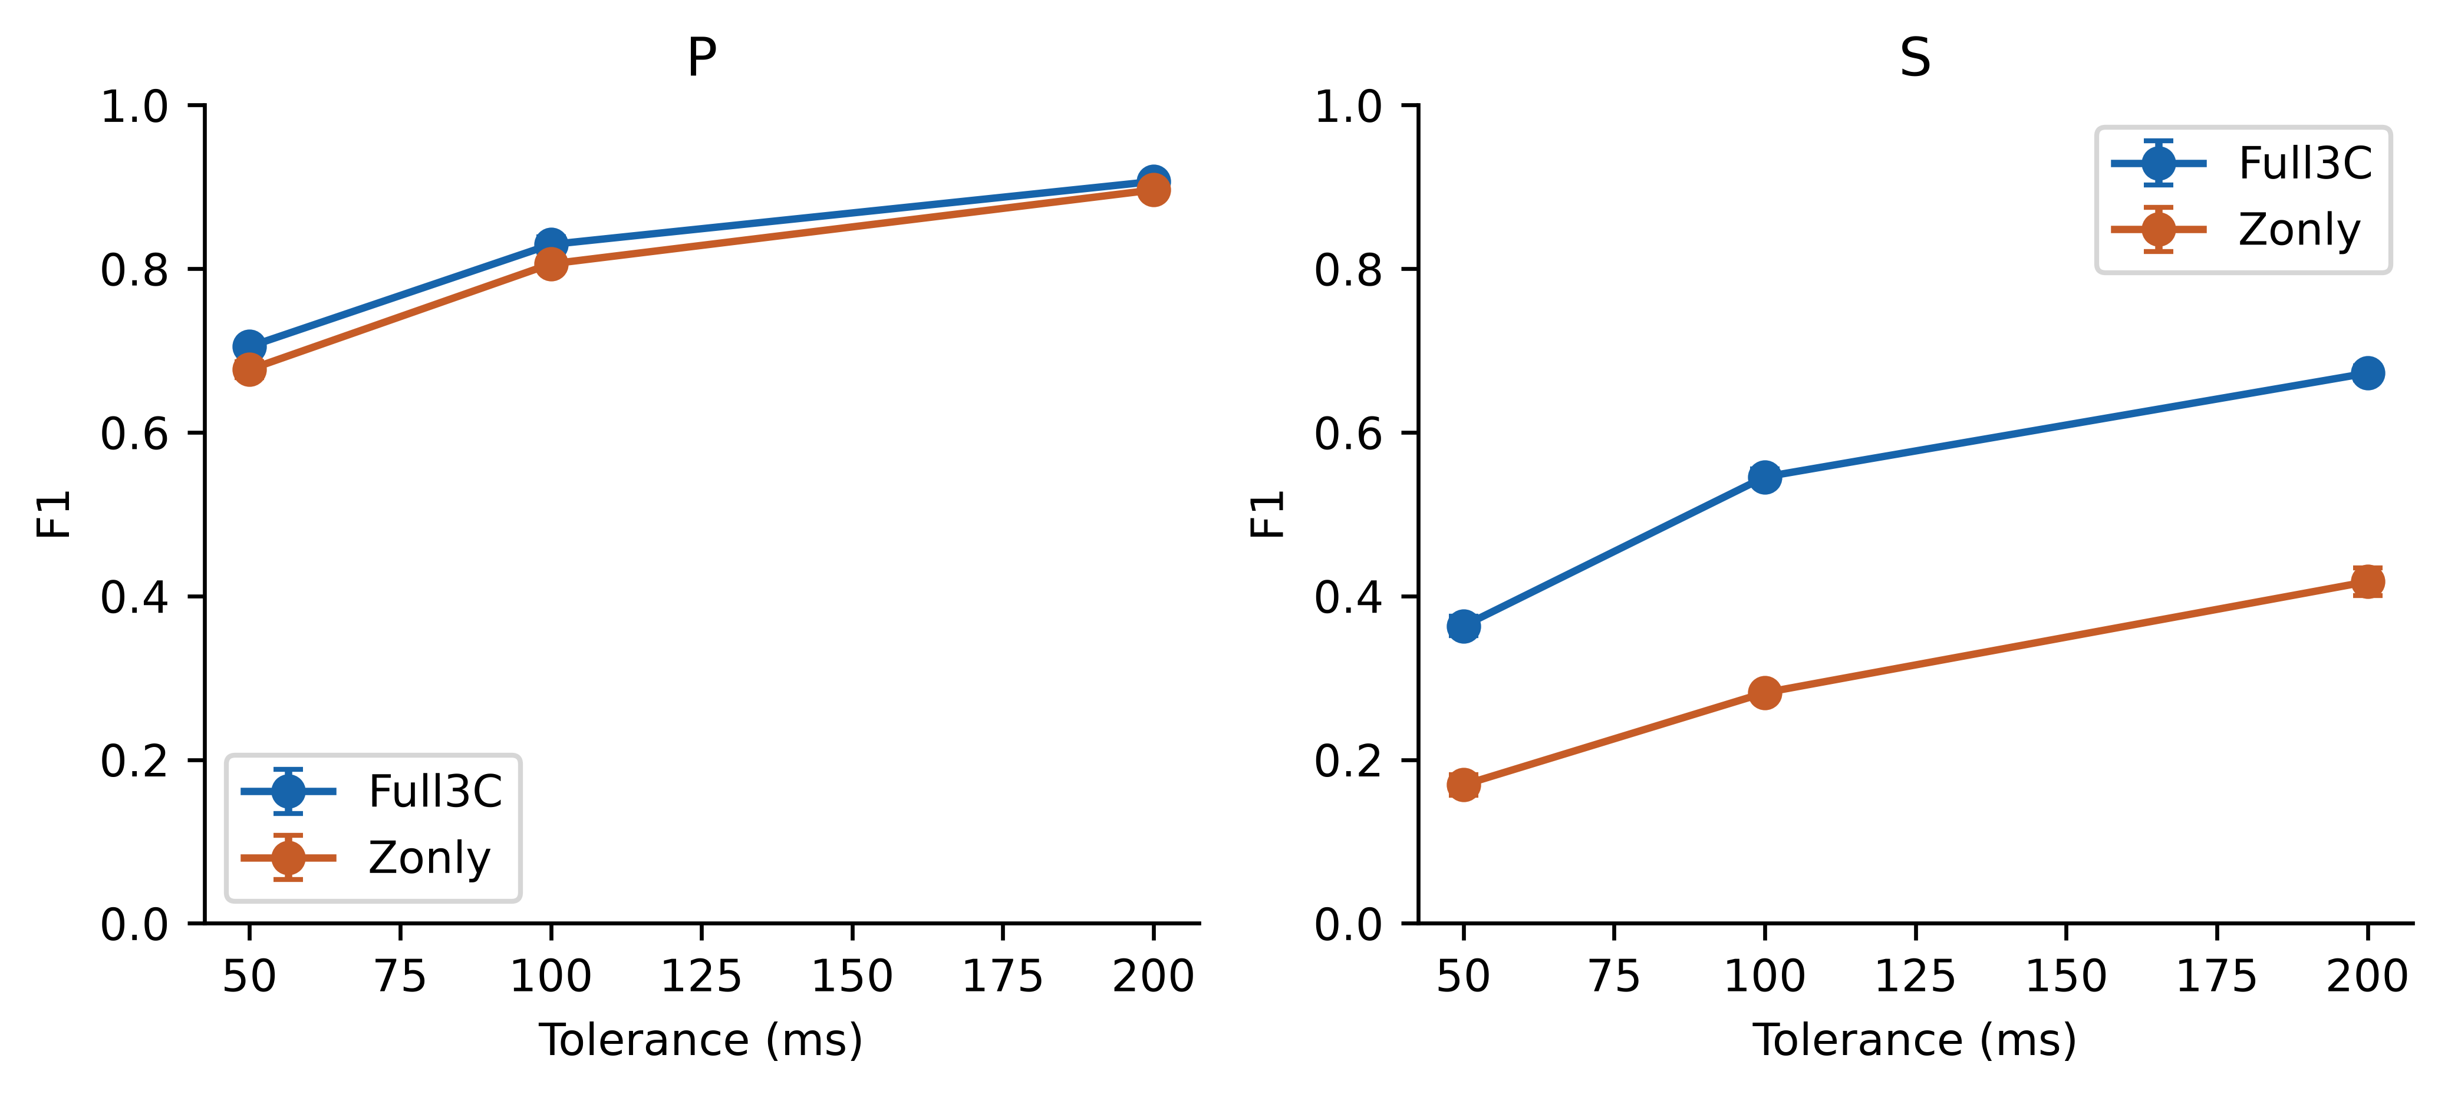
Fig. 5. Corrected base-42 F1 versus matching tolerance. Points and bars show mean and sample SD across its three meta seeds. Accepted picks include detected and uncertain outputs.
P errors were smaller and F1 higher than S errors and F1. High S accepted coverage coexisted with many picks outside 100 ms: candidate availability is distinct from precise timing. Record-level figures use base seed 42 and meta seed 42; Table 4 averages its three meta seeds. These figures are not summaries of the expanded base-seed experiment.
F1 increased with wider tolerance (Fig. 5 and Online Resource 1, Fig. S3). Fig. 6 presents residual distributions and Fig. 7 compares predicted and true times. Bootstrap intervals and detailed errors appear in Online Resource 1, Tables S2 and S3. Tolerance dependence alone does not establish a causal explanation for phase difficulty.
Under detected-only scoring at base seed 42, Full3C P/S F1 was 0.8337/0.5487 versus Z-only 0.8045/0.2606. S detected coverage was 94.75% and 64.55%, respectively (Online Resource 1, Table S10). The S component-access difference therefore persists under the stricter reporting mask. Conditional S metrics and P-rejection counts appear in Online Resource 1, Table S11. Ungated decoding changes both the S search domain and its quality calculation, so it is not a gate-only intervention.
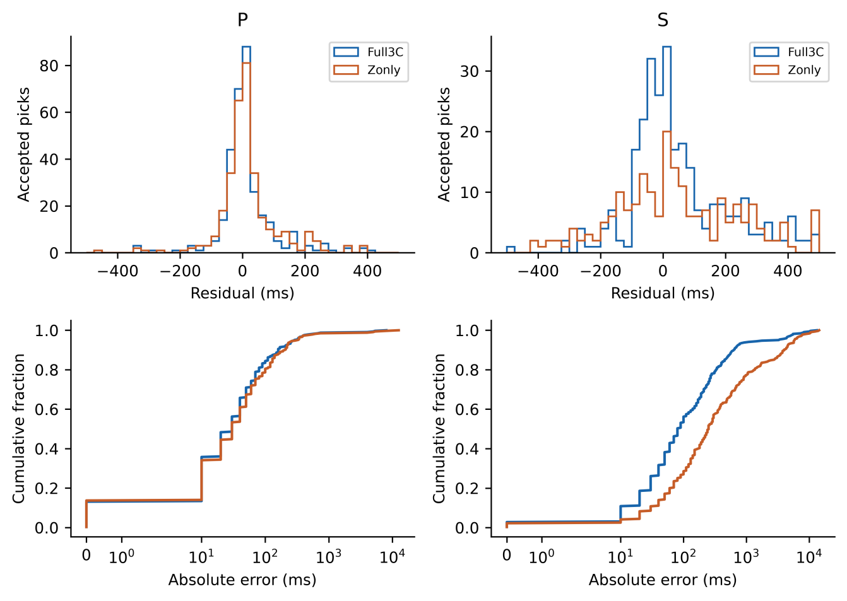
Fig. 6. Base-42/meta-42 accepted residuals. Top: histograms within the central ±500 ms display window. Bottom: full-range cumulative absolute-error distributions on symmetric logarithmic axes. Metrics include errors outside the top display window.
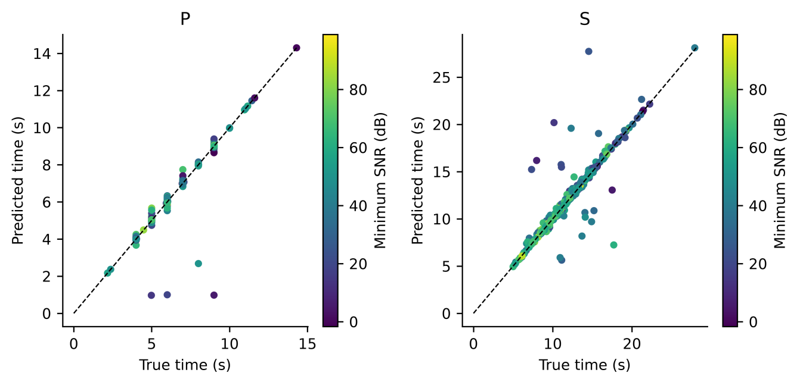
Fig. 7. Base-42/meta-42 Full3C predicted versus true P and S arrival times for accepted picks. Colour denotes minimum component SNR; dashed lines show equality.

4.4. Contribution of three-component seismic information
Across the expanded 3×3 base/meta grid, mean P F1@100 ms was 0.8268 for Full3C and 0.8134 for Z-only, while mean S F1 was 0.5536 versus 0.2686. The Full3C S advantage persisted in all nine matched base/meta combinations. Table 5 describes base seed 42, and Table 7 reports expanded conditional intervals.
Table 5. Corrected base-42 Full3C minus Z-only at ±100 ms. F1 values average three meta seeds; paired percentile 95% source-cluster intervals use 10,000 draws and condition on those fitted models and the single partition.
Phase | Full3C F1 | Z-only F1 | ΔF1 | 95% CI for Δ | Relative change %
P | 0.8296 | 0.8059 | +0.0237 | [-0.0012, 0.0510] | +2.94
S | 0.5455 | 0.2818 | +0.2637 | [0.2046, 0.3231] | +93.58
The component-access difference is consistent with horizontal motion contributing useful shear-wave information and persists across the three tested base seeds. It also includes changes to the classical-base fallback and separately fitted learned bases, so it does not isolate any individual channel. Source-split, station, and regional stability remain untested.
For the expanded stacking average, the paired 95% interval for Full3C minus Z-only F1@100 ms was −0.0016 to 0.0295 for P and 0.2293 to 0.3418 for S. The P interval does not establish equivalence; the S interval supports a component-access advantage conditional on these models and test sources. PhaseNetMatched also showed an S component-access difference of 0.2862 (interval 0.2345–0.3382), indicating that the finding is not unique to stacking.
On 287 both-phase manual records from 188 sources, stacking S Full3C-minus-Z-only ΔF1 was 0.2705 [0.2113, 0.3299], positive in all nine paired fits; PhaseNetMatched gave 0.2550 [0.2013, 0.3085]. This supports subset consistency, not annotation-error immunity. Both intervals included zero in the 20-record manual/no-historical-train-validation intersection, which still had historical test exposure (Online Resource 1, Table S25; Fig. S6).
Station stratification remains descriptive: the 12 records at nine currently unseen network–receiver keys provide only ten source clusters. Their S method-comparison intervals include zero and cannot establish station transfer (Online Resource 1, Table S26).
Across the predefined grid, accepted S Full3C-minus-Z-only ΔF1 ranged from 0.2839–0.2856 for stacking and 0.2862–0.2873 for PhaseNetMatched; all pointwise intervals were positive. Quality invariance reduces accepted scoring to nine peak/window combinations. Detected-only ranges were 0.2855–0.3031 and 0.2828–0.2875. The baseline P advantage persisted throughout. Accepted S method intervals included zero throughout, whereas 18/27 detected-only Z-only S intervals favoured the baseline. Stacking P component intervals depended on scoring policy (Online Resource 1, Table S27; Fig. S7). These fixed-model diagnostics neither select a new operating point nor establish historical calibration provenance.
Figures 8 and 9 describe residuals versus metadata attributes and SNR-stratified performance. These analyses did not drive model selection and do not establish causal relationships or controlled noise robustness. Online Resource 1, Fig. S4 ranks the largest P and S residuals.
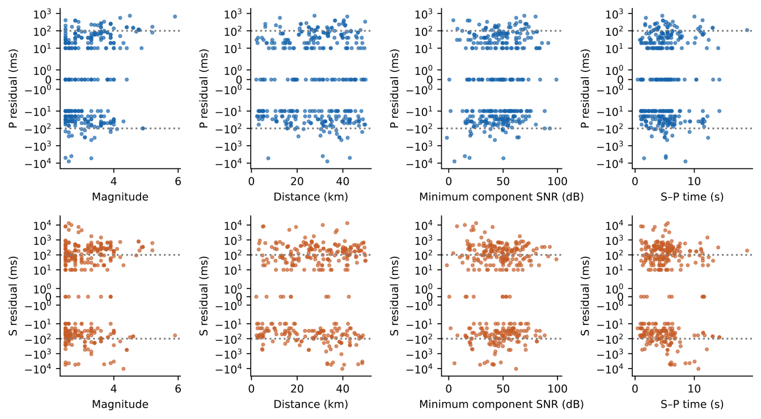
Fig. 8. Base-42/meta-42 Full3C residuals versus distance, magnitude, minimum component SNR, and S–P time. Rows show P and S. Symmetric logarithmic axes retain large errors; dotted lines mark ±100 ms. Plots are descriptive.
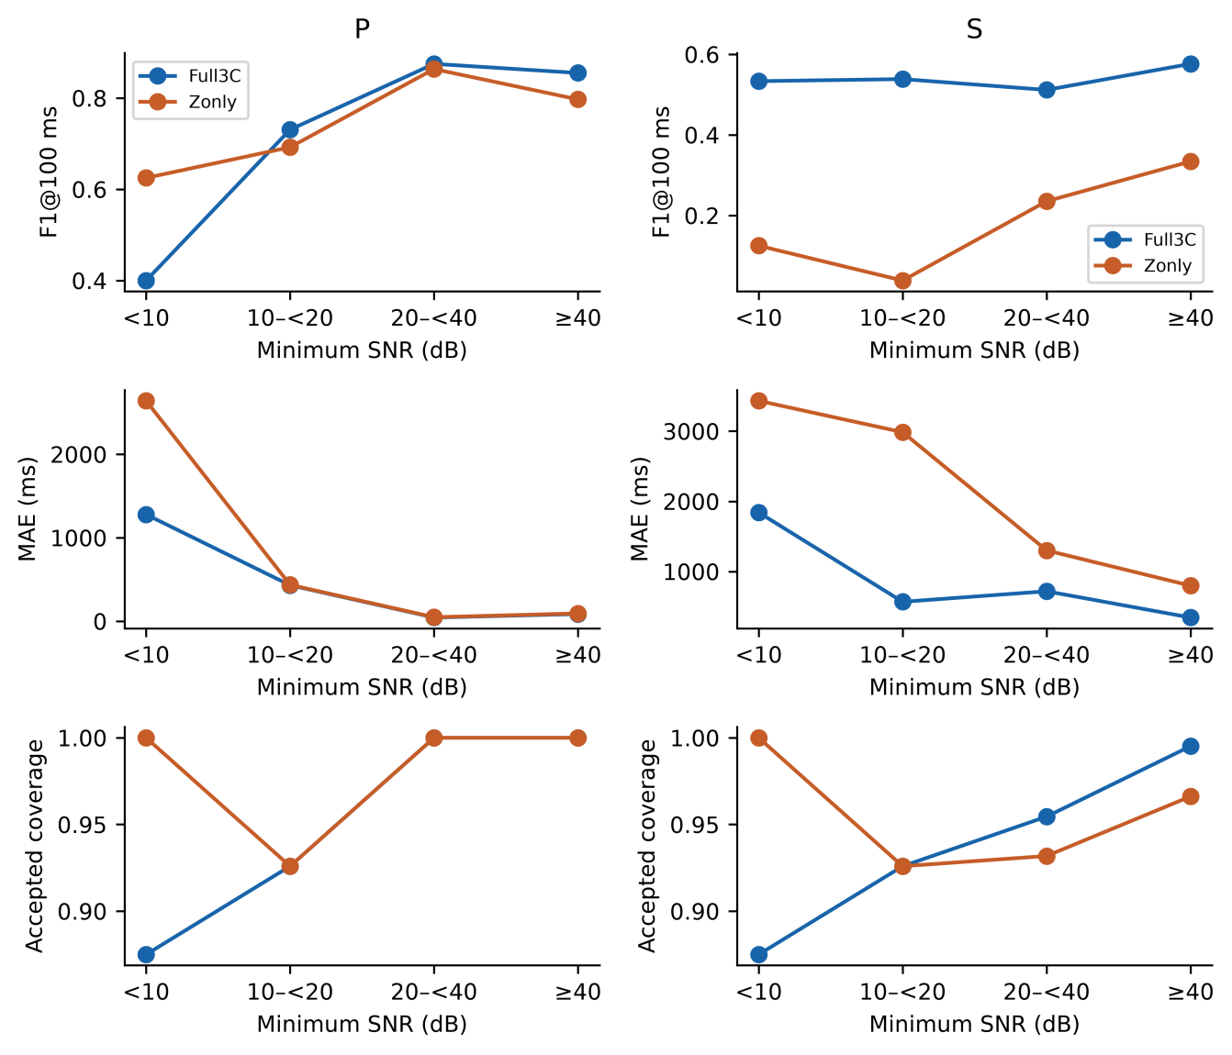
Fig. 9. Corrected base-42/meta-42 performance by recovered minimum component SNR: <10, 10–<20, 20–<40 and ≥40 dB. Rows show F1@100 ms, accepted-pick MAE and accepted coverage. Bins are descriptive and were not used for model selection.

4.5. Temporal stacking and heterogeneous fusion
Within the corrected base-42 comparator set, TCN P/S F1@100 ms was 0.8226/0.4935 versus stacker means 0.8296/0.5455 (Online Resource 1, Table S5). The S difference of 0.0520 had an exploratory paired 95% interval of 0.0165–0.0902. S F1 was 0.1407 for mean averaging and 0.4958 for validation-weighted averaging; the stacker-minus-weighted S interval was 0.0129–0.0885. Weights derive from phase-specific validation F1@100 ms. These conditional comparisons support an S benefit over these particular bases/ensembles, not a general superiority claim.
In the corrected base-42 experiment, full 15-channel, probability-only 12-channel, waveform-only 3-channel, and no-dilation meta-learners used seeds 42–44 with shared OOF inputs within Full3C. Online Resource 1, Table S6 reports mean ± sample SD and paired source-cluster intervals. Seeds vary the meta-learner only; SD is descriptive, not a two-SD significance threshold. Multiple ablation intervals are exploratory.
Probability-only mean P/S F1@100 ms was 0.8327/0.5177, waveform-only 0.7957/0.4716, and no-dilation 0.8325/0.5133. Full-model S differences had exploratory intervals above zero against all three variants, whereas the P intervals included zero. Thus the corrected base-42 ablations support phase-specific gains, including an S dilation benefit on this split, without establishing a universal effect. One logistic stacker achieved 0.8117/0.5090; its full-minus-logistic intervals included zero for both phases. Its independent binary heads use standardized OOF features every tenth sample, ridge penalty 0.01 and targets defined by phase masks >0.3. This changes temporal context and objective as well as learner type and does not isolate nonlinearity.
Base-42/meta-42 percentile errors are shown in Fig. 10; larger accepted errors and selected waveform cases are discussed in Section 4.6.
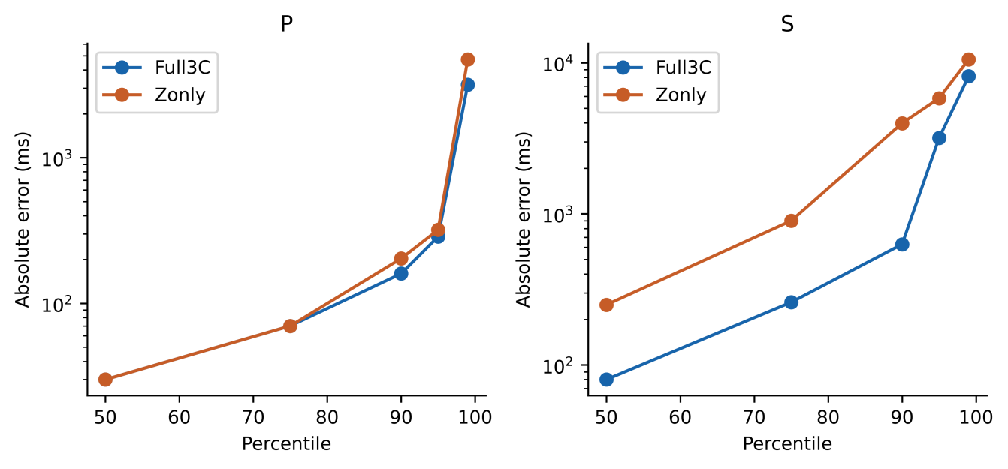
Fig. 10. Base-42/meta-42 accepted absolute-error percentiles (50, 75, 90, 95, 99) for Full3C and Z-only. The vertical axis is logarithmic. Compare error distributions together with acceptance rates.

4.5.1. Base-seed repetitions and the standalone neural baseline
Across three base-seed means, Full3C stacking F1@100 ms was 0.8268 ± 0.0069 for P and 0.5536 ± 0.0127 for S; Z-only values were 0.8134 ± 0.0073 and 0.2686 ± 0.0152. Each base mean averages three meta fits. Full3C exceeded Z-only S F1 in all nine paired fits. Table 6 separates these summaries from the three-seed standalone baseline. Figure 11 compares methods, and Fig. 12 separates individual meta fits from base-specific means. These repetitions characterize initialization variability on one source split, not uncertainty across partitions or regions.
Table 6. Expanded results at ±100 ms. Stacking SD is across three base-seed means after averaging meta seeds; baseline SD is across three fits. MAE includes all accepted picks.
Method | Mode | P F1 | S F1 | P MAE ms | S MAE ms
Stack | Full3C | 0.8268 ± 0.0069 | 0.5536 ± 0.0127 | 166.62 | 610.29
Stack | Zonly | 0.8134 ± 0.0073 | 0.2686 ± 0.0152 | 178.30 | 1172.94
PhaseNetMatched | Full3C | 0.9833 ± 0.0015 | 0.5857 ± 0.0313 | 34.47 | 170.12
PhaseNetMatched | Zonly | 0.9833 ± 0.0045 | 0.2995 ± 0.0180 | 25.64 | 504.30
PhaseNetMatched achieved higher mean F1 and lower accepted-pick MAE in both modes. For P, stacker minus baseline ΔF1 was −0.1565 in Full3C and −0.1699 in Z-only, with both conditional intervals below zero. For S, the corresponding differences were −0.0320 and −0.0309, but both intervals included zero (Table 7). Full3C S accepted coverage was 98.01% for stacking and 99.39% for the baseline; Z-only values were 92.05% and 99.70%. These results support the standalone P advantage. They neither establish an S advantage nor demonstrate S equivalence.
Table 7. Expanded mean ΔF1@100 ms and paired source-cluster 95% intervals (10,000 draws). Differences follow the order shown. Intervals condition on fixed fits and one split and are not multiplicity-adjusted.
Comparison | Phase | Mean ΔF1 | 95% interval
Stack Full3C minus Zonly | P | +0.0134 | [-0.0016, 0.0295]
PhaseNet Full3C minus Zonly | P | +0.0000 | [-0.0102, 0.0112]
Stack minus PhaseNet Full3C | P | -0.1565 | [-0.2033, -0.1123]
Stack minus PhaseNet Zonly | P | -0.1699 | [-0.2178, -0.1244]
Stack Full3C minus Zonly | S | +0.2850 | [0.2293, 0.3418]
PhaseNet Full3C minus Zonly | S | +0.2862 | [0.2345, 0.3382]
Stack minus PhaseNet Full3C | S | -0.0320 | [-0.0720, 0.0066]
Stack minus PhaseNet Zonly | S | -0.0309 | [-0.0662, 0.0050]
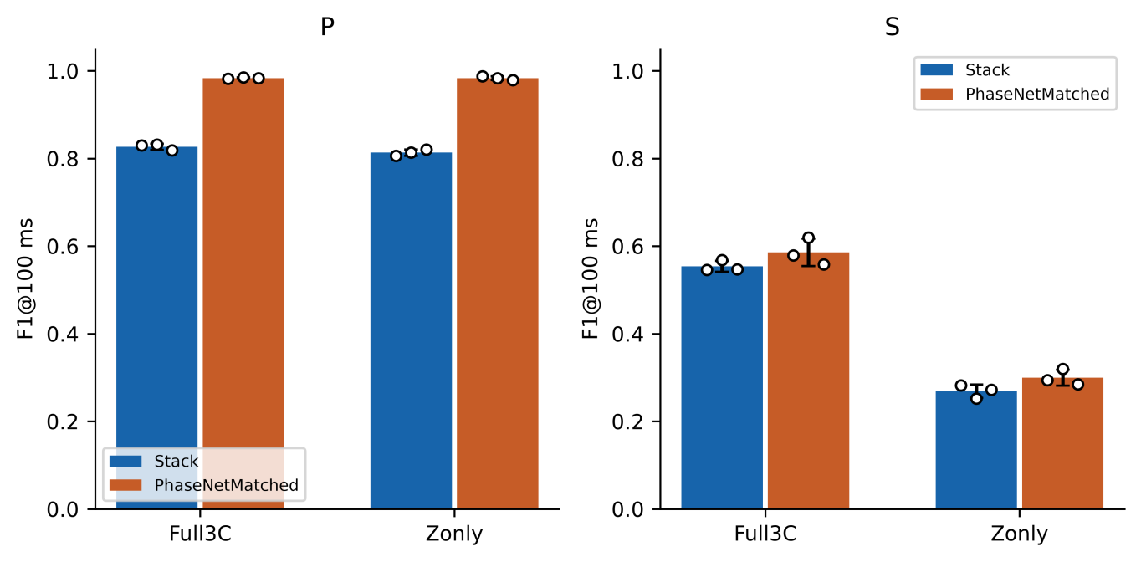
Fig. 11. Stacker versus PhaseNet-style MATLAB baseline on the same 330 test records from 221 sources: (a) P and (b) S F1 at ±100 ms, accepting detected and uncertain picks. Bars show means. For stacking, each white point is a mean over three meta seeds for one base seed; error bars are the sample SD of the three base-specific means. For the baseline, points are its three independently initialized fits and error bars are their sample SD. These are seed SDs, not confidence intervals; paired source-cluster intervals are reported in Table 7. Data and decoder are shared, but inputs and compute budgets differ.
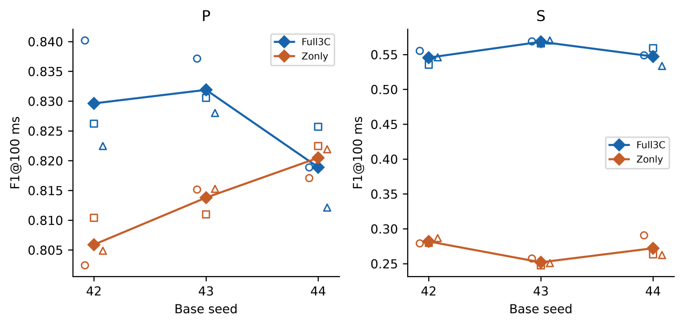
Fig. 12. Stacker initialization variability on one fixed source split: (a) P and (b) S F1 at ±100 ms. Colour identifies input mode, open symbols identify individual meta seeds, and filled diamonds show the three-meta-seed mean within each base seed. Horizontal offsets separate overlapping observations; lines connect means only as a visual guide. Panel y-axis ranges differ to expose the small P variations. Meta fits sharing a base are dependent. The source partition, OOF assignments and augmentation seeds remain fixed; this figure does not measure split or geographic uncertainty.

4.6. Decoder constraints and practical implications
The decoder restricts S to 0.1–30 s after accepted P, within the record. Disabling this restriction also changes the quality-score search domain, so the comparison is not an isolated post hoc safeguard with otherwise identical decoding.
Constrained and unconstrained predictions were compared record by record for the three base-42 meta seeds. Counts of changed S times or availability and P-rejected cases are supplied with Online Resource 1, Table S11. The comparison also changes the quality-score domain; it does not isolate post hoc ordering alone. Ordered constrained outputs do not demonstrate that the network independently learned the physical rule.
S timing remains a practical limitation: in the corrected Full3C base-42/meta-42 stacker, accepted S RMSE was 1596.78 ms and 6.21% of accepted errors exceeded 1 s. High candidate coverage is insufficient evidence for automatic catalogue use. PhaseNetMatched lowers mean accepted-pick MAE, but neither workflow has been validated for continuous monitoring or downstream location accuracy. Figures 13–14 display error tails and selected waveform cases.
For reuse, three evidence levels must remain distinct. Matching waveform and artifact identities establishes consistency of the computational objects. Source-disjoint fitting and OOF membership establish the specified exclusions within v2. Neither establishes independence from earlier research decisions involving these observations. This distinction connects data identification (Duerr et al. 2011) with validation design, while preserving the difference between the forecasting analyses of Jover-Alfaro et al. (2026) and the phase-picking case study here. The contribution is most useful as an auditable evaluation procedure whose limits are visible, rather than as a claim that additional pipeline complexity improves predictive skill.

4.7. Limitations
The study uses one retrospectively recovered STEAD subset and fixed split. Initialization repetitions and source bootstrapping exclude partition and training uncertainty; base-42 ablations lack replication at other base seeds. Meta fits share OOF features, and outer validation is reused for base selection, meta stopping and ensemble weighting. Most current test sources had historical training/validation exposure. Manual-status sensitivity does not quantify annotation error, and the unavailable extraction recipe limits assessment of selection bias. Twelve unseen-key records cannot establish station transfer. Threshold sensitivity does not prove validation-only calibration; multiple intervals remain exploratory. Regional transfer, continuous-stream false alarms, overlapping events and operational latency were not evaluated.
The additional comparator is a PhaseNet-style MATLAB adaptation, not the official PhaseNet implementation or a pretrained benchmark. It uses the same data and decoder but differs in architecture, input representation, minibatch size, and optimizer-step budget; the observed differences cannot be assigned to one design choice. TwoStream-EQT and SeismoDual report evaluation across additional datasets or acquisition settings (Peng et al. 2025; Tang and Chen 2026); their scores are not directly comparable here. The AIC score centre cannot exceed 9.99 s, whereas 234 of 330 test S arrivals and 15 test P arrivals occur later. This limits the classical comparator and supplied features; the study is not a general comparison against optimized AIC picking. These counts concern score centres before conditional decoding, not final error counts.
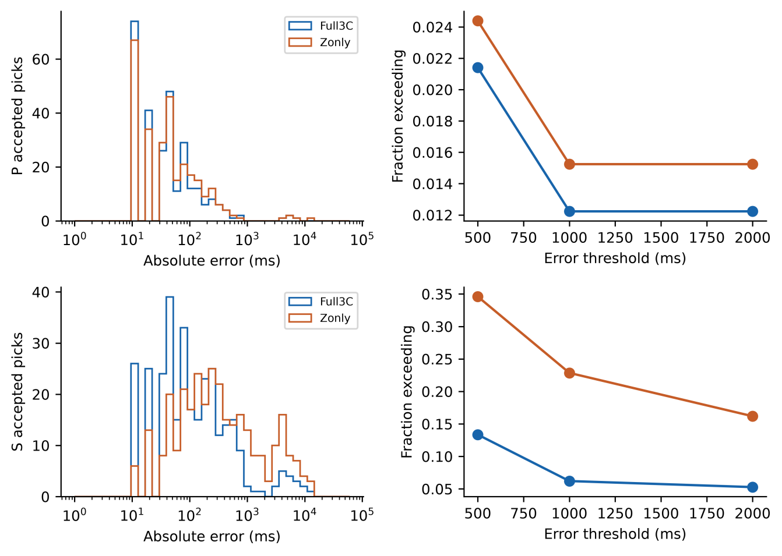
Fig. 13. Base-42/meta-42 accepted errors. Left: full-range histograms on logarithmic axes. Right: fractions exceeding 500, 1000, and 2000 ms. Rows show P and S; denominators are accepted picks.
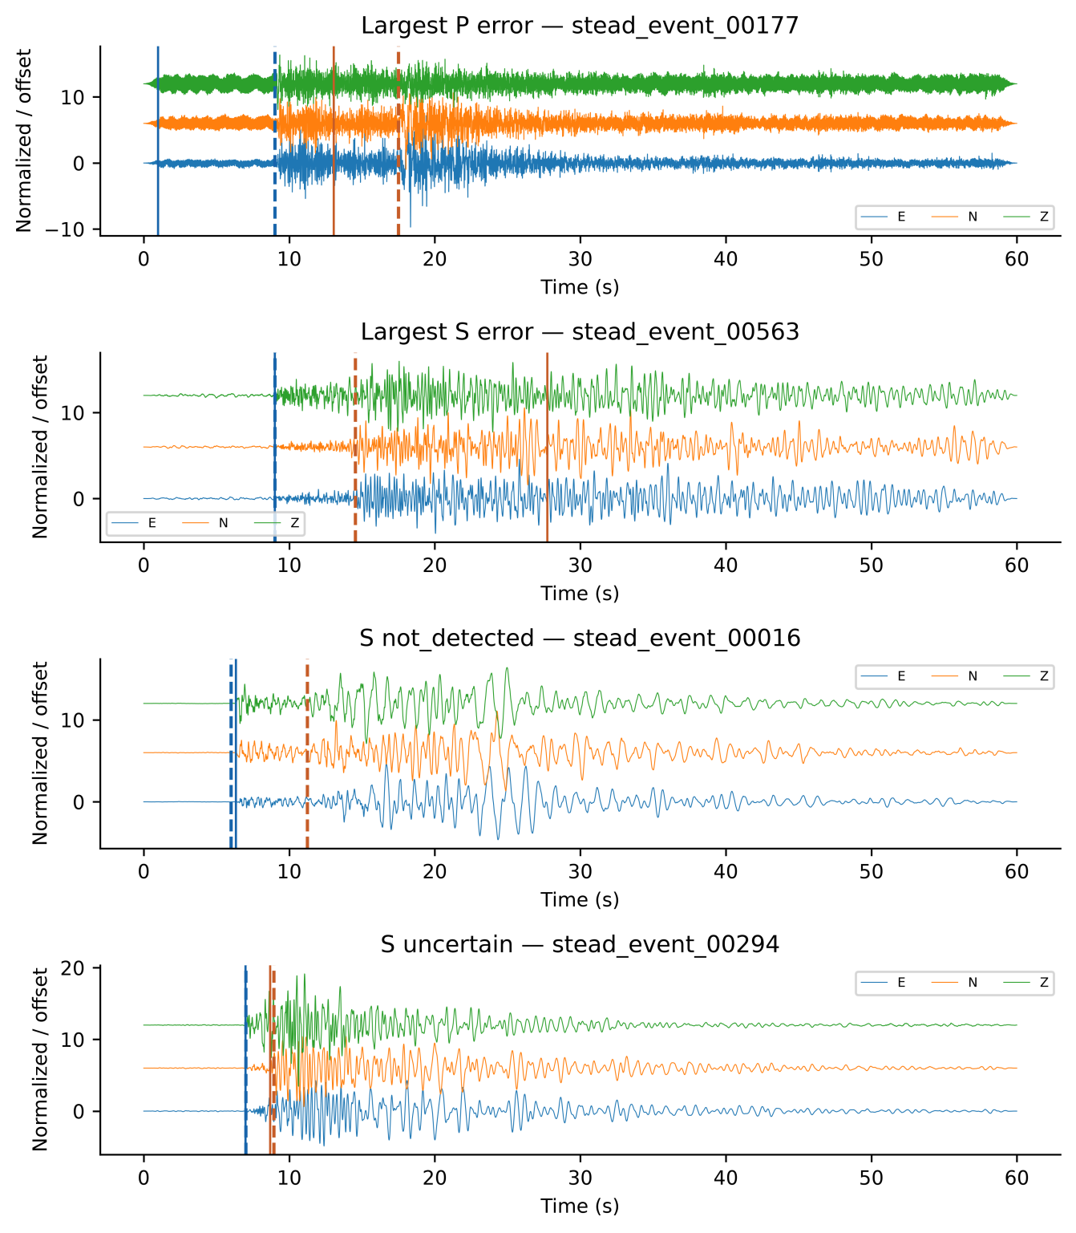
Fig. 14. Selected Full3C base-42/meta-42 cases: largest accepted P error, largest accepted S error, and first S not-detected and uncertain cases when present. Components are normalized individually and offset. Dashed lines mark true arrivals; solid lines mark reported predictions. Event IDs identify the selection.

4.8. Future directions
Confirmation requires data outside prior research and development; another split of this population cannot erase historical exposure. Additional source splits can measure partition sensitivity, while nested validation separates selection stages. Independent datasets, matched official picker implementations, continuous-record false alarms, latency and controlled perturbations remain necessary tests of transfer and mechanism.

5. Conclusions
The study demonstrates an executable connection between waveform identity, grouped feature generation, model provenance and reproducible evaluation. Unique matches in the local STEAD archive define the retained records and sources; membership assertions and replay make their computational use inspectable. Synthetic failures show what the implemented checks reject. These outcomes establish artifact consistency and specified within-run exclusions. Historical development exposure prevents an independent-confirmation claim, and station, regional and independent-dataset generalization remain unestablished.
On this fixed split of 330 records from 221 sources held out from v2 fitting and validation, accepted stacking P/S F1@100 ms was 0.8268/0.5536 for Full3C and 0.8134/0.2686 for Z-only. Between-base SDs were 0.0069/0.0127 and 0.0073/0.0152. Full3C accepted-pick MAE was 166.62/610.29 ms, with coverage 99.06%/98.01%. Acceptance combines detected and uncertain picks.
The S component difference was 0.2850 (conditional 95% interval 0.2293–0.3418). PhaseNetMatched achieved P/S F1 of 0.9833/0.5857 (Full3C) and 0.9833/0.2995 (Z-only); primary conditional intervals support its P advantage but include zero for both S method differences. Base-42 ablations support exploratory S context/dilation gains without isolating nonlinearity. Confirmation requires data kept outside prior development.

Statements and Declarations

Author contributions
Rahmat Catur Wibowo: Conceptualization, Methodology, Software, Validation, Formal analysis, Investigation, Data curation, Writing – original draft, Writing – review & editing, Visualization, Supervision, Project administration. Razki Alfatah Khairu Mahli: Software, Investigation, Validation, Visualization, Writing – review & editing. Karyanto: Software, Data curation, Investigation, Writing – review & editing. Hendra Amijaya: Methodology, Resources, Writing – review & editing. Aristoteles: Formal analysis, Validation, Writing – review & editing. Maman Hermana: Validation, Writing – review & editing. Muh Sarkowi: Conceptualization, Methodology, Supervision, Writing – review & editing.

Code availability
The implementation repository is https://github.com/rcw3712/ICNN_MetaPicker_Curated_STEAD_MATLAB. Release source-verified-v2.0.0, Git commit 8e82c781a1641191b6b56b15688d68e269b24918, is archived at https://doi.org/10.5281/zenodo.22824997. Its source_verified_v2 directory contains the recovery mapping, frozen partition and OOF protocol, training scripts, 106 checkpoints, predictions, independent audits, inference receipts and threshold/station diagnostics, with an English user guide, runnable synthetic examples and hash manifests. The downloaded archive matches all 1,241 package-manifest entries. Earlier releases contain historical partitions and must not be used to reproduce these corrected results. The archived release retains the earlier manuscript title. The present ESI manuscript reorganizes the presentation and updates literature and availability wording after archiving; numerical results and computational artifacts are unchanged. The archive is cited as Wibowo et al. (2026).

Data availability
The waveforms originate from STEAD (Mousavi et al. 2019), available through https://github.com/smousavi05/STEAD. The retained 2,234 records map to 1,477 recovered earthquake sources. Trace names, original source IDs and numerical waveform fingerprints specify the selected observations independently of their local ordinal filenames. Raw STEAD waveforms remain subject to the original distribution terms and are not redistributed here.
The corrected mapping and protocol identify current inputs; label quantization and prediction-based verification are documented. The exhaustive fingerprint index verifies exact-match multiplicity in the local HDF5 version, not other STEAD versions. Recovery establishes retained records but not the unavailable original extraction procedure. Historical roles and all threshold/station outputs accompany the audit.

Competing interests
The authors declare that they have no known competing financial interests or personal relationships that could have appeared to influence the work reported in this paper. The development of the I-CNN MetaPicker framework was conducted solely for academic research purposes and did not receive commercial sponsorship or involve any commercial entity.

Funding
This research was conducted as part of ongoing academic activities of the authors and did not receive dedicated external funding. The authors received no financial support for the research, authorship, or publication of this article.

AI assistance in manuscript preparation
During manuscript preparation, the authors used ChatGPT/Codex (OpenAI) and Claude (Anthropic) for language editing, organization, and assistance drafting tables and captions. After using these tools, the authors reviewed and edited the text, verified references and consistency with the study results, and take full responsibility for the content of the publication. AI assistance with the computational workflow is described in Section 3.

Supplementary information
Online Resource 1 (ESM_1.pdf): supplementary figures S1–S7 and tables S1–S27 documenting features, prediction diagnostics, ablations, seed-level results, source provenance, historical data roles, replay, manual-status sensitivity, threshold sensitivity and station overlap.

References
Allen RV (1978) Automatic earthquake recognition and timing from single traces. Bulletin of the Seismological Society of America 68 (5), 1521–1532. https://doi.org/10.1785/BSSA0680051521
Baer M, Kradolfer U (1987) An automatic phase picker for local and teleseismic events. Bulletin of the Seismological Society of America 77 (4), 1437–1445. https://doi.org/10.1785/BSSA0770041437
Bai S, Kolter JZ, Koltun V (2018) An empirical evaluation of generic convolutional and recurrent networks for sequence modeling. arXiv preprint arXiv:1803.01271. https://doi.org/10.48550/arXiv.1803.01271
Cheng A, Xu E, Yao P, Zhou Y, Huang S, Ye Z (2024) An automatic arrival time picking algorithm of P-wave based on adaptive characteristic function. Computers & Geosciences 185, 105544. https://doi.org/10.1016/j.cageo.2024.105544
Duerr RE, Downs RR, Tilmes C, Barkstrom B, Lenhardt WC, Glassy J, Bermudez LE, Slaughter P (2011) On the utility of identification schemes for digital earth science data: an assessment and recommendations. Earth Science Informatics 4:139–160. https://doi.org/10.1007/s12145-011-0083-6
Ioffe S, Szegedy C (2015) Batch normalization: accelerating deep network training by reducing internal covariate shift. Proceedings of the 32nd International Conference on Machine Learning, PMLR 37, 448–456. https://doi.org/10.48550/arXiv.1502.03167
Jover-Alfaro J, Arias-Antúnez E, Mateo-Cortés JA (2026) Forecasting earthquakes by Machine Learning techniques: lights and shadows. Earth Science Informatics 19:24. https://doi.org/10.1007/s12145-026-02078-x
Kingma DP, Ba J (2015) Adam: a method for stochastic optimization. Proceedings of the 3rd International Conference on Learning Representations (ICLR 2015). https://doi.org/10.48550/arXiv.1412.6980
Maeda N (1985) A method for reading and checking phase times in auto-processing system of seismic wave data. Zisin (Journal of the Seismological Society of Japan, Second Series) 38 (3), 365–379. https://doi.org/10.4294/zisin1948.38.3_365
Mousavi SM, Ellsworth WL, Zhu W, Chuang LY, Beroza GC (2020) Earthquake transformer—An attentive deep-learning model for simultaneous earthquake detection and phase picking. Nature Communications 11, 3952. https://doi.org/10.1038/s41467-020-17591-w
Mousavi SM, Sheng Y, Zhu W, Beroza GC (2019) STanford EArthquake Dataset (STEAD): A global data set of seismic signals for AI. IEEE Access 7, 179464–179476. https://doi.org/10.1109/ACCESS.2019.2947848
Münchmeyer J, Woollam J, Rietbrock A, Tilmann F, Lange D, Bornstein T, Diehl T, Giunchi C, Haslinger F, Jozinović D, Michelini A, Saul J, Soto H (2022) Which picker fits my data? A quantitative evaluation of deep learning based seismic pickers. Journal of Geophysical Research: Solid Earth 127 (1), e2021JB023499. https://doi.org/10.1029/2021JB023499
Peng L, Li L, Mousavi SM, Zeng X, Beroza GC (2025) TwoStream-EQT: A microseismic phase picking model combining time and frequency domain inputs. Computers & Geosciences 204, 105991. https://doi.org/10.1016/j.cageo.2025.105991
Sleeman R, van Eck T (1999) Robust automatic P-phase picking: An on-line implementation in the analysis of broadband seismogram recordings. Physics of the Earth and Planetary Interiors 113 (1–4), 265–275. https://doi.org/10.1016/S0031-9201(99)00007-2
Srivastava N, Hinton G, Krizhevsky A, Sutskever I, Salakhutdinov R (2014) Dropout: a simple way to prevent neural networks from overfitting. Journal of Machine Learning Research 15, 1929–1958. https://www.jmlr.org/papers/v15/srivastava14a.html
Tang K-W, Chen K-Y (2026) SeismoDual: A dual-domain deep learning framework for robust seismic phase picking. Computers & Geosciences 207, 106080. https://doi.org/10.1016/j.cageo.2025.106080
Vargas-Zamudio KA, Perton M, Legrand D, Sánchez-Sesma FJ (2026) Physically driven feature engineering for deep learning applications in seismo-volcanic signal analysis. Earth Science Informatics 19:11. https://doi.org/10.1007/s12145-025-02062-x
Wibowo RC, Mahli RAK, Karyanto, Amijaya H, Aristoteles, Hermana M, Sarkowi M (2026) Source-Grouped Evaluation of Temporal Stacking for Seismic Phase Picking with Three-Component Data. Version source-verified-v2.0.0. Zenodo. https://doi.org/10.5281/zenodo.22824997
Wolpert DH (1992) Stacked generalization. Neural Networks 5 (2), 241–259. https://doi.org/10.1016/S0893-6080(05)80023-1
Woollam J, Münchmeyer J, Tilmann F, Rietbrock A, Lange D, Bornstein T, Diehl T, Giunchi C, Haslinger F, Jozinović D, Michelini A, Saul J, Soto H (2022) SeisBench—A toolbox for machine learning in seismology. Seismological Research Letters 93 (3), 1695–1709. https://doi.org/10.1785/0220210324
Zhu W, Beroza GC (2019) PhaseNet: A deep-neural-network-based seismic arrival-time picking method. Geophysical Journal International 216 (1), 261–273. https://doi.org/10.1093/gji/ggy423

